Guided Wildlife Viewing Tour Operator Survey
Monterey Bay Region, California

This is a voluntary survey.

The public reporting burden for this collection of information is estimated to average 2.5 hours including the time for reviewing instructions, searching for existing data sources, gathering and maintaining the data needed, and completing and reviewing the collection of information. Send comments regarding this burden estimate or any other suggestions for reducing this burden to: Dr. Danielle Schwarzmann, NOAA National Ocean Service, Office of National Marine Sanctuaries, 1305 East-West Highway, Silver Spring, MD 20910. Responses provided for this survey will be anonymous. No personally identifiable information is being collected with this survey; responses will not be attributed to individual businesses. Notwithstanding any other provisions of the law, no person is required to respond to, nor shall any person be subjected to a penalty for failure to comply, with a collection of information subject to the requirements of the Paperwork Reduction Act unless that collection of information displays a currently valid OMB Control Number.

GENERAL INFORMATION

Respondent ID Number_______
(assigned by interviewer)

All questions should be answered by the business owner, unless the owner has specified someone better suited to provide a response.

Questions 1-5 are regarding the business owner.
1. Which of the following includes your age?
___18-30 ___31-40 ___41-50 ___51-60 ___over 60

2. Are you Hispanic or Latino?
___YES ___NO

3. What is your race? (Mark all that apply)
__ White __ Black or African American __ American Indian or Alaska Native
__ Asian __ Native Hawaiian or Other Pacific Islander
__ Other:____________

4. What is your gender?
___ Male ___ Female ___Decline to state

5. How many family members do you support (including yourself)?
Myself only 2 3 4 5 6 7 Greater than 7

6. What is your primary port/marina/location? ___________________________________________

7. Do you have a secondary port/marina/location from where you operate part of the year?
___YES ___NO

7a. If YES, which one? __________________________________________________

8. How many years have you been an ocean recreation business owner?
___ (number of years)

9. How many years have you been an ocean recreation business owner in the Monterey Bay region?
___ (number of years)

10. Do you visit state marine protected areas (reserves/conservation areas) specifically during your tours? (Interviewer—Please show state MPA map to identify specific quadrants)
___YES ___NO

10a. Why or why not? ___________________________________________________________________

10b. How often? _______________________________________________________________

10c. If YES, how many years have you conducted guided wildlife tours in state marine protected areas? ___ (number of years)

Question 11 is for whale watching operators only:
11. Do you currently have a naturalist on board during whale watching trips?
___YES ___NO

11a. If NO, would you be interested in having one on board if you had more information about the role they play with whale watching operators? ___YES ___NO

12. Are customers targeting particular wildlife species when they go on a guided tour?
___YES ___NO

12a. If YES, please list:__________________________________________________

13. How would you describe the wildlife viewing operation? (Mark one or more)
___ Full-time whale watching operation ___ Part-time whale watching operation
___ Seasonal whale watching operation

___ Full-time kayaking operation ___ Part-time whale watching operation ___Seasonal kayaking operation

___ Full-time dive/snorkeling operation ___ Part-time whale watching operation
___ Seasonal dive/snorkeling operation

___ Full-time seabird viewing operation ___ Part-time whale watching operation
___ Seasonal seabird viewing operation

___ Full-time sailing/boating operation ___ Part-time whale watching operation ___Seasonal sailing/boating operation

___ Full-time recreational fishing operation ___ Part-time whale watching operation
___ Seasonal recreational fishing operation

__ Full-time combination whale watching, recreational cruises, kayaking, diving/snorkeling, and wildlife observation operation

__ Part-time combination whale watching, recreational cruises, kayaking, diving/snorkeling, and wildlife observation

__ Seasonal combination whale watching, recreational cruises, kayaking, diving/snorkeling, and wildlife observation.

13a. If part time or seasonal, which months? ________________________________________________________________________

14. Number of boats/vessels at the operation:
____ (number of vessels)

Question 15-19 are for specific types of operators:
15. Average number of whale watching participants per vessel in operation:
Vessel 1: ____watchers Vessel 2: ____watchers
Vessel 3: ____watchers Vessel 4: ____watchers

16. Average number of participants per vessel in recreational fishing cruise operation:
Vessel 1: ____ participants Vessel 2: ____participants
Vessel 3: ____ participants Vessel 4: ____participants

17. Average number of kayakers and kayaks per guided tour:
____kayakers ____kayaks

18. Average number of divers/snorkelers per vessel in operation:
Vessel 1: ____divers/snorkelers Vessel 2: ____divers/snorkelers
Vessel 3: ____divers/snorkelers Vessel 4: ____divers/snorkelers

19. Average number of wildlife observers (seabirds and other) per vessel in operation (capacity):
Vessel 1: ____seabird observers ____ other wildlife observers
Vessel 2: ____seabird observers ____ other wildlife observers
Vessel 3: ____seabird observers ____ other wildlife observers
Vessel 4: ____seabird observers ____ other wildlife observers

20. Number of employees at the operation:
Full time _____
Part time _____
Seasonal _____

21. Number of vessel trips/guided tours per day (primary purpose):
Whale watching ___________
Recreational cruise (sailing, boating)___________
Fishing ___________
Kayaking ___________
Diving/snorkeling ___________
Seabird viewing ___________

Question 22 should be answered only if the person responding has been in the guided wildlife tour industry for 10 years or more.
22. In your opinion, on a scale of 1 to 5, how has the quality of the guided wildlife tour industry changed in the last 10 years?
1 – Much worse
2 – Somewhat worse
3 – No change
4 – Somewhat better
5 – Much better
No opinion

22a. If you believe that the quality of guided tours has changed, could you tell us how it’s changed?
_______________________________________________________________________
_______________________________________________________________________
_______________________________________________________________________
_______________________________________________________________________

22b. Are you the owner of the business you are representing?
___YES ___NO

23. Are you aware that wildlife in the region are sometimes unintentionally harassed?
___YES ___NO

23a. If YES, how concerned are you that harassment to wildlife (whales, pinnipeds, sea otters, and seabirds) may be having a negative impact on your business, with 1 being not concerned and 5 being extremely concerned?
1 – Not at all concerned
2 – Slightly concerned
3 – Somewhat concerned
4 – Moderately concerned
5 – Extremely concerned
No opinion

24. Currently, there are no regulations in MBNMS that require an "approach distance" to whales and other wildlife. However, there are official NOAA Fisheries guidelines that recommend wildlife viewing vessels maintain a minimum distance of 100 yards/meters from whales and wildlife. Does your operation have any kind of established policy regarding a minimum distance your vessels maintain from whales and wildlife?
___YES ___NO

24a. If YES, what is your company's approach distance policy?
___ 0-50 yards/meters
___ 50-100 yards/meters
___100-150 yards/meters
___ More than 150 yards/meters

25. Please give a brief explanation on how you think your business could be affected if a mandatory regulation were to be passed that would require an approach distance to whales and other wildlife.
__________________________________________________________________________________________________________________________________________________________________________________________________________________________________________

26. The Marine Mammal Health and Stranding Response Program authorizes a group of unpaid volunteers to respond to sightings of whales entangled in fishing gear and other debris. This group is called the Whale Entanglement Team (WET), and they respond to a 24/7 WET hotline at (877) SOS-WHALE.

26a. Have you ever heard of the Whale Entanglement Team?
___YES ___NO

26b. Have you/any of your employees ever called the WET hotline?
___YES ___NO

Please explain your response (i.e. reason why you called, did not call because you were not aware of program, did not call because you never encountered an entangled whale, etc.)
________________________________________________________________________________________________________________________________________________________________________________________________________________________

26c. Does your company have a policy about responding to injured or entangled wildlife?
___YES ___NO

If YES, what is your company’s policy about responding to injured or entangled wildlife?
________________________________________________________________________________________________________________________________________________________________________________________________________________________

27. Would you be interested in learning more about how your company can respond to injured or entangled wildlife?
___YES ___NO

27a. If YES, how would you like to receive information? (Check all options that apply)
___ Attend a seminar during business hours with other interested local wildlife tour operators

___ Attend a seminar after business hours with other interested local wildlife tour operators

___ Attend a webinar/online seminar with other interested local wildlife tour operators

___ Receive physical pamphlets/handouts/reading materials that are mailed to the business

___ Receive electronic pamphlets/handouts/reading materials that are emailed to the business

___ Receive an in-person training from an trained expert during business hours at your business

28. To the best of your knowledge, please rank the status/condition of the following resources in Monterey Bay National Marine Sanctuary, where 1 is much better and 5 is much worse.

RESOURCE Better Worse

a. Water Quality 1 2 3 4 5 N/A
b. Marine Debris/Ocean Pollution 1 2 3 4 5 N/A
c. Wildlife (whales, otters, pinnipeds) 1 2 3 4 5 N/A
d. Habitats (tidepools, beaches, kelp forests) 1 2 3 4 5 N/A
e. Introduced Species 1 2 3 4 5 N/A
f. Sensitive Areas
(haulout, roosting, nesting) 1 2 3 4 5 N/A

29a. Are there any categories listed above, in Question 28, where MBNMS been successful? (List all that apply)
________________________________________________________________________________________________________________________________________________________________________________________________________________________

29b. Are there any categories listed above, in Question 28, where MBNMS been unsuccessful? (List all that apply)?
________________________________________________________________________________________________________________________________________________________________________________________________________________________

ECONOMIC INFORMATION

30. What approximate percentage of the TOTAL business income is derived from guided wildlife viewing operations? ____%

31. What approximate percentage of your TOTAL household income is derived from guided wildlife viewing operations? ____%

32. Please list any outstanding balance on loan amounts for vessels and equipment.
$______________

33. Please provide your best estimate for the following expenses last year:
Permits/licenses $ ______________
Docking fees $ ______________
Interest payments on vessel(s) $ ______________
P&I insurance on vessel(s) $ ______________
Maintenance/repair on vessel/electronic equipment $ ______________
Maintenance/repair on dive/snorkel gear $ ______________
Maintenance/repair on rods/reels $ ______________
Maintenance/repair on compressors $ ______________
Maintenance/repair on other equipment $ ______________
Other dive equipment costs $ ______________
Advertising $ ______________
Office rent/mortgage $ ______________
Office utilities (electric, water, telephone, Internet) $ ______________
Depreciation of vessels and equipment $ ______________
Business taxes $ ______________
Other (specify):
_______________________________________ $ ______________
_______________________________________ $ ______________
_______________________________________ $ ______________

33a. Please provide your best estimate of the replacement value of the following items that you used last year (fill in year _____):
Vessel(s) and electronic equipment $ ______________
Diving and snorkeling gear $ ______________
Compressors $ ______________
Rods/reels $ ______________
Other gear (specify):
_______________________________________ $ ______________
_______________________________________ $ ______________
_______________________________________ $ ______________

34. Please provide your best estimate for the following trip related expenses last year:
Dive equipment costs $ ______________
Fuel/oil $ ______________
Ice $ ______________
Food/supplies $ ______________
Bait $ ______________
Captain wages & salaries (if not owner-captain) $ ______________
Crew wages & salaries Number ______ $ ______________
Other (specify):
_______________________________________ $ ______________
_______________________________________ $ ______________
_______________________________________ $ ______________

35. Please provide your best estimate of total business revenues last year.
$ ______________

36. Please provide your best estimate of total revenues and/or percent of total revenues last year in Monterey Bay National Marine Sanctuary.
$ ______________ % _____

Questions 37 – 39 pertain to whale watching operators only:
37. Does the number of whales seen per trip affect the profitability of that trip?
___YES ___NO

If you answered ‘yes’ to question 37, then
What is the minimum number of whales that need to be seen per trip in order to make the
trip profitable? ______________

38. What is the minimum number of customers/attendants that need to be booked per trip in order to make the trip profitable? _______________

39. If you do not see any whales on a trip, do you reimburse customers? ___YES ___NO

39a. If YES, how do you reimburse customers?
________________________________________________________________________

40. Use by activity and month:
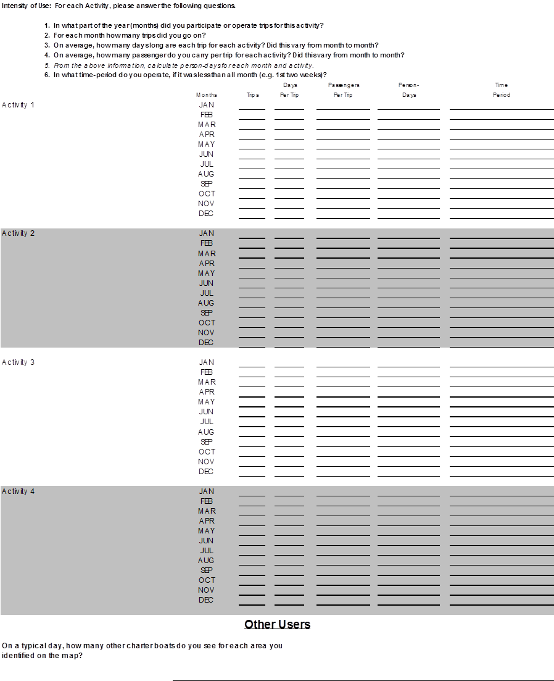

41. Mapping Exercise: Map the Distribution of Each Activity
Respondents will be advised to provide information on their anticipated spatial use of the Monterey Bay. This anticipated spatial use may be the same as their current use or it may be different. Respondents will be given a 100 penny budget, meaning one penny equals one percent of passenger activity. The respondent will allocate his or her budget across all map cells. Codes will be recorded on the coding sheet. The map cells will be referenced by column and row: For example, C1R1 1% means 1% of activity is in cell Column 1 Row 1. The percent of each activity must add up to 100.

42. Does this map reflect where you presently operate?
___YES ___NO

42a. If NO, please explain why future operations may be different than where you have historically operated.
________________________________________________________________________________________________________________________________________________________________________________________________________________________

