**Recruitment Text: “User Experiences with Smart Home Devices”**

**04/24/19**

**EMAIL RECRUITMENT**

**Subject line: Improve the Smart Home Devices of Tomorrow!**

The National Institute of Standards and Technology (NIST) is conducting interviews with owners of smart home devices (e.g., smart home security cameras and systems, smart thermostats, smart lighting systems, smart appliances). What we learn from this project will help the U.S. Government identify ways to improve the usability, safety, and security of future smart home devices, and make things better for consumers like you.

Interviews will last 60 minutes and will take place during the month of **[insert month]** at 1010 North Glebe Road, Arlington, VA (near the Ballston-MU Metro station).

If you are interested, we will need to ask you questions that will take about 5 to 10 minutes to complete to see if you qualify. If you qualify and are chosen to participate, we will contact you to schedule a time that is convenient for you.

For questions about the study, please contact Susanne Furman at susanne.furman@nist.gov or 301-975-3271.

**FLYER RECRUITMENT**

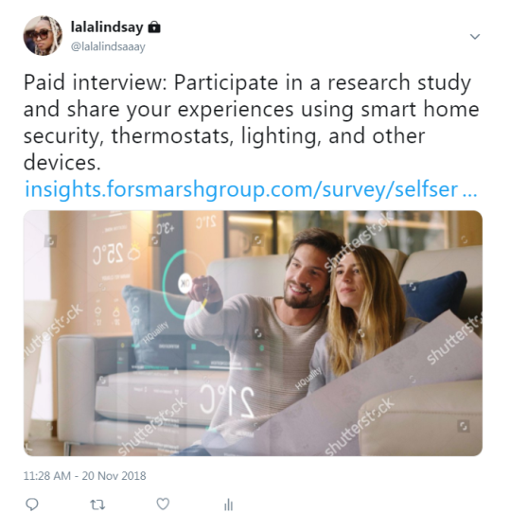**Paid interview:** Improve the future of smart home devices for consumers like you. Share your experiences using smart home devices.

The National Institute of Standards and Technology (NIST) is conducting interviews with owners of smart home devices (e.g., smart home security cameras and systems, smart thermostats, smart lighting systems, smart appliances). What we learn from this project will help the U.S. Government identify ways to improve the usability, safety, and security of future smart home devices, and make things better for consumers like you.

Interviews will last 60 minutes and will take place during the month of **[insert month]** at 1010 North Glebe Road, Arlington, VA (near the Ballston-MU Metro station).

If you are interested, we will need to ask you questions that will take about 5 to 10 minutes to complete to see if you qualify. If you qualify and are chosen to participate, we will contact you to schedule a time that is convenient for you.

For questions about the study, please contact Susanne Furman at susanne.furman@nist.gov or 301-975-3271.