Dear Manufacturer,

The National Institute of Standards and Technology (NIST), an agency within the Federal government, is studying the costs and benefits of firms adopting advanced maintenance techniques. This work relates to NIST’s efforts to develop standards that facilitate advanced maintenance. You are invited to participate in a survey on manufacturing maintenance. This is a study being conducted by the National Institute of Standards and Technology. Your participation in this survey is voluntary. You may refuse to take part in the research or exit the survey at any time without penalty. You are free to decline to answer any particular question you do not wish to answer for any reason.

There are no benefits or risks involved in participating in this study. Responses will help advance the economic knowledge on adopting advanced maintenance techniques and making the business case for adoption. There are no foreseeable risks involved in participating in this study other than those encountered in day-to-day life. Your survey answers are anonymous and confidential. Raw data will not be shared outside of the National Institute of Standards and Technology.

The survey can be completed and mailed back to NIST using the self-addressed envelope or it can be completed online at: https://www.nist.gov/el/applied-economics-office/machinery-maintenance-survey.

This collection of information contains Paperwork Reduction Act (PRA) requirements approved by the Office of Management and Budget (OMB). Notwithstanding any other provisions of the law, no person is required to respond to, nor shall any person be subject to a penalty for failure to comply with, a collection of information subject to the requirements of the PRA unless that collection of information displays a currently valid OMB control number. Public reporting burden for this collection is estimated to be 25 minutes per response, including the time for reviewing instructions, searching existing data sources, gathering and maintaining the data needed and completing and reviewing the collection of information. Send comments regarding this burden estimate or any aspect of this collection of information, including suggestions for reducing this burden, to the National Institute of Standards and Technology, Attn: douglas.thomas@nist.gov.

We appreciate your time,
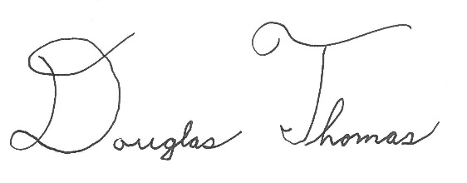

Douglas Thomas, Economist
douglas.thomas@nist.gov
301-975-4918
National Institute of Standards and Technology
100 Bureau Drive
Gaithersburg, MD 20899

