# Attachment 2: Youth Baseline INSTRUMENT

Form Approved

OMB No. 0910-0753

Exp. Date 10/31/2016

Evaluation of the Rural Smokeless Tobacco Education Campaign (RuSTEC)

**Subjects for Questionnaire:**

Section A: Demographic Items

Section B: Tobacco Use Behavior

Section C: Tobacco Use Intentions and Self-Efficacy

Section D: Cessation (Intention, Behavior, Motivation)

Section E: Attitudes, Beliefs & Risk Perceptions, Social Norm

Section F: Media Use and Awareness

Section G: Environment

**Introduction**

Thank you for agreeing to take part in this survey. The survey will take approximately 30 minutes to complete. You will be asked various questions about your experiences with tobacco products, media use, as well as some questions about your background. Even if you do not use tobacco products, the information you provide will still be very important.

Your responses will be kept strictly confidential, and neither your name nor other personal information will be associated with your responses. The data collected for this study will be combined with that of all participants before it is analyzed.

## Section A: Demographic Items

**A1.** The first part of the survey asks you some general questions about yourself.

How old are you?

1 11 years old

2 12 years old

3 13 years old

4 14 years old

5 15 years old

6 16 years old

7 17 years old

8 18 years old or older

9 Prefer not to answer

**A2.** Are you female or male?

1 Female

2 Male

9 Prefer not to answer

**A3.** Are you of Hispanic, Latino/a, or of Spanish origin? *Select all that apply.*

1 No, not of Hispanic, Latino/a, or Spanish origin

2 Yes, Mexican American, Chicano/a

3 Yes, Puerto Rican

4 Yes, Cuban

5 Yes, another Hispanic, Latino/a, or Spanish origin

9 Prefer not to answer

**A4.** In general, do you usually speak…

1 Only Spanish

2 Spanish more than English

3 Spanish and English equally

4 English more than Spanish

5 English only

6 Some other language

9 Prefer not to answer

[IF A4=6, ASK A4a]

**A4a.** What other language do you usually speak?

**________________**

**A5.** What race or races do you consider yourself to be? Please select one or more of these categories.

|  |  |
| --- | --- |
|  | **1**  **Yes** |
| **A4_1.** American Indian or Alaska Native | 1 |
| **A4_2.** Asian | 1 |
| **A4_3.** Black or African American | 1 |
| **A4_4.** Native Hawaiian or Other Pacific Islander | 1 |
| **A4_5.** White | 1 |
| **A4_6.** Other | 1 |

|  |  |
| --- | --- |
| **A3_7.** Prefer not to answer | 1 |

[IF A5_6=1, ASK A5a]

**A5a.** Please specify the other race you consider yourself to be.

**________________**

**A6.** What grade are you in? If school has not started for you, what grade are you going into?

1 5th

2 6th

3 7th

4 8th

5 9th

6 10th

7 11th

8 12th

9 Ungraded or other grade

99 Prefer not to answer

**A7.** During the past 30 days, about how much money did you have each week to spend any way you wanted to?

1 None

2 $5 or less

3 $6 to $10

4 $11 to $20

5 $21 to $35

6 $36 to $50

7 $51 to $75

8 $76 to $125

9 $126 or more

99 Prefer not to answer

Section B: Tobacco Use Behavior

### Cigarette Use

**B1.** The next section asks about your experiences with tobacco products.

Have you ever tried cigarette smoking, even one or two puffs?

1 Yes

2 No

9 Prefer not to answer

[IF B1=1 or 9, ASK B2. IF B1=2, ASK B5]

**B2.** During the past 30 days, on how many days did you smoke cigarettes?

1 0 days

2 1 or 2 days

3 3 to 5 days

4 6 to 9 days

5 10 to 19 days

6 20 to 29 days

7 All 30 days

9 Prefer not to answer

[IF B3=1, ASK B4, otherwise ask B3]

**B3.** During the past 30 days, on the days you smoked, how many cigarettes did you smoke per day?

1 Less than 1 cigarette per day

2 1 cigarette per day

3 2 to 5 cigarettes per day

4 6 to 10 cigarettes per day

5 11 to 20 cigarettes per day

6 More than 20 cigarettes per day

9 Prefer not to answer

**B4.** About how many cigarettes have you smoked in your entire life? Your best guess is fine.

1 0 cigarettes

2 1 or more puffs but never a whole cigarette

3 1 cigarette

4 2 to 5 cigarettes

5 6 to 15 cigarettes (about 1/2 a pack total)

6 16 to 25 cigarettes (about 1 pack total)

7 26 to 99 cigarettes (more than 1 pack, but less than 5 packs)

8 100 or more cigarettes (5 or more packs)

9 Prefer not to answer

### Other Tobacco Product Use

**B5.** The next questions are about smokeless tobacco, such as dip, chewing tobacco, snuff, or snus. Common brands include Copenhagen, Grizzly, Skoal, Camel Snus, Kodiak, and Longhorn.



Have you ever used smokeless tobacco even just a small amount?

1 Yes

2 No

9 Prefer not to answer

[IF B5=1, ASK B6]

**B6.** During the past 30 days, on how many days did you use smokeless tobacco?

1 0 days

2 1 or 2 days

3 3 to 5 days

4 6 to 9 days

5 10 to 19 days

6 20 to 29 days or

7 All 30 days

9 Prefer not to answer

**B7.** How many times have you used smokeless tobacco in your entire life?

1 1 time

2 2 to 10 times

3 11 to 20 times

4 21 to 50 times

5 51 to 99 times

6 100 or more times

9 Prefer not to answer

**B8.** How often do you swallow smokeless tobacco juices?

1 Always

2 Sometimes

3 Rarely

4 Never

9 Prefer not to answer

**B9.** How soon after you wake up do you use smokeless tobacco?

1 Within 5 minutes

2 6 to 30 minutes

3 31 to 60 minutes

4 More than 60 minutes

9 Prefer not to answer

**B10.** The next questions are about cigars, cigarillos, or little cigars such as Black & Mild, Swisher Sweets, Dutch Masters, Phillies Blunts, Prime Time, and Winchester.



Have you ever smoked cigars, cigarillos, or little cigars even one time?

1 Yes

2 No

9 Prefer not to answer

[IF B10=1, ASK B11]

**B11.** During the past 30 days, on how many days did you smoke cigars, cigarillos, or little cigars?

1 0 days

2 1 or 2 days

3 3 to 5 days

4 6 to 9 days

5 10 to 19 days

6 20 to 29 days or

7 All 30 days

9 Prefer not to answer

**B12.** Have you ever tried smoking tobacco out of a water pipe (also called “hookah”), even one time?

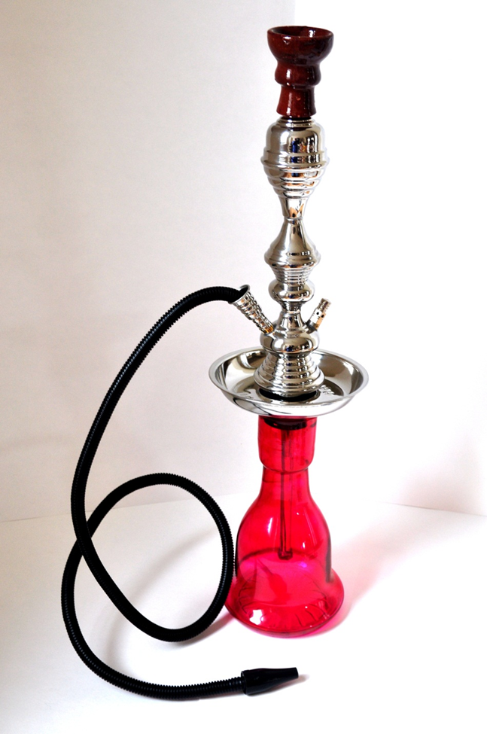

1 Yes

2 No

9 Prefer not to answer

[IF B12=1, ASK B13]

**B13.** During the past 30 days, on how many days did you smoke tobacco out of a water pipe (also called “hookah”)?

1 0 days

2 1 or 2 days

3 3 to 5 days

4 6 to 9 days

5 10 to 19 days

6 20 to 29 days or

7 All 30 days

9 Prefer not to answer

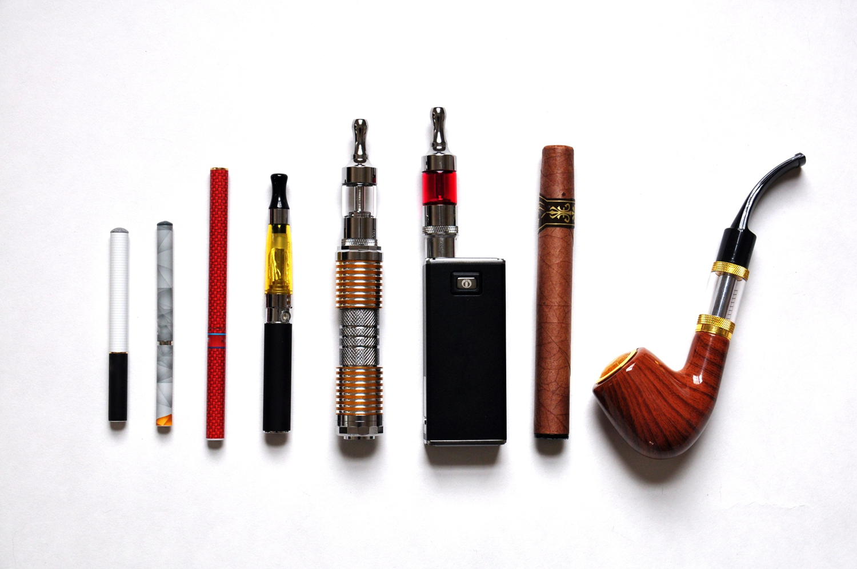

**B14.** The next questions are about e-cigarettes (e-cigs), sometimes also called vape pens, personal vaporizers and mods, e-cigars, e-pipes, e-hookahs and hookah pens.

Have you ever tried any e-cigarettes, even one time?

1 Yes

2 No

9 Prefer not to answer

[IF B14=1, ASK B15]

**B15.** During the past 30 days, on how many days did you use e-cigarettes?

1 0 days

2 1 or 2 days

3 3 to 5 days

4 6 to 9 days

5 10 to 19 days

6 20 to 29 days or

7 All 30 days

9 Prefer not to answer

[ASK IF B14=1]

**B16.** Does the e-cigarette you usually use contain nicotine?

1 Yes

2 No

3 Don’t Know

9 Prefer not to answer

### Marijuana use

**B17.** Have you ever tried marijuana, even one time?

1 Yes

2 No

9 Prefer not to answer

[IF B17=1, ASK B18]

**B18.** During the past 30 days, on how many days did you use marijuana?

1 0 days

2 1 or 2 days

3 3 to 5 days

4 6 to 9 days

5 10 to 19 days

6 20 to 29 days or

7 All 30 days

9 Prefer not to answer

## Section C: Tobacco Use Intentions and Self-Efficacy

**C1.** Thinking about the future…

|  |  |  |  |  |  |  |
| --- | --- | --- | --- | --- | --- | --- |
|  |  | **1**  **Definitely Yes** | **2**  **Probably Yes** | **3**  **Probably Not** | **4**  **Definitely Not** | **9**  **Prefer Not to Answer** |
| **C1_1.** | Do you think that you will smoke a **cigarette** soon? | 1 | 2 | 3 | 4 | 9 |
| **C1_2.** | Do you think you will smoke a **cigarette** at any time in the next year? | 1 | 2 | 3 | 4 | 9 |
| **C1_3.** | If one of your best friends were to offer you a **cigarette**, would you smoke it? | 1 | 2 | 3 | 4 | 9 |
| **C1_4.** | Have you ever been curious about smoking **cigarettes**? | 1 | 2 | 3 | 4 | 9 |

**C2.** Thinking about the future…

|  |  |  |  |  |  |  |
| --- | --- | --- | --- | --- | --- | --- |
|  |  | **1**  **Definitely Yes** | **2**  **Probably Yes** | **3**  **Probably Not** | **4**  **Definitely Not** | **9**  **Prefer Not to Answer** |
| **C2_1.** | Do you think that you will use **smokeless tobacco**? | 1 | 2 | 3 | 4 | 9 |
| **C2_2.** | Do you think you will use **smokeless tobacco** at any time in the next year? | 1 | 2 | 3 | 4 | 9 |
| **C2_3.** | If one of your best friends were to offer you **smokeless tobacco** would you use it? | 1 | 2 | 3 | 4 | 9 |
| **C2_4** | Have you ever been curious about using **smokeless tobacco**? | 1 | 2 | 3 | 4 | 9 |

**C3.** Thinking about the future…

|  |  |  |  |  |  |  |
| --- | --- | --- | --- | --- | --- | --- |
|  |  | **1**  **Definitely Yes** | **2**  **Probably Yes** | **3**  **Probably Not** | **4**  **Definitely Not** | **9**  **Prefer Not to Answer** |
| **C3_1.** | Do you think that you will use an **e-cigarette** soon? | 1 | 2 | 3 | 4 | 9 |
| **C3_2.** | Do you think you will use an **e-cigarette** at any time in the next year? | 1 | 2 | 3 | 4 | 9 |
| **C3_3.** | If one of your best friends were to offer you an **e-cigarette**, would you use it? | 1 | 2 | 3 | 4 | 9 |
| **C3_4** | Have you ever been curious about using **e-cigarettess**? | 1 | 2 | 3 | 4 | 9 |

**C4.** How sure are you that, if you really wanted to, **you could say no to smokeless tobacco,** if…

[RANDOMIZE C4_1-C4_3]

|  |  |  |  |  |  |  |
| --- | --- | --- | --- | --- | --- | --- |
|  | **1**  **Not at all sure** | **2**  **Slightly sure** | **3**  **Somewhat sure** | **4**  **Mostly sure** | **5**  **Completely sure** | **9**  **Prefer Not to Answer** |
| **C4_1.** You are hanging out where most people are using it? | 1 | 2 | 3 | 4 | 5 | 9 |
| **C4_2.** A friend offers it? | 1 | 2 | 3 | 4 | 5 | 9 |
| **C4_3.** If a family member offers it? | 1 | 2 | 3 | 4 | 5 | 9 |

Section D: Cessation (Intention, Behavior, Motivation)

Cigarette Use [Ask if B2=2-9]

**D1.** During the past 3 months, did you stop smoking cigarettes for one day or longer because you were trying to quit smoking cigarettes for good?

1 Yes

2 No

9 Prefer not to answer

**D2.** How much do you want to quit stop smoking?

1 Not at all

2 A little

3 Somewhat

4 A lot

9 Prefer not to answer

Other Tobacco Use [Ask if B5=2-9]

**D3.** During the past 3 months, did you stop using smokeless tobacco for one day or longer because you were trying to quit using smokeless tobacco for good?

1 Yes

2 No

9 Prefer not to answer

**D4.** How much do you want to stop using smokeless tobacco?

1 Not at all

2 A little

3 Somewhat

4 A lot

9 Prefer not to answer

Section E: Attitudes, Beliefs & Risk Perceptions, Social Norm

[Ask ALL] The next set of questions asks for your opinions on cigarette use and other tobacco products.

Attitude

**E1. Smoking cigarettes** is…

[RANDOMIZE E1_1-E1_3]

|  |  |  |  |  |  |  |  |  |  |
| --- | --- | --- | --- | --- | --- | --- | --- | --- | --- |
| **E1_1.** | **Bad** |  |  |  |  |  |  |  | **Good** |
| **E1_2.** | **Unenjoyable** |  |  |  |  |  |  |  | **Enjoyable** |
| **E1_3.** | **Harmful** |  |  |  |  |  |  |  | **Not Harmful** |

**E2. Using smokeless tobacco** is…

[RANDOMIZE E2_1-E2_3]

|  |  |  |  |  |  |  |  |  |  |
| --- | --- | --- | --- | --- | --- | --- | --- | --- | --- |
| **E2_1.** | **Bad** |  |  |  |  |  |  |  | **Good** |
| **E2_2.** | **Unenjoyable** |  |  |  |  |  |  |  | **Enjoyable** |
| **E2_3.** | **Harmful** |  |  |  |  |  |  |  | **Not Harmful** |

**E3. Using e-cigarettes** is…

[RANDOMIZE E3_1-E3_3]

|  |  |  |  |  |  |  |  |  |  |
| --- | --- | --- | --- | --- | --- | --- | --- | --- | --- |
| **E3_1.** | **Bad** |  |  |  |  |  |  |  | **Good** |
| **E3_2.** | **Unenjoyable** |  |  |  |  |  |  |  | **Enjoyable** |
| **E3_3.** | **Harmful** |  |  |  |  |  |  |  | **Not Harmful** |

Attitudinal Beliefs and Risk Perceptions

**E4.** How much do you agree or disagree with the following statements? **If I use smokeless tobacco, I will…**

|  |  |  |  |  |  |  |  |
| --- | --- | --- | --- | --- | --- | --- | --- |
|  |  | **1**  **Strongly Disagree** | **2**  **Disagree** | **3**  **Neither Agree or Disagree** | **4**  **Agree** | **5**  **Strongly Agree** | **9**  **Prefer Not to Answer** |
| **E4_1.** | Damage my body | 1 | 2 | 3 | 4 | 5 | 9 |
| **E4_2.** | Be controlled by smokeless tobacco | 1 | 2 | 3 | 4 | 5 | 9 |
| **E4_3.** | Be more attractive | 1 | 2 | 3 | 4 | 5 | 9 |
| **E4_4.** | Develop cancer of the lip, mouth, tongue or throat | 1 | 2 | 3 | 4 | 5 | 9 |
| **E4_5.** | Develop sexual and/or fertility problems | 1 | 2 | 3 | 4 | 5 | 9 |
| **E4_6.** | Fit in | 1 | 2 | 3 | 4 | 5 | 9 |
| **E4_7.** | Be unable to stop when I want to | 1 | 2 | 3 | 4 | 5 | 9 |
| **E4_8.** | Lose my teeth | 1 | 2 | 3 | 4 | 5 | 9 |
| **E4_9 .** | Shorten my life | 1 | 2 | 3 | 4 | 5 | 9 |
| **E4_10 .** | Get sick more often | 1 | 2 | 3 | 4 | 5 | 9 |
| **E4_11.** | End up wasting money on smokeless tobacco | 1 | 2 | 3 | 4 | 5 | 9 |
| **E4_12.** | Feel more relaxed | 1 | 2 | 3 | 4 | 5 | 9 |
| **E4_13.** | Miss out on things I enjoy doing | 1 | 2 | 3 | 4 | 5 | 9 |
| **E4_14.** | Gross out people I want to date | 1 | 2 | 3 | 4 | 5 | 9 |
| **E4_16.** | Develop gum disease? | 1 | 2 | 3 | 4 | 5 | 9 |
| **E4_17.** | Develop red or white patches in the mouth? | 1 | 2 | 3 | 4 | 5 | 9 |
| **E4_18.** | Consume harmful chemicals | 1 | 2 | 3 | 4 | 5 | 9 |

**E5.** How much do you agree or disagree with the following statements? If I smoke I will…

|  |  |  |  |  |  |  |  |
| --- | --- | --- | --- | --- | --- | --- | --- |
|  |  | **1**  **Strongly Disagree** | **2**  **Disagree** | **3**  **Neither Agree or Disagree** | **4**  **Agree** | **5**  **Strongly Agree** | **9**  **Prefer Not to Answer** |
| **E5_1.** | Be controlled by smoking | 1 | 2 | 3 | 4 | 5 | 9 |
| **E5_2.** | Be more attractive | 1 | 2 | 3 | 4 | 5 | 9 |
| **E5_3.** | Develop cancer of the lip, mouth, tongue or throat | 1 | 2 | 3 | 4 | 5 | 9 |
| **E5_4.** | Develop sexual and/or fertility problems | 1 | 2 | 3 | 4 | 5 | 9 |
| **E5_5.** | Be unable to stop when I want to | 1 | 2 | 3 | 4 | 5 | 9 |
| **E5_6.** | Develop skin problems | 1 | 2 | 3 | 4 | 5 | 9 |
| **E5_7.** | Lose my teeth | 1 | 2 | 3 | 4 | 5 | 9 |
| **E5_8.** | Feel more relaxed | 1 | 2 | 3 | 4 | 5 | 9 |
| **E5_9.** | Shorten my life | 1 | 2 | 3 | 4 | 5 | 9 |
| **E5_10.** | End up wasting money on cigarettes | 1 | 2 | 3 | 4 | 5 | 9 |
| **E5_11.** | Be more popular | 1 | 2 | 3 | 4 | 5 | 9 |

**E6.** How much do you agree or disagree with the following statements **about smoking cigarettes?**

|  |  |  |  |  |  |  |  |
| --- | --- | --- | --- | --- | --- | --- | --- |
|  |  | **1**  **Strongly Disagree** | **2**  **Disagree** | **3**  **Neither Agree or Disagree** | **4**  **Agree** | **5**  **Strongly Agree** | **9**  **Prefer Not to Answer** |
| **E6_1.** | Smoking can cause **immediate** damage to my body. | 1 | 2 | 3 | 4 | 5 | 9 |
| **E6_2.** | Smoking cigarettes helps people relieve stress. | 1 | 2 | 3 | 4 | 5 | 9 |
| **E6_3.** | Cigarette ingredients are disgusting. | 1 | 2 | 3 | 4 | 5 | 9 |
| **E6_4.** | Smoking cigarettes is a manly thing to do | 1 | 2 | 3 | 4 | 5 | 9 |

**E7.** How much do you agree or disagree with the following statements **about using smokeless tobacco such as dip, chewing tobacco, or snuff?**

|  |  |  |  |  |  |  |  |
| --- | --- | --- | --- | --- | --- | --- | --- |
|  |  | **1**  **Strongly Disagree** | **2**  **Disagree** | **3**  **Neither Agree or Disagree** | **4**  **Agree** | **5**  **Strongly Agree** | **9**  **Prefer Not to Answer** |
| **E7_1.** | Using smokeless tobacco can cause **immediate** damage to my body. | 1 | 2 | 3 | 4 | 5 | 9 |
| **E7_2.** | It is safe for me to use smokeless tobacco for only a year or two, as long as I quit after that. | 1 | 2 | 3 | 4 | 5 | 9 |
| **E7_3.** | If I used smokeless tobacco occasionally I would not become addicted. | 1 | 2 | 3 | 4 | 5 | 9 |
| **E7_4.** | Using smokeless tobacco helps people relieve stress. | 1 | 2 | 3 | 4 | 5 | 9 |
| **E7_5.** | Using smokeless tobacco is disgusting. | 1 | 2 | 3 | 4 | 5 | 9 |
| **E7_7.** | Using smokeless tobacco is a way to show others you’re not afraid to take risks | 1 | 2 | 3 | 4 | 5 | 9 |
| **E7_9** | Using smokeless tobacco is a manly thing to do | 1 | 2 | 3 | 4 | 5 | 9 |

**E8.** Does **smokeless tobacco such as dip, chewing tobacco, or snuff** contain….

*[Randomize E8_1 – E8_8]*

|  |  |  |  |  |  |  |  |
| --- | --- | --- | --- | --- | --- | --- | --- |
|  |  | **1**  **Definitely Yes** | **2**  **Probably Yes** | **3**  **Probably Not** | **4**  **Definitely Not** | **Don’t Know** | **9**  **Prefer Not to Answer** |
| **E8_1.** | Arsenic, a substance found in motor oil? | 1 | 2 | 3 | 4 | 5 | 9 |
| **E8_2.** | Beryllium, a substance used in nuclear weapons and nuclear power reactors? | 1 | 2 | 3 | 4 | 5 | 9 |
| **E8_3.** | Cadmium, a substance found in batteries? | 1 | 2 | 3 | 4 | 5 | 9 |
| **E8_4.** | Formaldehyde, a chemical used to preserve dead animals? | 1 | 2 | 3 | 4 | 5 | 9 |
| **E8_5.** | Lead, a substance found in bullets? | 1 | 2 | 3 | 4 | 5 | 9 |
| **E8_6.** | Naphthalene, a chemical found in mothballs? | 1 | 2 | 3 | 4 | 5 | 9 |
| **E8_7.** | Polonium 210, a poison? | 1 | 2 | 3 | 4 | 5 | 9 |
| **E8_8.** | Uranium, a substance used in nuclear weapons and nuclear power reactors? | 1 | 2 | 3 | 4 | 5 | 9 |

Social Norms

**E9.** How many of your four closest friends…

*[Randomize E9_1 – E9_3]*

|  |  |  |  |  |  |  |  |
| --- | --- | --- | --- | --- | --- | --- | --- |
|  |  | **0**  **None** | **1**  **One** | **2**  **Two** | **3**  **Three** | **4**  **Four** | **9**  **Prefer Not to Answer** |
| **E9_1.** | Smoke cigarettes? | 0 | 1 | 2 | 3 | 4 | 9 |
| **E9_2.** | Use smokeless tobacco? | 0 | 1 | 2 | 3 | 4 | 9 |
| **E9_3.** | Use e-cigarettes? | 0 | 1 | 2 | 3 | 4 | 9 |

**E10.** How many others your age…

*[Randomize E10_1 – E10_3]*

|  |  |  |  |  |  |  |  |
| --- | --- | --- | --- | --- | --- | --- | --- |
|  |  | **0**  **None** | **1**  **A few** | **2**  **Some** | **3**  **Most** | **4**  **All** | **9**  **Prefer Not to Answer** |
| **E10_1.** | Smoke cigarettes? | 0 | 1 | 2 | 3 | 4 | 9 |
| **E10_2.** | Use smokeless tobacco? | 0 | 1 | 2 | 3 | 4 | 9 |
| **E10_3.** | Use e-cigarettes? | 0 | 1 | 2 | 3 | 4 | 9 |

Section F: Media Use and Awareness

**F1.** Next, we’d like to ask you about your use of TV and other media.

How often do you… *[Randomize F1_1 – F1_8]*

|  |  |  |  |  |  |  |  |  |
| --- | --- | --- | --- | --- | --- | --- | --- | --- |
|  | **1**  **Several times a day** | **2**  **About Once a Day** | **3**  **3-5 days a week** | **4**  **1-2 days a week** | **5**  **Every few weeks** | **6**  **Less often** | **7**  **Never** | **9**  **Prefer Not to Answer** |
| **F1_1.** Watch television? | 1 | 2 | 3 | 4 | 5 | 6 | 7 | 9 |
| **F1_2.** Watch videos on YouTube/Twitch? | 1 | 2 | 3 | 4 | 5 | 6 | 7 | 9 |
| **F1_3.** Listen to radio? | 1 | 2 | 3 | 4 | 5 | 6 | 7 | 9 |
| **F1_4.** Listen to streaming radio? | 1 | 2 | 3 | 4 | 5 | 6 | 7 | 9 |
| **F1_5.** Play games on all electronic devices. Including cell phones/ smartphones, computers, laptops, tablets, consoles (Xbox, Wii, PS) and handheld players (Nintendo DS, Sony PSP, iPod)? | 1 | 2 | 3 | 4 | 5 | 6 | 7 | 9 |
| **F1_6.** Look at or reading any magazines on a computer, laptop, or tablet. | 1 | 2 | 3 | 4 | 5 | 6 | 7 | 9 |
| **F1_7.** Watch Netflix, Hulu or Amazon Prime video? | 1 | 2 | 3 | 4 | 5 | 6 | 7 | 9 |
| **F1_8.** Go to the movies at a movie theater? | 1 | 2 | 3 | 4 | 5 | 6 | 7 | 9 |

**F2.** Thinking about the social networking sites you use, about how often do you visit or use the following…

[RANDOMIZE ALL]

|  |  |  |  |  |  |  |  |  |
| --- | --- | --- | --- | --- | --- | --- | --- | --- |
|  | **1**  **Several times a day** | **2**  **About Once a Day** | **3**  **3-5 days a week** | **4**  **1-2 days a week** | **5**  **Every few weeks** | **6**  **Less often** | **7**  **Never** | **9**  **Prefer Not to Answer** |
| **F2_1.**  Facebook | 1 | 2 | 3 | 4 | 5 | 6 | 7 | 9 |
| **F2_2.**  Instagram | 1 | 2 | 3 | 4 | 5 | 6 | 7 | 9 |
| **F2_3.**  Twitter | 1 | 2 | 3 | 4 | 5 | 6 | 7 | 9 |
| **F2_4.**  Periscope | 1 | 2 | 3 | 4 | 5 | 6 | 7 | 9 |
| **F2_5.**  Snapchat | 1 | 2 | 3 | 4 | 5 | 6 | 7 | 9 |
| **F2_6.**  Vine | 1 | 2 | 3 | 4 | 5 | 6 | 7 | 9 |
| **F2_7.**  Skype | 1 | 2 | 3 | 4 | 5 | 6 | 7 | 9 |
| **F2_8.**  Google Hangouts | 1 | 2 | 3 | 4 | 5 | 6 | 7 | 9 |
| **F2_9.**  WhatsApp | 1 | 2 | 3 | 4 | 5 | 6 | 7 | 9 |

**F3.** Thinking about the following websites, about how often do you visit or use the following…

[RANDOMIZE ALL]

|  |  |  |  |  |  |  |  |  |
| --- | --- | --- | --- | --- | --- | --- | --- | --- |
|  | **1**  **Several times a day** | **2**  **About Once a Day** | **3**  **3-5 days a week** | **4**  **1-2 days a week** | **5**  **Every few weeks** | **6**  **Less often** | **7**  **Never** | **9**  **Prefer Not to Answer** |
| **F3_1.** WEBSITE NAME  <http://www.xxxx.com> | 1 | 2 | 3 | 4 | 5 | 6 | 7 | 9 |
| **F3_2.** WEBSITE NAME  <http://www.xxxx.com> | 1 | 2 | 3 | 4 | 5 | 6 | 7 | 9 |
| **F3_3.** WEBSITE NAME  <http://www.xxxx.com> | 1 | 2 | 3 | 4 | 5 | 6 | 7 | 9 |
| **F3_4.** WEBSITE NAME  <http://www.xxxx.com> | 1 | 2 | 3 | 4 | 5 | 6 | 7 | 9 |
| **F3_5.** WEBSITE NAME  <http://www.xxxx.com> | 1 | 2 | 3 | 4 | 5 | 6 | 7 | 9 |
| **F3_6.** WEBSITE NAME  <http://www.xxxx.com> | 1 | 2 | 3 | 4 | 5 | 6 | 7 | 9 |

**F4.** We want to ask you about some slogans or themes that might or might not have appeared in the media around here, as part of ads about tobacco.

**F4_1**. In the past 3 months, that is since [FILL DATE], have you seen or heard the following slogan or theme?

truth

1 Yes

2 No

3 Not Sure

9 Prefer not to answer

**F4_2.** In the past 3 months, that is since [FILL DATE], have you seen or heard the following slogan or theme?

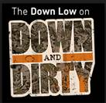Down and Dirty

1 Yes

2 No

3 Not Sure

9 Prefer not to answer

**F4_3.** In the past 3 months, that is since [FILL DATE], have you seen or heard the following slogan or theme?

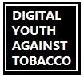Digital Youth Against Tobacco (DYAT)

1 Yes

2 No

3 Not Sure

9 Prefer not to answer

C:\Users\ntaylor\AppData\Local\Microsoft\Windows\Temporary Internet Files\Content.Outlook\7AKNJJEU\Real Cost.jpg**F4_4.** In the past 3 months, that is since [FILL DATE], have you seen or heard the following slogan or theme?

The Real Cost

1 Yes

2 No

3 Not Sure

9 Prefer not to answer

**F4_5.** In the past 3 months, that is since [FILL DATE], have you seen or heard the following slogan or theme?

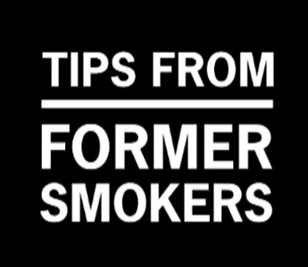Tips from Former Smokers (Tips)

1 Yes

2 No

3 Not Sure

9 Prefer not to answer

Follow-up survey Place holder: F5_3 – F14_X

ASK F5_3 IF F3_6=1 or 3, OTHERWISE ASK F7_x.

**F5_3.** Where have you seen or heard about CAMPAIGN NAME? Check all that apply.

1 2

Yes No

[RANDOMIZE]

**F5_3a.** On TV or the Internet/online

**F5_3b.** On the radio

**F5_3c.** In magazines

**F5_3d.** Billboards or other outdoor or mall ads

**F5_3_e.** At the movie theatre

F5_3_f. I have not seen or heard about CAMPAIGN NAME

**F6.** The CAMPAIGN NAME campaign is online. Have you ever seen the CAMPAIGN NAME on… Check all that apply.

1 2

Yes No

**F6_1.** Facebook?

**F6_2.** Twitter?

**F6_3.** YouTube?

**F6_4.** Hulu?

**F6_5.** Pandora or Spotify?

**F6_6.** In video games?

**F7_*x*.** Now we would like to show you some advertisements that have been shown in the U.S. Once you have viewed the video or screenshot, please click on the forward arrow below to continue with the survey.

[DISPLAY VIDEOS OR SCREENSHOTS IN RANDOM ORDER. Use VIDEO for CAMPAIGN NAME and SCREENSHOTS for ads from other campaigns]

**F8_*x*.** Apart from this survey, how frequently have you seen this ad [SCREENSHOT LANGUAGE: these ads] in the past [FILL MONTHS SINCE LAST SURVEY]?

1 Never

2 Rarely

3 Sometimes

4 Often

5 Very Often

9 Prefer not to answer

**LOOP BACK TO ASK ABOUT NEXT AD HERE.**

**SHOW SCREENGRAB OF AD**

F19_x. What is the main message of this ad? Select only one response

[RANDOMIZE ORDER OF CHECKBOX LIST] [notes here indicate the ad for which this is a key message]

1___ Smokeless tobacco can damage your teeth [face of denial]

3___ Smokeless tobacco is addictive [football, movie monster]

4___ Smokeless tobacco can control your life [football, movie monster]

5___ Smokeless tobacco can cause mouth cancer [face of denial, jeans]

6___ Smokeless tobacco contains cancer-causing chemicals [pound]

7___ Smokeless doesn’t mean harmless

99__ I am not sure

**F10_x**. How would you describe this advertisement?

|  |  |  |  |  |  |  |  |  |  |
| --- | --- | --- | --- | --- | --- | --- | --- | --- | --- |
| **F10_1.** | **Bad** | -3 | -2 | -1 | 0 | +1 | +2 | +3 | **Good** |
|  |  |  |  |  |  |  |  |  |  |

**F11_x.** Please tell us if you strongly agree, agree, neither agree nor disagree, disagree, or strongly disagree with the following statements.

|  |  |  |  |  |  |  |  |
| --- | --- | --- | --- | --- | --- | --- | --- |
|  |  | **1**  **Strongly Disagree** | **2**  **Disagree** | **3**  **Neither Agree or Disagree** | **4**  **Agree** | **5**  **Strongly Agree** | **9**  **Prefer Not to Answer** |
| **F11_1.** | This ad is worth  remembering | 1 | 2 | 3 | 4 | 5 | 9 |
| **F11_2.** | This ad grabbed my attention | 1 | 2 | 3 | 4 | 5 | 9 |
| **F11_3.** | This ad is powerful | 1 | 2 | 3 | 4 | 5 | 9 |
| **F11_4.** | This ad is informative | 1 | 2 | 3 | 4 | 5 | 9 |
| **F11_5.** | This ad is meaningful to me | 1 | 2 | 3 | 4 | 5 | 9 |
| **F11_6.** | This ad is convincing | 1 | 2 | 3 | 4 | 5 | 9 |
| **F11_7.** | This ad is terrible | 1 | 2 | 3 | 4 | 5 | 9 |
| **F11_10.** | This ad told me things I never knew before about tobacco | 1 | 2 | 3 | 4 | 5 | 9 |
| **F10_12.** | This ad gave me good reasons not to use tobacco | 1 | 2 | 3 | 4 | 5 | 9 |

**F12_x.** On a scale of 1 to 5, indicate whether the ad made smokeless tobacco look like something you would or wouldn’t want to do.

1. The ad makes me want to USE smokeless tobacco

2

3

4

5. The ad makes me want to NOT USE made tobacco

**F13_*x*.** On scale of 1 to 5, where 1 means “not at all” and 5 means “very”, please indicate how much this ad made you feel…

1 2 3 4 5

[RANDOMIZE ORDER] Not at all Very

**F13a_*x*.** Afraid

**F13b_*x*.** Hopeful

**F13c_*x*.** Motivated

**F13d_*x*.** Worried

**F13e_*x*.** Understood

**F13f_x.** Surprised

**[REPEAT F10_*x* - F18x FOR OTHER CAMPAIGN NAME ADS]**

**F18a.** Have you visited CAMPAIGN WEBSITE in the past [FILL MONTHS] months, since **[FILL DATE]**?

1 Yes

2 No

**F14_x.** Did you talk to anyone in person or online about these ads?

1 Yes

2 No

9 Prefer not to answer

[IF F14=1, ASK F15]

**F5.** Do your parents have rules about what you are allowed to do on the computer, which video games you are allowed to play, or what music you’re allowed to listen to?

1 Yes, my parents have lots of rules about it.

2 Yes, my parents have a few rules about it.

3 No, my parents don’t have any rules about it.

9 Prefer not to answer

**F6.** How often do your parents let you watch movies or videos that are rated R?

1 Never

2 Once in awhile

3 Sometimes

4 All the time

9 Prefer not to answer

**F7.** Please tell us if you strongly agree, agree, disagree, or strongly disagree with the following statements.

I try to do what my parents want me to do.

1 Strongly agree

2 Agree

3 Disagree

4 Strongly disagree

**F8.** What my parents think of me is important.

1 Strongly agree

2 Agree

3 Disagree

4 Strongly disagree

**F9.** I do what my friends want me to do, even if I don’t want to.

1 Strongly agree

2 Agree

3 Disagree

4 Strongly disagree

**F10.** To keep my friends, I’d even do things I don’t want to do.

1 Strongly agree

2 Agree

3 Disagree

4 Strongly disagree

Section G: Environment

**G1.** The next section asks some questions about your household and peers.

Other than you, has anyone who lives with you used any of the following during the past 30 days? *Select all that apply.*

1 Cigarettes

2 Smokeless tobacco

3 Cigars, cigarillos, or little cigars

4 Tobacco out of a water pipe (also called “hookah”)

5 Electronic cigarettes

6 Any other form of tobacco

7 No, no one who lives with me has used any form of tobacco during the past 30 days

9 Prefer not to answer

**G2.** Do you have any brother(s) and/or sister(s) who have used smokeless tobacco during the past 30 days?

1 Yes

2 No

3 I don’t know

4 I don’t have any brothers or sisters

9 Prefer not to answer

**G3.** Which statement best describes the rules about smoking in your home? Would you say…

1 Smoking is not allowed anywhere inside your home

2 Smoking is allowed in some places or at some times

3 Smoking is allowed anywhere inside the home

4 There are no rules about smoking inside the home

9 Prefer not to answer

**G4.** Which statement best describes the rules about using smokeless tobacco in your home? Would you say…

1 Smokeless tobacco is not allowed anywhere inside your home

2 Smokeless tobacco is allowed in some places or at some times

3 Smokeless tobacco is allowed anywhere inside the home

4 There are no rules about using smokeless tobacco inside the home

9 Prefer not to answer

**G5.** How well would you say you have done in school? Would you say…

1 Much better than average

2 Better than average

3 Average

4 Below average

5 Much worse than average

9 Prefer not to answer

**G6.** Please tell us if you strongly disagree, disagree, neither agree nor disagree, agree, or strongly agree with the following statements.

I feel close to people at my school. Would you say you…

1 Strongly Disagree

2 Disagree

3 Neither agree nor disagree

4 Agree

5 Strongly Agree

9 Prefer not to answer

**G7.** I am happy to be at my school. Would you say you…

1 Strongly Disagree

2 Disagree

3 Neither agree nor disagree

4 Agree

5 Strongly Agree

9 Prefer not to answer

**G8.** I feel like I am a part of my school. Would you say you…

1 Strongly Disagree

2 Disagree

3 Neither agree nor disagree

4 Agree

5 Strongly Agree

9 Prefer not to answer

**G9.** How far do you think you will go in school?

1 I don’t plan to go to school anymore

2 9th grade

3 10th grade

4 11th grade

5 12th grade or GED

6 Some college or technical school but no degree

7 Technical school degree

8 College degree

9 Graduate school, medical school, or law school

99 Prefer not to answer

**G10.** How many close friends do you have? Close friends include people whom you feel at ease with, can talk to about private matters, and can call on for help.

__________

9 Prefer not to answer

**G11.** How often do you attend church or religious services? Would you say…

1 Never

2 Less than once a month

3 About once a month

4 About 2 or 3 times a month

5 Once a week

6 More than once a week

9 Prefer not to answer

**G12.** Please tell us if you strongly disagree, disagree, neither agree nor disagree, agree, or strongly agree with the following statements.

I would like to explore strange places. Would you say you…

1 Strongly Disagree

2 Disagree

3 Neither agree nor disagree

4 Agree

5 Strongly Agree

9 Prefer not to answer

**G13.** I like to do frightening things. Would you say you…

1 Strongly Disagree

2 Disagree

3 Neither agree nor disagree

4 Agree

5 Strongly Agree

9 Prefer not to answer

**G14.** I like new and exciting experiences, even if I have to break the rules. Would you say you…

1 Strongly Disagree

2 Disagree

3 Neither agree nor disagree

4 Agree

5 Strongly Agree

9 Prefer not to answer

**G15.** I prefer friends who are exciting and unpredictable. Would you say you…

1 Strongly Disagree

2 Disagree

3 Neither agree nor disagree

4 Agree

5 Strongly Agree

9 Prefer not to answer

**G16.**  Thinking about your mental health, which includes stress, depression, and problems with emotions, for how many days during the past 30 days was your mental health not good?

_____ Number of days

3 Don’t know

9 Prefer not to answer

**G17.** The next section asks some questions about how you feel about your current relationship with your parents or guardians.

Thinking about the adult or adults you live with would you say you are satisfied with the way you communicate with each other.

1 Strongly Disagree

2 Disagree

3 Neither agree nor disagree

4 Agree

5 Strongly Agree

9 Prefer not to answer

**G18.** How close do you feel to the adult or adults you live with?

1 Not at all close

2 Not very close

3 Somewhat close

4 Quite close

5 Very close

9 Prefer not to answer

**G19.** How often has a parent or other adult caregiver said things that really hurt your feelings or made you feel like you were not wanted or loved?

1 One time

2 Two times

3 Three to five times

4 Six to ten times

5 More than ten times

6 This has never happened

7 Don’t know

9 Prefer not to answer

**G20.** Has a parent or other adult caregiver ever talked to you about reasons for not using smokeless tobacco?

1 Yes

2 No

9 Prefer not to answer

**G21.** During the past 7 days, on how many days did you and one or both of your parents or other adult caregivers do something together just for fun?

__________

9 Prefer not to answer

**Thank you for taking time to complete this survey.**

**OMB No: 0910-0753 Expiration Date: 10/31/2016**

**Paperwork Reduction Act Statement: The public reporting burden for this collection of information has been estimated to average 30 minutes per response. Send comments regarding this burden estimate or any other aspects of this collection of information, including suggestions for reducing burden to PRAStaff@fda.hhs.gov.**