2019 Electronic Nicotine Delivery Systems Formative Data Collection to Inform Experimenter and Established User Definitions – SURVEY INSTRUMENT

[DISPLAY THE FOLLOWING TEXT IN SMALL GREY FONT IN UPPER OR LOWER CORNER (E.G., AS HEADER OR FOOTER) OF EACH PAGE IN THE SURVEY INSTRUMENT: “OMB #0910-0810, Expires 10/31/2021”]
SECTION A: ENDS USE

A_INTRO. Based on your responses to the previous questions, you qualify to participate in this survey.

First, we would like to ask you a few additional questions about vaping products or vapes.

[INCLUDE THE STATEMENT BELOW A_INTRO IN SMALLER GREY FONT AT THE BOTTOM OF THE PAGE:

Paperwork Reduction Act Statement: The public reporting burden for this information collection has been estimated to average 18 minute per response to complete this survey (the time estimated to read and complete). Send comments regarding this burden estimate or any other aspects of this information collection, including suggestions for reducing burden, to PRAStaff@fda.hhs.gov.]

A1. How many times have you vaped in your entire life? Your best guess is fine.

1. 1 time
2. 2 to 5 times
3. 6 to 15 times
4. 16 to 25 times
5. 26 to 50 times
6. 50 – 99 times
7. 100 or more
99. Prefer not to answer

A2. When did you last use a vaping product, even one or two times?

1. Earlier today
2. Not today but sometime during the past 7 days
3. Not during the past 7 days but sometime during the past 30 days
4. Not during the past 30 days but sometime during the past 6 months
5. Not during the past 6 months but sometime in the past year
6. 1 to 4 years ago
7. 5 or more years ago
99. Prefer not to answer

[ASK IF A2 = 1-3]
A3. During the past 30 days, on how many days did you vape?

1. 0 days
2. 1 or 2 days
3. 3 to 5 days
4. 6 to 9 days
5. 10 to 19 days
6. 20 to 29 days
7. All 30 days
99. Prefer not to answer

A4. Please think of the first time you ever tried a vaping product. When you first vaped, what flavor did you use?

[RANDOMIZE ORDER OF OPTIONS 1-9, KEEP OPTIONS 10 - 12 FIXED AT END]

1. Tobacco-flavored
2. Menthol
3. Mint
4. Clove or spice
5. Fruit
6. Chocolate
7. An alcoholic drink (such as wine, cognac, margarita or other cocktails)
8. A non-alcoholic drink (such as coffee, soda, energy drinks, or other beverages)
9. Candy, desserts or other sweets
10. Unflavored
11. Some other flavor (SPECIFY)__________
12. I don’t know
99. Prefer not to answer

[ASK IF A2 = 1-3]
A5. Which flavors of vaping products do you currently use? Select all that apply.

[RANDOMIZE ORDER OF OPTIONS 1-9, KEEP 10 - 11 FIXED AT END]

1. Tobacco-flavored
2. Menthol
3. Mint
4. Clove or spice
5. Fruit
6. Chocolate
7. An alcoholic drink (such as wine, cognac, margarita or other cocktails)
8. A non-alcoholic drink (such as coffee, soda, energy drinks, or other beverages)
9. Candy, desserts or other sweets
10. Unflavored
11. Some other flavor (SPECIFY)__________
99. Prefer not to answer

A6. Where do you usually get vaping products?

1. Friend
2. Parent/Adult
3. Gas Station
4. Online
5. Tobacco Shop
6. Mall Kiosk
7. Other
99. Prefer not to answer

A7. What type of vape product do you typically use?

1. Vaping products that you can’t refill using bottles of e-liquid
2. Vaping products with refillable tanks and special features like temperature control
3. Vaping products with refillable tanks and no special features
4. Vaping products that you use with replaceable cartridges or pods
5. Some other type of device
6. Don’t know
99. Prefer not to answer

A8. What brand of vaping product do you typically use?
[RANDOMIZE ORDER OF OPTIONS 1 – 11; FIX OPTIONS 12 AND 13 AT END]

1. JUUL
2. Phix
3. Suorin
4. Ziip
5. Smok
6. KandyPen
7. Blu
8. MarkTen
9. Vuse
10. Logic
11. NJOY
12. Some other brand of vape (Specify:____________)
13. Not sure
99. Prefer not to answer

A9. Do you own your own vape product?

1. Yes
2. No

SECTION B: SOCIAL CONTEXT OF ENDS USE

These next few questions are about vaping and your family and friends.

B1. Besides yourself does anyone who lives in your home use vaping products now?

1. Yes
2. No

B2. How many of your friends vape?

1. None of my friends
2. 1 of my friends
3. 2 of my friends
3. 3 of my friends
4. 4 or more of my friends

B3. Is there a rule at your school that students are not allowed to vape anywhere on school property?

1. Yes
2. No
3. I don’t know

[ASK IF B3 = 1]
B4. How easy or difficult do you think it would it be for a student to get away with vaping on school property?

[USE SLIDING SCALE]

1. Very easy
2.
3.
4.
5.
6.
7. Very difficult

B5. In the past week, how often have you seen students at your school vaping anywhere on school property?

1. Every day
2. Most days
3. Few days
4. Never

B6. Please read the following questions and choose a response option.

[USE SCROLLING LIST. RANDOMIZE ORDER OF QUESTIONS]

1. Very wrong
2. Wrong
3. A little bit wrong
4. Not wrong at all

B6_1. How wrong do you think it is for someone your age to vape?
B6_2. How wrong do your friends feel it would be for you to vape?
B6_3. How wrong do your parents feel it would be for you to vape?

B7. Did you ever practice ways to say 'no' to vaping in any of your classes (for example by role playing)?

1. Yes
2. No

SECTION C: ENDS DEPENDENCE

[ASK IF A2 = 1-3]
C1. On days that you can vape freely, how soon after you wake up do you first use your vaping product?

1. 0–5 mins
2. 6–15
3. 16–30
4. 31–60
5. 61–120
6. 121+ mins
99. Prefer not to answer

C2. Right now, how much do you want to vape?

1. Extremely
2. Very
3. Somewhat
4. Slightly
5. Not at all

C3. How much of the time have you felt the urge to vape in the past 24 hours?

1. All the time
2. Almost all the time
3. A lot of the time
4. Some of the time
5. A little of the time
6. Not at all

C4. For the next few questions, please indicate how often you do the following.

[USE SCROLLING LIST. RANDOMIZE ORDER OF QUESTIONS]

1. Never
2. Rarely
3. Sometimes
4. Often
5. Almost always
99. Prefer not to answer

C4_1. I find myself reaching for my vaping product without thinking about it.
C4_2. I vape more before going into a situation where vaping is not allowed.
C4_3. When I haven’t been able to vape for a few hours, the craving gets intolerable.
C4_4. I drop everything to go out and get vape products or e-juice.

SECTION D: ENDS-RELATED KABS

Next, we would like to ask you some questions about your opinion about vaping products.

D1. Vaping is…

1. Very Bad
2. Bad
3. Neither Good or Bad
4. Good
5. Very Good

D2. Vaping is…

1. Very Unenjoyable
2. Unenjoyable
3. Neither enjoyable or unenjoyable
4. Enjoyable
5. Very Enjoyable

D3. Out of every 10 people your age, how many do you think vape?

1. 1 person
2. 2 people
3. 3 people
4. 4 people
5. 5 people
6. 6 people
7. 7 people
8. 8 people
9. 9 people
10. 10 people

D4. Compared to smoking cigarettes, would you say that vaping products are…

1. Much less harmful than cigarettes
2. Less harmful than cigarettes
3. Just as harmful as cigarettes
4. More harmful than cigarettes
5. Much more harmful than cigarettes

D5. For the next few questions, please tell us how much you agree or disagree with the following statements.

[USE SCROLLING LIST. RANDOMIZE ORDER OF QUESTIONS]

1. Strongly Disagree
2. Disagree
3. Neither Agree or Disagree
4. Agree
5. Strongly Agree

D5_1. Vaping just a little can make you crave more
D5_2. Flavored vapes may contain nicotine
D5_3. Addiction is a disease you can get from vaping
D5_4. Vapes are addictive, like cigarettes
D5_5. Vape ingredients are dangerous
D5_6. Vaping makes you more likely to smoke cigarettes
D5_7. Most vapes that teens are using contain nicotine
D5_8. Vapes contain toxic chemicals
D5_9. Vaping can harm your lungs
D5_10. Vapes contain formaldehyde
D5_11. Vaping can cause irreversible lung damage
D5_12. Vaping can release dangerous chemicals into your bloodstream
D5_13. The nicotine in vapes changes your brain

D6. If I vape, I will…

[USE SCROLLING LIST. RANDOMIZE ORDER OF QUESTIONS]

1. Strongly Disagree
2. Disagree
3. Neither Agree or Disagree
4. Agree
5. Strongly Agree

D6_1. Inhale microscopic metal particles such as nickel, tin, and lead
D6_2. Develop serious health problems
D6_3. Miss out on activities I enjoy
D6_4. Damage my body
D6_5. Get stunted lungs
D6_6. Become addicted
D6_7. Decrease my sports performance
D6_8. Be controlled by nicotine
D6_9. Be controlled by vaping
D6_10. Be unable to stop when I want to
D6_11. Expose my brain to nicotine
D6_12. Be a bad influence on others
D6_13. Be more likely to smoke cigarettes

SECTION E: ENDS ADVERTISING AND COUNTERMARKETING EXPOSURE

Next, we would like to ask you a few questions about advertising and promotions for and against vaping.

E1. Below are some screenshots from a series of ads against vaping.

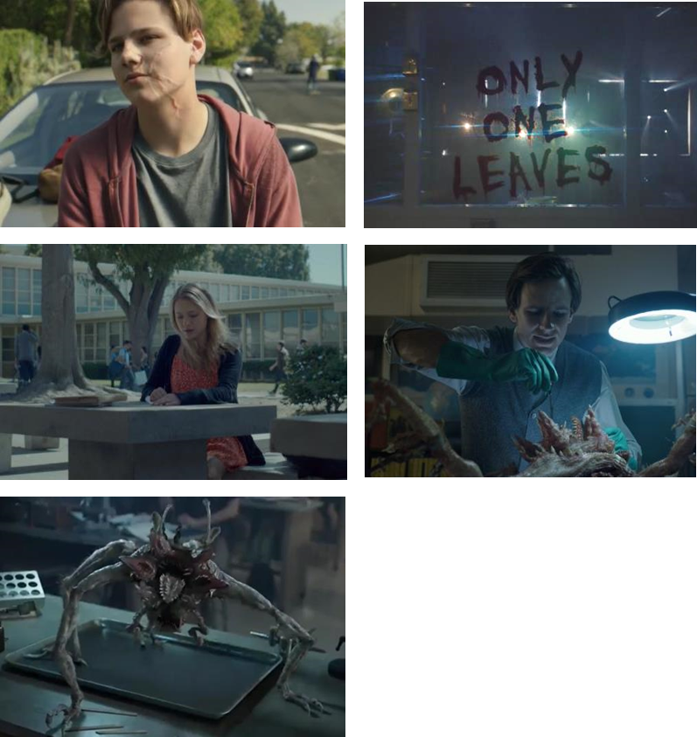

In the past 3 months, how frequently have you seen any of these ads?

1. Never
2. Rarely
3. Sometimes
4. Often
5. Very Often

E2. In the past 3 months, have you seen any vaping product ads or promotions in any of the following places? Select all that apply.

[RANDOMIZE ORDER OF E2_1 – E2_5, FIX E2_6 IN LAST POSITION.]

E2_1. Websites
E2_2. Social Media
E2_3. Magazines
E2_4. Stores
E2_5. Television
E2_6. I have not seen any vaping ads or promotions in any of the places above [EXCLUSIVE]

E3. Has anyone discussed vaping products when you are on…

[USE SCROLLING LIST. RANDOMIZE ORDER OF RESPONSE OPTIONS]

1. Yes
2. No
3. I don’t use this social media

E3_1. Instagram?
E3_2. Snapchat?
E3_3. Facebook?
E3_4. YouTube?
E3_5. Twitter?
E3_6. WhatsApp?
E3_7. Discord?
E3_8. Kik?

E4. Have you ever liked or followed any vaping brands (e.g., Juul, Vuse, Sourin) on social media?

1. Yes
2. No

E5. Have you seen social media posts about vaping from any of the following sources? Select all that apply.

[RANDOMIZE ORDER OF E5_1 – E5_5, FIX E5_6 and E5_7 AT END.]

E5_1. My Friends
E5_2. Other teens
E5_3. Celebrities/influencers
E5_4. Vape brands
E5_5. News media
E5_6. Other sources, specify:_____________
E5_7. I have not seen any social media posts about vaping [EXCLUSIVE]

E6. What type of information about vaping have you seen people post on social media? Select all that apply.

[RANDOMIZE ORDER OF E6_1 – E6_5, FIX E6_6 IN LAST POSITION.]

E6_1. Negative health consequences of vaping
E6_2. News about vaping
E6_3. Benefits of vaping
E6_4. Jokes/ memes about vaping
E6_5. Reviews of vaping products
E6_6. Other, specify:__________

E7. Have you ever posted or shared information about vaping on social media?

1. Yes
2. No

SECTION F: CORRELATES OF ENDS USE

F1. For the next few questions, please tell us how much you agree or disagree with the following statements.

[USE SCROLLING LIST. RANDOMIZE ORDER OF QUESTIONS]

1. Strongly Disagree
2. Disagree
3. Neither Agree or Disagree
4. Agree
5. Strongly Agree

F1_1. I would like to explore strange places
F1_2. I like to do frightening things
F1_3. I like new and exciting experiences, even if I have to break the rules
F1_4. I prefer friends who are exciting and unpredictable

SECTION G: OTHER TOBACCO PRODUCT USE

These next few questions are about use of other tobacco products.

G1. Have you ever…

[USE SCROLLING LIST. RANDOMIZE ORDER OF QUESTIONS]

1. Yes
2. No
99. Prefer not to answer

G1_1. Tried cigarette smoking, even one or two puffs?
G1_2. Smoked cigars or cigarillos, even one or two puffs?
G1_3. Used smokeless tobacco, even one or two pinches?
G1_4. Smoked tobacco out of a hookah or waterpipe, even one or two puffs?

G2. When was the last time you…

[USE SCROLLING LIST. RANDOMIZE ORDER OF QUESTIONS]

1. Earlier today
2. Not today but sometime in the past 7 days
3. Not in the past 7 days but sometime in the last 30 days
4. Not in the past 30 days but sometime in the past 6 months
5. Not in the past 6 months but sometime in the past year
6. 1 to 4 years ago
7. 5 or more years ago
99. Prefer not to answer

[ASK IF G1_1 = 1]
G2_1. Smoked a cigarette, even one or two puffs?

[ASK IF G1_2 = 1]
G2_2. Used cigar/cigarillos, even one or two puffs?

[ASK IF G1_3 = 1]
G2_3. Used smokeless tobacco, even one or two pinches?

[ASK IF G1_4 = 1]
G2_4. Used hookah, even one or two puffs?

[ASK IF G1_1 = 1]
G3. How many cigarettes have you smoked in your entire life? A pack usually has 20 cigarettes in it.

1. 1 or more puffs but never a whole cigarette
2. 1 cigarette
3. 2 to 10 cigarettes (about 1/2 pack total)
4. 11 to 20 cigarettes (about 1/2 pack to 1 pack)
5. 21 to 50 cigarettes (more than 1 pack but less than 3 packs)
6. 51 to 99 cigarettes (more than 2 1/2 packs but less than 5 packs)
7. At least 100 or more cigarettes (5 packs or more)
99. Prefer not to answer

SECTION H: DEMOGRAPHICS

We just have a few more questions about your background.
H1. Are you male or female?

1. Male
2. Female
99. Prefer not to answer

H2. Are you Hispanic, Latino/a, or Spanish origin?

1. Yes
2. No

H3. What is your race? (One or more categories may be selected)

1. American Indian or Alaska Native
2. Asian
3. Black or African American
4. Native Hawaiian or Other Pacific Islander
5. White

ENDSCREEN: You’ve reached the end of the survey. Thank you for your participation.

