ATTACHMENT 3: evaluation of the FRESH EMPIRE campaign on tobacco

WEB SCREENER survey

Form Approved
OMB No. 0910-0788
Exp. Date 08/31/2021
RIHSC No. 15-052CTP

Evaluation of the Fresh Empire Campaign on Tobacco- Outcome Survey Web Screener (EFECT-S)

Subjects for Questionnaire:
Section S: Study Screener

THIS QUESTIONNAIRE IS INTENDED FOR SOCIAL MEDIA RESPONDENTS ON THE WEB

PROGRAMMER: THE WEB INSTRUMENT WILL BE OPTIMIZED FOR MOBILE

UPON ARRIVING AT THE WEBSITE, PLEASE PRESENT A POPUP THAT REQUESTS THE RESPONDENT’S AGE.

Welcome! To provide the best browsing experience, please enter your date of birth.

PROGRAMMER: CHECK FOR VALID DATE AND ONLY ALLOW 2-DIGIT MONTH AND DAY AND 4 DIGIT YEAR. ALLOW ALL AGES TO PROCEED.
PLEASE PROGRAM AS A DROP DOWN BOX FOR EACH FIELD. THE RANGE OF YEARS SHOULD BE FROM 1950-2010.

ASK: All social media web respondents.
WELCOME This survey contains questions about you and your friends. It should take less than 5 minutes to complete. Please take your time and answer each question. Thank you!

NEXT
ASK: All social media web respondents.
WECON

We would like to ask you some questions about yourself and your friends. Your participation is voluntary. You can quit the survey at any time. No absolute guarantees can be made because of the technology used for electronic surveys like these, but we are taking extensive precautions to protect the privacy of your data to the extent allowed by law.

There are no physical risks to you from participating in this survey. It is possible that some questions might make you mildly uncomfortable, depending on your responses.

There are no direct benefits to you from answering our questions. However, you will be contributing to important research related to tobacco use among youth.

[IF AGE < 15] If you meet our criteria to participate in the study, you will be invited to provide your email address or mobile number and a parent or legal guardian’s first name and phone number so that we can get their permission for you to participate in our study. Your answers will not be shared with your parent or guardian. Once we receive your parent or guardian’s permission, we will email or text you a link to invite you to take a 40 minute survey online. You can decide whether or not you want to take the survey. If you decide to take the survey, you will receive a $25 virtual gift card upon completion. To help us understand changes over time, we may contact you again in the future. You can decide at a later date whether or not you would like to take any additional surveys.

[IF AGE IS 15 TO 17] If you meet our criteria to participate in the study, you will be invited to take part in our web survey. Your answers will not be shared with your parent or guardian. This is a 40 minute survey online. You can decide whether or not you want to take the survey. If you decide to take the survey, you will receive a $25 virtual gift card upon completion. To help us understand changes over time, we may contact you again in the future. You can decide at a later date whether or not you would like to take any additional surveys.

[IF AGE IS 18 AND OLDER] If you meet our criteria to participate in the study, you will be invited to take part in our web survey. This is a 40 minute survey online. You can decide whether or not you want to take the survey. If you decide to take the survey, you will receive a $25 virtual gift card upon completion. To help us understand changes over time, we may contact you again in the future. You can decide at a later date if you would like to take any additional surveys.

Please check the appropriate box below.

[IF YOUNGER THAN 15]
I understand that I will be answering some questions about myself, and if I meet the criteria, I will need to provide my email or mobile number and my parents’ first name and phone number to get their permission for me to be in the study.

[IF 15 OR OLDER]
I understand that I will be answering some questions about myself, and if I meet the criteria, I will be invited to participate in a 40 minute survey for $25.

If you have any questions about the survey, please contact our research team at efectsurvey@rti.org or call 800-845-6708.

1 I understand – GO TO S0
2 I decline to participate – GO TO REF

NEXT
ASK: All social media web respondents.

S0. How did you find out about this survey?
  - Snapchat ad
  - Instagram/Sponsored post on Instagram
  - Someone sent it to me on Snapchat
  - Someone sent it to me on Instagram
  - Someone sent it to me in another way
  - Another way (Please specify____________)

- Prefer not to answer

ASK: All social media web respondents.
S2. What is your gender?
1 Female
2 Male
3 Other (Please specify _______________)

9 Prefer not to answer

ASK: All social media web respondents.
S3. Are you of Hispanic, Latino/a, or Spanish origin? Select all that apply.
1 No, not of Hispanic, Latino, Latina, or Spanish origin
2 Yes, Mexican, Mexican American, Chicano or Chicana
3 Yes, Puerto Rican
4 Yes, Cuban
5 Yes, Another Hispanic, Latino/a or Spanish origin

9 Prefer not to answer

ASK: All social media web respondents.

S4. What race or races do you consider yourself to be? Select all that apply.
1 American Indian or Alaska Native
2 Asian
3 Black or African American
4 Native Hawaiian or Other Pacific Islander
5 White
6 Other (Please specify) __________________________

9 Prefer not to answer

ASK: All social media web respondents.

S5a. Rank the three people that would BEST FIT in your main group of friends, starting with the best fit. Click on the picture to make a selection.

1st Best Fit | 2nd Best Fit | 3rd Best Fit

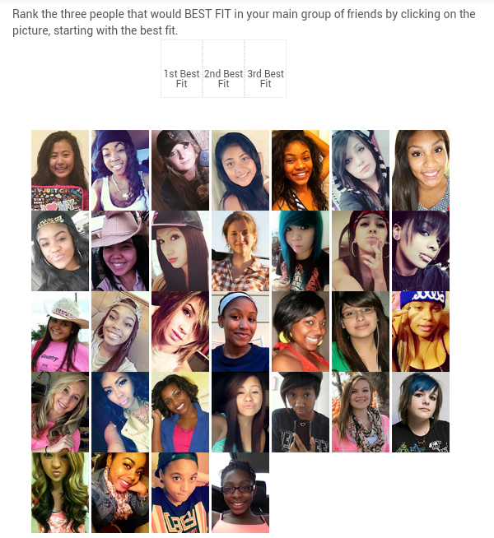

ASK: All social media web respondents.

S5b. Rank the three people that would LEAST FIT in your main group of friends, starting with the worst fit. Click on the picture to make a selection.

1st Worst Fit | 2nd Worst Fit | 3rd Worst Fit

ASK: All social media web respondents.

S6a. Rank the three people that would BEST FIT in your main group of friends, starting with the best fit. Click on the picture to make a selection.

1st Best Fit | 2nd Best Fit | 3rd Best Fit

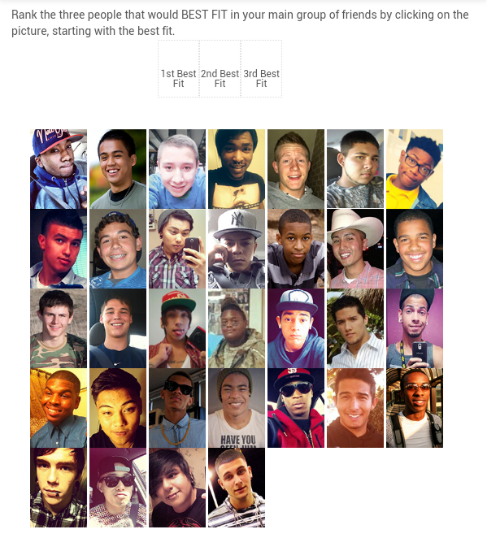
ASK: All social media web respondents.

S6b. Rank the three people that would LEAST FIT in your main group of friends, starting with the worst fit. Click on the picture to make a selection.

1st Worst Fit | 2nd Worst Fit | 3rd Worst Fit

ASK: All social media web respondents.

S7. What is your zip code?

_______________________ NUMERIC 5 DIGIT ENTRY REQUIRED. LEADING 0 ALLOWED.

□ Don’t Know
□ Prefer Not to Answer

PROGRAMMER: VALIDATE ZIP.

ADD A POP UP BOX CHECK IF S7=DK OR PNTA. IF S7=DK OR PNTA, POP UP BOX SHOULD SAY: “Please enter a valid zip code. If you don’t know or prefer not to enter your zip code, you will not be able to take part in the study. Choose Change Answer to enter a valid zip code for a chance to take part in the study or Keep Answer to continue.” THE POP UP BOX WILL HAVE TWO OPTIONS: ‘CHANGE ANSWER’ OR ‘KEEP ANSWER AND CONTINUE’
ASK: All social media web respondents.
PROGRAMMER CHECK POINT – CALCULATE ELIG_ZIP. IF ZIP CODE IS A STUDY ZIP CODE THEN ELIG_ZIP=1. ELSE ELIG_ZIP= 0.

ASK: All social media web respondents

S7a. What is your date of birth?

MM/DD/YYYY

PROGRAMMER: PLEASE PROGRAM AS A DROP DOWN BOX FOR EACH FIELD. THE RANGE OF YEARS SHOULD BE FROM 1950-2010.
WEB RESPONDENTS’ DOB AT FIRST QUESTION SHOULD MATCH S7A. IF MISMATCH, MAKE INELIGIBLE.

ASK: All social media web respondents
PROGRAMMER CHECKPOINT – CALCULATE ELIG_AGE AND ELIG_DOBm.
IF CURRENT DATE - AGE AT S7a=13-17 AND WEB THEN ELIG_AGE=1. ELSE ELIG_AGE=0. IF DOB AT POP UP = DOB AT S7a THEN ELIG_DOBm=1. ELSE ELIG_DOBm=0.
_________________________________________________________________________

PROGRAMMER CHECKPOINT. CALCULATE THE PICTURE SORTING SCORE.

=(IF(OR(B2=2,B2=8,B2=10,B2=13,B2=16,B2=21,B2=23),3,0))
+(IF(OR(C2=2,C2=8,C2=10,C2=13,C2=16,C2=21,C2=23),2,0))
+(IF(OR(D2=2,D2=8,D2=10,D2=13,D2=16,D2=21,D2=23),1,0))
+(IF(OR(E2=2,E2=8,E2=10,E2=13,E2=16,E2=21,E2=23),-3,0))
+(IF(OR(F2=2,F2=8,F2=10,F2=13,F2=16,F2=21,F2=23),-2,0))
+(IF(OR(G2=2,G2=8,G2=10,G2=13,G2=16,G2=21,G2=23),-1,0))
+(IF(OR(H2=33,H2=43,H2=51,H2=56,H2=58,H2=62,H2=64),3,0))
+(IF(OR(I2=33,I2=43,I2=51,I2=56,I2=58,I2=62,I2=64),2,0))
+(IF(OR(J2=33,J2=43,J2=51,J2=56,J2=58,J2=62,J2=64),1,0))
+(IF(OR(K2=33,K2=43,K2=51,K2=56,K2=58,K2=62,K2=64),-3,0))
+(IF(OR(L2=33,L2=43,L2=51,L2=56,L2=58,L2=62,L2=64),-2,0))
+(IF(OR(M2=33,M2=43,M2=51,M2=56,M2=58,M2=62,M2=64),-1,0))
A HIP HOP SCORE OF 4 OR HIGHER IS ELIGIBLE

PROGRAMMER: CALCULATE ELIG_PIC. IF HIP HOP SCORE IS 4 OR HIGHER THEN ELIG_PIC=1. ELSE ELIG_PIC=0.

ASK: All social media web respondents
PROGRAMMER CHECKPOINT: CALCULATE ELIGIBILITY.

IF ELIG_PIC=1 AND ELIG_AGE=1 AND ELIG_DOBm=1 AND ELIG_ZIP=1 THEN RESPONDENT IS ELIGBLE. GO TO S8. ELSE GO TO S9.

ASK: All social media web respondents
GO TO: If the respondent is age 13 to 17 (web) and DOBs entered are consistent and zip code is eligible and hip hop score is 4 or higher, go to S8. Else, go to the next question S9.
S9. [IF NOT ELIGIBLE]
That was the last question. Unfortunately, you do not qualify for the study. Thank you for your time and responses.

ASK: Respondents who entered an invalid or missing zip code in S7 or were not age 13 to 17 (web) according to S7a. Also, respondents who have a picture sorting score of less than 4, or respondents whose DOB at the pop up did not match S7a DOB (if applicable).

________________________________________________________________
________________________________________________________________

S8. [IF WEB AND ELIGIBLE]
What is your first name? ____________________________

ASK: Social media web respondents who are eligible
S10_2. [IF ELIGIBLE AND WEB AND (AGE =15-17)]
You are eligible to take part in an online study conducted by the U.S. Food and Drug Administration (FDA). This survey will take about 40 minutes to complete. The survey will ask questions about tobacco use, media use, illegal behaviors, opinions about tobacco, and experiences at home and at school. Everyone who completes the online study will receive a $25 gift card by email.

Note: You can participate only once and are eligible to receive only one gift card.
NEXT

PROGRAMMER: SKIP TO S10A.

ASK: Social media web respondents who are eligible were age 15 to 17, according to S7a.
GO TO: Go to S10A.
S10. [IF ELIGIBLE AND WEB AND (AGE = 13 OR 14)]
You are eligible to take part in an online study conducted by the U.S. Food and Drug Administration (FDA). This survey will take about 40 minutes to complete. The survey will ask questions about tobacco use, media use, illegal behaviors, opinions about tobacco, and experiences at home and at school. Everyone who completes the online study will receive a $25 gift card by email.

Note: You can participate only once and are eligible to receive only one gift card.

We need your parent’s/guardian’s permission for you to take the survey. Your answers will not be shared with your parent/guardian. They will be kept private.

Please provide the information below. If your parent/guardian gives their permission for you to take the survey, we will send the survey link to you.

Parent/Guardian Name ___________________
Phone Number __________________________

ASK: Social media web respondents who are eligible and are age 13 or 14, according to S7a.
GO TO: Go to S11.

S10a. [IF ELIGIBLE AND WEB AND AGE=15-17]
Press FINISH on the next screen to be directed to the survey. In case you don’t finish the survey today or in case we need to reach you, please enter your email address. We will only use this address to contact you about the study.

Email address:___________________

Verify Email address:________________

Note: You can participate only once and are eligible to receive only one gift card.

ASK: Social media web respondents who are eligible and were age 15 to 17, according to S7a.
S11. [IF ELIGIBLE AND WEB AND (AGE=13 OR 14)]
The survey can be taken on a computer, tablet or on the web on a smart phone, like an iPhone or an Android. How do you prefer to take the survey?

- Laptop/Desktop Computer
- Tablet
- Cell Phone

ASK: Social media web respondents who are eligible and were age 13 or 14, according to S7a.
S12. [IF ELIGIBLE AND WEB AND (AGE=13 OR 14)]
Thanks! Please provide your contact information so that we can send you the survey. We will try to send it by email or text, depending on which way you prefer. Just in case, please provide both your email and cell phone number. We will only use this information to contact you about the survey.

Your email address ______________________
I don’t have an email address

Your cell phone number (xxx-xxx-xxxx) ___-___-_____
I don’t have a cell phone

PROGRAMMER: IF EMAIL IS NOT MISSING AND CELL PHONE IS NOT MISSING – SKIP TO S15.
IF EMAIL IS NOT MISSING AND CELL PHONE IS MISSING – SKIP TO S14.
IF EMAIL IS MISSING AND CELL PHONE IS NOT MISSING – GO TO S13
ASK: Social media web respondents who are eligible and were age 13 or 14, according to S7a.
GO TO: If the respondent enters a valid email address and cell phone number, go to S15. If the respondent does not enter a valid email address, go to the next question S13. If the respondent does not enter a valid cell phone number, go to S14.
S13. [IF ELIGIBLE AND WEB AND (AGE=13 OR 14) AND NO EMAIL ADDRESS]
Can you please provide the email address of someone in your family? We can email the survey to them and ask them to share it with you.
Family member’s email address____________________
Don’t Know Family Member’s email address

ASK: Social media web respondents who are eligible; are age 13 or 14, according to S7a; and don’t have an email address, according to S12.
GO TO: If respondent has provided a cell phone in S12, GO TO S15. If respondent has not provided a cell phone, GO TO S14.
S14. [IF ELIGIBLE AND WEB AND (AGE=13 OR 14) AND NO CELL PHONE]
Can you please provide the cell phone number of someone in your family who will share their phone with you?

Family member’s cell phone number (xxx-xxx-xxxx) ___-___-_____
□ Don’t Know Family Member’s cell phone number

ASK: Social media web respondents who are eligible; are age 13 or 14, according to S7a; and don’t have a cell phone, according to S12.
GO TO: If we have not yet collected a cell phone or an email address, go to S14a. If we have this information, go to S15.
S14a. [IF ELIGIBLE AND WEB AND (AGE=13 OR 14) AND (NO PHONE AND NO EMAIL AND NO FAMILY EMAIL AND NO FAMILY PHONE)]
To be able to take the next survey, you need to provide contact information. Please provide an email address or a cell phone number below.

Email_________________

Cell Phone (xxx-xxx-xxxx) ___-___-_____

I don’t have/know this information

ASK: Social media web respondents who are eligible, are age 13 or 14, according to S7a, don’t have an email address and cell phone, according to S12, and don’t have a family member’s email address or cell phone number, according to S14.
GO TO: If the respondent doesn’t provide an email address or a cell phone in this item, GO TO S14b. If respondent provides an email address and a cell phone, GO TO S15.
S14b. [IF S14a=I DON’T HAVE INFO AND AGE=13 OR 14 AND WEB] Thank you for your responses. That was the last question.

ASK: Social media web respondents who continue to not provide any contact information for themselves or family and friends.
S15. [IF AGE=13 OR 14 AND WEB] Thank you for your responses! Please be on the look-out for an email or text message with a link to the survey in the next few days. Everyone who completes the survey will receive a $25 virtual Gift Card.

Note: You can participate only once and are eligible to receive only one gift card.

ASK: All social media web respondents.
S16. PROGRAMMER: IF R IS 15-17 AND ELIGIBLE AND WEB, ROUTE TO THE BEGINNING OF THE MAIN INSTRUMENT.
CREATE AND STORE CREDENTIALS TO BE SENT TO THEM VIA EMAIL/TEXT IF THEY BREAKOFF OR LOSE THEIR CONNECTION.

Thank you for your time.

HEND. You may now close your browser or navigate away from this page.

ASK: All social media web respondents

Paperwork Reduction Act Statement: The public reporting burden for this information collection has been estimated to average 5 minutes per response to complete the web screener (the time estimated to read, review, respond). Send comments regarding this burden estimate or any other aspects of this information collection, including suggestions for reducing burden, to PRAStaff@fda.hhs.gov.

