ATTACHMENT 1A: STORYBOARDS FOR CAMPAIGN ADS (EFECT)

Form Approved
OMB No. 0910-0788
Exp. Date 8/31/2021
RIHSC No. 15-052CTP

Campaign Ad Storyboards: Evaluation of the Fresh Empire Campaign on Tobacco (EFECT)

BE NEXT

AUDIO:
Slow hip-hop beat underscores VO.

SCRIPT:
VISUALS | COPY
Text on an alarm clock background. | RISE
The symbol “&” is added. | RISE &
The word “Grind” is added. | RISE & GRIND
 | GRIND IS HUSTLE
Hip Hop concert | HUSTLE TO BE...FREE
Abstract cloud. | FREE FROM ADDICTION TO TOBACCO
Urban environment. | FREE TO RUN IT LIKE A
Hip Hop youth looking like a young CEO. | BOSS
Bold color. | BE TOBACCO-FREE & IN CONTROL
Hip Hop youth. | SO YOU CAN...
Text on clock. | RISE & GRIND EVERYDAY
ENDCARD WITH LOGO LOCKUP | KEEP IT FRESH. LIVE TOBACCO-FREE.

LEVEL UP – Female :15

LEAD TALENT: AA Female
VO: AA Female

VISUALS | COPY
Open on a giant chessboard. Hero lands with a superhero kneeling stance. The chess pieces (glowing blue like a video game) go flying. She stands confidently | VO: This is the game.  You make moves to level up.
Cut to: The word “ADDICTION TO CIGARETTES” rising from the dark background from black ooze. Tar and ooze seep from it and drips down from the letters. Very gross. The title sequence of David Fincher’s The Girl With The Dragon Tattoo is a great reference for this aesthetic. | VO: But certain moves,
Cut to: The words “ADDICTION TO CIGARETTES” glow in harsh neon, surrounded by an industrial underground scene including biohazard markings. | VO: like an addiction to cigarettes, can make you lose control of the game.
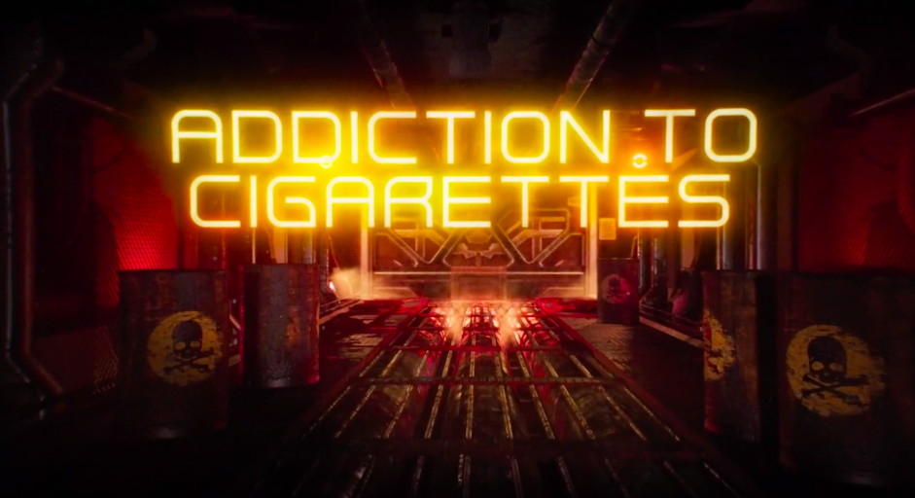
Cut to a close up of our hero sitting casually in a glowing, ornate throne on the giant chessboard. Logo fades in. | VO:  And having an addiction?  Hey, dude, legends can’t be held down.
Endtag | VO: Level up. Keep it fresh. Live tobacco-free.

LITTLE BROTHER
AUDIO:
Slow hip-hop beat underscores VO.

SCRIPT:

VISUALS | VOICEOVER
The younger brother is trying on the older brother’s hat while in the mirror. He gets caught, and kicked out the room. | VO:  My little brother. He’s always in my stuff.
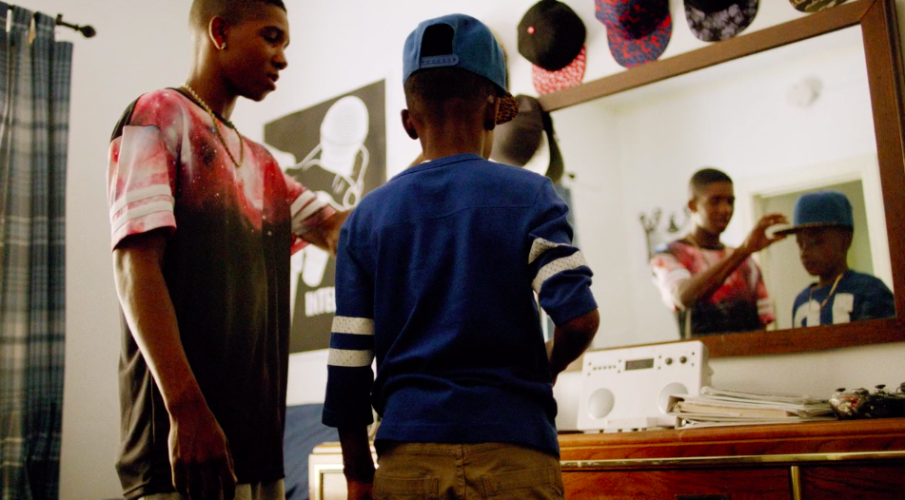
The older brother is facetiming with a girl while the younger brother sneaks into the shot and makes faces in the background. | VO:  I swear… the little dude plays too much.
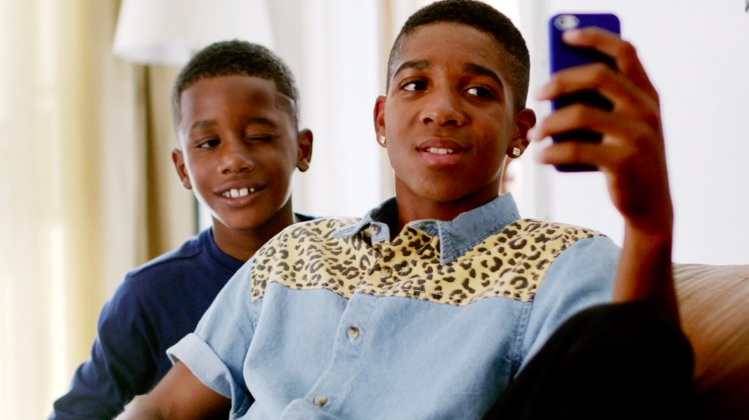
The older brother is talking/flirting with a girl outside when the younger brother runs up and interrupts. The older brother is annoyed that his moment was ruined and motions for him to get away. | VO:  …and yeah, he’s always WATCHING me, but I’m always LOOKING OUT for him.
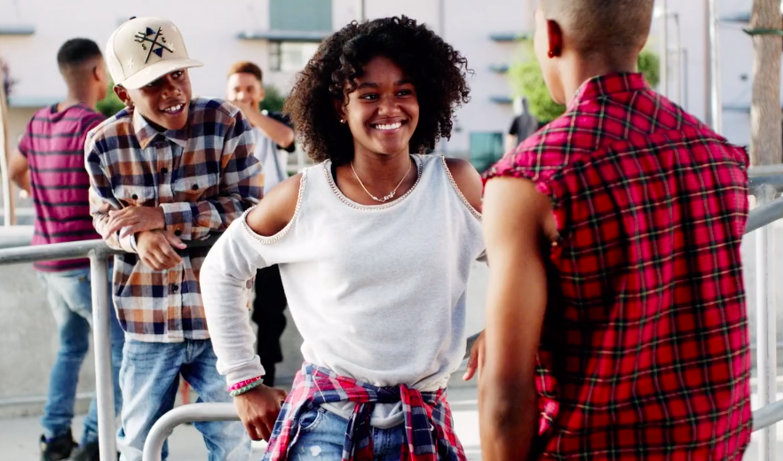
The younger brother sits on stoop and watches the older brother is hangout with friends. In the foreground the little brother sees his older brother interacting with the slightly older teens.  Onscreen text: “FACT: If you smoke cigarettes, your little brothers and sisters are more likely to smoke too.” | VO:  I’m staying fresh, like skipping out on cigarettes, because I know if I smoke, he’s more likely to smoke cigarettes too. And no matter how much he gets on my nerves, he’s family.
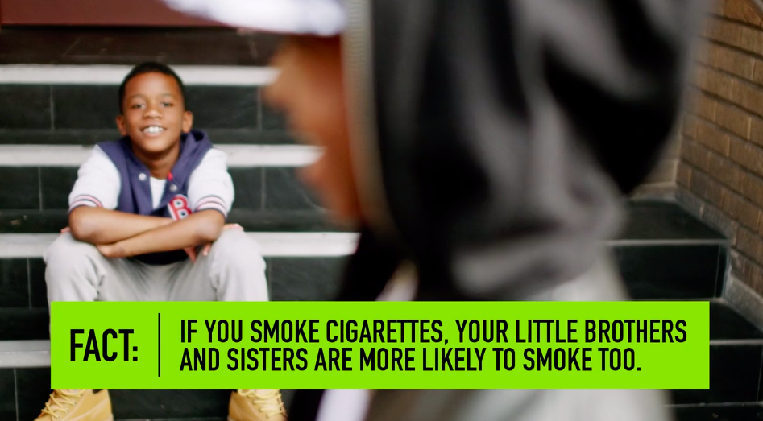
The older brother notices he was being watched, and leaves his friends and joins little brother on stoop. | VO:  Livin’ tobacco-free means I can influence him to come up fresh like me.  For the love of...family.
VIS: Fresh Empire logo with “Keep It Fresh” and “Live Tobacco-Free”. | VO:  Keep it Fresh. Live Tobacco- Free.
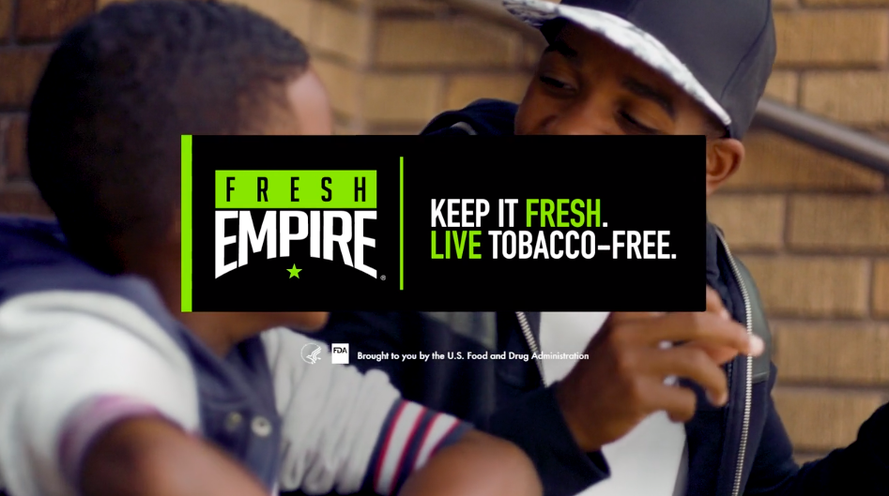

WAKE UP
AUDIO:
Slow hip-hop beat underscores VO.

SCRIPT:

VISUALS |  | COPY
The camera is high overhead. Middle of a city street. Daytime. Wide shot of our Hero standing in an ocean of people rushing past him.  His head pointed down in a sea of muted color hoodies and other drab wardrobe choices. His wardrobe is bold and colorful standing out against the ocean of people walking past him as he stands in the middle of this bustling current of people.  The camera cranes down to close-up of our Hero. |  | VO: Some still sleepin’...
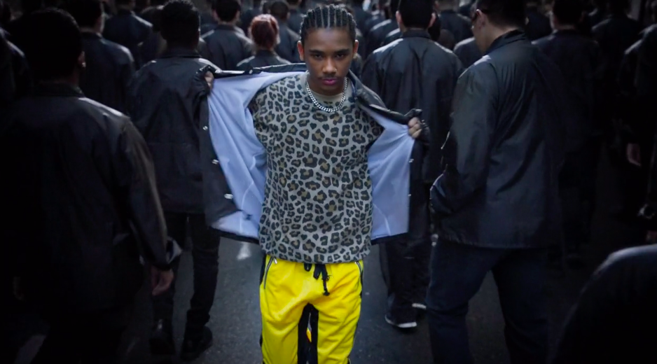
The camera trucks back even further, coming out to an epicly wider shot. |  | VO: …I’m awake. Wise to the fact: ain’t nothin’ changed.
We can see the ocean of people continuing down the street, off into the horizon. |  | VO:  If you smoke cigarettes, you can  become addicted.
In this wide shot we reveal several more young heroes maneuvering their way towards our first hero. They too deftly avoid smoke and the wrong types of people.  As they do, that drabness falls off them, literally, revealing bright fashionable clothing. | VO: Addiction to cigarettes will just get in your way.  So if addiction ain’t in the plan for you, then don’t sleep on the facts.
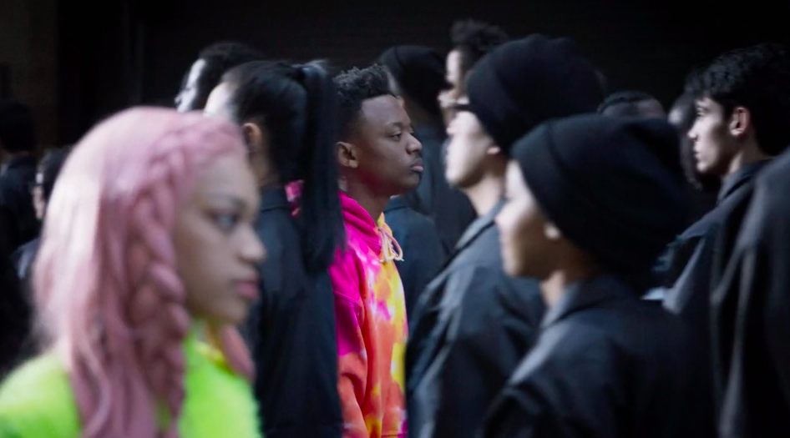
Cut to a frontal wide shot, as the heroes start converging, making it to the front. The camera tracks in to medium shot of the group. The ocean of people behind them is moving away. The group stops and stares straight at the camera as we rise up into the air with a drone, pulling up and back to a super-high angle. We see the cityscape stretching off into the distance, as the endcard and supers come up. |  | AVO: Keep it fresh. Live tobacco-free.

