Supporting Statement A for

National Children’s Study (NCS) Vanguard Data and Sample Archive and Access System (NICHD)
OMB clearance #0925-0730, expiration date 2/28/2019
Note: This is a revision to a previously approved information collection.
Text highlighted in Yellow has been added or amended.

Date: January 24, 2018
Check off which applies:
- New
- Revision
- Reinstatement with Change
- Reinstatement without Change
- Extension
- Emergency

Federal Government Employee Information:
Name: Jack Moye, Jr., MD
Address: The National Children's Study
Eunice Kennedy Shriver National Institute of Child Health and Human Development
6710B Rockledge Boulevard, Room 2130, MSC 7002
Bethesda, MD 20892-7002
Telephone: 301-594-8624
Fax:
Email: moyej@mail.nih.gov

Table of contents
A. Justification
A.1 Circumstances Making the Collection of Information Necessary
A.2. Purpose and Use of the Information Collection
A.3 Use of Information Technology and Burden Reduction
A.4 Efforts to Identify Duplication and Use of Similar Information
A.5 Impact on Small Businesses or Other Small Entities
A.6 Consequences of Collecting the Information Less Frequently
A.7 Special Circumstances Relating to the Guidelines of 5 CFR 1320.5
A.8 Comments in Response to the Federal Register Notice and Efforts to Consult Outside Agency
A.9 Explanation of Any Payment of Gift to Respondents
A.10 Assurance of Confidentiality Provided to Respondents
A.11 Justification for Sensitive Questions
A.12 Estimates of Hour Burden Including Annualized Hourly Costs
A.13 Estimate of Other Total Annual Cost Burden to Respondents or Record keepers
A.14 Annualized Cost to the Federal Government
A.15 Explanation for Program Changes or Adjustments
A.16 Plans for Tabulation and Publication and Project Time Schedule
A.17 Reason(s) Display of OMB Expiration Date is Inappropriate
A.18 Exceptions to Certification for Paperwork Reduction Act Submissions

List of Attachments
Attachment A.1 NCS Vanguard DATA USER AGREEMENT Form
Attachment A.2 NCS Vanguard Data Request Form
Attachment A.3 NCS Vanguard SAMPLE and Data Request Form
Attachment A.4 Research Materials Distribution Agreement
Attachment A.5 Example Screenshot to Show NCS Branding on Data Forms
Attachment A.6 NCS ARCHIVE Data User Training
Attachment A.7 NICHD NAT’L CHILDREN’S STUDY SIGNED PRIVACY OFFICER MEMO_02-02-16
ATTACHMENT A.8 NCS ARCHIVE MINI SUPPORTING STATEMENT
A. Justification
This document contains information supporting a request for the Office of Management and Budget (OMB) to approve renewal of a generic clearance for registration procedures associated with the National Children’s Study (NCS) Data and Sample Archive and Access System (“NCS Archive”) of the Eunice Kennedy Shriver National Institute of Child Health and Human Development at the National Institutes of Health.
The NCS Vanguard Study (OMB #0925-0593; expiration date 6/30/2017) undertook data collection at 40 study locations from 2009-2014. Data was collected from approximately 6,000 U.S. families. Data collection ceased in December 2014 and an expert review committee advised the NIH Director to make the existing Vanguard study data and materials available for use by interested investigators.
In February 2016 the NCS received OMB approval to collect information from researchers who seek access to the NCS Vanguard data which is housed securely in the NCS Archive, so that researchers may be allowed access to the data in a secure virtual data enclave. A significant potential public benefit to sharing NCS Vanguard Study data with a broader audience was anticipated initially, and one example of the realization of such benefit has been use of the NCS Vanguard data to generate over 40 scientific publications to date. In addition to NCS data use by researchers for publications and presentations, NCS data have been used in a variety of other ways to increase opportunities for research and teaching.
A.1 Circumstances Making the Collection of Information Necessary
NICHD requires institutional and investigator contact information from users of the NCS Data and Sample Archive and Access System (NCS Archive). This information collected from potential data users is necessary to fulfill the requirements of their proposed research projects, ensure compliance with Department of Health and Human Services regulations for the protection of human subjects in research (45 CFR 46) and the Common Rule (45 CFR 46 Subpart A), and to document, track, and monitor the use of the NCS Archive, which provides opportunities for qualified researchers to use data and samples collected by the NCS Vanguard phase, for approved research projects. There is no plan to publish the data collected under this request other than to post on the NCS Archive website the titles of approved research projects together with project investigators’ institutional affiliations.
Authority for the collection of the information requested from the submitting investigators comes from the authorities regarding the establishment of the National Institutes of Health, its general authority to conduct and fund research and to provide training assistance, and its general authority to maintain records in connection with these and its other functions (42 U.S.C. 203, 241, 289l-1 and 44 U.S.C. 3101), and Section 301 and 493 of the Public Health Service Act. These records will be maintained in accordance with the Privacy Act System of Record Notice 09-25-0200 covering “Clinical, Basic and Population-based Research Studies of the National Institutes of Health (NIH), HHS/NIH/OD.”

A.2 Purpose and Use of the Information Collection
This is a request for generic OMB approval for three years to allow for the collection of information from potential archive users.
The primary use of this information collected from potential data users is to fulfill requirements necessary to conduct their proposed research projects, ensure regulatory compliance, and to document, track, and monitor the use of the NCS Archive. The Data User Agreement Form (Attachment A.1) requests contact information including name, email, institution, address and phone which is required for the registered website. This is the first point where information is requested. The Data Request Form (Attachment A.2) and/or Sample and Data Request Form (Attachment A.3) request information about the proposed project, including Requestor Information, Recipient Institution Information, and other details about the type of information or number and type of samples requested. The Research Materials Distribution Agreement (Attachment A.4) outlines the terms and conditions for use of the Research Materials. These attachments are required for the researcher portal level of access. This form requires signature of the requesting investigator and the authorized representative of the recipient institution. This information is required fulfill the requirements of the proposed research projects, ensure compliance with Department of Health and Human Services regulations for the protection of human subjects in research (45 CFR 46) and the Common Rule (45 CFR 46 Subpart A), and to document, track, and monitor the use of the NCS Archive. In addition, the information will help NIH better understand the use of archived data and samples by the research community.
As of January 2019, the NCS Archive has been visited over 16,474 times and has 441 registered users from over 35 countries across six continents who have completed a registration process for access to downloadable files, data tools, and other materials that are located on restricted access portions of the site. More than 10,086 cumulative total downloads and 87,214 pageviews have been requested. Downloads average approximately 12 documents per workday. In the last three months, the Archive had 2,498 visits and 1,527 downloads. Overall demand averages 100-200 visits per week. In addition, 68 registered users have requested data and/or specimens from the archive.
A.3 Use of Information Technology and Burden Reduction
The NCS Archive relies on a web-based portal that enables investigators to request data access and obtain data electronically. The NCS Archive will allow for access to electronic data files and biological and environmental samples.
Data users provide basic contact information and agree to terms and conditions of data and archive use prior to accessing any data.
Data users start at the public facing website where they can review limited Study information. The researcher may register to access additional Study information, access the downloadable metadata files, and to submit a proposal and request for additional study data/elements. The proposal request may include existing electronic NCS data and/or a request for NCS samples. If the researcher’s request is approved by the NICHD review committee, the researcher will be given access to a secure virtual workstation in the Researcher Portal and a statistical and data support team member will work with the researcher and make available the requested data. The support team member can help bring in laboratory result data or extant data as needed. The researcher will be able to work with NCS data in the secure environment with provided statistical tools. Once the researcher completes his/her work and is ready to publish, a data reviewer will work to help assure the requested data meets disclosure standards.
The NCS Data Archive has three components: a public website, an NCS Registered Website and a secure Researcher Portal. An example screenshot is provided to show NCS branding for the data request forms (Attachment A.5). The flow diagrams in Figure 1 show the access requirements for the three tiers of access.

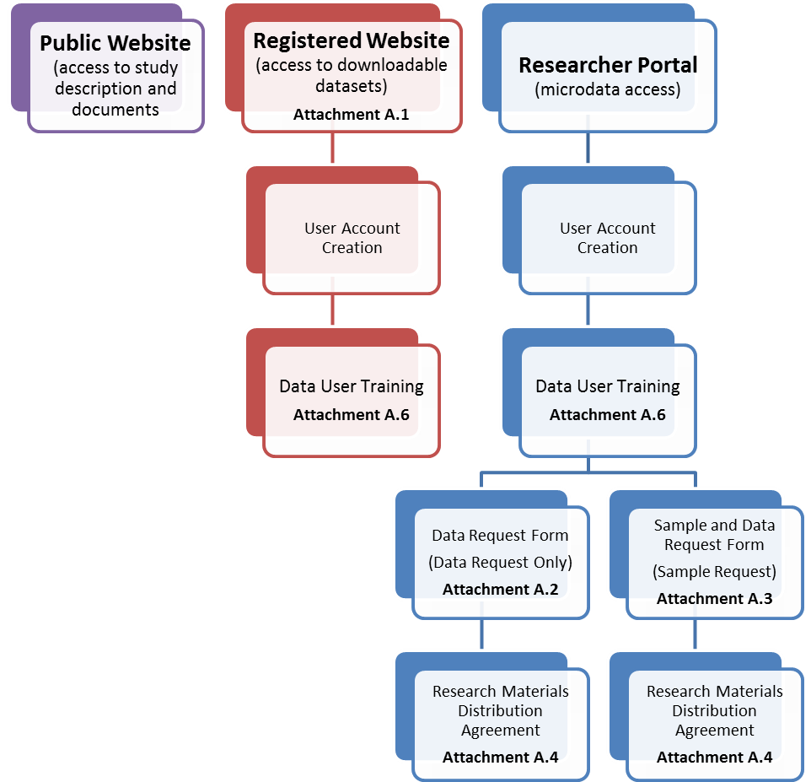

Figure 1. Access requirements for data in the three proposed tiers: Public Website, Registered Website, and Researcher Portal.

Access to the Public Website does not require any information from the user. To access the downloadable files a user must create a user account and complete Data User Training (Attachment A.6). To access microdata the user must complete the same user account creation and Data User Training (if not already completed), then complete a Data Request form followed by a Research Materials Distribution Agreement. Specimen requests are similar, starting with a user account, Data User Training then a Sample and Data Request form followed by the Research Materials Distribution Agreement.
The NICHD Chief Information Officer issued information system security accreditation and full Authority to Operate on January 12, 2016 for the NCS Archive, the security assessment for which included a Privacy Impact Assessment.

A.4 Efforts to Identify Duplication and Use of Similar Information
No similar data are gathered or maintained by the agency or are available from other sources known to the agency.

A.5 Impact on Small Businesses or Other Small Entities
There is no impact on small businesses or other small entities. None will be involved.

A.6 Consequences of Collecting the Information Less Frequently
The information requested in the NCS Archive forms does not ask investigators to generate any new information, because the type of information being requested (see A.2 and A.3) is fundamental to conducting any research study. The data are collected on an as needed basis. Data will be collected only once for each investigator request.

A.7 Special Circumstances Relating to the Guidelines of 5 CFR 1320.5
No special circumstances relating to the guidelines of 5 CFR 1320.5 are applicable to this request.

A.8.1 Comments in Response to the Federal Register Notice

A Federal Register Notice was published on November 8, 2018. No comments were received.

A.8.2 Efforts to Consult Outside Agency
The NCS consulted experts within and outside the agency on various aspects of the data archive design. The NCS received demonstrations from the Data and Specimen Hub (DaSH, NIH/NICHD), the Biospecimen Repository Access and Data Sharing program (BRAD, NIH/NICHD), the Prostate, Lung, Colorectal, and Ovarian Cancer Screening Trial (PLCO, NIH/NCI) and the Biologic Specimen and Data Repository Information Coordinating Center (BioLINCC, NIH/NHLBI) in order to determine which existing archive and repository solutions may best serve the dissemination of NCS Vanguard Study data. The NCS reviewed data sharing practices for NHANES (CDC/NCHS), NDAR (NIH/NIMH), and the NICHD Population Dynamics Branch. Some of the criteria evaluated included data specifications, data documentation and discovery tools, remote analysis functionality, and privacy protection measures.
The NCS also consulted the Office of Management and Budget’s Office of Information and Regulatory Affairs on March 16, 2015, who indicated that the NCS must have a generic clearance that is specific to data sharing.
Solicitations for user input have been included with each new NCS Archive data release announcement.

A.9 Explanation of Any Payment of Gift to Respondents
No incentives have been nor will be provided to respondents.
A.10 Assurance of Confidentiality Provided to Respondents
The Privacy Act of 1974 ensures that no sensitive or personally identifiable information, located in federal systems of records (e.g., Recipient NIH records), is shared. A system of records is any group of records under the control of a federal agency from which information is retrieved by the name of the individual or by some identifying number, symbol, or other identifying particular assigned to the individual. The NIH and any sites that are provided access to the datasets will have access to the data collected from the Recipient (which includes personally identifiable information as specified in Section A.2) for the purposes described above. In addition, the Act allows, in accordance with the routine uses made of the information stored in the system, the release of some information in the Recipient’s records without his/her permission; for example, for research purposes and if it is required by members of Congress or other authorized individuals. The information requested is voluntary, but necessary for obtaining access to data.

The information requested from the investigator seeking access to the NCS Archive, as part of the NCS Data Use Agreement, Data Request, and RMDA forms, may be made public in part or in whole for tracking and reporting purposes.

A Privacy Act Notification is displayed on the face page of the Data User Agreement, Data Request, and RMDA forms pursuant to Public Law 93-579, Privacy Act of 1974, 5 U.S.C. Section 552a. Authority for the collection of the information requested comes from the authorities regarding the establishment of the National Institutes of Health, its general authority to conduct and fund research and to provide training assistance, and its general authority to maintain records in connection with these and its other functions (42 U.S.C. 203, 241, 289l-1 and 44 U.S.C. 3101), and Section 301 and 493 of the Public Health Service Act. These records will be maintained in accordance with the Privacy Act System of Record Notice 09-25-0200 covering “Clinical, Basic and Population-based Research Studies of the National Institutes of Health (NIH), HHS/NIH/OD.” The NIH System of Record Notice was previously published in the Federal register on September 26, 2002, Volume 67, No 187, page 60742. Although the NCS Vanguard Study data will be coded (de-identified) and the NIH will not hold direct identifiers to individuals within the NCS Archive, the agency recognizes the personal and potentially sensitive nature of NCS Vanguard Study data. All investigators who request access to NCS Vanguard Study data must be authorized by the NCS and the Federal government to receive and store study information and agree to protect participant privacy by reporting aggregate results only. As noted in A.2, investigators and their institutions must complete an RMDA and abide by the RMDA terms.

A.11 Justification for Sensitive Questions
The NCS Archive asks no sensitive questions of any prospective data users.

A.12.1 Estimates of Hour Burden Including Annualized Hourly Costs
Table 12-1 Estimated Annualized Burden Hours
Type of Respondent | Form | Number of Respondents | Frequency of Response | Average Time Per Response (hours) | Total Annual Burden Hours
Research scientists | NCS Vanguard Downloadable Data Access Form (Attachment A.1) | 300 | 1 | 10/60 | 50
Research scientists | NCS Vanguard Data Request Form (Attachment A.2) | 50 | 1 | 20/60 | 17
Research scientists | NCS Vanguard Specimen and Data Request Form (Attachment A.3) | 50 | 1 | 30/60 | 25
Research scientists | Research Materials Distribution Agreement (Attachment A.4) | 100 | 1 | 10/60 | 17
 | Total | 500 | 500 |  | 109

A.12.2 Annual Cost to respondent

Table 12-2 Annualized Cost to Respondents
Type of Respondent | Form | Estimate Total Annual Burden Hours | Wage Rate | Total Costs
Research scientists | NCS Vanguard Downloadable Data Access Form (Attachment A.1) | 50 | $ 35.76 | $ 1,788
Research scientists | NCS Vanguard Data Request Form (Attachment A.2) | 17 | $ 35.76 | $ 608
Research scientists | NCS Vanguard Specimen and Data Request Form (Attachment A.3) | 25 | $ 35.76 | $ 894
Research scientists | Research Materials Distribution Agreement (Attachment A.4) | 17 | $ 35.76 | $608
 | Total | 109 |  | $ 3,898

Salary/Wage Source: Bureau of Labor Statistics/Occupational Employment Statistics May 2017 “Life, Physical, and Social Scientist”, occupational code 19-0000.

A.13 Estimate of Other Total Annual Cost Burden to Respondents or Record Keepers
There are no additional costs other than the respondents’ cost burden given in Table 12-2.

A.14 Annualized Cost to the Federal Government
Staff | Grade/Step | Salary | % of Effort | Fringe (if applicable) | Total Cost to Gov’t
Federal Oversight
Program Officer | GS-14 Step 4 | $126,049 | 10 |  | $12,065
Branch Chief | GS-15 Step 4 | $148,267 | 5 |  | $7,413
Contractor Cost
Technical Support |  | $130,970 | 50 | $39,291 | $85,131
Total Annualized Cost |  |  |  |  | $104,609
Salary/Wage Source: Office of Personnel Management 2018 General Schedule Locality Salary Table for various GS-levels; Bureau of Labor Statistics/Occupational Employment Statistics May 2017 “Computer and Information Research Scientists”, occupational code 15-1111, Washington-Arlington-Alexandria, DC-VA-MD-WV Metropolitan Division.

A.15 Explanation for Program Changes or Adjustments
This is an ongoing data collection. There have been no program changes or adjustments.

A.16 Plans for Tabulation and Publication and Project Time Schedule
A.16 - 1 Project Time Schedule
Activity | Time Schedule
Data archive open to public | On OMB approval
Information collection from data users | Ongoing after data archive opens to public

There are currently no plans to publish the data collected through requests for data access other than to post on the NCS Archive website the titles of approved research projects together with project investigators’ institutional affiliations. The data otherwise are for internal monitoring purposes only, to assess the archive resource requirements and for quality improvement.

A.17 Reason(s) Display of OMB Expiration Date is Inappropriate
Not applicable.
A.18 Exceptions to Certification for Paperwork Reduction Act Submissions
Not applicable.

