Attachment A: Contact Information Update

This voluntary collection of information is being collected under OMB Control Number 1220-0157 (Expiration: 3/31/2019). Without this currently approved number we could not collect this information. These questions should take only 1 minute. In accordance with the Confidential Information Protection and Statistical Efficiency Act of 2002, the Privacy Act, and other applicable Federal laws, the Bureau of Labor Statistics, its employees and agents, will, to the full extent permitted by law, use the information you provide for statistical purposes only, will hold your responses in confidence, and will not disclose them in identifiable form without your informed consent.

Please confirm the spelling of your name:
FirstNam First _______________________________
MiddleNm Middle ____________________
LastName Last _____________________________

Please provide your contact information: (
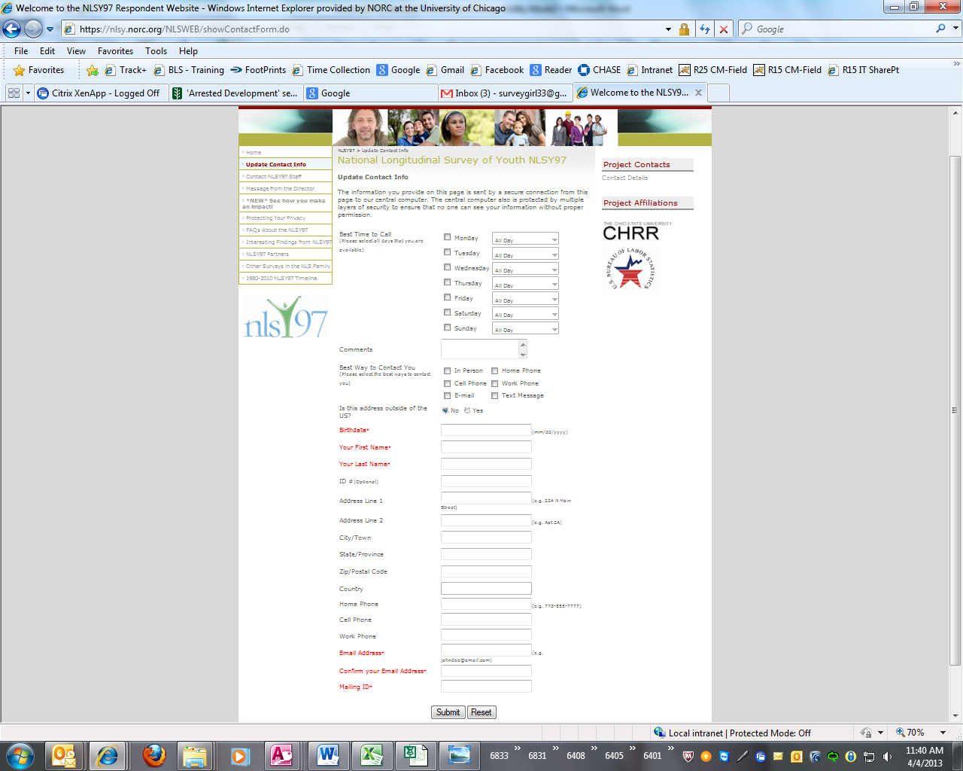

addrLin1 Address Line 1 ______________________________
addrLin2 Address Line 2 ______________________________
Unit Unit/Apt: ____________
City City/Town _________________
State State/Province___________ _____
ZipCode Zip/Postal Code __________
Country Country (if outside of US): _________________________
Homephon Landline Phone: ____________________
Cellphon Cell Phone: __________________
Workphon Work Phone: ______________________
Email Email Address: _______________________________

Thank you screen: Thank you for taking the time to update your contact information. We will be in touch with you again in the Fall of 2019 for your next interview!
If you have any question or concerns about the questions you just answered or the NLSY97 study in general, please contact us at xxx-xxx-xxxx or email us at xxxx@norc.org.

