# Home[1]

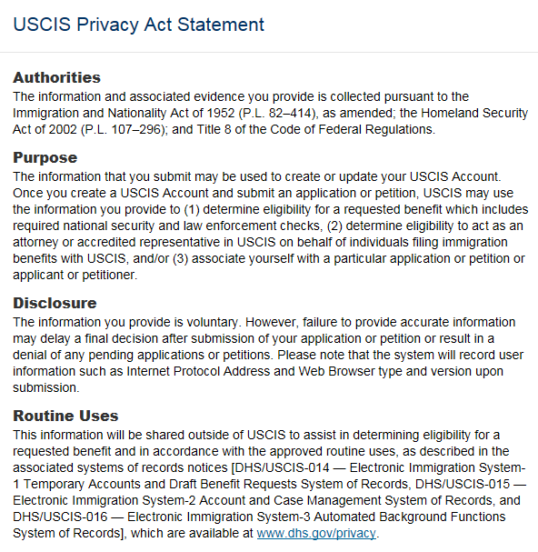

**CONTINUE**

# Account Creation

## Online Account Setup

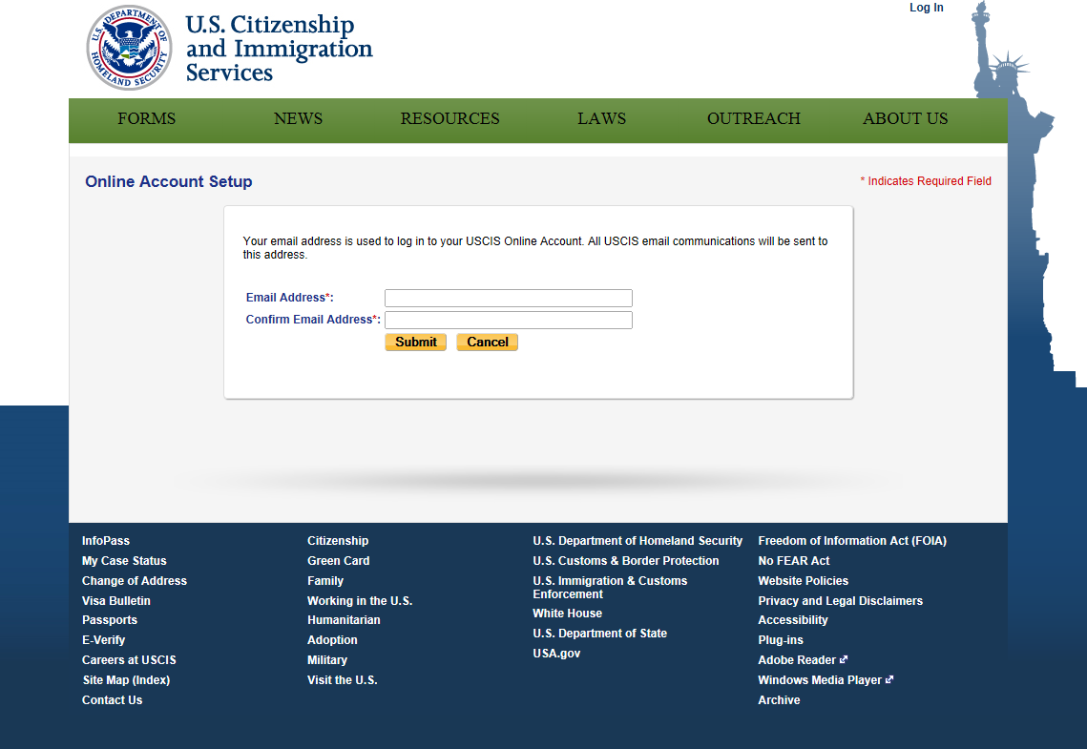

OMB No. 1615-0122

Expires 07/31/2015

*Indicates Required Field

## Email Confirmation

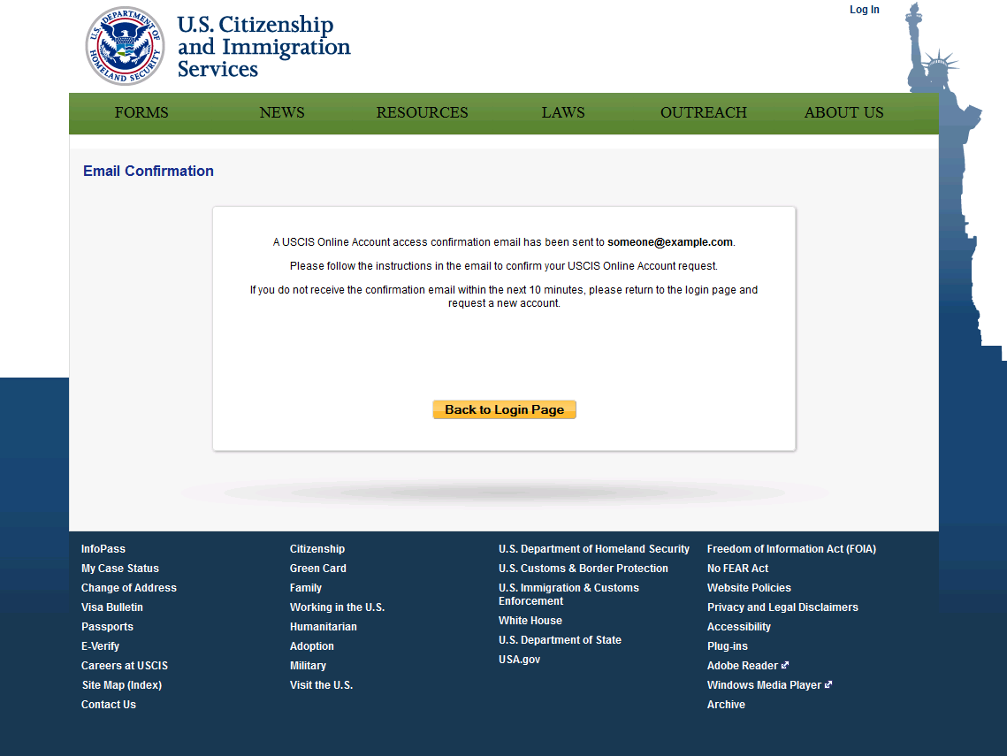

## Email Confirmation Message

|  |  |
| --- | --- |
| Subject: | USCIS Confirmation Code and Token ID |
| Message: | This is your USCIS Confirmation Code and Token ID. Please click on the link below or enter the information below on the Email Confirmation Code page as directed.  Link:  [http://*<HOSTNAME>*/camp/registration/confirmRegisterEmail?confirmationId=AMkudhxiPEKD87vUJuYBPadwJ14=&email=someone@example.com&tokenId=rvdoi/a6lKG+wixUqYyRKPPN9AU=](http://HOSTNAME/camp/registration/confirmRegisterEmail?confirmationId=AMkudhxiPEKD87vUJuYBPadwJ14=&email=someone@example.com&tokenId=rvdoi/a6lKG+wixUqYyRKPPN9AU=)  Email Address: someone@example.com  Confirmation Code: AMkudhxiPEKD87vUJuYBPadwJ14  Token ID: rvdoi/a6lKG+wixUqYyRKPPN9AU |

## Email Confirmation Code

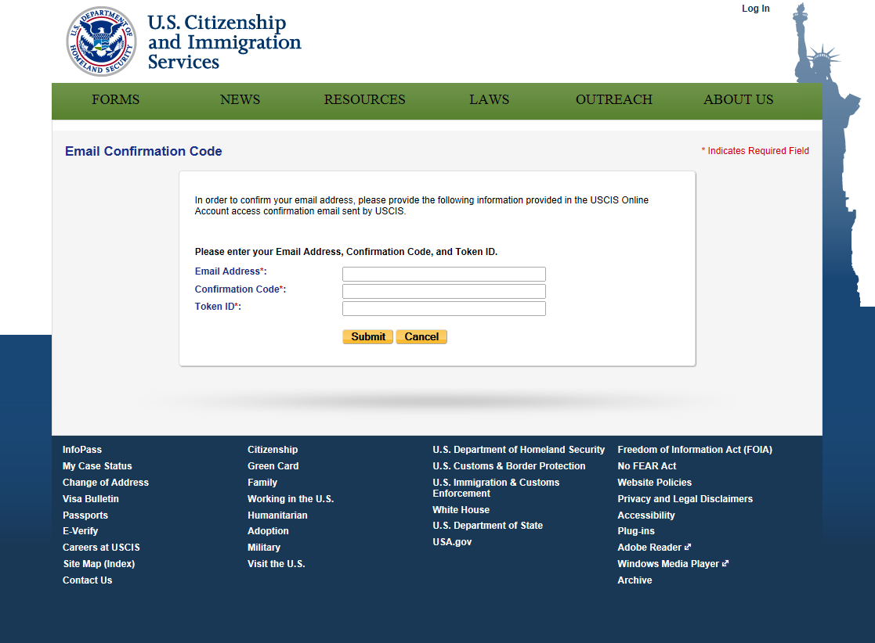

## Provide Password Reset Questions

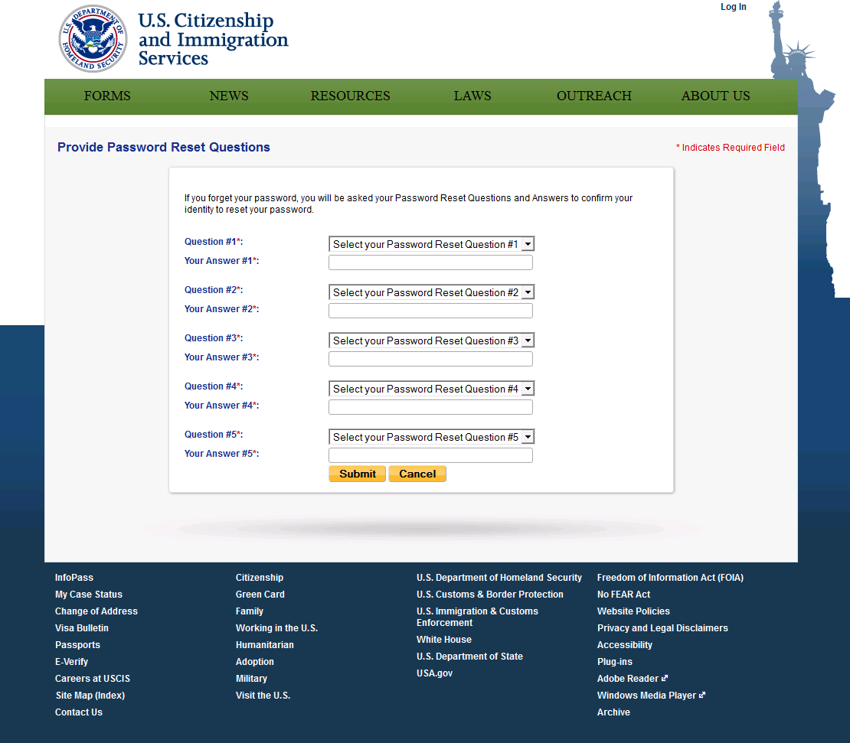

| **Password Reset Questions[2]** |
| --- |

|  |
| --- |
| Set 1 |
| What was your favorite toy when you were a child? |
| What is the last name of your favorite childhood teacher? |
| What is the name of the company of your first paid job? |
| What is the first city you visited without your parents? |
| What was the make and model of your first car? |

|  |
| --- |
| Set 2 |
| What was the first team sport you played? |
| In what city/town were you in when you saw the ocean for the first time? |
| What is the first and last name of your oldest cousin?  Who was your childhood hero? |
|
| What type of work did you do in your first job? |

|  |
| --- |
| Set 3 |
| In what city/town were you on January 1, 2000? |
| What was the name of your second pet? |
| Where was your wedding reception held? (location or city/town) |
| What is your father's mother's maiden name? |
| What is the name of the company of your first paid job? |

|  |
| --- |
| Set 4 |
| What is the name of the first school you attended? |
| When was your youngest sibling born? (month and year) |
| What is the country of your ultimate dream vacation? |
| What is the first and last name of a famous, now deceased person that you would have liked to meet? |
| In what city/town did you meet your spouse/significant other? |

|  |
| --- |
| Set 5 |
| What was the last name of your first sports coach? |
| What was the name of the company in which you got your first promotion? |
| What was the first thing you learned to cook? |
| In what city did you first visit a museum? |
| What is the first and last name of your favorite childhood friend? |
|

|  |
| --- |
| Set 6 |
| What is your maternal grandmother’s maiden name? |
| What is the city/town and year in which your mother was born? |
| What is your spouse's mother's maiden name? |
| What is the name of a college/university you applied to but did not attend? |
| Where did you go on your honeymoon? |

|  |
| --- |
| Set 7 |
| What is the middle name of your oldest child? |
| What is the first musical instrument you learned to play? |
| What is the date of your parents' wedding anniversary? (dd/mm/yyyy) |
| What is the last name of the first person you voted for? |
| In what city/town did your mother and father meet? |

|  |
| --- |
| Set 8 |
| When did you own your first computer (month, year)? |
| What is the middle name of your oldest sibling? |
| What was the first dance you learned? |
| In what city/town did you meet your spouse? |
| What was your childhood nickname? |

## Create Account

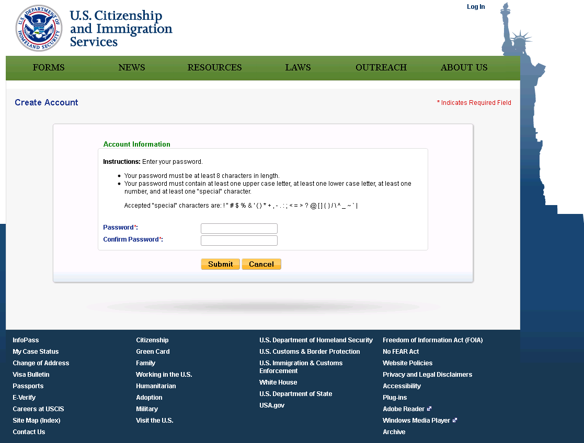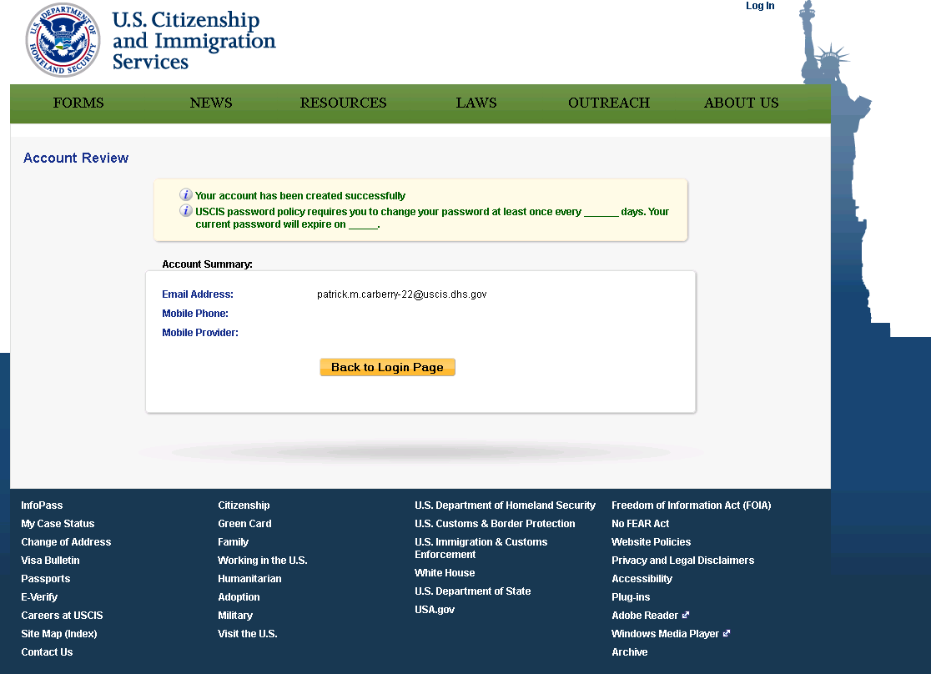

## Secure OTP Test

### OTP (Email)

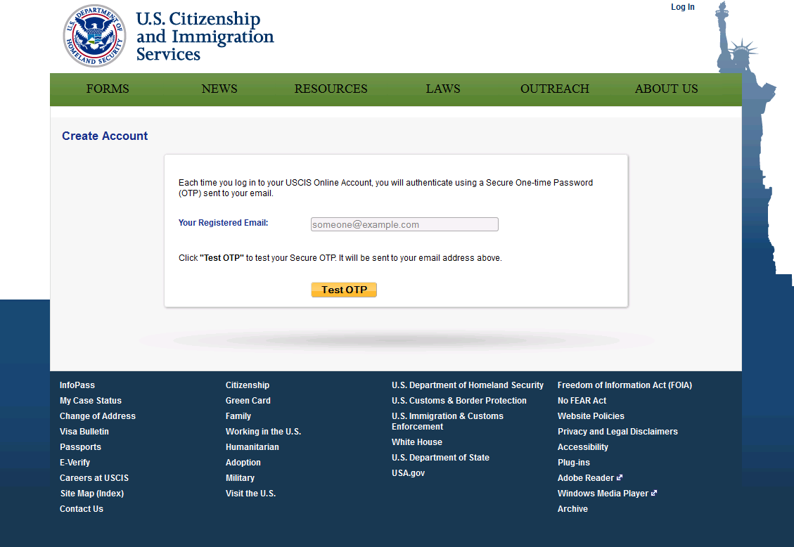

### OTP (Text Message)

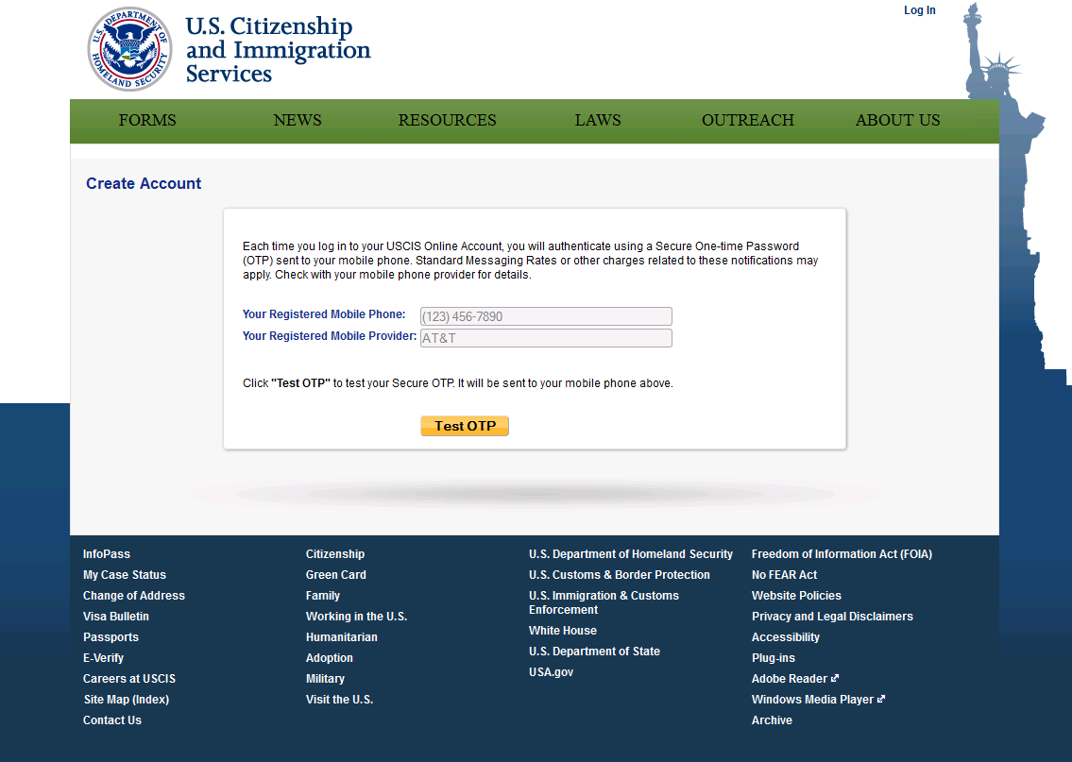

### OTP (Email and Text Message)

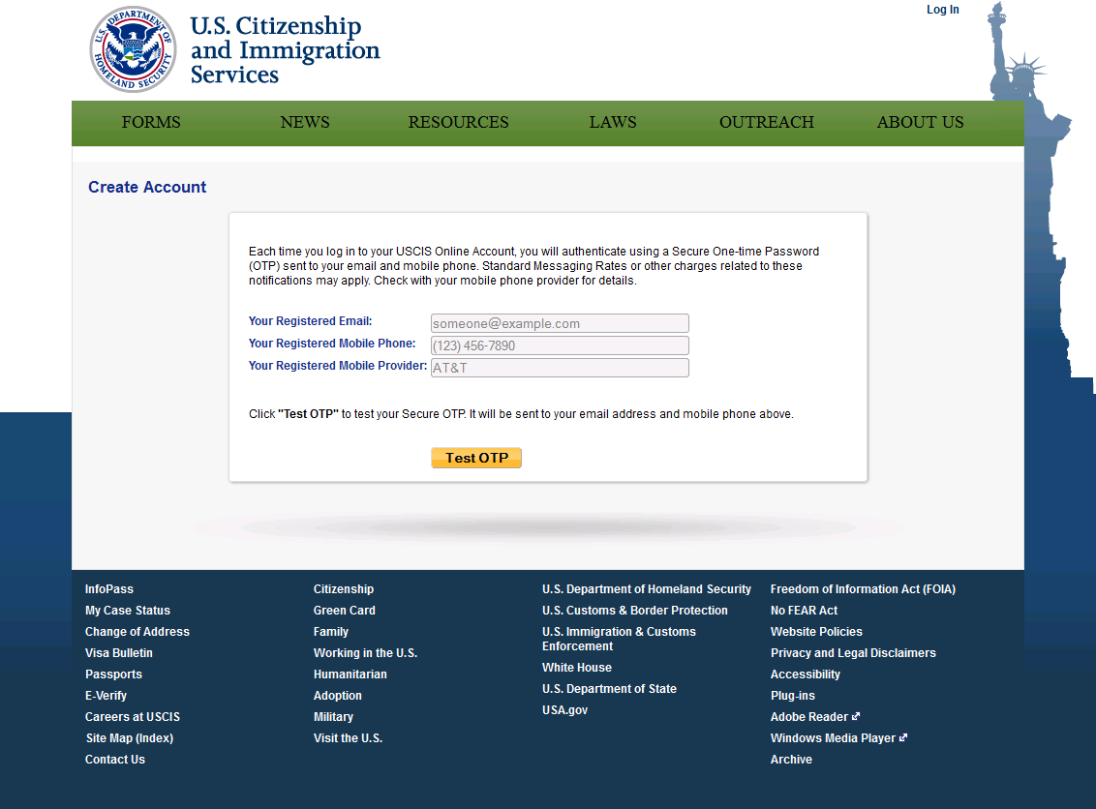

## Secure OTP Message

|  |  |
| --- | --- |
| Subject: | Your USCIS One-time Password |
| Message: | Your USCIS One-time Password is 12345678. It expires in 10 minutes. |

## Secure OTP Test

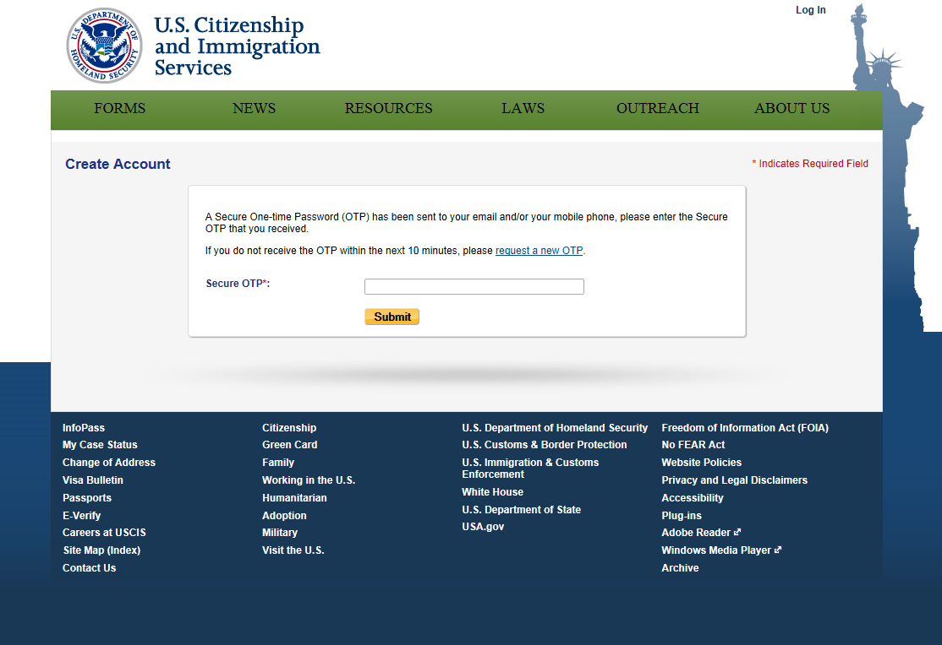

## Account Review



# Login*

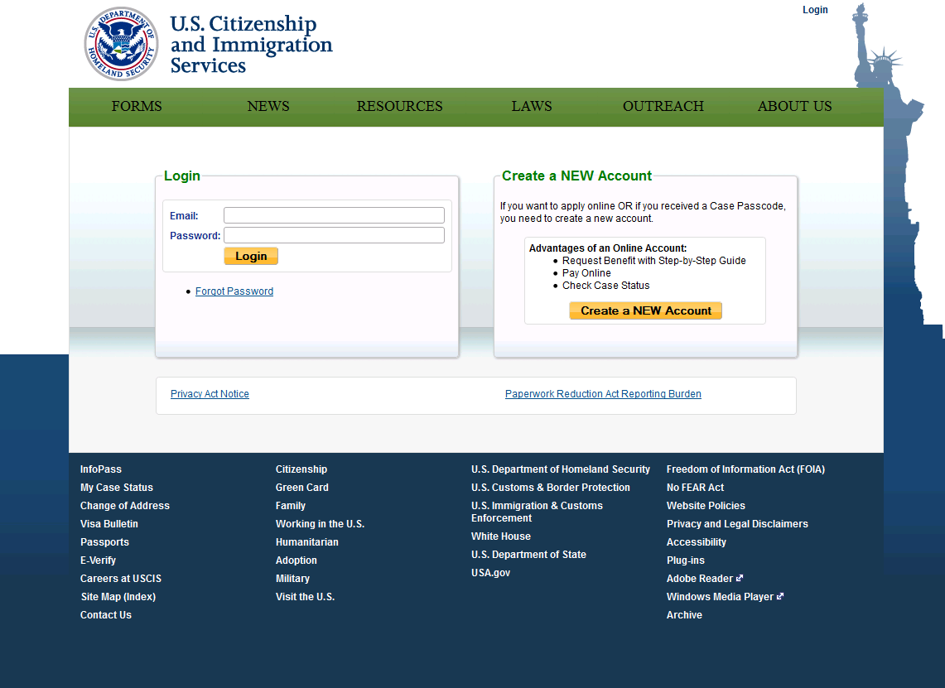

## Provide Secure OTP

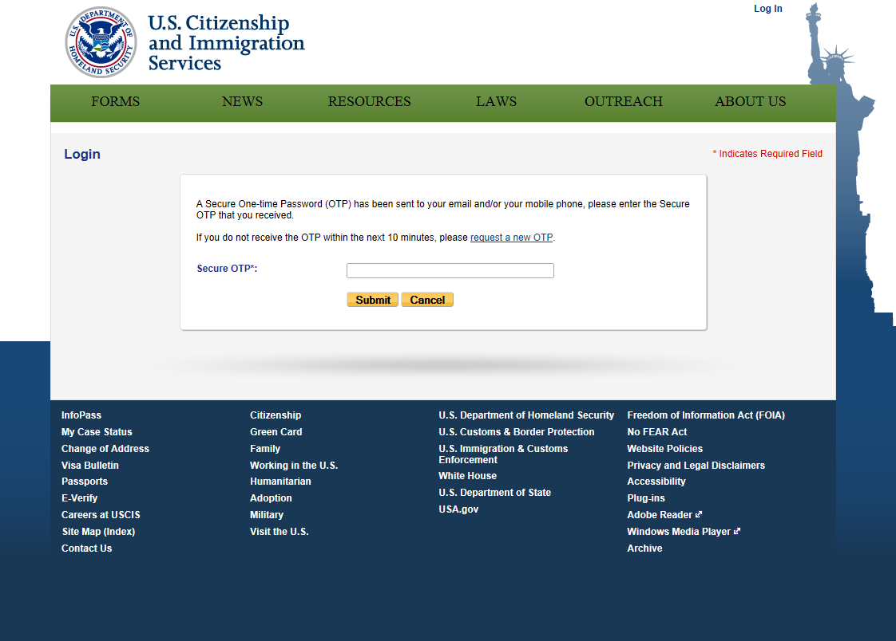

## My Services

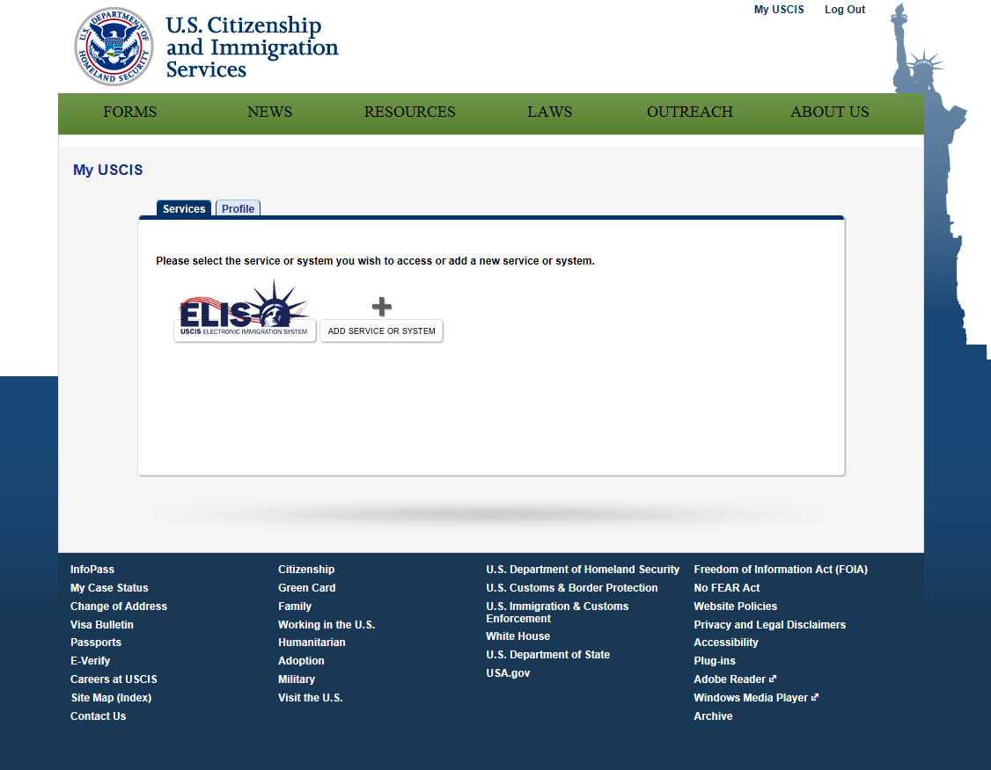

### Add Service or System

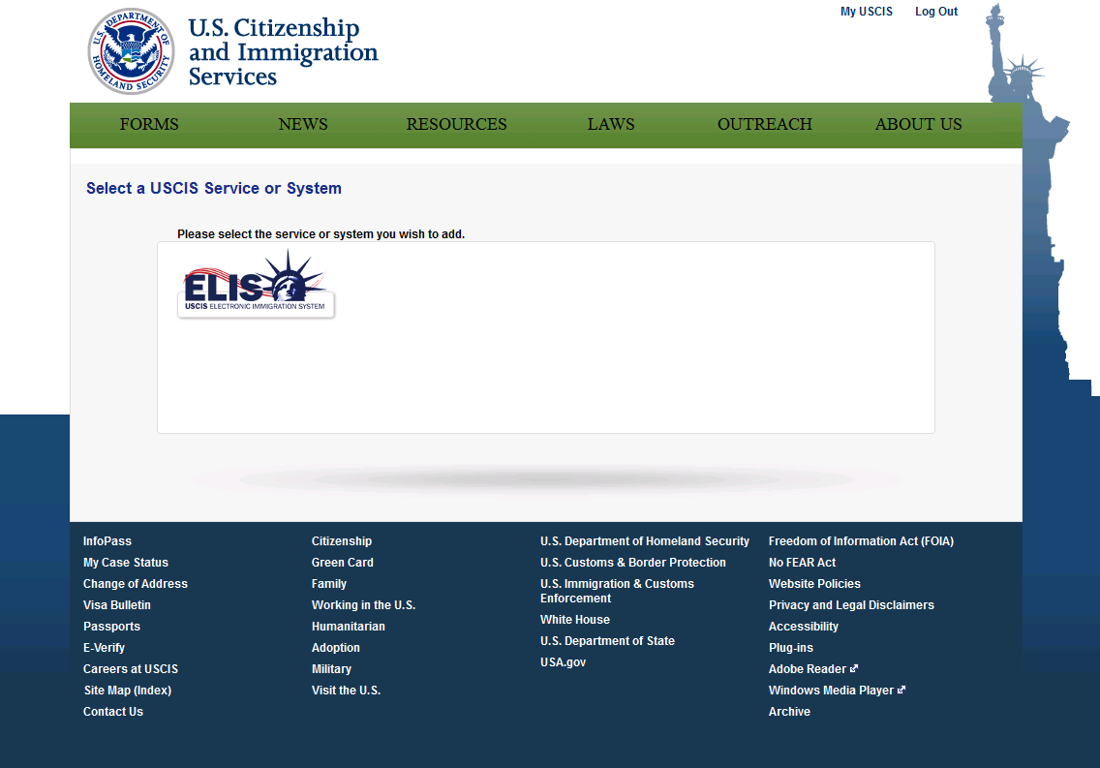

### You have selected to add the USCIS Electronic Immigration System

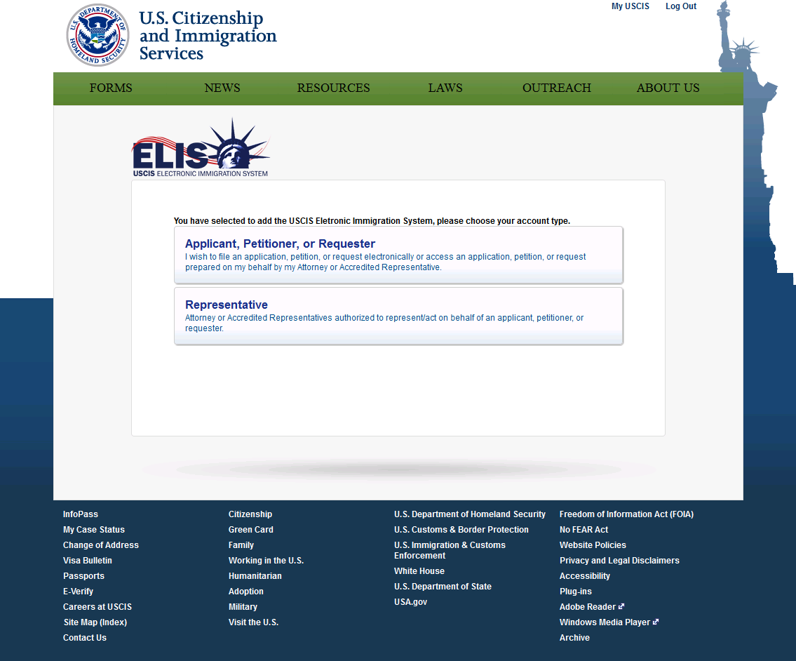

## My Profile

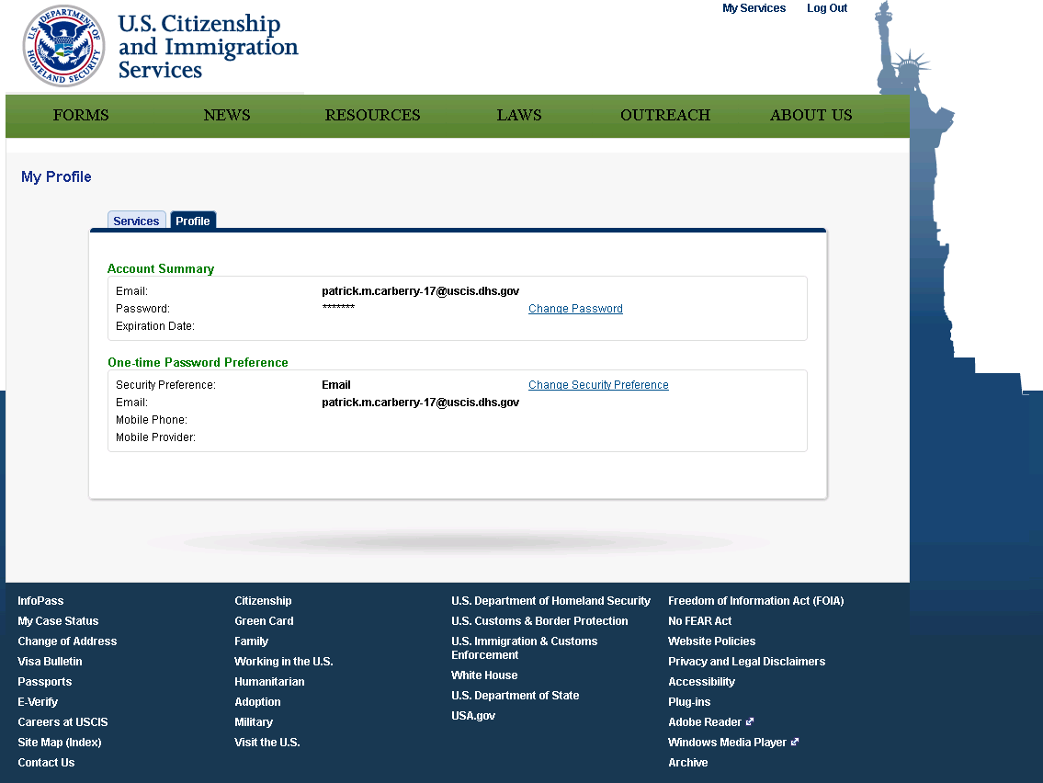

### Change Name

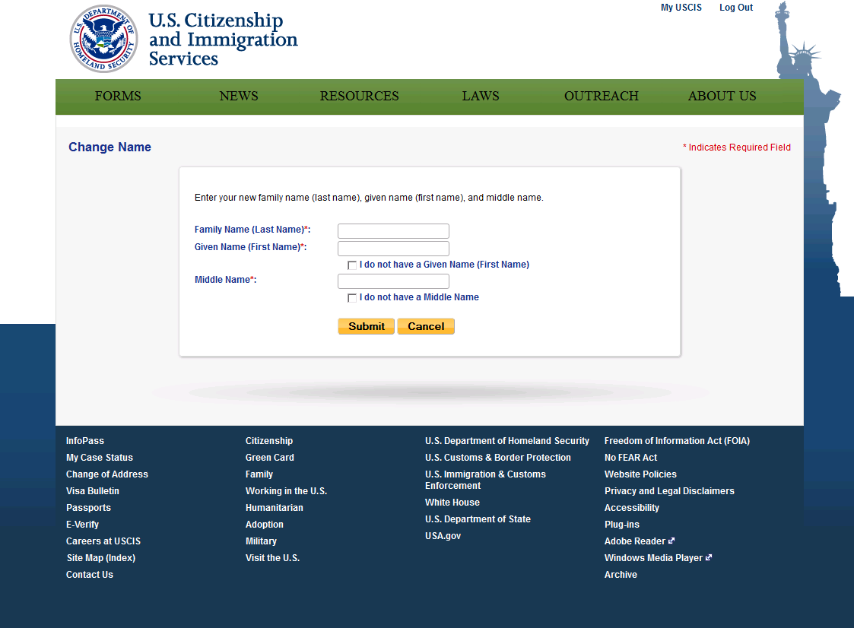

### Change Password

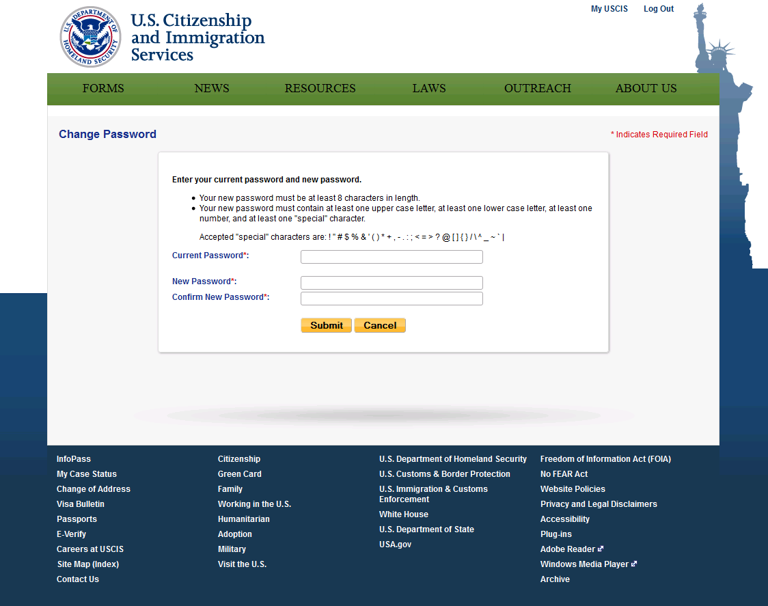

### Change Security Preference

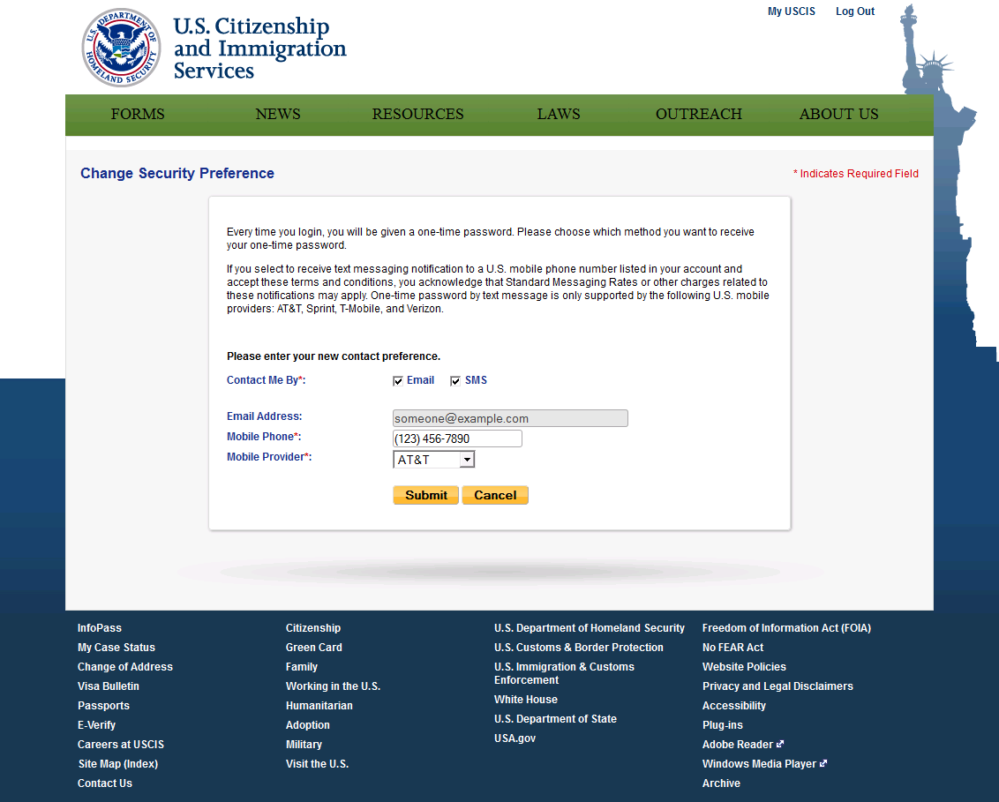

# Password Reset*



## Password Reset

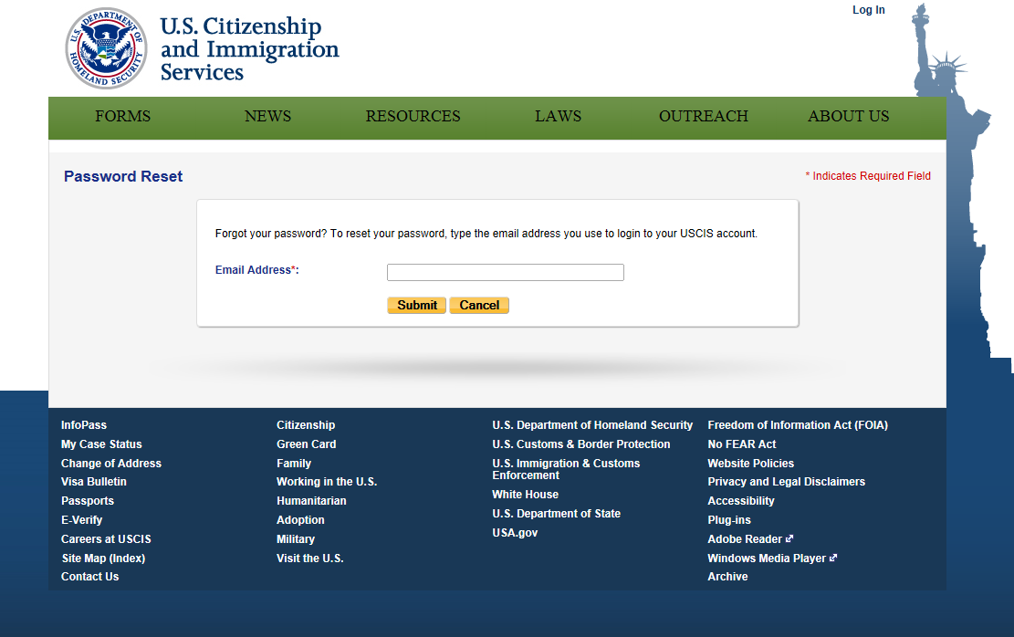

## Provide Password Reset Answer

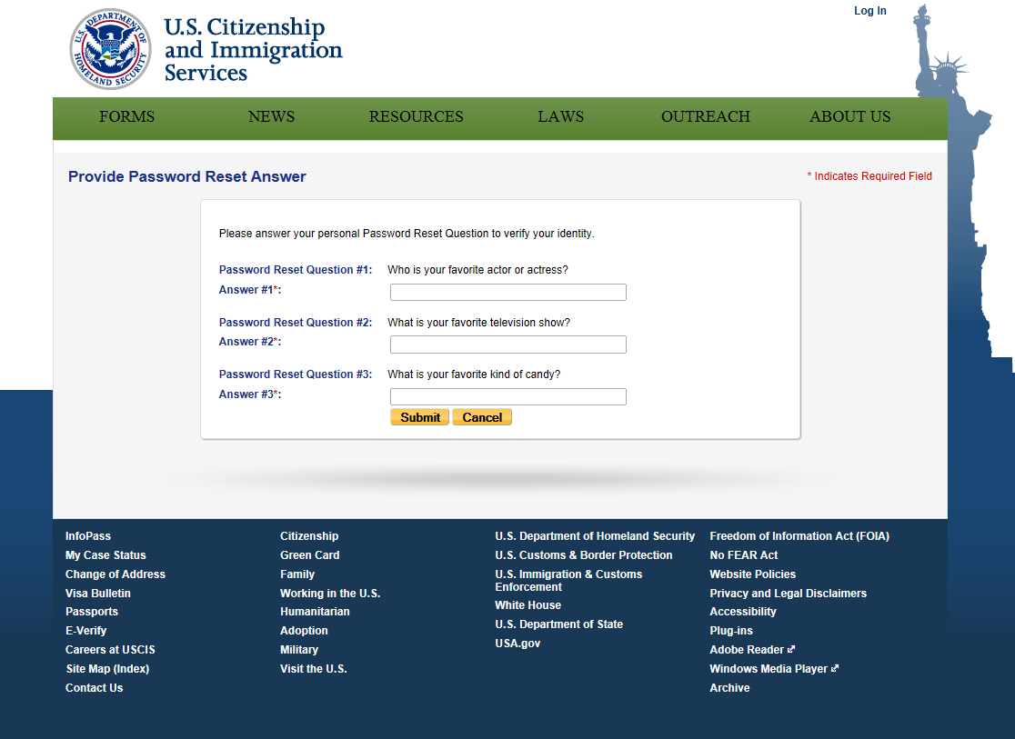

## Password Reset Confirmation

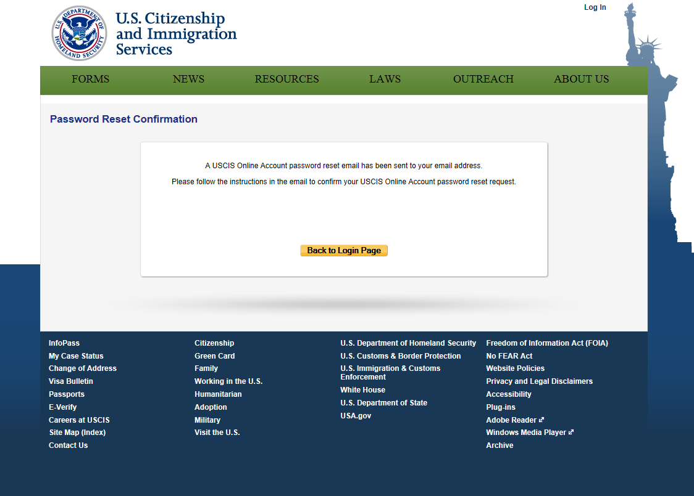

## Change Password

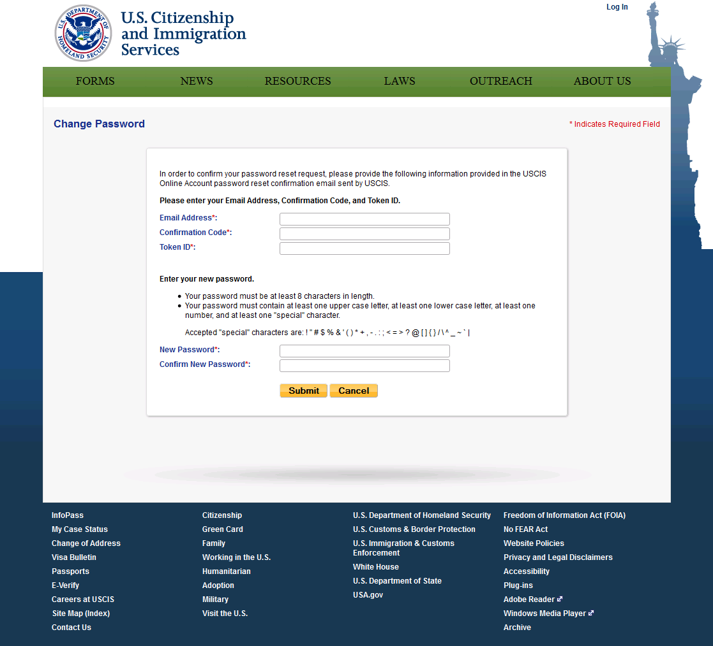

## Password Updated

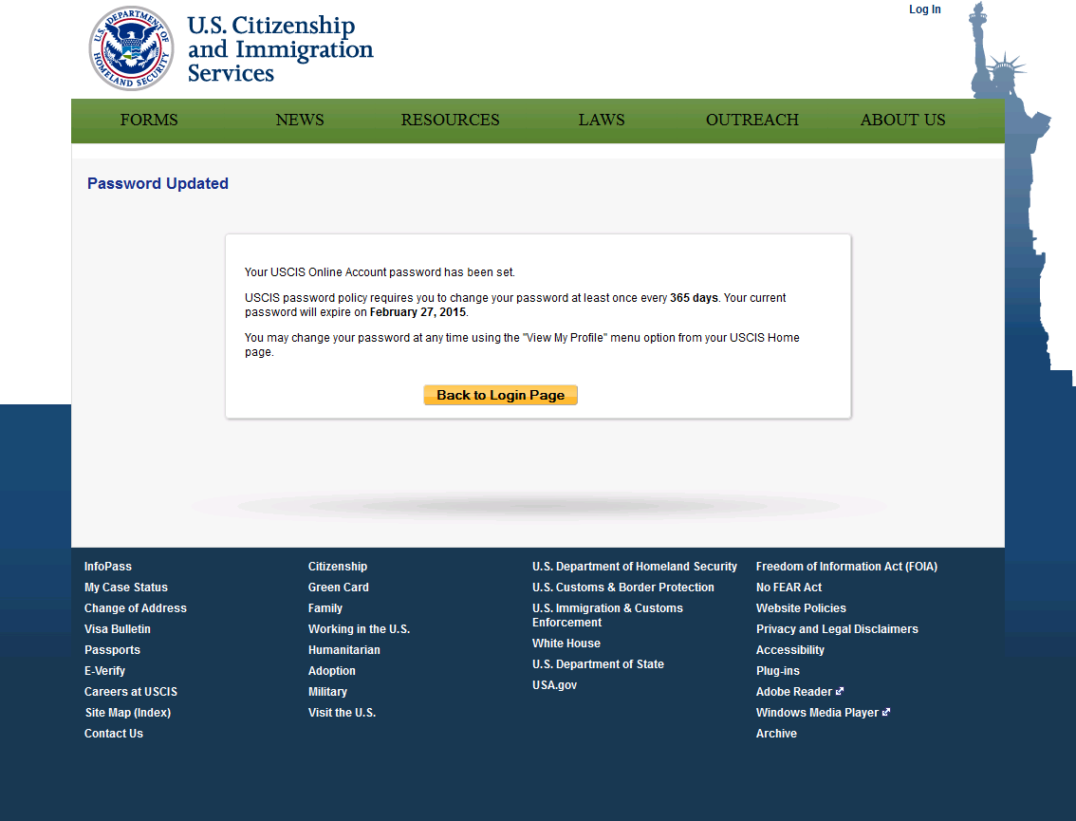

1.
2. The preliminary password reset questions as of May 13, 2014.