**United States Department of Agriculture**

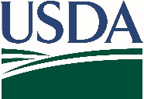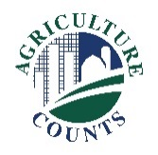

National Agricultural Statistics Service

(Date)

**Why am I getting this letter?**

**What should I do when I receive a questionnaire?**

Complete your survey **online** at [www.agcounts.usda.gov](http://www.agcounts.usda.gov). ***Online reporting is fast, cost-effective, and secure.*** All you need is the 17-digit survey code on the enclosed form to begin.

By **fax**: complete the survey questionnaire and fax it to   
(855) 415-3687.

The North Dakota State University’s Upper Great Plains Transportation Institute, in cooperation with the Agricultural Marketing Service and the National Agricultural Statistics Service, is collecting data to better understand local grain transportation market flows and investments of a small select group of famers in Iowa, Illinois, Indiana, Kansas, and Nebraska. The survey is focused on winter wheat, corn, and soybean. Your participation and assistance is needed to provide the most accurate information about grain transportation from field to market, especially decisions regarding marketing routes and truck fleet.

H:\Shared\CSDSAB\EESS\Grain Transportation\2014\Questionnaire\UGPTI logo.JPG 

**How will the data be used?**

Findings will be a valuable resource for local and state decision-makers in managing road investments and operations. This is especially true for local roads which are critical to the farm industry. We hope you will take a few minutes to complete this survey. Your participation is important and will aid in making decisions about traffic safety programs and key information concerning farm-to-market first point of delivery. If we do not hear from you by (Day, and Date), we may attempt to contact you by telephone to conduct an interview.

Thank you for participating and for your support of our programs and U.S. agriculture. If you have any questions, please feel free to contact us at 1-888-424-7828.

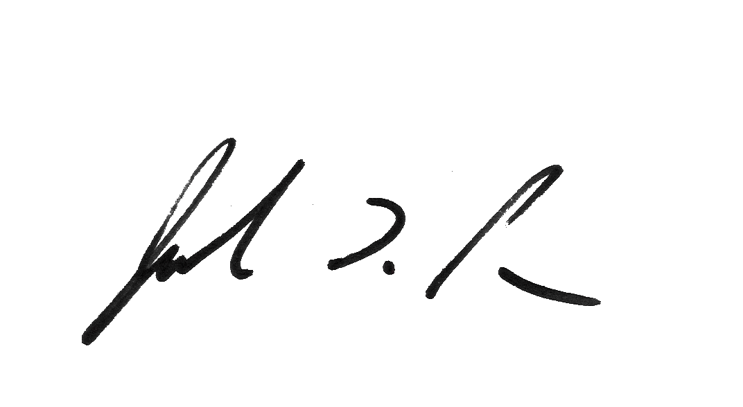

Sincerely,

Joseph L. Parsons

Chair, Agricultural Statistics Board