[Add date of mailing]

We need your help with a study about agricultural nutrient management and the use of poultry litter and its co-products being conducted by the University of Delaware, University of Maryland, and Virginia Tech. The goals of this study are to 1) better utilize poultry litter nutrients as a fertilizer for crop production and 2) improve the distribution of poultry litter across the Delmarva and throughout grain producing regions of Delaware, Maryland, Pennsylvania, and Virginia. Results from this study will benefit farmers and protect natural resources. To learn more about poultry litter or poultry litter co-products, please visit the following link to read VCE publication SPES-187NP: https://www.pubs.ext.vt.edu/SPES/spes-187/spes-187.html.
Please complete the short questionnaire enclosed with this letter, which will take about 20 minutes to complete. We want to learn about your operation and experiences regardless of whether or not you have used poultry litter or poultry litter co-products. Only farmers in Delaware, Maryland, Pennsylvania, and Virginia have been selected to participate in this survey, so your response is extremely important.

If we do not hear from you by XXXX, 2020, we will attempt to contact you to arrange a telephone interview.
This survey is being administered by the National Agricultural Statistics Services (NASS), with funding from the United States Department of Agriculture (USDA), the National Science Foundation, and the National Fish and Wildlife Foundation. Your participation is completely voluntary, and your responses are confidential. We will never share your name or the name of your operation. The results of this survey will be available in aggregate form only, ensuring that no individual operation or producer can be identified, as required by federal law.
Thank you for your time and your assistance with this important project. If you have any questions about this survey, please contact Shareefah Williams at shareefah.williams@usda.gov or 301-347-8179.
Sincerely,

Fertilizer: The Many Forms You Can Use
Poultry Litter
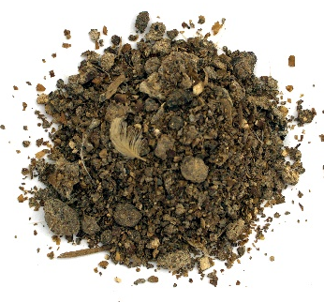
- Poultry litter is a substance found on the floor of poultry houses that is comprised of a base bedding material, such as wood shavings, pine bark, rice hulls, peanut hulls, or ground warm season grasses, and is then mixed with water, feed, feathers, additives (such as alum) and poultry manure as the chicken or turkey matures.
- Relative low nutrient analysis of N-P-K (Table 1).

Poultry Litter Ash (Co-Products)
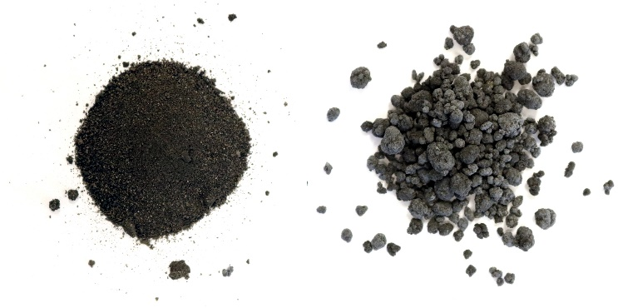
- After combustion or gasification, the resulting product is poultry litter ash (PLA), with a reduction in the original feedstock material by 90% by weight. The PLA is sterile, and is a powder like material with high concentrations of nutrients (Table 1).
- Ash can be granulated into prills similar to commercial fertilizer.

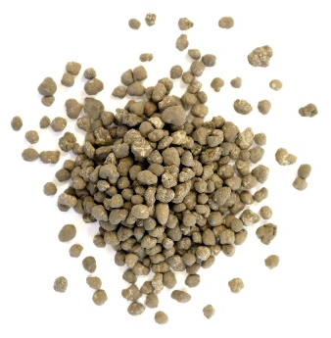
Inorganic Fertilizers
- Known and consistent concentrations of nitrogen, phosphorus, potassium, and sulfur presented in a standard format of N-P₂O₅-K₂O-S.
- Typical sources include urea and liquid urea-ammonium nitrate (UAN) for nitrogen and triple super phosphate and diammonium phosphate for phosphorus.

