The Whole Enchilada Trail

US Forest Service: Conditions, User Experience & Comment Survey 2019

The Whole Enchilada (WE) is a multi-trail system that spans across 30 miles of diverse landscapes, ecosystems, and federal land management jurisdictions. While the trail is multiple use—hiker, biker, equestrian and some portions of motorized vehicles—the trail is predominantly used by mountain bikers and is among the nation’s preeminent mountain bike trails. This trail has increased in popularity and is receiving heavy use, especially in October. This survey is intended to gauge public sentiment about conditions, use, experience and management of the trail. The results will be used by the US Forest Service to help better manage the Whole Enchilada trail and provide a more enjoyable user experience.
Please answer the following 20 questions:
- Please rate your current experience level in selected activity:
□Beginner □Novice □Intermediate □Advanced □Expert □Professional/
Sponsored

- How would you describe your user group/activity? Check one that applies to your visit to the Whole Enchilada (WE) trail system:
□ Hiker/Runner □ Biker □ Equestrian □Backpacker □Other__________________

- How many times have you ever accessed the Whole Enchilada trail system in 2018?
□1 □2 □3 □4 -6 □7-10 □ 10+ 3a) And in 2019? □1 □2 □3 □4-6 □7-10 □10+

- What Whole Enchilada trail head did you begin at today? Check one:
□ Geyser Pass/Burro □ Hazard County □ Kokopelli/Jimmy Keen □ UPS □LPS □ Porcupine Rim (P-Rim) □Don’t know/ Can’t remember

- How did you access the Whole Enchilada trail head today? Check one:
□Hike □Bike □Personal Car □Commercial Shuttle Vehicle □Horse/Stock □Other__________

- What did you like the most about your Whole Enchilada (WE) experience? __________________________________________________________________________________

- What did you like the least about your Whole Enchilada (WE) experience?
__________________________________________________________________________________

- What is one thing you would have the US Forest Service change about the trail system or the way it is managed? ______________________________________________________________________________________________________________________________________________________________________________________________________________________________________________________
- How did you find the conditions while on USFS sections of the Whole Enchilada: Geyser Pass Road, Burro Pass Trail and Hazard County? 1=very unacceptable, 2= unacceptable 3=neither unacceptable nor acceptable (Neutral) 4=acceptable, and 5=Very acceptable N/A=Not Applicable

 | Very Unacceptable | Unacceptable | Neutral | Acceptable | Very Acceptable | Not applicable
 | 1 | 2 | 3 | 4 | 5 | N/A
Quiet/Solitude | ◌ | ◌ | ◌ | ◌ | ◌ | ◌
Amount of parking | ◌ | ◌ | ◌ | ◌ | ◌ | ◌
Conditions of the roads | ◌ | ◌ | ◌ | ◌ | ◌ | ◌
Restroom facilities (cleanliness/wait time) | ◌ | ◌ | ◌ | ◌ | ◌ | ◌
Trash/human waste near parking lot/trailhead | ◌ | ◌ | ◌ | ◌ | ◌ | ◌
Trailhead/kiosk information (quality and quantity) | ◌ | ◌ | ◌ | ◌ | ◌ | ◌
Information & ease of booking shuttle transport | ◌ | ◌ | ◌ | ◌ | ◌ | ◌
Value received for commercial shuttle fees | ◌ | ◌ | ◌ | ◌ | ◌ | ◌
Availability of commercial shuttle services (Quantity) | ◌ | ◌ | ◌ | ◌ | ◌ | ◌
Helpfulness/friendliness of commercial shuttle services | ◌ | ◌ | ◌ | ◌ | ◌ | ◌
Availability of information about WE (In town, online or outside the USFS?) | ◌ | ◌ | ◌ | ◌ | ◌ | ◌
Trash/Human waste on or nearby trail | ◌ | ◌ | ◌ | ◌ | ◌ | ◌
Directional signage along trail (Quantity?) | ◌ | ◌ | ◌ | ◌ | ◌ | ◌
Crowding on or along trail | ◌ | ◌ | ◌ | ◌ | ◌ | ◌
Crowding at trailheads | ◌ | ◌ | ◌ | ◌ | ◌ | ◌
Personal safety | ◌ | ◌ | ◌ | ◌ | ◌ | ◌
Posting of USFS rules & regulations | ◌ | ◌ | ◌ | ◌ | ◌ | ◌
Compliance of Rules & Regulations (Did you notice other users following USFS rules/regulations?) | ◌ | ◌ | ◌ | ◌ | ◌ | ◌
Overall condition of WE trail | ◌ | ◌ | ◌ | ◌ | ◌ | ◌
Overall experience on the WE | ◌ | ◌ | ◌ | ◌ | ◌ | ◌
Other________________________________________ | ◌ | ◌ | ◌ | ◌ | ◌ | ◌

- Did any of the conditions listed in Question 9 negatively affect your experience on USFS lands? If so, which and how so? ______________________________________________________________________________________________________________________________________________________________________________________________________________________________________________________
- Did you find any aspect of your visit/time on the forest to be crowded? □Yes □ No (Skip Question #12) □ Don’t Care (Skip Question #12)
- Did your perception of crowding affect your recreation experience? □ Yes □ No

and 5 being positive, please rate your interaction with each user group you encountered:
13) Did you encounter any the following user groups? If yes, was the encounter negative, neutral or positive? On a scale of 1 to 5, 1 being negative

 |  |  | If encountered, effect on experience:
 | Encountered? |  | Negative |  | Neutral | Positive
 | No | YES | 1 | 2 | 3 | 4 | 5
Hikers | ◌ | ◌ | ◌ | ◌ | ◌ | ◌ | ◌
Trail Runners | ◌ | ◌ | ◌ | ◌ | ◌ | ◌ | ◌
Backpackers | ◌ | ◌ | ◌ | ◌ | ◌ | ◌ | ◌
Equestrians | ◌ | ◌ | ◌ | ◌ | ◌ | ◌ | ◌
Bikers | ◌ | ◌ | ◌ | ◌ | ◌ | ◌ | ◌
e-Bikers | ◌ | ◌ | ◌ | ◌ | ◌ | ◌ | ◌
Motorcycles | ◌ | ◌ | ◌ | ◌ | ◌ | ◌ | ◌

 | Group A |  |  |  | Group B |  |  |  | Group C |  |  |  | Group D
Photo Number | 1 | 2 | 3 | 4 | 1 | 2 | 3 | 4 | 1 | 2 | 3 | 4 | 1 | 2 | 3 | 4
Not crowded | ◌ | ◌ | ◌ | ◌ | ◌ | ◌ | ◌ | ◌ | ◌ | ◌ | ◌ | ◌ | ◌ | ◌ | ◌ | ◌
Slightly crowded | ◌ | ◌ | ◌ | ◌ | ◌ | ◌ | ◌ | ◌ | ◌ | ◌ | ◌ | ◌ | ◌ | ◌ | ◌ | ◌
Crowded | ◌ | ◌ | ◌ | ◌ | ◌ | ◌ | ◌ | ◌ | ◌ | ◌ | ◌ | ◌ | ◌ | ◌ | ◌ | ◌
Very Crowded | ◌ | ◌ | ◌ | ◌ | ◌ | ◌ | ◌ | ◌ | ◌ | ◌ | ◌ | ◌ | ◌ | ◌ | ◌ | ◌
- From the photos presented, please rate each group of pictures--mark only one per column in each group:

- During the peak season, the Whole Enchilada receives an average of 150-200 mountain bike riders per day. The highest day was just under 600 riders beginning at Burro Pass. Given your experience and your preference, should use on this trail be: □Significantly less □ Slightly less □About the same (no change) □Slightly more □Significantly more
16) On a peak day, Geyser Pass Road may have 20-30 commercial shuttle vehicles before 12 pm. That does not include those shuttling themselves. The total number of vehicles on a peak day may be upwards of 60-100 vehicles. Do you feel that this road should or could have:
□ Significantly less traffic □ Slightly less traffic □ About the same (no change) □ Slightly more traffic □ Significantly more traffic □No opinion
17) How would you feel about these managerial actions to protect natural resources, limit use, and/or mitigate social impacts such as crowding and user encounters or conflicts? 1=very unacceptable, 2= unacceptable 3=neither unacceptable nor acceptable (Neutral), 4=acceptable, and 5=Very acceptable, DK= Don’t Know
 | Very unacceptable | Unacceptable | Neutral | Acceptable | Very acceptable | Do not know
 | 1 | 2 | 3 | 4 | 5 | DK
Additional fees to access or ride WE? | ◌ | ◌ | ◌ | ◌ | ◌ | ◌
Fee for public parking at WE trailhead? | ◌ | ◌ | ◌ | ◌ | ◌ | ◌
Instituting a mandatory permit system, unlimited but with fee? | ◌ | ◌ | ◌ | ◌ | ◌ | ◌
Instituting a mandatory permit system, limited but free? | ◌ | ◌ | ◌ | ◌ | ◌ | ◌
Seasonal opening and closing dates?  (i.e. July 1st to October 31st) | ◌ | ◌ | ◌ | ◌ | ◌ | ◌
Increased USFS presence/patrols on trail? | ◌ | ◌ | ◌ | ◌ | ◌ | ◌
Increased restrictions on current commercial use?  (i.e. limit of shuttles run or limit of total riders shuttled per day) | ◌ | ◌ | ◌ | ◌ | ◌ | ◌
Restricting further future commercial use?  (i.e. no additional shuttles or guided tours) | ◌ | ◌ | ◌ | ◌ | ◌ | ◌
Increasing commercial outfitters/shuttle services? | ◌ | ◌ | ◌ | ◌ | ◌ | ◌
Additional fee (per rider) for shuttle vehicles? | ◌ | ◌ | ◌ | ◌ | ◌ | ◌
Dedicated time slots for shuttle service departures? | ◌ | ◌ | ◌ | ◌ | ◌ | ◌
No mountain bike days(i.e. Tuesday-Thursday)? | ◌ | ◌ | ◌ | ◌ | ◌ | ◌
Limit total amount of mountain bikes per day? | ◌ | ◌ | ◌ | ◌ | ◌ | ◌
Set use limits for all user groups per day?  (i.e. bikers=500, hikers=100) | ◌ | ◌ | ◌ | ◌ | ◌ | ◌
Dedicated time slots for different use groups?  (i.e. bikers; 6-12pm, hikers/equestrians; 12 pm onward) | ◌ | ◌ | ◌ | ◌ | ◌ | ◌
Alternating use days?  (i.e. bikers on even days, hikers/equestrian on odd days) | ◌ | ◌ | ◌ | ◌ | ◌ | ◌
Allow class 1, pedal assisted e-Bikes on WE?  (i.e.to increase user accessibility) | ◌ | ◌ | ◌ | ◌ | ◌ | ◌
Allow class 1 pedal assisted e-Bikes on trails other than the WE? | ◌ | ◌ | ◌ | ◌ | ◌ | ◌
Implementing more sustainable trail work?  (building more bridges, armored switchbacks, re-routes,  less steep and more flowing trail (where applicable)) | ◌ | ◌ | ◌ | ◌ | ◌ | ◌
Separate user groups by using bypass trails? | ◌ | ◌ | ◌ | ◌ | ◌ | ◌
Other__________________________________________________ | ◌ | ◌ | ◌ | ◌ | ◌ | ◌
- What would be the most you would be willing to pay, in US Dollars, for the following:
(All fees would help fund maintenance and improvement solely on the Whole Enchilada trail system)

Public parking fee | Daily Permit Fee | Additional shuttle fee (per rider)
□$0 □$1-2 □$3-4  □$5-7 □ $8-10 | □$0 □$1-2 □$3-4  □$5-7 □ $8-10 | □$0 □$1-2 □$3-4  □$5-7 □ $8-10

19) Have you ever not been able to, or chosen not to, access the WE trail system because of crowding or limited shuttle service? □Yes □No If YES, how many times?____________
Did you go somewhere else to do the same activity?□Yes □No
20)
Age:_______ Sex: □Male□ Female□ Prefer not to answer Zip Code of primary residence:_________

Number of people in your party, including yourself:_________


For more information about this survey contact:
Zachary Lowe
Recreation Specialist
zklowe@fs.fed.us
435-259-7155
Mail correspondence or survey to:
Manti-La Sal National Forest
Moab Ranger District
62 East 100 North
Moab, Utah 84532

Do you have any other comments? ___________________________________________________________________________________________________________________________________________________________________________________________________________________________________________________________________________________________________________________________________________________________________________________________________________________________________________________
Thank you for your help!

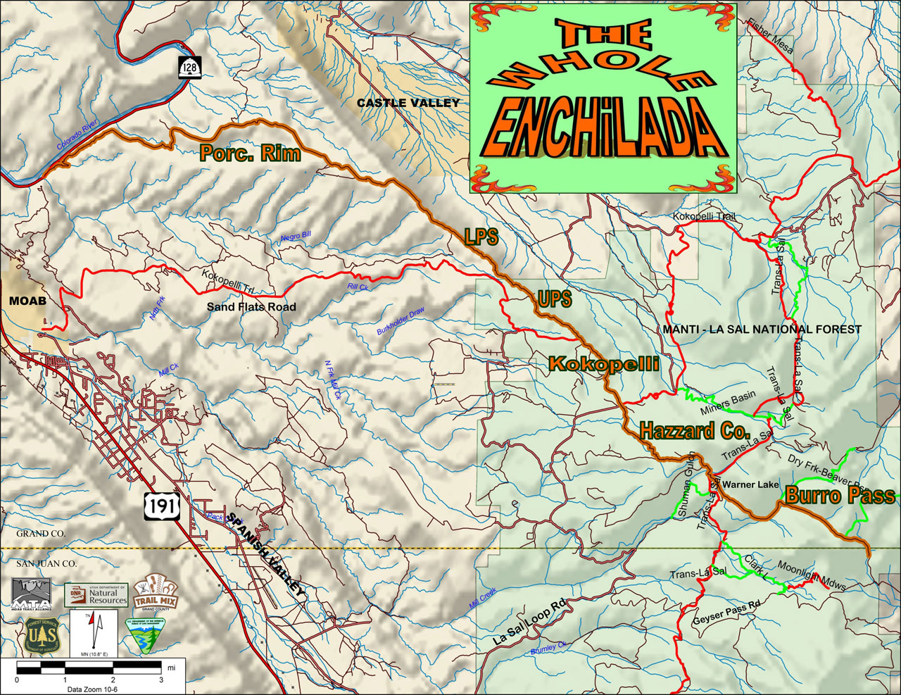
[Map may change, but will have same information]
Burden Statement for Forms – Information Collection Requests

According to the Paperwork Reduction Act of 1995, an agency may not conduct or sponsor, and a person is not required to respond to a collection of information unless it displays a valid OMB control number. The valid OMB control number for this information collection is 0596-NEW. The time required to complete this information collection is estimated to average 15 minutes per person, including the time for reviewing instructions, searching existing data sources, gathering and maintaining the data needed, and completing and reviewing the collection of information.

The U.S. Department of Agriculture (USDA) prohibits discrimination in all its programs and activities on the basis of race, color, national origin, age, disability, and where applicable, sex, marital status, familial status, parental status, religion, sexual orientation, genetic information, political beliefs, reprisal, or because all or part of an individual’s income is derived from any public assistance program (Not all prohibited bases apply to all programs.) Persons with disabilities who require alternative means for communication of program information (Braille, large print, audiotape, etc.) should contact USDA’s TARGET Center at (202) 720-2600 (voice and TDD). To file a complaint of discrimination, write to USDA, Director, Office of Civil Rights, 1400 Independence Ave., S.W., Washington, D.C. 20250-9410, or call (800) 795-3272 (TDD). USDA is an equal opportunity provider and employer.

