BOAT RAMP EXIT INTERVIEW SURVEY
(Insert Lake Name) LAKE

Date:________________ Ramp:_____________________________________ Time:________________

Observe what type of boat was used? (circle one)
Runabout/Speedboat/Ski Boat Houseboat Cabin Cruiser
Pontoon Boat Canoe/Kayak Fishing Boat
PWC (Jet Ski) Sailboat
High Performance Boat (cigarette boat) Other: ___________________________________

“Hello. My name is __________. I am conducting a survey of boaters to help the Corps of Engineers learn more about boating experiences on ___________ Lake. Participation in this survey is completely voluntary, however your responses are important to the completeness and accuracy of this study. No personal information is requested and the responses you provide are combined with all other responses to help the lake managers understand boating use at this lake. The card I provided you has details about the applicable authorities and Privacy Act Statement. This survey will only take about 10 minutes. May I ask you a few questions?”

1. Have you boated on _________ lake before today? Yes No
If YES, How many total years have you been boating on this Lake? ________ years.

2. How many times per year do you typically boat on this Lake? ________ Times Per Year.

3. Including yourself, how many people were in your boat today? __________ (enter whole number)
How many of those were less than 18 years of age? ____________

4. How much time did you spend on the water today? _________ hours _________ minutes
What percent of that time would you estimate your boat motor was running? ______________%

5. Please estimate the amount of time spent today on the following activities. (should total 100%)
If Other, describe activity here:
_______________________
_______________________
Fishing | ________% | Swimming | ________%
Cruising | ________% | Relaxing | ________%
Water Skiing | ________% | Sailing | ________%
Tubing | ________% | Other: | ________%

6. Did you pull your boat ashore and step out of your boat to access the shoreline while boating today?
Yes No

7. What is the length of this boat? Feet: _____ Inches: _____ 8. What is the horsepower? ______________

9. How congested do you feel the boat ramp at the lake was today?
Not Congested | Somewhat Congested | Moderately Congested | Very Congested | Extremely Congested

Now I would like to ask you a few questions about where you do and do not go on the lake. Current location is marked with a star (*)
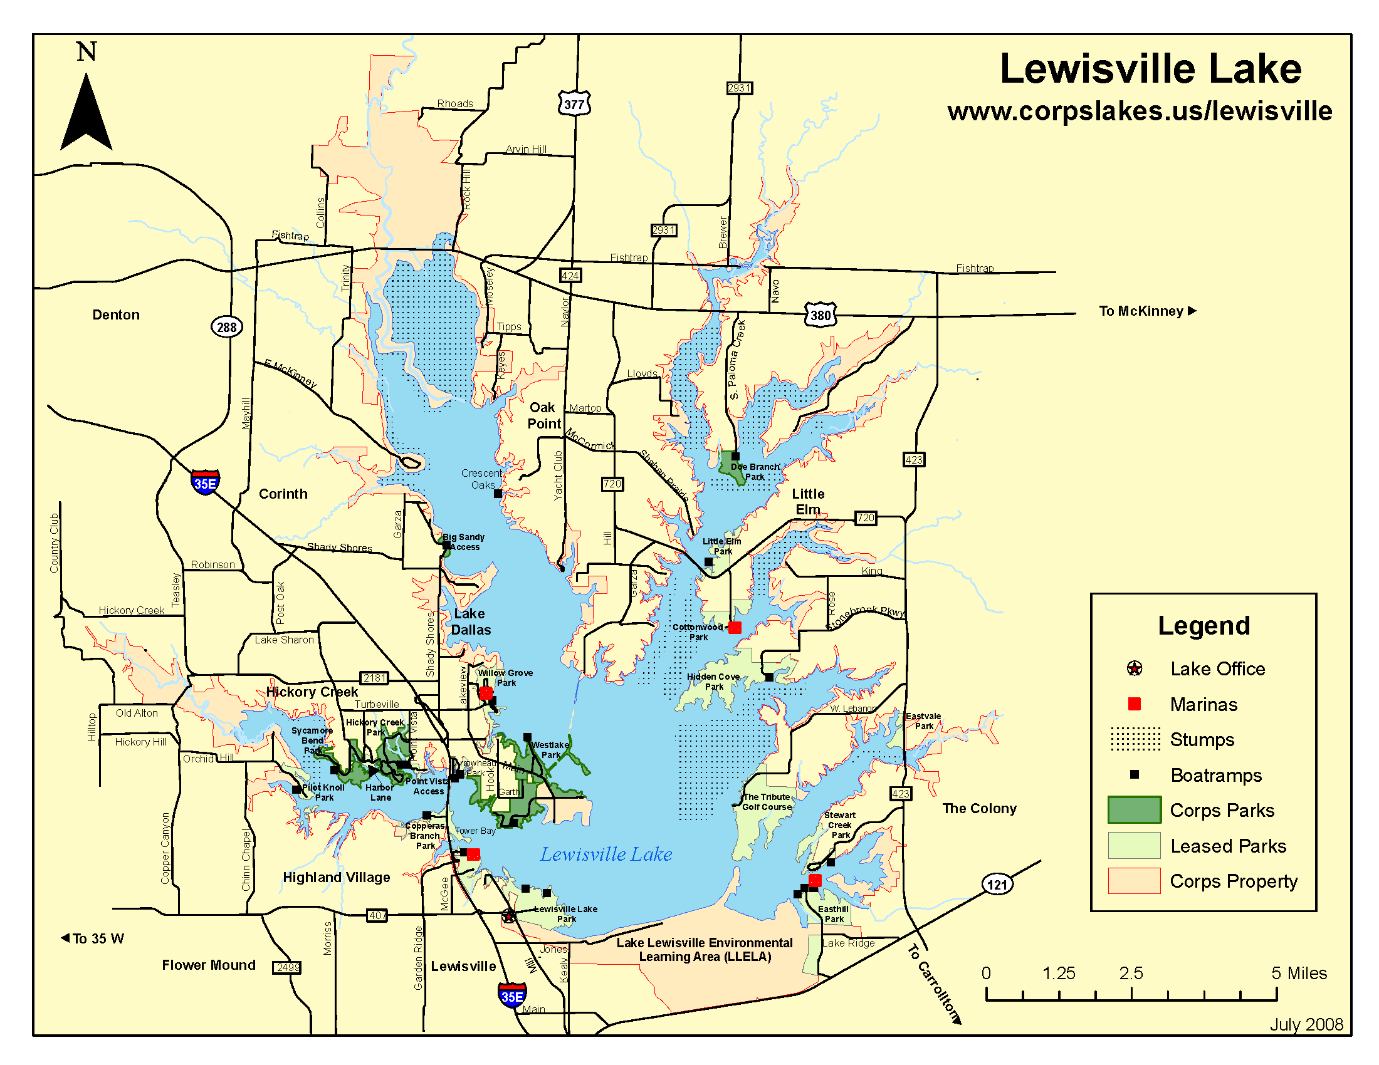
10. Do you have a favorite place to go on the lake? Yes No
If yes, please point to your favorite place on the lake. (interviewer circles and marks with an “F”)
Why is this your favorite location? _________________________________________________________________
11. Are there locations you deliberately avoid? Yes No
If yes, please point to the places you avoid on the lake. (interviewer circles and mark with A1, A2, etc)
Why do you avoid these locations? _________________________________________________________________
12. Are there locations where you feel unsafe? Yes No
If yes, please point to the places where you feel unsafe. (interviewer circles and marks with U1, U2, etc)
Why do you feel unsafe in these locations? ___________________________________________________________
13. How safe did you feel today at the following locations? (circle corresponding number)
Location | Not at all safe | Somewhat safe | Moderately safe | Very Safe | Extremely safe
At the boat ramp when launching your boat | 1 | 2 | 3 | 4 | 5
On the water while boating | 1 | 2 | 3 | 4 | 5

14. How crowded did you feel today at the following locations and situations? (circle corresponding number)
Location | Not at all crowded | Somewhat crowded | Moderately crowded | Very Crowded | Extremely crowded
At the boat ramp when launching your boat | 1 | 2 | 3 | 4 | 5
On the water while boating | 1 | 2 | 3 | 4 | 5
At the boat ramp when loading your boat? | 1 | 2 | 3 | 4 | 5

15. I’d like to ask your opinion about the quantity of facilities and services on the lake. For each of the following, please indicate whether you think there are too many, about enough or more needed.
Boat Ramps Too many About enough more needed
Parking Areas Too many About enough More needed
Water Patrol Officers Too many About enough More needed
Park Rangers Too many About enough More needed
Marinas Too many About enough More needed

16. Have you noticed any changes at this lake in the last five years? Yes No
(If yes, prompt for positive and negative)
What are the Positive changes: __________________________________________________________________________________________
What are the Negative changes: __________________________________________________________________________________________

17. We would like to know if you agree or disagree with the following statements about your experience today at __________ Lake. Options are strongly disagree, disagree, neutral, agree or strongly agree.
Statement | Strongly Disagree | Disagree | Neutral | Agree | Strongly Agree
The overall quality of my experience has been positive. | 1 | 2 | 3 | 4 | 5
The level of noise from motorized boating is acceptable to me. | 1 | 2 | 3 | 4 | 5
The quality of water is acceptable to me. | 1 | 2 | 3 | 4 | 5
The traffic on the water from motorized boats is acceptable to me. | 1 | 2 | 3 | 4 | 5
The size of the boats that I saw is acceptable. | 1 | 2 | 3 | 4 | 5

18. What is the city, state and zip code of your primary residence?
City: __________________________ State: _____ Zip: ________________
If not from the US, prompt for country of residence. Country: ______________________

19. Do you have any additional comments? (Write comments below)

THANK YOU FOR YOUR TIME

