Post card 1
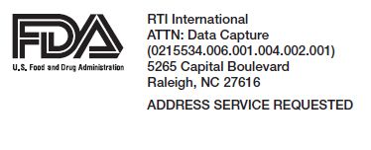

[NAME]
[RECIPIENT ADDRESS]
[CITY, ST ZIP]

<caseid>

Dear [NAME]
Last week, I mailed you a letter asking you to complete an online questionnaire to follow up on your previous participation in in the Point of Sale Intervention for Tobacco Evaluation (POSITEv), an important study sponsored by the U.S. Food and Drug Administration. You may recall first completing an in-person interview in [month], 2018. [You also participated in a follow-up interview either in-person or online in Month, year and Month, year.]
If you already completed the online questionnaire, please accept my sincere thanks. If not, we hope you will please do so today.
You will receive $25 if you complete the questionnaire online and a bonus $5 ($30 total) if you do so on or before [Early bird date].
If you prefer to complete the survey in-person for $25, or if you have any questions, please call us at 1-800-957-6457 between 9 am and 5 pm, Eastern Time, Monday through Friday or email us at fdastudy@rti.org.
Many thanks,
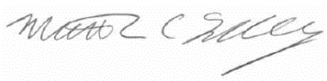
Dr. Matthew Farrelly, POSITEv Study Director, RTI International

Dr. Matthew Farrelly
RTI International

- In your web browser type the study website address: <<address>>
- On the login screen, type your username and password exactly as shown below:
Username: [Case ID]
Password: [Password]

You will receive $25 if you complete the questionnaire online and a bonus $5 ($30 total) if you do so on or before [Early bird date].

OMB No. 0910-0851
Exp. Date 04/30/2021
RIHSC No. 17-082CTP

Post card 2

[NAME]
[ADDRESS]
[CITY, ST ZIP]

<caseid>

Dear [NAME]
A few weeks ago, I mailed you a letter asking you to complete an online questionnaire to follow up on your previous participation in the Point of Sale Intervention for Tobacco Evaluation (POSITEv). Your continued participation will help the Food and Drug Administration develop programs that will improve Americans’ health.
If you already completed the online questionnaire, please accept my sincere thanks. If not, we hope you will please do so today.
You will receive $25 if you complete the questionnaire online and a bonus $5 ($30 total) if you do so by [Early bird date]. If you prefer to complete the questionnaire in-person, you will receive $25 at the end; an interviewer may contact you if we do not hear from you by [date].
If you have any questions or if you would like to schedule an in-person interview, please call us at 1-800-957-6457 between 9 am and 5 pm, Eastern Time, Monday through Friday or email us at fdastudy@rti.org.
Sincerely,
Dr. Matthew Farrelly, POSITEv Study Director, RTI International

- In your web browser type the study website address: <<address>>
- On the login screen, type your username and password exactly as shown below:
Username: [Case ID]
Password: [Password]

You will receive $25 if you complete the questionnaire online and a bonus $5 ($30 total) if you do so on or before [Early bird date].

OMB No. 0910-0851
Exp. Date 04/30/2021
RIHSC No. 17-082CTP

