**Attachment 1a: Screen Shots - Customer Feedback Forensic Toxicology**

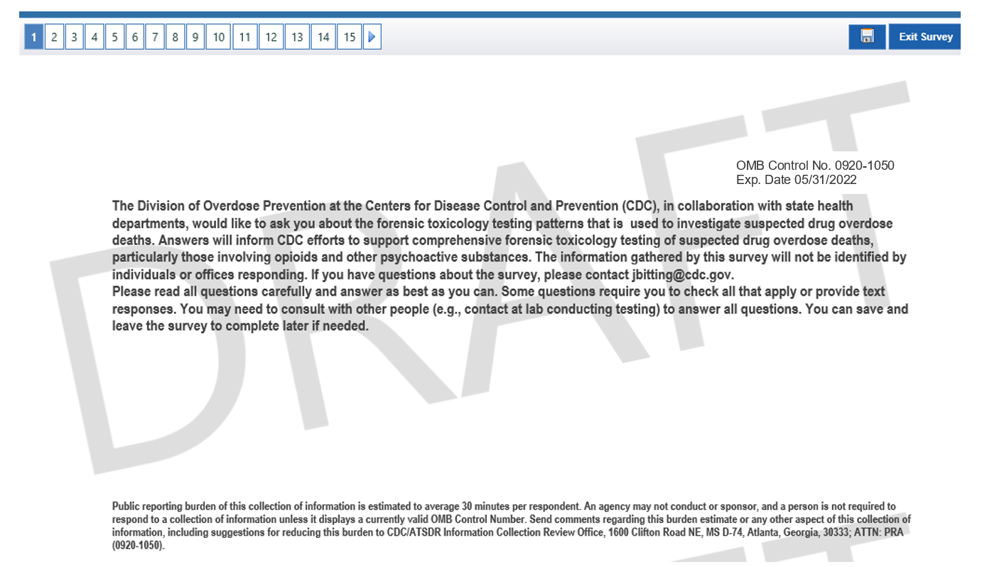

NOTE: Question #3 has a skip pattern. The first of two options is shown on this page. If the respondent checks “Medical Examiner Office” in response to question #3, they will be asked question #3b: “Please specify the type of Medial Examiner in charge of your office. (Please select only one response):”

NOTE: Question #3 has a skip pattern. The second of two options is shown on this page. If the respondent does not check “Medical Examiner Office” in response to question #3, the next question the respondent will be asked is #4.

