Attachment F: End-of-Training Survey Invitation

From: NNPHI Convenings [convenings@nnphi.org](mailto:convenings@nnphi.org)

To: [Auto-Populated- Individual Email Address of Registrant]

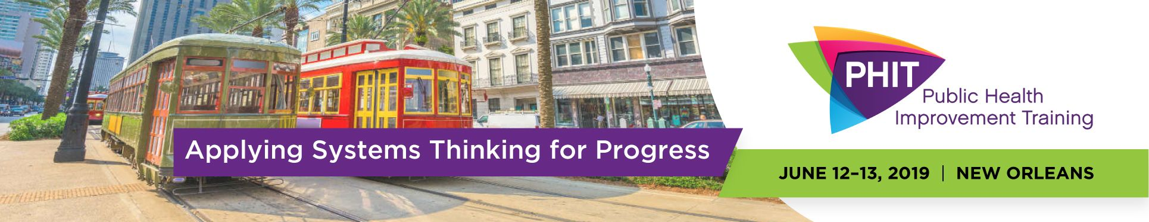

Dear [ExampleContactFirstName],

Please complete the [end of training evaluation](https://nnphi.az1.qualtrics.com/jfe/preview/SV_ddjeFnllDqW8sRv?Q_SurveyVersionID=current&Q_CHL=preview) for the Public Health Improvement Training (PHIT) 2019 to tell us what worked and how to improve. The survey will take about 4 minutes to complete. We use your ratings, comments, and ideas to plan for the future so please let us know how to best serve you! Also, it’s not too late yet to complete your session evaluations through the app. Presenters are eager to get feedback about their sessions so please complete this evaluation for anonymous feedback to presenters.

Thanks again for your participation in PHIT 2019.  
  
PHIT Team  
National Network of Public Health Institutes

