Microbiology-Oriented eLearning Learner Feedback Survey FY2019: Invitation and Reminders

Invitation
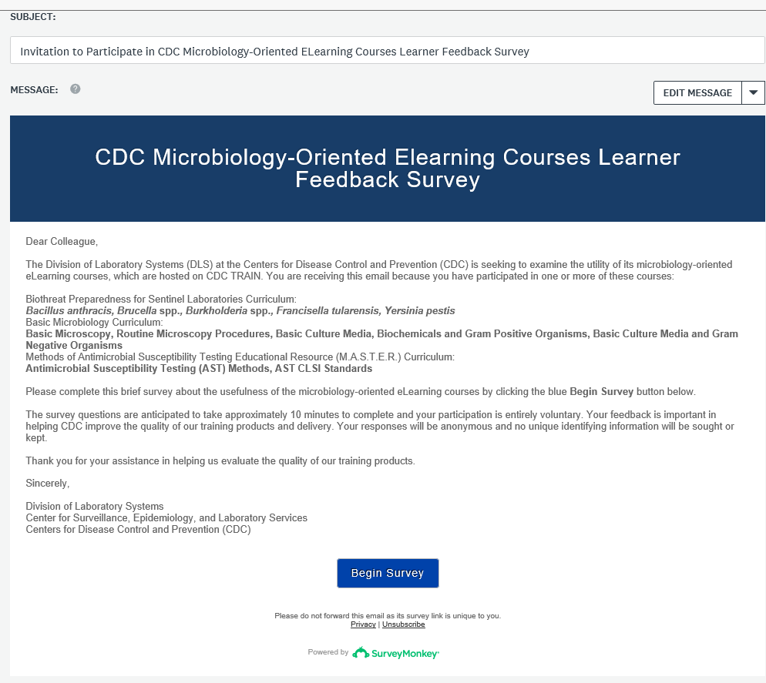

Reminder
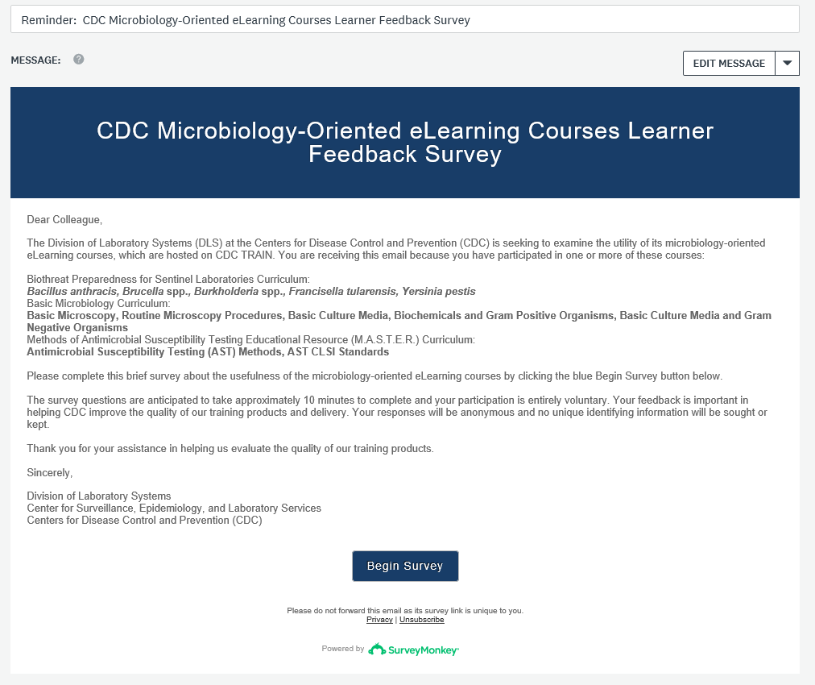

Final Reminder
