# Revised Screens

# Justification for Non-Substantive Change to

**Form SSA-1020/i1020**

***Application for Extra Help with Medicare Prescription Drug Plan Costs***

**OMB No. 0960-0696**

***Change 1:***

**Revised MEDQ Default Screen (QDIS)**

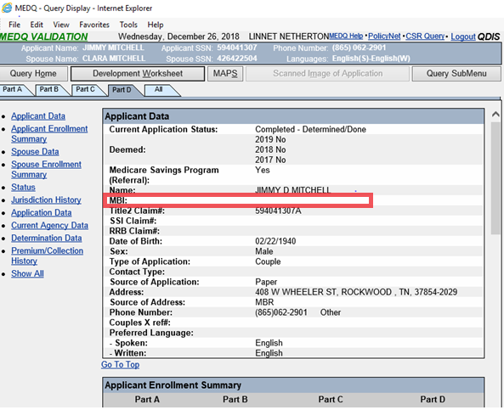

99999999999

**Revised QDIS display: Client Data section (Part A tab)**



**Revised QDIS display: Client Data section (Part B tab)**



**Revised QDIS display: Client Data section (Part C tab)**



**Revised QDIS display: Applicant Data section (Part D & ‘All’ tab)**



**Revised QDIS display: Spouse Data section (Part D & ‘All’ tab)**



