Current Screens

Justification for Non-Substantive Change to

Form SSA-1020/i1020
Application for Extra Help with Medicare Prescription Drug Plan Costs

OMB No. 0960-0696 – Current Screens
Change 1:

Current MEDQ Default Screen (QDIS)
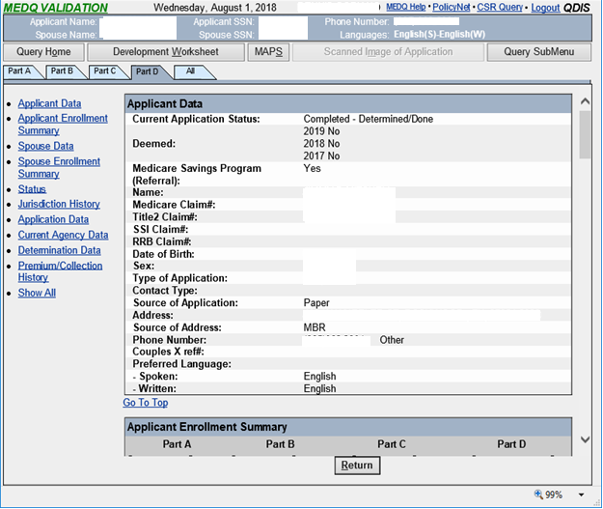

Current QDIS display: Client Data section (Part A tab)

Client Data

Name:
Medicare Claim#: Title2 Claim#: SSI Claim#:
RRB Claim#: Date of Birth: Sex:
Address:
Source of Address: MBR
Phone Number: Couples X ref#:
Preferred Language:
- Spoken: English
- Written: English

Current QDIS display: Client Data section (Part B tab)

Client Data

Name:
Medicare Claim#: Title2 Claim#: SSI Claim#:
RRB Claim#: Date of Birth: Sex:
Address:
Source of Address: MBR
Phone Number: Couples X ref#: Preferred Language:
- Spoken: English
- Written: English

Current QDIS display: Client Data section (Part C tab)

Client Data
Name:
Medicare Claim#: Title2 Claim#: SSI Claim#:
RRB Claim#: Date of Birth: Sex:
Address:
Source of Address: MBR
Phone Number: Couples X ref#: Preferred Language:
- Spoken: English
- Written: English

Current QDIS display: Applicant Data section (Part D & ‘All’ tab)

Applicant Data
Current Application Status: Completed - Determined/Done 2019 No

Deemed:
2018 No
2017 No

Medicare Savings Program (Referral): Yes
Name:
Medicare Claim#: Title2 Claim#: SSI Claim#:
RRB Claim#:
Date of Birth: Sex:
Type of Application: Contact Type:
Source of Application: Paper
Address:
Source of Address: MBR
Phone Number: Other
Couples X ref#: Preferred Language:
- Spoken: English
- Written: English

Current QDIS display: Spouse Data section (Part D & ‘All’ tab)

Spouse Data
Current Application Status: Completed - Determined/Done 2019 No

Deemed:
2018 No
2017 No

Medicare Savings Program (Referral): Yes
Name:
Medicare Claim#: Title2 Claim#: SSI Claim#:
RRB Claim#:
Date of Birth: Sex:
Type of Application: Contact Type:
Source of Application: Paper
Address:
Source of Address: MBR
Phone Number: Other
Couples X ref#: Preferred Language:
- Spoken: English
- Written: English

