ATTACHMENT P  
  
Advance Letter for Adult Phone Follow-Up Survey

**This page has been left blank for double-sided copying.**

OMB: XXXX-XXXX

EXP: XX/XX/XXXX

[DATE]

Dear [PARTICIPANT NAME]:

I am writing about the *Strengthening Relationship Education and Marriage Services* evaluation, also known as *STREAMS,* an important study that the U.S. Department of Health and Human Services (HHS) is conducting. The study is being done to learn more about how well programs designed to help people improve their relationships work. HHS has asked Mathematica Policy Research to help with it. You agreed to be a part of this study when you enrolled in the [PROGRAM] about one year ago.

In about one week, someone from Mathematica Policy Research will call you to update the information you gave us a year ago and ask you some new questions. We will ask about your relationships, your family, your work, and how you are doing. The interview takes about 45 minutes to complete. **To thank you for your participation, we will send you a $25 gift card after you complete the interview.**

Your participation is important, but voluntary. Your answers will be kept completely private to the extent allowed by federal law, and you will never be identified in any report based on the survey. You can choose to stop participating at any time with no consequences. The only risk connected with the study is that you may be uncomfortable answering some questions in the survey. If that happens, you can refuse to answer those questions.

If your telephone is unlisted or has changed since the last time we spoke, please call today (toll-free) at **[FILL NUMBER]** to tell us how we can reach you. There is no charge for the call. Though we will call you soon about this study, you can also call the toll-free number to take part in your interview today, or make an appointment for a time that is convenient for you.

This is your chance to make a difference. Your answers will help us understand how relationship education program help people and how they can be improved in the future.

We look forward to talking with you soon.

Sincerely,

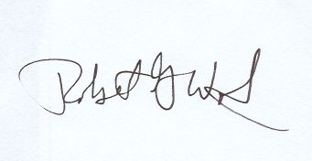

Robert Wood, PhD

Project Director

Mathematica Policy Research