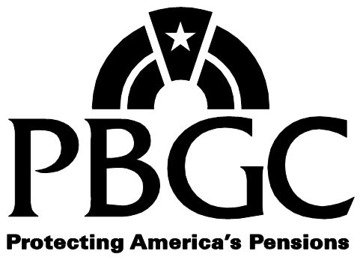 | Certification of Social Security Disability Status |  | PBGC Form 716
Pension Benefit Guaranty Corporation.  P.O. Box 151750, Alexandria, Virginia 22315-1750 |  | For assistance, call 1-800-400-7242

 | Plan Name: FX.PrismCase.CaseTitle.XF
 | Plan Number: FX.PrismCase.CaseIdNmbr.XF | Participant Name : FX.PrismCust.FullName.XF
 | Date Printed: 12/14/2015
 | Date of Plan Termination: FX.PrismCase.DOPT.XF

INSTRUCTIONS: Please complete and return this form to PBGC within the timeframe indicated in the cover letter. PBGC needs your certification to determine whether to continue paying your current benefit amount. If you have questions, call our Customer Contact Center at 1-800-400-7242. Please print clearly with blue or black ink.

1. General information about you

Last Name |  |  |  |  |  |  |  |  |  |  |  |  |  |  |  |  |  |  |  | First Name
Middle Name |  |  |  |  |  |  |  |  |  |  | Other Last Name(s) Used
Social Security Number |  |  |  |  |  |  |  |  |  |  | Date of Birth
 |  |  | - |  |  | - |  |  |  |  |  |  | / |  |  | /
Mailing Address |  |  |  |  |  |  |  |  |  |  |  |  |  |  |  |  | Apartment / Route Number
City |  |  |  |  |  |  |  |  |  |  |  |  |  |  |  |  | State |  |  |  | Zip Code
Country |  |  |  |  |  |  |  |  |  |  |  |  |  |  |  |  | Email (optional)
Daytime Phone |  |  |  |  |  |  |  |  |  |  |  |  |  | Extension |  |  |  | Evening Phone
( |  |  |  | ) |  |  |  | - |  |  |  |  | x |  |  |  |  | ( |  |  |  | ) |  |  |  |  | -

2. Certification – Check the box below that describes the current status regarding your disability benefit from the Social Security Administration (SSA).

◻ I certify that I am still eligible for Social Security disability benefits.
◻ I certify that effective ___/____/________ I am no longer eligible for SSA disability benefits. .

I understand that in the future I may be required to provide supporting documentation.

3. Signature – Sign and date this form. Knowingly and willfully making false, fictitious or fraudulent statements to the Pension Benefit Guaranty Corporation is a crime punishable under Title 18, Section 1001, United States Code.

I declare under penalty of perjury that all of the information I have provided on this form is true and correct.
signature |  | date

Approved OMB 1212-0055
Expires xx/xx/xx

