ARS to QBS Transition Screen

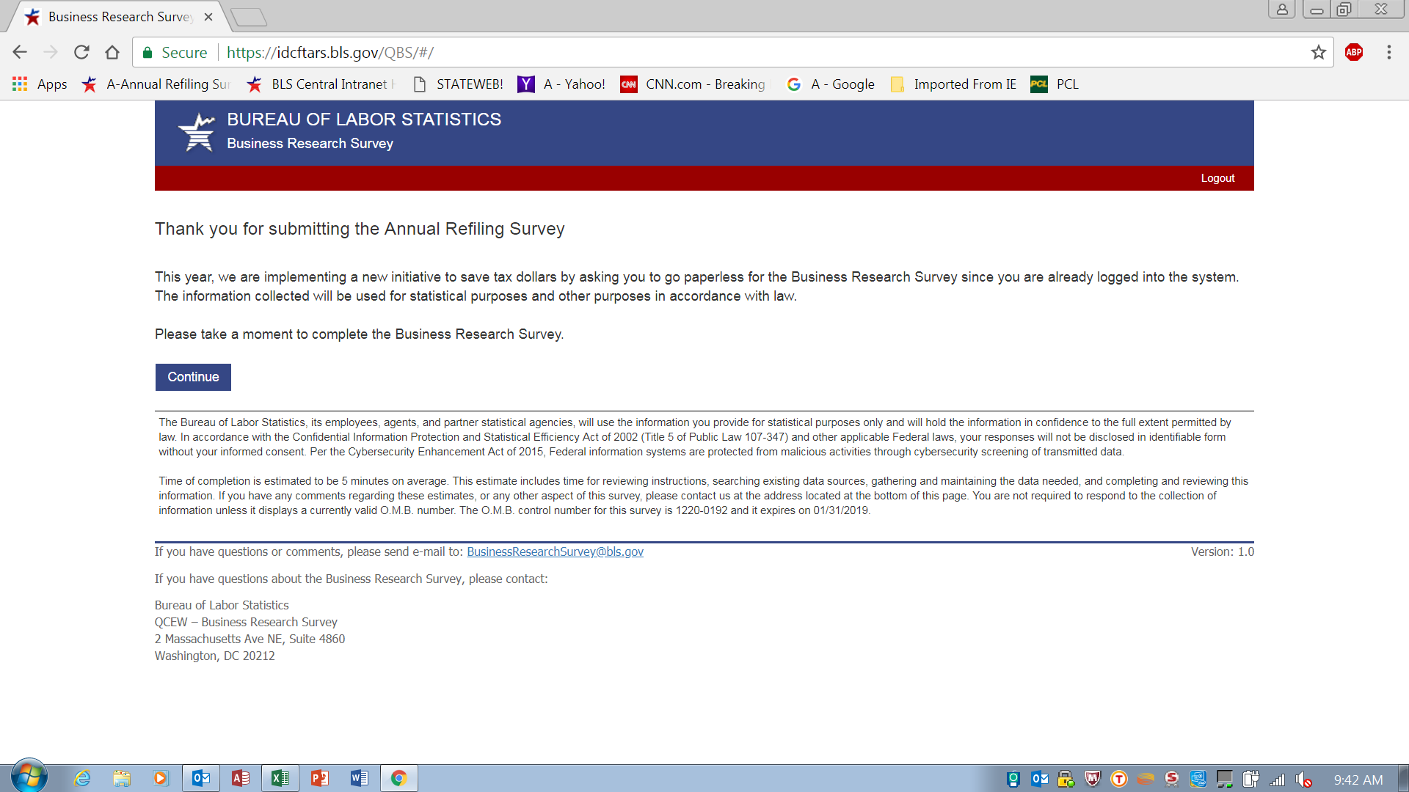
The Bureau of Labor Statistics, its employees, agents, and partner statistical agencies, will use the information you provide for statistical purposes only and will hold the information in confidence to the full extent permitted by law. In accordance with the Confidential Information Protection and Statistical Efficiency Act (44 USC §3561 et seq.) and other applicable Federal laws, your responses will not be disclosed in identifiable form without your informed consent. Per the Federal Cybersecurity Enhancement Act of 2015, Federal information systems are protected from malicious activities through cybersecurity screening of transmitted data.

Time of completion is estimate to be 3 minutes on average. This estimate includes time for reviewing instructions, searching existing data sources, gathering and maintaining the data needed, and completing and reviewing this information. If you have any comments regarding these estimates, or any other aspect of this survey, please contact us at the address located at the bottom of this page. You are not required to respond to the collection of information unless it displays a currently valid O.M.B. number. The O.M.B. control number for this survey is 1220-0192 and expires on xx/xx/xxxx.

QBS Welcome Screen
Frequently Asked Questions (FAQs)
What is the Business Research Survey?
This year, the Bureau of Labor Statistics is asking a small number of ARS respondents to answer a few additional questions after completing the ARS online as part of the Business Research Survey project. These yes/no questions are designed to help us understand the types of information available to our respondents. These additional questions should only take about five minutes to complete.

Why was my business selected to participate?
A sample of establishments was randomly selected from all businesses filing unemployment insurance taxes. Your business was selected to represent other businesses of similar size in the same geographical area and industry. That's why your response is critical.

Is this survey mandatory?
This Business Research Survey is asking for your voluntary participation. Your response is vital to the statistical validity of this new study.

Is the information I provide confidential?
Yes. Your information and identity are kept in strict confidence in accordance with Bureau of Labor Statistics Data Integrity Guidelines and with the Confidentiality Information Protection and Statistical Efficiency Act (CIPSEA.

What will you do with my answers?
Your answers will be combined with the answers from other establishments of comparable size in your industry and geographical area. The results of this research study will allow the BLS to examine the validity of adding special topic questions to the ARS in order to save tax dollars.

We have multiple establishments and work sites. Which should we report for?
Please report only for the physical location address shown on the Address and Contact Information Update screen.

Will I be asked to complete this survey every year?
The Business Research Survey is conducted in conjunction with the Annual Refiling Survey (ARS). The ARS is conducted on a 3-year cycle, so you will only be asked to participate in the ARS once every three years. Because the BRS is a randomly selected sample from all U.S. businesses, you may not be selected to participate in the future unless your business is randomly selected to participate again.

QBS Questions Screen
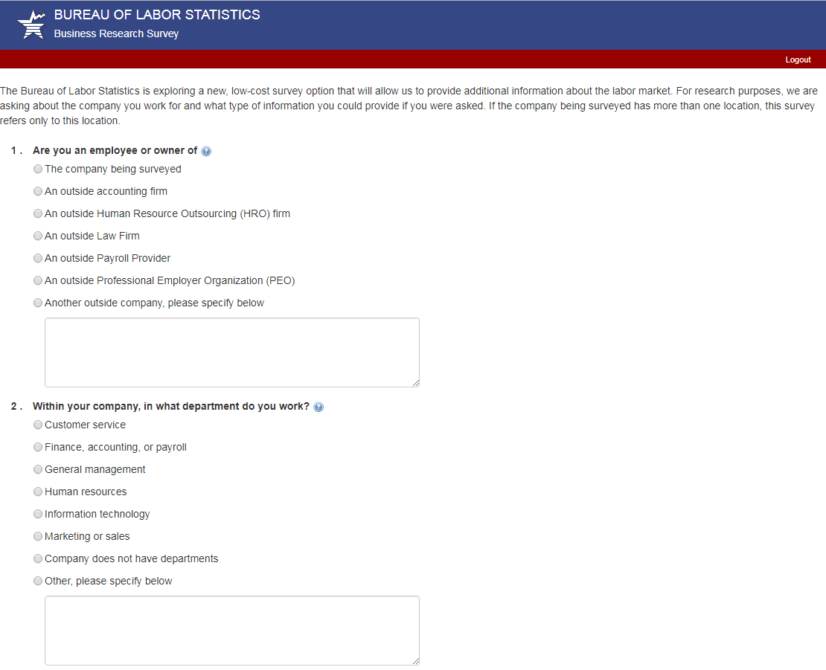

QBS Questions Screen
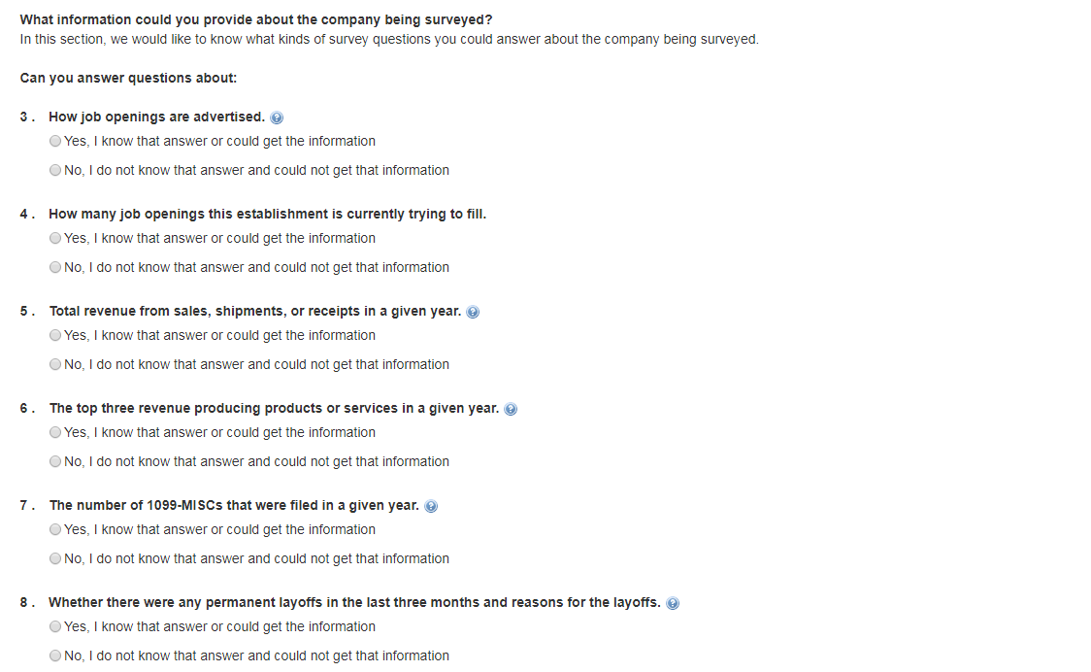
9. How many employees worked or received pay during the pay period including the 12th of last month? ____________

QBS Thank You Screen
