CALCULATING **INTERMITTENT** LAPSE REGISTRATION FEES

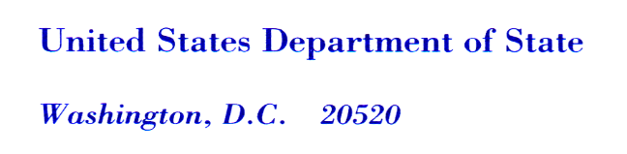

Lapse registration fees become applicable if the duration of the lapse occurs for more than one month after the expiration date **up to a maximum of five (5) years**. Pursuant to ITAR §§ 122.3(c) and 129.8((b)(2), an applicant who fails to renew a registration and after an intervening period, seeks to register again must pay registration fees for any part of the intervening period during which the applicant engaged in ITAR-controlled business of manufacturing, exporting, temporary importing, or brokering defense articles or defense services. If an applicant was engaged in ITAR-controlled business, at any point during the lapse, the applicant must pay the Tier 1 annual flat registration fee (i.e. $2,250 for 12 months). Also, if the renewal is submitted within a year of expiration, DDTC uses the monthly-prorated amount ($187.50) of the Tier 1 annual flat fee to calculate the total lapse fee.

An applicant who received a renewal registration letter and allowed its registration to lapse must include all applicable ITAR-controlled business start and stop dates during the lapse period on the DS-2032 Statement of Registration. During registration submission, the DECCS system will add the applicable lapse fee to the total renewal amount.

In this example, a company allowed its registration to lapse at the end of December 2015. Subsequently, from March 2016 through October 2016, the company engaged in ITAR-controlled business of manufacturing defense articles. Later, from May 2017 until renewal, the company engaged in ITAR manufacturing activity. The table below calculates the total lapse and renewal fees, and provides the total amount due in **November 2017** to re-establish registration with DDTC.

|  |  |  |
| --- | --- | --- |
| **Duration** | **Amount** | **Explanation** |
| March 2016 through March 2017  **12 months** | $2,250.00 | While ITAR activity occurred for only 9 months (from March 2016 through October 2016) engaging at any point during the lapse period, the registrant must pay the entire Tier 1 annual flat fee (i.e., $2,250 for 12-months) registration fee, unless renewal occurs within 12 month period. In this instance, the registration period is **12 months.** |
| May 2017 through October 2017  **6 months** | $1,125.00 | While ITAR activity occurred at a point during the lapse period, the amount due is not the entire Tier 1 annual flat fee ($2,250 for 12-months) registration fee because renewal occurred in November 2017. In this instance the registration period is **6 months.** 6 x $187.50 |
| **18 months** | **$3,375.00** | Subtotal **(Total Lapse fee due)** |
| November 2017 through November 2018 | $2, 250.00 | Tier 1 Annual flat fee for the renewal fee |
|  | **$5,625.00** | Grand total (Lapse fee of 18 months plus December 2015 renewal fee (Tier 1 annual flat fee of $2,250) |

In the example above, in November 2017, the company would need to pay $5,625.00 in order to re-establish registration with DDTC through November 2018.

Registration Fee Table

|  |  |  |
| --- | --- | --- |
| **Timeframe** | **Annual Cost** | **Prorated Cost Per Month** |
| October 2008 to Present | $2,250 | $187.50 |