OMB Control Number: XXXX-XXXX

The National Study of the Implementation of Adult Education Under the Workforce Innovation and Opportunity Act

Request for Clearance

Appendix C: Provider List and Updated Provider List
May 2019

1000 Thomas Jefferson Street NW
Washington, DC 20007-3835
202.403.5000
www.air.org

Contents
Page
Introduction 1
Provider List 1
Updated Provider List 2
Updated Provider List—Cont. 3

Introduction
The Provider List and Updated Provider List will be sent to State Directors as Excel spreadsheets. Both documents are intended as templates that the State Directors may populate or use as a guide when downloading data from their system. The lists are presented in Word format in this appendix to facilitate review.

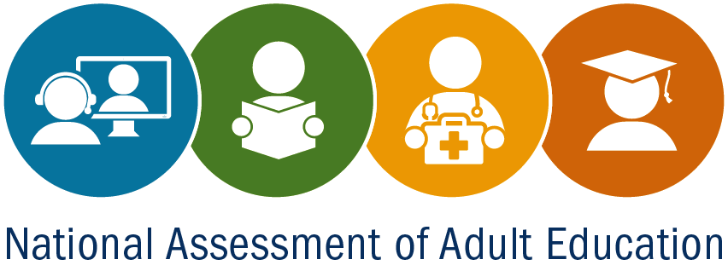
Provider List
National Study of the Implementation of Adult Education

State Agency Name:
Name of Person Completing This Form:
Provider agency name | Type of providerª | Contact first name | Contact last name | Address 1 | Address 2 | City | State | ZIP | Phone number | E-mail | Funded under Title II in program year (PY) 2018–19? | Newly funded under Title II in PY 2018–19? | Operational in PY 2019–20?
ª Types of providers include: (1) Local education agency; (2) community-based organization; (3) faith-based organization; (4) library; (5) community, junior, and technical colleges; (6) four-year college or university; (7) other institution of higher educations; (8) correctional institution; and (9) other institution (non-correctional).
According to the Paperwork Reduction Act of 1995, no persons are required to respond to a collection of information unless such a collection displays a valid OMB control number. The valid OMB control number for this information collection is XXXX-XXXX. Public reporting burden for this collection is estimated to average 30 minutes.

Updated Provider List
National Study of the Implementation of Adult Education

State Agency Name:
Name of Person Completing This Form:
Provider Agency Name | Address 1 | Address 2 | City | State | ZIP | Enrollment by Program Type for program year (PY) 2018-19 |  |  |  | Enrollment by Educational Functioning Level for program year PY 2018–19 |  |  |  |  |  |  |  |  |  |  |  | Integrated Education and Training (IET) enrollment for PY 2018–19
 |  |  |  |  |  | Adult Basic Education (ABE) | Adult Secondary Education (ASE) | English as a Second Language (ESL) | Integrated English Literacy and Civics Education (IELCE) | ABE Level 1 | ABE Level 2 | ABE Level 3 | ABE Level 4 | ABE Level 5 | ABE Level 6 | ESL Level 1 | ESL Level 2 | ESL Level 3 | ESL Level 4 | ESL Level 5 | ESL Level 6 | ABE IET | ASE IET | ELA IET | IELCE IET
According to the Paperwork Reduction Act of 1995, no persons are required to respond to a collection of information unless such a collection displays a valid OMB control number. The valid OMB control number for this information collection is XXXX-XXXX. Public reporting burden for this collection is estimated to average 30 minutes.

Updated Provider List—Cont.
Funding sources
and total amount (in dollars) for PY 2018–19
Federal government funding | State government funding | Local government funding

