Memorandum United States Department of Education
Institute of Education Sciences

National Center for Education Statistics

Date: November 23, 2018

To: Robert Sivinski, OMB

From: Linda Hamilton, NCES

Through: Kashka Kubzdela, NCES
Re: National Assessment of Educational Progress (NAEP) 2019 and 2020 Update 2 Change Request (OMB# 1850-0928 v.12)

The National Assessment of Educational Progress (NAEP), conducted by the National Center for Education Statistics (NCES), is a federally authorized survey of student achievement at grades 4, 8, and 12 in various subject areas, such as mathematics, reading, writing, science, U.S. history, civics, geography, economics, technology and engineering literacy (TEL), and the arts. The National Assessment of Educational Progress Authorization Act (Public Law 107-279 Title III, section 303) requires the assessment to collect data on specified student groups and characteristics, including information organized by race/ethnicity, gender, socio-economic status, disability, and limited English proficiency. It requires fair and accurate presentation of achievement data and permits the collection of background, noncognitive, or descriptive information that is related to academic achievement and aids in fair reporting of results. The intent of the law is to provide representative sample data on student achievement for the nation, the states, and subpopulations of students and to monitor progress over time. The nature of NAEP is that burden alternates from a relatively low burden in national-level administration years to a substantial burden increase in state-level administration years when the sample has to allow for estimates for individual states and some of the large urban districts. The request to conduct NAEP 2019 and 2020 was approved in September 2018 with a change request in October 2018 (OMB# 1850-0928 v.10-11) including operational assessments, pilot tests, and special studies, and all final procedures and materials for NAEP 2019, which comprise operational, national-level, Digitally Based Assessments (DBA) in mathematics, reading, and science at grades 4, 8, and 12; operational, state-level DBA in mathematics and reading at grades 4 and 8; pilot DBA for 2021 reading and mathematics at grades 4 and 8; a paper-based assessment (PBA) to DBA bridge studies in mathematics and reading at grade 12, and science at grades 4, 8, and 12; National Indian Education Study (NIES); Computer Access and Familiarity Study (CAFS); Socioeconomic Status (SES) Questionnaire Study; High School Transcript Study (HSTS); and Middle School Transcript Study (MSTS).
This request updates the confidentiality pledge and login screenshot for MyNAEP, found in Appendix J1. Additionally, it updates the login screenshot for the HSTS MyNAEP (Appendix J3) and the Family Educational Rights and Privacy Act (FERPA) and The Education Sciences Reform Act (ESRA) confidentiality pledges cited on the HSTS and MSTS MyNAEP website and within the HSTS Brochure, found in Appendix J3 and J4. Finally, this request clarifies that the MSTS MyNAEP pages are contained within the HSTS MyNAEP website, and provides the screenshots displaying the access to these specific pages.
This request does not change the approved estimated respondent burden or the cost to the federal government.
The table below summarizes the changes made to the last approved NAEP 2019 and 2020 clearance submission documents (OMB# 1850-0928 v.11).
Document | Changes
Appendix J1 | Updated login text and screenshot on pages 4-5 to reflect 2019 timing and expiration date.
Appendix J3 | Updated login screenshot on page on page 4.  Updated confidentiality language specific to FERPA for screenshots on pages 6, 13 & 14. Updated confidentiality language specific to ESRA in the NAEP 2019 In Your School Brochure, page 19.
Appendix J4 | 1) Revised the procedures for accessing the MSTS information by means of the HSTS website given that the MSTS site will not have a specific login page. Specifically, added text on page 3 (see below).  2) Removed the MSTS-specific login page as it is no longer a separate website.  3) Added a screen shot on page 3, displaying the HSTS page where the TUDAs will access the MSTS activities.  4) Added a screen shots on page 5, displaying the HSTS pages where the TUDAs will access MSTS: Submit Course Catalogs and the MSTS: Complete the District Information Form.  5) Added a screen shot on page 7, displaying the HSTS page where the TUDAs will access the MSTS: Submit Transcripts.  6) Added a screen shot on page 9, displaying the HSTS page where the TUDAs will access the MSTS: Submit Student Information.
Appendix J1
MyNAEP Login Screen (pp.4-5)
According to the Paperwork Reduction Act of 1995, no persons are required to respond to a collection of information unless it displays a valid OMB control number. The valid OMB control number for this voluntary information collection is 1850-0928. The time required to complete this information collection is estimated to average 180 270 minutes for schools that do not submit student sample information or 300 390 minutes for schools that submit student sample information manually, plus an additional 10 minutes for each student identified as SD or ELL, plus an additional 30 minutes for schools participating in the NAEP-NTPS Linking Study, including the time to review instructions, search existing data resources, gather the data needed, and complete and review the information collection. If you have any comments concerning the accuracy of the time estimate, suggestions for improving this collection, or any comments or concerns regarding the status of your individual submission, please write to: National Assessment of Educational Progress (NAEP), National Center for Education Statistics (NCES), Potomac Center Plaza, 550 12th St., SW, 4th floor, Washington, DC 20202.
OMB No. 1850-0928 APPROVAL EXPIRES 07/31/2020 09/30/2021
Screenshot
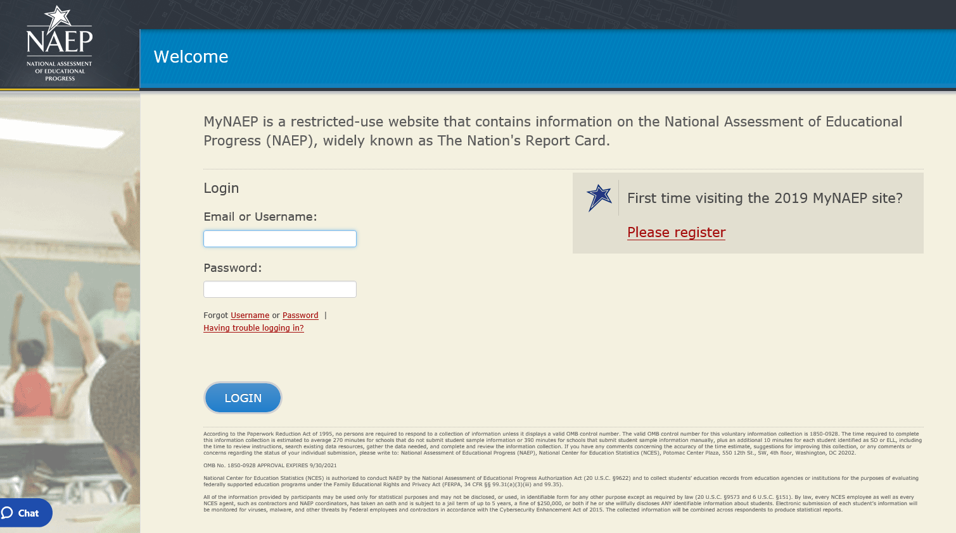
Appendix J3
HSTS MyNAEP Login Screen (p.4)
Screenshot
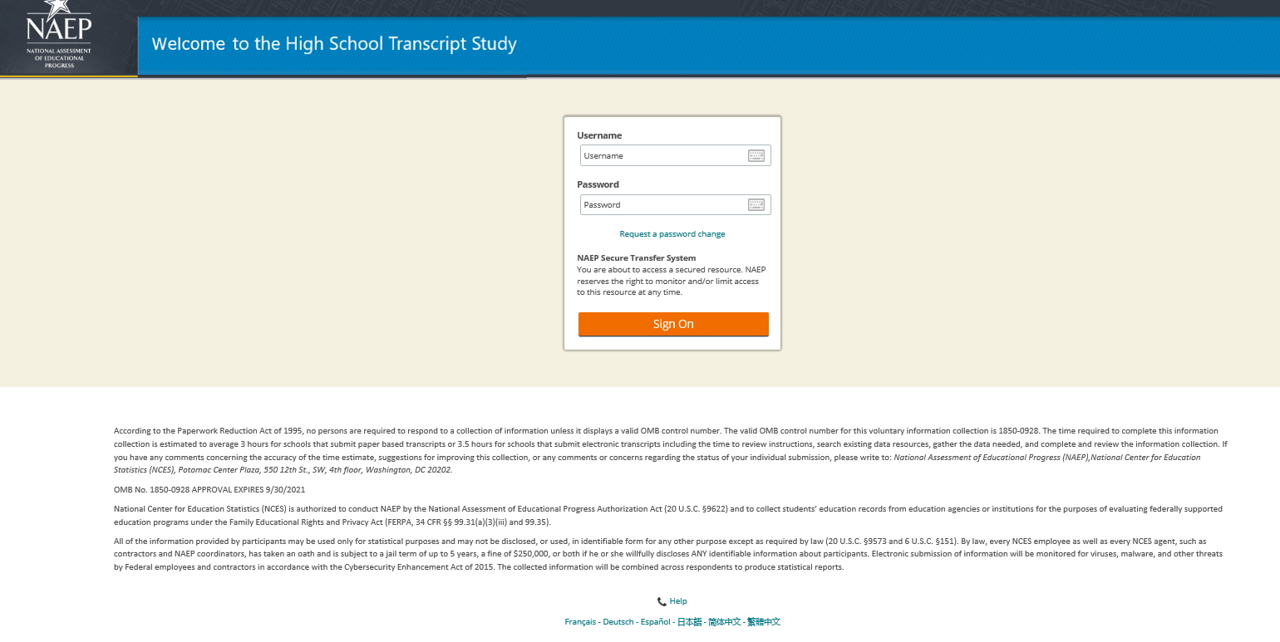

Learn about Your Role on the High School Transcript Study screenshot (p.6)
Screenshot
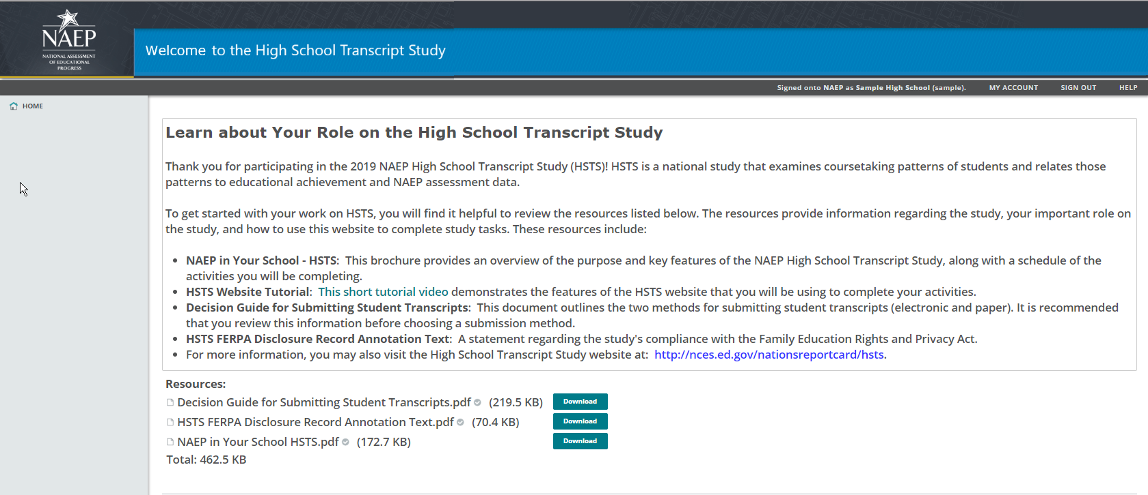

Review Parent Information Letter screenshot (p.13)
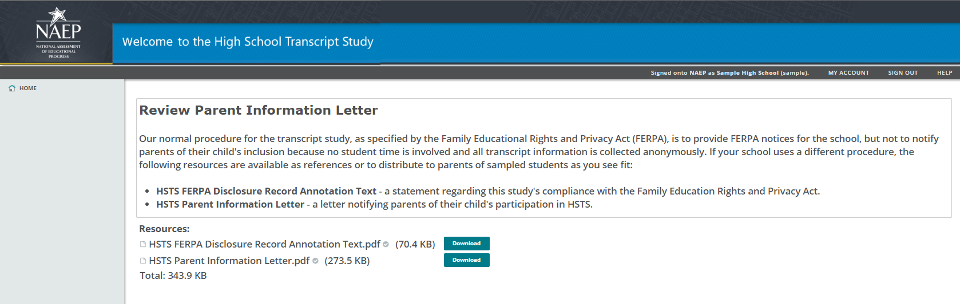

Welcome to the High School Transcript Study! Please Register screenshot (p.14)
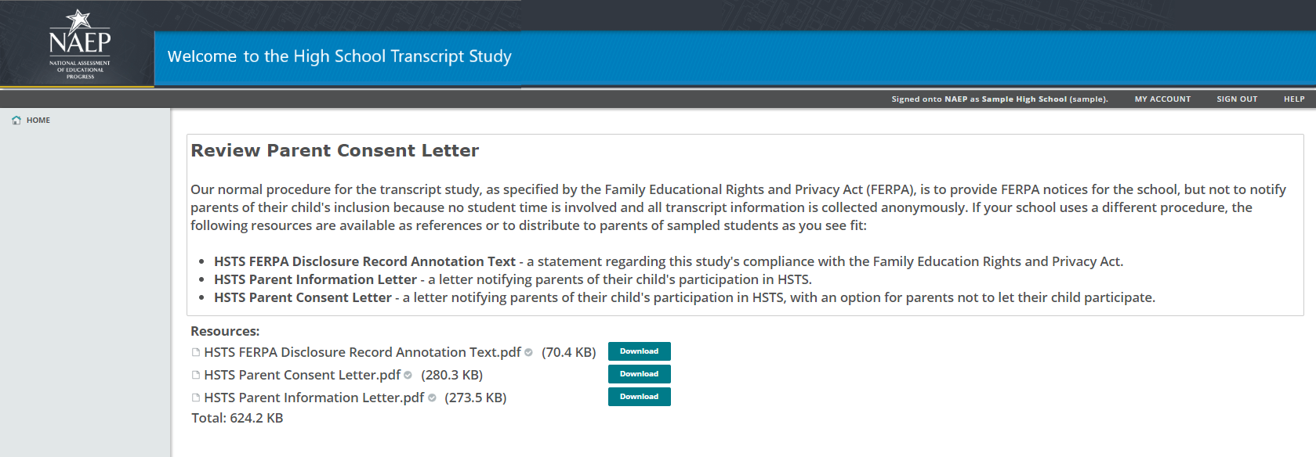
HSTS Brochure – formatted version (pp.18-19)

Appendix J4
MSTS intro and Activities screenshot (p.3)

MSTS Integration with the HSTS Website
The NAEP TUDA Coordinators are responsible for providing information and materials for MSTS, including course catalogs and student transcripts. As the NAEP TUDA Coordinators are, in most cases, providing the equivalent materials for their schools involved in the High School Transcript Study, for their convenience and efficiency, NAEP TUDA Coordinators will access the activities for both transcript studies in a single, central location: the HSTS website.
While schools will use the HSTS website exclusively for HSTS activities, the NAEP TUDA Coordinators are a small subset of users who will see activities for both studies on the website. The NAEP Support and Service Center provides ongoing training and support to the NAEP TUDA Coordinators for using the website to complete HSTS and MSTS activities.
NAEP TUDA Coordinators may access the website directly via the site url, or they may use links to the website located in the NAEP School Control System of the MyNAEP website. The HSTS/MSTS section of the School Control System lists all of the activities for both HSTS and MSTS. Clicking on a link for a particular HSTS or MSTS activity will direct the user to the website.
The NAEP TUDA Coordinators will see the HSTS website exactly as it is described and shown in Appendix J3. The only difference that NAEP TUDA Coordinators will experience compared to other users is that they will have additional, MSTS-specific activities. Appendix J3 explains that the HSTS website Home Page is dynamic and individualized, showing each user the specific activities that the user is designated to complete. In other words, the list of activities on the Home Page differs according to the needs of each individual user. Therefore, for most TUDAs, this customization involves the inclusion of both HSTS and MSTS activities (as shown below). The MSTS activities are clearly labeled as such, in order to differentiate them from the HSTS activities.
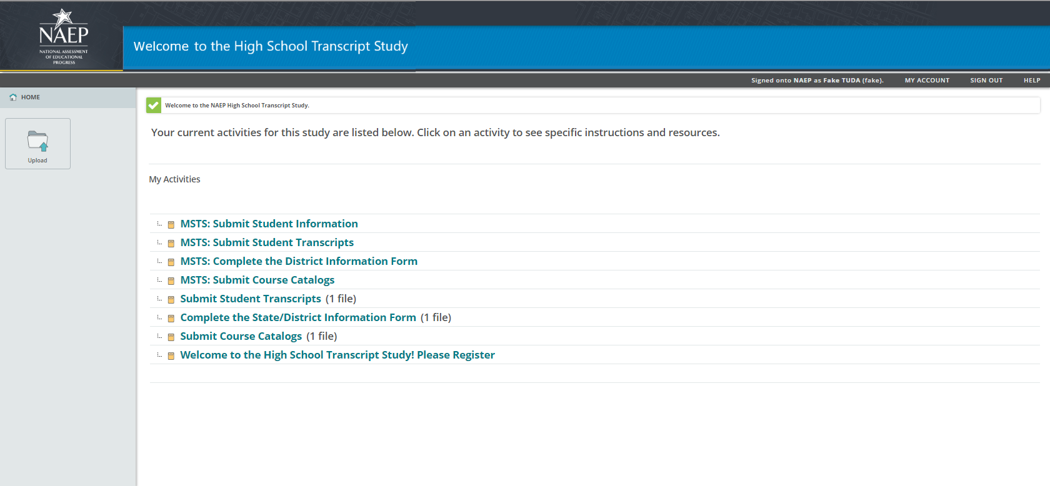
This appendix is supplementary to Appendix J3 and contains the content of the four MSTS activities that are available to TUDAs on the HSTS website.
MSTS: Submit Course Catalogs screenshot (p.5)
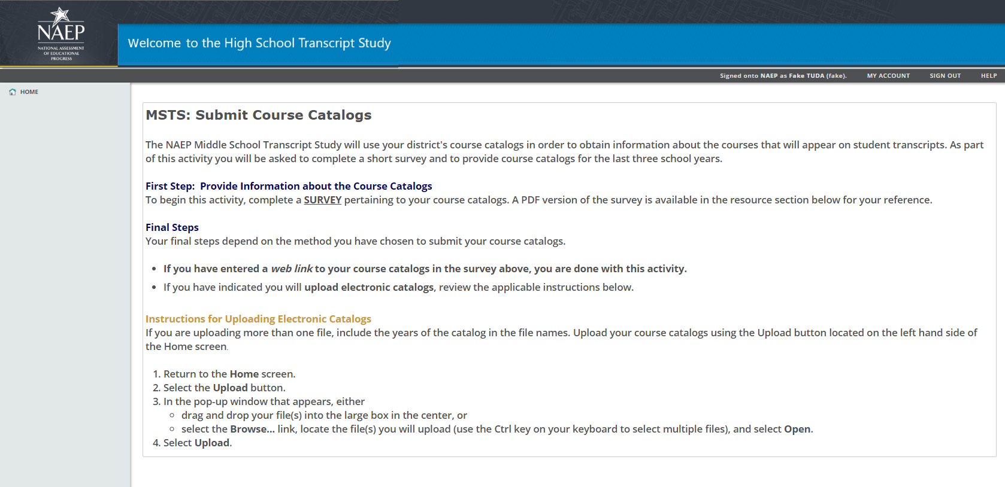

MSTS: Complete the District Information Form screenshot (p.5)
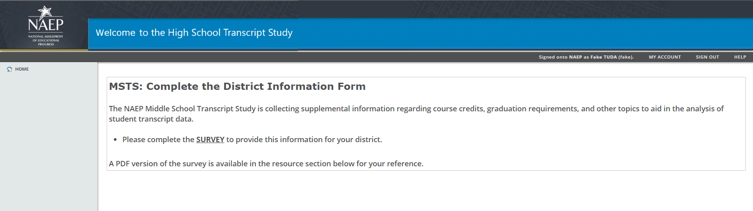

MSTS: Submit Student Transcripts screenshot (p.7)
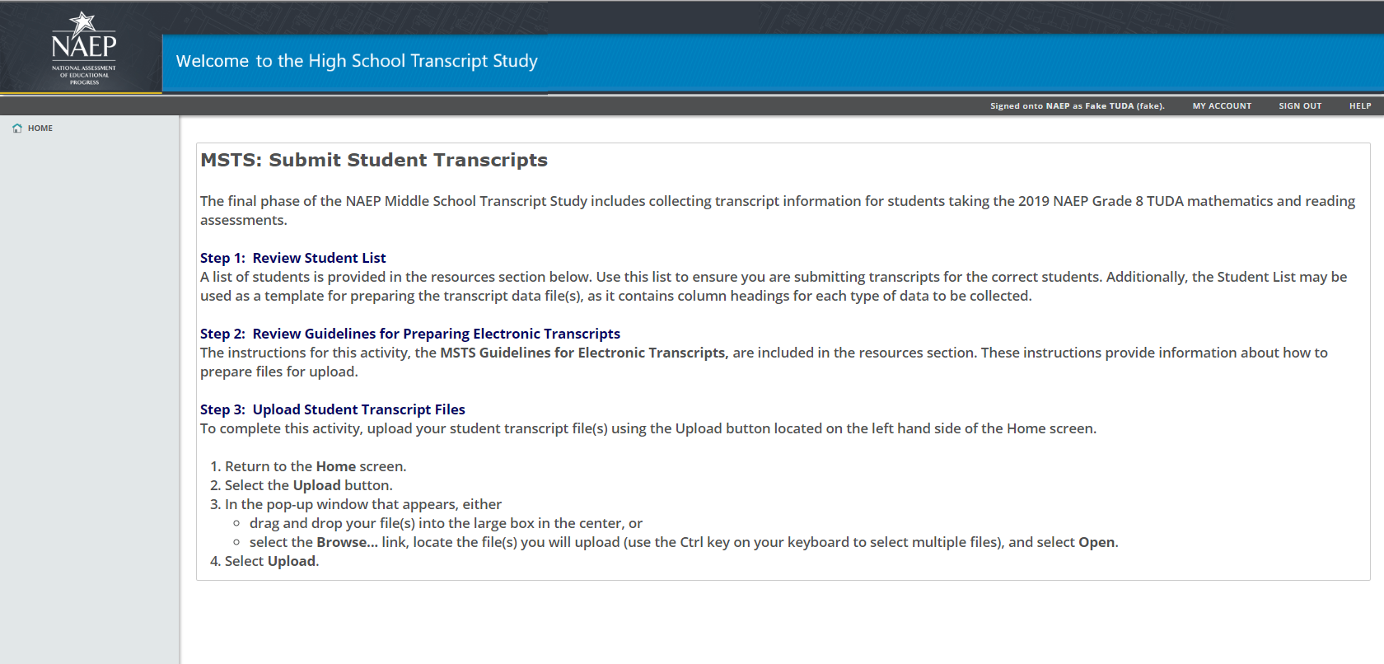

MSTS: Submit Student Information screenshot (p.9)
