SUPPORTING STATEMENT
FOR THE
PART 70 STATE OPERATING
PERMITS PROGRAM
(RENEWAL)

EPA Tracking No. 1587.14

OMB Control No. 2060-0243

Dylan Mataway-Novak
Operating Permits Group
Air Quality Policy Division
Office of Air Quality Planning and Standards
Office of Air and Radiation
United States Environmental Protection Agency
Research Triangle Park, North Carolina 27711

February 2018

TABLE OF CONTENTS

Page
LIST OF TABLES iv
1. IDENTIFICATION OF THE INFORMATION COLLECTION 1
1(a) Title of the Information Collection Request (ICR) 1
1(b) Short Characterization/Abstract 1
2. NEED FOR AND USE OF THE COLLECTION 1
2(a) Need/Authority for the Collection 1
2(b) Practical Utility/Users of the Data 2
2(c) Caveats and Considerations 2
3. NON-DUPLICATION, CONSULTATIONS AND OTHER COLLECTION CRITERIA 2
3(a) Non-Duplication 2
3(b) Public Notice Required Prior to ICR Submission to OMB 3
3(c) Consultations 3
3(d) Effects of Less Frequent Collection 3
3(e) General Guidelines 3
3(f) Confidentiality 4
3(g) Sensitive Questions 4
4. THE RESPONDENTS AND THE INFORMATION REQUESTED 4
4(a) Respondents/ Standard Industrial Classification (SIC) Codes 4
4(b) Information Requested 4
4(b)(i) Data items, including recordkeeping requirements 5
4(b)(ii) Respondent activities 5
5. THE INFORMATION COLLECTED – AGENCY ACTIVITIES, COLLECTION METHODOLOGY AND INFORMATION MANAGEMENT 7
5(a) Agency Activities 7
5(b) Collection Methodology and Management 7
5(c) Small Entity Flexibility 7
5(d) Collection Schedule 8
6. ESTIMATING THE BURDEN AND COST OF THE COLLECTION 9
6(a) Estimating Respondent Burden 9
6(b) Estimating Respondent Costs 10
6(b)(i) Estimating Labor Costs 10
6(b)(ii) Estimating Capital and Operating and Maintenance (O&M) Costs 12
6(b)(iii) Capital/Start-up vs. O&M Costs 12
6(b)(iv) Annualizing Capital Costs 13
6(c) Estimating Agency Burden and Cost 13
6(d) Estimating the Respondent Universe and Total Burden and Costs 14
6(e) Bottom Line Burden Hours and Cost Tables 17
6(e)(i) Respondent Tally 17
6(e)(ii) The Agency Tally 18
6(e)(iii) Variations in the Annual Bottom Line 19
6(g) Burden Statement 19
ATTACHMENT 1 21
ASSUMPTIONS FOR PART 70 ICR RENEWAL 21
ATTACHMENT 2 25
TITLE V OF THE CLEAN AIR ACT, THE STATUTORY REQUIREMENTS FOR THE RESPONDENT INFORMATION 25

LIST OF TABLES

Page

Table 1. Average Source Burden by Activity 9

Table 2. Average Permitting Authority Burden by Activity 10

Table 3. Average EPA Burden by Activity 13

Table 4. Burden and Cost of EPA Activities 14

Table 5. Identification of Affected Entities and Permit Issuance Schedule 15

Table 6. Burden and Cost of Source Activities 16

Table 7. Burden and Cost of Permitting Authority Activities 17

Table 8. Bottom Line Average Annual Respondent Burden (Hours) 18

Table 9. Bottom Line Average Annual Respondent Cost (2018$) 18

Table 10. Bottom Line Average Annual EPA Burden and Cost 19

Table 11. Burden Change from 2016 ICR to Current ICR (Hours) 19

Table 12. Burden Statement (Hours) 20

1. IDENTIFICATION OF THE INFORMATION COLLECTION

1(a) Title of the Information Collection Request (ICR)

This analysis is titled: “Supporting Statement for the Part 70 State Operating Permits Program.” It fulfills the U.S. Environmental Protection Agency’s (EPA’s) requirements under the Paperwork Reduction Act (PRA) to determine, report and periodically update the regulatory burden associated with the Operating Permits Program, codified in 40 CFR part 70. This report has been assigned EPA tracking number 1587.14. The Office of Management and Budget (OMB) control number for this ICR is 2060-0243.

1(b) Short Characterization/Abstract

This ICR renewal covers state, local and tribal (state) air quality operating permitting programs under 40 CFR part 70 (part 70), as authorized under Title V of the Clean Air Act (CAA or the Act) for the period of April 1, 2019, through March 31, 2022. Part 70 requires states to issue operating permits to all sources that fall under any CAA definition of “major source” and certain other non-major sources that are subject to federal air quality regulations. In general, part 70 requires subject sources to submit initial permit applications and renewal applications every 5 years, conduct monitoring, recordkeeping and reporting as required by the permit and apply for permit modifications, as necessary. States are responsible for processing permit applications (for initial permits, renewals and modifications), for issuing the permits and for conducting all implementation activities related to the permits. The role of the EPA is primarily one of oversight of state permitting authorities and review of state operating permits.

2. NEED FOR AND USE OF THE COLLECTION

2(a) Need/Authority for the Collection

In implementing title V of the Act and the EPA's part 70 operating permit regulations, state and local permitting authorities must develop programs and submit them to the EPA for approval. CAA § 502(d). Sources subject to the program must prepare operating permit applications and submit them to the permitting authority within 1 year after approval of the program by the EPA, or within one year of the source becoming subject to the requirement to have a permit. CAA § 503. Permitting authorities will then issue permits, CAA § 503(c), and thereafter enforce, revise and renew those permits at no more than 5-year intervals. CAA § 502(b)(5). Permit applications and proposed permits will be provided to, and are subject to review by, the EPA. CAA § 505(a). The permit and all information submitted by a source shall be available for public review except for confidential information which will be protected from disclosure, CAA § 503(e), and the public shall be given public notice of, and an opportunity for comment on, permit actions, CAA § 502(b)(6). Sources will submit monitoring reports semiannually and compliance certification reports annually, to the permitting authorities. CAA § 503(b)(2). The EPA has the responsibility to oversee implementation of the program. CAA § 502(c). Sections 502 through 504 of title V of the Act are included in Attachment 2.

2(b) Practical Utility/Users of the Data

The burden estimates included in this ICR include the total burden of implementing the part 70 Operating Permits Program for the 3-year period covered by this renewal ICR (April 1, 2019 through March 31, 2022). To carry out the activities of the program (listed above in section 1(b)), permitting authorities must obtain the required information from sources subject to the program and they must then carry out their functions (e.g., permit issuance, renewal and revision and report review) based on the information. Specifically, this ICR only accounts for the paperwork burden of implementing the part 70 Operating Permits Program. See 5 C.F.R. § 1320.3(b) (defining “burden” under the PRA). Typical ICR burden activities include reviewing instructions, maintaining records, completing paperwork, gathering information, and reporting information. Burden estimates also include any costs associated with the information collection activities, such as capital costs and operations and maintenance costs. Id. Furthermore, the burden estimates in this ICR do not include activities derived from “applicable requirements” (e.g., New Source Performance Standards (NSPS) and National Emissions Standards for Hazardous Air Pollutants (NESHAP)) that are not required by part 70. Activities required by NSPS and NESHAP regulations are counted in the ICRs for those rules.

2(c) Caveats and Considerations

The information included in this ICR is based upon the best data sources available to the Agency at this time. However, inconsistencies in permitting authority reporting techniques, incomplete data sets and certain other data limitations necessitated a certain amount of extrapolation and “best-guess” estimations by permitting authority and EPA experts. Consequently, the reader should not consider the conclusions to be an exact representation of the level of burden or cost that will occur during the 3 years of this ICR.

Throughout this ICR, the reader will observe estimated values that show accuracy to the single hour or dollar. Because this ICR estimates the expected impact of the part 70 Operating Permits Program, reporting values at the single unit level may be misleading. In most situations, the proper way to present estimated data would be to determine an appropriate level of precision and truncate values accordingly, usually in terms of thousands or millions of units. For instance, a spreadsheet-generated estimation of $5,456,295 would be presented in the text as $5.5 (millions) or $5,456 (thousands). One problem with such an approach is the loss of data richness when the report contains a mixture of very large and very small numbers. Such was the case with this ICR, where source values are consistently in the millions and federal values in the tens of thousands. Consequently, to avoid the loss of information through rounding, this ICR reports all values at the single unit level and reminds the reader that there is no implied precision inherent in this style of reporting.

3. NON-DUPLICATION, CONSULTATIONS AND OTHER COLLECTION CRITERIA

3(a) Non-Duplication

While much of the information requested under this ICR existed prior to the creation of the part 70 Operating Permits Program, an operating permit is a compilation of existing requirements; the purpose being to bring all requirements applicable to a source into one document. The intent of this compilation is to (1) resolve any questions of applicability at the time of permit issuance, (2) provide certainty to sources as to their obligations and (3) provide the public access to a source's obligations and compliance status. The Agency has no leeway to not require such previously existing information under this ICR since consolidation of the information into the operating permit and providing public access is the whole purpose of the statute. To the extent that similar information was previously collected (e.g., state permits under state implementation plans), the part 70 program may replace those activities thus avoiding duplication of efforts.

3(b) Public Notice Required Prior to ICR Submission to OMB

EPA solicited public comment via a Federal Register notice on September 11, 2018. No comments were received.

3(c) Consultations

For the purposes of updating the ICR renewal and drafting the supporting statement, the EPA relied on the latest information on the number of sources subject to the program and the number of permits issued, provided by the EPA Regional Offices, which is based on information gathered from the state and local permitting agencies. Also, the EPA contacted the Association of Air Pollution Control Agencies (AAPCA) and the National Association of Clean Air Agencies (NACAA) to obtain input from both agencies on the draft ICR renewal for part 70 that was released for public comment on September 11, 2018.

Some NACAA members provided input during a conference call with the EPA. During this conference call, some NACAA members commented that all the costs of title V did not appear to be included in the ICR and that the costs appeared lower than they might expect. In response, the EPA explained that the part 70 ICR does not account for burden associated with implementing “applicable requirements” as explained in section 2(b) of this ICR. Further, the part 70 ICR does not address all activities that might be included title V fee calculations because the ICR only accounts the “paperwork” burden of implementing a part 70 program. For purposes of this ICR renewal, the EPA continues to rely on the burden estimates we used for the 2015 ICR renewal.

With regard to AAPCA members, Wyoming noted that their state was listed in section 6(e)(i) of the Draft Supporting Statement for the 2018 ICR Renewal as one of the permitting authorities with relatively fewer sources and a lower than average burden. Wyoming explained that their program actually had higher burden hours (12,935 hours) compared to the average estimated by the ICR (8,137 hours) due to the state’s separate, rigorous New Source Review (NSR) program. Although the hours spent developing an NSR permit are not consider in the part 70 ICR, Wyoming indicated that the vast number of applicable requirements created by their NSR program leads to a lot of title V burden hours being spent updating and developing title V permits associated with the NSR permits. In response to this information from Wyoming, this ICR no longer lists Wyoming as an example of a state with relatively fewer sources and a lower than average burden.

3(d) Effects of Less Frequent Collection

In general, the information collections included in this ICR are one-time submittals per activity (e.g., permit application, permit issuance and permit revision). Exceptions are deviation reports that must be submitted at least semiannually, the semiannual monitoring data report and the annual compliance certification. These reports are required by section 503(b)(1) and (2) of the Act, respectively. Also see section 5(d) of this supporting statement for more information on information collection schedules for this ICR.

3(e) General Guidelines

Part 70 requires retention of all monitoring data and support information and all permit applications, proposed permits and final permit records for a period of 5 years to match the 5-year general statute of limitations that applies to violations under the Act. See 40 CFR § 70.6(a)(3)(ii)(B).

3(f) Confidentiality

All information, other than confidential business information, relating to the permitting of sources under this program and related to compliance monitoring are required by section 503(e) of the Act to be subject to public review at all times. Section 70.4(b)(3)(viii) of part 70 requires the permitting authority to make available to the public any permitting information except that entitled to protection from disclosure under section 114(c) of the Act. Protected information may be required to be submitted directly to the EPA. Such information will be stored in the EPA's Confidential Business Information office.

3(g) Sensitive Questions

The consideration of sensitive questions (i.e., sexual, religious, personal or other private matters) is not applicable to the part 70 Operating Permits Program. The information gathered for purposes of establishing a part 70 permit for a source do not include personal data on any owner or operator.

4. THE RESPONDENTS AND THE INFORMATION REQUESTED

4(a) Respondents/ Standard Industrial Classification (SIC) Codes

Respondents to this information collection come from two groups: permitting authorities and sources required to obtain operating permits.

All states are required by title V to develop a part 70 operating permits program. In many instances, local agencies administer a program in their jurisdictions in lieu of the state and are thereby subject to the same program requirements as states. In total, there are 117 state, local, and tribal agencies administering operating permits programs.

Under title V, all major stationary sources must obtain an operating permit. Some non-major sources may also be subject to the program if they are subject to a federal standard such as a NSPS pursuant to section 111 of the Act or a NESHAP pursuant to section 112 of the Act. Some of these sources have been exempted from the program. Information provided to the EPA by permitting authorities indicates that 13,712 sources are subject to the program, representing more than 500 SIC codes.

4(b) Information Requested

All activities associated with the part 70 Operating Permits Program are considered information collection activities and are reflected in the ICR for part 70. Following are lists of the data items submitted by sources and permitting authorities and program activities performed by permitting authorities and sources.

4(b)(i) Data items, including recordkeeping requirements

Permitting Authorities (submitted to the EPA)
- Applications for initial permits, permit revisions and permit renewals
- Draft permits and proposed permits, permit revisions or permit renewals
- Final permit
- Annual report of enforcement activities

Sources (submitted to permitting authority)
- Application for initial permits, permit revisions and permit renewals
- Deviation reports that must be filed no less often than semiannually
- Semiannual monitoring report
- Annual compliance certification report

4(b)(ii) Respondent activities

PERMITTING AUTHORITY ACTIVITIES

- Program administration: Responding to inquiries about the program from the EPA and others; developing internal and external program guidance; developing rules, forms and other mechanisms to implement the program; planning; attending program training; permit fee collection; providing source training; attending EPA meetings and conferences; providing public education; and other program-related activities.
- Permit application review, including discussions with a source concerning the completeness of the permit application, review of applications for completeness and technical approach, and requests for additional information, when necessary.
- Draft permit preparation, including contact with the source to clarify the specific requirements that apply, drafting the “statement of basis,” drafting gap-filling monitoring, when necessary, and drafting permit terms and conditions to reflect existing requirements.
- Comment period notification: Providing notice to the public, the EPA and affected states of the comment period on a draft permit (for initial permit issuance, permit renewal and significant permit modification). Affected state notification is also required for minor permit modification.
- Public hearing administration: Administering a public hearing, when appropriate, for initial permit issuance, permit renewal and significant permit modification.
- Interaction with the EPA on a proposed permit, including negotiations, re-drafting and formal EPA objections (including those attributable to public petitions).
- Response to public comments: Analyzing public comments and revising the draft permit accordingly, when appropriate.
- Permit issuance: Formalizing permits, placing copies of final permits on public websites, entering information into the EPA’s permit website (The Integrated Compliance Information System (ICIS) for Air) and providing copies to sources.
- General permits administration (Burden for issuing general permits included with other permit issuance burden).
- Permit revision: Modifying permits to reflect changes at the source otherwise prohibited by the permit, including public participation and affected state review, when needed.
- Permit renewal: Updating the permit to reflect changes at the source not captured through permit revision (includes reviewing application, drafting changes, public notice, public hearings (when needed), responding to public comments (when needed) and permit issuance).
- Monitoring and compliance certification: Reviewing deviation and semiannual monitoring reports and annual compliance certification reports required by part 70, and any enforcement activities related to such reviews.
- Annual reporting: Preparing and submitting to the EPA annually a report of the state's enforcement activities.

SOURCE ACTIVITIES

- Permit application preparation, including internal meetings, permitting authority discussions, management and legal department involvement, responsible official certification and contractor services.
- Draft permit development: Interaction with the permitting authority on draft permit development.
- Gap-filling monitoring development: Development of “periodic” monitoring or reporting, where necessary.
- Operate gap-filling periodic monitoring: Operation of monitoring equipment and the taking and keeping of records, where necessary.
- Monitoring reports: Preparing deviation and semiannual monitoring data reports and annual compliance certifications, including data analysis, responsible official certification and report submission.
- Permit revisions: Preparing applications for revisions.
- Permit renewal: Preparing permit renewal applications.
- Other activities associated with permit renewal, including discussions with permitting authority and public hearing participation.

5. THE INFORMATION COLLECTED – AGENCY ACTIVITIES, COLLECTION METHODOLOGY AND INFORMATION MANAGEMENT

5(a) Agency Activities

The EPA’s activities under the program are as follows:

- Review proposed permits and permit revisions to determine if they provide for compliance with all applicable requirements.
- Review monitoring provisions of proposed permits or permit revisions to see if they contain applicable requirements or to add periodic monitoring if needed.
- Consult with the permitting authority on any problems detected in the proposed permit or permit revision including interaction related to fact finding on permit petitions.
- Program oversight including review of program changes, review annual reports of enforcement activities, program evaluation, issuing notices of deficiency, development of formal EPA responses to public petitions and applying sanctions to states, as appropriate.

5(b) Collection Methodology and Management

The EPA will receive proposed permits or permit revisions in hard copy or electronically, depending on permitting authority capability. Each EPA Regional Office has determined with its permitting authorities the most efficient system to exchange information. Each Regional Office maintains files of permit information only to the extent that the office determines the need for file retention. This will vary depending on factors such as the source (e.g., large, complicated sources vs. small), the type of permit (general vs. single-source permits), the number of actions occurring at a source or the record of the source with respect to compliance. There is no need for the EPA to maintain complete files of permit actions for public access since these are maintained by permitting authorities.

5(c) Small Entity Flexibility

Title V provides few ways to mitigate the effects of operating permit regulations on small entities. Under section 502(a) of the Act, the Agency has exempted or deferred applicability of title V for those non-major source categories for which compliance with title V will be impractical, infeasible or unnecessarily burdensome. The EPA decides whether to exercise its discretion to exempt area sources on a case-by-case basis at the time each NSPS or NESHAP is promulgated, which is an on-going process. The Agency has not analyzed how many of these non-major sources will be small businesses, but believes that a large percentage may fall under that definition.

For industries with a large number of identical sources (e.g., bulk gasoline distribution terminals and gravel mining operations) general permits may be used to meet the requirements of title V (instead of a source-specific permit). General permits can reduce the burden of the program on small businesses.

Even though the part 70 Operating Permits Program is not anticipated to have an adverse impact on a significant number of small businesses, measures are in place to assist in those incidental exceptions. Implementation of small business stationary source technical and environmental compliance assistance programs at the federal and state levels, as called for in section 507 of the Act, can reduce the reporting burden of small entities that are subject to part 70 permitting. These programs may significantly alleviate the economic burden on small sources by establishing: (1) programs to assist small businesses with determining what CAA requirements apply to their sources and when they apply; and (2) guidance on alternative control technology and pollution prevention for small businesses.

5(d) Collection Schedule

Items identified in section 4(b)(i) are listed below with their schedule for submission.

Permitting Authorities (submitted to the EPA):
- Application for permits, permit revision and permit renewal should be submitted to the EPA with the proposed permit or permit revision.
- Draft permits, proposed permits, permit revisions or permit renewals should be submitted when the state wants to commence the EPA review period of the proposed permit or permit revision.
- The final permit should be submitted to the EPA soon after it is issued, but there is no deadline in part 70 for this submission.
- The annual report of enforcement activities is submitted to the EPA annually, but part 70 does not specify a date.
- Responding to program evaluation questionnaires.

Sources (submitted to permitting authority):
- New permit applications are due within 1 year after a source becomes subject to the program.
- Permit revision applications are submitted by a source when it wishes to make a change to its permit. There is no schedule for these submissions in that they are at the discretion of the source.
- Permit renewal applications are due at least 6 months prior to expiration of the permit.
- The semiannual periodic monitoring report is due to be submitted to the permitting authority twice a year on dates specified by the permitting authority.
- The annual compliance certification report is due annually on a date specified by the permitting authority.
- Deviation reports (frequency is defined by permitting authority but at least semiannually).

6. ESTIMATING THE BURDEN AND COST OF THE COLLECTION

6(a) Estimating Respondent Burden

The assumptions in Tables 1 and 2 have remained the same since the 2016 ICR, which included adjustments for the Flexible Air Permits rule and the Greenhouse Gas Tailoring rule as explained previously in the 2016 ICR. The EPA suspects that the E-Notice Rule has resulted in a reduction in burden hours of comment period notifications for permitting authorities. However, the EPA is waiting to consult with permitting authorities before making any adjustments to the estimates below.

Table 1. Average Source Burden by Activity
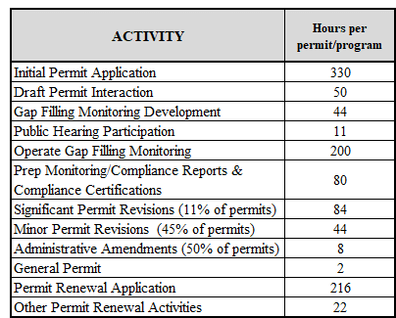

Table 2. Average Permitting Authority Burden by Activity
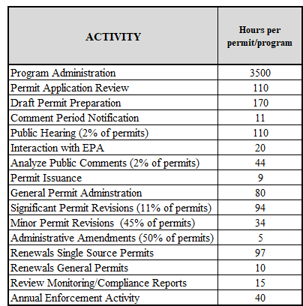

6(b) Estimating Respondent Costs

6(b)(i) Estimating Labor Costs

In order to improve the accuracy of burden estimates, this ICR renewal updates the respondent labor rates to values in 2018 dollars based on recent publications by the Bureau of Labor Statistics (BLS). For this ICR renewal we are using the same calculation methodology for labor cost as the methodology used in the 2016 ICR renewal.

The labor rate used to calculate sources’ labor cost for this ICR renewal is $69.86 per hour. This source labor rate was calculated on the assumption that, while most of the labor for sources will be performed by Environmental Engineers, approximately 50 percent of the labor hours expended for two of the activities listed above in Table 1 will be carried out by Environmental Engineering Technicians. Specifically, we assumed that Environmental Engineering Technicians will expend half of the labor hours to “Operate Gap-filling Monitoring” and “Prepare Monitoring Reports.”

To derive this composite labor rate, we obtained the mean hourly wage for Environmental Engineers of $43.83 from the most recent BLS Occupational Employment Statistics, which gives wages as of May 2017. Similarly, we obtained the May 2017 mean hourly wage for Environmental Engineering Technicians of $25.77. In each case, we escalated the hourly wages to June 2018 using the BLS ECI for private industry workers, resulting in hourly wages of $44.73 for Environmental Engineers and hourly wages of $26.30 for Environmental Engineering Technicians. An example escalation calculation for Environmental Engineers is as follows:

$${Wage}_{Jun2018}={Wage}_{May2013}×\frac{{ECI}_{Jun2017}}{{ECI}_{Jun2018}}$$

$${Wage}_{Jun2018}=\$43.83×\frac{126.3}{128.9}=\$44.73$$

We then calculated a weighted average hourly wage for sources using the total hours projected for sources over the 3 years of this ICR, as shown later in this document in Table 6, apportioned between Environmental Engineers and Environmental Engineering Technicians as discussed above. This calculation results in a weighted average hourly wage of $38.31. Finally, to determine the total labor rate, we assumed an 80 percent factor to account for benefits and overhead, which we believe to be representative. The resultant rate was rounded to the nearest dollar, yielding $69.86 per hour in 2018 dollars. This labor rate was applied to all source burden hours to calculate the sources’ labor costs.

The updated labor rate used for permitting authority respondents in this ICR renewal of $58.03 per hour was determined similarly. For permitting authorities, we assumed that permit engineers are all Environmental Engineers, but experience tells us that these positions are typically filled by younger engineers, early in their careers. For this reason, we selected the 25th percentile hourly wage of $31.59 for Environmental Engineers from the same recent BLS Occupational Employment Statistics publication that we used for sources. We escalated this May 2017 hourly wage to June 2018 as discussed above using the ECI for state and local government workers, resulting in hourly wages of $32.24. As above, we assumed an 80 percent factor to account for benefits and overhead and rounded the resultant rate to the nearest dollar, yielding $58.03 per hour in 2018 dollars.

6(b)(ii) Estimating Capital and Operating and Maintenance (O&M) Costs

The EPA believes that sources will incur little or no capital cost to comply with part 70 requirements. Even if a part 70 permit applicant is a brand new company and the prospective source is a “greenfield” source (the EPA estimates less than 1 percent of sources fit that description) most, and perhaps all, of the equipment needed to prepare permit applications (for example, the computers and basic software) will be part of the source’s business operation inventory. Monitoring can require capital expenditures for new sources or new operations at existing sources, but these expenditures generally are accounted for in the ICRs for the applicable requirements under which they are required (e.g., NSPS or NESHAP). The one exception to this is the part 70 requirement to develop and operate gap-filling monitoring to assure compliance with applicable requirements in certain, limited situations where the applicable requirements themselves do not require adequate monitoring. However, such gap-filling monitoring typically consists of periodically monitoring and recording operating conditions or other parameters that the source already monitors for operational purposes. Thus, we believe that capital costs are negligible for sources.

Permitting authorities similarly incur negligible capital costs. As with sources, we believe that most, and perhaps all, of the computers and other office equipment needed to administer the part 70 program will be part of the permitting authority’s office inventory. In any case, all the permitting authorities operate mature part 70 programs, so there is no need for initial equipment purchases to outfit a new program office.

Since the purchase of capital equipment is believed to be an insignificant factor under part 70, the EPA assumes the operation, maintenance or services for same are negligible. Further, once a permit is issued, there is minimal O&M cost associated with it. It remains unaltered unless it must be revised, and such revisions are accounted for as burden hours in section 6(a) above. As noted previously, part 70 requires sources to submit deviation reports, semiannual reports of monitoring and annual compliance certification reports, but these reports generally are coordinated with similar reports that are required under the source’s applicable requirements. The O&M costs (e.g., photocopying and postage) for the reports required under the applicable requirements are included in the ICRs for those rules, and we believe that it would constitute double counting to include such costs here as well. In addition, electronic reporting by sources is increasingly prevalent, with no associated O&M costs. Accordingly, we include no O&M costs in this ICR for sources. For parallel reasons, we believe that O&M costs for permitting authorities will be minimal, and none are included in this ICR.

6(b)(iii) Capital/Start-up vs. O&M Costs

Capital/start-up and O&M costs are non-labor related costs. One-time capital/start-up costs are incurred with the purchase of durable goods needed to provide information. According to the PRA, capital/start-up cost should include, among other items, preparations for collecting information such as purchasing computers and software, monitoring, sampling, drilling and testing equipment. As a practical matter, most these costs are not typical of the costs associated with preparing a part 70 permit application. As discussed in the previous section, we believe that the gap-filling monitoring required of some sources under part 70 will not involve capital spending. For the same reason, the O&M costs associated with start-up capital equipment are zero for this ICR. In addition, we believe that overlapping reporting accounted for in other ICRs and electronic reporting result in zero O&M costs for this ICR.

6(b)(iv) Annualizing Capital Costs

Typically, annualized capital cost would be derived from a discounted net present value of the stream of capital costs that would occur over the life of the permit, or the ICR, whichever is shorter. However, in the case of the part 70 Operating Permits Program, there are only labor costs for preparing and processing permit applications, conducting gap-filling monitoring, and preparing and reviewing reports. Labor costs are expensed when incurred and not amortized. Therefore, the annualized capital costs for this program are zero.

6(c) Estimating Agency Burden and Cost

The estimated burden associated with each of the activities listed above in section 5(a) for the EPA is presented below in Table 3. All activities in Table 3 remain unchanged from the 2016 ICR renewal.

Table 3. Average EPA Burden by Activity
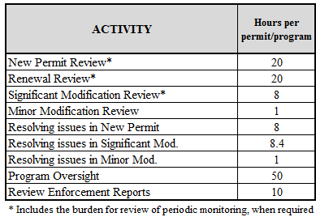

The estimated EPA labor rate for this ICR is $55.26 per hour. The rate reflects the assumption that the EPA personnel overseeing the part 70 Operating Permits Program are classified as Grade 12, Step 5. The corresponding salary is loaded with benefits at the standard rate of 60 percent.

The burden and costs for EPA activities are presented below in Table 4. The table lists the burden categories, the number of estimated permits or programs involved, and the expected cost for each, based on the burden estimations from Table 3. As seen in the table, the annual average burden to the EPA is estimated at 29,737 hours at a cost of $1,643,239.

Table 4. Burden and Cost of EPA Activities
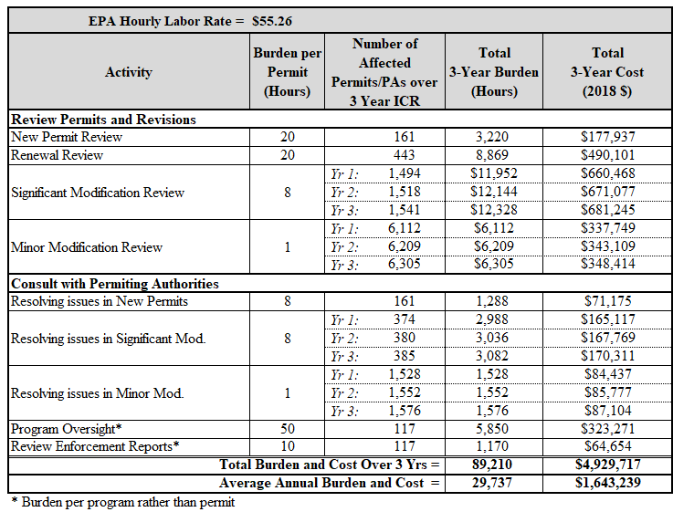

6(d) Estimating the Respondent Universe and Total Burden and Costs

There are 117 permitting authorities acting within the United States for the purposes of the part 70 Operating Permits Program. Forty-nine states operate as permitting authorities, with California employing 35 local air quality districts in lieu of a statewide permitting authority. Puerto Rico, the Virgin Islands and Washington D.C. all have operating permits programs. There are 29 local permitting authorities within states that operate in a manner similar to that of California. Also, there is one tribal government, the Southern Ute Indian Tribe that has been granted authority to operate as a part 70 permitting authority.

For the renewal ICR, based on the most recent data available to the Agency, we assume that by April 1, 2019, the beginning of year 1 of the analysis, there will be 13,712 part 70 sources subject to permitting under part 70, 13,368 of which have already received permits, representing a backlog of 344 sources. We consider sources who have not yet received initial permits to be in the backlog if the deadline for the permitting authority to act on the application has passed and a permit has not been issued. Also, between April 1, 2019, and March 31, 2022, the EPA estimates that 300 new permits (100 permits/year) and 344 backlogged permits (about 115 permits/year) will be issued for an overall increase of 644 permits over the 3-year period of the analysis (about 115 new permits/year). Thus, by the end of the period covered by this analysis, the EPA estimates there will be a total of 14,012 issued permits. Table 5 summarizes the number of permitting authorities and the number of permits to be issued during the period of this ICR renewal.

Table 5. Identification of Affected Entities and Permit Issuance Schedule
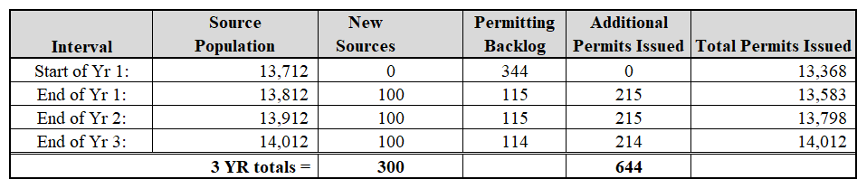

An example of regulatory relief incorporated into the operating permits program is the general permit, which allows large numbers of homogenous major sources of pollution to receive the same permit. This program has been successful in allowing approximately 16 percent of all part 70 sources a cost-effective alternative to single-source permitting. The EPA estimates that by April 1, 2019, (when the period of this ICR begins), the total population of part 70 sources will be 13,712, and that 16 percent of these permitted sources (about 2,200 sources) will have received general permits. Because notice of coverage under general permits are typically relatively easy to issue, the Agency assumes that all existing sources eligible for general permits will have received them by April 1, 2019, and that none of the 344 backlogged sources will be issued general permits during the 3 years of this ICR. We further assume that none of the estimated 300 newly subject sources will receive general permits during the period of this ICR.

Data collected by the EPA suggests there will be renewal backlog of 2,536 permits as of March 31, 2019. These permits will need to be renewed during the 3-year ICR period in order to eliminate the backlog. Additional permits will become subject to renewal during the ICR period because their initial or previous renewal permits are expiring. Thus, the total number of permits projected to be renewed during the ICR period is 10,557. The EPA assumes that the total number of permits to be renewed in each year of the ICR will be one third of the backlog plus whatever permits would normally come up for review because their permits are at the end of their 5-year term, or 3,519 per year. This analysis also assumes that 84 percent of renewal permits will be issued as single-source permits and 16 percent as general permits.

Table 6 lists the burden categories for respondent sources, the number of estimated occurrences for each item and the expected cost for each, based on the burden estimations from Table 1. Table 7 lists the burden categories for respondent permitting authorities, the expected number of permits or programs involved and the expected cost for each, based on the burden estimations from Table 2.
Table 6. Burden and Cost of Source Activities
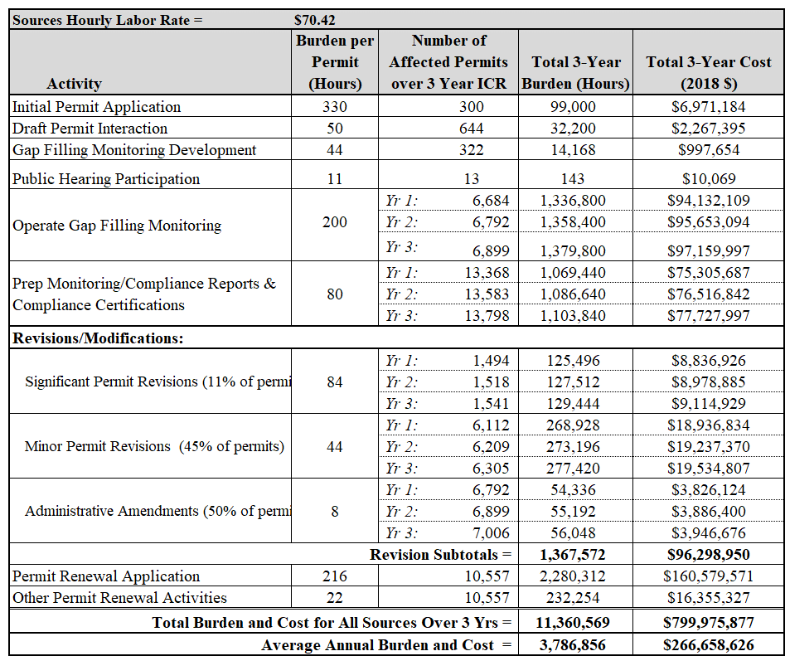

Table 7. Burden and Cost of Permitting Authority Activities
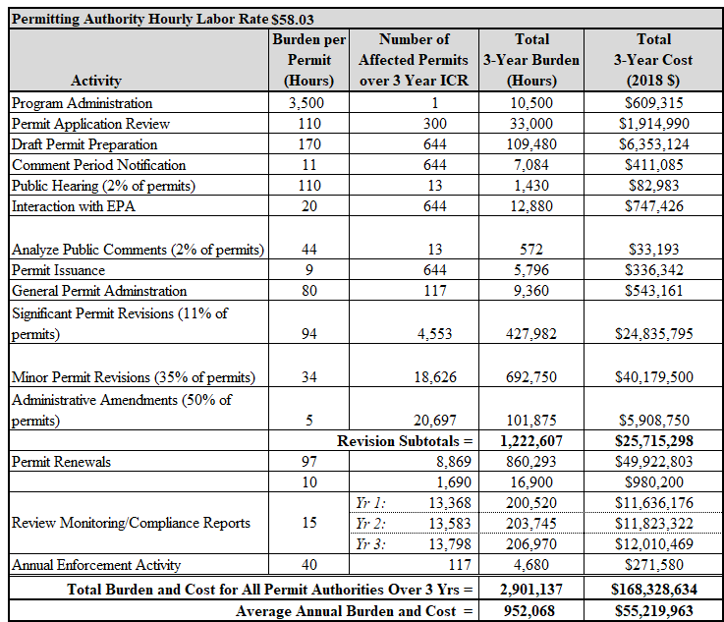

6(e) Bottom Line Burden Hours and Cost Tables

The burden and costs associated with part 70 are shown above in Tables 6 and 7 for sources and permitting authorities, respectively. The burden and costs incurred by the EPA in its oversight role is discussed above in section 6(c).

6(e)(i) Respondent Tally

Table 8 and 9 show the bottom line average annual burden and cost, respectively, for the source and permitting authority respondents under this ICR renewal for implementation of the part 70 Operating Permits Program between April 1, 2019, and March 31, 2022. Of the 4.7 million hours the Agency anticipates it will take to perform all the functions required by title V annually, about 80 percent of the burden applies to sources. However, the magnitude of the total expected burden can be misleading, due to the number of permitted sources

Permitting authorities incur most of the remaining 20 percent of the burden in Table 8 and 9, with the total burden spread between a significantly smaller number of entities than for sources. On average, the Agency estimates the permitting authority burden associated with the part 70 Operating Permits Program will be about 8,137 hours per year. However, for some permitting authorities with relatively fewer sources (Vermont, New Hampshire, etc.), this estimate will exceed their actual burden. On the other hand, for permitting authorities with more than the average number of sources (Louisiana, Texas, etc.), the estimated average burden will be lower than the actual burden. A better measure of the effect of title V regulations on permitting authorities would be to divide the total estimated hours by the number of operating permits. On average, each permitting authority can expect to spend about 68 hours per year managing and overseeing each permit in its jurisdiction, at a cost of approximately $3,941 per permit. However, this cost cannot be considered an Unfunded Mandate from the federal government, because the net cost to permitting authorities for their management of an operating permits program must, by law, be passed on to sources in the form of permit fees of sufficient magnitude to fully offset all permit management costs. Therefore, the true annual cost to permitting authorities under title V is zero, and the true annual cost to sources is $266,658,626, or approximately $19,031 per permit.

Table 8. Bottom Line Average Annual Respondent Burden (Hours)
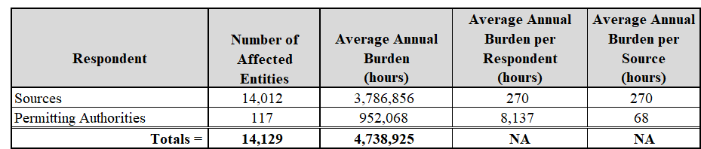

Table 9. Bottom Line Average Annual Respondent Cost (2018$)
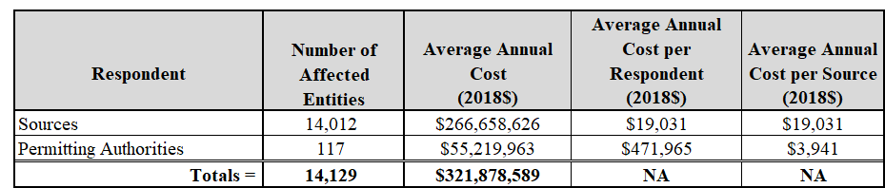

6(e)(ii) The Agency Tally

Table 3 above displays the activities undertaken by the federal government (EPA) for the part 70 program. Section 6(c) gives the derivation of hourly costs for the EPA, and Table 4 gives expected burden and costs (in 2018 dollars) for the EPA. In Table 10 we show the calculation of the average annual burden and cost for the EPA.

Table 10. Bottom Line Average Annual EPA Burden and Cost
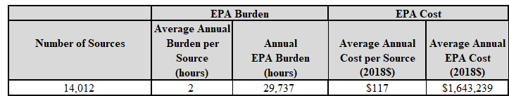

As can be seen from Table 10, the bottom line burden incurred by the EPA for the part 70 Operating Permits Program is estimated to be about 29,737 hours and $1,643,239 per year. This total represents approximately 2 hours and $117 per source.

6(e)(iii) Variations in the Annual Bottom Line

The annual burden is not expected to change significantly from year to year over the 3 years covered by this ICR renewal. However, the burden is expected to increase incrementally each year as the number of permitted sources increases by about 1.6 percent per year.

6(f) Reasons for Change in Burden

Table 11 compares the burden on respondents in the 2016 ICR with the burden in this ICR renewal. The approved burden level in the 2016 ICR renewal was about 4,115,560 hours per year for sources and 1,053,255 burden hours per year for permitting authorities, for a total of about 5,168,815 hours. This ICR renewal estimates total annual source burden at 3,805,639 burden hours per year for sources and 952,068 burden hours per year for permitting authorities, for a total of 4,738,925 hours. This change in burden from the previous ICR renewal is primarily due to updated estimates of the number of sources and permits subject to the part 70 programs, rather than any new federal mandates (i.e., changes in paperwork requirements for respondents). There are several reasons for the changes in estimates in this ICR renewal compared to the previous ICR renewal. The 2016 ICR renewal overestimated the number of sources that would be permitted by the end of that ICR period. We calculated that there would be 15,780 permitted sources by October 31, 2018, but the data we have supports that the actual number of permitted sources was 13,368.

Table 11. Burden Change from 2016 ICR to Current ICR (Hours)
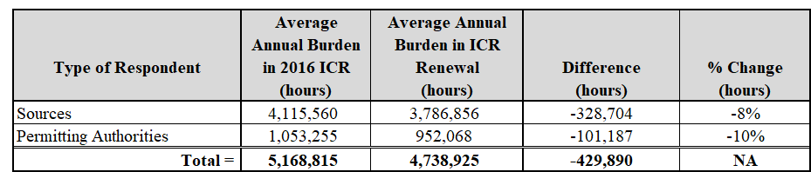

For the EPA, the estimated burden level in the 2016 ICR renewal was about 31,544 hours per year, which we estimate will decrease to about 29,737 hours per year over the 3 years of this ICR renewal. Based on the projected decrease in burden hours, we estimate that the cost to the federal government of the part 70 program will decrease by about $99,855.

6(g) Burden Statement

As previously noted, it is impractical to attempt to delineate burden by respondent and activity due to the large number of respondents, the variation in the circumstances for each respondent, and the varied nature of the activities of the program. Following in Table 12 is the apportioned burden for each type of respondent. This is derived from the total permitting authority hourly burden divided by the number of permitting authorities, and similarly for sources.

Table 12. Burden Statement (Hours)
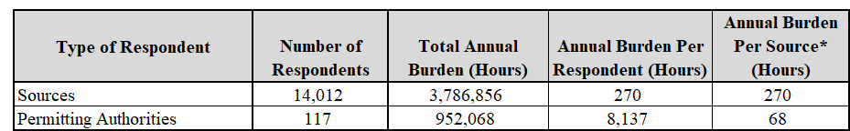

For the federal government, the EPA is the only affected entity covered by this ICR. We project an annual burden of 29,737 hours for the EPA, or about 2 hours per source.

Burden means the total time, effort, or financial resources expended by persons to generate, maintain, retain, or disclose or provide information to or for a federal agency. This includes the time needed to review instructions; develop, acquire, install, and utilize technology and systems for the purposes of collecting, validating, and verifying information, processing and maintaining information, and disclosing and providing information; adjust the existing ways to comply with any previously applicable instructions and requirements; train personnel to be able to respond to a collection of information; search data sources; complete and review the collection of information; and transmit or otherwise disclose the information. An agency may not conduct or sponsor, and a person is not required to respond to, a collection of information unless it displays a currently valid OMB control number. The OMB control numbers for the EPA's regulations are listed in 40 CFR part 9 and 48 CFR chapter 15.

To comment on the Agency's need for this information, the accuracy of the provided burden estimates, and any suggested methods for minimizing respondent burden, including the use of automated collection techniques, the EPA has established a public docket for this ICR under Docket ID Number EPA-HQ-OAR-2004-0015, which is available for online viewing at www.regulations.gov, or in-person viewing at the Air and Radiation Docket and Information Center in the EPA Docket Center (EPA/DC), EPA West, Room 3334, 1301 Constitution Avenue, NW, Washington, D.C. The EPA Docket Center Public Reading Room is open from 8:30 a.m. to 4:30 p.m., Monday through Friday, excluding legal holidays. The telephone number for the Reading Room is (202) 566-1744, and the telephone number for the Air and Radiation Docket and Information Center is (202) 566-1742. An electronic version of the public docket is available at www.regulations.gov. This site can be used to submit or view public comments, access the index listing of the contents of the public docket, and to access those documents in the public docket that are available electronically. When in the system, select “search,” then key in the Docket ID Number identified above. Also, you can send comments to the Office of Information and Regulatory Affairs, Office of Management and Budget, 725 17th Street, NW, Washington, D.C. 20503, Attention: Desk Officer for EPA. Please include the EPA Docket ID Number EPA-HQ-OAR-2004-0015 and OMB Control Number 2060-0243 in any correspondence.

ATTACHMENT 1

ASSUMPTIONS FOR PART 70 ICR RENEWAL

TIME PERIOD OF ICR

The time period covered by this ICR is April 1, 2019, to March 31, 2022

SOURCE POPULATION

- Estimated total population of title V sources as of April 1, 2019 = 13,712.
- This ICR projects that 100 new sources will become subject to title V each year increasing the population as follows:
- Source population at the end of ICR year 1 = 13,812
- Source population at the end of ICR year 2 = 13,912
- Source population at the end of ICR year 3 = 14,012

INITIAL PERMIT ISSUANCE BACKLOG

- The estimated total backlog of existing sources that will have not received their initial permits is 344 sources as of April 1, 2019.
- We assume that that all backlogged initial permits will be issued by the end of the ICR period, with 115 issued the first year, 115 the second year, and 114 the third year.

GENERAL PERMITS

- Assume 16% of existing permits at beginning of ICR period are general permits.
- Assume no new general permits will be issued during period of ICR
- Assume 16% of renewals will be for general permits.

INITIAL PERMITS ISSUANCE RATE

- Single-source permits are non-general permits.
- There will be 344 backlogged initial single-source permits that will be issued in equal amounts each year of the ICR.
- Source with backlogged permits have already submitted permit applications.
- There will be 300 new single-source permits issued during the ICR (100 per year).
- Initial permits are composed of the new permits issued to new sources and new permits issued to reduce the backlog of sources that have submitted applications but are awaiting permit issuance (300 new + 344 backlog = 644 initial permits)

PERMIT APPLICATIONS

During the period of this ICR, it is assumed that only the new initial sources will submit applications for initial title V permits—backlogged initial sources are assumed to have already prepared and submitted permit applications.

PERMIT REVISION RATES

- Sources covered by general permits will not apply for permit revisions.
- Permit revisions estimates for any year are based on the number of single-source permits in force at the beginning of the year.
- Significant modifications occur for 11% of existing single-source permits per year.
- Minor permit modifications occur for 45% of existing single-source permits per year.
- Administrative amendments occur for 50% of existing single-source permits per year.

PERMIT RENEWAL

- Both single-source and general permits are renewed but we treat them separately because burdens differ greatly.
- Data indicates there will be a permit renewal backlog of 2,536 single-source permits as of April 1, 2019 (permits that are passed their deadline for renewal).
- We assume that equal numbers of backlogged permits are renewed each year.
- An additional 2,674 single-source permits will come due for renewal each year on their normal schedule (approximately 1/5 of the universe of permits issued or renewed 5 years previously, due to 5-year permit term).
- Assume 16% of all renewals are general permits and 84% single-source permits.

OPERATION OF GAP-FILING MONITORING

- We assume operation of such monitoring in 50% of all permits.

MONITORING AND COMPLIANCE STATUS REPORTS

- These reports are made based on all previously-issued permits (single-source and general), so the permit total at the beginning of each ICR year is used to calculate the number of reports occurring each year.

PERMITTING AUTHORITY ACTIVITIES

- Program administration, general permits administration, and preparing the enforcement reports occur on a yearly basis.
- All new initial single-source permits (new and backlog) are assumed to go through the activities of permit drafting, public notification, interaction with the EPA, and issuance notifications.
- The activities of public hearings and finalizing draft permits that have public comment is assumed for 2% of new permits.

EPA ACTIVITIES

- The EPA reviews 25% of all new initial permits and consults on 25% of issues on new single-source permits, significant modifications, and minor permit modification.
- The EPA reviews all significant and minor permit modifications to single-source permits.
- The EPA reviews 5% of all single-source permit renewals.
- Program oversight and review of enforcement reports occurs on a yearly basis

ATTACHMENT 2

TITLE V OF THE CLEAN AIR ACT, THE STATUTORY REQUIREMENTS FOR THE RESPONDENT INFORMATION

SEC. 502. PERMIT PROGRAMS

(a) Violations.- After the effective date of any permit program approved or promulgated under this title, it shall be unlawful for any person to violate any requirement of a permit issued under this title, or to operate an affected source (as provided in title IV), a major source, any other source (including an area source) subject to standards or regulations under section 111 or 112, any other source required to have a permit under parts C or D of title I, or any other stationary source in a category designated (in whole or in part) by regulations promulgated by the Administrator (after notice and public comment) which shall include a finding setting forth the basis for such designation, except in compliance with a permit issued by a permitting authority under this title. (Nothing in this subsection shall be construed to alter the applicable requirements of this Act that a permit be obtained before construction or modification.) The Administrator may, in the Administrator's discretion and consistent with the applicable provisions of this Act, promulgate regulations to exempt one or more source categories (in whole or in part) from the requirements of this subsection if the Administrator finds that compliance with such requirements is impracticable, infeasible, or unnecessarily burdensome on such categories, except that the Administrator may not exempt any major source from such requirements.
(b) Regulations.- The Administrator shall promulgate within 12 months after the date of the enactment of the Clean Air Act Amendments of 1990 regulations establishing the minimum elements of a permit program to be administered by any air pollution control agency. These elements shall include each of the following:
(1) Requirements for permit applications, including a standard application form and criteria for determining in a timely fashion the completeness of applications.
(2) Monitoring and reporting requirements.
(3)(A) A requirement under State or local law or interstate compact that the owner or operator of all sources subject to the requirement to obtain a permit under this title pay an annual fee, or the equivalent over some other period, sufficient to cover all reasonable (direct and indirect) costs required to develop and administer the permit program requirements of this title, including section 507, including the reasonable costs of -
(i) reviewing and acting upon any application for such a permit,
(ii) if the owner or operator receives a permit for such source, whether before or after the date of the enactment of the Clean Air Act Amendments of 1990, implementing and enforcing the terms and conditions of any such permit (not including any court costs or other costs associated with any enforcement action),
(iii) emissions and ambient monitoring,
(iv) preparing generally applicable regulations, or guidance,
(v) modeling, analyses, and demonstrations, and
(vi) preparing inventories and tracking emissions.
(B) The total amount of fees collected by the permitting authority shall conform to the following requirements:
(i) The Administrator shall not approve a program as meeting the requirements of this paragraph unless the State demonstrates that, except as otherwise provided in subparagraphs (ii) through (v) of this subparagraph, the program will result in the collection, in the aggregate, from all sources subject to subparagraph (A), of an amount not less than $25 per ton of each regulated pollutant, or such other amount as the Administrator may determine adequately reflects the reasonable costs of the permit program.
(ii) As used in this subparagraph, the term "regulated pollutant" shall mean (I) a volatile organic compound; (II) each pollutant regulated under section 111 or 112; and (III) each pollutant for which a national primary ambient air quality standard has been promulgated (except that carbon monoxide shall be excluded from this reference).
(iii) In determining the amount under clause (i), the permitting authority is not required to include any amount of regulated pollutant emitted by any source in excess of 4,000 tons per year of that regulated pollutant.
(iv) The requirements of clause (i) shall not apply if the permitting authority demonstrates that collecting an amount less than the amount specified under clause (i) will meet the requirements of subparagraph (A).
(v) The fee calculated under clause (i) shall be increased (consistent with the need to cover the reasonable costs authorized by subparagraph (A)) in each year beginning after the year of the enactment of the Clean Air Act Amendments of 1990 by the percentage, if any, by which the Consumer Price Index for the most recent calendar year ending before the beginning of such year exceeds the Consumer Price Index for the calendar year 1989. For purposes of this clause -
(I) the Consumer Price Index for any calendar year is the average of the Consumer Price Index for all-urban consumers published by the Department of Labor, as of the close of the 12-month period ending on August 31 of each calendar year, and
(II) the revision of the Consumer Price Index which is most consistent with the Consumer Price Index for calendar year 1989 shall be used.
(C)(i) If the Administrator determines, under subsection (d), that the fee provisions of the operating permit program do not meet the requirements of this paragraph, or if the Administrator makes a determination, under subsection (i), that the permitting authority is not adequately administering or enforcing an approved fee program, the Administrator may, in addition to taking any other action authorized under this title, collect reasonable fees from the sources identified under subparagraph (A). Such fees shall be designed solely to cover the Administrator's costs of administering the provisions of the permit program promulgated by the Administrator.
(ii) Any source that fails to pay fees lawfully imposed by the Administrator under this subparagraph shall pay a penalty of 50 percent of the fee amount, plus interest on the fee amount computed in accordance with section 6621(a)(2) of the Internal Revenue Code of 1986 (relating to computation of interest on underpayment of Federal taxes).
(iii) Any fees, penalties, and interest collected under this subparagraph shall be deposited in a special fund in the United States Treasury for licensing and other services, which thereafter shall be available for appropriation, to remain available until expended, subject to appropriation, to carry out the Agency's activities for which the fees were collected. Any fee required to be collected by a State, local, or interstate agency under this subsection shall be utilized solely to cover all reasonable (direct and indirect) costs required to support the permit program as set forth in subparagraph (A).
(4) Requirements for adequate personnel and funding to administer the program.
(5) A requirement that the permitting authority have adequate authority to:
(A) issue permits and assure compliance by all sources required to have a permit under this title with each applicable standard, regulation or requirement under this Act;
(B) issue permits for a fixed term, not to exceed 5 years;
(C) assure that upon issuance or renewal permits incorporate emission limitations and other requirements in an applicable implementation plan;
(D) terminate, modify, or revoke and reissue permits for cause;
(E) enforce permits, permit fee requirements, and the requirement to obtain a permit, including authority to recover civil penalties in a maximum amount of not less than $10,000 per day for each violation, and provide appropriate criminal penalties; and
(F) assure that no permit will be issued if the Administrator objects to its issuance in a timely manner under this title.
(6) Adequate, streamlined, and reasonable procedures for expeditiously determining when applications are complete, for processing such applications, for public notice, including offering an opportunity for public comment and a hearing, and for expeditious review of permit actions, including applications, renewals, or revisions, and including an opportunity for judicial review in State court of the final permit action by the applicant, any person who participated in the public comment process, and any other person who could obtain judicial review of that action under applicable law.
(7) To ensure against unreasonable delay by the permitting authority, adequate authority and procedures to provide that a failure of such permitting authority to act on a permit application or permit renewal application (in accordance with the time periods specified in section 503 or, as appropriate, title IV) shall be treated as a final permit action solely for purposes of obtaining judicial review in State court of an action brought by any person referred to in paragraph (6) to require that action be taken by the permitting authority on such application without additional delay.
(8) Authority, and reasonable procedures consistent with the need for expeditious action by the permitting authority on permit applications and related matters, to make available to the public any permit application, compliance plan, permit, and monitoring or compliance report under section 503(e), subject to the provisions of section 114(c) of this Act.
(9) A requirement that the permitting authority, in the case of permits with a term of 3 or more years for major sources, shall require revisions to the permit to incorporate applicable standards and regulations promulgated under this Act after the issuance of such permit. Such revisions shall occur as expeditiously as practicable and consistent with the procedures established under paragraph (6) but not later than 18 months after the promulgation of such standards and regulations. No such revision shall be required if the effective date of the standards or regulations is a date after the expiration of the permit term. Such permit revision shall be treated as a permit renewal if it complies with the requirements of this title regarding renewals.
(10) Provisions to allow changes within a permitted facility (or one operating pursuant to section 503(d)) without requiring a permit revision, if the changes are not modifications under any provision of title I and the changes do not exceed the emissions allowable under the permit (whether expressed therein as a rate of emissions or in terms of total emissions: Provided, That the facility provides the Administrator and the permitting authority with written notification in advance of the proposed changes which shall be a minimum of 7 days, unless the permitting authority provides in its regulations a different time frame for emergencies.
(c) Single Permit.- A single permit may be issued for a facility with multiple sources.
(d) Submission and Approval.- (1) Not later than 3 years after the date of the enactment of the Clean Air Act Amendments of 1990, the Governor of each State shall develop and submit to the Administrator a permit program under State or local law or under an interstate compact meeting the requirements of this title. In addition, the Governor shall submit a legal opinion from the attorney general (or the attorney for those State air pollution control agencies that have independent legal counsel), or from the chief legal officer of an interstate agency, that the laws of the State, locality, or the interstate compact provide adequate authority to carry out the program. Not later than 1 year after receiving a program, and after notice and opportunity for public comment, the Administrator shall approve or disapprove such program, in whole or in part. The Administrator may approve a program to the extent that the program meets the requirements of this Act, including the regulations issued under subsection (b). If the program is disapproved, in whole or in part, the Administrator shall notify the Governor of any revisions or modifications necessary to obtain approval. The Governor shall revise and resubmit the program for review under this section within 180 days after receiving notification.
(2)(A) If the Governor does not submit a program as required under paragraph (1) or if the Administrator disapproves a program submitted by the Governor under paragraph (1), in whole or in part, the Administrator may, prior to the expiration of the 18-month period referred to in subparagraph (B), in the Administrator's discretion, apply any of the sanctions specified in section 179(b).
(B) If the Governor does not submit a program as required under paragraph (1), or if the Administrator disapproves any such program submitted by the Governor under paragraph (1), in whole or in part, 18 months after the date required for such submittal or the date of such disapproval, as the case may be, the Administrator shall apply sanctions under section 179(b) in the same manner and subject to the same deadlines and other conditions as are applicable in the case of a determination, disapproval, or finding under section 179(a).
(C) The sanctions under section 179(b)(2) shall not apply pursuant to this paragraph in any area unless the failure to submit or the disapproval referred to in subparagraph (A) or (B) relates to an air pollutant for which such area has been designated a nonattainment area (as defined in part D of title I).
(3) If a program meeting the requirements of this title has not been approved in whole for any State, the Administrator shall, 2 years after the date required for submission of such a program under paragraph (1), promulgate, administer, and enforce a program under this title for that State.
(e) Suspension.- The Administrator shall suspend the issuance of permits promptly upon publication of notice of approval of a permit program under this section, but may, in such notice, retain jurisdiction over permits that have been federally issued, but for which the administrative or judicial review process is not complete. The Administrator shall continue to administer and enforce federally issued permits under this title until they are replaced by a permit issued by a permitting program. Nothing in this subsection should be construed to limit the Administrator's ability to enforce permits issued by a State.
(f) Prohibition.- No partial permit program shall be approved unless, at a minimum, it applies, and ensures compliance with, this title and each of the following:
(1) All requirements established under title IV applicable to "affected sources."
(2) All requirements established under section 112 applicable to "major sources", "area sources," and "new sources."
(3) All requirements of title I (other than section 112) applicable to sources required to have a permit under this title. Approval of a partial program shall not relieve the State of its obligation to submit a complete program, nor from the application of any sanctions under this Act for failure to submit an approvable permit program.
(g) Interim Approval.- If a program (including a partial permit program) submitted under this title substantially meets the requirements of this title, but is not fully approvable, the Administrator may by rule grant the program interim approval. In the notice of final rulemaking, the Administrator shall specify the changes that must be made before the program can receive full approval. An interim approval under this subsection shall expire on a date set by the Administrator not later than 2 years after such approval, and may not be renewed. For the period of any such interim approval, the provisions of subsection (d)(2), and the obligation of the Administrator to promulgate a program under this title for the State pursuant to subsection (d)(3), shall be suspended. Such provisions and such obligation of the Administrator shall apply after the expiration of such interim approval.
(h) Effective Date.- The effective date of a permit program, or partial or interim program, approved under this title, shall be the effective date of approval by the Administrator. The effective date of a permit program, or partial permit program, promulgated by the Administrator shall be the date of promulgation.
(i) Administration and Enforcement.- (1) Whenever the Administrator makes a determination that a permitting authority is not adequately administering and enforcing a program, or portion thereof, in accordance with the requirements of this title, the Administrator shall provide notice to the State and may, prior to the expiration of the 18-month period referred to in paragraph (2), in the Administrator's discretion, apply any of the sanctions specified in section 179(b).
(2) Whenever the Administrator makes a determination that a permitting authority is not adequately administering and enforcing a program, or portion thereof, in accordance with the requirements of this title, 18 months after the date of the notice under paragraph (1), the Administrator shall apply the sanctions under section 179(b) in the same manner and subject to the same deadlines and other conditions as are applicable in the case of a determination, disapproval, or finding under section 179(a).
(3) The sanctions under section 179(b)(2) shall not apply pursuant to this subsection in any area unless the failure to adequately enforce and administer the program relates to an air pollutant for which such area has been designated a nonattainment area.
(4) Whenever the Administrator has made a finding under paragraph (1) with respect to any State, unless the State has corrected such deficiency within 18 months after the date of such finding, the Administrator shall, 2 years after the date of such finding, promulgate, administer, and enforce a program under this title for that State. Nothing in this paragraph shall be construed to affect the validity of a program which has been approved under this title or the authority of any permitting authority acting under such program until such time as such program is promulgated by the Administrator under this paragraph. [42 U.S.C. 7661a]

SEC. 503. PERMIT APPLICATIONS.

(a) APPLICABLE DATE.-Any source specified in section 502(a) shall become subject to a permit program, and required to have a permit, on the later of the following dates-
(1) The effective date of a permit program or partial or interim permit program applicable to the source; or
(2) The date such source becomes subject to section 502(a).
(b) COMPLIANCE PLAN.-(1) The regulations required by section 502(b) shall include a requirement that the applicant submit with the permit application a compliance plan describing how the source will comply with all applicable requirements under this Act. The compliance plan shall include a schedule of compliance, and a schedule under which the permittee will submit progress reports to the permitting authority no less frequently than every 6 months.
(2) The regulations shall further require the permittee to periodically (but no less frequently than annually) certify that the facility is in compliance with any applicable requirements of the permit, and to promptly report any deviations from permit requirements to the permitting authority.
(c) DEADLINE.-Any person required to have a permit shall, not later than 12 months after the date on which the source becomes subject to a permit program approved or promulgated under this title, or such earlier date as the permitting authority may establish, submit to the permitting authority a compliance plan and an application for a permit signed by a responsible official, who shall certify the accuracy of the information submitted. The permitting authority shall approve or disapprove a completed application (consistent with the procedures established under this title for consideration of such applications), and shall issue or deny the permit, within 18 months after the date of receipt thereof, except that the permitting authority shall establish a phased schedule for acting on permit applications submitted within the first full year after the effective date of a permit program (or a partial or interim program). Any such schedule shall assure that at least one-third of such permits will be acted on by such authority annually over a period of not to exceed 3 years after such effective date. Such authority shall establish reasonable procedures to prioritize such approval or disapproval actions in the case of applications for construction or modification under the applicable requirements of this Act.
(d) TIMELY AND COMPLETE APPLICATIONS.-Except for sources required to have a permit before construction or modification under the applicable requirements of this Act, if an applicant has submitted a timely and complete application for a permit required by this title (including renewals), but final action has not been taken on such application, the source's failure to have a permit shall not be a violation of this Act, unless the delay in final action was due to the failure of the applicant timely to submit information required or requested to process the application. No source required to have a permit under this title shall be in violation of section 502(a) before the date on which the source is required to submit an application under subsection (c).
(e) COPIES; AVAILABILITY.-A copy of each permit application, compliance plan (including the schedule of compliance), emissions or compliance monitoring report, certification, and each permit issued under this title, shall be available to the public. If an applicant or permittee is required to submit information entitled to protection from disclosure under section 114(c) of this Act, the applicant or permittee may submit such information separately. The requirements of section 114(c) shall apply to such information. The contents of a permit shall not be entitled to protection under section 114(c).

SEC. 504. PERMIT REQUIREMENTS AND CONDITIONS.

(a) CONDITIONS.-Each permit issued under this title shall include enforceable emission limitations and standards, a schedule of compliance, a requirement that the permittee submit to the permitting authority, no less often than every 6 months, the results of any required monitoring, and such other conditions as are necessary to assure compliance with applicable requirements of this Act, including the requirements of the applicable implementation plan.
(b) MONITORING AND ANALYSIS.-The Administrator may by rule prescribe procedures and methods for determining compliance and for monitoring and analysis of pollutants regulated under this Act, but continuous emissions monitoring need not be required if alternative methods are available that provide sufficiently reliable and timely information for determining compliance. Nothing in this subsection shall be construed to affect any continuous emissions monitoring requirement of title IV, or where required elsewhere in this Act.
(c) INSPECTION, ENTRY, MONITORING, CERTIFICATION, AND REPORTING.-Each permit issued under this title shall set forth inspection, entry, monitoring, compliance certification, and reporting requirements to assure compliance with the permit terms and conditions. Such monitoring and reporting requirements shall conform to any applicable regulation under subsection (b). Any report required to be submitted by a permit issued to a corporation under this title shall be signed by a responsible corporate official, who shall certify its accuracy.

§70.5(c) Standard applications form and required information. The State program under this part shall provide for a standard application form or forms. Information as described below for each emissions unit at a part 70 source shall be included in the application. The Administrator may approve as part of a State program a list of insignificant activities and emissions levels which need not be included in permit applications. However, for insignificant activities which are exempted because of size or production rate, a list of such insignificant activities must be included in the application. An application may not omit information needed to determine the applicability of, or to impose, any applicable requirement, or to evaluate the fee amount required under the schedule approved pursuant to §70.9 of this part. The permitting authority may use discretion in developing application forms that best meet program needs and administrative efficiency. The forms and attachments chosen, however, shall include the elements specified below:
(1) Identifying information, including company name and address (or plant name and address if different from the company name), owner's name and agent, and telephone number and names of plant site manager/contact.
(2) A description of the source's processes and products (by Standard Industrial Classification Code) including any associated alternative scenario identified by the source.
(3) The following emission related information:
(i) All emissions of pollutants for which the source is major, and all emissions of regulated air pollutants. A permit application shall describe all emissions of regulated air pollutants emitted from any emissions unit, except where such units are exempted under this paragraph (c) of this section. The permitting authority shall require additional information related to the emissions of air pollutants sufficient to verify which requirements are applicable to the source, and other information necessary to collect any permit fees owed under the fee schedule approved pursuant to §70.9(b) of this part.
(ii) Identification and description of all points of emissions described in paragraph (c)(3)(i) of this section in sufficient detail to establish the basis for fees and applicability of requirements of the Act.
(iii) Emissions rate in tpy and in such terms as are necessary to establish compliance consistent with the applicable standard reference test method.
(iv) The following information to the extent it is needed to determine to regulate emissions: Fuels, fuel use, raw materials, production rates, and operating schedules.
(v) Identification and description of air pollution control equipment and compliance monitoring devices or activities.
(vi) Limitations on source operation affecting emissions or any work practice standards, where applicable, for all regulated pollutants at the part 70 source.
(vii) Other information required by any applicable requirement (including information related to stack height limitations developed pursuant to section 123 of the Act.)
(viii) Calculations on which the information on paragraphs (c)(3)(i) through (c)(3)(vii) of this section is based.
(4) The following air pollution control requirements:
(i) Citation and description of all applicable requirements, and
(ii) Description of or reference to any applicable test method for determining compliance with each applicable requirement.
(5) Other specific information that may be necessary to implement and enforce other applicable requirements of the Act or of this part or to determine the applicability of such requirements.
(6) An explanation of any proposed exemptions from otherwise applicable requirements.
(7) Additional information as determined to be necessary by the permitting authority to define alternative operating scenarios identified by the source pursuant to § 70.6(a)(9) of this part or to define permit terms and conditions implementing § 70.4(b)(12) or § 70.6(a)(10) of this part.
(8) A compliance plan for all part 70 sources that contains all the following:
(i) A description of the compliance status of the source with respect to all applicable requirements.
(ii) A description as follows:
(A) For applicable requirements with which the source is in compliance, a statement that the source will continue to comply with such requirements.
(B) For applicable requirements that will become effective during the permit term, a statement that the source will meet such requirements on a timely basis.
(C) For requirements for which the source is not in compliance at the time or permit issuance, a narrative description of how the source will achieve compliance with such requirements.
(iii) A compliance schedule as follows:
(A) For applicable requirements with which the source is in compliance, a statement that the source will continue to comply with such requirements.
(B) For applicable requirements that will become effective during the permit term, a statement that the source will meet such requirements on a timely basis. A statement that the source will meet in a timely manner applicable requirements that become effective during the permit term shall satisfy this provision, unless a more detailed schedule is expressly required by the applicable requirement.
(C) A schedule of compliance for sources that are not in compliance with all applicable requirements at the time of permit issuance. Such a schedule shall include a schedule of remedial measures, including an enforceable sequence of actions with milestones, leading to compliance with any applicable requirements for which the source will be in noncompliance at the time of permit issuance. This compliance schedule shall resemble and be at least as stringent as that contained in any judicial consent decree or administrative order to which the source is subject. Any such schedule of compliance shall be supplemental to and shall not sanction noncompliance with, the applicable requirements on which it is based.
(iv) A schedule for submission of certified progress reports no less frequently than every 6 months for sources required to have a schedule of compliance to remedy a violation.
(v) The compliance plan content requirements specified in this paragraph shall apply and be included in the acid rain portion of a compliance plan for an affected source, except as specifically superseded by regulations promulgated under title IV of the Act with regard to the schedule and method(s) the source will use to achieve compliance with the acid rain emissions limitations.
(9) Requirements for compliance certification, including the following:
(i) A certification of compliance with all applicable requirements by a responsible official consistent with paragraph (d) of this section and section 114(a)(3) of the Act;
(ii) A statement of methods used for determining compliance, including a description of monitoring, record keeping, and reporting requirements and test methods;
(iii) A schedule for submission of compliance certifications during the permit term, to be submitted no less frequently than annually, or more frequently if specified by the underlying applicable requirement or by the permitting authority; and
(iv) A statement indicating the source's compliance status with any applicable enhanced monitoring and compliance certification requirements of the Act.
(10) The use of nationally-standardized forms for acid rain portions of permit applications and compliance plans, as required by regulations promulgated under title IV of the Act.
(d) Any application form, report, or compliance certification submitted pursuant to these regulations shall contain certification by a responsible official of truth, accuracy, and completeness. This certification and any other certification required under this part shall state that, based on information and belief formed after reasonable inquiry, the statements and information in the document are true, accurate, and complete.

The EPA has reanalyzed Appendix A of part 70 and concluded that there are actually 117 permitting authorities instead of the 116 permitting authorities assumed by previous part 70 ICRs.
All definitions of “major” in the Act.
Each permitting authority has discretion to set the frequency of these reports as long as no reports are received less frequently than semiannually. For example, some states require deviations that result in excess emissions (e.g., the breakdown of a control device) to be reported within 24 hours, with deviations that do not result in excess emissions (e.g., failure to meet a recordkeeping requirement) to be first reported with the semiannual monitoring report.
This involves writing permit terms that reflect the “applicable requirements” that apply to sources. These “applicable requirements” (e.g., NSPS and NESHAP) are not required by part 70; they are required by other federal rules and their burden is counted in the ICRs for those rules. Nevertheless, writing permit terms to reflect those requirements is a part 70 burden. Also, part 70 burden includes imposing additional monitoring through part 70, such as gap-filing monitoring. See CAA § 504(c); 40 CFR § 70.6(a)(3)(i)).
74 FR 51418 (October 6, 2009).
75 FR 31514 (June 3, 2010); 77 FR 41051 (July 12, 2012).
Environmental Engineer hourly wages obtained from “Occupational Employment Statistics, Occupational Employment and Wages, May, 2017, 17-2081 Environmental Engineers,” U.S. Dept. of Commerce, BLS. (http://www.bls.gov/oes/current/oes172081.htm accessed August 2018).
Environmental Engineering Technician hourly wages obtained from “Occupational Employment Statistics, Occupational Employment and Wages, May, 2017, 17-3025 Environmental Engineering Technicians,” U.S. Dept. of Commerce, BLS. (https://www.bls.gov/oes/current/oes173025.htm accessed August 2018).
Employment Cost Indexes for sources obtained from “Employment Cost Index Historical Listing, Current-dollar, March 2003–June 2018 (December 2005=100), Table 2. Employment Cost Index for wages and salaries, by occupational group and industry (Seasonally adjusted),” U.S. Dept. of Commerce, BLS, pg. 31 Private Industry Workers - All Workers. (http://www.bls.gov/web/eci/echistrynaics.pdf accessed August 2018).
Employment Cost Indexes for permitting authorities obtained from “Employment Cost Index Historical Listing, Current-dollar, March 2003–June 2018 (December 2005=100), Table 2. Employment Cost Index for wages and salaries, by occupational group and industry (Seasonally adjusted),” U.S. Dept. of Commerce, BLS, pg. 46 State and Local Government Workers - Public Administration. (http://www.bls.gov/web/eci/echistrynaics.pdf accessed August 2018).
Federal Labor Cost obtained from U.S. Office of Personnel Management 2018 General Schedule Table 2018-GS. Hourly labor rate assumed is GS-12, Step 5 (Technical Labor).

