Appendix K: Debriefing Guide for Data Entry Training

Now that you have completed the training, how confident are you in your ability to successfully use the FoodLogger?
1: Not confident at all 2 3 4 5: Extremely confident

Within this study, what do we mean by “food acquisition”?

You stopped by a farmer’s market and bought a dozen eggs during the second day of the study. However, FoodLogger somehow didn’t capture this stop. How can you add this stop to your food log?

In FoodLogger, what is the difference between a stop and a food event?

What is a combo meal and how is it different from other meals?

Which is an image of a PLU code?
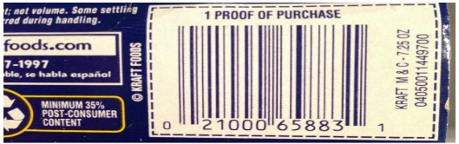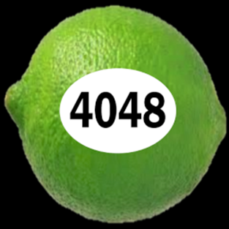

How confident are you in your ability to report a food item by scanning a barcode?
1: Not confident at all 2 3 4 5: Extremely confident

How confident are you in your ability to take pictures of and upload receipts in FoodLogger?
1: Not confident at all 2 3 4 5: Extremely confident

Can you list three things by which you are challenged during training?

Please select a response that best describes your impression about the amount of time taken to complete the training.
1: Training was too short 2 3 4 5: Training was too long

Is there a topic in particular that you found too difficult to understand?

