**Appendix W: Debriefing Guide for Lab-Based Usability Testing**

1. When entering your food items in FoodLogger, did you notice this bar at the top of the screen? [*Show P picture of the status bar*].

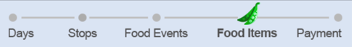

* What does it tell you?
* Is it helpful to you?

1. What does a “combo meal” mean to you?
   * What would be an example of a combo meal that is *not* from a fast-food restaurant?
2. [Present screenshot] The app asks this question. In your own words, what does “packaging” mean to you? What does it mean for a food item to be pre-packaged?

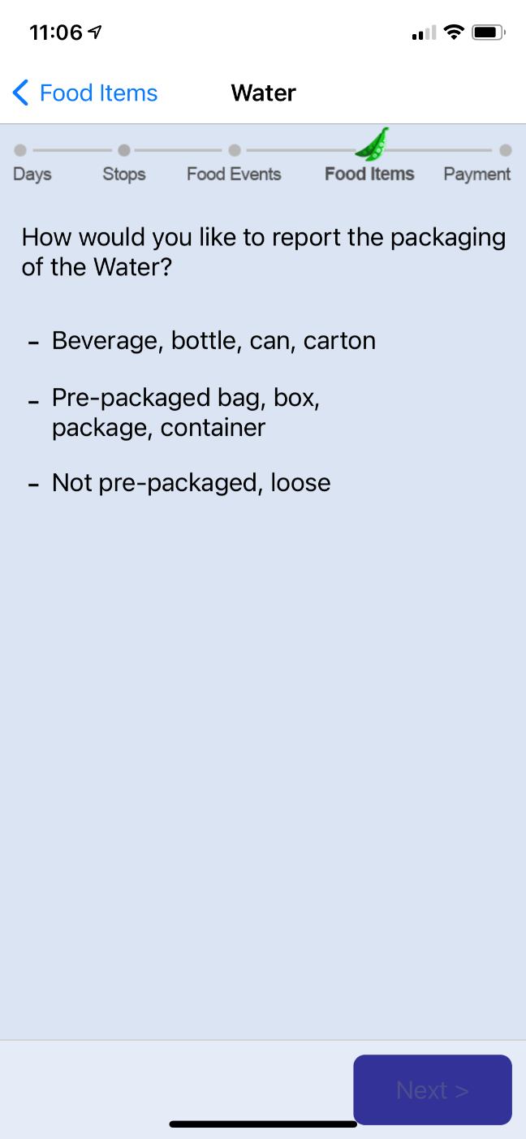

1. Sometimes the app asks you to enter information on the size or weight of your food items. Did you have problems or difficulties when reporting the size or weight of any food items? [If yes: Please describe what these were.]
2. [Present screenshot] For this question, what does the word “volume” mean to you? How would you determine an item’s volume?

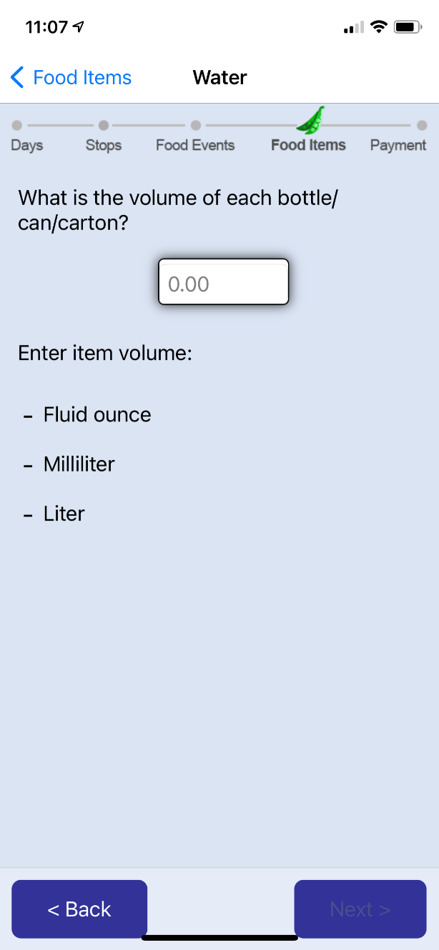

1. [Present screenshot] In this question, how easy or difficult was it to report the information?

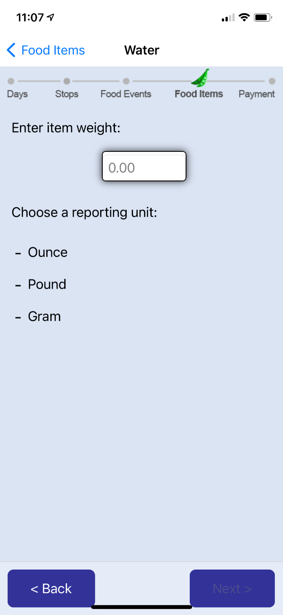

1. [*Present screenshot*] Do you remember seeing this question? How easy or difficult was it to make selection?

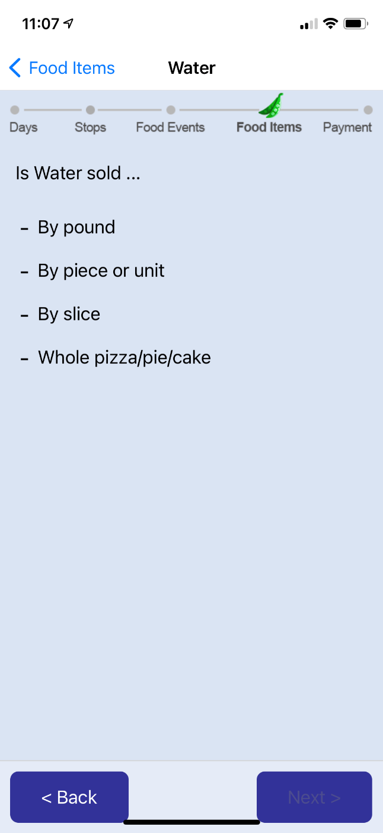

1. How confident are you that you were able to accurately report the size or weight of your food items? [If not entirely confident: For which items was difficult to report size and weight?] [On a scale 1-5, with 1 being least difficult and 5 most difficult, how would you like to rate your difficulty?]
2. Did you notice that there is a “Help” button on the bottom of the screen?
   * [If yes: Did you ever use it?]
   * Do you remember what you had trouble with?
   * Did you find the help texts to be useful?
   * Were there questions you had that were not answered by the help texts?

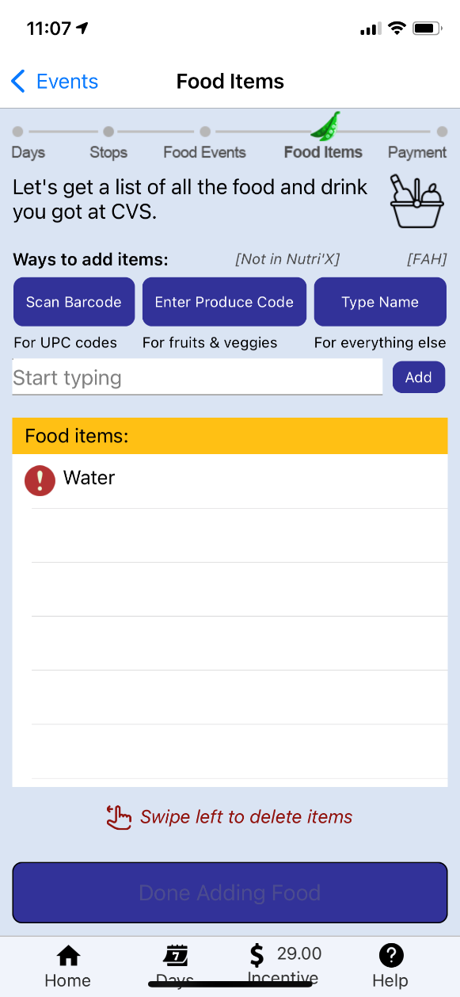

Additional ad-hoc questions based on participant’s performance.