**Appendix A: Screenshots of Smartphone Application, Food Log Portion of FoodLogger**

[PROGRAMMER: DO NOT SHOW QUESTION NUMBERS. PLACE ONE QUESTION ON ONE SCREEN UNLESS SPECIFIED OTHERWISE.]

# DAYS PAGE

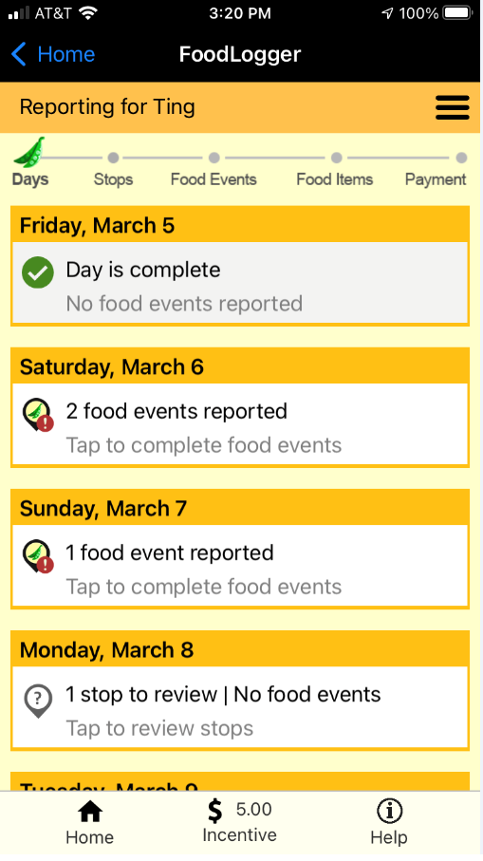

# STOPS PAGE

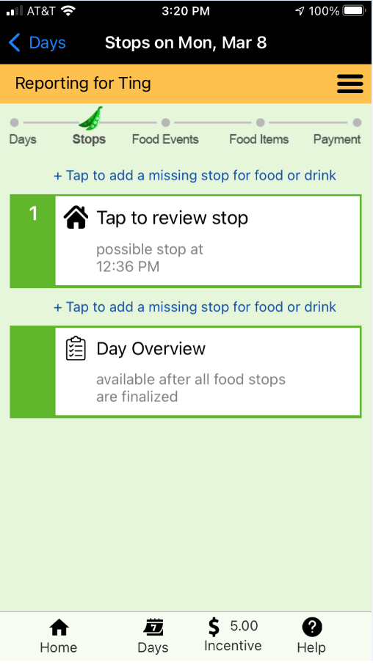

# FOOD STOP QUESTIONS (SURVEY 103)

[PROGRAMMER NOTE: ASK LEVEL 103 QUESTIONS BELOW FOR EACH STOP PASSIVELY RECORDED. ]

**FOOD_BUY. Did you get any food or drink here?**

1. YES →GO TO FOOD EVENT QUESTIONS (LEVEL 105)

2. NO →REMOVE THIS STOP AND GO TO NEXT STOP

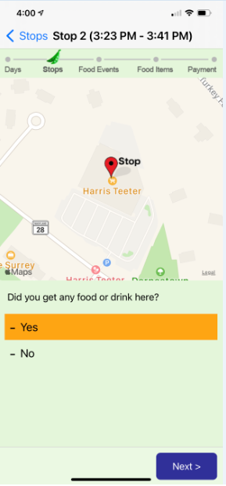

# FOOD EVENT QUESTIONS (SURVEY 105)

## Scenario S1: GPS detected food locations detected

[IF FOOD PLACES ARE DETECTED AT THE STOP, GO TO LOCATION_CHOICE. ELSE GO TO WHERE_FOOD]

**LOCATION_CHOICE. Did you get food/drink from one of these places?**

[PROGRAMMER NOTE: SHOW MAP WITH MARKER ON THE TOP OF SCREEN; DISPLAY FOOD RELATED PLACES FOUND IN NUTRIONIX AND GOOGLE SEARCH DATABASE AS OPTIONS PLUS “NONE OF THESE”.]

* {DISPLAY PLACE NAME FROM NUTRIONIX/GOOGLE SEARCH}
* **NONE OF THESE**

[PROGRAMMER NOTE:

-CATEGORIZE FOOD PLACE TYPE BASED ON GOOGLE TAGS AND NUTRITIONIX

]



[IF SUGGESTED FOOD PLACE NAME IS SELECTED, GO TO PLACE_HOW. ELSE GO TO WHERE_FOOD]

**PLACE_HOW. How did you get the food or drink?**

1. Purchased or acquired in-person

2. Ordered online for in-person pickup

3. Ordered by phone for in-person pickup



**[IF PLACE_HOW=2 (ORDERED ONLINE FOR IN-PERSON PICKUP) OR 3 (ORDERED BY PHONE FOR IN-PERSON PICKUP, ASK ORDER_VERIFY. ELSE GO TO EVENT_TYPE]**

**ORDER_VERIFY. Have you already reported this food order on the Food Log?**

1. Yes
2. No



**[IF ORDER_VERIFY=YES, GO TO NEXT FOOD STOP. IF ORDER_VERIFY=NO, GO TO EVENT_TYPE]**

## Scenario S2: No GPS food places detected OR user clicks “None of Above” in S1

[When *no* food place is detected or when “nONE OF THESE” IS SELECTED FOR LOCATION_CHOICE, ASK WHERE_FOOD. ELSE GO TO EVENT_TYPE].

**WHERE_FOOD.**

(IF FOOD PLACE *NOT* DETECTED AT FOOD STOP, SHOW: **We didn’t detect any food places at this location.** ) **How did you get the food/drink?**

1. In-person purchase

2. In-person Pickup

3. Ordered for later pickup

4. Ordered for delivery

5. From neighbor, friend, or family outside my household

[PROGRAMMER NOTE: IF WHERE_FOOD=5 (NEIGHBOR/FRIEND/FAMILY), CATEGORIZE FOOD EVENT AS FAFH AND FREE EVENT]

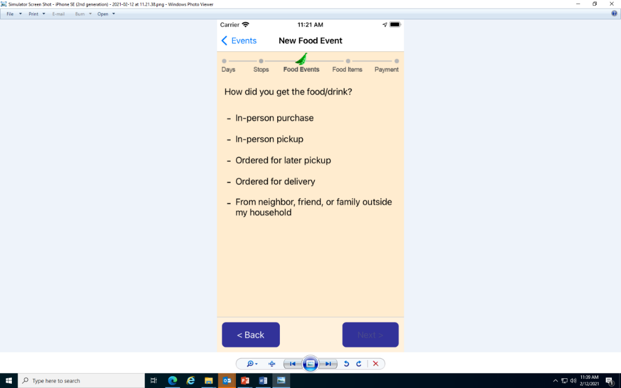

[IF WHERE_FOOD=2 (IN-PERSON PICKUP) OR 3 (ORDERED FOR LATER PICKUP) OR 4 (DELIVERY_PURCHASE), ASK ORDERED_BY. ELSE GO TO WHERE_FOOD_NAME]

**ORDERED_BY: How was the food ordered?**

1. Phone call

2. Website or app

[PROGRAMMER NOTE: IF ORDERED_BY=2 (WEB SITE OR APP) THEN CATEGORIZE AS ONLINE FOOD ACQUISITION]



**WHERE_FOOD_NAME:**

(IF WHERE_FOOD=1 (IN-PERSON PURCHASE) OR 2 (IN-PERSON PICKUP), SHOW: ) **What was the name of the place?**

**If you don’t see the address you are looking for, select the closest one.**

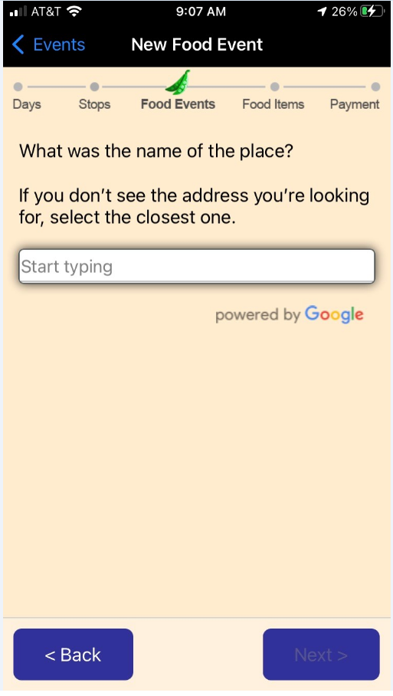

**(**IF WHERE_FOOD=3 (ORDERED FOR LATER PICKUP), SHOW: ) **What was the name of the place?**

**If you don’t see the address you are looking for, select the closest one.**



(IF WHERE_FOOD=4 (DELIVERY PURCHASE) AND ORDERED_BY=1 (PHONE CALL), SHOW: ) **What is the name of the place you called for delivery? Please enter store or restaurant name here, not the delivery service like GrubHub or UberEats.**

**If you don’t see the address you are looking for, select the closest one.**

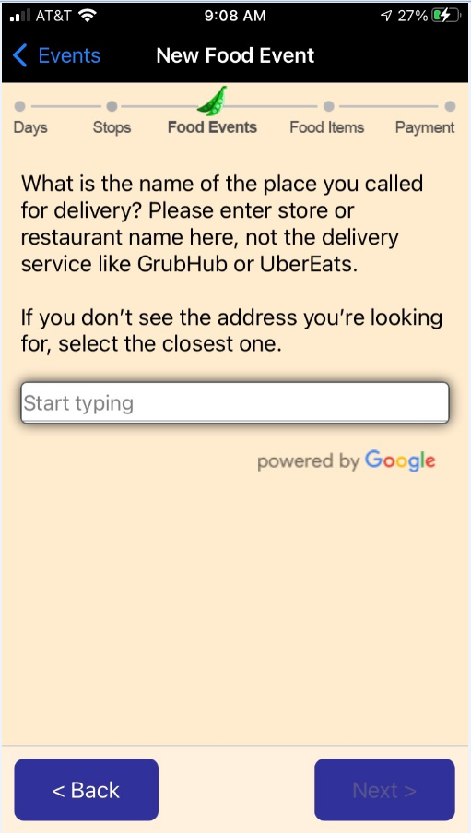

(IF WHERE_FOOD=4 (DELIVERY PURCHASE) AND ORDERED_BY=2 (WEB SITE OR APP), SHOW: ) **What is the name of the place you ordered from for delivery**? **Please enter store or restaurant name here, not the delivery service like GrubHub or UberEats.**

**If you don’t see the address you are looking for, select the closest one.**

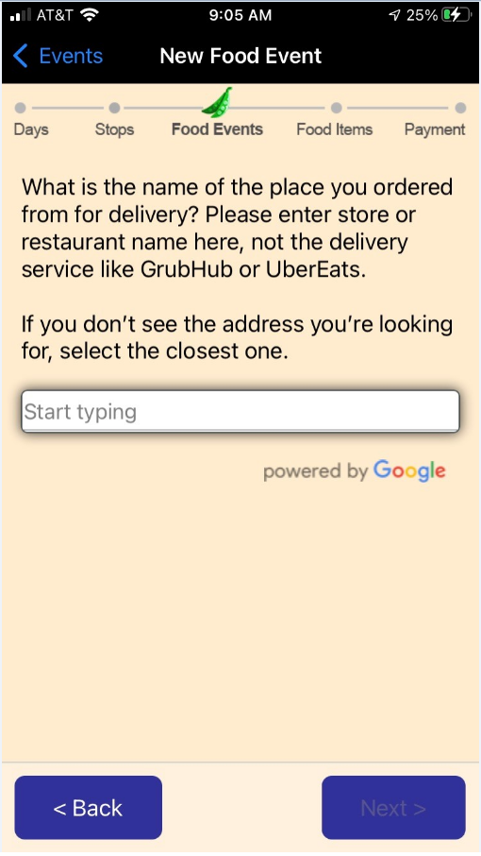

**FOOD_PLACE_TYPE:** **What type of place is (FILL IN: WHERE_FOOD_NAME)?**

1. A place like a grocery store where I got groceries or other foods or drinks I brought home

2. A place like a restaurant where I got prepared meals, snacks, or drinks to eat

3. Other, please describe: _____

[PROGRAMMER NOTE:

IF FOOD_PLACE_TYPE=1 (PLACE LIKE GROCERY STORE) THEN CATEGORIZE EVENT AS FAH EVENT;

IF FOOD_PLACE_TYPE =2 (PLACE LIKE RESTAURANT) THEN CATEGORIZE EVENT AS FAFH EVENT;

IF FOOD_PLACE_TYPE=3 (OTHER) SHOW FOOD_PLACE_TYPE_O THEN CATEGORIZE EVENT FAFH EVENT]



**FOOD_PLACE_TYPE_O: Other, please describe this place:**

[text box for people to write down description when Option 3 is selected]

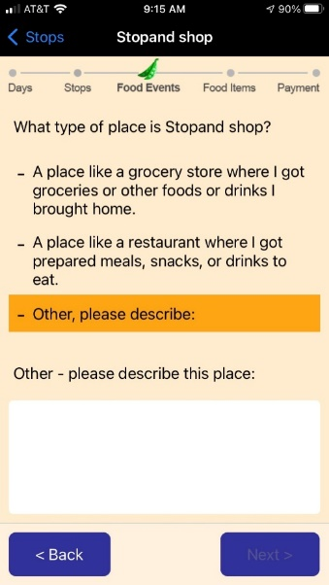

**EVENT_TYPE:** **Who paid for this food/drink?**

1. I or someone in my household paid for this food/drink

2. Someone outside of my household paid for this food/drink

3. It was free

[PROGRAMMER NOTE: IF EVENT_TYPE =2 (SOMEONE OUTSIDE PAID) OR 3 (IT WAS FREE), CATEGORIZE AS FREE EVENT]



# D. FOOD ITEM QUESTIONS (SURVEY 106)

## Food At Home (FAH) section

[IF FAH EVENT, ASK FAH_ITEM_ENTRY TO ITEM_AMOUNT. ELSE IF FAFH EVENT, GO TO COMBO_OR_ITEM]

**FAH_ITEM_ENTRY. Let’s get a list of all the food and drink you got at [FOOD PLACE NAME]?**

* Scan barcode ->GO TO *ITEM_BARCODE_UPC*
* Enter PLU code →GO TO ITEM_PLU
* Type name →GO TO *ITEM_DESCRIPTION*

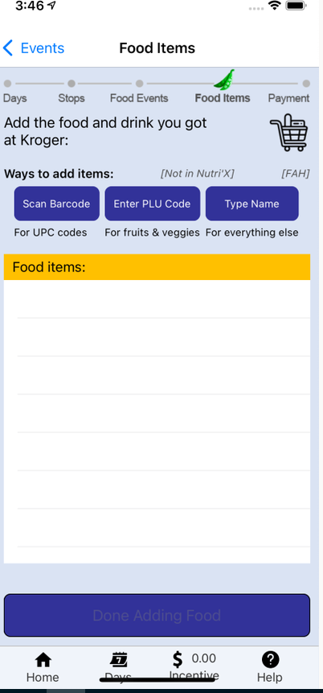

**ITEM_BARCODE_UPC: Please scan the item’s barcode:**

**If the item is incorrect, tap above to edit its name.**



**ITEM_PLU:** **Please enter the PLU code of this item.**

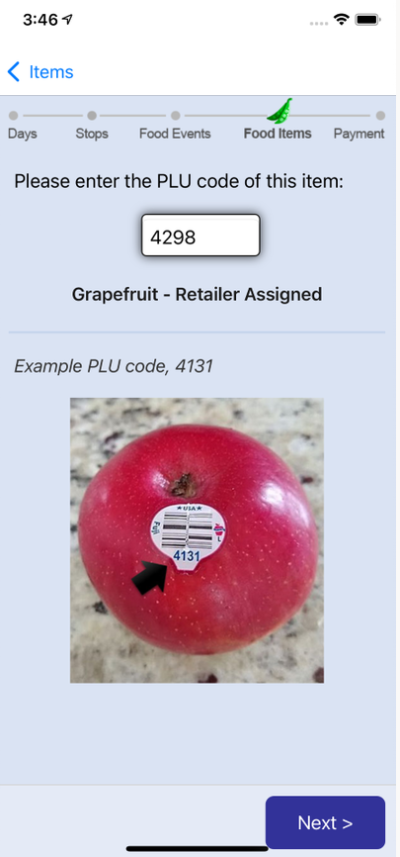

**ITEM_DESCRIPTION:** **Type name.**

___________________



[IF FAH_ITEM_ENTRY=2 (PLU CODE), GO TO PLU_SIZE_UNIT. ELSE GO TO INSTRUCTION BEFORE ITEM_UNIT]

**PLU_SIZE_UNIT: Is [] sold…**

1. By pound→GO TO ITEM_POUND

2. By single unit/bunch/head →GO TO ITEM_QUANTITY

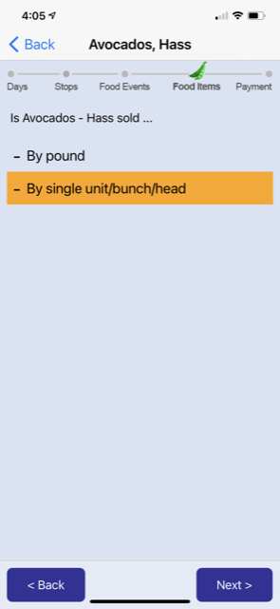

[IF FAH_ITEM_ENTRY =3 (TYPE NAME) OR BARCODE *NOT* MATCHED WITH WEIGHT, ASK ITEM_UNIT.]

**ITEM_UNIT:** **How would you like to report the packaging of the []?**

1. Beverage, bottle, can, carton→GO TO ITEM_VOLUME

2. Pre-packaged bag, box, package, container →GO TO ITEM_WEIGHT

3. Not pre-packaged, loose →GO TO ITEM_LOOSE



[IF ITEM_UNIT=1 (BOTTLE/CAN/CARTON) THEN ASK ITEM_VOLUME. ELSE GO TO INSTRUCTION BEFORE ITEM_WEIGHT]

**ITEM_VOLUME: What is the volume of *each* bottle/can/carton?**

___________

(ITEM_VOLUME_UNIT) **Choose a reporting unit:** (Fluid ounce, Milliliter, Liter, Gallon)

THEN GO TO ITEM_QUANTITY

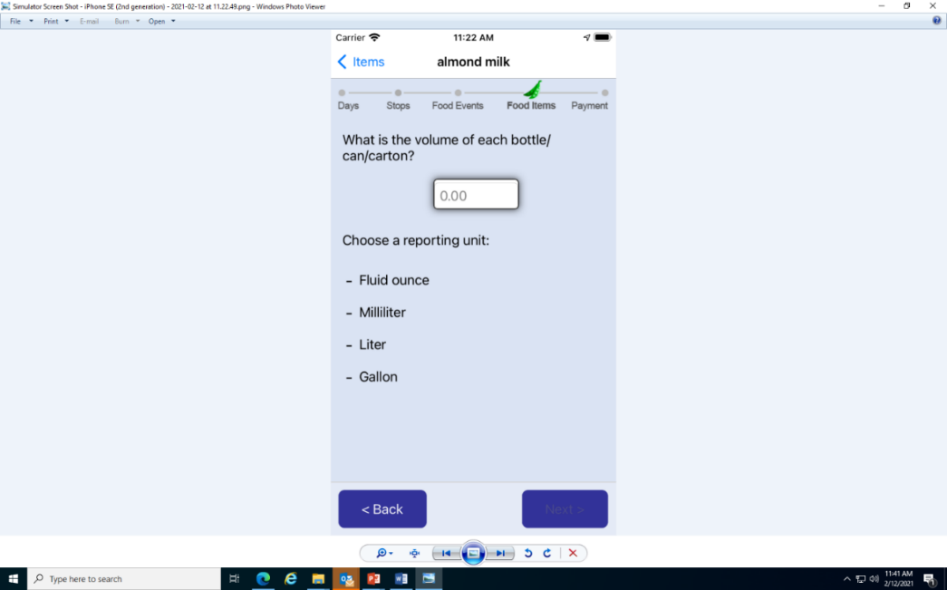

[IF ITEM_UNIT=2 (BOX/BAG/PACKAGE/CONTAINER) THEN ASK ITEM_WEIGHT. ELSE GO TO INSTRUCTION BEFORE ITEM_LOOSE]

(ITEM_WEIGHT) **What is the weight of each box/bag/package/container?____**

(ITEM_WEIGHT_UNIT) **Choose a reporting unit:** (Ounce, Pound, Gram)

THEN GO TO ITEM_QUANTITY

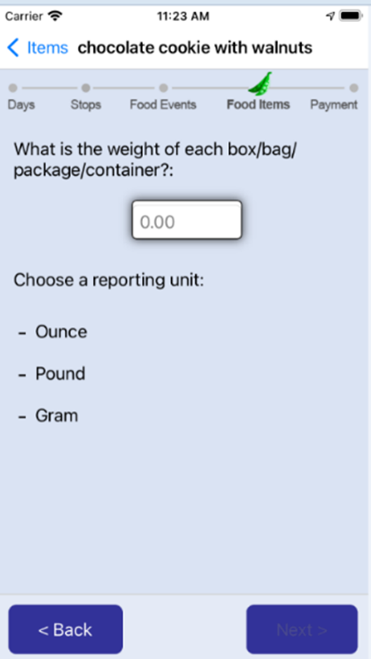

[IF ITEM_UNIT=3 THEN ASK ITEM_LOOSE. ELSE GO TO INSTRUCTION BEFORE ITEM_QUANTITY]

**ITEM_LOOSE. Is [] sold…**

1. By pound→GO TO ITEM_POUND

2. By piece or unit→GO TO ITEM_QUANTITY

3. By slice→GO TO ITEM_SLICE

4. Whole pizza/pie/cake→GO TO ITEM_QUANTITY

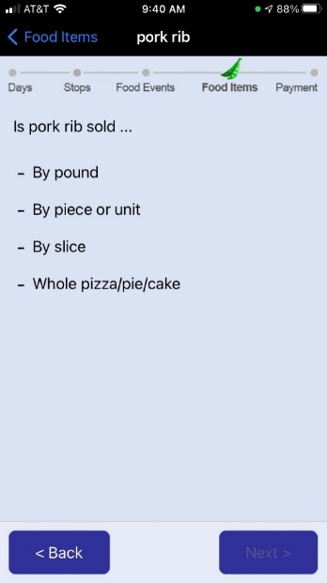

[IF ITEM_LOOSE=3 (BY SLICE), ASK ITEM_SLICE. ELSE GO TO INSTRUCTIONS BEFORE ITEM_POUND]

**ITEM_SLICE:** **How many slices of [] did you get?**

______________

THEN GO TO ITEM_AMOUNT



[IF PLU_SIZE_UNIT =1 (BY POUND) OR ITEM_LOOSE=1 (BY POUND), ASK ITEM_POUND. ELSE GO TO INSTRUCTIONS BEFORE ITEM_QUANTITY]

**ITEM_POUND:** **How many pounds of [] did you get?**

__________

THEN GO TO ITEM_AMOUNT

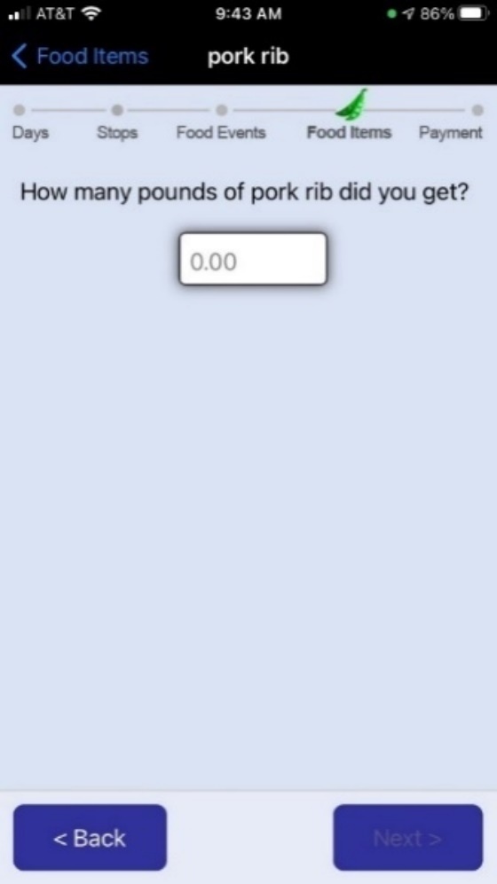

[IF BARCODE MATCHED WITH WEIGHT, OR PLU_SIZE_TYPE=2 (BY UNIT/BUNCH/HEAD), OR ITEM_UNIT=1 (BOTTLE/CAN/CARTON), OR ITEM_UNIT=2 (BAG/BOX/PACKAGE/CONTAINER), OR ITEM_LOOSE=2 (BY PIECE/UNIT), OR ITEM_LOOSE=4 (WHOLE PIZZA/PIE/CAKE), ASK ITEM_QUANTITY. ELSE ASK ITEM_AMOUNT]

**ITEM_QUANTITY:**

IF BARCODE MATCHED WITH WEIGHT, SHOW: **How many [] did you get?**



IF PLU_SIZE_TYPE=2 (BY UNIT/BUNCH/HEAD), SHOW: **How many units/bunches/heads of [] did you get?**

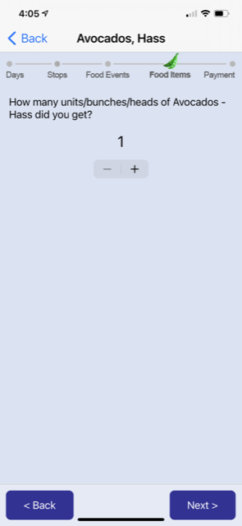

IF ITEM_UNIT=1 (BOTTLE/CAN/CARTON), SHOW: **How many bottles/cans/cartons of [] did you get?**

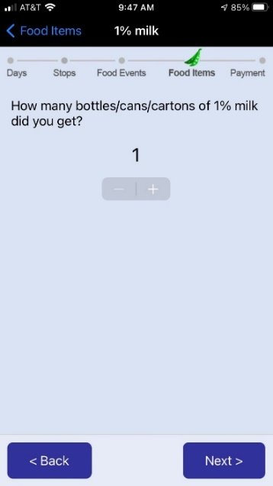

IFITEM_UNIT=2 (BAG/BOX/PACKAGE/CONTAINER), SHOW: **How many bags/boxes/packages/containers of [] did you get?**



IF ITEM_LOOSE=2 (BY PIECE/UNIT), SHOW: **How many pieces/units of [] did you get?**

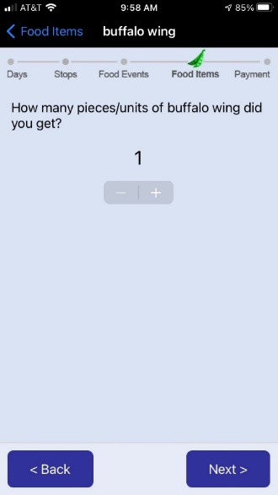

IF ITEM_LOOSE=4 (WHOLE PIZZA/PIE/CAKE), SHOW: **How many [] did you get?**

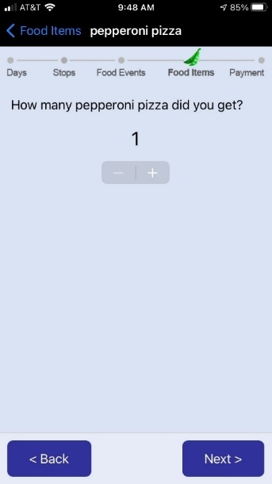

**[IF FREE EVENT, SKIP ITEM_AMOUNT]**

**ITEM_AMOUNT: How much did you pay after any discounts? (IF ITEM_QUANTITY>1, SHOW: You can choose to report the price per unit or total prices across all units.** )

$____

(IF ITEM_QUANTITY>1, SHOW:

**This is what you paid for:**

1. Each [FOOD ITEM NAME]
2. [ITEM_QUANTITY] [FOOD ITEM NAME])

[THEN GO TO FOOD ITEMS PAGE]

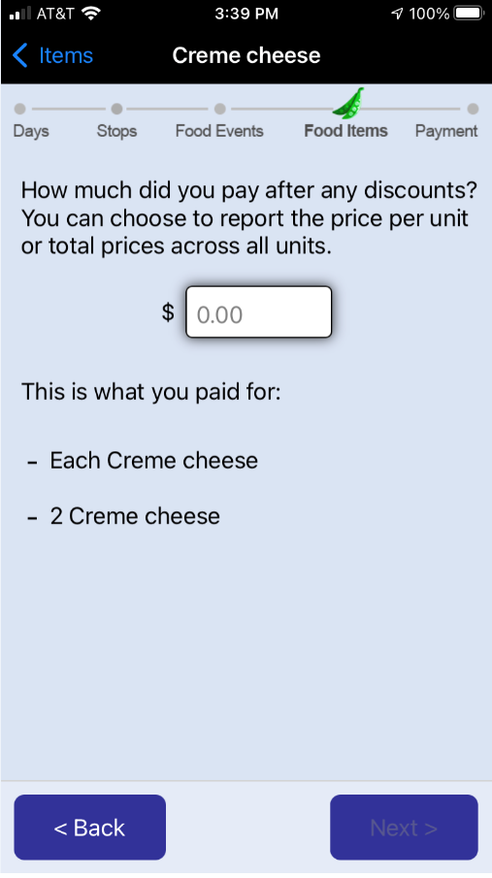

## Food Away from Home (FAFH) – Food Item page

**[IF FAFH EVENT, THEN ASK COMBO_OR_ITEM TO ITEM_OTHER_SPEC.]**

**COMBO_OR_ITEM:**

**Let’s get a list of all the food and drink you got at [].**

**Ways to add items**

1. COMBO MEAL (MULTIPLE ITEMS SOLD FOR ONE PRICE)

2. INDIVIDUAL ITEM (ITEMS SOLD SEPARATELY)

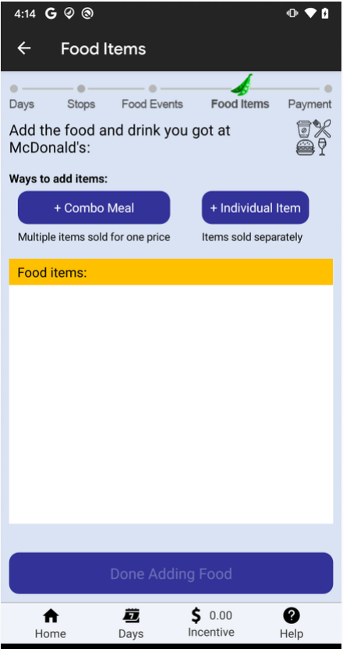

[PROGRAMMER NOTE: A RANDOM NUMBER IS TO BE GENERATED]

[IF GENERATED NUMBER DESIGNATE PICTURE, GO TO FAFH_PIC. ELSE GO TO INSTRUCTION BEFORE COMBO_NAME]

**PIC_TAKE. Please take a picture of this (COMBO_OR_ITEM=1: combo meal/COMBO_OR_ITEM=2: item). Is it available for photographing?**

1. Yes
2. No, I already ate it
3. No, I don’t want to

[PROGRAMMER NOTE: WHEN 2 OR 3 IS SELECTED, R IS TAKEN TO CMB_NAME OR FAFH_ITEM_NAME]



## Food Away from Home (FAFH), Combo Item section

[IF COMBO_OR_ITEM=1 (COMBO MEAL), ASK COMBO_NAME. ELSE GO TO FAFH_ITEM_NAME]

**CMB_NAME. When several food/drink items are sold together for one price, they are considered a combo meal. Type a name for the combo meal.**

______________

**CMB_QUANTITY. How many of this kind of meal did you get?**

_______________



[IF FREE EVENT, SKIP CMB_AMOUNT AND CMB_AMOUNT_SINGLE]

**CMB_AMOUNT. Enter what you actually paid for this item (after all discounts).**

$__________

**CMB_AMOUNT_SINGLE.**

**This is what you paid for:**

1. Each single [FILL IN: COMBO_NAME]
2. [FILL IN: COMBO_QUANTITY] [FILL IN: COMBO_NAME]

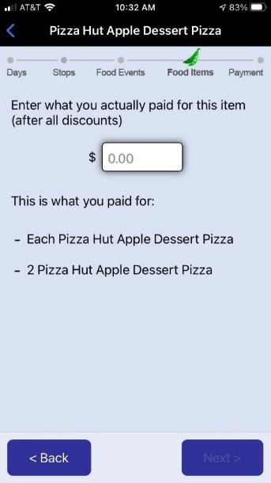

**CMB_ITEM_NAME_#: Report individual food/drink items included in [FILL IN: COMBO_NAME].**

**What is the name of the (first/next) food/drink item?**

______________



[IF FOOD PLACE IS IDENTIFIED IN NUTRITIONIX AND COMBO_NAME IS MATCHED IN MENU ITEMS IN NUTRITIONIX, GO TO COMBO_MORE. ELSE ASK COMBO_ITEM_TYPE].

**CMB_ITEM_TYPE_#. What type of food or drink is this item?**

1. Beverage →GO TO CMB_BEV_SIZE
2. Sandwich/sub →GO TO CMB_SUB_SIZE
3. Soup/Chili →GO TO CMB_SOUP_SIZE
4. Salad->GO TO CMB_SALAD_SIZE
5. Fries/Chips/Hash browns →GO TO CMB_FRIES_SIZE
6. Ice Cream→GO TO CMB_ICE_SIZE
7. Pizza, pie, or cake →GO TO CMB_PIE_SIZE
8. Chicken wings/tenders/nuggets →GO TO CMB_WING_SIZE
9. Other



**CMB_BEV_SIZE_#. What size is this beverage?**

1. Kid’s
2. Small
3. Medium
4. Large
5. Standard size/No size
6. Ounces
7. Other

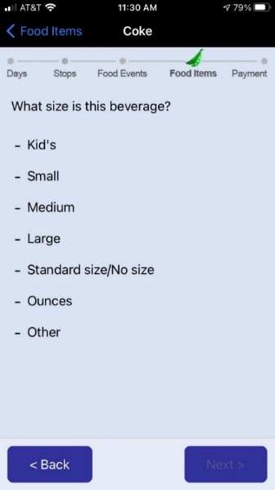

[IF CMB_BEV_SIZE_#=OUNCES, ASK CMB_BEV_SIZE_OUNCES_#. ELSE GO TO COMBO_MORE]

**CMB_BEV_SIZE_OUNCES_#: How many ounces?**

**_________**

THEN GO TO COMBO_MORE

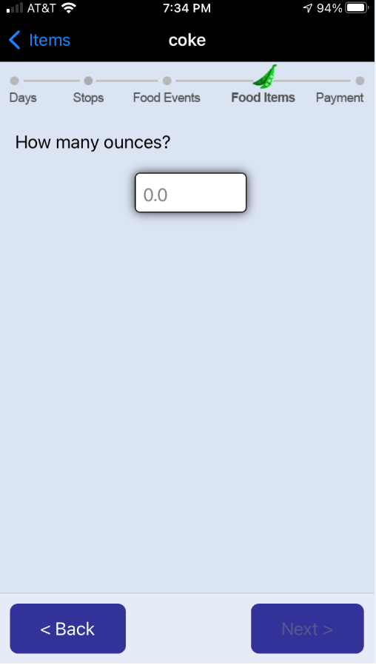

**CMB_SUB_SIZE_#. What size is the sandwich/sub?**

1. Half
2. Standard/No size
3. Inches
4. Other

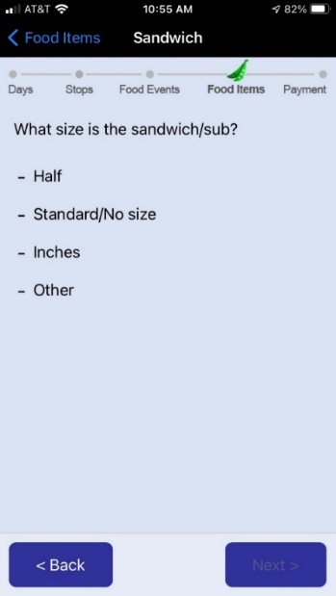

[IF CMB_SUB_SIZE_#=INCHES, ASK CMB_SUB_SIZE_INCHES_#. ELSE GO TO COMBO_MORE]

**CMB_SUB_SIZE_INCHESES_#: How many inches?**

_________

THEN GO TO COMBO_MORE

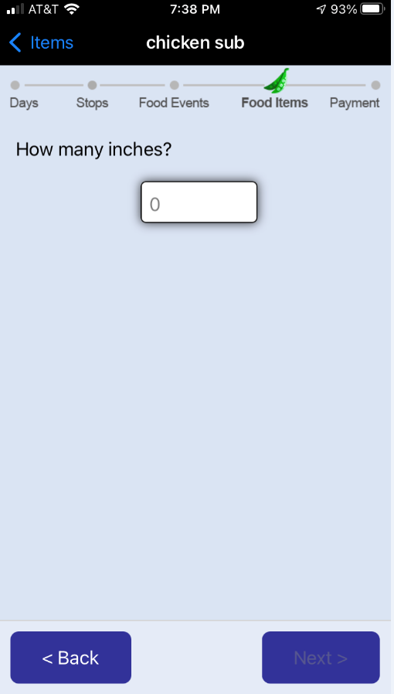

**CMB_SOUP_SIZE_#. What size is the soup?**

1. Cup
2. Bowl
3. Other

THEN GO TO COMBO_MORE

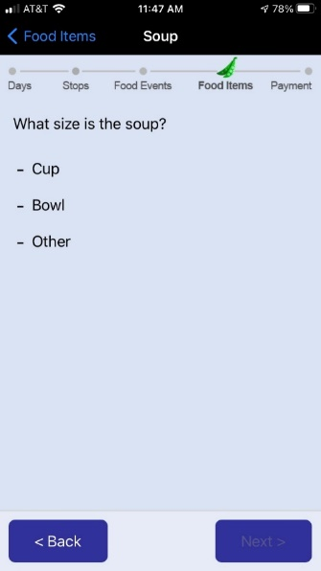

**CMB_SALAD_SIZE_#. Is this salad…?**

1. Side or half a salad
2. Entrée salad
3. Other

THEN GO TO COMBO_MORE

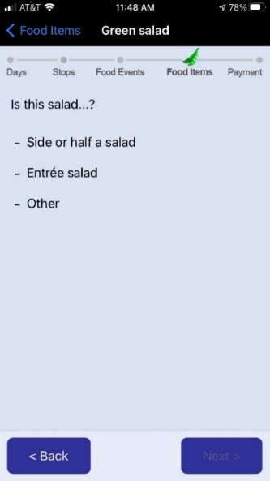

**CMB_FRIES_SIZE_#. What size is [FILL IN: COMBO_ITEM_NAME]?**

1. Kid’s

2. Small

3. Medium

4. Large

5. Standard/No size

6. Other

THEN GO TO COMBO_MORE

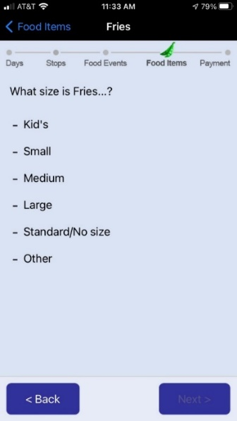

**CMB_ICE_SIZE_#. What size is the ice cream?**

1. Kid’s
2. Small
3. Medium
4. Large
5. Scoops
6. Other

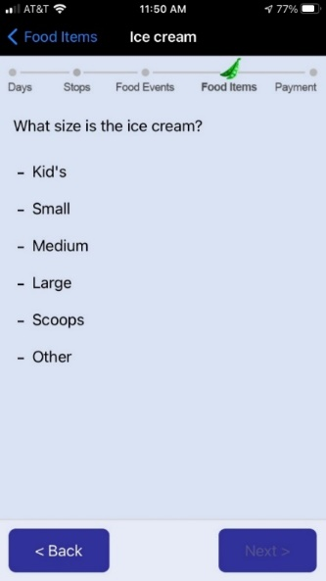

[IF CMB_ICE_SIZE_#=SCOOPS, ASK CMB_ICE_SIZE_SCOOPS_#. ELSE GO TO COMBO_MORE]

**CMB_ICE_SIZE_SCOOPS_#: How many scoops?**

_________

THEN GO TO COMBO_MORE

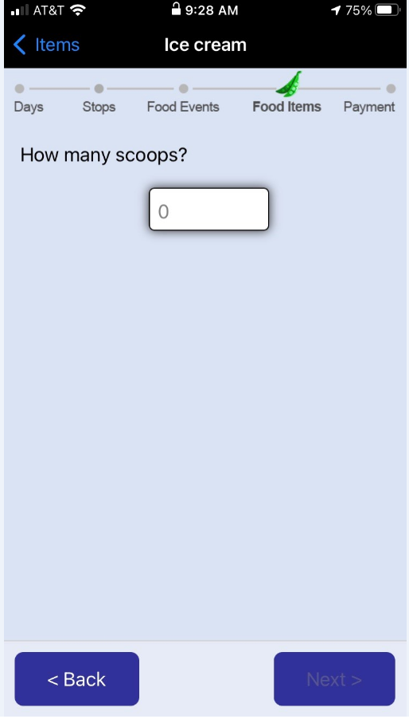

**CMB_PIE_SIZE_#. Is it a…?**

1. Kid’s/Personal Size
2. Whole
3. Slice
4. Inches

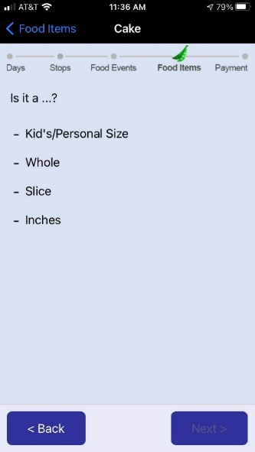

[IF CMB_PIE_SIZE_#=INCHES, ASK CMB_PIE_SIZE_INCHES_#. ELSE GO TO COMBO_MORE]

**CMB_PIE_SIZE_INCHESES_#: How many inches?**

**_________**

THEN GO TO COMBO_MORE

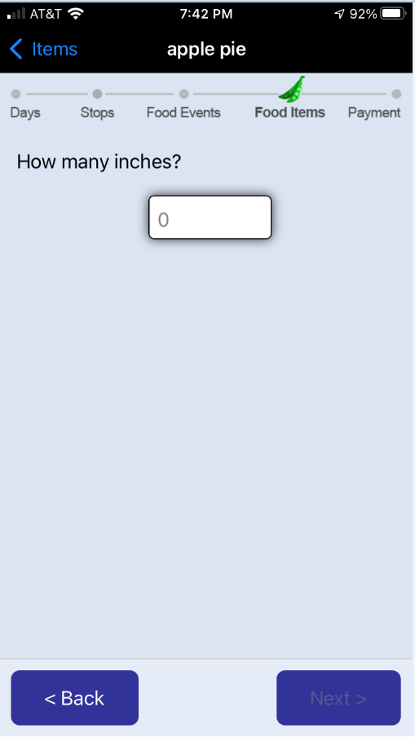

**CMB_WING_SIZE_#:** How many pieces did you get?

________________

THEN GO TO COMBO_MORE

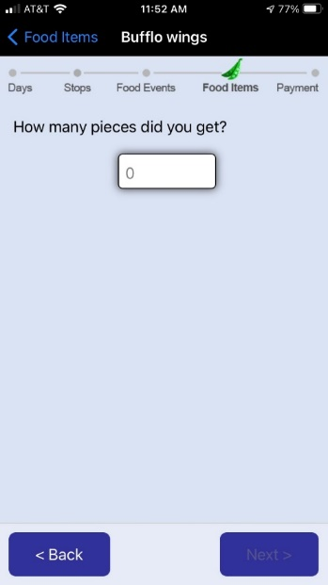

**COMBO_MORE. So far, [COMBO_NAME] contains:**

1. **[COMPONENT FOOD NAME]**

**Are there other food or drink items included in [FILL IN: COMBO_NAME]?**

1. Yes, add one more food/drink item→GO TO COMBO_ITEM_NAME
2. No, done reporting this combo →GO TO COMBO_OR_ITEM



## Food Away from Home (FAFH), Individual Item section

[IF COMBO_OR_ITEM=2 (INDIVIDUAL FOOD ITEM), ASK FAFH_ITEM_NAME. ELSE GO TO INSTRUCTIONS BEFORE EVENT_AMOUNT]

**FAFH_ITEM_NAME. Type the name of the individual food/drink.**

_____________________

**FAFH_ITEM_QUANTITY. How many did you get?**

______________



[IF FREE EVENT, SKIP FAFH_ITEM_AMOUNT AND FAFH_ITEM_AMOUNT_SINGLE]

**FAFH_ITEM_AMOUNT. Enter what you actually paid for this item (after all discounts).**

$:___________

[IF FAFH_ITEM_QUANTITY>1, SHOW FAFH_ITEM_AMOUNT_SINGLE]

**FAFH_ITEM_AMOUNT_SINGLE**

**This is what you paid for:**

- [FILL IN: FAFH_ITEM_NAME

- [FILL IN: FAFH_ITEM_QUANTITY] [FILL IN: FAFH_ITEM_NAME]

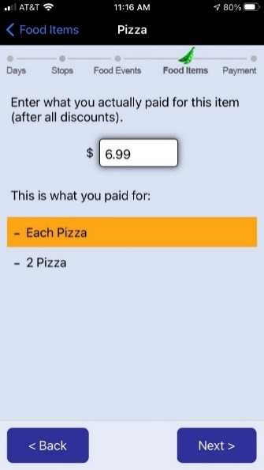

[IF FOOD PLACE IS IDENTIFIED IN NUTRITIONIX AND FAFH_ITEM_NAME IS MATCHED IN NUTRITIONIX, GO TO COMBO_OR_ITEM. ELSE ASK FAFH_ITEM_TYPE].

**FAFH_ITEM_TYPE What type of food or drink is this item?**

1. Beverage →GO TO ITEM_BEV_SIZE
2. Sandwich/sub →GO TO ITEM_SUB_SIZE
3. Soup/Chili →GO TO ITEM_SOUP_SIZE
4. Salad->GO TO ITEM_SALAD_SIZE
5. Fries/Chips/Hash browns →GO TO ITEM_FRIES_SIZE
6. Ice Cream →GO TO ITEM_ICE_SIZE
7. Pizza, pie, or cake →GO TO ITEM_PIE_SIZE
8. Chicken wings/tenders/nuggets -GO TO ITEM_WING_SIZE
9. Other

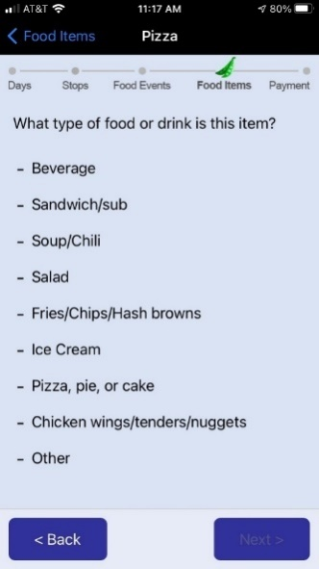

**ITEM_BEV_SIZE. What size is this beverage?**

1. Kid’s
2. Small
3. Medium
4. Large
5. Standard/No size
6. Ounces
7. Other

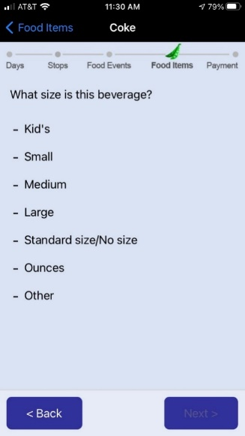

[IF ITEM_BEV_SIZE_#=OUNCES, ASK ITEM_BEV_SIZE_OUNCES_#. ELSE GO TO COMBO_OR_ITEM]

**ITEM_BEV_SIZE_OUNCES_#: How many ounces?**

_________



THEN GO TO COMBO_OR_ITEM

**ITEM_SUB_SIZE. What size is the sandwich/sub?**

1. Half
2. Standard/No size
3. Inches
4. Other

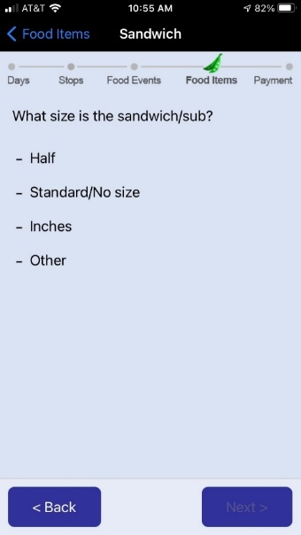

[IF ITEM_SUB_SIZE_#=INCHES, ASK ITEM_SUB_SIZE_INCHES_#. ELSE GO TO COMBO_OR_ITEM]

**ITEM_SUB_SIZE_INCHESES_#: How many inches?**

_________

THEN GO TO COMBO_OR_ITEM



**ITEM_SOUP_SIZE. What size is the soup?**

1. Cup

2. Bowl

3. Other

THEN GO TO COMBO_OR_ITEM

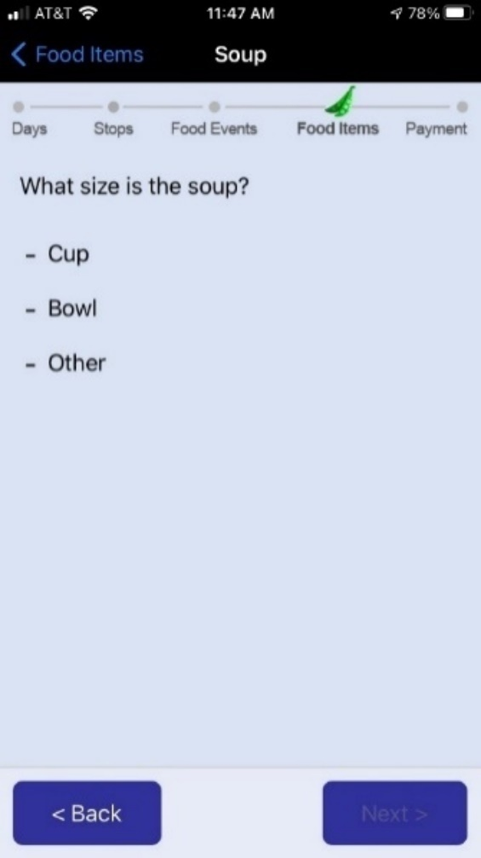

**ITEM_SALAD_SIZE. Is this salad…?**

1. Side or half a salad
2. Entrée salad
3. Other

THEN GO TO COMBO_OR_ITEM

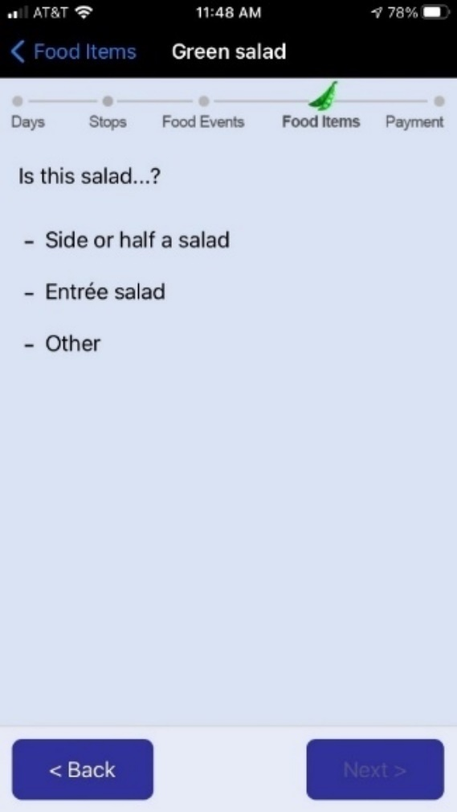

**ITEM_FRIES_SIZE. What size is [FILL IN: FAFH_ITEM_NAME]?**

1. Kid’s
2. Small
3. Medium
4. Large
5. Standard/No size
6. Other

THEN GO TO COMBO_OR_ITEM

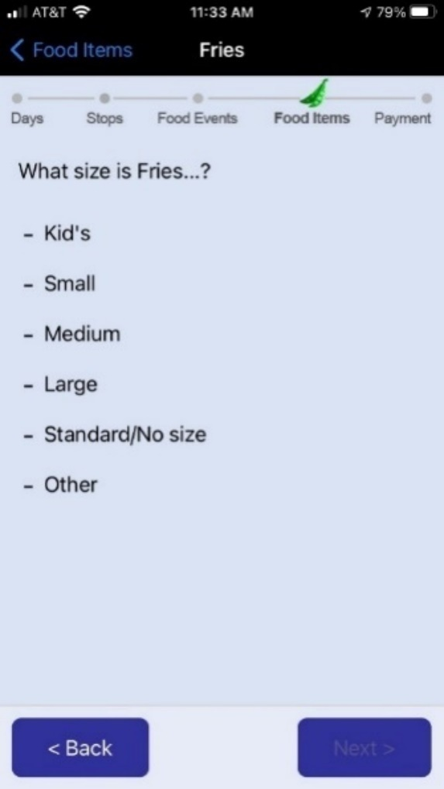

**ITEM_ICE_SIZE. What size is the ice cream?**

1. Kid’s
2. Small
3. Medium
4. Large
5. Scoops
6. Other

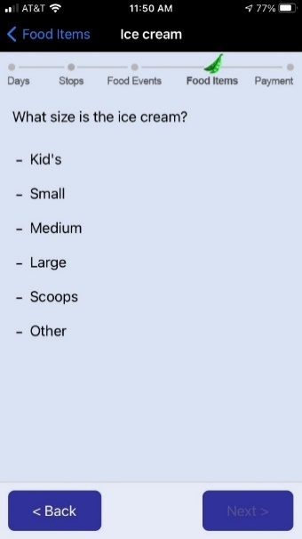

[IF ITEM_ICE_SIZE_#=SCOOPS, ASK ITEM_ICE_SIZE_SCOOPS_#. ELSE GO TO COMBO_OR_ITEM]

**ITEM_ICE_SIZE_SCOOPS_#: How many scoops?**

**_________**

THEN GO TO COMBO_OR_ITEM



**ITEM_PIE_SIZE. Is it a…?**

1. Kid’s/Personal Size
2. Whole
3. Slice
4. Inches

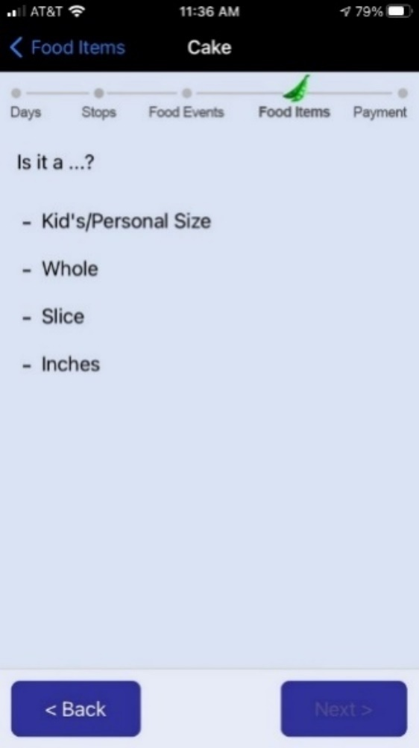

[IF ITEM_PIE_SIZE_#=INCHES, ASK ITEM_PIE_SIZE_INCHES_#. ELSE GO TO COMBO_OR_ITEM]

**ITEM_PIE_SIZE_INCHES_#: How many inches?**

_________

THEN GO TO COMBO_OR_ITEM



**ITEM_WING_SIZE. How many pieces did you get?**

____________

THEN GO TO COMBO_OR_ITEM

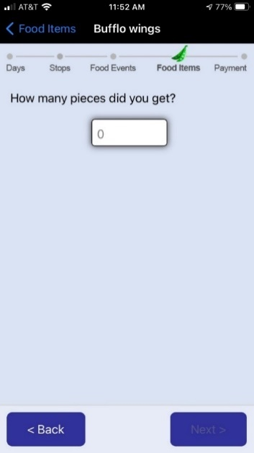

# E. FOOD EVENT PAYMENT QUESTIONS (SURVEY 107)

[IF EVENT_TYPE=1 (I OR SOMEONE IN MY HOSEHOLD PAID, ASK EVENT_AMOUNT. ELSE GO TO EVENT_TIP]

**EVENT_AMOUNT. Enter the total amount paid for this food/drink purchase including tax, tip, non-food items, and delivery/service fees.**

$_______

**\***

**-**

**EVENT_TIP. Does the total amount paid include a tip?**

1. Yes

2. No



[IF WHERE_FOOD=3 (DELIVERY PURCHASE), ASK EVENT_DELIVERY. ELSE GO TO INSTRUCTIONS BEFORE NON_FOOD]

**EVENT_DELIVERY. Did you or someone in your household pay for delivery/service fees?**

1. Yes

2. No



[IF EVENT_TYPE=1 (I OR SOMEONE IN MY HOSEHOLD PAID), ASK NON_FOOD. ELSE GO TO HAVE_RECEIPT]

**NON_FOOD.** **Are there any non-food or non-drink items (such as paper towels, napkins, toiletries, etc.) included in this purchase?**

1. Yes

2. No

3. Don’t know

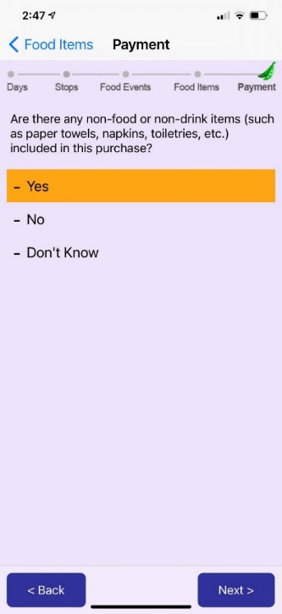

**EVENT_PAYMENT. How did you pay for this food/drink? Check all that apply.**

1. Cash

2. Credit card

3. Debit card

4. Mobile payment (e.g., Apple Pay)

5. SNAP EBT

6. WIC or WIC EBT

7. School Meal Card

8. Personal Check

9. Gift card

10. Other (Specify: _________)



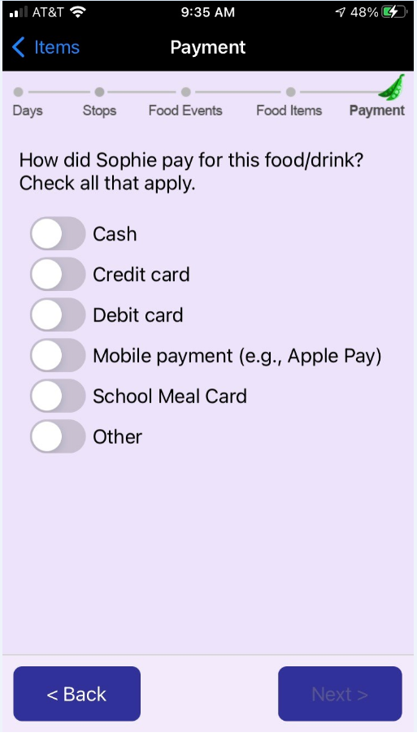

[IF EVENT_PAYMENT=5 (SNAP EBT), ASK EVENT_SNAP. ELSE GO TO EVENT_COUPON]

**EVENT_SNAP: How much did {you/NAME} pay with {your/his/her? SNAP EBT card?**

$_______

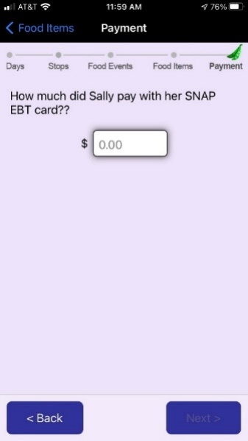

**EVENT_COUPON. Did you receive any discounts for this purchase (either from a sale, coupon, or use of a store loyalty card)?**

1. Yes

2. No



**HAS_RECEIPT. Do you have a receipt from the food/drink purchase?**

1. Yes, I have a paper receipt

2. Yes, I have an electronic receipt

3. No, I don’t have a receipt →GO TO FOOD EVENTS PAGE



[IF HAS_RECEIPT=1 (PAPER RECEIPT), NEXT SCREEN ALLOWS RS TO TAKE A PICTURE OF THE RECEIPT OR UPLOAD THE PICTURE OF RECEIPT FROM ALBUM, THEN GO TO FOOD EVENTS PAGE]

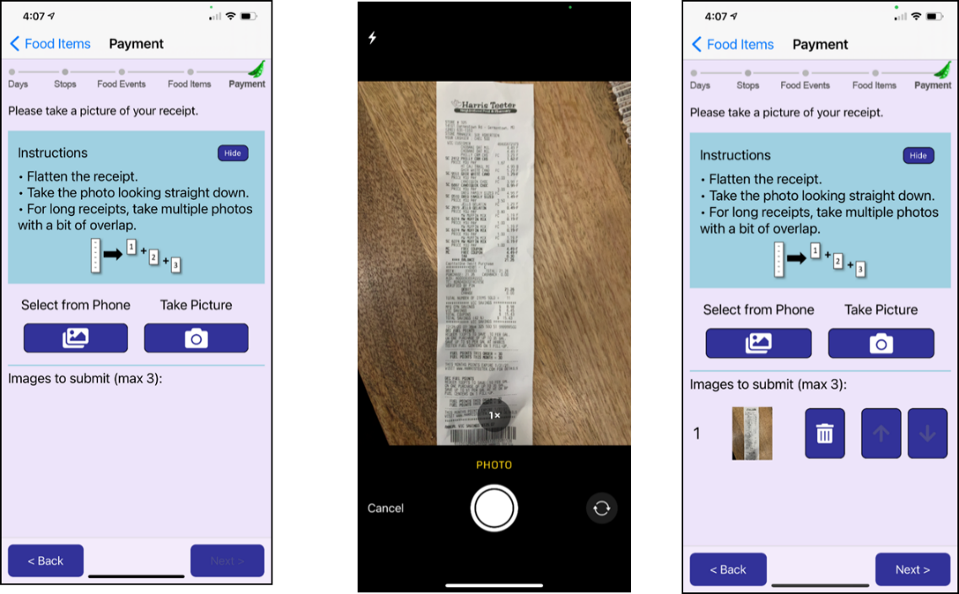

IF HAS_RECEIPT=2 (ELECTRONIC RECEIPT), NEXT SCREEN ALLOWS RS TO TAKE A SCREEN CAPTURE OF ELECTRONIC RECEIPT, OR COPY AND PASTE FROM ELECTRONIC RECEIPT. THEN GO TO FOOD EVENTS PAGE.

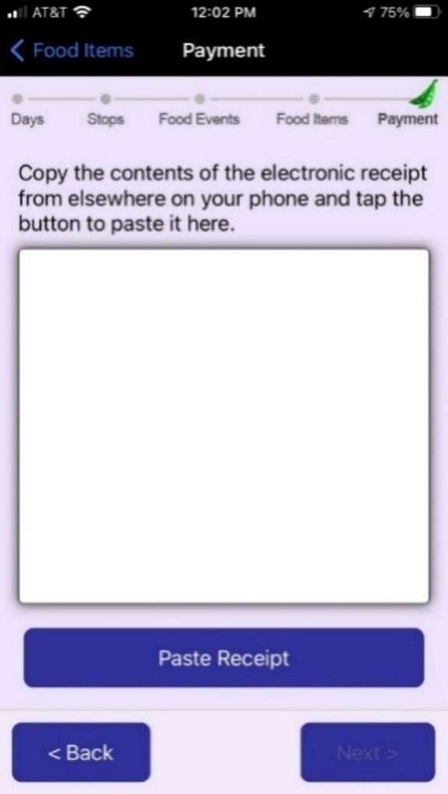

# F. DAY OVERVIEW QUESTIONS (SURVEY 104)

[WHEN PARTICIPANT CLICKS ON ‘DAY SURVEY’ ICON, THEY ARE BROUGHT TO THIS SURVEY]

[PROGRAMMER NOTE:

FOR HEADER:

* Use short date including short version of day of week (Mon, Tues, etc.).
* Use short month (e.g., Jan, Feb, Mar) – not the numerical month (1, 2, 3) as the words are easier to read.

Type: A set of toggle buttons.

* Each toggle button should be OFF by default.
* It’s OK if RESPONDENT checks NONE of these items.
* Show long version of day of week in bold (e.g., Monday, Tuesday).

]

**MEALS_SNACKS:** **We have just a few additional questions about the food you obtained on [DAY].**

**What meals and snacks did you eat on this day?**

1. Breakfast
2. Morning snack
3. Lunch
4. Afternoon snack
5. Dinner
6. Evening snack.
7. None of the above

[Dev notes

* DAY should be the long version of the weekday (e.g., “Monday”)
* Choices above are toggle switches
* User is NOT required to check any of them.

]

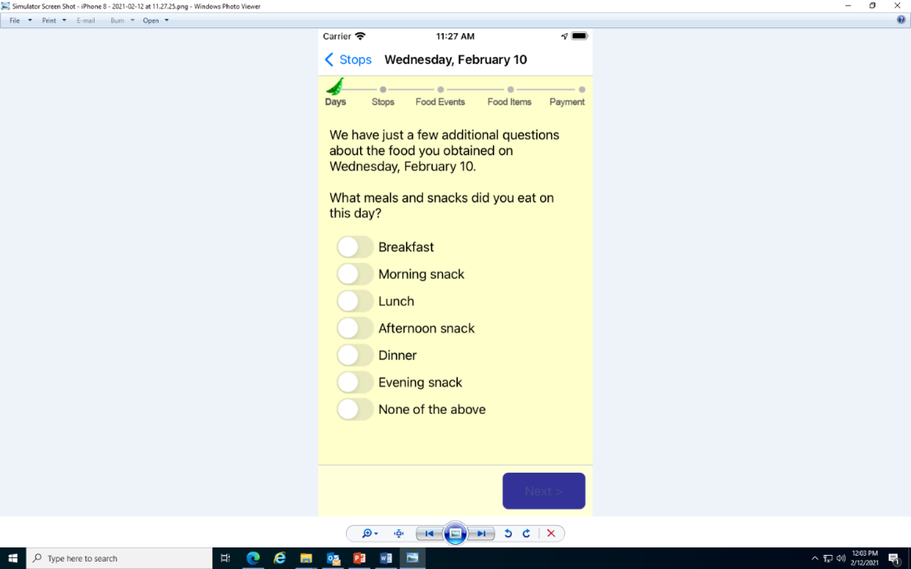

**REPORTED_ALL:** **Thinking about the meals and snacks you checked above, are you sure you reported all the food you bought or obtained for free on this day?**

[PROGRAMMER: IF NO FOOD EVENT IS REPORTED, SHOW OPTIONS 1 AND 3. IF AT LEAST ONE FOOD EVENT IS REPORTED, SHOW OPTIONS 2 AND 3].

1. I DID NOT buy or obtain for free any food on this day.
2. I reported *all* the food I bought or obtained for free on this day.
3. I forgot to report some food I bought or obtained for free on this day.

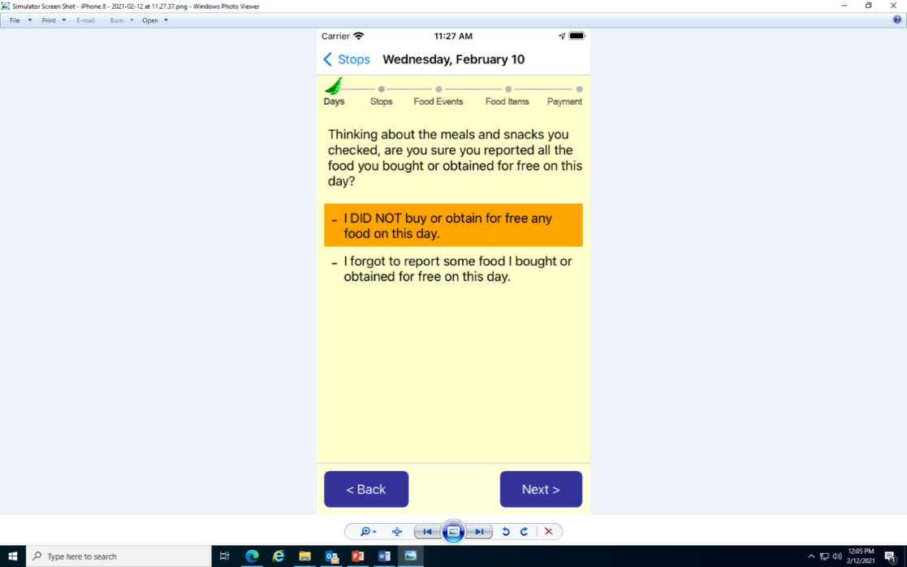

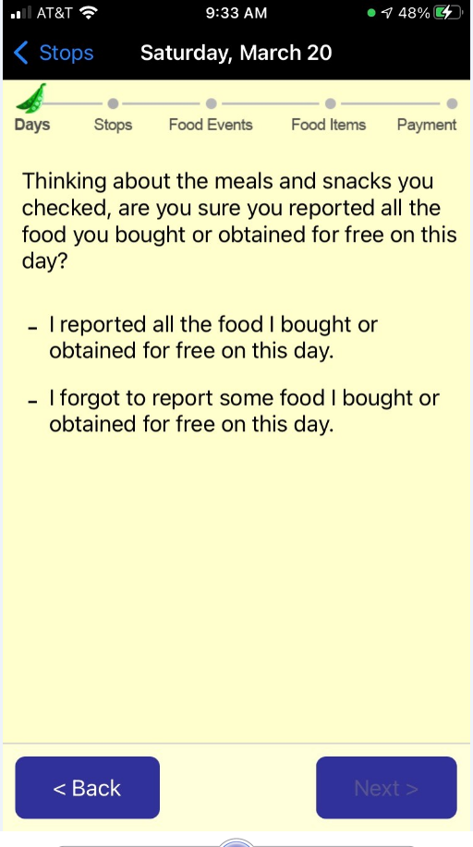

**FOOD_NONHH:** **Did you buy food or drinks for anyone who is not in your household on this day?**

1. Yes
2. No

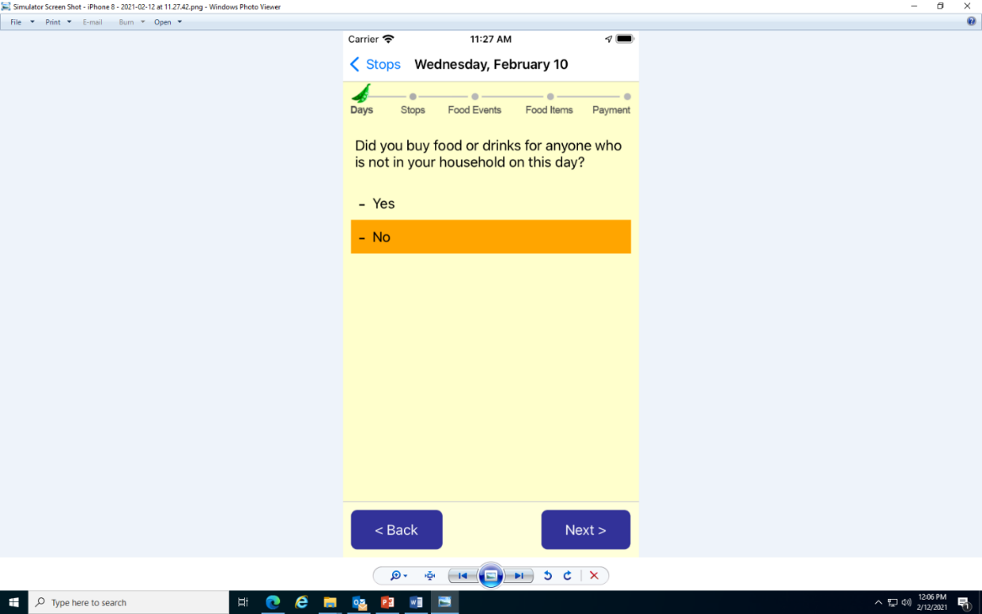

[IF REPORTED_ALL=1 (I DID NOT GET FOOD) OR 2 (I REPORTED ALL FOOD), SHOW DO_END. ELSE GO TO DO_3]

**DO_END:** **Thank you for completing [DAY]! Tap FINISH to return to the list of days.**

[PROGRAMMER NOTE:

* DAY = long form of day of week (e.g., “Monday”).
* TAKE RESPONDENT BACK TO LIST OF DAYS AND MARK THE DAY AS COMPLETE, UPDATE TILE ACCORDINGLY
* Note: ALLOW RESPONDENT TO GO BACK TO THE DAY TO ENTER MORE FOOD EVENTS. IF NEW FOOD EVENT IS ENTERED, WE NEED TO REVALIDATE ON MISSING DATA. IF THERE IS MISSING DATA, UPDATE TILE TO SHOW THE NEW STATUS. In other words, completing the Day Survey does NOT lock the day from being changed.]

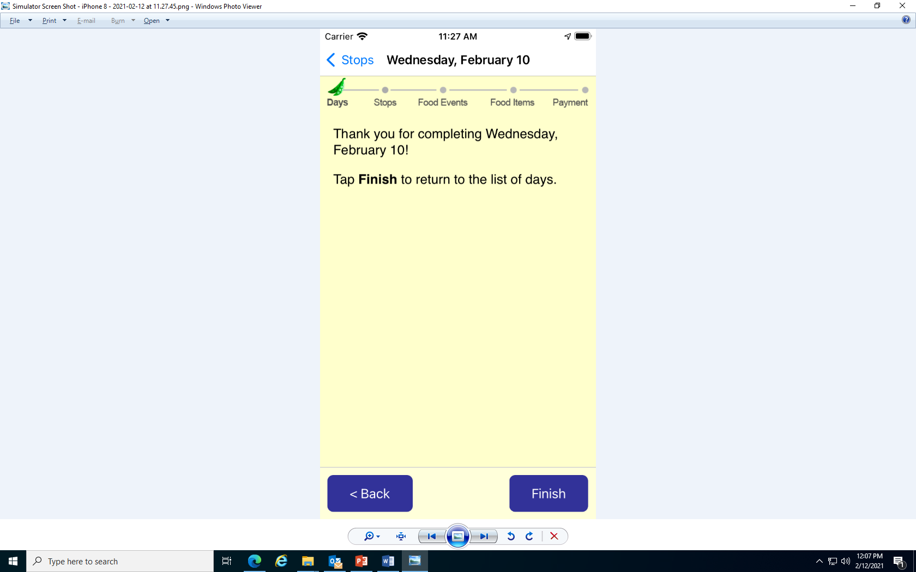

[IF REPORTED_ALL=3 (I FORGOT TO REPORT SOME FOOD ITEMS), ASK DO_3].

[PROGRAMMER NOTE: showing day of week on this page -- use long form (“Monday”, etc.)]

**DO_3**. **No problem!**

**To add missing food items, tap Next to return to [DAY].**

**Tap a link, “Tap to add a missing stop for food or drink” to report a food event.**

[PROGRAMMER NOTES:

* DAY = long version of day of week (e.g., “Monday”).
* Takes RESPONDENTS to STOPS page for this particular day.]

