Appendix Z: Instructions for Installing Microsoft Teams and Sharing Smartphone Screen
- On your smartphone, go to the App store (on iPhones) or Google Play store (for Androids).
- Search “Microsoft Teams”
- Download the free Microsoft Teams app
- On your smartphone, open the email from the researchers that contains the invitation to the Microsoft Teams meeting
- Tap “Click here to join the meeting”. The Microsoft Teams app will open automatically.

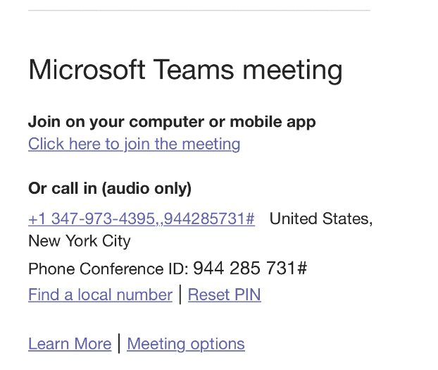

- Tap “Join as a guest” then enter your name and tap “Join meeting”

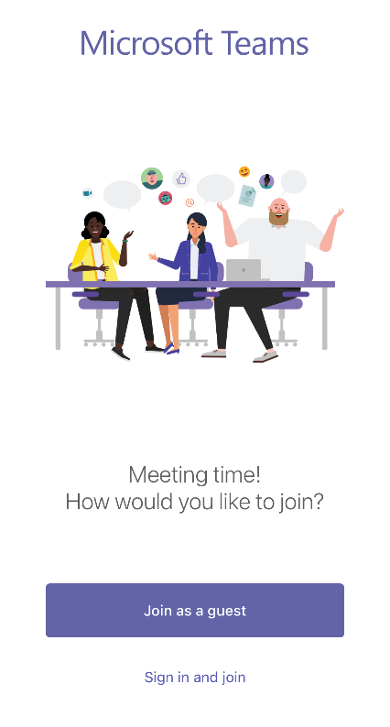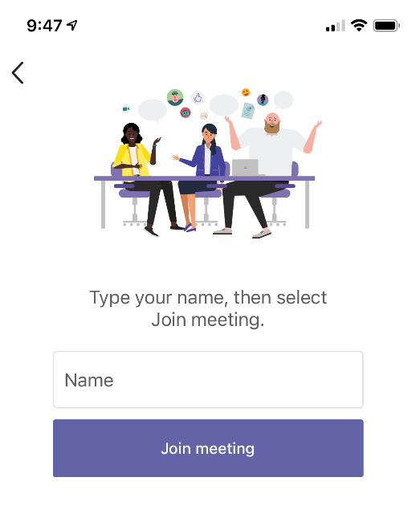

- After you are admitted into the meeting, to share your screen, tap the three dots at the bottom of the screen.
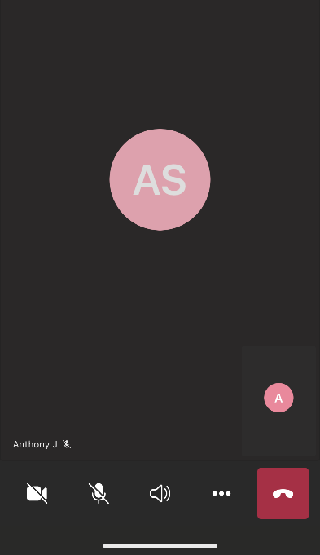
- Tap “Share” then tap “Share screen”
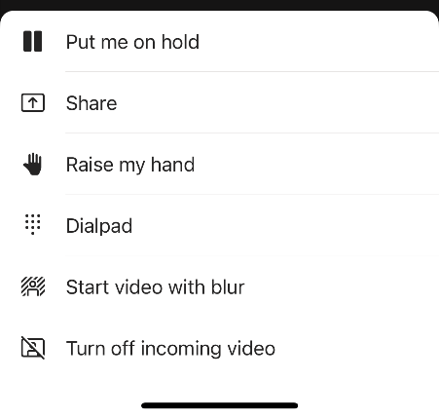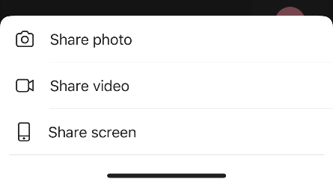

- Tap “Start Broadcast”. Broadcast will begin with message. You are now sharing your smartphone screen. For iPhones, there will be a red oval around the time in the upper left to indicate your screen is being shared.
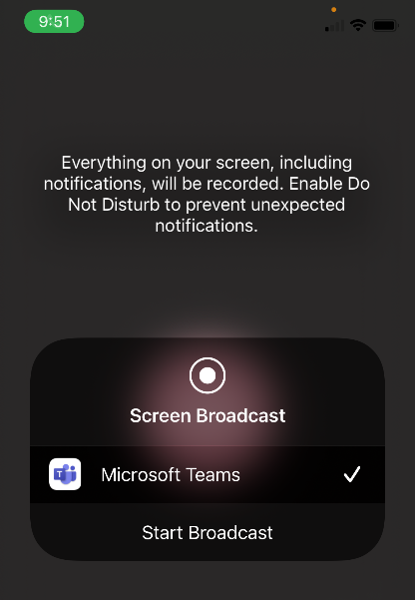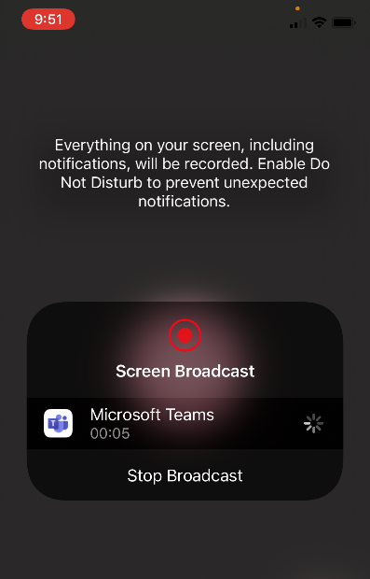

- Exit the Teams app and open the FoodLogger app.

- After the research session, return to the Teams app and tap “Stop presenting” and exit the meeting by tapping the red square on the bottom right of the screen.

