Welcome page.

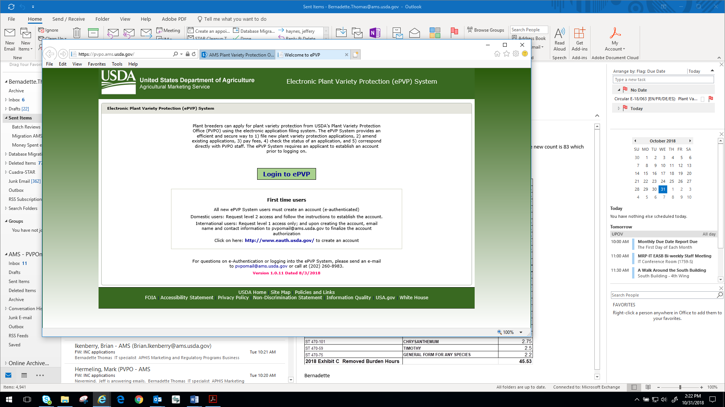

Internal User Main Page

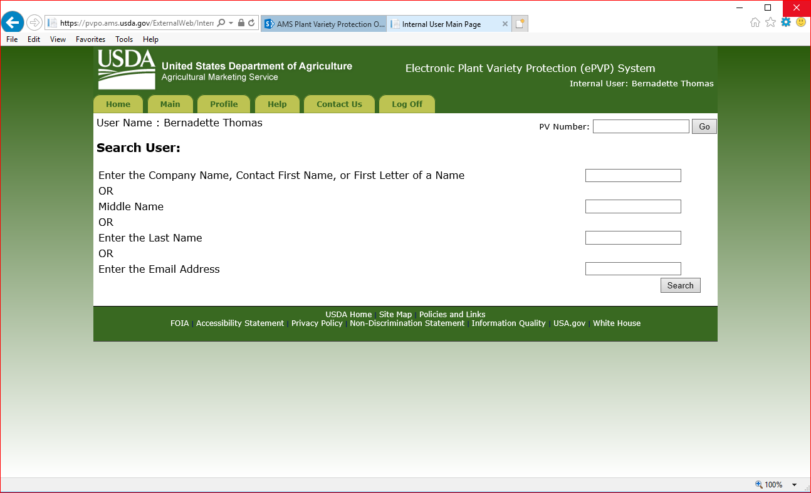

External User Main Page (Copy sent by user)

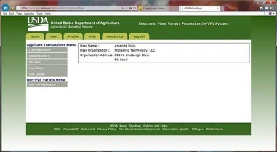

Application (ST-470)

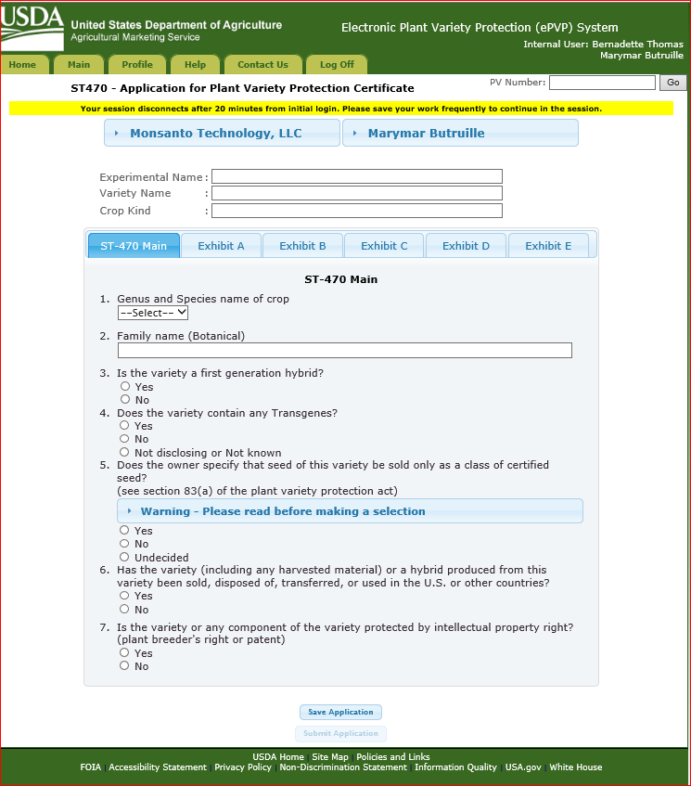

Exhibit A

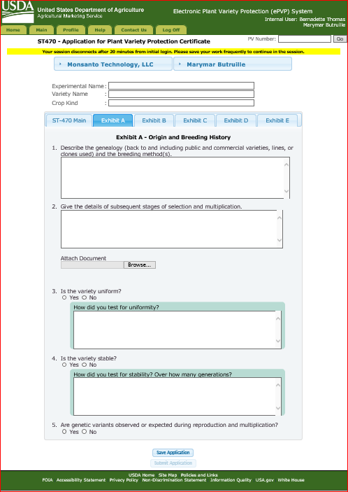

Exhibit B

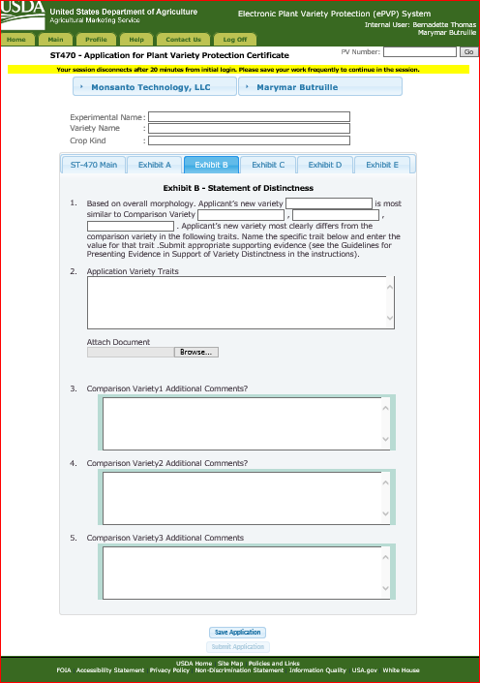

Exhibit C

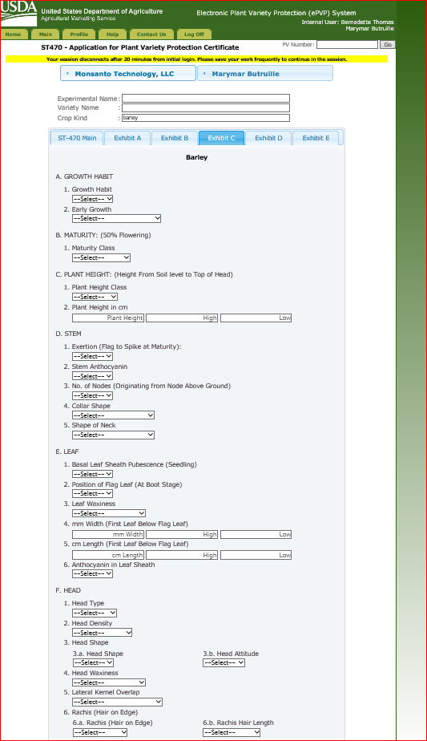 Could not capture the entire Exhibit C form in one snapshot.

Exhibit D

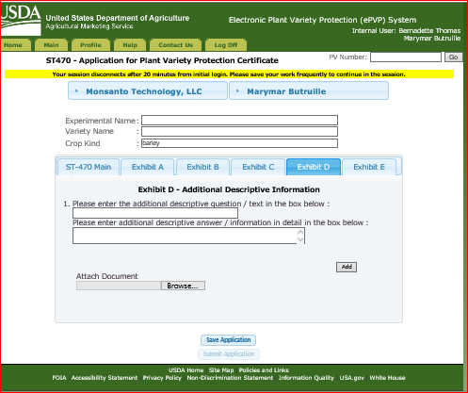

Exhibit E

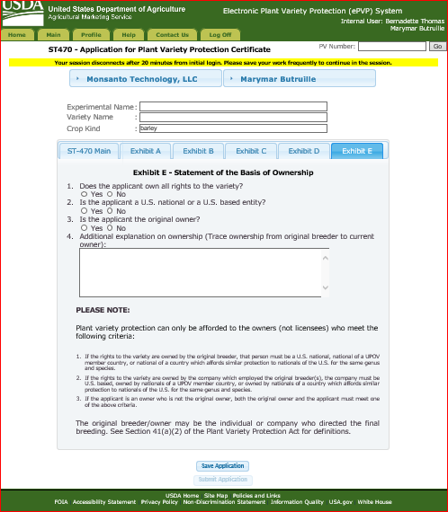

Pay Fees page contain a list of applications that require fee payments. You select from that list and Continue to the pay.gov section.

Pay.gov – the user is redirected to a page in pay.gov. The only information is returned to epvp is the information on the image below which is stored in the CRM part of the system.

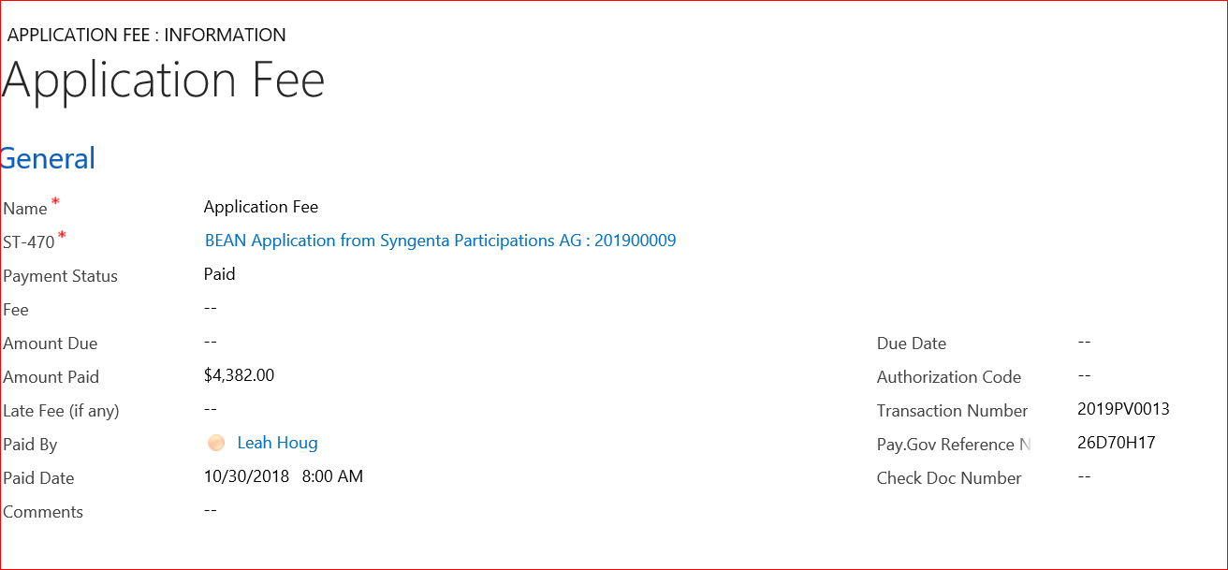

Workplace

ST 470 with DropDown sections

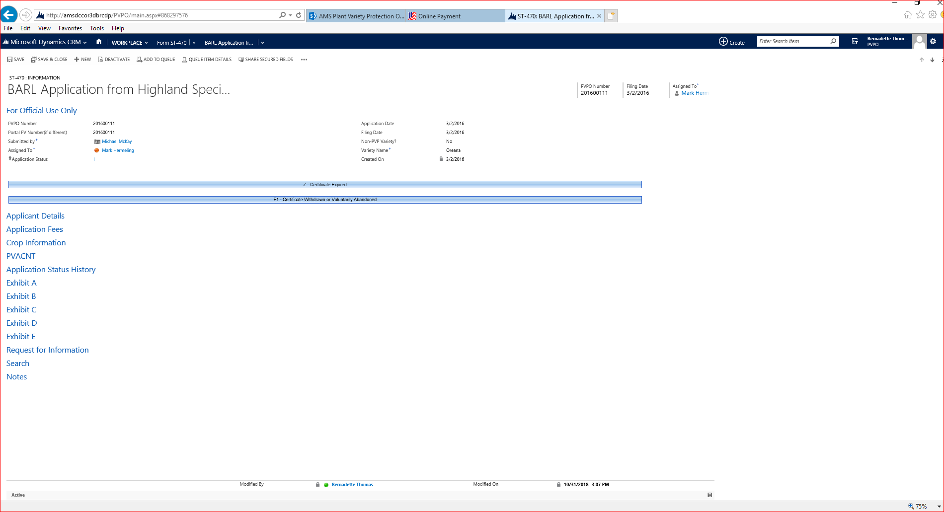

Exhibit C crop data from Portal submission

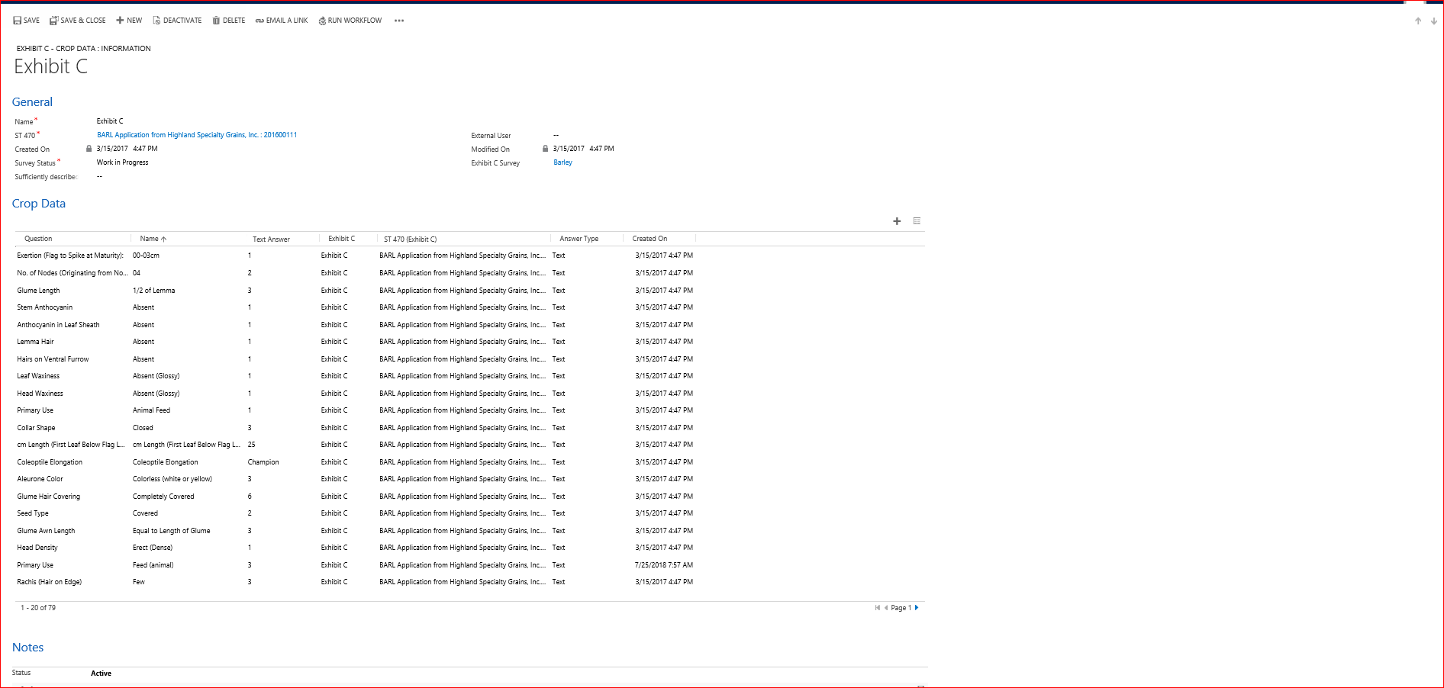

ST 470 Application information from Portal data entry

