Appendix E:   
Screening Questionnaires

Appendix E1:   
Web-Based Screening Questionnaire

Screen 1

Thank you for your interest in our research study, which is funded by the U.S. Department of Agriculture and conducted by researchers from North Carolina State University and RTI International.

According to the Paperwork Reduction Act of 1995, an agency may not conduct or sponsor, and a person is not required to respond to, a collection of information unless it displays a valid OMB control number. The valid OMB control number for this information collection is 0583-0169 and the expiration date is xx/xx/xxxx. The time required to complete this information collection is estimated to average 8 minutes per response, including the time for reviewing instructions, searching existing data sources, gathering and maintaining the data needed, and completing and reviewing the collection of information.

Screen 2

If you are eligible for the study, you will be asked to prepare a meal using pre-packaged frozen foods while being videotaped and participate in an interview. The study will last up to 90 minutes, and you will receive a $75 gift card and a small gift for taking part in the study.

To determine whether you are eligible, you will need to answer a few questions. These questions will take less than 10 minutes to complete. Your participation in this study is completely voluntary. All of your answers and your contact information will be kept private. Please click the “>>” arrows below if you would like to continue.

Question Screens

1. Have you received any type of food safety training, such as ServSafe, in the past 5 years?

Yes 🡪***Ineligible. Terminate.***

No

1. Have you cooked or worked professionally in a food preparation setting in the past 5 years?

Yes 🡪***Ineligible. Terminate.***

No

1. Have you participated in any research studies about cooking in the past 2 years?

Yes 🡪***Ineligible. Terminate.***

No

1. Do you have any children living in your household who are less than 18 years of age?

Yes

No

1. Which of the following have you purchased in the past 6 months for your family to eat at home?*(Select all that apply.)*

Frozen pizza

Frozen waffles

Frozen breaded chicken nuggets or tenders

Frozen stuffed chicken, such as chicken Cordon bleu or chicken Kiev

Frozen pre-formed hamburger patties

Frozen vegetables

Frozen fruit

1. Which of the following have you prepared at home in the past 6 months?*(Select all that apply.)*

Frozen pizza

Frozen waffles

Frozen breaded chicken nuggets or tenders

Frozen stuffed chicken breasts, such as chicken Cordon bleu or chicken Kiev

Frozen pre-formed hamburger patties

Frozen vegetables

Frozen fruit

1. [IF Q4 = YES] Which of the following have your children, 18 years or younger, prepared at home in the past 6 months?*(Select all that apply.)*

Frozen pizza

Frozen waffles

Frozen breaded chicken nuggets or tenders

Frozen stuffed chicken breasts, such as chicken Cordon bleu or chicken Kiev

Frozen pre-formed hamburger patties

Frozen vegetables

Frozen fruit

**NOTE: Continue if Q6 = frozen breaded chicken nuggets/tenders or frozen stuffed chicken breasts OR Q7 = frozen breaded chicken nuggets/tenders or frozen stuffed chicken breasts (i.e., respondent or their child prepares these products).**

1. How often do you prepare frozen breaded chicken nuggets or tenders for your family to eat at home?

Less than once a month

About once a month

Two or three times a month

About once a week

More than once a week

1. How often do you prepare frozen stuffed chicken breasts for your family to eat at home?

Less than once a month

About once a month

Two or three times a month

About once a week

More than once a week

1. [IF Q4 = Yes] How often do your children, 18 years or younger, prepare frozen breaded chicken nuggets or tenders to eat at home?

Less than once a month

About once a month

Two or three times a month

About once a week

More than once a week

1. [IF Q4 = Yes] How often do your children, 18 years or younger, prepare frozen stuffed chicken breasts to eat at home?

Less than once a month

About once a month

Two or three times a month

About once a week

More than once a week

1. When cooking a food product at home for the first time, how often do you read the cooking instructions on the package before you start cooking?

Always

Most of the time

Sometimes

Hardly ever

Never

1. Which of the following items do you have in your kitchen? *(Select all that apply.)*

Chef’s knife

Garlic press

Citrus zester

Food thermometer

Manual can opener

Vegetable peeler

Cheese grater

Wine opener

None of the above

1. Do you identify as …?

Female

Male

Other

Prefer not to answer

1. Are you…?

Hispanic or Latino

Not Hispanic or Latino

1. What is your race? Please select one or more.

American Indian or Alaska Native

Asian

Black or African American

Native Hawaiian or Other Pacific Islander

White

1. What is the highest level of education that you have completed?

Less than high school

High school graduate or GED

Technical or vocational school

Some college, but did not get a degree

2-year associates degree

4-year college degree

Post-graduate degree

1. Are you or any members of your household …? *(Select all that apply.)*

60 years of age or older

5 years of age or younger

Pregnant

Breastfeeding

Diagnosed with an allergy to any food or food ingredient

Diagnosed with diabetes or kidney disease

Diagnosed with a condition that weakens the immune system, such as cancer, HIV, or AIDS; a recipient of a transplant; or receiving treatments, such as chemotherapy, radiation, or special drugs or medications to treat these conditions

None of the above

1. Where did you hear about this study?

Facebook

Twitter

Craigslist

Email from a North Carolina extension program

Sign

Specify location: __________________________

Other

Specify location: __________________________

Don’t know

1. Great! You qualify for the study. Would you like to participate in the Convenience Food Study?

Yes

No 🡪 ***Terminate.***

Contact Screen 1

Great! Please enter your name and telephone number so that a study team member can call you and schedule an appointment for the Convenience Food Study at a day and time that works best for you. The study will last up to 90 minutes, and you will receive a $75 gift card and a small gift for taking part in the study.

[ENTER NAME]

[ENTER TELEPHONE NUMBER]

Contact Screen 2

Please enter your email address so we can send you a confirmation email with directions. [ENTER EMAIL ADDRESS; REQUIRE DOUBLE ENTRY FOR VERIFICATION].

No Email

***[If no email]*** Please enter your mailing address. [STREET ADDRESS, CITY, NC, ZIP]

Thank you for your time. A study team member will call you in 1 or 2 days to schedule an appointment with you.

If you have any questions about the study or scheduling, you may contact Lisa Shelley at 919-659-8254. If you have concerns about your rights as a research participant, contact North Carolina State University’s Office of Research Protection at 919-515-8754 or via email at [irb-director@ncsu.edu](mailto:irb-director@ncsu.edu).

Ineligible/Terminate Screen

Thank you for your time. Unfortunately, you are not eligible to take part in our study. Have a great day.

Appendix E2:   
Telephone Screening Questionnaire

Hello. My name is _______________. Thank you for your interest in our research study, which is funded by the U.S. Department of Agriculture and conducted by researchers from North Carolina State University and RTI International.

If you are eligible for the study, you will be asked to prepare two recipes while being videotaped and participate in an interview at a day and time convenient for you. The study will last no more than 90 minutes, and you will receive $75 and a small gift for taking part in the study.

To determine whether you are eligible, I need to ask you a few questions. These questions will take less than 10 minutes to complete. Your participation in this study is completely voluntary. All of your answers and your contact information will be kept private.

1. May I please ask you a few questions to determine whether you are eligible to participate in our study?

Yes

No🡪***Refusal. Terminate.***

1. Have you received any type of food safety training, such as ServSafe, in the past five years? *(Select one.)*

Yes 🡪***Ineligible. Terminate.***

No

1. Have you cooked or worked professionally in a food preparation setting in the past five years? *(Select one.)*

Yes 🡪***Ineligible. Terminate.***

No

1. Have you participated in any research studies about cooking in the past 2 years?

Yes 🡪***Ineligible. Terminate.***

No

1. Do you have any children living in your household who are less than 18 years of age?

Yes

No

1. Which of the following have you purchased in the past 6 months for your family to eat at home?*(Read list. Select all that apply.)*

Frozen pizza

Frozen waffles

Frozen breaded chicken nuggets or tenders

Frozen stuffed chicken, such as chicken Cordon bleu or chicken Kiev

Frozen pre-formed hamburger patties

Frozen vegetables

Frozen fruit

1. Which of the following have you prepared at home in the past 6 months?*(Read list. Select all that apply.)*

Frozen pizza

Frozen waffles

Frozen breaded chicken nuggets or tenders

Frozen stuffed chicken breasts, such as chicken Cordon bleu or chicken Kiev

Frozen pre-formed hamburger patties

Frozen vegetables

Frozen fruit

1. [IF Q5 = YES] Which of the following have your children, 18 years or younger, prepared at home in the past 6 months?*(Select all that apply.)*

Frozen pizza

Frozen waffles

Frozen breaded chicken nuggets or tenders

Frozen stuffed chicken breasts, such as chicken Cordon bleu or chicken Kiev

Frozen pre-formed hamburger patties

Frozen vegetables

Frozen fruit

**NOTE: Continue if Q7 = frozen breaded chicken nuggets/tenders or frozen stuffed chicken breasts OR Q8 = frozen breaded chicken nuggets/tenders or frozen stuffed chicken breasts (i.e., respondent or their child prepares these products).**

1. How often do you prepare frozen breaded chicken nuggets or tenders for your family to eat at home? *(Read list. Select one.)*

Less than once a month

About once a month

Two or three times a month

About once a week

More than once a week

1. How often do you prepare frozen stuffed chicken breasts for your family to eat at home? *(Read list. Select one.)*

Less than once a month

About once a month

Two or three times a month

About once a week

More than once a week

1. [IF Q5 = Yes] How often do your children, 18 years or younger, prepare frozen breaded chicken nuggets or tenders to eat at home? *(Read list. Select one.)*

Less than once a month

About once a month

Two or three times a month

About once a week

More than once a week

1. [IF Q5 = Yes] How often do your children, 18 years or younger, prepare frozen stuffed chicken breasts to eat at home? *(Read list. Select one.)*

Less than once a month

About once a month

Two or three times a month

About once a week

More than once a week

1. When cooking a food product at home for the first time, how often do you read the cooking instructions on the package before you start cooking? *(Read list. Select one.)*

Always

Most of the time

Sometimes

Hardly ever

Never

1. Which of the following items do you have in your kitchen? *(Read list. Select all that apply.)*

Chef’s knife

Garlic press

Citrus zester

Food thermometer

Manual can opener

Vegetable peeler

Cheese grater

Wine opener

None of the above

1. Do you identify as …?(Select one.)

Female

Male

Other

Prefer not to answer

1. Are you…?(Select one.)

Hispanic or Latino

Not Hispanic or Latino

1. What is your race? (Read list. Select all that apply.)

American Indian or Alaska Native

Asian

Black or African American

Native Hawaiian or Other Pacific Islander

White

1. What is the highest level of education that you have completed? *(Select one.)*

Less than high school

High school graduate or GED

Technical or vocational school

Some college, but did not get a degree

2-year associates degree

4-year college degree

Post-graduate degree

1. Are you or any members of your household …? *(Read list. Select all that apply.)*

60 years of age or older

5 years of age or younger

Pregnant

Breastfeeding

Diagnosed with an allergy to any food or food ingredient

Diagnosed with diabetes or kidney disease

Diagnosed with a condition that weakens the immune system, such as cancer, HIV, or AIDS; a recipient of a transplant; or receiving treatments, such as chemotherapy, radiation, or special drugs or medications to treat these conditions

None of the above (DO NOT READ)

1. Where did you hear about this study? (DO NOT READ. Select all that apply.)

Facebook

Twitter

Craigslist

Email from a North Carolina extension program

Sign

Specify location: __________________________

Other

Specify location: __________________________

Don’t know

1. Great! You qualify for the study. Would you like to participate in the study?

Yes

No 🡪 ***Terminate.***

Great! We are conducting the study the week of [DATE] between [TIME] and [TIME]. The study will last no more than 90 minutes, and you will receive $75 and a small gift for taking part in the study. What day and time is convenient for you to participate?

[SCHEDULE DAY AND TIME]

I have you scheduled for [DATE] at [TIME]. Your participation will take up to 90 minutes. The study will be held on NC State’s campus. May I please have your name, telephone number, and email address so we can send you a confirmation email with directions?

[ENTER NAME]

[ENTER TELEPHONE NUMBER]

[ENTER EMAIL ADDRESS].

Thank you for your time.

If you have any questions about the study or need to reschedule or cancel, you may contact [NAME] at [PHONE NUMBER]. If you have concerns about how participants are being treated in the study, you may contact North Carolina State University’s Office of Research Protection at 919-515-4514.

Ineligible/Terminate Screen

Thank you for your time. Unfortunately, you are not eligible to take part in our study. Have a great day.

|  |
| --- |
| According to the Paperwork Reduction Act of 1995, an agency may not conduct or sponsor, and a person is not required to respond to, a collection of information unless it displays a valid OMB control number. The valid OMB control number for this information collection is 0583-0169 and the expiration date is 06/30/2018. The time required to complete this information collection is estimated to average 8 minutes per response, including the time for reviewing instructions, searching existing data sources, gathering and maintaining the data needed, and completing and reviewing the collection of information. |

Appendix E3:   
Screenshots for Web-Based Version of Screening Questionnaire

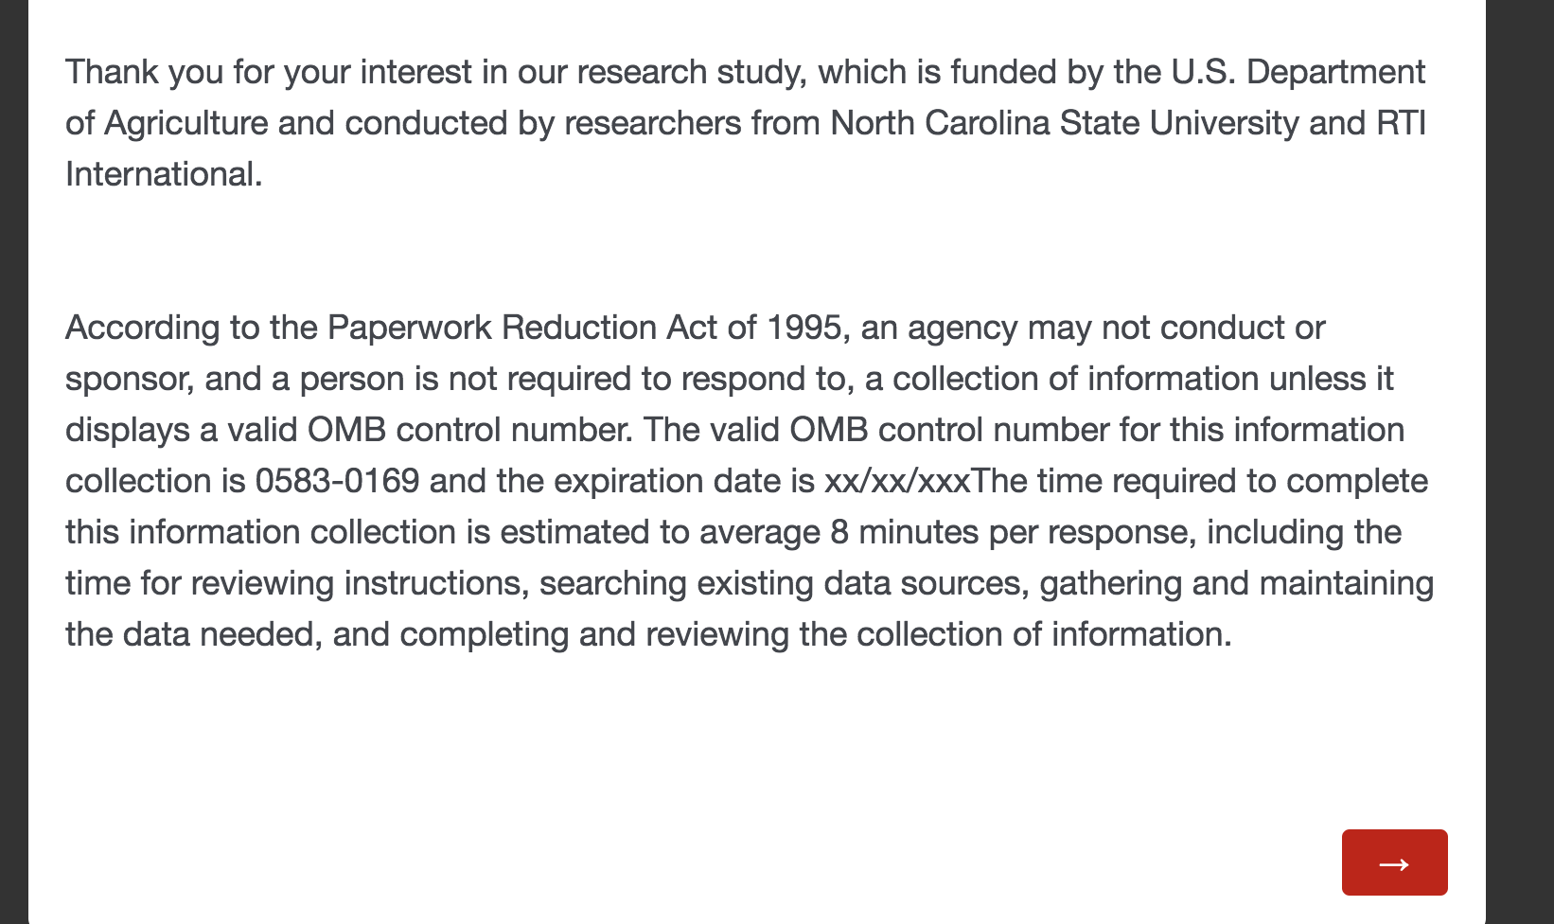

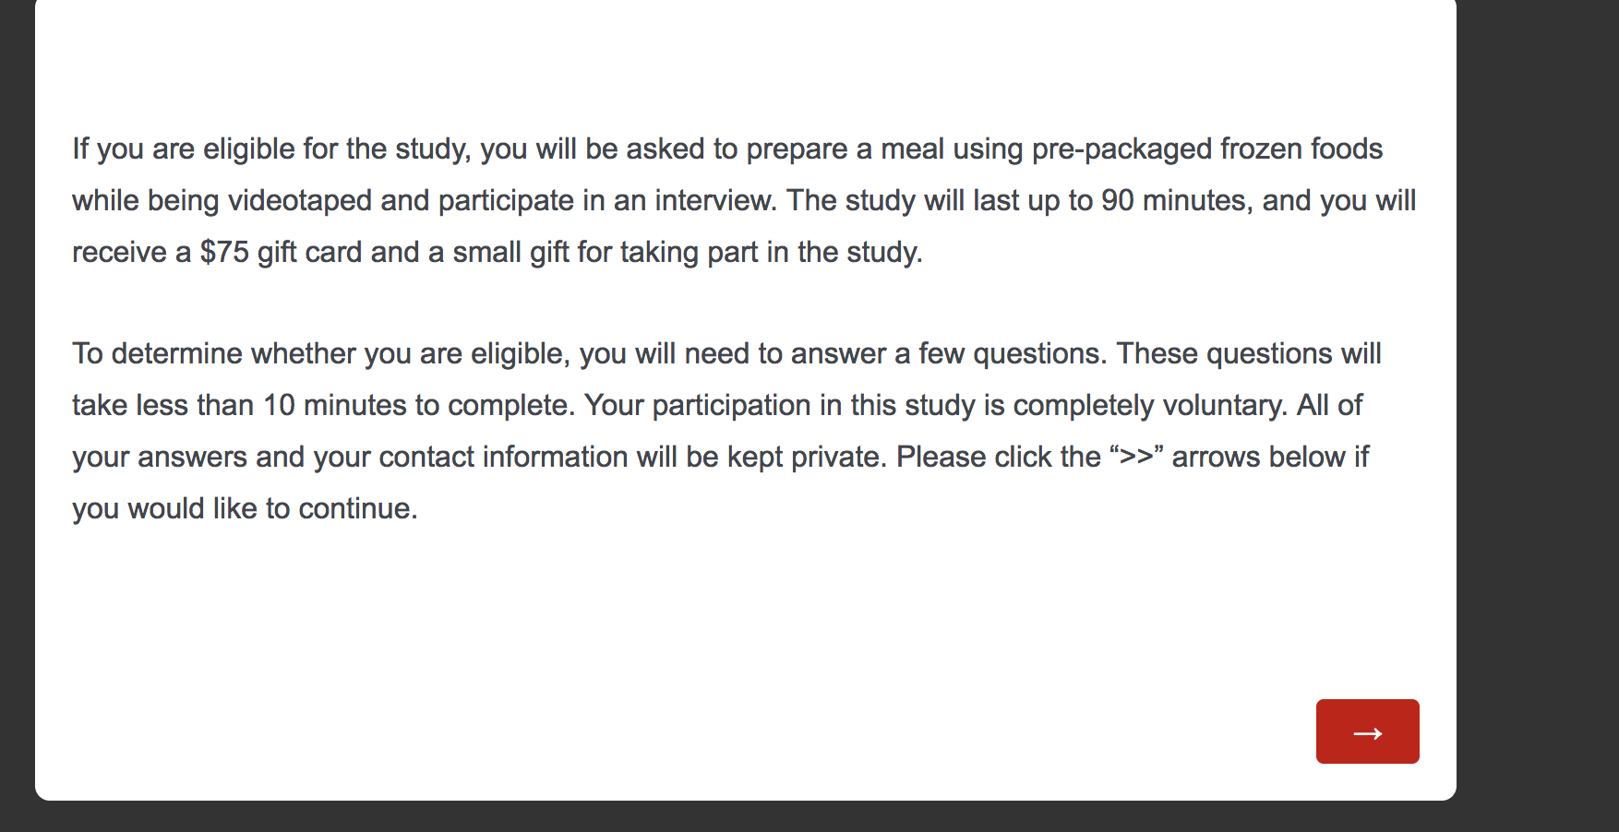

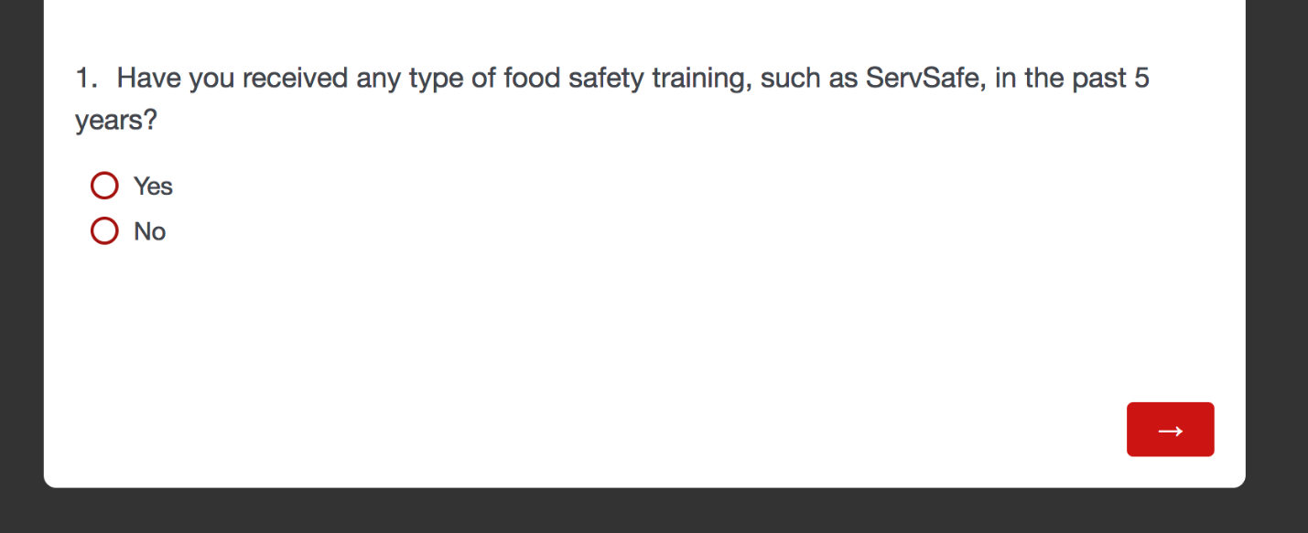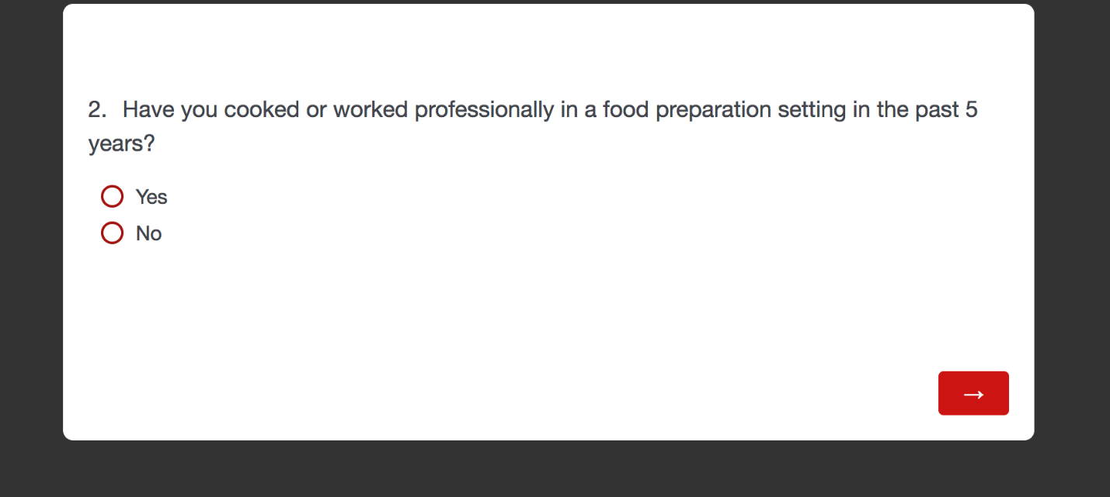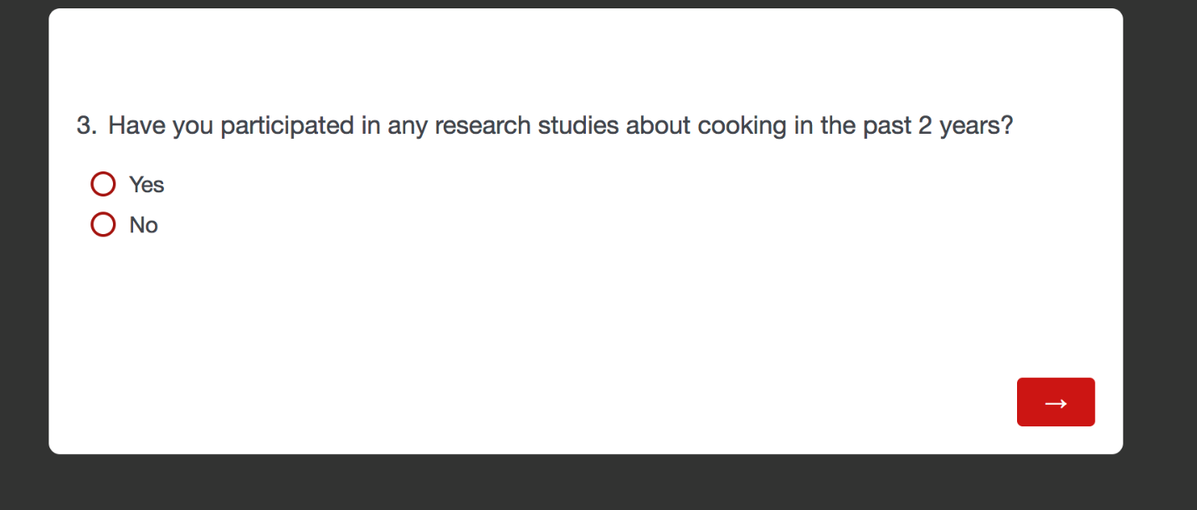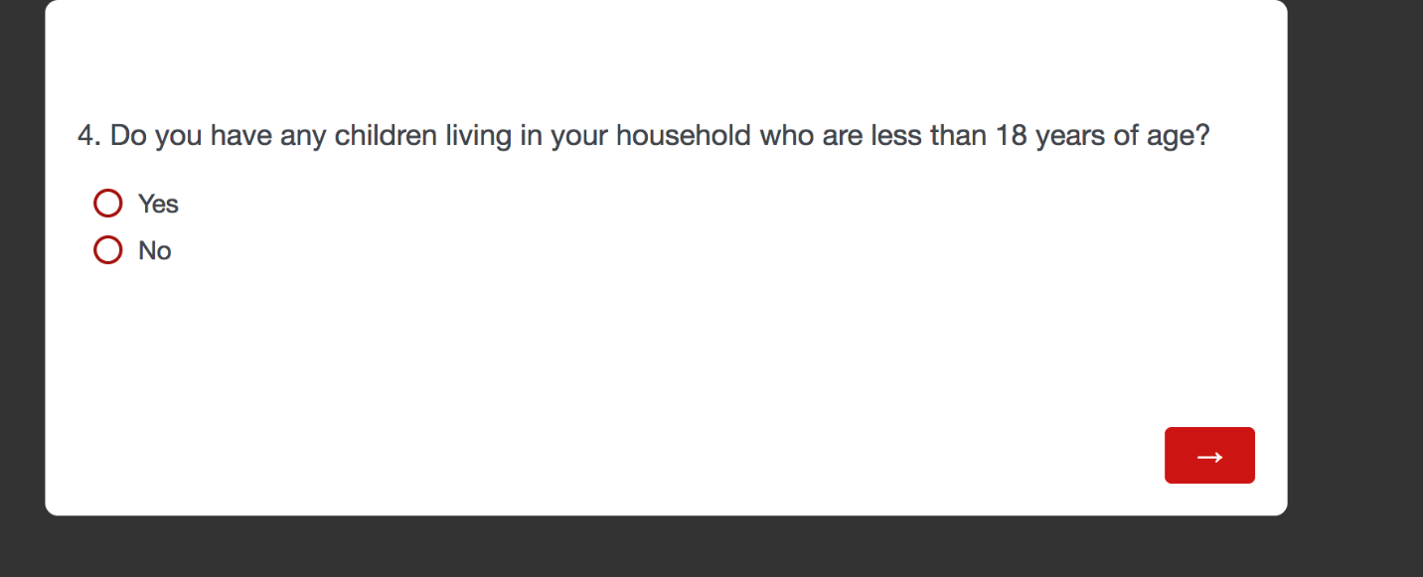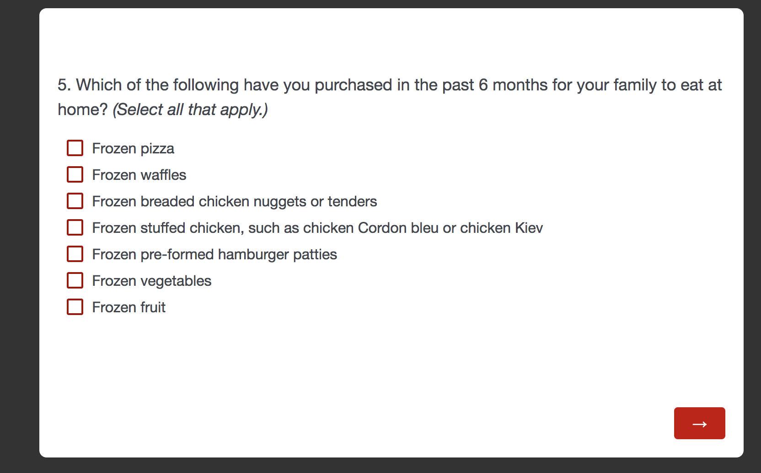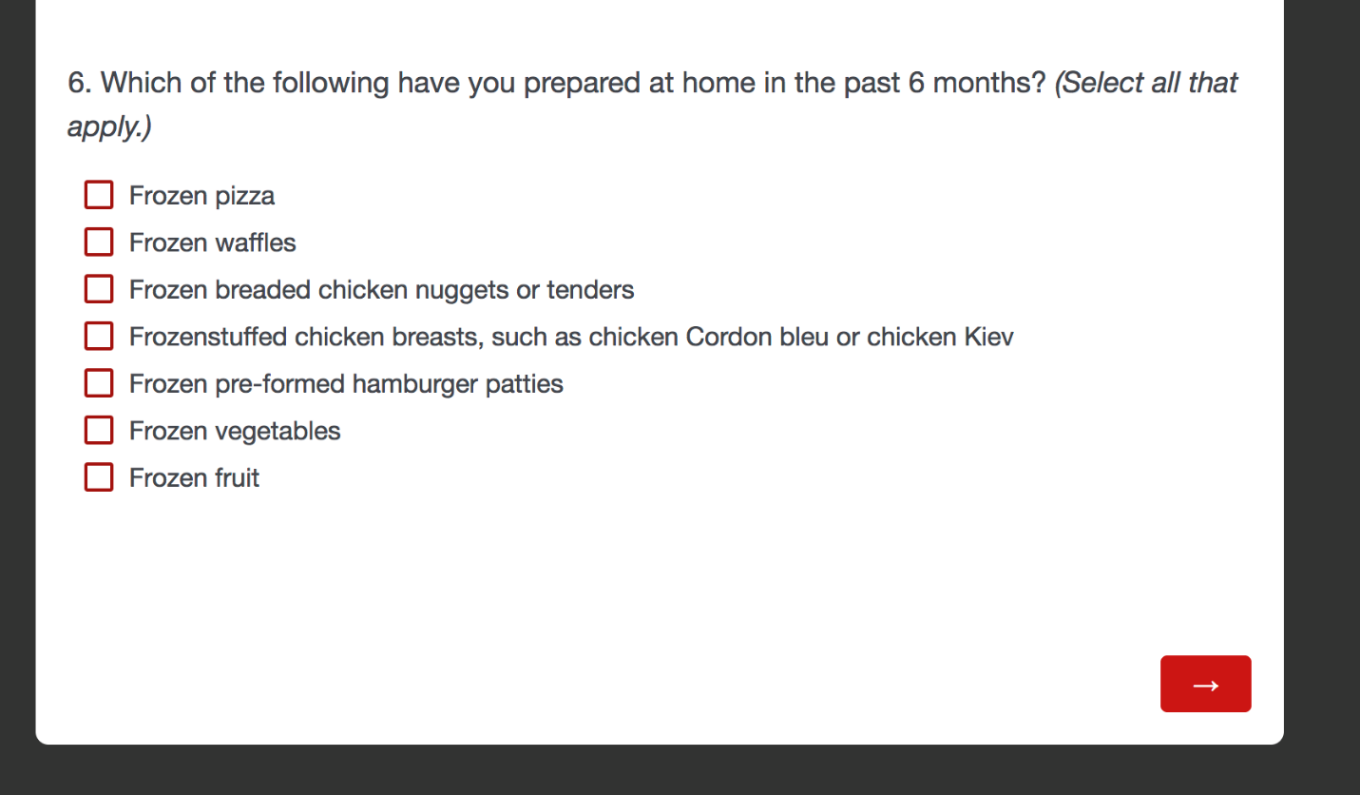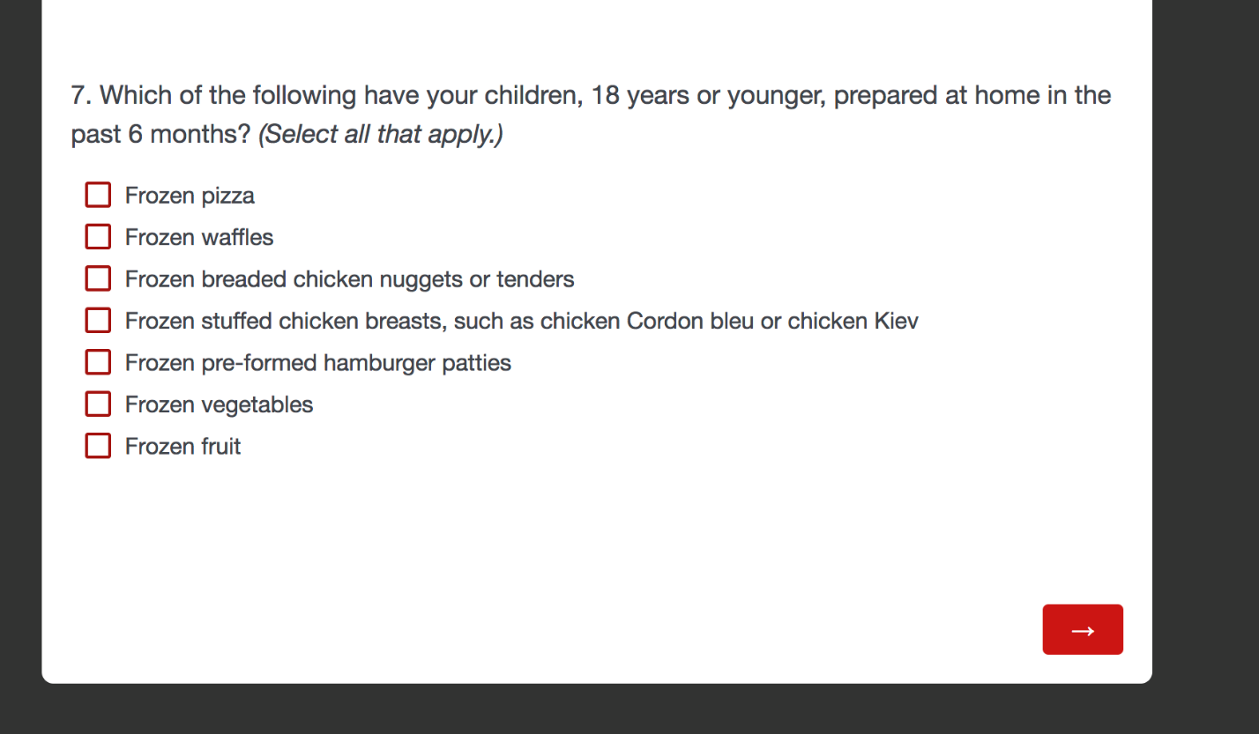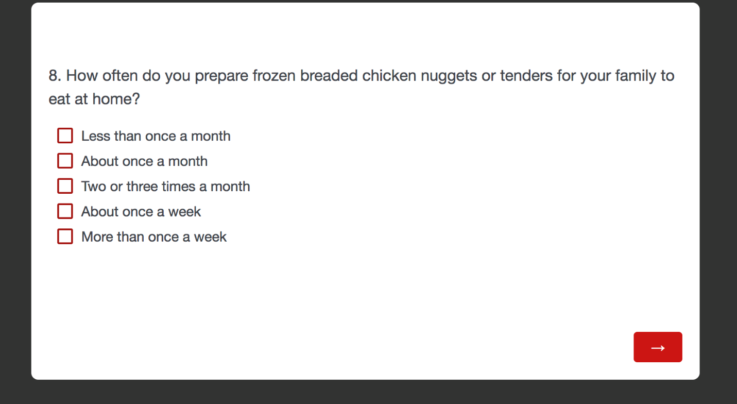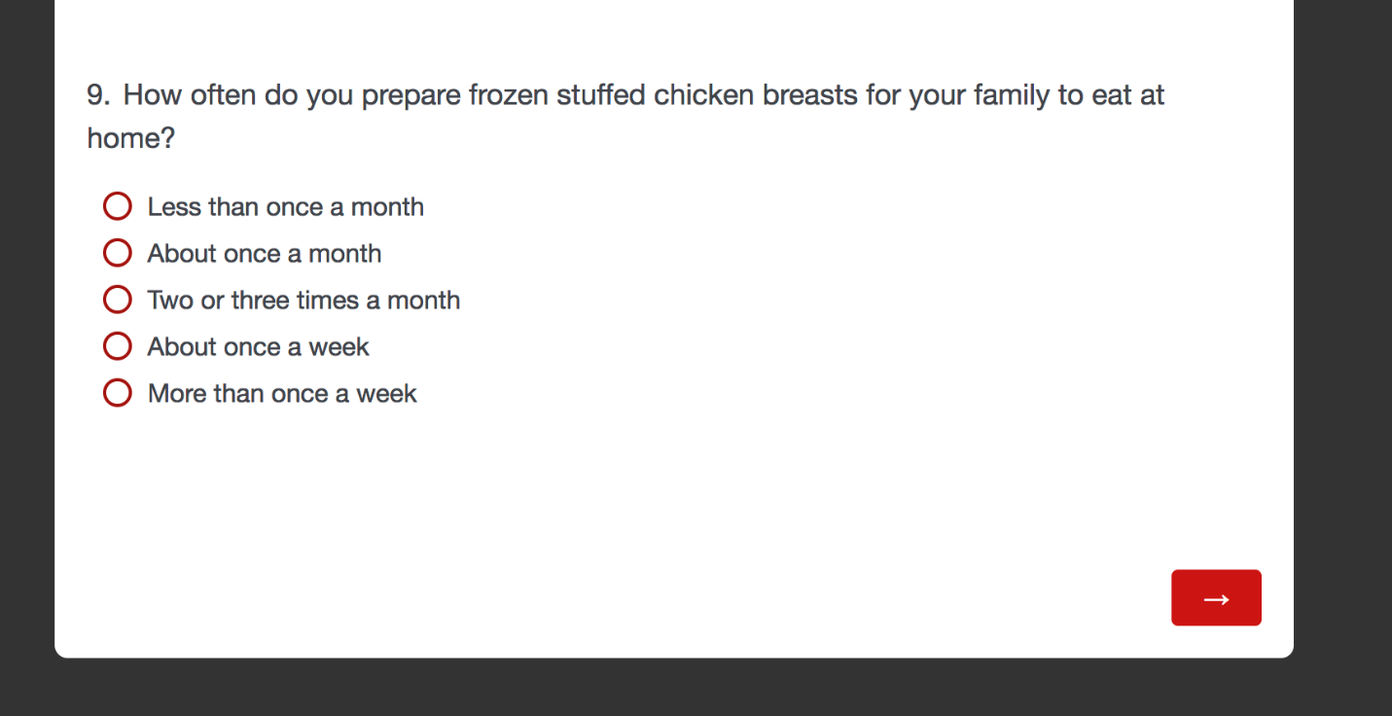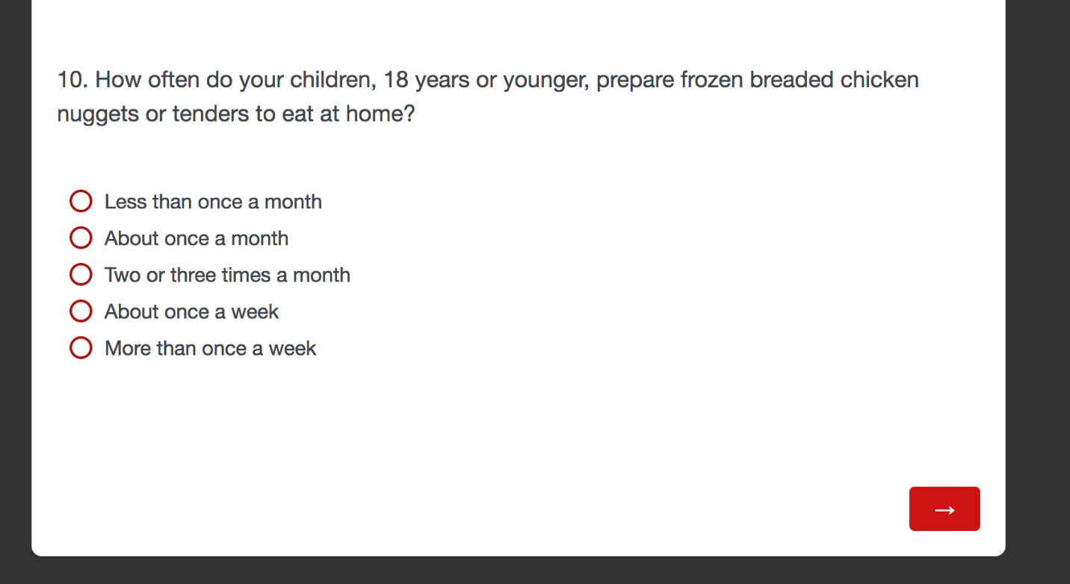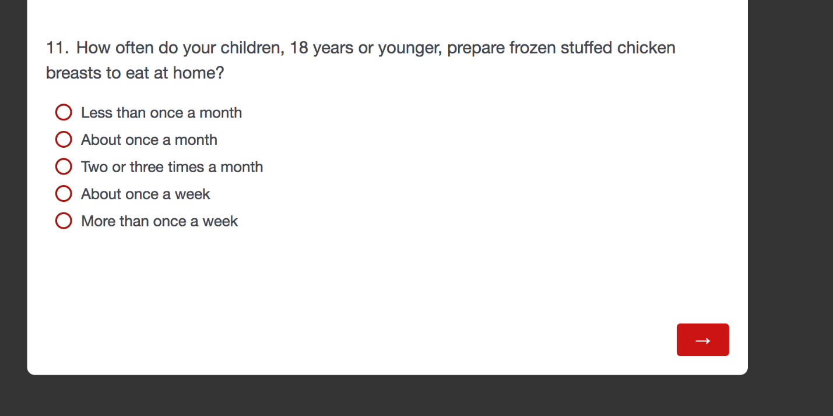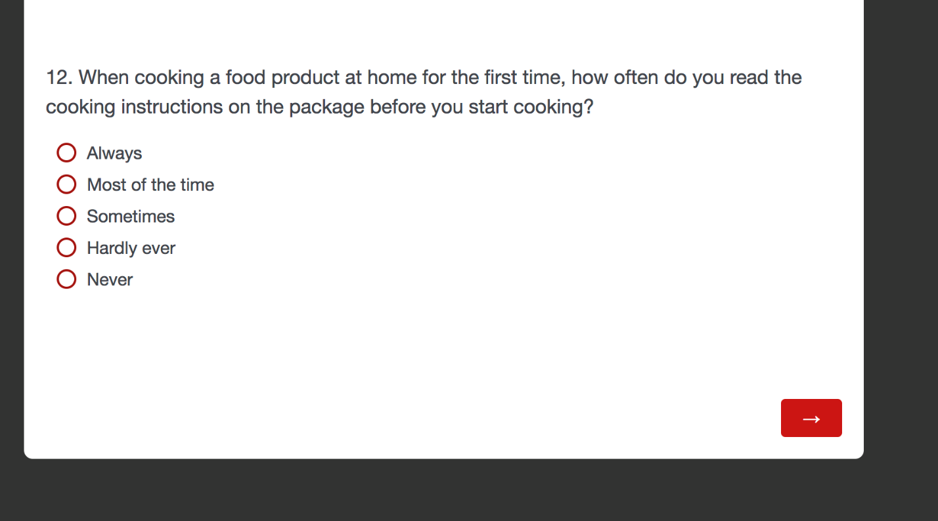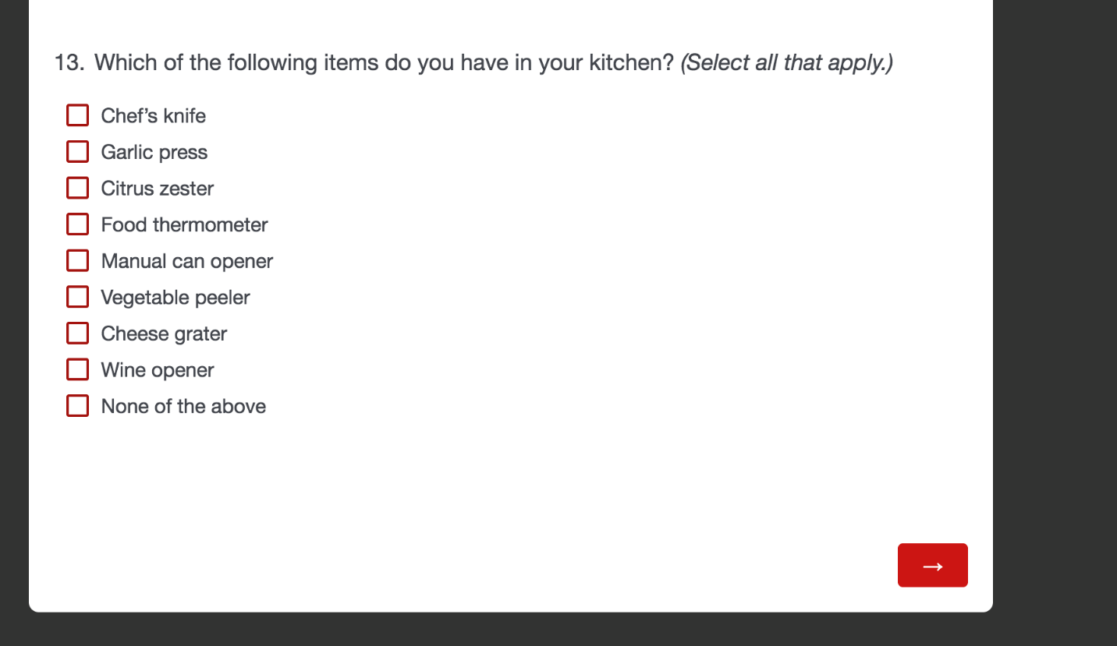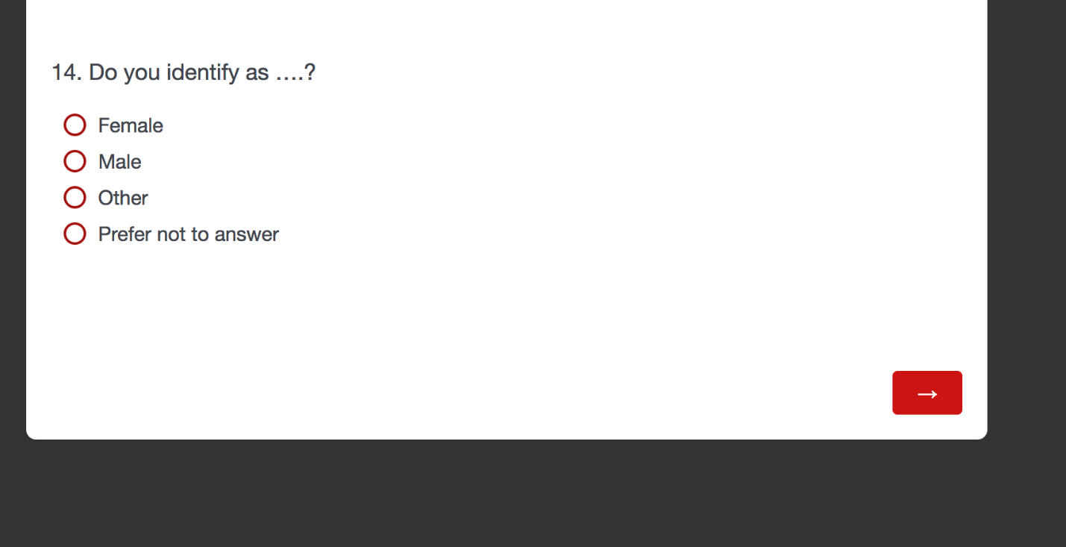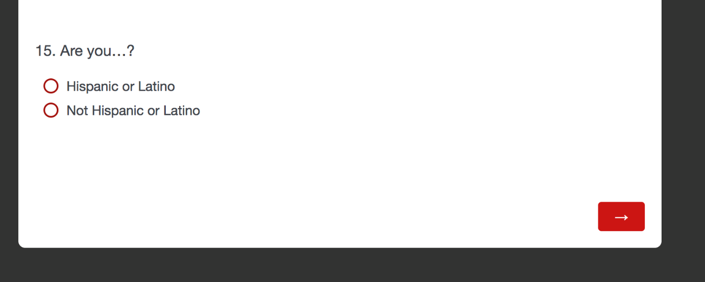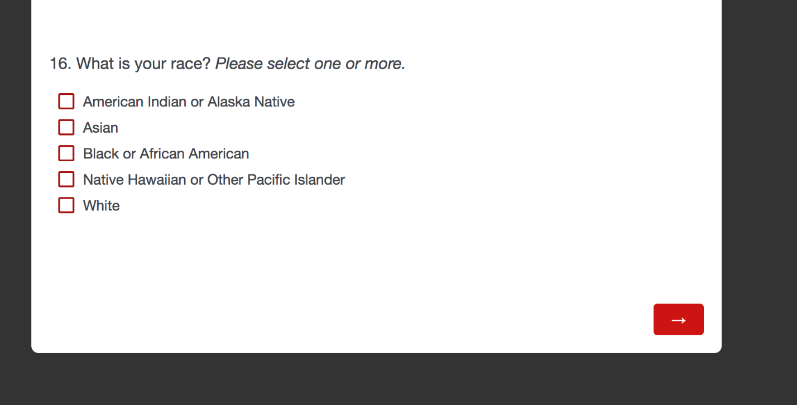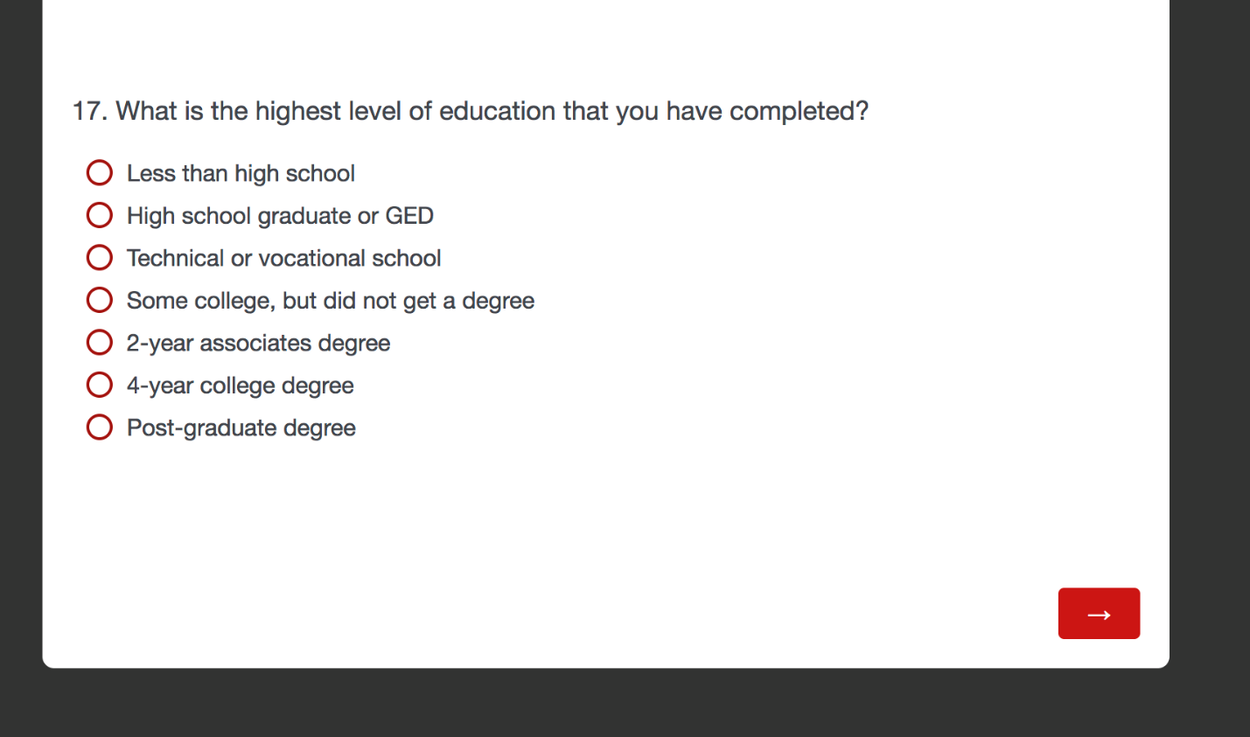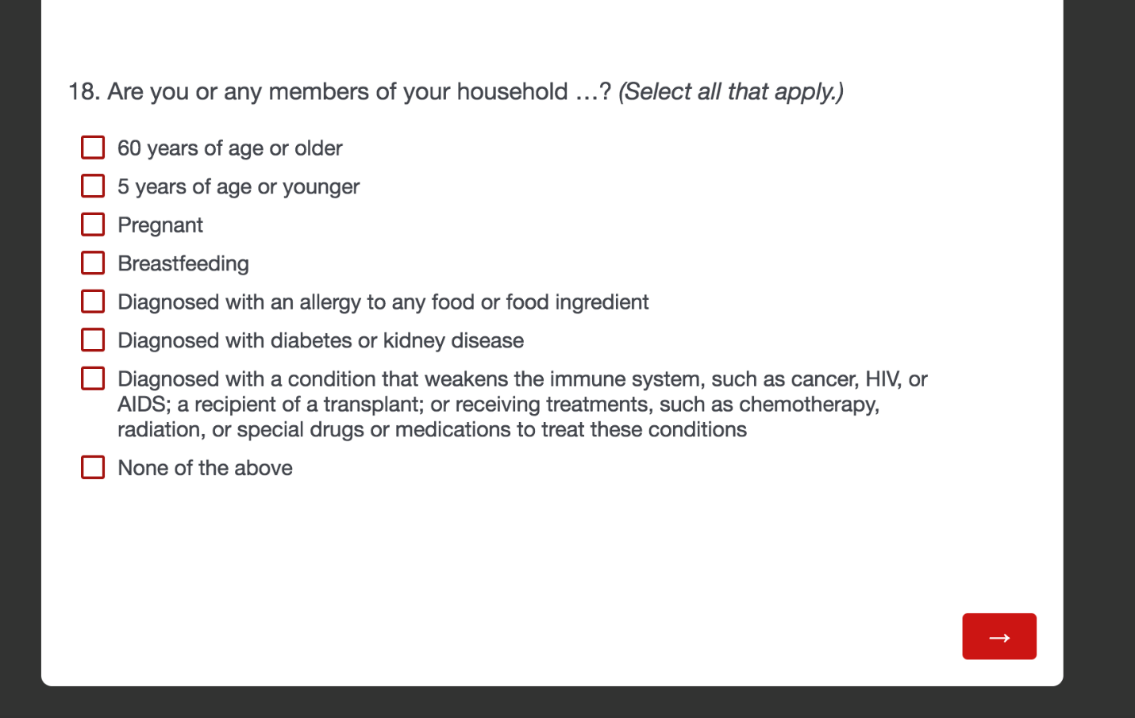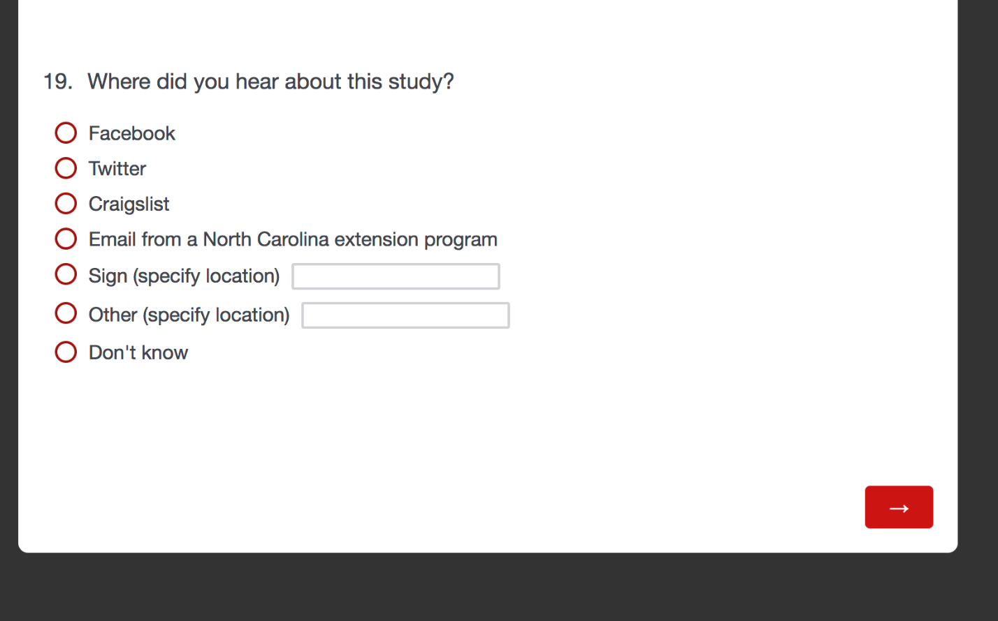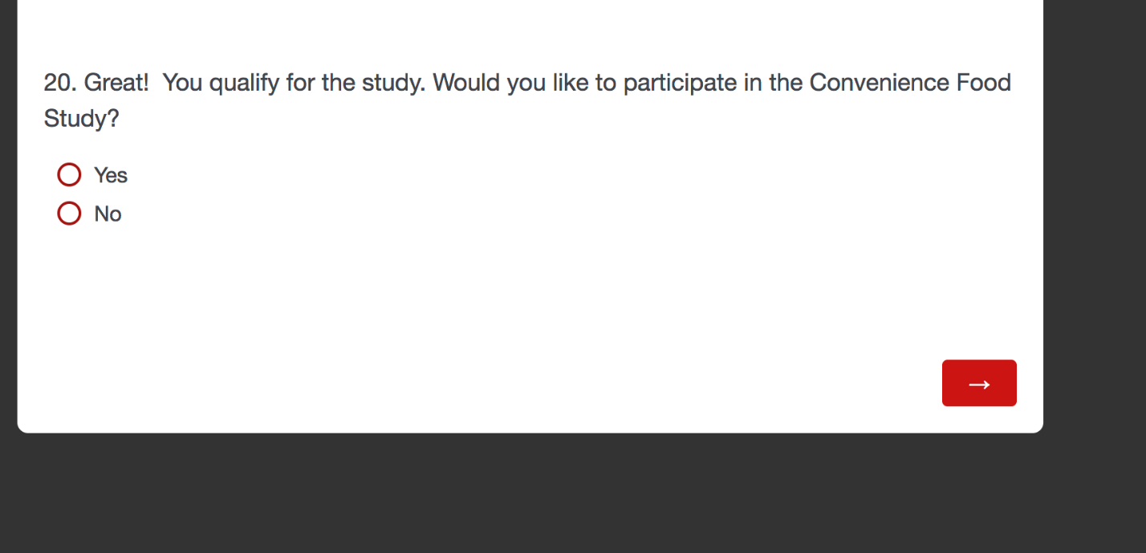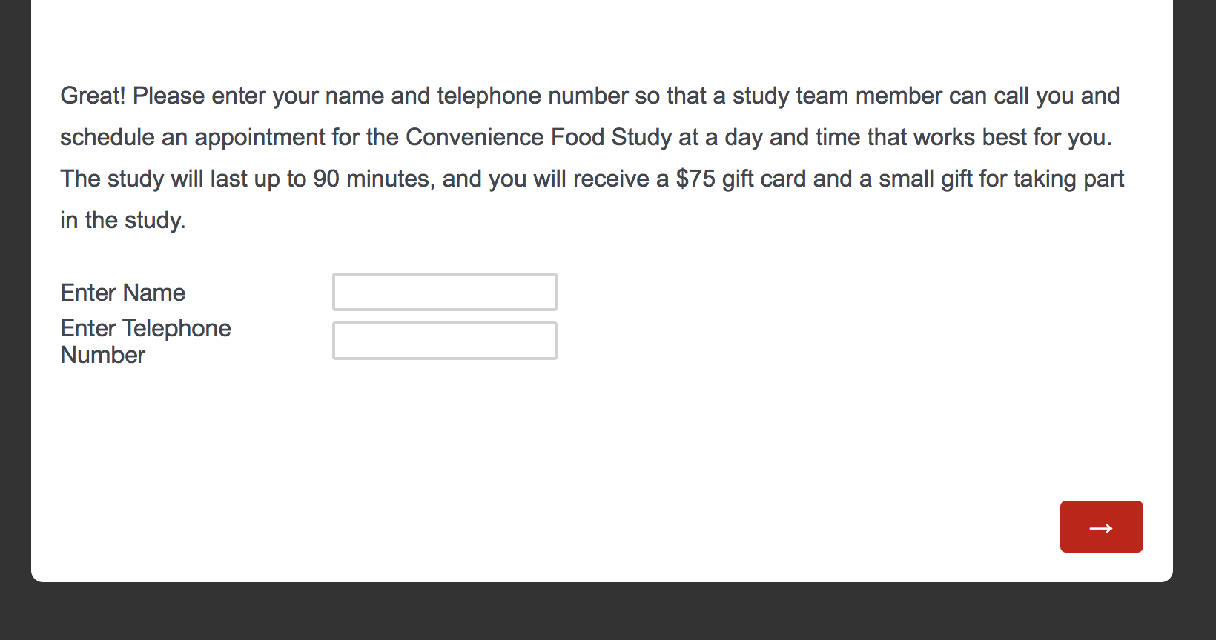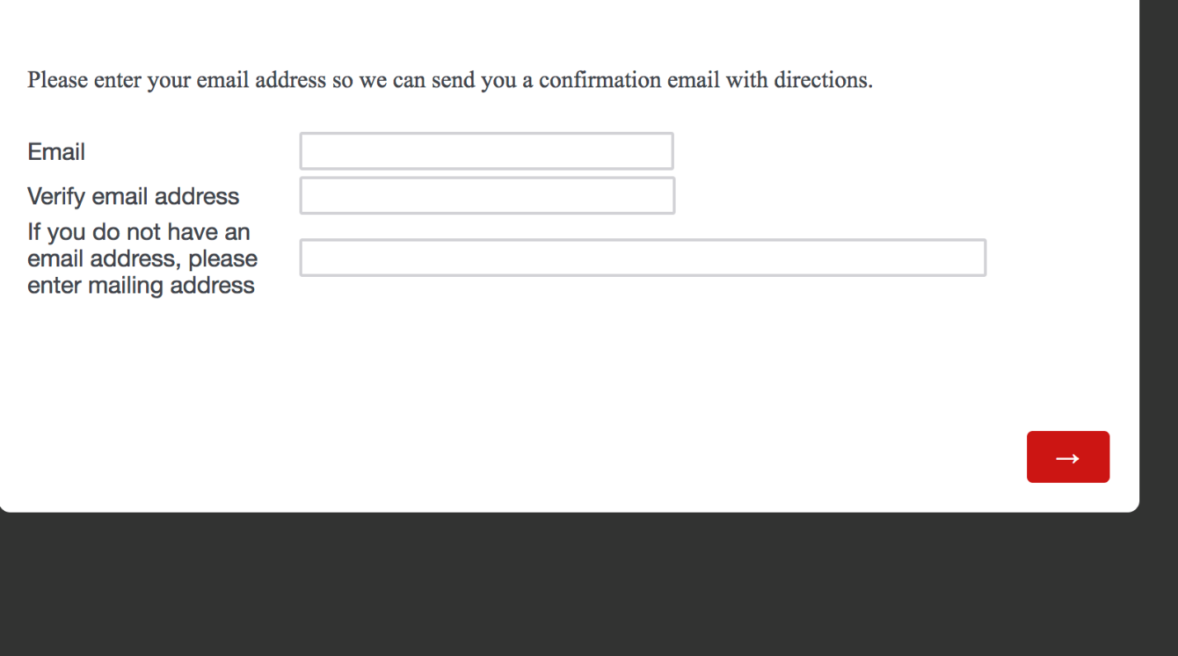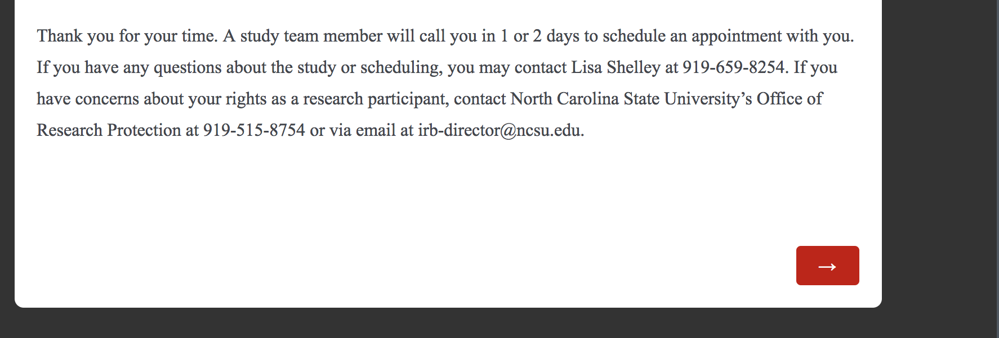

Ineligible/Terminate Screen

