**Form Approved**

**OMB No. 0920-0856**

**Exp. Date xx/xx/XXXX**

**National Quitline Data Warehouse**

**Instructions for Submitting Summary Caller Intake and 7-Month Follow-Up Data to CDC**

1. Open Internet Explorer (it doesn’t work with Mozilla Firefox)
2. Go to <ftp://sftp.cdc.gov>.  You may see the following:

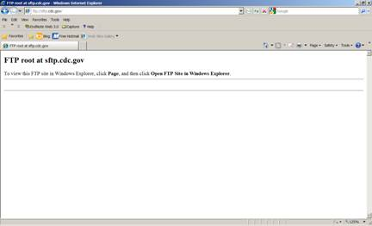

On the right hand side, select “Page”.  Then select “Open FTP Site in Windows Explorer”.

1. Enter your username and password.
2. A file folder will appear.  It should look like this.

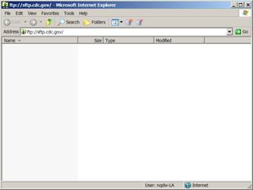

1. Drag and drop the respective file.  If the file is large, we would appreciate if you would compress the file before dropping it into the folder.
2. If you choose not to submit data through the FTP server, please mail a CD/DVD to the following address:

Henraya F. McGruder, Ph.D

CDC/OSH

4770 Buford Highway, NE Mailstop K-50

Atlanta, GA 30341