Form Approved
OMB No. 0920-0856
Exp. Date xx/xx/XXXX

National Quitline Data Warehouse
Instructions for Submitting Summary Caller Intake and 7-Month Follow-Up Data to CDC
- Open Internet Explorer (it doesn’t work with Mozilla Firefox)
- Go to ftp://sftp.cdc.gov. You may see the following:
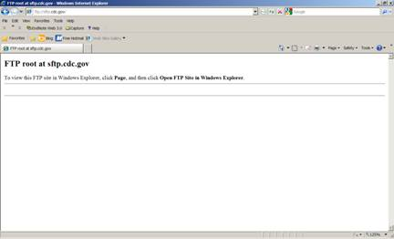
On the right hand side, select “Page”. Then select “Open FTP Site in Windows Explorer”.
- Enter your username and password.
- A file folder will appear. It should look like this.
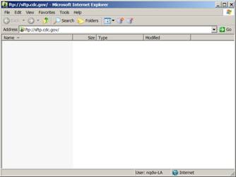
- Drag and drop the respective file. If the file is large, we would appreciate if you would compress the file before dropping it into the folder.
- If you choose not to submit data through the FTP server, please mail a CD/DVD to the following address:
Henraya F. McGruder, Ph.D
CDC/OSH
4770 Buford Highway, NE Mailstop K-50
Atlanta, GA 30341

