Attachment 4 – FMS Alumni Directory

Fellowship Management System (FMS)

FMS Alumni Directory | 2014
Epidemic Intelligence Service (EIS) Alumni Directory Example

Privacy Act and Public Burden Information
Privacy Act Information
The Privacy Act applies to this information collection. Information collected will be kept private as noted in the System of Records Notice is 09-20-0112, Fellowship Program and Guest Researcher Records.

Public Burden Information
Form Approved
OMB No. 0920-0765
Exp. Date 04/30/2018

Public reporting burden of this collection of information is an estimated average of 15 minutes per response, including the time for reviewing instructions, searching existing data sources, gathering and maintaining the data needed, and completing and reviewing the collection of information. An agency may not conduct or sponsor, and a person is not required to respond to a collection of information unless it displays a currently valid OMB control number. Send comments regarding this burden estimate or any other aspect of this collection of information, including suggestions for reducing this burden to CDC/ATSDR Reports Clearance Officer; 1600 Clifton Road NE, MS D-74, Atlanta, Georgia 30333; ATTN: PRA (0920-0765).

Table of Contents

1 Introduction 1
1.1 Document Structure 1
2 Login and Registration Pages 3
2.1 Login Page 3
2.2 Registration Page (For New Users) 4
2.3 Forgot Your E-mail? Page 5
2.4 Forgot Your Password? Page 6
2.5 Reset Password 7
3 Consent 8
3.1 Electronic Consent Section 8
4 Directory Home Page 8
4.1 Home Page 8
5 Contact Information Page 9
5.1 Contact Information Section 9
5.2 Additional Information Section 11
6 Education, Training, Skills Page 12
6.1 Education Section 12
6.2 Clinical Training Section 14
6.3 U.S. Board Certification Section 14
6.4 Fellowship 15
6.5 Fellowship Assignment 15
6.6 Language 16
7 Professional Experience 17
7.1 Professional Experience Section 17
8 Account Setting 19
8.1 Account Setting 19
9 Directory 20
9.1 Directory Reports 20
9.2 Current Fellows Report Example 21
9.3 Fellowship Classes by Year 21
9.4 Current/Alumni by Geographic Locations 21
9.5 International Fellows 21
10 Appendix A – EIS Example E-mails 22
10.1 Invitation to Register 22
10.2 Registration Confirmation 23
11 Appendix B – List Of Values 24

Introduction
The purpose of this document is to list all the data elements collected online from alumni through the Fellowship Management System (FMS). The FMS online alumni directory module is a self-service connection to allow alumni of the Centers for Disease Control and Prevention (CDC) fellowships to update their personal information including current addresses, contact, and education information. The FMS is a robust, flexible framework and is successfully tailored for various fellowships.

The following fellowships currently use the FMS Alumni Directory to collect information from fellowship alumni:
- Epidemic Intelligence Service (EIS)
- CDC-Hubert Global Health Fellowship (Hubert)

The following fellowships are currently not collecting any information from alumni:
- Public Health Informatics Fellowship (PHIF)
- CDC Epidemiology Elective Program for senior medical and veterinary Students (Epi-Elect)
- Prevention Effectiveness Fellowship (PEF)
- Preventive Medicine Residency and Fellowship (PMR/F)
- Public Health Associate Program (PHAP)

Document Structure
This document is broken down by the major pages of the FMS Alumni Directory. In this document, each page of the FMS Alumni Directory has sections and some sub-sections. In addition, instructions, login, and registration pages are included. Appendix A provides examples of emails generated by FMS for the EIS Alumni Directory. The instructions and emails provided in this document are examples from EIS; instructions and emails in the FMS Alumni Directory are tailored to each CDC fellowship program.

The main screenshots of the Alumni Directory pages, sections, or subsections are from EIS. Following the screenshots in each section is a table that shows the status of the collection of data elements by each CDC fellowships. The following labels indicate the status of the collection:
- “Yes” indicates that the fellowship collects the information and that alumni are required to submit this information.
- “Opt” indicates that the fellowship collects the information and that it is optional for alumni to submit this information.
- “-” indicates that the fellowship does not collect this information.

In addition, the table shows the data values of each data element, and for ones that have a list of dropdown values, the data value category is hyperlinked to its list located in Appendix B.

The following table (Table 1.1-a) provides an overview of the major pages and sections in the FMS Alumni Directory used by each fellowship program. The “Yes” indicates that the fellowship uses the page or section, whereas, the “-” indicates that the fellowship does not use the page or section.

Table 1.1-a. FMS Alumni Directory Page and Section used by Fellowship Programs
Section | EIS | PHIF | Hubert | Epi-Elect | PEF | PMR/F | PHAP
Login Page | Yes | - | Yes | - | - | - | -
Registration Page | Yes | - | Yes | - | - | - | -
Forgot Email Page | Yes | - | Yes | - | - | - | -
Forgot Password Page | Yes | - | Yes | - | - | - | -
Reset Password | Yes | - | Yes | - | - | - | -
Consent | Yes | - | Yes | - | - | - | -
Home Page | Yes | - | Yes | - | - | - | -
Contact Information Page | Yes | - | Yes | - | - | - | -
Contact Information Section | Yes | - | Yes | - | - | - | -
Additional Information Section | Yes | - | Yes | - | - | - | -
Education Page | Yes | - | Yes | - | - | - | -
Education Section | Yes | - | Yes | - | - | - | -
Clinical Training Section | Yes | - | Yes | - | - | - | -
U.S. Board Certification Section | Yes | - | Yes | - | - | - | -
Fellowship Section | Yes | - | Yes | - | - | - | -
Fellowship Assignment Section | Yes | - | Yes | - | - | - | -
Language Section | Yes | - | Yes | - | - | - | -
Professional Experience Page | Yes | - | Yes | - | - | - | -
Account Setting Page | Yes | - | Yes | - | - | - | -
Directory Page | Yes | - | Yes | - | - | - | -
Current Fellows Section | Yes | - | Yes | - | - | - | -
Fellowship Classes by Year Section | Yes | - | Yes | - | - | - | -
Current/Alumni by Geographic Location Section | Yes | - | Yes | - | - | - | -
International Fellows Section | Yes | - | Yes | - | - | - | -

Login and Registration Pages

Login Page

Figure 2.1-a. Application Home Page Log In
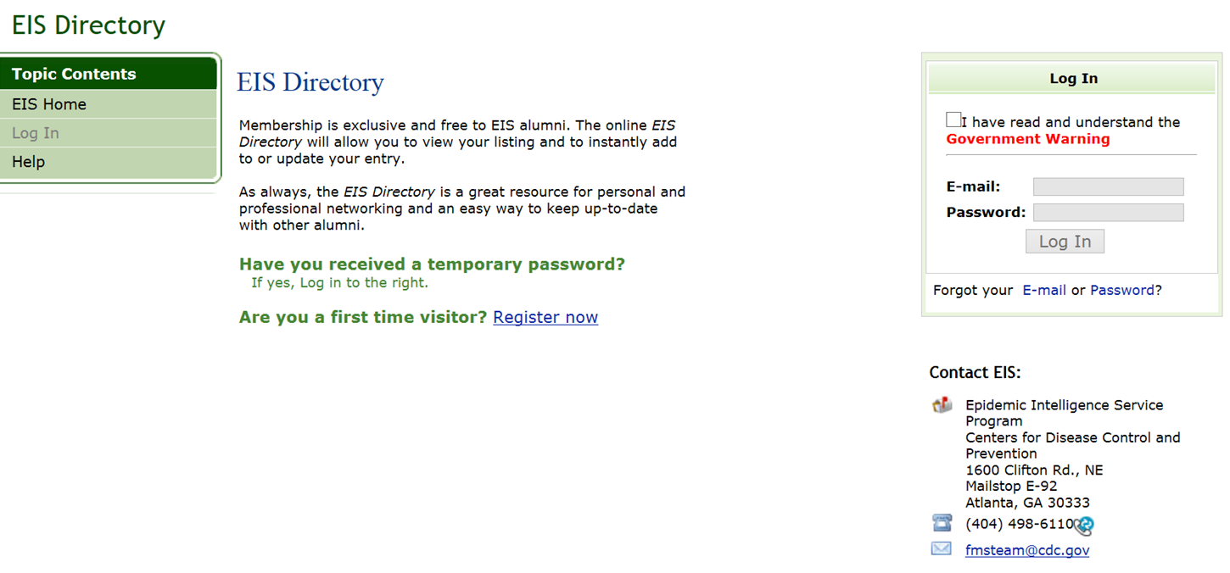

Privacy Act and Public Burden Information
Privacy Act Information
The Privacy Act applies to this information collection. Information collected will be kept private as noted in the System of Records Notice is 09-20-0112, Fellowship Program and Guest Researcher Records.

Public Burden Information
Form Approved
OMB No. 0920-0765
Exp. Date 04/30/2018

Public reporting burden of this collection of information is an estimated average of 15 minutes per response, including the time for reviewing instructions, searching existing data sources, gathering and maintaining the data needed, and completing and reviewing the collection of information. An agency may not conduct or sponsor, and a person is not required to respond to a collection of information unless it displays a currently valid OMB control number. Send comments regarding this burden estimate or any other aspect of this collection of information, including suggestions for reducing this burden to CDC/ATSDR Reports Clearance Officer; 1600 Clifton Road NE, MS D-74, Atlanta, Georgia 30333; ATTN: PRA (0920-0765).

Table 2.1-a. Login Page Data Elements
Data Elements | Data Values | EIS | PHIF | Hubert | Epi-Elect | PEF | PMR/F | PHAP
E-Mail | Alphanumeric | Yes | - | Yes | - | - | - | -
Password | Alphanumeric | Yes | - | Yes | - | - | - | -

Registration Page (For New Users)

Figure 2.2-a. Registration Page
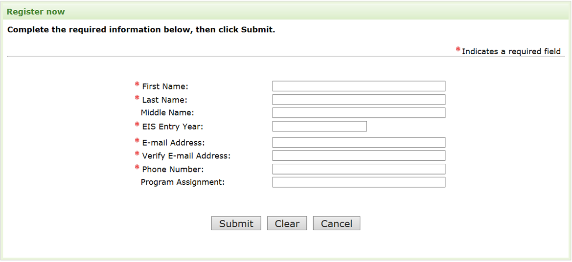

Figure 2.2-b. Registration Confirmed

Table 2.2-a. Registration Page Data Elements
Data Elements | Data Values | EIS | PHIF | Hubert | Epi-Elect | PEF | PMR/F | PHAP
First Name | Text | Yes | - | Yes | - | - | - | -
Middle Name | Text | Opt | - | Yes | - | - | - | -
Last Name | Text | Yes | - | Yes | - | - | - | -
Program Entry Year | Numeric – YYYY | Yes | - | Yes | - | - | - | -
E-mail Address | Alphanumeric | Yes | - | Yes | - | - | - | -
Verify E-mail Address | Alphanumeric | Yes | - | Yes | - | - | - | -
Phone Number | Numeric | Yes | - | Yes | - | - | - | -
Program Assignment | Text | Opt | - | Yes | - | - | - | -

Forgot Your E-mail? Page

Figure 2.3-a. Forgot your Email? Contact Information
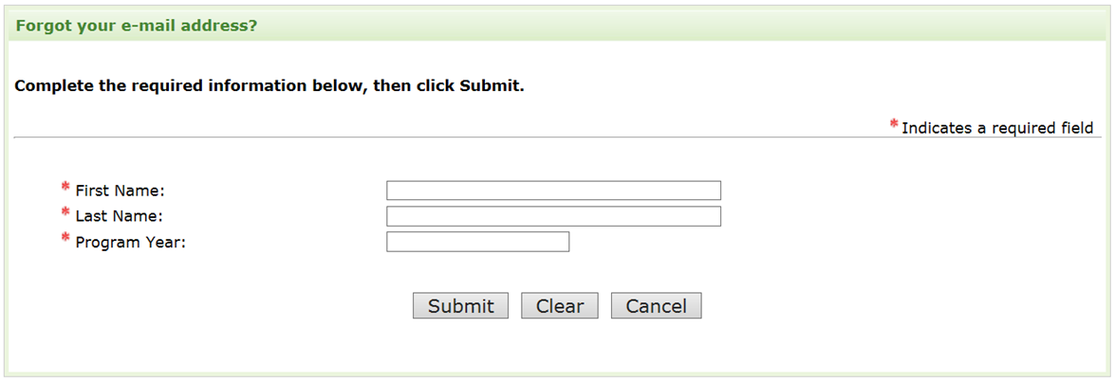

Figure 2.3-b. Forgot your Email? Secret Question
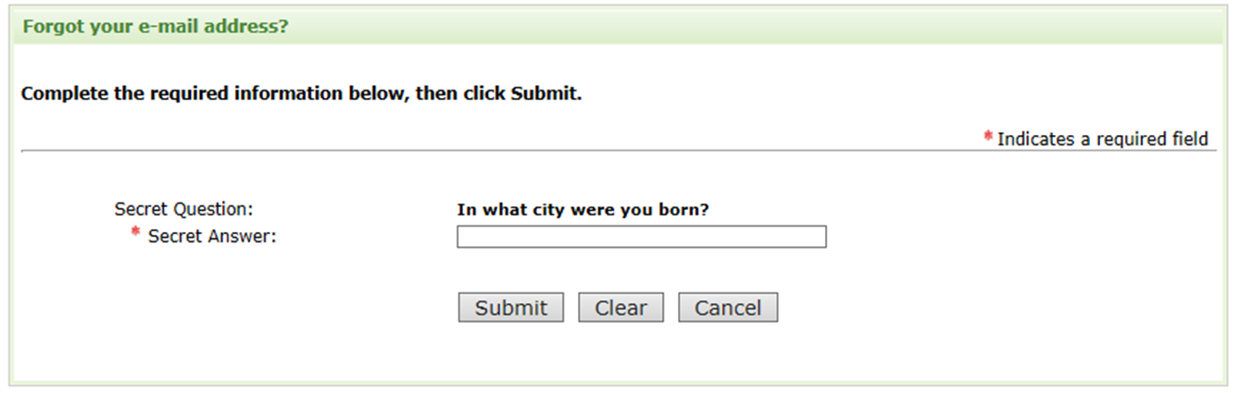

Figure 2.3-c. Forgot your Email? Email Display
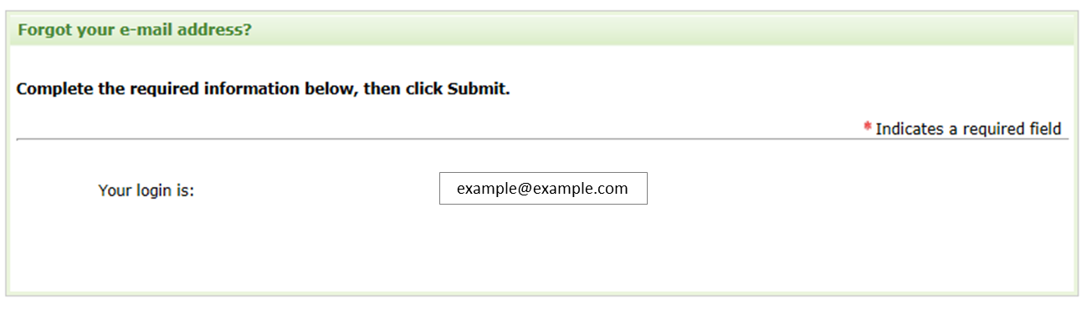

Table 2.3-a. Forgot your E-mail? Page Data Elements
Data Elements | Data Values | EIS | PHIF | Hubert | Epi-Elect | PEF | PMR/F | PHAP
First Name | Text | Yes | - | Yes | - | - | - | -
Last Name | Text | Yes | - | Yes | - | - | - | -
Program Entry Year | Numeric – YYYY | Yes | - | Yes | - | - | - | -
Secret Question | Selected Secret Question | Yes | - | Yes | - | - | - | -
Secret Answer | Alphanumeric | Yes | - | Yes | - | - | - | -

Forgot Your Password? Page

Figure 2.4-a. Forgot your Password? Contact Information
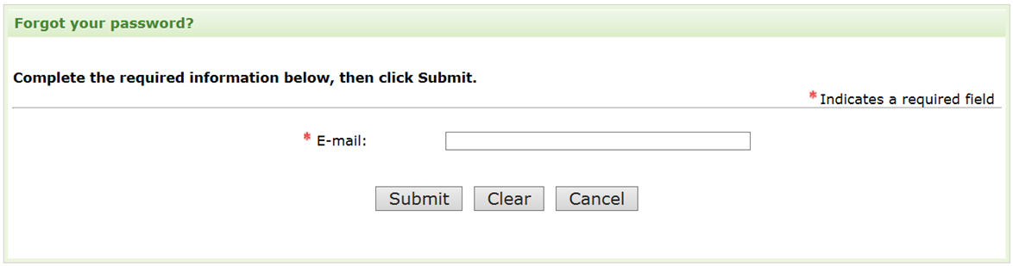

Figure 2.4-b. Forgot your Password? Secret Question
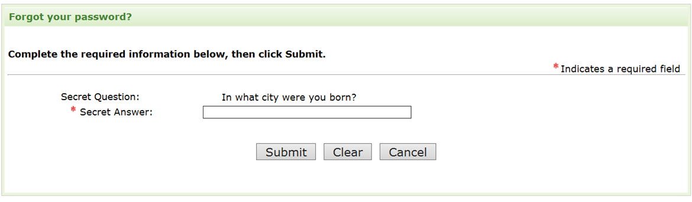

Figure 2.4-c. Forgot your Password? New Password
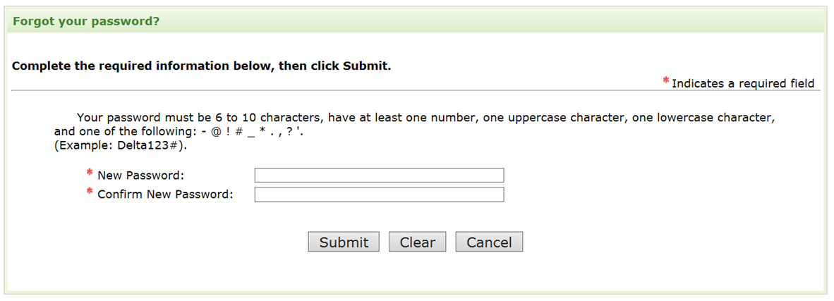

Figure 2.4-d. Forgot your Password? Password Changed


Table 2.4-a. Forgot your Password Page Data Elements
Data Elements | Data Values | EIS | PHIF | Hubert | Epi-Elect | PEF | PMR/F | PHAP
E-mail | Alphanumeric | Yes | - | Yes | - | - | - | -
Secret Question | Selected Secret Question | Yes | - | Yes | - | - | - | -
Secret Answer | Alphanumeric | Yes | - | Yes | - | - | - | -
New Password | Alphanumeric | Yes | - | Yes | - | - | - | -
Verify New Password | Alphanumeric | Yes | - | Yes | - | - | - | -

Reset Password

Figure 2.5-a. Reset Password
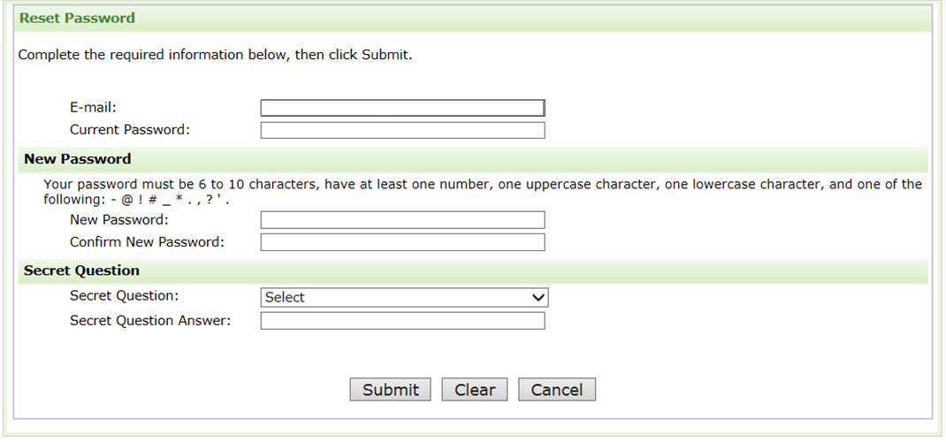

Table 2.5-a. Reset Password Data Elements
Data Elements | Data Values | EIS | PHIF | Hubert | Epi-Elect | PEF | PMR/F | PHAP
E-mail | Alphanumeric | Yes | - | Yes | - | - | - | -
Current Password | Alphanumeric | Yes | - | Yes | - | - | - | -
New Password | Alphanumeric | Yes | - | Yes | - | - | - | -
Verify New Password | Alphanumeric | Yes | - | Yes | - | - | - | -
Secret Question | Secret Questions | Yes | - | Yes | - | - | - | -
Secret Answer | Alphanumeric | Yes | - | Yes | - | - | - | -

Consent

Electronic Consent Section

Figure 3.1-a. Electronic Consent Example

Thank you for participating in the EIS Directory. As an EIS alumnus, you will be able to view and update your own profile in the online system. Information about you will be used by CDC to generate internal aggregate reports about alumni career paths and to produce standard downloadable reports including the EIS Directory and a listing of current EIS officers. Access to these reports is limited to EIS officers, alumni, and staff. Filling in any field in the online directory is optional. If you provide consent, all of the information you provide will be included in the standard downloadable reports that are only accessible to EIS officers, alumni, and EIS staff. These reports will not be accessible to the public. If you choose not to participate, only your name and EIS year will be included in the standard downloadable reports. You may choose to give your consent now and then change your choice at any time.

By clicking yes to the consent of release of my profile to EIS officers, alumni, and staff through this electronic EIS directory, I hereby certify that I am the individual in this profile and that I understand that the knowing and willful request for or acquisition of a record pertaining to an individual under false pretenses is a criminal offense under the Privacy Act subject to a $5,000 fine.

Figure 3.1-b. Electronic Consent Data Element
Data Elements | Data Values | EIS | PHIF | Hubert | Epi-Elect | PEF | PMR/F | PHAP
Consent | Yes/No Choices | Yes | - | Yes | - | - | - | -

Directory Home Page

Home Page

Figure 4.1-a. Home Page
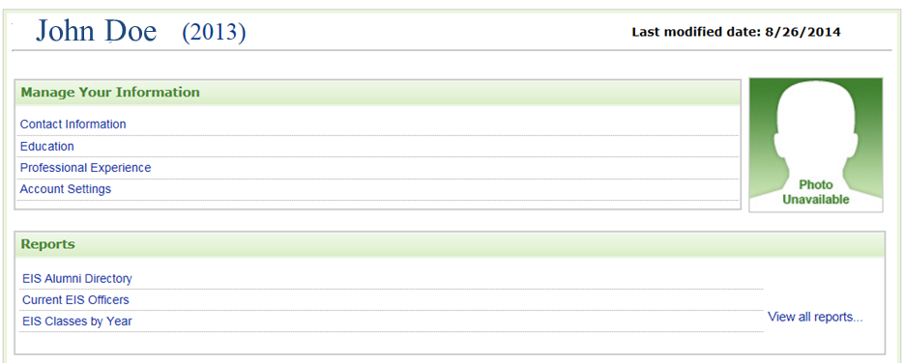

Contact Information Page

Contact Information Section

Figure 5.1-a. Contact Information
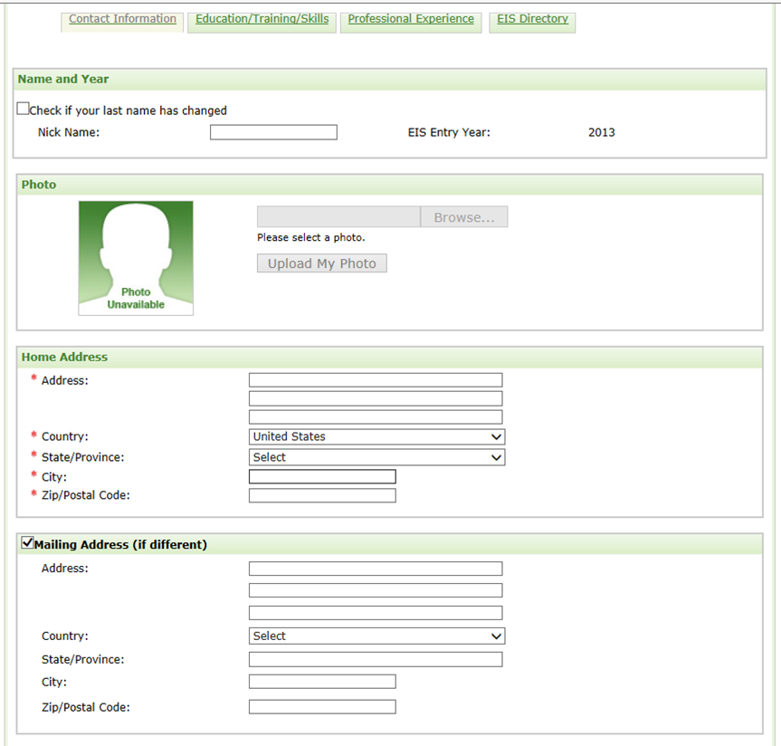

Table 5.1-a. Contact Information Section Data Elements
Data Elements | Data Values | EIS | PHIF | Hubert | Epi-Elect | PEF | PMR/F | PHAP
Name change | Checkbox | Opt | - | Opt | - | - | - | -
Current Last Name | Text | Opt | - | Opt | - | - | - | -
Nick Name | Text | Opt | - | Opt | - | - | - | -
Program Year | Already Populated | Opt | - | Opt | - | - | - | -
Photograph | File Upload | Opt | - | Opt | - | - | - | -
Home Address Line 1 | Text | Opt | - | Opt | - | - | - | -
Home Address Line 2 | Text | Opt | - | Opt | - | - | - | -
Home Address Line 3 | Text | Opt | - | Opt | - | - | - | -
Home Country | Countries | Opt | - | Opt | - | - | - | -
Home State/Province | States | Opt | - | Opt | - | - | - | -
Home City | Text | Opt | - | Opt | - | - | - | -
Home Zip/Postal Code | Numeric | Opt | - | Opt | - | - | - | -
Mailing Address | Checkbox | Opt | - | Opt | - | - | - | -
Mailing Address Line 1 | Text | Opt | - | Opt | - | - | - | -
Mailing Address Line 2 | Text | Opt | - | Opt | - | - | - | -
Mailing Address Line 3 | Text | Opt | - | Opt | - | - | - | -
Mailing Country | Countries | Opt | - | Opt | - | - | - | -
Mailing State/Province | States | Opt | - | Opt | - | - | - | -
Mailing City | Text | Opt | - | Opt | - | - | - | -
Mailing Zip/Postal Code | Numeric | Opt | - | Opt | - | - | - | -

Additional Information Section

Figure 5.2-a. Additional Information Section
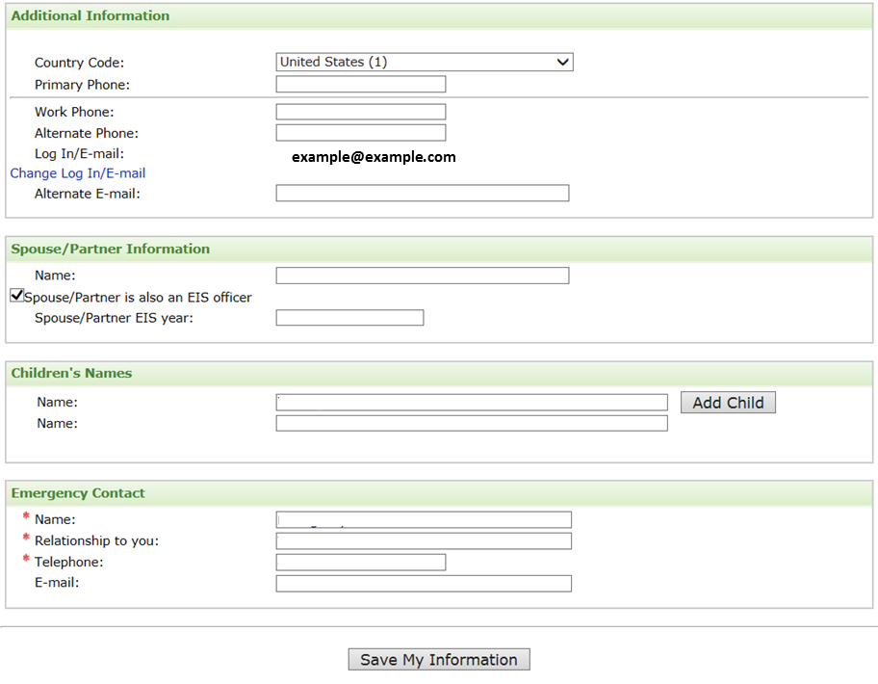

Figure 5.2-b. Additional Information Section Data Elements
Data Elements | Data Values | EIS | PHIF | Hubert | Epi-Elect | PEF | PMR/F | PHAP
Daytime Phone | Numeric | Opt | - | Opt | - | - | - | -
Evening Phone | Numeric | Opt | - | Opt | - | - | - | -
E-mail Address | Already Populated | Opt | - | Opt | - | - | - | -
Alternate E-mail | Alphanumeric | Opt | - | Opt | - | - | - | -
Spouse/Partner Name | Text | Opt | - | - | - | - | - | -
Spouse/Partner Alumni | Checkbox | Opt | - | - | - | - | - | -
Spouse/Partner Year | Numeric | Opt | - | - | - | - | - | -
Children’s Name | Text | Opt | - | - | - | - | - | -
Emergency Contact (EC) Name | Text | Yes | - | Yes | - | - | - | -
Relationship | Text | Yes | - | Yes | - | - | - | -
EC Telephone | Numeric | Yes | - | Yes | - | - | - | -
E-mail | Alphanumeric | Opt | - | Opt | - | - | - | -

Education, Training, Skills Page

Education Section

Figure 6.1-a. Education Page
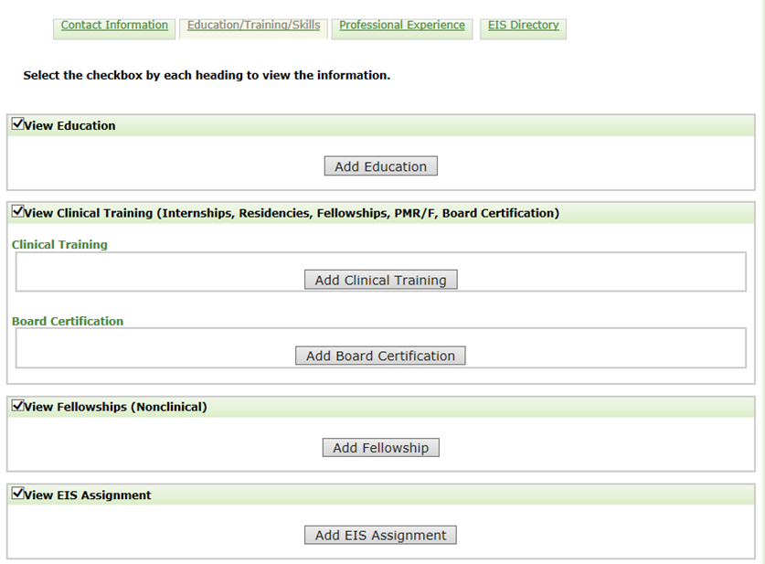

Figure 6.1-b. Education Section
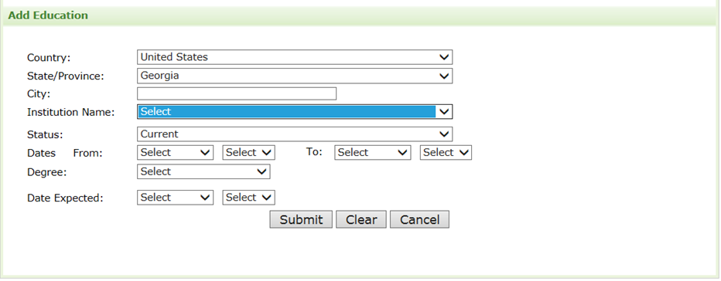

Figure 6.1-c. Major for Conferred Degrees
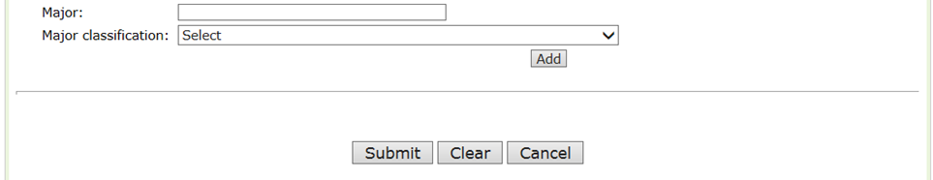

Table 6.1-a. Education Section Data Elements
Data Elements | Data Values | EIS | PHIF | Hubert | Epi-Elect | PEF | PMR/F | PHAP
Country | Countries | Opt | - | Opt | - | - | - | -
State | States | Opt | - | Opt | - | - | - | -
City | Text | Opt | - | Opt | - | - | - | -
Name | College Names | Opt | - | Opt | - | - | - | -
Status | Degree Statuses | Opt | - | Opt | - | - | - | -
Attended From | Date | Opt | - | Opt | - | - | - | -
Attended To | Date | Opt | - | Opt | - | - | - | -
Degree | Degrees | Opt | - | Opt | - | - | - | -
Degree Month | Months | Opt | - | Opt | - | - | - | -
Degree Year | Years | Opt | - | Opt | - | - | - | -
Major | Text | Opt | - | Opt | - | - | - | -
Major Classification | Major Classifications | Opt | - | Opt | - | - | - | -

Clinical Training Section

Figure 6.2-a. Clinical Training Section
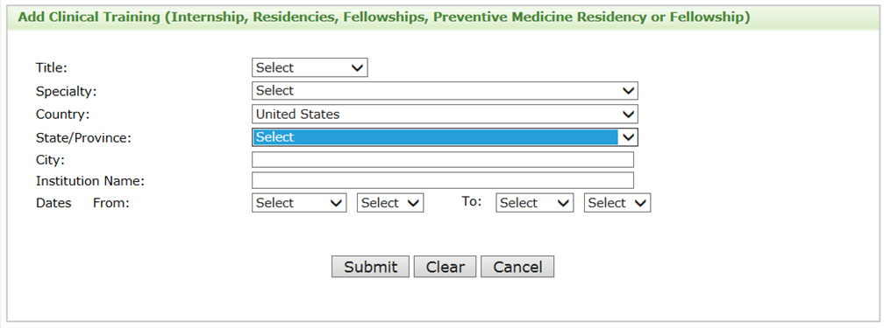

Table 6.2-a. Clinical Training Section Data Elements
Data Elements | Data Values | EIS | PHIF | Hubert | Epi-Elect | PEF | PMR/F | PHAP
Clinical Title | Clinical Titles | Opt | - | Opt | - | - | - | -
Medical Specialty | Specialties | Opt | - | Opt | - | - | - | -
Country | Countries | Opt | - | Opt | - | - | - | -
State/Province | Text | Opt | - | Opt | - | - | - | -
City | Text | Opt | - | Opt | - | - | - | -
Institution Name | Text | Opt | - | Opt | - | - | - | -
Date From | Date | Opt | - | Opt | - | - | - | -
Date To | Date | Opt | - | Opt | - | - | - | -

U.S. Board Certification Section

Figure 6.3-a. U.S. Board Certification Section
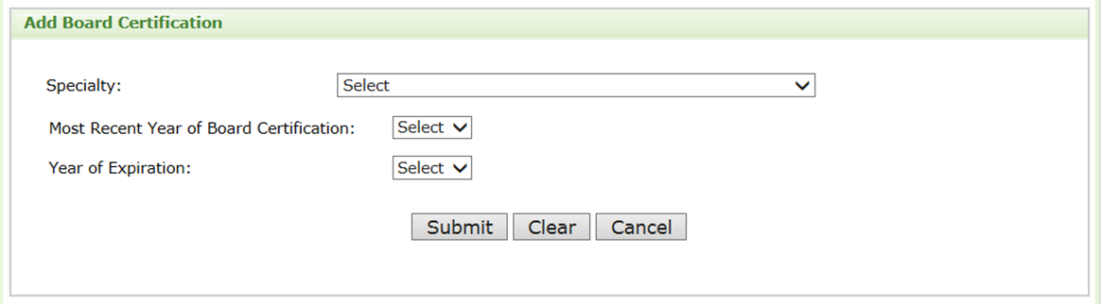

Table 6.3-a. U.S. Board Certification Section Data Elements
Data Elements | Data Values | EIS | PHIF | Hubert | Epi-Elect | PEF | PMR/F | PHAP
Specialty | Specialties | Opt | - | Opt | - | - | - | -
Certification Year | Years | Opt | - | Opt | - | - | - | -
Expiration Year | Years | Opt | - | Opt | - | - | - | -

Fellowship

Figure 6.4-a. Fellowship Section
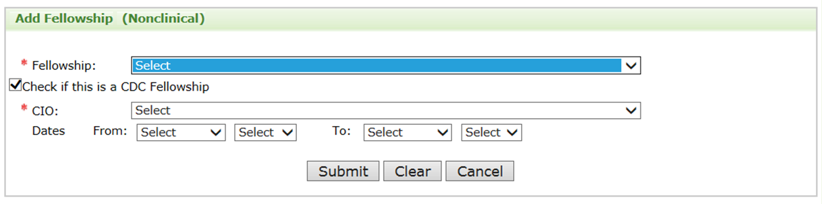

Table 6.4-a. Additional Training Section Data Elements
Data Elements | Data Values | EIS | PHIF | Hubert | Epi-Elect | PEF | PMR/F | PHAP
Training Program Name | Training Programs | Opt | - | Opt | - | - | - | -
CDC Fellowship | Checkbox | Opt | - | Opt | - | - | - | -
CIO | CIOs | Opt | - | Opt | - | - | - | -
Date From | Date | Opt | - | Opt | - | - | - | -
Date To | Date | Opt | - | Opt | - | - | - | -

Fellowship Assignment

Figure 6.5-a. Additional Training and Certifications Section
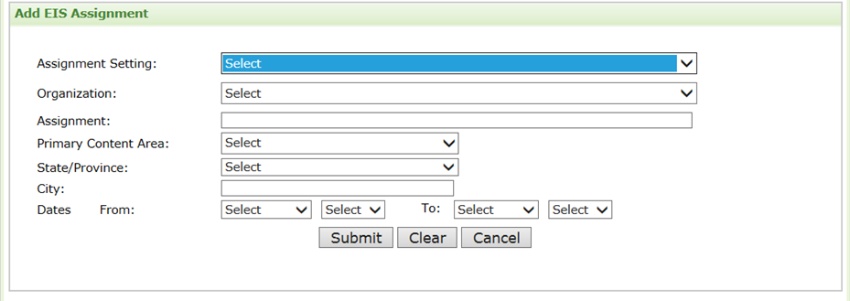

Table 6.5-a. Additional Training Section Data Elements
Data Elements | Data Values | EIS | PHIF | Hubert | Epi-Elect | PEF | PMR/F | PHAP
Assignment Setting | Work Settings | Opt | - | Opt | - | - | - | -
Organization | Organizations | Opt | - | Opt | - | - | - | -
Assignment | Text | Opt | - | Opt | - | - | - | -
Primary Content Area | Content Areas | Opt | - | Opt | - | - | - | -
State/Province | States | Opt | - | Opt | - | - | - | -
City | Text | Opt | - | Opt | - | - | - | -
Country | Countries | - | - | Opt | - | - | - | -
Date From | Date | Opt | - | Opt | - | - | - | -
Date To | Date | Opt | - | Opt | - | - | - | -

Language

Figure 6.6-a. Language Section
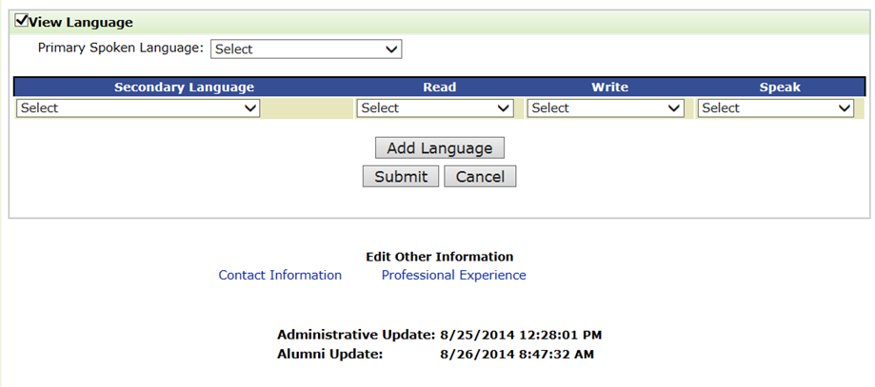

Table 6.6-a. Language Section Data Elements
Data Elements | Data Values | EIS | PHIF | Hubert | Epi-Elect | PEF | PMR/F | PHAP
Language Skills | Yes/No Choices | Opt | - | Opt | - | - | - | -
Primary Spoken Language | Languages | Opt | - | Opt | - | - | - | -
Secondary Languages | Languages | Opt | - | Opt | - | - | - | -
Language - Read | Proficiencies | Opt | - | Opt | - | - | - | -
Language - Write | Proficiencies | Opt | - | Opt | - | - | - | -
Language - Speak | Proficiencies | Opt | - | Opt | - | - | - | -
Section Complete | Yes/No Choices | Opt | - | Opt | - | - | - | -

Professional Experience

Professional Experience Section

Figure 7.1-a. Professional Experience Section


Table 7.1-a. Professional Experiences


Table 7.1-b. Job Functions and Roles
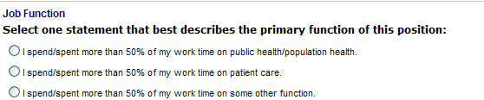

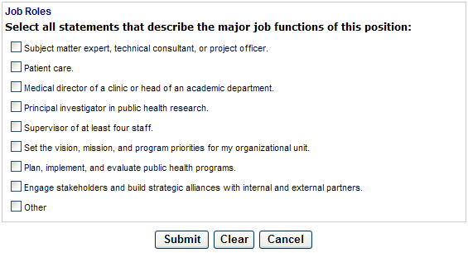

Table 7.1-c. Professional Experiences Section Data Elements
Data Elements | Data Values | EIS | PHIF | Hubert | Epi-Elect | PEF | PMR/F | PHAP
Work Setting | Work Settings | Opt | - | Opt | - | - | - | -
Organization | Organizations | Opt | - | Opt | - | - | - | -
Employer | Text | Opt | - | Opt | - | - | - | -
Title | Text | Opt | - | Opt | - | - | - | -
Country | Countries | Opt | - | Opt | - | - | - | -
State/Province | Text | Opt | - | Opt | - | - | - | -
City | Text | Opt | - | Opt | - | - | - | -
Date From | Date | Opt | - | Opt | - | - | - | -
Date To | Date | Opt | - | Opt | - | - | - | -
Job Function | Job Functions | Opt | - | Opt | - | - | - | -
Job Role | Job Roles | Opt | - | Opt | - | - | - | -

Account Setting

Account Setting

Table 8.1-a. account Setting
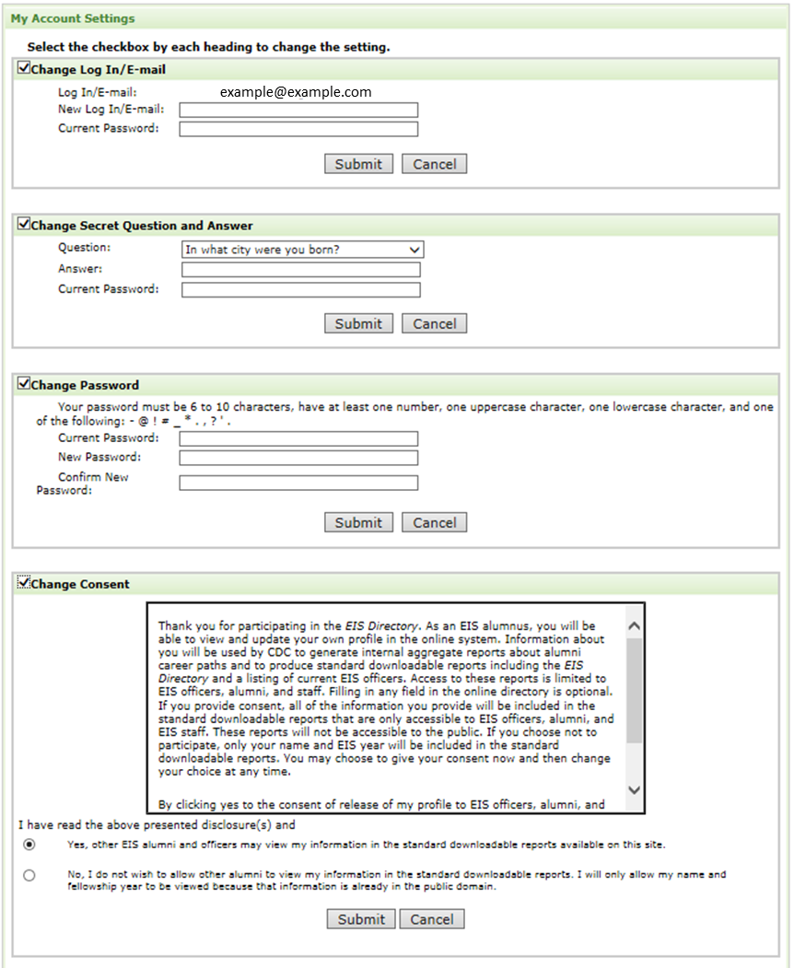
Figure 8.1-a. Account Settings Data Elements
Data Elements | Data Values | EIS | PHIF | Hubert | Epi-Elect | PEF | PMR/F | PHAP
Change Email | Checkbox | Opt | - | Opt | - | - | - | -
Login E-mail | Already Populated | Opt | - | Opt | - | - | - | -
New Login E-mail | Alphanumeric | Opt | - | Opt | - | - | - | -
Current Password | Alphanumeric | Opt | - | Opt | - | - | - | -
Change Secret Question | Checkbox | Opt | - | Opt | - | - | - | -
Secret Question | Secret Questions | Opt | - | Opt | - | - | - | -
Current Password | Alphanumeric | Opt | - | Opt | - | - | - | -
Change Password | Checkbox | Opt | - | Opt | - | - | - | -
New Password | Alphanumeric | Opt | - | Opt | - | - | - | -
Verify Password | Alphanumeric | Opt | - | Opt | - | - | - | -
Change Consent | Checkbox | Opt | - | Opt | - | - | - | -
Consent | Yes/No Choice | Opt | - | Opt | - | - | - | -

Directory

Directory Reports

Figure 9.1-a. Directory Reports
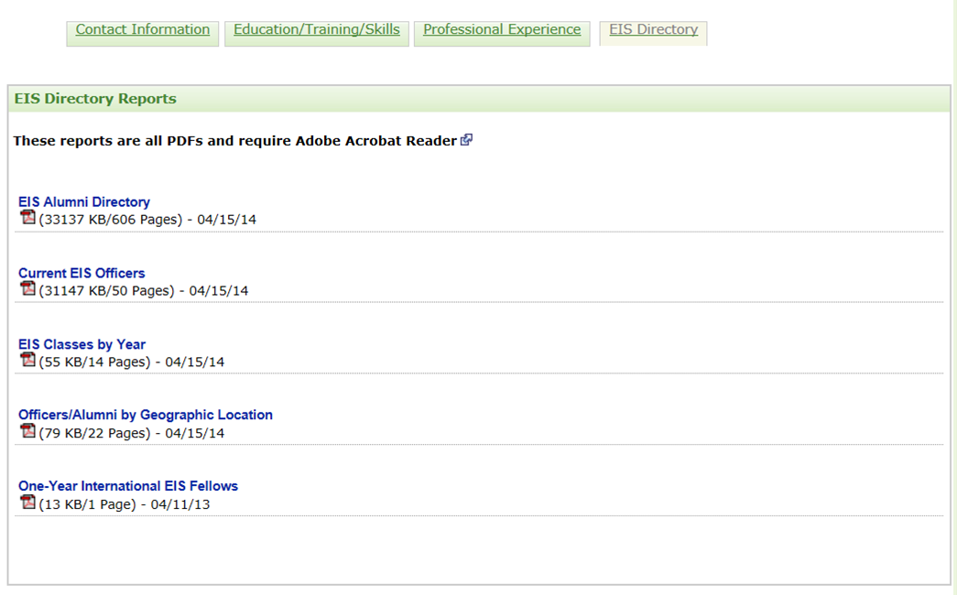

Current Fellows Report Example

Figure 9.2-a. Current Fellows Report Example
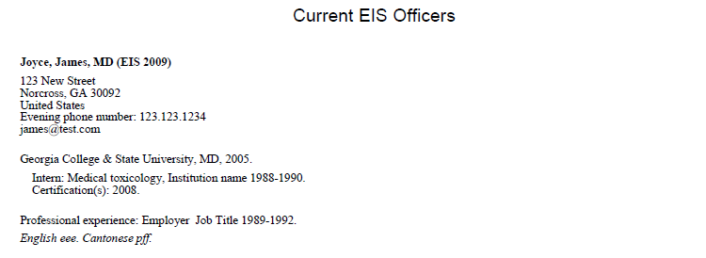

Fellowship Classes by Year

Figure 9.3-a. Classes by Year
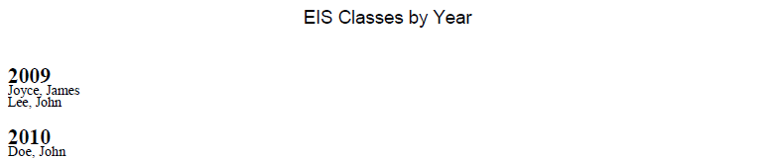

Current/Alumni by Geographic Locations

Figure 9.4-a. Current and Alumni by Geographic Locations
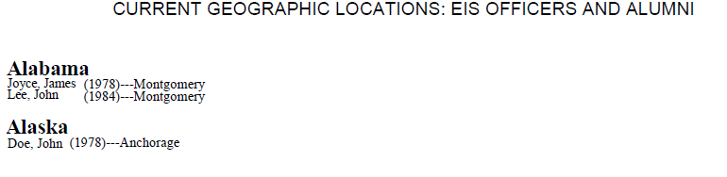

International Fellows
Figure 9.5-a. International Fellows
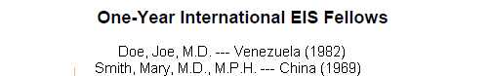

Appendix A – EIS Example E-mails

Invitation to Register
Dear $strFname$ $strLname$:
The $strAddressText$ is now available to you.
Once you log in to the site, please take a few minutes to carefully review, verify, and update all your $strProgramName$ information. We have migrated much of the historical directory data, but we believe some data were lost.
Thank you in advance for taking the time to ensure we have accurate information for you. It is important for the EIS program to maintain a current alumni database so we may provide summary reports to stakeholders (including you) on the program's impact.
Your Login Information
E-mail*: $strEmail$
Temporary password: $pw$
Visit the $strProgramName$ at: $strAddress$
*Use this e-mail address the first time you log in. You may change your e-mail address later.
Best Wishes,
Patricia M. Simone, M.D.
Acting EIS Chief
Centers for Disease Control and Prevention
Please do not reply to this e-mail. This e-mail address is not monitored.
CONFIDENTIALITY NOTICE: This electronic mail may contain information that is privileged, confidential, or otherwise protected from disclosure to anyone other than its intended recipients. Any dissemination or use of this electronic mail or its contents by persons other than the intended recipients is strictly prohibited. If you have received this communication in error, please delete the original message.

Registration Confirmation
Dear $strFname$ $strLname$:
Thank you for registering with the online $strAddressText$. We have confirmed your registration.
Once you login to the site, please take a few minutes to verify and update all your $strProgramName$ information.
It is important for the EIS to maintain a current alumni database so we may provide summary reports to stakeholders (including you) on the program's impact.
Your Login Information:
E-mail*: $strEmail$
Temporary password: $pw$
$strProgramName$: $strAddress$
*Use this e-mail address the first time you log in. You may change your e-mail address later.
Best Wishes,
Patricia M. Simone, M.D.
Acting EIS Chief
Centers for Disease Control and Prevention

Please do not reply to this e-mail. This e-mail address is not monitored.
CONFIDENTIALITY NOTICE: This electronic mail may contain information that is privileged, confidential, or otherwise protected from disclosure to anyone other than its intended recipients. Any dissemination or use of this electronic mail or its contents by persons other than the intended recipients is strictly prohibited. If you have received this communication in error, please delete the original message.

Appendix B – List Of Values

Secret Questions
- In what city were you born?
- In what city was your mother born?
- In what city was your father born?
- What was the name of your first pet?
- What was your high school mascot?
- What is your favorite color?

Degree Statuses
- Current
- Graduated (Degree Program)
- Completed (Non-Degree Program)
- Incomplete

Clinical Titles
- Intern
- Fellow
- Resident
- Chief Resident

License Statuses
- Received
- Expected

Board Statuses
- Certified
- Eligible

Language Proficiencies
- Poor
- Fair
- Good
- Excellent

Work Settings
- Government (including as contractor)
- Nongovernmental, community, or other organization
- Academia
- Other clinical setting
- Industry

Degree Statues
- Current
- Graduated (Degree Program)
- Completed (Non-Degree Program)
- Incomplete

Countries
- Afghanistan  - Albania  - Algeria  - Andorra  - Angola  - Anguilla (U.K.)  - Antigua and Barbuda  - Argentina  - Armenia  - Aruba  - Australia  - Austria  - Azerbaijan  - Azores  - Bahamas, The  - Bahrain  - Bangladesh  - Barbados  - Belarus  - Belgium  - Belize  - Benin  - Bermuda (U.K.)  - Bhutan  - Bolivia  - Bosnia and Herzegovina  - Botswana  - Brazil  - British Indian Ocean Territory (U.K.)  - British Virgin Islands  - Brunei  - Bulgaria  - Burkina Faso  - Burma (Myanmar)  - Burundi  - Cambodia  - Cameroon  - Canada  - Canary Islands (Spain)  - Cape Verde  - Cayman Islands (U.K.)  - Central African Republic  - Chad  - Chile  - China  - Christmas Island (Australia)  - Cocos (Keeling) Islands (Australia)  - Colombia | - Comoros  - Congo, Democratic Republic of the  - Congo, Republic of the  - Cook Islands (New Zealand)  - Costa Rica  - Côte d'Ivoire  - Croatia  - Cuba  - Cyprus  - Czech Republic  - Denmark  - Djibouti  - Dominica  - Dominican Republic  - Easter Island (Chile)  - Ecuador  - Egypt  - El Salvador  - Equatorial Guinea  - Eritrea  - Estonia  - Ethiopia  - Falkland Islands (Malvinas)  - Falkland Islands (U.K.)  - Faroe Islands (Denmark)  - Fiji  - Finland  - France  - French Guiana (France)  - French Polynesia (France)  - Gabon  - Gambia, The  - Georgia  - Germany  - Ghana  - Gibraltar (U.K.)  - Greece  - Greenland (Denmark)  - Grenada  - Guadeloupe  - Guatemala  - Guinea  - Guinea-Bissau  - Guyana  - Haiti  - Honduras  - Hong Kong SAR (China)  - Hungary | - Iceland  - India  - Indonesia  - Iran  - Iraq  - Ireland  - Israel  - Italy  - Jamaica  - Japan  - Jordan  - Kazakhstan  - Kenya  - Kiribati  - Korea, North  - Korea, South  - Kosovo  - Kuwait  - Kyrgyzstan  - Laos  - Latvia  - Lebanon  - Lesotho  - Liberia  - Libya  - Liechtenstein  - Lithuania  - Luxembourg  - Macau SAR (China)  - Macedonia  - Madagascar  - Madeira Islands (Portugal)  - Malawi  - Malaysia  - Maldives  - Mali  - Malta  - Marshall Islands  - Martinique (France)  - Mauritania  - Mauritius  - Mayotte (France)  - Mexico  - Moldova  - Monaco  - Mongolia  - Montenegro  - Montserrat (U.K.)  - Morocco  - Mozambique | - Namibia  - Nauru  - Nepal  - Netherlands Antilles  - Netherlands, The  - New Caledonia (France)  - New Zealand  - Nicaragua  - Niger  - Nigeria  - Niue (New Zealand)  - Northfolk Island (Australia)  - Northern Mariana Islands (U.S.)  - Norway  - Oman  - Other  - Pakistan  - Palau  - Panama  - Papua New Guinea  - Paraguay  - Peru  - Philippines  - Pitcairn Islands (U.K.)  - Poland  - Portugal  - Qatar  - Réunion (France)  - Romania  - Russia  - Rwanda  - Saint Helena (U.K.)  - Saint Kitts and Nevis  - Saint Lucia  - Saint Pierre and Miquelon (France)  - Saint Vincent and the Grenadines  - Samoa  - San Marino  - São Tomé and Príncipe  - Saudi Arabia  - Senegal  - Serbia  - Seychelles  - Sierra Leone  - Singapore | - Slovakia  - Slovenia  - Solomon Islands  - Somalia  - South Africa  - Spain  - Sri Lanka  - Sudan  - Suriname  - Swaziland  - Sweden  - Switzerland  - Syria  - Taiwan  - Tajikistan  - Tanzania  - Thailand  - Timor-Leste (East Timor)  - Togo  - Tokelau (New Zealand)  - Tonga  - Trinidad and Tobago  - Tunisia  - Turkey  - Turkmenistan  - Turks and Caicos Islands (U.K.)  - Tuvalu  - Uganda  - Ukraine  - United Arab Emirates  - United Kingdom  - United States  - Uruguay  - Uzbekistan  - Vanuatu  - Venezuela  - Vietnam  - Western Sahara  - Yemen  - Zambia  - Zimbabwe

States
- Alabama  - Alaska  - Arizona  - Arkansas  - California  - Colorado  - Connecticut  - Delaware  - Washington, DC  - Florida  - Georgia  - Hawaii  - Idaho  - Illinois  - Indiana  - Iowa  - Kansas  - Kentucky  - Louisiana  - Maine  - Maryland  - Massachusetts  - Michigan  - Minnesota  - Mississippi  - Missouri  - Montana  - Nebraska  - Nevada | - New Hampshire  - New Jersey  - New Mexico  - New York  - North Carolina  - North Dakota  - Ohio  - Oklahoma  - Oregon  - Pennsylvania  - Rhode Island  - South Carolina  - South Dakota  - Tennessee  - Texas  - Utah  - Vermont  - Virginia  - Washington  - West Virginia  - Wisconsin  - Wyoming  - Puerto Rico  - Guam  - American Samoa  - U.S. Virgin Islands  - Alberta  - British Columbia  - Manitoba | - New Brunswick  - Newfoundland and Labrador  - Nova Scotia  - Nunavut  - N.W.T.  - Ontario  - Quebec  - Saskatchewan  - Yukon  - Australian Capital Territory  - New South Wales  - Northern Territory  - Queensland  - South Australia  - Tasmania  - Victoria  - Western Australia  - Andra Pradesh  - Arunachal Pradesh  - Assam  - Bihar  - Chhattisgarh  - Goa  - Gujarat  - Haryana  - Himachal Pradesh | - Jammu and Kashmir  - Jharkhand  - Karnataka  - Kerala  - Madya Pradesh  - Maharashtra  - Manipur  - Meghalaya  - Mizoram  - Nagaland  - Orissa  - Punjab  - Rajasthan  - Sikkim  - Tamil Nadu  - TripuraUttaranchal  - Uttar Pradesh  - West Bengal  - Andaman and Nicobar Islands  - Chandigarh  - Dadar and Nagar Haveli  - Daman and Diu  - Delhi  - Lakshadeep  - Pondicherry

Languages
- Afrikaans  - Albanian  - Amharic  - Arabic (Egyptian)  - Aramaic  - Armenian  - Assamese  - Aymara  - Azerbaijani  - Basque  - Belarusian  - Bengali  - Bislama  - Bosnian  - Bulgarian  - Burmese  - Catalan  - Cebuano  - Cherokee  - Mandarin  - Croatian  - Czech  - Danish  - Dutch  - Egyptian |  | - English Estonian Finnish  - French  - Georgian  - German  - Greek  - Guarani  - Gujarati  - Creole (Haitian)  - Hausa  - Hawaiian  - Hebrew  - Hindi  - Hungarian  - Icelandic  - Irish  - Italian  - Japanese  - Javanese  - Kannada  - Kazakh  - Khmer  - Korean  - Lao  - Latvian |  | - Lithuanian  - Macedonian Malagasy Malayalam  - Marathi  - Mongolian  - Nahuatl  - Navajo  - Nepali  - Norwegian  - Oriya  - Oromo  - Farsi  - Polish  - Portuguese  - Punjabi  - Pashto  - Romanian  - Romany  - Russian  - Sanskrit  - Serbian  - Slovak  - Slovenian  - Somali  - Spanish |  | - Swahili  - Swedish  - Tagalog  - Tajik  - Tamil Telugu  - Thai  - Tibetan  - Tok Pisin  - Turkish  - Turkmen  - Ukrainian  - Urdu  - Uzbek  - Vietnamese  - Welsh  - Xhosa  - Yiddish  - Yoruba  - Zapotec  - Zulu  - Arabic (Levantine)  - Arabic (Modern Standard)  - Arabic (Moroccan) |  | - Indonesian (Not Specified)  - Bahasa Melayu  - Balochi  - Berber  - Cantonese  - Dari  - Ilokano  - Inuit  - Kurdi  - Kyrgyz  - Lakota  - Ojibwa  - Quechua  - Quiche  - Uyghur  - Yucatec Maya  - Arabic (Not Specified)  - Chinese (Not Specified)  - Creole (Not Specified)  - Malay

Degrees
- AA  - AAS  - AB  - AD  - ADN  - AM  - AS  - ASN  - BA  - BAC  - BBA  - BCE  - BDS  - BEng  - BFA  - BHB  - BIE  - BM  - BMBS  - BMed  - BNSc  - BNurs  - BPharm  - BS  - BS/BA | - BSc  - BSChE  - BScN  - BSE  - BSEE  - BSFS  - BSJ  - BSME  - BSPH  - BSN  - BVS  - BVSc  - DCH  - DDS  - DHA  - DHS  - DHSc  - DMD  - DNSc  - DO  - DPA  - DPE  - DPH  - DPhil  - DPM |  | - DPT  - DrPH  - DrS  - DrSc  - DSc  - DScD  - DScH  - DScVM  - DVM  - EdD  - JD  - LLB  - LLD  - MA  - MAS  - MAT  - MB  - MBA  - MBBCh  - MBBS  - MBChB  - MCPS  - MD  - MDCM  - MDiv |  | - MEd  - MFA  - MHA  - MHS  - MHSc  - MHSE  - MMS  - MN  - MNS  - MOH  - MOT  - MPA  - MPAS  - MPH  - MPharm  - MPhil  - MPHTM  - MPP  - MPVM  - MRP  - MS  - MSVPH  - MSc  - MScPH  - MSD |  | - MSHSA  - MSM  - MSN  - MSPH  - MSPM  - MSW  - MTM&H  - MUS  - MVSc  - OD  - PA  - PharmD  - PhB  - PhD  - PNP  - PsyD  - RN  - SB  - ScB  - ScD  - ScM  - SM  - SMHyg  - VMD

Major Classifications
- Biological, biomedical, or animal sciences  - Business Management  - Community health, public health  - Decision or quantitative sciences  - Economics (agricultural, applied, health)  - Engineering, industrial engineering, operations research  - Environmental, occupational sciences  - Epidemiology  - Global, international health  - Health education  - Informatics (public health, clinical, nursing)  - Health services administration, health policy analysis | - Health services research, quantitative policy analysis  - Information technology, information science, computer science  - Liberal arts, general studies, humanities, language, literature  - Maternal and child health  - Mathematical sciences, statistics, biostatistics  - Physical or chemical sciences  - Political science, law  - Public administration, policy analysis  - Social/behavior science (anthropology, social work, psychology)  - Other

Content Areas
- Birth Defects
- Chronic Disease
- Environmental Health
- Infectious Disease
- Injury
- Occupational Health
- Maternal/Child Health
- Global Health
- Health Statistics
- Emergency Preparedness
- General/Consulting
- General – public health practice
- Other

Medical Specialties
- Aerospace medicine  - Medical toxicology  - Undersea and hyperbaric medicine  - Allergy and immunology  - Clinical and laboratory immunology  - Anesthesiology  - Adult Cardiothoracic Anesthesiology  - Critical care medicine  - Pain medicine  - Pediatric anesthesiology  - Colon and rectal surgery  - Dermatology  - Dermatopathology  - Procedural dermatology  - Emergency medicine  - Medical toxicology  - Pediatric emergency medicine  - Sports medicine  - Undersea and hyperbaric medicine  - Family medicine  - Geriatric medicine  - Sports medicine  - Internal medicine  - Cardiovascular disease  - Clinical cardiac electrophysiology  - Critical care medicine  - Endocrinology, diabetes, and metabolism  - Gastroenterology  - Geriatric medicine  - Hematology  - Hematology and oncology  - Infectious disease  - Interventional cardiology  - Nephrology  - Oncology  - Pulmonary disease | - Pulmonary disease and critical care medicine  - Rheumatology  - Sports medicine  - Transplant hepatology  - Medical genetics  - Molecular genetic pathology  - Neurological surgery  - Endovascular surgical neuroradiology  - Neurology  - Child neurology  - Clinical neurophysiology  - Neuromuscular medicine  - Neurodevelopmental disabilities  - Pain medicine  - Vascular neurology  - Nuclear medicine  - Obstetrics and gynecology  - Occupational medicine  - Medical toxicology  - Undersea and hyperbaric medicine  - Ophthalmology  - Orthopaedic surgery  - Adult reconstructive orthopaedics  - Foot and ankle orthopaedics  - Hand surgery  - Musculoskeletal oncology  - Orthopaedic sports medicine  - Orthopaedic surgery of the spine  - Orthopaedic trauma  - Pediatric orthopaedics  - Otolaryngology  - Neurotology  - Pediatric otolaryngology  - Pain medicine  - Palliative and hospice care  - Pathology-anatomic and clinical | - Blood banking/transfusion medicine Chemical pathology Cytopathology  - Forensic pathology  - Hematology  - Medical microbiology  - Neuropathology  - Pediatric pathology  - Selective pathology  - Pediatrics  - Adolescent medicine  - Neonatal-perinatal medicine  - Pediatric cardiology  - Pediatric critical care medicine  - Pediatric emergency medicine  - Pediatric endocrinology  - Pediatric gastroenterology  - Pediatric hematology/ oncology  - Pediatric infectious diseases  - Pediatric nephrology  - Pediatric pulmonology  - Pediatric rheumatology  - Pediatric sports medicine  - Developmental-behavioral pediatrics  - Physical medicine and rehabilitation  - Pain medicine  - Pediatric rehabilitation  - Spinal cord injury medicine  - Plastic surgery  - Craniofacial surgery  - Hand surgery | - Preventive medicine (CDC PMR/F/F ONLY)  - Preventive medicine (General/PH)  - Medical toxicology Undersea and hyperbaric medicine  - Psychiatry Addiction psychiatry  - Child and adolescent psychiatry  - Forensic psychiatry  - Geriatric psychiatry  - Pain medicine  - Psychosomatic medicine  - Radiation oncology  - Radiology, diagnostic  - Abdominal radiology  - Cardiothoracic radiology  - Endovascular surgical neuroradiology  - Musculoskeletal radiology  - Neuroradiology  - Nuclear radiology  - Pediatric radiology  - Vascular and interventional radiology  - Sleep medicine  - Surgery  - Hand surgery  - Pediatric surgery  - Surgical critical care  - Vascular surgery  - Vascular surgery — Integrated  - Thoracic surgery  - Congenital Cardiac Surgery  - Urology  - Pediatric urology  - Transitional year  - Internal Medicine/Pediatrics

Training Program Names
- American Society for Microbiology Fellowship
- Association of Schools of Public Health Fellowship/Internship (ASPH)
- Association for Prevention Teaching and Research (APTR) Fellowship (formerly Association for Teachers of Preventive Medicine)
- Association of Public Health Labs Environmental Laboratory Fellowship (APHL)
- The CDC Experience Applied Epidemiology Fellowship
- CSTE/CDC Applied Epidemiology Fellowship
- Emerging Infectious Disease Laboratory Program (EID)
- Emerging Leaders Program (ELP)
- Epidemiology Elective for Medical/Veterinary Students
- James A. Ferguson Emerging Infectious Diseases Summer Research Fellowship Program
- Fogarty/Ellison Overseas Fellowship in Global Health and Clinical Research Training
- Hispanic-Serving Health Professions Fellowship (HSPHS)
- Hubert Fellowship in International Health
- Presidential Management Fellowship (PMF)
- Prevention Effectiveness Fellowship Program (PEFP)
- Preventive Medicine Residency (non-CDC)
- Preventive Medicine Residency/Fellowship (PMR/F/F-CDC)
- Project IMHOTEP Summer Research Intern Program
- Public Health Informatics Fellowship Program (PHIF)
- Public Health Prevention Service (PHPS)
- Public Health Sciences Institute Internship
- Public Health Summer Fellowship Program
- Epidemic Intelligence Service (EIS)

CDC CIOs
- Coordinating Office for Global Health
- Coordinating Office for Terrorism Preparedness and Emergency Response
- National Center for Environmental Health/ Agency for Toxic Substances and Disease Registry
- National Center for Injury Prevention and Control
- National Center for Health Marketing
- National Center for Health Statistics
- National Center for Public Health Informatics
- National Center on Birth Defects and Developmental Disabilities
- National Center for Chronic Disease Prevention and Health Promotion
- Agency for Toxic Substances and Disease Registry
- Office of Genomics and Disease Prevention
- National Center for HIV/AIDS, Viral Hepatitis, STD, and TB Prevention
- National Center for Immunization and Respiratory Diseases
- National Center for Preparedness, Detection, and Control of Infectious Diseases
- National Center for Zoonotic, Vector-Borne, and Enteric Diseases
- National Institute for Occupational Safety and Health
- OD/ Immunization Safety Office
- OD/ Office of Workforce and Career Development
- EIS Field Assignments Branch
- Office of the Chief Science Officer
- National Office of Public Health Genomics
- Office of the Chief Information Security Officer
- Office of Strategy and Innovation
- OD/ Office of Workforce and Career Development
- Office of Chief of Public Health Practice
- Office of Health and Safety
- National Center for Emerging and Zoonotic Infectious Diseases
- Center for Global Health
- Office of Associate Director for Policy
- Office of Associate Directory for Program

Months
- January
- February
- March
- April
- May
- June
- July
- August
- September
- October
- November
- December

Years
- 2020  - 2019  - 2018  - 2017  - 2016  - 2015  - 2014  - 2013  - 2012  - 2011  - 2010  - 2009  - 2008  - 2007  - 2006  - 2005  - 2004  - 2003  - 2002  - 2001  - 2000  - 1999  - 1998  - 1997  - 1996  - 1995  - 1994  - 1993  - 1992  - 1991 | - 1990  - 1989  - 1988  - 1987  - 19861985  - 1984  - 1983  - 1982  - 1981  - 1980  - 1979  - 1978  - 1977  - 1976  - 1975  - 1974  - 1973  - 1972  - 1971  - 1970  - 1969  - 1968  - 1967  - 1966  - 1965  - 1964  - 1963  - 1962  - 1961  - 1960 | - 1959  - 1958  - 19571956  - 1955  - 1954  - 1953  - 1952  - 1951  - 1950  - 1949  - 1948  - 1947  - 1946  - 1945  - 1944  - 1943  - 1942  - 1941  - 1940  - 1939  - 1938  - 1937  - 1936  - 1935  - 1934  - 1933  - 1932  - 1931  - 1930

Organizations

Government
- CDC
- International public health (WHO, foreign ministry of health)
- Other U.S. Department of Health and Human Services
- Other federal government
- State health department
- Local health department
- Other

Nongovernmental, community, or other organization
- Community-based organization
- Foundation
- Other organizations with mission targeting the health of the public

Academia
- School of Public Health
- School of Medicine (allopathic or osteopathic)
- School of Veterinary Medicine
- School of Nursing
- Other health sciences/health professional school
- Other university
- Other

Other Clinical Setting
- Hospital- or clinic-based
- Health maintenance organization
- Private practice
- Other

Industry
- Pharmaceutical company
- Other

Job Functions
- I spend/spent more than 50% of my work time on public health/population health.
- I spend/spent more than 50% of my work time on patient care.
- I spend/spent moer than 50% of my work on some other function.

Job Roles
- Subject matter expert, technical consultant, or project officer
- Patient care
- Medical director of a clinic or head of an academic department
- Principal investigator in public health research
- Supervisor of at least four staff
- Set the vision, mission, and program priorities for my organizational unit
- Plan, implement, and evaluate public health programs
- Engage stakeholders, and build strategic alliances with internal and external partners
- Other

College Names

Alabama
- Air University  - Alabama A&M University  - Alabama State University  - Athens State University  - Auburn University  - Auburn University at Montgomery  - Birmingham-Southern College  - Concordia College-Selma  - Faulkner University  - Huntingdon College  - Jacksonville State University | - Judson College  - Miles College  - Oakwood College  - Samford University  - Southeastern Bible College  - Southern Christian University Spring Hill College  - Stillman College  - Talladega College  - Troy University (main campus)  - Troy University (Dothan campus) | - Troy University (Montgomery campus)  - Tuskegee University  - United States Sports Academy  - University of Alabama (main campus)  - University of Alabama (Birmingham)  - University of Alabama (Huntsville)  - University of Mobile  - University of Montevallo  - University of North Alabama  - University of South Alabama  - University of West Alabama

Alaska
- Alaska Bible College  - Alaska Pacific University | - Sheldon Jackson College  - University of Alaska, Anchorage | - University of Alaska, Fairbanks  - University of Alaska, Southeast (Juneau)

Arizona
- A.T. Still University of Health Sciences  - American Indian College of the Assemblies of God  - Arizona State University  - Arizona State University Polytechnic Campus | - Arizona State University West DeVry University-Phoenix  - Embry-Riddle Aeronautical University  - Grand Canyon University  - Northcentral University Northern Arizona University  - Prescott College | - Southwestern College Thunderbird, The Garvin School of International Management  - University of Arizona  - University of Phoenix  - Western International University

Arkansas
- Arkansas Baptist College  - Arkansas State University, Jonesboro  - Arkansas Tech University  - Central Baptist College  - Harding University  - Henderson State University  - Hendrix College | - John Brown University  - Lyon College  - Ouachita Baptist University  - Philander Smith College Southern Arkansas University  - University of Arkansas, Fayetteville  - University of Arkansas, Fort Smith  - University of Arkansas, Little Rock | - University of Arkansas, Medical Sciences  - University of Arkansas, Monticello  - University of Arkansas, Pine Bluff  - University of Central Arkansas  - University of the Ozarks  - Williams Baptist College

College Names Continued

California
- Alliant International University  - Antioch University-Los Angeles  - Art Center College of Design  - Azusa Pacific University  - Bethany College  - Bethesda Christian University  - Biola University  - California Baptist University  - California College of the Arts  - California Institute of the Arts  - California Institute of Integral Studies  - California Institute of Technology  - California Lutheran University  - California Pacific University  - Humboldt State University  - San Diego State University  - San Francisco State University  - San Jose State University  - Sonoma State University  - California Maritime Academy  - California Polytechnic State University, San Luis Obispo  - California State Polytechnic University, Pomona  - California State University, Bakersfield  - California State University, Channel Islands  - California State University, Chico  - California State University, Dominguez Hills  - California State University, East Bay  - California State University, Fresno  - California State University, Fullerton  - California State University, Long Beach  - California State University, Los Angeles  - California State University, Monterey Bay  - California State University, Northridge  - California State University, Sacramento  - California State University, San Bernardino  - California State University, San Marcos  - California State University, Stanislaus  - Chapman University  - Charles R. Drew University of Medicine & Science  - Church Divinity School of the Pacific  - Claremont Graduate University  - Claremont McKenna College  - Harvey Mudd College  - Keck Graduate Institute of Applied Life Sciences  - Pitzer College | - Pomona College  - Scripps College  - Cogswell Polytechnical College  - Concordia University-Irvine  - DeVry University-Long Beach  - DeVry University-Pomona  - Dominican School of Philosophy & Theology  - Dominican University of California  - Fielding Graduate Institute  - Franciscan School of Theology  - Fresno Pacific University  - Fuller Theological Seminary  - Golden Gate University  - Graduate Theological Union  - Holy Names University  - Hope International University  - Humphreys College  - Institute of Transpersonal Psychology  - Jesuit School of Theology at Berkeley  - John F. Kennedy University  - La Sierra University  - Life Pacific College  - Lincoln University  - Loma Linda University  - Loyola Marymount University  - Marymount College  - The Master's College  - The Master's Seminary  - Menlo College  - Mills College  - Monterey Institute of International Studies  - Mount St. Mary's College  - National Hispanic University  - National University  - Naval Postgraduate School  - New College of California  - Notre Dame de Namur University  - National University  - Naval Postgraduate School  - New College of California  - Notre Dame de Namur University  - Occidental College  - Otis College of Art & Design | - Pacific Oaks College  - Pacific Union College  - Pacifica Graduate Institute  - Pardee RAND Graduate School  - Patten College  - Pepperdine University  - Platt College  - Point Loma Nazarene University  - Saint Mary's College of California  - Samuel Merritt College  - San Diego Christian College  - Santa Clara University  - Saybrook Graduate School & Research Center  - Simpson University  - Soka University of America  - Southern California Institute of Architecture  - Southwestern University School of Law  - Stanford University  - Thomas Aquinas College  - University of California, Berkeley  - University of California, Davis  - University of California, Hastings College of the Law  - University of California, Irvine  - University of California, Los Angeles  - University of California, Merced  - University of California, Riverside  - University of California, San Diego  - University of California, San Francisco  - University of California, Santa Barbara  - University of California, Santa Cruz  - American Jewish University  - University of La Verne  - University of Northern California  - University of the Pacific  - University of Redlands  - University of San Diego  - University of San Francisco  - University of Southern California  - Vanguard University of Southern California  - Western State University College of Law  - Western University of Health Sciences  - Westminster Seminary California  - Westmont College  - Whittier College  - William Howard Taft University  - William Jessup University  - Woodbury University

College Names Continued

Colorado
- Adams State College  - Colorado Christian University  - Colorado College  - Colorado School of Mines  - Colorado State University  - Colorado State University-Pueblo  - Colorado Technical University  - Fort Lewis College  - Jones International University  - Mesa State College | - Metropolitan State College of Denver  - Naropa Institute National Technological University  - Nazarene Bible College  - Regis University  - Rocky Mountain College of Art & Design  - United States Air Force Academy  - University of Colorado, Boulder | - University of Colorado, Colorado Springs  - University of Colorado, Denver  - University of Colorado, Health Sciences Center  - University of Denver  - University of Northern Colorado  - Western State College

Connecticut
- Albertus Magnus College  - Central Connecticut State University  - Charter Oak State College  - Connecticut College  - Eastern Connecticut State University  - Fairfield University  - Holy Apostles College & Seminary | - Mitchell College  - Post University  - Quinnipiac College  - Sacred Heart University St. Joseph College  - Southern Connecticut State University  - Trinity College  - United States Coast Guard Academy | - University of Bridgeport  - University of Connecticut  - University of Hartford  - University of New Haven  - Wesleyan University  - Western Connecticut State University  - Yale University

Delaware
- Delaware State University  - Goldey-Beacom College | - University of Delaware  - Wesley College | - Wilmington College

Florida
- The Baptist College of Florida  - Barry University  - Beacon College  - Bethune-Cookman College  - Carlos Albizu University-Miami  - Chipola College  - Clearwater Christian College  - DeVry University-Orlando  - Eckerd College  - Edward Waters College  - Embry-Riddle Aeronautical University  - Flagler College  - Florida Agricultural & Mechanical University  - Florida Atlantic University  - Florida Christian College  - Florida College  - Florida Gulf Coast University  - Florida Hospital College of Health Sciences  - Florida Institute of Technology | - Florida International University  - Florida Memorial University  - Florida Metropolitan University  - Florida Southern College  - Florida State University  - Hobe Sound Bible College  - Hodges University  - Jacksonville University  - Jones College  - Keiser University  - Lynn University  - Miami International University of Art & Design  - New College of Florida  - Northwood University  - Nova Southeastern University  - Palm Beach Atlantic University  - Ringling School of Art & Design  - Rollins College  - Saint John Vianney College Seminary  - Saint Leo College  - St. Petersburg College | - St. Thomas University South Florida Bible College & Theological Seminary  - Southeastern University  - Stetson University  - Trinity College of Florida  - Troy State University-Florida Region  - University of Central Florida  - University of Florida  - University of Miami  - University of North Florida  - University of South Florida  - University of Tampa  - University of West Florida  - Warner Southern College  - Webber International University

College Names Continued

Georgia
- Agnes Scott College  - American InterContinental University  - Art Institute of Atlanta  - Atlanta Christian College  - Augusta State University  - Bauder College  - Berry College  - Brenau University  - Brewton-Parker College  - Clark Atlanta University  - Covenant College  - Dalton State College  - University of Devry-Georgia  - Emmanuel College  - Emory University  - Interdenominational Theological Center  - LaGrange College | - Life University  - Mercer University  - Morehouse College  - Morehouse School of Medicine  - Oglethorpe University  - Paine College  - Piedmont College  - Reinhardt College  - Savannah College of Art & Design  - Shorter College South University  - Spelman College  - Thomas University  - Toccoa Falls College  - Truett-McConnell College  - Albany State University  - Armstrong Atlantic State University  - Augusta State University  - Clayton College & State University  - Columbus State University | - Fort Valley State University  - Georgia College & State University  - Georgia Institute of Technology  - Georgia Southern University  - Georgia Southwestern State University  - Georgia State University  - Kennesaw State University  - Macon State College  - Medical College of Georgia  - North Georgia College & State University  - Savannah State University  - Southern Polytechnic State University  - State University of West Georgia  - University of Georgia  - Valdosta State University  - Wesleyan College

Guam
- University of Guam

Hawaii
- Brigham Young University-Hawaii  - Chaminade University | - Hawaii Pacific University  - University of Hawaii, Hilo | - University of Hawaii, Manoa  - University of Hawaii, West Oahu

Idaho
- Albertson College of Idaho  - Boise State University  - Brigham Young University-Idaho | - Idaho State University  - Lewis-Clark State College | - Northwest Nazarene College  - University of Idaho

College Names Continued

Illinois
- Adler School of Professional Psychology  - American College of Education  - Argosy University  - Augustana College  - Aurora University  - Benedictine University  - Blackburn College  - Bradley University  - The Chicago School of Professional Psychology  - Chicago State University  - College of DuPage  - Columbia College  - Concordia University-Chicago  - DePaul University  - DeVry University  - DeVry University-Chicago  - DeVry University-DuPage  - Dominican University  - East-West University  - Eastern Illinois University  - Elmhurst College  - Erikson Institute  - Eureka College  - Governors State University | - Greenville College  - Illinois College  - Illinois Institute of Technology  - Illinois State University  - Illinois Wesleyan University  - Judson College  - Kendall College  - Knox College  - Lake Forest College  - Lake Forest Graduate School of Management  - Lakeview College of Nursing  - Lewis University  - Lincoln Christian College & Seminary  - Loyola University Chicago  - Lutheran School of Theology at Chicago  - McKendree College  - McMurray College  - Midwestern University  - Millikin University  - Monmouth College  - Moody Bible Institute  - National University of Health Sciences  - National-Louis University  - North Central College | - North Park University  - Northeastern Illinois University Northern Illinois University  - Northwestern University  - Olivet Nazarene University  - Principia College  - Quincy University  - Robert Morris College  - Rockford College  - Roosevelt University  - Rush University  - Saint Anthony College of Nursing  - St. Xavier University  - School of the Art Institute of Chicago  - Shimer College  - Southern Illinois University  - Spertus Institute of Jewish Studies  - Trinity Christian College  - Trinity International University  - University of Chicago  - University of Illinois  - University of St. Francis  - Western Illinois University  - Wheaton College

Indiana
- Anderson University  - Ball State University  - Bethel College  - Butler University  - Calumet College of St. Joseph  - Christian Theological Seminary  - Concordia Theological Seminary-Fort Wayne  - DePauw University  - Earlham College  - Franklin College  - Goshen College  - Grace College  - Hanover College  - Holy Cross College  - Huntington University  - Indiana Institute of Technology  - Indiana State University  - Indiana University, Bloomington  - Indiana University, East  - Indiana University, Kokomo | - Indiana University, Northwest  - Indiana University, South Bend  - Indiana University, Southeast  - Indiana Wesleyan University  - Manchester College  - Marian College  - Martin University  - Oakland City University  - Purdue University  - Purdue University Calumet  - Purdue University North Central  - Indiana University/Purdue University at Columbus  - Indiana University/Purdue University at Fort Wayne  - Indiana University/Purdue University at Indianapolis  - School of Technology at Anderson/Muncie | - School of Technology at Indianapolis School of Technology at Kokomo  - School of Technology at New Albany  - School of Technology at Richmond  - College of Technology at South Bend/Elkhart  - Rose-Hulman Institute of Technology  - Saint Joseph's College  - Saint Mary-of-the-Woods College  - Saint Mary's College  - Taylor University  - Tri-State University  - University of Evansville  - University of Indianapolis  - University of Notre Dame  - University of Saint Francis  - University of Southern Indiana  - Valparaiso University  - Wabash College

College Names Continued

Iowa
- Allen College  - Ashford University  - Briar Cliff College  - Buena Vista University  - Central College  - Clarke College  - Coe College  - Cornell College  - Des Moines University-Osteopathic Medical Center  - Divine Word College  - Dordt College  - Drake University | - Emmaus Bible College  - Faith Baptist Bible College & Theological Seminary  - Graceland College  - Grand View College  - Grinnell College  - Iowa State University  - Iowa Wesleyan College  - Kaplan University  - Loras College  - Luther College  - Maharishi University of Management | - Morningside College  - Mount Mercy College  - Northwestern College of Iowa  - St. Ambrose University  - Simpson College  - University of Dubuque  - University of Iowa  - University of Northern Iowa  - Upper Iowa University  - Vennard College  - Waldorf College  - Wartburg College  - William Penn University

Kansas
- Baker University  - Barclay College  - Benedictine College  - Bethany College  - Bethel College  - Central Christian College  - Emporia State University  - Fort Hays State University  - Friends University | - Haskell Indian Nations University  - Kansas State University  - Kansas Wesleyan University  - Manhattan Christian College  - McPherson College  - Mid-America Nazarene College  - Newman University  - Ottawa University  - Pittsburg State University | - Southwestern College  - Sterling College  - Tabor College  - University of Kansas  - University of Kansas Medical Center  - University of Saint Mary  - Washburn University  - Wichita State University

Kentucky
- Alice Lloyd College  - Asbury College  - Asbury Theological Seminary  - Bellarmine College  - Berea College  - Brescia University  - Campbellsville University  - Centre College  - Clear Creek Baptist Bible College  - Eastern Kentucky University  - Georgetown College  - Kentucky Christian University | - Kentucky Mountain Bible College  - Kentucky State University  - Kentucky Wesleyan College  - Lexington Theological Seminary  - Lindsey Wilson College  - Mid-Continent College  - Midway College  - Morehead State University  - Murray State University  - Northern Kentucky University  - Pikeville College  - St. Catharine College | - Southern Baptist Theological Seminary  - Spalding University  - Sullivan University  - Thomas More College  - Transylvania University  - Union College  - University of Kentucky  - University of Louisville  - University of the Cumberlands  - Western Kentucky University

Louisiana
- Centenary College of Louisiana  - Dillard University  - Grambling State University  - Louisiana College  - Louisiana State University, Alexandria  - Louisiana State University, Baton Rouge  - Louisiana State University, Health Sciences Center | - Louisiana State University, Shreveport  - University of New Orleans  - Louisiana Tech University  - Loyola University New Orleans  - McNeese State University  - Nicholls State University  - New Orleans Baptist Theological Seminary  - Northwestern State University of Louisiana | - Our Lady of Holy Cross College  - Our Lady of the Lake College  - Southeastern Louisiana University  - Southern University, Baton Rouge  - Southern University, New Orleans  - Tulane University  - University of Louisiana, Monroe  - University of Louisiana, Lafayette  - Xavier University of Louisiana

College Names Continued

Maryland
- Baltimore Hebrew University  - Baltimore International College  - Bowie State University  - Capitol College  - Chesapeake College  - College of Notre Dame of Maryland  - Columbia Union College  - Coppin State University  - Goucher College  - Frostburg State University  - Hood College  - Johns Hopkins University | - Loyola College  - Maryland institute, College of Art  - McDaniel College  - Morgan State University  - Mount Saint Mary's University  - National Labor College St. John's College-Annapolis  - St. Mary's College of Maryland  - St. Mary's Seminary & University  - Salisbury University  - Soujourner-Douglass College  - Tai Sophia Institute  - Towson University |  |  | - The Uniformed Services University of the Health Sciences  - United States Naval Academy  - University of Baltimore  - University of Maryland, Baltimore  - University of Maryland, Baltimore County  - University of Maryland, College Park  - University of Maryland, Eastern Shore  - University College  - Washington Bible College  - Washington College  - Villa Julie College

Massachusetts
- American International College  - Amherst College  - Anna Maria College  - Assumption College  - Atlantic Union College  - Babson College  - Bay Path College  - Becker College  - Benjamin Franklin Institute of Technology  - Bentley College  - Berklee College of Music  - Boston College  - Boston Conservatory  - Boston Graduate School of Psychoanalysis  - Boston University  - Brandeis University  - Bridgewater State College  - Cambridge College  - Clark University  - College of the Holy Cross  - Curry College  - Eastern Nazarene College  - Elms College  - Emerson College  - Emmanuel College  - Endicott College |  | - Fitchburg State College  - Gordon College  - Framingham State College  - Gordon-Conwell Theological Seminary  - Hampshire College  - Harvard University  - Hult International Business School  - Lasell College  - Lesley College  - Massachusetts College of Art  - Massachusetts College of Liberal Arts  - Massachuetts College of Pharmacy & Health Sciences  - Massachusetts Institute of Technology  - Massachusetts Maritime Academy  - Massachusetts School of Professional Psychology  - Merrimack College  - Mount Holyoke College  - Mount Ida College  - New England College of Optometry  - New England Conservatory of Music  - Newbury College  - Nichols College  - North Adams State College  - Northeastern University  - Pine Manor College  - Regis College | - Salem State College  - Simmons College  - Simon's Rock College  - Smith College  - Springfield College  - Stonehill College  - Suffolk University  - Tufts University  - University of Massachusetts, Amherst  - University of Massachusetts, Boston  - University of Massachusetts, Dartmouth  - University of Massachusetts, Lowell  - University of Massachusetts, Medical School at Worcester  - Wellesley College  - Wentworth Institute of Technology  - Western New England College  - Westfield State College  - Weston Jesuit School of Theology  - Wheaton College  - Wheelock College  - Williams College  - Worcester Polytechnic Institute  - Worcester State College

College Names Continued

Michigan
- Adrian College  - Albion College  - Alma College  - Andrews University  - Aquinas College  - Baker College  - Calvin College  - Central Michigan University  - Cleary University  - College for Creative Studies  - Concordia College-Ann Arbor  - Cornerstone University  - Cranbrook Academy of Art  - Davenport University  - Eastern Michigan University  - Ferris State University | - Finlandia University Grace Bible College  - Grand Valley State University  - Hillsdale College  - Hope College  - Kalamazoo College  - Kendall College of Art & Design  - Kettering University  - Kuyper College  - Lake Superior State University  - Lawrence Technological University  - Madonna University  - Marygrove College  - Michigan State University  - Michigan Technological University  - Northern Michigan University  - Northwood University | - Oakland University  - Olivet College  - Rochester College  - Saginaw Valley State University  - Siena Heights University  - Spring Arbor University  - University of Detroit Mercy  - University of Michigan, Ann Arbor  - University of Michigan, Dearborn  - University of Michigan, Flint  - Walsh College  - Wayne State University  - Western Michigan University

Minnesota
- Alfred Adler Institute  - Augsburg College  - Bethany Lutheran College  - Bethel University & Seminary  - Capella University  - Carleton College  - College of Saint Benedict  - College of St. Catherine  - College of St. Scholastica  - College of Visual Arts  - Concordia College-Moorhead  - Concordia College-St. Paul  - Crossroads College  - Crown College  - Gustavus Adolphus College  - Hamline University | - Luther Seminary  - Macalester College  - Martin Luther College  - Minneapolis College of Art & Design  - Bemidji State University  - Metropolitan State University  - Minnesota State University, Mankato  - Minnesota State University, Moorhead  - Southwest Minnesota State University  - St. Cloud State University  - Winona State University  - North Central University  - Northwestern College | - Oak Hills Christian College  - Pillsbury Baptist Bible College  - Saint John's University  - Saint Mary's University of Minnesota  - Saint Olaf College  - University of Minnesota, Crookston  - University of Minnesota, Duluth  - University of Minnesota, Morris  - University of Minnesota, Twin Cities  - University of Saint Thomas  - Walden University  - William Mitchell College of Law

Mississippi
- Alcorn State University  - Belhaven College  - Blue Mountain College  - Delta State University  - Jackson State University  - Magnolia Bible College | - Millsaps College  - Mississippi College  - Mississippi State University  - Mississippi University for Women  - Mississippi Valley State University  - Rust College | - Tougaloo College  - University of Mississippi  - University of Mississippi Medical Center  - University of Southern Mississippi  - William Carey College

College Names Continued

Missouri
- A.T. Still University of Health Sciences  - Avila College  - Baptist Bible College  - Calvary Bible College & Theological Seminary  - Central Bible College  - Central Christian College of the Bible  - Central Methodist University  - Central Missouri State University  - Cleveland Chiropractic College  - College of the Ozarks  - Columbia College  - Concordia Seminary-St. Louis  - Culver-Stockton College  - DeVry University-Kansas City | - Drury University Evangel University Fontbonne University  - Forest Institute of Professional Psychology  - Greenleaf University  - Hannibal-Lagrange College  - Harris-Stowe State University  - Lincoln University  - Lindenwood University  - Logan College of Chiropractic  - Maryville University of St. Louis  - Missouri Baptist College  - Missouri Southern State University  - Missouri State University  - Missouri Valley College  - Missouri Western State University  - Northwest Missouri State University  - Ozark Christian College |  | - Park University  - Rockhurst University  - St. Louis College of Pharmacy  - Saint Louis University  - Southeast Missouri State University  - Southwest Baptist University  - Stephens College  - Truman State University  - University of Missouri, Columbia  - University of Missouri, Kansas City  - University of Missouri, Rolla  - University of Missouri, St. Louis  - Washington University in St. Louis  - Webster University  - Westminster College  - William Jewell College  - William Woods University

Montana
- Carroll College  - Montana State University, Billings  - Montana State University, Bozeman | - Montana State University, Northern  - Rocky Mountain College  - Salish Kootenai College  - University of Great Falls |  | - Montana Tech  - University of Montana, Missoula  - University of Montana, Western

Nebraska
- Bellevue University  - Chadron State College  - Clarkson College  - College of Saint Mary  - Concordia University-Nebraska  - Creighton University  - Dana College  - Doane College | - Grace University  - Hastings College  - Midland Lutheran College  - Nebraska Christian College  - Nebraska Methodist College  - Nebraska Wesleyan University  - Peru State College  - Union College |  | - University of Nebraska, Kearney  - University of Nebraska, Lincoln  - University of Nebraska, Medical Center  - University of Nebraska, Omaha  - Wayne State College  - York College

Nevada
- Great Basin College | - Sierra Nevada College |  | - University of Nevada

New Hampshire
- Antioch New England  - Chester College of New England  - Colby-Sawyer College  - Daniel Webster College  - Dartmouth College  - Franklin Pierce College  - Franklin Pierce Law Center | - Granite State College  - Keene State College  - New England College  - Plymouth State College  - Rivier College  - Saint Anselm College  - Southern New Hampshire University |  | - The Thomas More College of Liberal Arts  - University of New Hampshire  - University of New Hampshire at Manchester

College Names Continued

New Jersey
- Berkeley College  - Bloomfield College  - Caldwell College  - Centenary College  - The College of New Jersey  - College of Saint Elizabeth  - Drew University  - Fairleigh Dickinson University  - Felician College  - Georgian Court College  - Kean University | - Monmouth University  - Montclair State University  - New Jersey City University  - New Jersey Institute of Technology  - Princeton University  - Ramapo College  - Richard Stockton College of New Jersey  - Rider University  - Rowan University  - Rutgers University, Camden | - Rutgers University, New Brunswick/Piscataway  - Rutgers University, Newark Saint Peter's College  - Seton Hall University  - Stevens Institute of Technology  - Thomas Edison State College  - University of Medicine & Dentistry of New Jersey  - William Paterson University

New Mexico
- College of Santa Fe  - College of the Southwest  - Eastern New Mexico University  - Institute of American Indian Arts | - New Mexico Institute of Mining & Technology  - New Mexico Highlands University  - New Mexico State University | - St. John's College-Santa Fe  - Southwestern College  - University of New Mexico  - Western New Mexico University

College Names Continued

New York
- Adelphi University  - Albany College of Pharmacy  - Albany Medical College  - Alfred University  - Bank Street College of Education  - Bard College  - Barnard College  - Boricua College  - Canisius College  - Cazenovia College  - Baruch College  - Brooklyn College  - City College  - College of Staten Island  - Graduate School & University Center  - Hunter College  - John Jay College of Criminal Justice  - Lehman College  - Medger Evers College  - New York City College of Technology  - Queens College  - York College  - Clarkson University  - Colgate University  - College of Mount St. Vincent  - College of New Rochelle  - College of Saint Rose  - Columbia University  - Concordia College-Bronxville  - The Cooper Union for the Advancement of Science & Art  - Cornell University  - Culinary Institute of America  - Daemen College  - Davis College  - Dominican College  - Dowling College  - D´Youville College  - Elmira College  - Excelsior College  - Five Towns College  - Fordham University  - Hamilton College  - Hartwick College  - Hebrew Union College-Jewish Institute of Religion  - Hilbert College | - Hobart and William Smith Colleges Hofstra University  - Houghton College  - Iona College  - Ithaca College  - The Jewish Theological Seminary of America  - The Juilliard School  - Keuka College  - Le Moyne College  - Laboratory Institute of Merchandising  - Long Island University, Brentwood Campus  - Long Island University, Brooklyn Campus  - Long Island University, C.W. Post Campus  - Long Island University, Rockland Graduate Campus  - Long Island University, Southampton Graduate Campus  - Long Island University, Westchester Graduate Campus  - Arnold & Marie Schwartz College of Pharmacy & Health Sciences  - Manhattan College  - Manhattan School of Music  - Manhattanville College  - Marist College  - Marymount College  - Marymount Manhattan College  - Medaille College  - Mercy College  - Metropolitan College of New York  - Molloy College  - Monroe College  - Mount Saint Mary College  - Nazareth College  - New School University  - New York College of Podiatric Medicine | - New York Institute of Technology  - New York Medical College New York University  - Niagara University  - Nyack College  - Pace University  - Parsons School of Design  - Paul Smith's College  - Polytechnic University of New York  - Pratt Institute  - Rensselaer Polytechnic Institute  - Roberts Wesleyan College  - Rochester Institute of Technology  - The Rockefeller University  - The Sage Colleges  - St. Bonaventure University  - Saint Francis College  - St. John Fisher College  - St. John's University  - St. Joseph's College  - St. Lawrence University  - St. Thomas Aquinas College  - Sarah Lawrence College  - School of Visual Arts  - Siena College  - Skidmore College  - State University of New York, Albany  - State University of New York, Binghamton  - State University of New York, Buffalo  - State University of New York, Stony Brook  - College at Brockport  - College at Buffalo (Buffalo State College)  - College at Cortland  - College at Fredonia  - College at Geneseo  - College at New Paltz  - College at Old Westbury | - College at Oneonta  - College at Oswego  - College at Plattsburgh  - College at Potsdam  - College at Purchase  - College of Agriculture & Technology at Cobleskill  - College of Agriculture & Technology at Morrisville (Morrisville State College)  - College of Environmental Science & Forestry  - College of Optometry  - College of Technology at Alfred (Alfred State University)  - College of Technology at Canton  - College of Technology at Delhi  - College of Technology at Farmingdale (Farmingdale State University)  - Downstate Medical Center  - Empire State College  - Fashion Institute of Technology  - Institute of Technology at Utica/Rome  - Maritime College at Ft. Schuyler  - Upstate Medical University  - Syracuse University  - Teachers College, Columbia University  - Touro College  - Unification Theological Seminary  - Union College  - Union Theological Seminary  - United States Merchant Marine Academy  - United States Military Academy  - University of Rochester  - Utica College of Syracuse University  - Vassar College  - Vaughn College of Aeronautics & Technology  - Wagner College  - Webb Institute  - Wells College  - Yeshiva University

College Names Continued

North Carolina
- Appalachian State University  - Barton College  - Belmont Abbey College  - Bennett College  - Brevard College  - Campbell University  - Catawba College  - Chowan College  - Davidson College  - Duke University  - East Carolina University  - Elizabeth City State University  - Elon University  - Fayetteville State University  - Gardner-Webb University  - Greensboro College  - Guilford College  - High Point University  - Johnson C. Smith University  - Lees-McRae College | - Lenoir-Rhyne College  - Livingstone College  - Louisburg College  - Mars Hill College  - Meredith College  - Methodist College  - Montreat College  - Mount Olive College  - North Carolina Central University  - North Carolina A&T State University  - North Carolina School of the Arts  - North Carolina State University  - North Carolina Wesleyan College  - Peace College  - Pfeiffer University  - Piedmont Baptist College  - Queens University of Charlotte  - Roanoke Bible College  - St. Andrews Presbyterian College  - St. Augustine's College | - Salem College  - Shaw University  - University of North Carolina, Asheville  - University of North Carolina, Chapel Hill  - University of North Carolina, Charlotte  - University of North Carolina, Greensboro  - University of North Carolina, Pembroke  - University of North Carolina, Wilmington  - Wake Forest University  - Warren Wilson College  - Western Carolina University  - Wingate University  - Winston-Salem State University

North Dakota
- Dickinson State University  - Jamestown College  - Mayville State University | - Minot State University  - North Dakota State University  - Trinity Bible College | - University of Mary  - University of North Dakota  - Valley City State University

Ohio
- Air Force Institute of Technology  - Antioch College  - Art Academy of Cincinnati  - Ashland University  - Baldwin-Wallace College  - Bowling Green State University  - Bluffton University  - Capital University  - Case Western Reserve University  - Cedarville University  - Central State University  - Cincinnati Christian University  - Cleveland Institute of Art  - Cleveland Institute of Music  - Cleveland State University  - College of Mount St. Joseph  - The College of Wooster  - Columbus College of Art & Design  - David N. Myers University  - Defiance College  - Denison University  - Franciscan University of Steubenville  - Franklin University  - Heidelberg College | - Hiram College  - John Carroll University  - Kent State University  - Kenyon College  - Lake Erie College  - Laura & Alvin Siegal College of Judaic Studies  - Lourdes College  - Malone College  - Marietta College  - Miami University of Ohio  - Mount Union College  - Mount Vernon Nazarene University  - Muskingum College  - Northeastern Ohio Universities College of Medicine  - Notre Dame College  - Oberlin College  - Ohio Christian University  - Ohio Dominican University  - Ohio Northern University  - Ohio State University, Columbus  - Ohio State University, Lima  - Ohio State University, Mansfield | - Ohio State University, Marion  - Ohio University  - Ohio Wesleyan University  - Otterbein College  - Shawnee State University  - Tiffin University  - Union Institute & University  - University of Akron  - University of Cincinnati  - University of Dayton  - The University of Findlay  - University of Northwestern Ohio  - University of Rio Grande  - University of Toledo  - University of Toledo Health Science Campus  - Urbana University  - Ursuline College  - Walsh University  - Wilberforce University  - Wilmington College  - Wittenberg University  - Wright State University  - Xavier University  - Youngstown State University

College Names Continued

Oklahoma
- Bacone College  - Cameron University  - East Central University  - Langston University  - Mid-America Christian University  - Northeastern State University, Broken Arrow campus  - Northeastern State University, Muskogee campus  - Northwestern Oklahoma State University  - Oklahoma Baptist University  - Oklahoma Christian University of Science & Arts | - Oklahoma City University  - Oklahoma Panhandle State University  - Oklahoma State University, Center for Health Sciences  - Oklahoma State University, Stillwater  - Oklahoma State University, Tulsa  - Oklahoma Wesleyan University  - Oral Roberts University  - Phillips University (closed July 1998)  - Rogers State University  - St. Gregory's University | - Southeastern Oklahoma State University  - Southern Nazarene University  - Southwestern Oklahoma State University  - University of Central Oklahoma  - University of Oklahoma  - University of Oklahoma Health Sciences Center  - University of Science & Arts of Oklahoma  - University of Tulsa

Oregon
- Art Institute of Portland  - Concordia University-Portland  - Corban College  - Eastern Oregon University  - Eugene Bible College  - George Fox University  - Lewis & Clark College  - Linfield College  - Marylhurst University  - Mount Angel Seminary | - Multnomah Bible College & Seminary National College of Naturopathic Medicine  - Northwest Christian College  - Oregon Graduate Institute of Science & Technology  - Oregon Health Sciences University  - Oregon Institute of Technology  - Oregon State University  - Pacific Northwest College of Art | - Pacific University  - Portland State University Reed College  - Southern Oregon University  - University of Oregon  - University of Portland  - Warner Pacific College  - Western Oregon University  - Western States Chiropractic College  - Willamette University

College Names Continued

Pennsylvania
- Albright College  - Allegheny College  - Alvernia College  - American College  - Arcadia University  - Baptist Bible College  - Bloomsburg University of Pennsylvania  - Bryn Athyn College of the New Church  - Bryn Mawr College  - Bucknell University  - Cabrini College  - California University of Pennsylvania  - Carlow College  - Carnegie Mellon University  - Cedar Crest College  - Chatham College  - Chestnut Hill College  - Cheyney University  - Clarion University of Pennsylvania  - College Misericordia  - Curtis Institute of Music  - Delaware Valley College  - DeSales University  - Dickinson College  - Drexel University  - Duquesne University  - East Stroudsburg University of Pennsylvania  - Eastern College  - Edinboro University of Pennsylvania  - Elizabethtown College  - Franklin & Marshall College  - Gannon University  - Geneva College  - Gettysburg College  - Gratz College  - Grove City College  - Gwynedd Mercy College  - Haverford College in Pennsylvania  - Holy Family University  - Immaculata College  - Indiana University of Pennsylvania  - Juniata College  - Keystone College  - Kings College  - Kutztown University of Pennsylvania  - La Roche College | - Lafayette College  - Lancaster Bible College  - LaSalle University  - Lebanon Valley College  - Lehigh University  - Lincoln University  - Lock Haven University of Pennsylvania  - Lycoming College  - Mansfield University of Pennsylvania  - Marywood University  - Mercyhurst College  - Messiah College  - Millersville University of Pennsylvania  - Moore College of Art & Design  - Moravian College  - Mount Aloysius College  - Muhlenberg College  - Neumann College  - Peirce College  - Pennsylvania College of Optometry  - Pennsylvania State University, Abington  - Pennsylvania State University, Altoona  - Pennsylvania State University, Beaver  - Pennsylvania State University, Berks  - Pennsylvania State University, Brandywine  - Pennsylvania State University, College of Medicine  - Dickinson School of Law  - Pennsylvania State University, DuBois  - The Behrend College, Erie  - Pennsylvania State University, The Eberly Campus  - Pennsylvania State University, Great Valley  - Pennsylvania State University, Greater Allegheny  - Pennsylvania State University, Harrisburg  - Pennsylvania State University, Hazleton  - Pennsylvania State University, Lehigh Valley  - Pennsylvania State University, Mont Alto  - Pennsylvania State University, New Kensington  - Pennsylvania College of Technology  - Pennsylvania State University, Schuylkill | - Pennsylvania State University, Shenango University Park (main campus)  - Pennsylvania State University, Wilkes-Barre  - Pennsylvania State University, Worthington Scranton  - Pennsylvania State University, York  - Philadelphia Biblical University  - Philadelphia University  - Point Park University  - Robert Morris College  - Rosemont College  - Saint Francis University  - Saint Joseph's University  - Saint Vincent College  - Seton Hill College  - Shippensburg University of Pennsylvania  - Slippery Rock University of Pennsylvania  - Susquehanna University  - Swarthmore College  - Temple University  - Thiel College  - Thomas Jefferson University  - United States Army War College  - University of Pennsylvania  - University of Pittsburgh, Bradford  - University of Pittsburgh, Greensburg  - University of Pittsburgh, Johnstown  - University of Scranton  - University of the Arts  - University of the Sciences in Philadelphia  - Ursinus College  - Valley Forge Christian College  - Villanova University  - Washington & Jefferson College  - Waynesburg College  - West Chester University of Pennsylvania  - Westminster College  - Westminster Theological Seminary  - Widener University  - Wilkes University  - Wilson College  - York College of Pennsylvania  - University of Pittsburgh (main campus)  - University of Pittsburgh, Titusville  - Pennsylvania State University, University Park

College Names Continued

Puerto Rico
- American University of Puerto Rico  - Antillean Adventist University  - Caribbean University  - Carlos Albizu University, San Juan  - Centro de Estudios Avanzados de Puerto Rico y el Caribe  - Conservatorio de Musica de Puerto Rico  - Escuela de Artes Plasticas de Puerto Rico  - Polytechnic University of Puerto Rico  - Ponce School of Medicine  - Pontificia Universidad Catolica de Puerto Rico  - Seminario Evangelico de Puerto Rico  - Sistema Universitario Ana G. Mendez  - Universidad del Este  - Universidad Metropolitana  - Universidad del Turabo | - Universidad Central de Bayamon  - Universidad Central del Caribe  - Universidad del Sagrado Corazon  - Universidad Interamericana de Puerto Rico (Aguadilla Campus)  - Universidad Interamericana de Puerto Rico (Arecibo Campus)  - Universidad Interamericana de Puerto Rico (Barranquitas Campus)  - Universidad Interamericana de Puerto Rico (Bayamon Campus)  - Universidad Interamericana de Puerto Rico (Fajardo Campus)  - Universidad Interamericana de Puerto Rico (Guayama Campus)  - Universidad Interamericana de Puerto Rico (Metropolitan Campus)  - Universidad Interamericana de Puerto Rico (Ponce Campus) | - Universidad Interamericana de Puerto Rico (San German Campus)  - Universidad Interamericana de Puerto Rico, School of Law  - Universidad Interamericana de Puerto Rico, School of Optometry  - University of Puerto Rico, Aguadilla  - University of Puerto Rico, Arecibo  - University of Puerto Rico, Bayamon  - University of Puerto Rico, Carolina  - University of Puerto Rico, Cayey  - University of Puerto Rico, Ciencias Medicas  - University of Puerto Rico, Humacao  - University of Puerto Rico, Mayagüez  - University of Puerto Rico, Ponce  - University of Puerto Rico, Rio Piedras  - University of Puerto Rico, Utuado

Rhode Island
- Brown University  - Bryant College  - Johnson & Wales University  - Naval War College | - New England Institute of Technology  - Providence College  - Rhode Island College | - Rhode Island School of Design  - Roger Williams University  - Salve Regina University  - University of Rhode Island

South Carolina
- Allen University  - Anderson College  - Benedict College  - Bob Jones University  - Charleston Southern University  - The Citadel  - Claflin University  - Clemson University  - Coastal Carolina University  - Coker College  - College of Charleston  - Columbia College  - Columbia International University  - Converse College | - Erskine College Francis Marion University  - Furman University  - Johnson & Wales University-Charleston  - Lander University  - Limestone College  - Medical University of South Carolina  - Morris College  - Newberry College  - North Greenville University  - Presbyterian College  - Sherman College of Straight Chiropractic | - South Carolina State University Southern Wesleyan University  - University of South Carolina, Aiken  - University of South Carolina, Beaufort  - University of South Carolina, Columbia  - University of South Carolina, Lancaster  - University of South Carolina, Sumter  - University of South Carolina, Union  - University of South Carolina, Upstate  - Voorhees College  - Winthrop University  - Wofford College

South Carolina
- Augustana College  - Black Hills State University  - Dakota State University  - Dakota Wesleyan University  - Mount Marty College | - National American University  - Northern State University  - Oglala Lakota College  - Presentation College  - Sinte Gleska University | - South Dakota School of Mines & Technology  - South Dakota State University  - University of Sioux Falls  - University of South Dakota

College Names Continued

Tennessee
- Aquinas College  - Austin Peay State University  - Baptist Memorial College of Health Sciences  - Belmont University  - Bethel College  - Bryan College  - Carson-Newman College  - Christian Brothers University  - Church of God Theological Seminary  - Crichton College  - Cumberland University  - East Tennessee State University  - Fisk University  - Freed-Hardeman University  - Johnson Bible College  - King College |  | - Knoxville College Lambuth University  - Lane College  - Lee University  - LeMoyne-Owen College  - Lincoln Memorial University  - Lipscomb University  - Martin Methodist College  - Maryville College  - Meharry Medical College  - Memphis College of Art  - Middle Tennessee State University  - Milligan College  - Rhodes College  - South College  - Southern Adventist University |  |  | - Southern College  - Southern College of Optometry  - Tennessee State University  - Tennessee Technological University  - Tennessee Temple University  - Tennessee Wesleyan College  - Trevecca Nazarene University  - Tusculum College  - Union University  - University of Memphis  - University of Tennessee, Chattanooga  - University of Tennessee, Knoxville  - University of Tennessee, Martin  - University of Tennessee, Memphis  - University of the South  - Vanderbilt University

Texas
- Abilene Christian University  - Ambassador University (closed spring 1997)  - Amberton University  - Arlington Baptist College  - Art Institute of Dallas  - Art Institute of Houston  - Austin College  - Austin Graduate School of Theology  - Austin Presbyterian Theological Seminary  - Baptist Missionary Association Theological Seminary  - Baylor College of Medicine  - Baylor University  - College of Saint Thomas More  - Concordia University-Texas  - Criswell College  - Dallas Baptist University  - Dallas Christian College  - Dallas Theological Seminary  - DeVry University-Dallas  - East Texas Baptist University  - Episcopal Theological Seminary of the Southwest  - Hardin-Simmons University  - Houston Baptist University  - Howard Payne University  - Huston-Tillotson University  - Jarvis Christian College  - LeTourneau University  - Lubbock Christian University  - McMurry University  - Midwestern State University  - Northwood University  - Oblate School of Theology  - Our Lady of the Lake University  - Parker College of Chiropractic  - Paul Quinn College  - Rice University |  | - St. Edward's University  - St. Mary's University of San Antonio  - Schreiner University  - Southern Methodist University  - South Texas College of Law  - Southwestern Adventist University  - Southwestern Assemblies of God University  - Southwestern Baptist Theological Seminary  - Southwestern Christian College  - Southwestern University  - Stephen F. Austin State University  - Baylor College of Dentistry  - Texas A&M University, College Station  - Texas A&M University, Commerce  - Texas A&M University, Corpus Christi  - Texas A&M University, Galveston  - Texas A&M University, Health Science Center  - Texas A&M University, Kingsville  - Prairie View A&M University  - Tarleton State University  - Texas A&M University, Texarkana  - Texas A&M International University  - West Texas A&M University  - Texas Chiropractic College  - Texas Christian University  - Texas College  - Texas Lutheran University  - Texas Southern University  - Lamar University  - Sam Houston State University  - Sul Ross State University  - Texas State University, San Marcos  - Texas State University  - Angelo State University  - Health Sciences Center |  |  | - Texas Tech University  - Texas Wesleyan University  - Texas Woman's University  - Trinity University  - University of Dallas  - University of Houston (main campus)  - University of Houston, Clear Lake  - University of Houston, Downtown  - University of Houston, Victoria  - University of Mary Hardin-Baylor  - University of North Texas  - University of North Texas, Health Science Center at Ft. Worth  - University of Saint Thomas  - University of Texas, Arlington  - University of Texas, Austin  - University of Texas, Brownsville  - University of Texas, Dallas  - University of Texas, El Paso  - University of Texas, Pan American  - University of Texas, Permian Basin  - University of Texas, San Antonio  - University of Texas, Tyler  - University of Texas, Health Science Center at Houston  - University of Texas, Health Science Center at San Antonio  - University of Texas, Health Center at Tyler  - University of Texas, M.D. Anderson Cancer Center  - University of Texas, Medical Branch at Galveston  - University of Texas, Southwestern Medical Center at Dallas  - University of the Incarnate Word  - Wayland Baptist University  - Wiley College
 | College Names Continued
 | Utah
 | - Brigham Young University  - College of Eastern Utah  - Dixie State College  - Southern Utah University |  | - University of Utah  - Utah State University  - Utah Valley State College | - Weber State University  - Western Governors University  - Westminster College
 | Vermont
 | - Bennington College  - Burlington College  - Castleton State University  - Champlain College  - College of St. Joseph  - Goddard College  - Green Mountain College |  | - Johnson State College  - Lyndon State College  - Marlboro College  - Middlebury College  - Norwich University  - Saint Michael's College  - School for International Training | - Southern Vermont College  - Sterling College  - University of Vermont  - Vermont Law School  - Vermont Technical College
 | Virginia
 | - Averett College  - Bluefield College  - Bridgewater College  - Christendom College  - Christopher Newport University  - College of William and Mary  - DeVry University-Crystal City  - Eastern Mennonite University  - Eastern Virginia Medical School  - ECPI College of Technology  - Emory & Henry College  - Ferrum College  - George Mason University  - George Washington University-Virginia Campus  - Hampden-Sydney College  - Hampton University  - Hollins University  - Institute for the Psychological Sciences |  | - Institute of Textile Technology  - James Madison University  - Jefferson College of Health Sciences  - Liberty University  - Longwood University  - Lynchburg College  - Marine Corps University  - Mary Baldwin College  - Marymount University  - Norfolk State University  - Old Dominion University  - Radford University  - Randolph-Macon College  - Randolph College  - Regent University  - Roanoke College  - Saint Paul's College  - Shenandoah University | - Sweet Briar College  - United States Marine Corps University  - University of Mary Washington  - University of Richmond  - University of Virginia  - University of Virginia's College at Wise  - Virginia Commonwealth University  - Virginia Intermont College  - Virginia Military Institute  - Virginia Polytechnic Institute and State University  - Virginia State University  - Virginia Union University  - Virginia Wesleyan College  - Washington Bible College/Capital Bible Seminary  - Washington & Lee University
 | Washington
 | - Antioch University-Seattle  - Art Institute of Seattle  - Bastyr University  - Central Washington University  - City University  - Eastern Washington University  - Evergreen State College  - Gonzaga University  - Heritage University  - Northwest University  - Pacific Lutheran University |  | - St. Martin's College  - Seattle Pacific University  - Seattle University  - Trinity Lutheran College  - University of Puget Sound  - University of Washington (Bothell campus)  - University of Washington (Tacoma campus)  - Walla Walla University | - Washington State University (Spokane campus)  - Washington State University (Tri-Cities campus)  - Washington State University (Vancouver campus)  - Western Washington University  - Whitman College  - Whitworth College  - University of Washington (Seattle/Main campus)

College Names Continued

Washington, DC
- George Washington University (Main campus/Foggy Bottom)  - American University  - The Catholic University of America  - Corcoran College of Art & Design  - Gallaudet University  - George Washington University (Mount Vernon campus) | - George Washington University (Virginia Campus)  - Georgetown University  - Howard University  - Institute of World Politics  - Joint Military Intelligence College  - National Defense University | - Southeastern University  - Strayer University  - Trinity University  - University of the District of Columbia  - Washington Theological Union  - Wesley Theological Seminary

West Virginia
- Alderson-Broaddus College  - Bethany College  - Bluefield State College  - Concord University  - Davis & Elkins College  - Fairmont State College  - Glenville State College | - Marshall University Mountain State University Ohio Valley College  - Salem International University  - Shepherd University  - University of Charleston  - West Liberty State College | - West Virginia State University  - West Virginia University West Virginia University Institute of Technology  - West Virginia University at Parkersburg  - West Virginia Wesleyan College  - Wheeling Jesuit University

Wisconsin
- Alverno College  - Beloit College  - Cardinal Stritch College  - Carroll College  - Carthage College  - Concordia University-Wisconsin  - Edgewood College  - Herzing College  - Lakeland College  - Lawrence University  - Maranatha Baptist Bible College  - Marian College of Fond du Lac  - Marquette University | - Medical College of Wisconsin  - Milwaukee School of Engineering  - Mount Mary College  - Northland College  - Ripon College  - St. Norbert College  - Silver Lake College  - University of Wisconsin, Eau Claire  - University of Wisconsin, Green Bay  - University of Wisconsin, LaCrosse  - University of Wisconsin, Madison  - University of Wisconsin, Milwaukee | - University of Wisconsin, Oshkosh  - University of Wisconsin, Parkside  - University of Wisconsin, Platteville  - University of Wisconsin, River Falls  - University of Wisconsin, Stevens Point  - University of Wisconsin, Stout  - University of Wisconsin, Superior  - University of Wisconsin, Whitewater  - Viterbo University  - Wisconsin Lutheran College  - Wisconsin School of Professional Psychology

Wyoming
- University of Wyoming

