Attachment 1 – Screen Shots for Modifications and Additions to the Existing FMS Application Module
OMB CONTROL NUMBER 0920-0765
FELLOWSHIP MANAGEMENT SYSTEM
NON-SUBSTANTIVE CHANGE REQUEST

PROPOSED MODIFICATIONS FOR CDC EPIDEMIC INTELLIGENCE SERVICE (EIS) FELLOWSHIP
FMS APPLICATION MODULE
DATE SUBMITTED: March 12, 2018
No Changes will be made to sections 1.1–5.1
Changes begin in section 5.2

5.2 Citizenship Status Section
Figure 5.2-a. Country of Citizenship
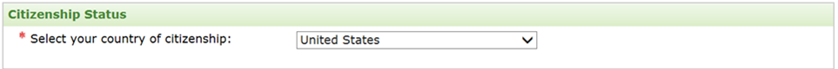
Figure 5.2-b Primary Language Spoken
Question Moved
Primary Language Spoken (moved to 5.2-b from 7.1, Postgraduate Training and Skills Page.)
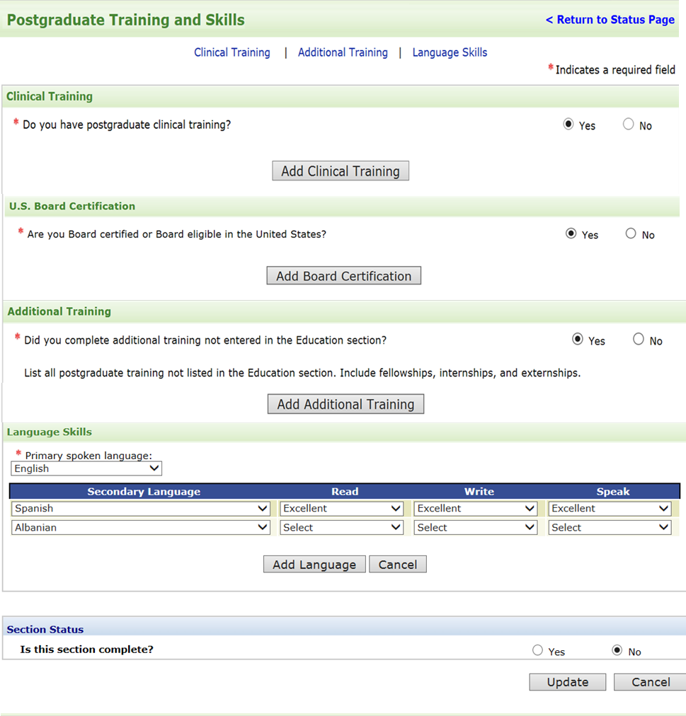
Figure 5.3-e. TOFEL Exam Scores 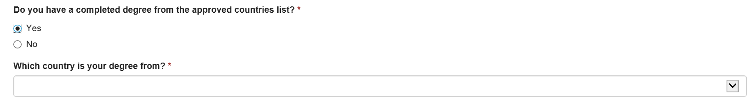
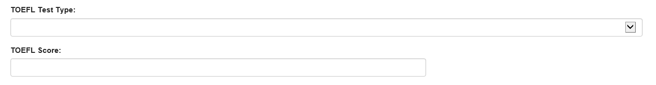
New Question
For international applicants: Do you have a completed degree from an approved country list?
5.2e TOEFL Exam Scores will be added.

No changes will be made to sections 5.3-6.2.

6.3 High School Education Section
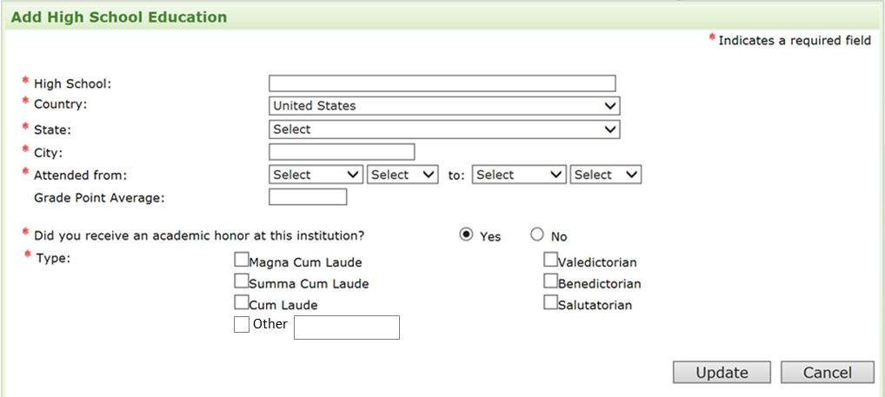
Fields Removed: The above questions with strike through marks will be removed from the application.

6.4 College/University Education Section
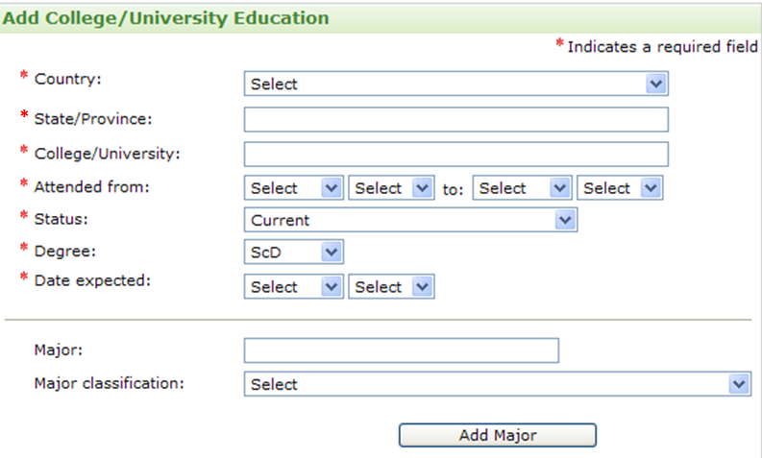
New Field
The following question will be added under the Date expected question for PhD candidates.

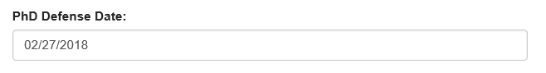

7.1 Postgraduate Training and Skills Page
Figure 7.1-a. Postgraduate Training and Skills Page
Section Replaced
This section will be removed and replaced with information requests in screenshots below.

Postgraduate Training and Skills Screenshot
New question displayed; answer skips to relevant section. 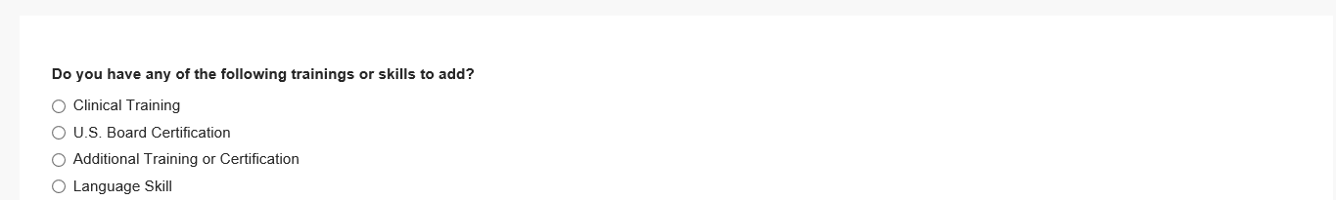

8.1a Work and Volunteer Experience
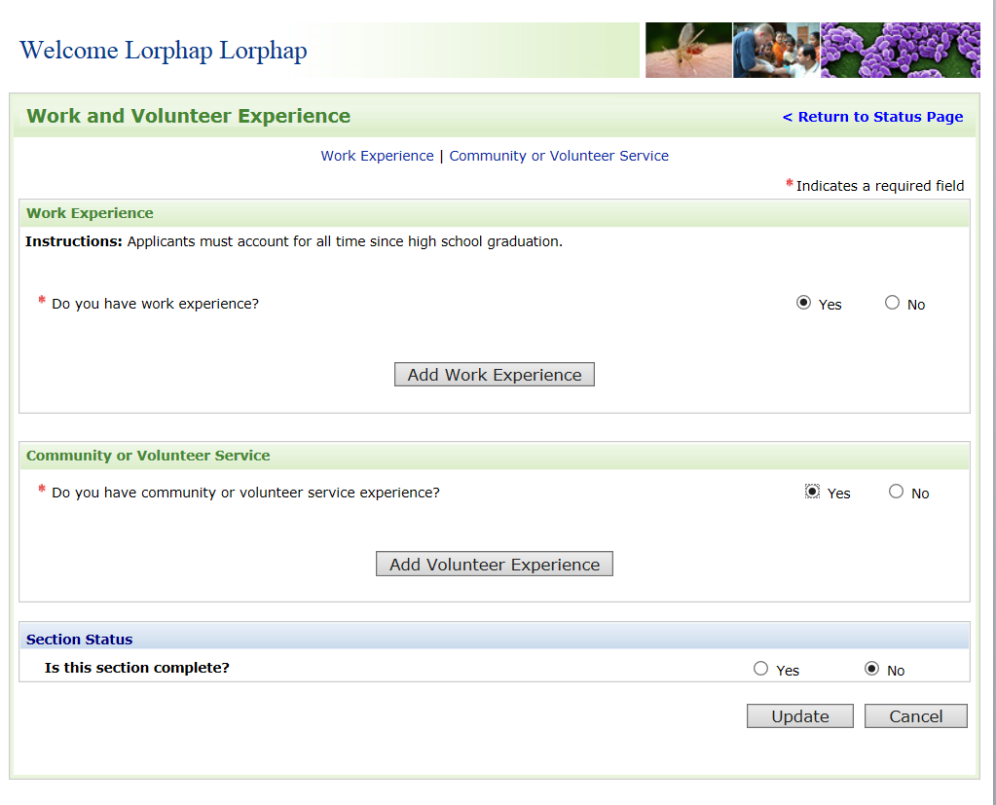
Section Replaced
This section will be removed and replaced with information requested in the screenshots below.
Work and Volunteer Experience Screenshot
Step 2: New question displayed; answer skips to relevant section.
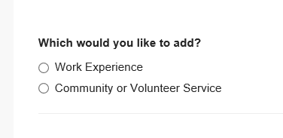

9.1a Publications, Presentations, Grants Page
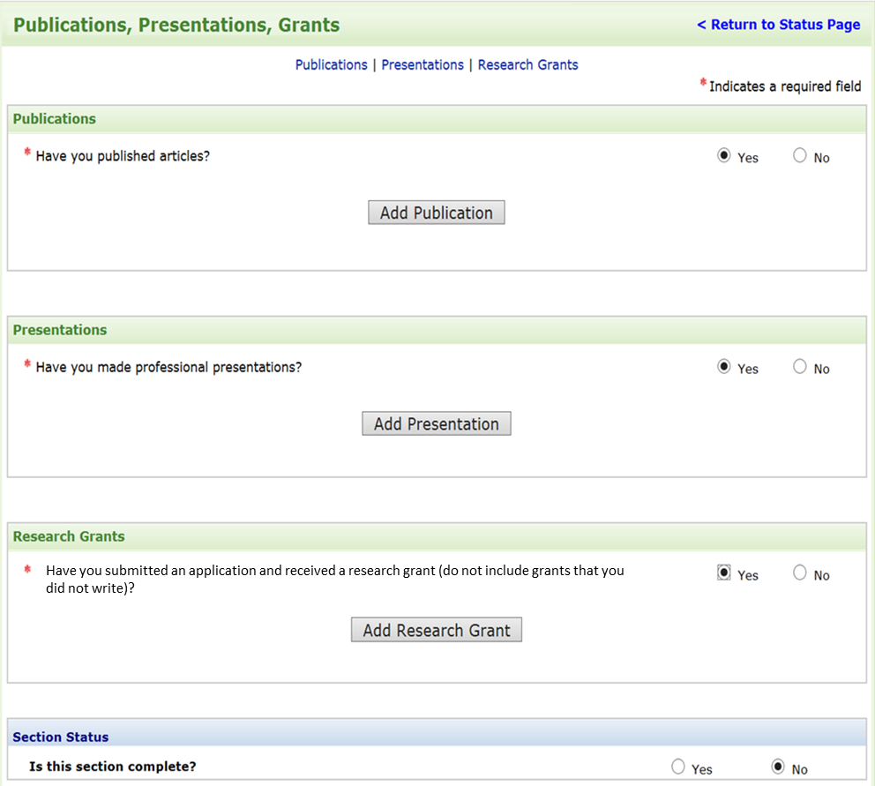
Section Replaced
This section will be removed and replaced with information requested in the screenshots below.

10.1a Honors and Awards Page
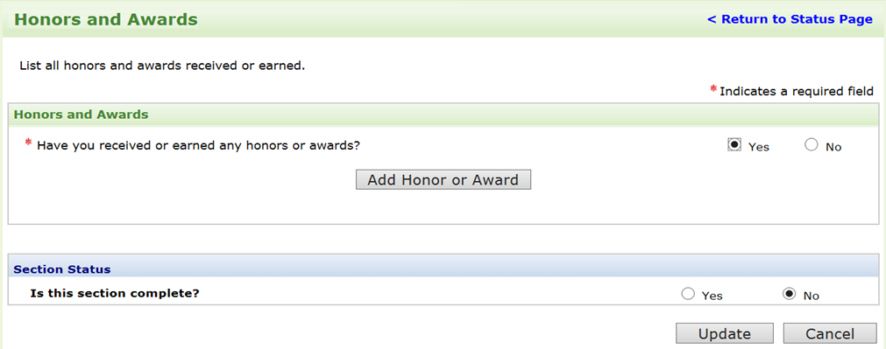
Section Replaced
This section will be removed and replaced with the information requested in the screenshots below.

Publications, Presentations, Grants, Honors, and Awards Screenshot
New question displayed; answer skips to relevant section.

No changes will be made to sections 8.1-17. See original package for details.

