APPENDIX B

SUPPORTING STATEMENT
H-2A Temporary Agricultural Labor Certification Program
OMB Control Number 1205-0466

Public Comment Responses

This is an appendix to the Office of Management and Budget’s (OMB) Supporting Statement for the collection of information under the H-2A H-2A Temporary Agricultural Labor Certification Program, OMB Control Number 1205-0466, which includes application forms and general instructions. This document is to be reviewed in conjunction with in Question 8 of the Supporting Statement. This appendix includes a summary of all public comments received in response to the 60-day Federal Register Notice (FRN) the Department of Labor’s (Department) Employment and Training Administration (ETA), Office of Foreign Labor Certification (OFLC) published in the Federal Register on October 25, 2018 (83 FR 53911). The Department received 17 responses to its solicitation of comments in the 60-day FRN, many of which included several consolidated comments. One of these responses was submitted by a group of 13 agricultural advocacy organizations, hereinafter referred to as “the combined worker advocacy organizations.” Two of the comments received discussed issues that are outside the scope of this ICR. Other commenters made specific suggestions on topics related to this ICR, but the suggestions would require rulemaking and, therefore, are beyond the scope of this ICR. The comments have been considered, summarized, and addressed in this document.

- Support for the Department’s Proposed Revisions

Some of the commenters expressed general support for the Department’s proposed revisions, while others expressed support for specific proposals. Two commenters noted that they “supported efforts to streamline information collections and eliminate redundancy.” One of the commenters expressed appreciation for the Department’s elimination of “redundancy in the filings with the State Workforce Agencies [SWAs].” The other commenter stated that the proposals constitute “a much-appreciated effort to modernize, streamline, and generally improve the application filing process” by eliminating the “repetition and redundancy of submitting information, particularly on non-compatible forms, requiring manual entry of the same information two or more times.” Several other commenters expressed support for proposals in specific sections or fields of the forms.

The Department appreciates the commenters’ acknowledgement of the reorganized information collection to aid the Department in its administration of the H-2A program. As mentioned in its 60-Day FRN, the Department is proposing to streamline its current collection of information, and better clarify existing employer obligations required by the Department’s 2010 H-2A Final Rule. See 20 Code of Federal Regulations (CFR) 655, Subpart B. The proposed form revisions provide standardized formats for the collection of information required by the Department’s H-2A regulations at 20 CFR 655, Subpart B, to reduce employer time and burden preparing applications, and promote greater efficiency and transparency in OFLC’s review and issuance of temporary labor certification decisions under the H-2A visa program. The Department emphasizes that these proposed revisions do not create new obligations for employers; rather, they reiterate and support compliance with existing regulatory requirements. As a result, the Department has determined that it will retain the majority of its proposed revisions. However, the Department has made some modifications to its original proposal in response to public comments requesting clarifications to the proposed information collection. This document discusses in detail the Department’s decisions with respect to the modifications made to its proposed collections.

One commenter commended the Department’s efforts to streamline and modernize the forms, but recommended the Department further reduce information collections to ensure collection of only the information required by the Immigration and Nationality Act (INA). The Department appreciates the comment, but it has determined that the proposed and revised forms collect from H-2A employers only the minimally required information to determine program eligibility and allow OFLC to administer the H-2A labor certification program.

- Burden Imposed by the Department’s Proposed Revisions

Two commenters expressed concerns with the Department’s estimates of the burden these Information Collection Request (ICR) proposals will impose on an employer. One of the commenters stated that the “projected estimated number of applications does not reflect the actual, or expected increases in the number of applications being filed.” This commenter also stated that the “estimated time for completion also does not reflect total time involved in generating the information to complete the form,” and that “most employers hire additional help for form completion, legal review… (averages $250.00/ application), and to track the application throughout the process to secure approval by the 4 government agencies.” The other commenter suggested the Department project application increases of 10 to 20 percent due to “unemployment rates at all-time lows within the ‘normal’ agricultural workforce, an aging U.S. farmworker population, and robust immigration related enforcement strategies.” This commenter was also concerned that the time burdens estimated by the Department are too low, stating that the 5.96 hour figure “does not appear to include” Notice of Deficiency (NOD) “response time” and may not account for the time required to develop the application. Finally, this commenter suggested “an estimate should be included for” Agricultural Recruitment System (ARS) “Clearance Order applications in addition to ‘H-2A submissions.’”

The Department explained in the 60-Day FRN Supporting Statement its methodology for estimating the number of applications, which was based on actual program filing data, compiled for the past three years. The Department also thoroughly assessed the overall burden associated with filing the Forms ETA-790/790A, including its addenda (i.e., ARS Clearance Order), and ETA-9142A, including its appendix, and employers responses to NODs, and provided a detailed breakdown of the estimated burden associated with each. The burden estimates represent an average of all responses based on OFLC’s experience processing applications, including both simple and complex applications and both first filings using the collection and recurring filings in subsequent years. Regarding the burden of completing the proposed forms, the Department's electronic filing system will continue to allow for re-use of data entered in prior applications, which significantly reduces the time burden associated with employers completing more complex applications (e.g., applications with large numbers of worksites, crop activities, or wages) that are typically reused in subsequent filings.

Several other commenters expressed concerns about the data entry burden associated with completing the proposed Form ETA-790A addenda (e.g., worksite, crop activity, and wage information), which the Department addresses in the specific sections below. However, these commenters did not provide specific input for the Department to consider regarding the current burden and cost estimates. The Department has revised the burden figures, as appropriate, to accommodate changes made in response to comments received for the 60-Day FRN. During the 30-day comment period, the public may submit further comments about the burden estimates to the attention of OMB as instructed by the Federal Register notice.

- The Department’s Authority to Revise the H-2A Forms

Three commenters asserted that the Department’s proposed collection of information is not legally required or does not reflect statutory or regulatory language, and should not be collected unless the Department engages in rulemaking. The Department respectfully disagrees with the commenters and maintains that its proposed changes do not alter employers’ substantive legal obligations under the INA and the Department’s accompanying regulations. Therefore, neither regulatory nor statutory amendments are necessary, as the revisions contained in this ICR are within the Department’s existing authority to administer the H-2A temporary labor certification process. Form changes under the Department’s existing authority do not require the Department to engage in rulemaking under the Administrative Procedure Act (APA) and its associated notice and comment process. Rather, the Department has made available its proposed revisions for public inspection, as mandated by and in compliance with the PRA and its notice and comment process. The Department’s proposal better organizes the collection of information in more usable and efficient formats, and codifies information it currently receives from employers as paper-based attachments into new standardized forms and associated appendices. The Department believes its proposed revisions, in response to all public comments received, will facilitate a proper disclosure of the material terms and conditions of employment, reduce employer confusion about H-2A regulatory requirements, and improve the accuracy, completeness, and quality of information received.

Two commenters asserted that the Department exceeded its authority because it failed to provide sufficient space in the proposed Form ETA-790/790A or permit adequate upload functionality for attachments, which impedes the employer’s ability to describe the terms and conditions of employment fully and accurately. The commenters claimed that these limitations effectively result in the Department proscribing terms and conditions that make the job “more attractive to U.S. workers.” One of these commenters recommended the Department “allow employers . . . to provide details regarding material job requirements and duties.”

As discussed in response to the comments above, the Department proposes a new Addendum C, which will allow employers to disclose, fully and completely, additional information concerning the material terms and conditions of the job offer. The Department also reminds the commenters that this ICR relates to an employer’s request for nonimmigrant workers, as well as the materials terms and conditions of employment, including those relating to wages, working conditions, and other benefits, that facilitate the recruitment of U.S. workers and issuance of temporary labor certifications under the H-2A program. To that end, the Department’s proposed Form ETA-790/790A is designed to collect the material terms and conditions in a more uniform and electronic format that can most effectively advertise the employer’s job offer to prospective U.S. workers within a multi-state region of traditional or expected labor supply, as required by the INA.

- The Department’s Proposed Changes to the Form ETA-9142A and General Instructions

- General Comments

One commenter commended the Department for “accommodat[ing] joint employers,” but expressed a concern that the Form ETA-9142A does not appear to include a section in which all employers seeking to jointly employ a worker can be identified. The commenter recommended the Department propose an additional addendum to collect joint employer information. The Department appreciates the comment, but declines to make the requested modification. This application filing situation arises when two or more individual employers, who are operating in the same area of intended employment, have a shared need for the worker(s) to perform the same agricultural labor or services during the same period of employment, but each employer cannot guarantee full-time employment for the worker(s) during each workweek. In this situation, any one of the joint employers may file the Form ETA-9142A by marking “Joint Employer” in Field A.1 and then completing the employer information (Section B) and employer point of contact information (Section C) sections. To identify the other employers who will jointly employ the worker(s), the employer will mark “Yes” in Field C.7 on the Form ETA-790A and complete all applicable fields on the Addendum B to identify the other employer(s) that seek to jointly employ the worker(s). The collection of this information, coupled with the signed ETA-9142A, Appendix A, from each employer provides sufficient information for the Department to identify and review applications from joint employers.

One commenter recommended the Department include on the Form ETA-9142A additional fields or spaces for an employer to “enter a statement of temporary need as well as other details … [like] a small employer’s request for exemption to the ‘50% rule’…” The Department appreciates the commenter’s concern, but declines to make the requested modification. Employers seeking a small farm exemption to the 50 percent rule, as permitted by the INA at 8 U.S.C. 1188(c)(3)(B)(ii), can disclose their requests directly on the Form ETA-790A by using the new Addendum C. The Form ETA-790A is the most appropriate form to collect this request because the SWAs use this form to facilitate the interstate recruitment U.S. workers through the ARS, as required by the INA. No additional form or attachments are necessary for employers to identify a small farm exemption to the 50 percent rule.

The combined worker advocacy organizations recommended the Department add a question on the Form ETA-9142A “that require[s] the employer, or its attorney or agent . . . to provide the identity and address of any recruiter or agent” that it “hired, who has received compensation, and/or who is reasonably known . . . to be helping in efforts to identify, recruit, or hire” foreign workers. The commenters also recommended the Department include a question that collects information on “the identity and location of all persons and entities hired by, working for, or reasonably known . . . to be helping the recruiter or agent, and any agents or employees of those persons and entities, to identify, recruit, or hire” foreign workers. The commenters also recommended the Department “affirmatively require[e]” attorneys and agents to confirm “that they, or any persons used by them to recruit H-2A workers, have complied with the no-fees requirements of [20] CFR § 655.135(j) and (k).” The commenters stated that this information “is necessary to protect H-2A workers from unlawful fees” and to “ensure that DOL is fulfilling its statutory responsibilities in the H-2A certification process . . . .” More specifically, they stated the information is necessary to “enforcement of [the] prohibition against recruitment fees” and they note that “illegal fees is a common problem in the H-2A program . . . .”

The Department understands the commenters’ concerns, but declines to make the requested modifications. The proposed Form ETA-9142A, Appendix A, already includes the assurances about prohibited fees, payments, etc., required by regulation. Appendix A, Items B.11 and B.12 reflect the regulatory language at 20 CFR 655.135(j) and (k). See Form ETA-9142A, Appendix A, Assurance Items B.11 and B.12. To collect specific, detailed information about foreign recruiters, or to expand the B.11 and/or B.12 assurance language, would require rulemaking and is beyond the scope of this ICR.

- Section A – Nature of H-2A Application

One commenter expressed concern that Field A.4 is “ambiguous and certain to lead to considerable confusion.” The commenter stated that it does not make sense for the Department to remove the Statement of Temporary Need field from this section and instead require this information in a separate attachment, given the Department is proposing to prohibit submission of attachments in response to the collection of most other information on the forms. The commenter stated that the instructions for completing the field also are ambiguous and confusing because they appear to indicate that an employer need not include a Statement of Temporary Need if “the nature of the employer’s need is clearly seasonal,” but do not indicate what might qualify as “clearly seasonal.” The commenter recommended the Department “promulgate specific guidelines explaining how and why such employers are entitled to such deference to the exclusion of others.” More specifically, the commenter recommended the Department “clearly specify its criteria and methodology in the instructions so that employers are apprised as to when it will require a statement of temporary need.” The commenter also stated that an exclusion of some employers from the requirement to describe temporary need would be “entirely unfair and inequitable” because it would “treat some industries as ‘clearly’ seasonal while imposing additional burdens of proof on other industries . . . .” The commenter concluded that such a proposal would be “contrary to law” and would constitute “de facto rulemaking that requires public notice and comment . . . .”

The commenter is correct that the Department proposes to eliminate certain attachments in this ICR. However, the Department’s prohibition on employer submissions of free-form attachments is limited to the Form ETA-790A, as it serves to collect all essential job-related information in a standardized format for circulation within the ARS, as discussed in greater detail below. In contrast, the Department has not proposed eliminating all attachments to the Form ETA-9142A. The Department’s proposed Form ETA-9142A permits employers to submit attachments to justify responses to certain collection fields on the form, such as supporting documentation required by regulation for H-2ALCs or copies of agreements for agents authorized to represent employers identified on the form. Like the other attachments to the Form ETA-9142A, a statement of temporary need attachment may be necessary for an employer to show that its application for temporary employment certification meets all statutory and regulatory criteria for certification.

Although the Department disagrees with the commenter’s assertion that the ICR impermissibly exempts a certain class of employers from showing their need qualifies as seasonal or temporary under the regulatory standard, the Department is proposing minor modifications to the General Instructions, Form ETA-9142A, to clarify the proposed collection of temporary need information. OFLC will continue to review an employer’s temporary or seasonal need for workers as part of the labor certification review. However, the vast majority of employers using the H-2A visa program do so on a predictable and recurring seasonal agricultural growing cycle, and many of these job opportunities were previously granted labor certification and do not employ workers to perform the services or labor in other months or seasons of the calendar year. Thus, the nature of the need for the services or labor to be performed has been and may continue to be determined temporary due to the unique nature of the agricultural industry.

Further, much of the information that is reviewed by OFLC to determine temporary need, such as a description of the employer’s business, period of employment, number of workers needed, and the temporary services required, is already collected on other parts of the Forms ETA-9142A and ETA-790/790A without the need for additional explanation or supporting documentation. Generally, such information will be consistent with OFLC’s experience related to that agricultural crop or commodity’s recurring growing cycle in that local or regional area and the employer’s recent filing history. Requiring all employers to enter additional information in the form of a statement of seasonal or temporary need would be unnecessary for OFLC’s determination in many cases. However, for employers who have a need for workers other than seasonal (e.g., one-time occurrence based on extraordinary circumstance), OFLC’s experience demonstrates that additional documentation submitted with the Form ETA-9142A, at the time of filing, is necessary to better determine whether the nature of the employer’s need is temporary. The Department will clarify in the General Instructions, Form ETA-9142A, that where information about the employer’s job opportunity or the nature of its seasonal or temporary need changes or is unclear and requires further explanation, OFLC will continue to issue a NOD requesting an additional explanation or supporting documentation during application review. The proposed General Instructions were intended to permit employers to initially omit a statement of seasonal or temporary need if the employer believes it would provide redundant information; they were not intended to exempt any employer from demonstrating a seasonal or temporary need.

Finally, the Department reminds the commenter that USCIS collects substantially similar information regarding temporary or seasonal need at the time the employer files the petition. The DHS regulations and the Department regulations use the same definition of temporary or seasonal need. See 8 CFR 214.2(h)(5)(iv)(A); 20 CFR 655.103(d). Unlike other aspects of the Department’s H-2A labor certification, DHS does not treat the Department’s temporary need determination as final. Rather, the DHS regulations provide that the Department’s finding that an employer’s need is temporary or seasonal “is normally sufficient” for the purpose of an H-2A Petition but goes on to state that notwithstanding the Department’s finding, DHS will find employment:

not to be temporary or seasonal where an application for permanent labor certification has been filed for the same alien, or for another alien to be employed in the same position, by the same employer or by its parent, subsidiary or affiliate. This can only be overcome by the petitioner’s demonstration that there will be at least a 6-month interruption of employment in the United States after H-2A status ends. Also, eligibility will not be found, notwithstanding the issuance of a temporary agricultural labor certification, where there is substantial evidence that the employment is not temporary or seasonal. 8 CFR 214.2(h)(5)(iv)(B).

Thus, even in situations where OFLC grants temporary labor certification, USCIS retains independent authority to review temporary need, as required by the INA, and to deny the employer’s petition based on this issue.

- Section B – Employer Information

The combined worker advocacy organizations expressed concern that Fields B.1 and B.2 are insufficient to protect workers’ rights because “too many employers operate under dissolved, inactive, or defunct corporations, limited liability corporations, and limited liability partnerships . . . .” The commenters explained that these entities often “lack[] income and assets sufficient to pay wages owed to workers, back wages or civil monetary penalties assessed by the Department, or judgments obtained by the workers in civil litigation.” The commenters recommended the Department add a checkbox to Section B that requires the employer to indicate the entity form and attest that the business is in good standing. The Department understands the commenters’ concerns, but declines to make the requested changes because the corporate form is often apparent in the entity’s name and adding a checkbox to collect an employer's attestation would not accomplish the commenters’ goal of verifying an entity is in good standing. Furthermore, OFLC does not have the regulatory authority to collect, or expertise to review, information regarding an employer’s good standing or ability to pay, or the effect of such limited liability corporations or partnerships in the temporary labor certification process.

- Section C – Employer Point of Contact Information

One commenter expressed concern that Section C does not permit an employer to provide multiple phone numbers and recommended the Department expand its collection to permit employers to disclose multiple phone numbers. The Department appreciates the commenter's concern, but declines to make the requested modification to the Form ETA-9142A. The employer point of contacted listed in Section C should be the person most familiar with the content of the Forms ETA-9142A and ETA-790/790A and able to receive and engage in regular communications with the OFLC and SWA, as appropriate. The phone number listed in Section C should be the one primarily used by the employer’s point of contact for its normal business operations. Permitting multiple contact phone numbers on the Form ETA-9142A may lead to confusing and potentially duplicative communications among the employer, SWA, and OFLC.

The combined worker advocacy organizations expressed concern about the Department’s proposed elimination of the following fields currently collected in Section C of the Form ETA-9142A: the number of non-family full-time equivalent employees, annual gross revenue, and year [the business was] established. The commenters stated that this information “would be material for DOL Wage and Hour enforcement, including jurisdiction under the FLSA” and that “[t]he year the business was established . . . helps to verify the employer is an established business.” The commenters urged the Department to continue the collection of these items on the proposed Form ETA-9142A. The Department appreciates the comments but declines to make additional modifications to its proposal. With respect to the three fields noted above, the Department removed these fields because of its assessment that they do not provide practical utility, and any use of this information to profile certain employers for potential non-compliance issues would be speculative. During an OFLC audit or an investigation by WHD, the Department can and does request additional information.

One commenter recommended the Department change Field C.14 from mandatory to conditional because some employers, such as “small agricultural businesses,” may “not have email addresses or utilize the internet.” Another commenter noted that some employers do not use email due to religious beliefs. A third commenter recommended the Department alter Field C.14 to allow an employer to include an association or agent email in the limited situation where an employer does not have or use an email address. Alternatively, the third commenter recommended the Department permit employers to use “some alternative means of communication.” The Department appreciates the commenters’ concern that some small agricultural businesses may not possess an email address and some may have limited or no access to the internet, which would inhibit them from obtaining an email account and address. To address this concern, the Department is proposing minor changes to the Form ETA-9142A, General Instructions, to better align with the General Instructions for this same collection item on the Form ETA-790A. Specifically, the Department will clarify that the email entered in Field C.14 on the Form ETA-9142A must be the same as the one regularly used by the employer’s point of contact for its business operations and must be capable of sending and receiving electronic communications from OFLC regarding the processing of this temporary labor certification application. If the employer’s point of contact does not possess a business email address, an entry of “N/A” in Field C.14 will be acceptable as a signifier that the collection item is “Not Applicable” for employers who do not have a business email address. Finally, it is not acceptable for the email address of the employer’s agent or attorney to be included in Field C.14, because that email address is already collected in Field D.14 of the Form ETA-9142A.

- Section D – Attorney or Agent Information

One commenter commended the Department’s “decision to differentiate between agents and attorneys,” but states the “form incorrectly assumes that the agent is a natural person” and “is not designed to contemplate a corporation or other legal business entity serving as the agent.” This commenter expressed a concern that Fields D.1 to D.4 include collection of an individual’s name, as the agent may be an entity, not an individual working for that entity. In addition, this commenter further stated that collecting the individual’s name may conflict with Field D.20 because “the ‘agreement’ between the employer and the agent that authorizes the agent to act on the employer's behalf will be executed naming the entity as the agent, not the individual listed in [Fields D.1 to D.4].” This commenter recommended the Department permit entry of “a business entity in lieu of the agent’s last name, first name, and middle initial” in Fields D.2, D.3, and D.4. Alternatively, this commenter recommended the Department clarify in the instructions that “the individual listed as the ‘agent’ is merely serving as the lawful representative of the entity . . . .” The Department appreciates the comment, but respectfully declines to modify Fields D.2, D.3, and D.4 because the proposed collection of this information is not a change from the current collection. The Department collects the agent’s business entity name, if applicable, in Field D.15. Collecting both the entity’s name and the individual’s name enables the Department to communicate appropriately with the representative the employer has authorized to engage with the Department on its behalf in the filing and processing of the Form ETA-9142A. Further, the agent’s agreement will clarify, rather than conflict with, the information provided in Fields D.2, D.3, D.4, and D.15 and enable the Department to understand the type of agent involved (i.e., entity and/or person) and the nature of the agent’s relationship with the employer. To the extent the concern originated in the General Instructions for the Form ETA-9142A, Appendix A, the Department will revise those instructions for clarity.

The above commenter also recommended the Department permit entry of an association or agency “general email address” in Field D.14, instead of the email address of an individual. The Department agrees with the commenter and will propose a minor clarification to the General Instructions for completing Field D.14, by adding the word “business” to modify “email” (“Enter the business email of the attorney/agent . . . .”) to clarify the collection does not explicitly require a specific person’s email address.

The combined worker advocacy organizations expressed a concern that Field D.21 requires only an H-2A agent, not an attorney, to attach a Foreign Labor Contractor (FLC) Certificate of Registration that identifies FLC activities the agent is authorized to perform. The commenters noted that “[m]any, if not all . . . attorneys engage in [FLC] activities.” The commenters recommended the Department require attorneys to “attach a copy of their FLC certificate of registration to the Form ETA-9142A.” The Department understands the commenters’ concerns, but respectfully declines to require a response to D.21 from all attorneys. However, the Department proposes revisions to the Form ETA-9142A, General Instructions, to remove “Attorney only” and “Agent only” text introducing D.17 to D.19 and D.20 to D.21 and replace it with language that is not mutually exclusive. For example, rather than “Agent Only” introducing D.20 and D.21, the Department will revise the introductory language to state: “Questions 20 and 21 in this section must be answered when “Agent” is selected in response to question D.1.” These changes better reflect the Department’s current application of 20 CFR 655.133 and collect the minimal information necessary to reach a determination. With this revision, if “Agent” is indicated in question D.1, a response to D.21 continues to be required in all cases. If “Attorney” is indicated in D.1, the attorney is not relieved of the obligation to obtain an FLC certificate of registration if required by MSPA and the attorney may respond to D.21; however, the Department will not require a response to D.21. The Department collects the information essential to pursue compliance with responsibilities and obligations from licensed attorneys through D.17 to D.19.

- Section E – Job Opportunity & Supporting Documentation

The combined worker advocacy organizations commended the Department for proposing a new Section E of the Form ETA-9142A, which the commenters stated “is helpful to both H-2ALCs and DOL officials as it reminds them of the additional responsibilities of H-2ALCs.” These commenters specifically commended the Department for including fields such as Field E.4 that “prompts the employer to affirm that where the application is an application by joint employers, that the Form ETA-790A includes the name, address, total number of workers needed, and crops and agricultural work for each employer that will employ workers” and Fields E.5 through E.9 that clarify additional requirements for H-2ALCs.

Regarding Field E.4, one commenter “presumes . . . DOL intends employers to list joint employers on the SWA job order rather than the ETA-9142A,” but expresses concern that “it is unclear . . . where such listing must occur” on the Form ETA-790/790A. The commenter also anticipates confusion between joint employers and FLC client businesses, if the Department intends to use Addendum B to collect names and locations for both of those types of entities. The commenter recommended the Department add a “section that would allow employers to list joint employers directly on the ETA-9142A rather than outsourcing this task to the ETA-790/790A.” Alternatively, the commenter recommended the Department “create a clear and obvious place where such information is intended to go” and “furnish appropriate instructions for doing so.” The Department appreciates the comment, but declines to make the requested modifications. The Form ETA-790A is the most appropriate place to collect the information because the locations where work will be performed, including the name and addresses of the joint employers, are material terms and conditions of the job offered. Because the employer will submit the Form ETA-790/790A and Addenda to OFLC with the Form ETA-9142A, to collect the same information on the Form ETA-9142A would be redundant.

As previously stated, any one of the joint employers may file the Form ETA-9142A by marking “Joint Employer” in Field A.1 and then completing the employer information (Section B) and employer point of contact information (Section C) sections. The employer will mark “Yes” in Field C.7 on the Form ETA-790A and complete all applicable fields on the Addendum B to identify the other employer(s) that seek to jointly employ the worker(s). The collection of this information, coupled with the signed ETA-9142A, Appendix A, from each employer provides sufficient information for the Department to identify and review applications from joint employers. The Department does not anticipate confusion in understanding the nature of the businesses listed on the Addendum B. For a joint employer application, the employer information listed in Addendum B will be the participating joint employers. For an H-2ALC application, the place(s) of employment listed in Addendum B will be the employer’s clients. Unlike a joint employer application, an H-2ALC application will be accompanied by contracts for each business listed on Addendum B.

One commenter recommended the Department add the option “N/A” to Field E.8 because “some special procedures exempt this requirement for certain FLCs.” The Department agrees with the commenter and is modifying its proposed collection for the Form ETA-9142A, Section E, Field E.8, and General Instructions to include an option for employers to select "N/A" where the requirement to obtain a FLC Certificate of Registration does not apply. This proposed modification will also achieve consistency with a similar question asked of authorized agents representing the employer under Section D, Field 21.

- Section F – Declaration of Employer and Attorney/Agent

The combined worker advocacy organizations commended the Department’s proposed Section F declaration language that requires each joint employer to sign Appendix A to confirm each employer has reviewed, and agrees with, all applicable terms, assurances, and obligations.

- Section G – Preparer

The Department did not receive any comments on Section G.

- General Instructions

Two commenters expressed concern about the “note” in the General Instructions for the Form ETA-9142A, Field A.1, that presents the regulatory definition of an “agricultural association.” These commenters stated that many associations filing H-2A applications on behalf of their members would not “fit [the] narrow definition of Agricultural Association” that is “limit[ed] to ‘any nonprofit or cooperative association of farms . . . that recruits, solicits, hires, employs, furnishes, houses, or transports any worker that is subject to 8 U.S.C. 1188.” One of the commenters asserted that “[t]he terms ‘recruits,’ ‘solicits,’ and ‘furnishes’ are perhaps misleading in this context, as opposed to [the Migrant and Seasonal Agricultural Worker Protection Act] MSPA or other settings.” The Department appreciates the comments, but declines to change the proposed language. The definition of an agricultural association is included in the Department’s regulation at 20 CFR 655.103(b) and citations to that term in the Form ETA-9142A, General Instructions, are included for reference. Therefore, to change the “note” as the commenters suggest would require rulemaking and is beyond the scope of this ICR.

One commenter recommended the Department remove language proposed in the introduction of the instructions for Appendix A that states the agent agreement must include “a statement appointing a specific person as agent for the employer.” The commenter stated, first, that in the case of association filers, multiple employees of the association may be involved in completing the Form ETA-9142A and it is the association, not any one of its employees, acting as the employer’s agent. Second, the commenter expressed a concern that “placing a specific name in the application could expose an individual to unwanted and unnecessary attention from individual activists who oppose use of the H-2A program.”

In response to the commenter’s concerns about the requirement to include a statement appointing a specific person as agent for the employer, the Department will propose minor clarifications to the Form ETA-9142A, General Instructions, for the Appendix A to better align with existing regulatory requirements. Specifically, the Department will provide the following clarification:

If “Attorney” or “Agent” is checked in Question D.1, the Attorney or Agent must complete Section A of the Appendix A, Form ETA-9142A. In accordance with 20 CFR 655.133(a), an agent filing an Application for Temporary Employment Certification on behalf of an employer must provide a copy of the agent agreement or other document demonstrating the agent’s authority to represent the employer. For more information concerning the definitions of an attorney and agent, please read the Department’s regulation at 20 CFR 655.103(b).

In response to the commenter’s concern regarding unwanted attention from individual activists due to disclosure of a person’s name on the Appendix A, the Department notes that the proposed information collection is not a change from the current collection. The Form ETA-9142A, Section D, and the Appendix A both collect the name of the attorney or agent and the name of the law firm or business that employs the attorney or agent. This information is necessary to confirm the person(s) the employer has designated to act on its behalf in connection with the filing and processing of the Form ETA-9142A and the nature of the agent’s relationship with the employer.

- The Department’s Proposed Changes to the Form ETA-9142A, Appendix A

The Department’s regulations at 20 CFR 655.130(a) and (d) and 655.135 require an employer and, if applicable, the employer’s attorney or agent to submit a completed Appendix A attesting to compliance with all terms, assurance, and obligations required for the employer to obtain an H-2A temporary labor certification. The Department’s proposed revisions to Appendix A better align information collection requirements with the Department’s current regulatory framework, provide greater clarity to employers on regulatory requirements, and promote greater transparency in OFLC’s review and issuance of temporary labor certification decisions under the H-2A program.

- Section A – Attorney or Agent Declaration

One commenter objected to the language of the declaration that requires the attorney/agent to certify that it has provided to the employer the Form ETA-9142A, ETA-790/790A, and all supporting documentation for review. The commenter asserted that there is no “basis for this requirement in the regulations or the statute.” A second commenter recommended the elimination of this declaration, stating it is “unnecessary and duplicative” because “[i]f the employer has approved the ETA-790/790A then that approval should extend to the same information on the ETA-9142A.” The Department disagrees with the commenter that there is no legal basis for the attorney or agent to assure that it has provided the Form ETA-9142A, ETA-790/790A, and all supporting documentation to the employer for review. By signing Section A of the Appendix A, the attorney or agent is assuring that it has been designated by the employer to act on its behalf in connection with the H-2A application. The attorney or agent is not preparing the required forms and supporting documentation on its own, but rather is performing these activities in conjunction with its employer-client, who concurrently assures the Department that it has read and reviewed every page of the required forms and supporting documentation. The Department reminds the commenter that regardless of whether the employer is represented by an attorney or agent, the employer is required to sign the Form ETA-9142A, Appendix A, Form ETA-790/790A, and review all supporting documentation submitted to the SWA and the Department. This proposed language will strengthen program integrity by ensuring that employers that designate attorneys or agents to act on their behalf have full knowledge of the information and disclosures that are prepared on their behalf prior to the filing of the required forms and all documentation with the Department. The Department also believes this change will guard against the shifting of culpability between employers and attorneys or agents during the course of administrative or investigative proceedings where program violations are discovered.

The combined worker advocacy organizations recommended the Department add an assurance from attorney/agents “that they, or any persons used by them to recruit H-2A workers, have complied with the no-fees requirements of [20] CFR § 655.135(j) and (k)” and collect information about foreign labor recruiters on the form. The Department understands the commenters’ concerns. The proposed Form ETA-9142A includes the assurances about prohibited fees, payments, etc., required by regulation in Appendix A. Items B.11 and B.12 in Appendix A reflect the regulatory language at 20 CFR 655.135(j) and (k). To collect specific, detailed information about foreign recruiters, or to require the assurance directly from the agent/attorney, would require rulemaking and is beyond the scope of this ICR. See 20 CFR 655.135(k).

Two commenters recommended the Department modify Appendix A, Fields A.1, A.2, and A.3 to permit entry of “the name of a business entity in lieu of the agent’s last name, first name, and middle initial.” Alternatively, one of the commenters recommended the Department clarify in the form or its General Instructions that “the individual listed as the ‘agent’ is merely serving as the lawful representative of the entity . . . .” The Department appreciates the commenters’ suggestions, but notes that this proposed information collection is not a change from the current collection. As previously discussed, the Form ETA-9142A, Section D, and the Appendix A both collect the name of the attorney or agent and the name of the law firm or business that employs the attorney or agent. This information is necessary to confirm the person(s) the employer has designated to act on its behalf in connection with the filing and processing of the Form ETA-9142A.

Two commenters noted that the instructions to Appendix A, Field A.5 instruct the attorney/agent to enter its email address, but this field actually requests the attorney/agent signature. One of these commenters also noted that the instructions to Field A.6 instruct the attorney/agent to sign the form, but the space provided on the form requests the “Date Signed.” The Department agrees with the commenters and will propose modifications to the Form ETA-9142A, General Instructions, for the Appendix A to remove instructions related to the collection of an email address and adjust the numbering so that the General Instructions correlate to the Fields A.5 and A.6.

Finally, one commenter noted that the final sentence of the first paragraph includes the phrase “then I have attached an agency agreement” and the commenter believed the Department should replace the word “agency” with “agent.” The Department agrees with the commenter, and will make a minor modification to the Form ETA-9142A, Appendix A, Attorney or Agent Declaration, to better align with the language used in the regulation at 20 CFR 655.133(a). The proposed language for the first paragraph under the Attorney or Agent Declaration will read as follows:

I hereby declare under penalty of perjury that I am an attorney for the employer, or that I am an employee of, or hired by, the employer listed in Section B of the Form ETA-9142A, and that I have been designated by that employer in accordance with 20 CFR 655.133 to act on its behalf in connection with this application, as evidenced by the attached agent agreement.

Finally, in completing the Appendix A, the Department proposed that the attorney or agent acknowledge “to knowingly furnish materially false information in the preparation of this form and any supplement thereto or to aid, abet, or counsel another to do so is a federal offense punishable by fines, imprisonment, or both (18 U.S.C. 2, 1001, 1546, 1621).” However, in reviewing this proposed language, the Department noticed an inaccuracy in the legal standard under 18 U.S.C. Section 2, 1001, 1546, and 1621. Therefore, the Department proposes a modification to this declaration to state “to knowingly and/or willfully furnish materially false information” [emphasis added] in order to more accurately reflect the legal standard in 18 U.S.C. Section 2, 1001, 1546, and 1621.

- Section B – Employer Declaration

One commenter recommended the Department remove the attestations listed in Appendix A, Section B, stating that their “inclusion is inappropriate” because “[t]he attestations serve no purpose not already served by the regulations themselves.” Citing Matter of Island Holdings, 2013-PWD-00002 (Dec. 3, 2013), the commenter added that “[i]f the attestations differ[] from the regulations, they are nullities and may not be lawfully imposed by DOL.” Finally, the commenter stated that “even a set of attestations that exactly matches the regulations raises an issue” because “several federal crimes address providing materially false information to federal officers” so a violation of the attestations would “attach[] criminal penalties to civil administrative violations, something that DOL does not have the authority to do . . . .”

The Department respectfully disagrees with the commenter’s assertions and declines to modify the proposed Appendix A to remove the listed attestations. The Department has the authority to determine the manner in which employers, who choose to use the H-2A program, assure compliance with all assurances, obligations, and conditions of employment applicable to hiring H-2A workers and/or U.S. workers in corresponding employment for job opportunities under the Forms ETA-9142A and ETA-790/790A. Section I of the Form ETA-790A summarizes the regulatory requirements to which the agricultural job order is subject under ARS interstate clearance and the H-2A program. Section B of the Form ETA-9142A, Appendix A, summarizes the additional statutory and regulatory requirements to which the H-2A employer is subject, beyond the agricultural job order, in a succinct manner that helps employers better understand their obligations and responsibilities for deciding to participate in the H-2A program. These assurances, obligations, and conditions of employment do not create any no new legal obligations.

One commenter asserted that the declaration at B.9.iv “incorrectly states the law” at 20 CFR 655.122(e) and “imposes an additional requirement not required by the regulations.” The commenter expressed a concern that the proposed declaration expressly requires the employer to provide workers’ compensation insurance coverage at no charge to the worker, but the Department’s regulation uses the phrase “without charge to the worker” only in the clause pertaining to circumstances in which “the type of employment for which the certification is sought is not covered by or is exempt from the State’s workers’ compensation law.” The commenter recommended the Department reword the declaration to mirror the language at 20 CFR 655.122(e).

The Department agrees with the commenter and proposes modifications to the Form ETA-9142A, Appendix A, Item B.9(iv) that will more accurately reflect the statutory and regulatory requirement for employers to provide workers’ compensation insurance coverage. Specifically, the Department will modify the declaration to state the following:

Will provide workers’ compensation insurance coverage in compliance with State law covering injury and disease arising out of and in the course of the worker’s employment. If the type of employment for which the certification is sought is not covered by or is exempt from the State’s workers’ compensation law, the employer will provide, at no cost to the worker, insurance coverage with benefits at least equal to those provided under the State workers’ compensation law for other comparable employment.

The combined worker advocacy organizations expressed concerns that the declaration at B.15 “oversimplifies a worker’s duty to return to his country of origin when his employment ends and, thus, of the employer’s duty to so inform the worker” because it “does not sufficiently account for grace periods that workers may have to depart the country.” The commenters recommended the Department “consult with the [DHS] to craft simple, but accurate language” to prevent employers from calling Immigration and Customs Enforcement immediately for workers to be detained and deported. The Department understands the commenters’ concerns, but respectfully declines to make the requested modification. The proposed language under declaration B.15 accurately reflects the regulatory requirement at 20 CFR 655.135(i), which requires employers to notify workers of their duty depart the United States when their employment ends, unless they have been sponsored for subsequent employment in the United States. Any additional guidance or interpretation of an H-2A employer’s obligation to notify workers of this duty to depart the United States is beyond the scope of the ICR.

Those combined worker advocacy organizations also recommended the Department add a new declaration, applicable to all employers, that mirrors declaration B.17.iii, which requires an H-2ALC to certify that it “is able to provide proof of its ability to discharge financial obligations . . . .” The commenters interpret this language as an attestation that the employer has enough funds to pay the offered wages under the temporary labor certification. The Department respectfully declines to add the requested declaration for all non-H-2ALC employers similar to the one at B.17.iii, because it is not an existing regulatory requirement and is beyond the scope of this ICR. Declaration B.17.iii reflects the regulatory requirement at 20 CFR 655.132(b)(3) that an employer meeting the definition of an H-2ALC must submit an original surety bond with its application. This is not a regulatory requirement for all employers filing an H-2A application.

These commenters also suggested modifying the Appendix A to include the following declaration: (1) that the employer has paid all wages due to workers in the past years, and (2) that “[i]n compliance with the William Wilberforce Trafficking Victims Protection Reauthorization Act, the employer will not hold or confiscate workers’ passports, visas, or other immigration documents. 20 CFR 655.135(e).” In response to these comments, the Department respectfully declines to add the requested declaration that the employer has paid all wages due in the past years, because such a declaration is not an existing regulatory requirement and is beyond the scope of this ICR. Regarding the second declaration, the Department maintains that the existing language under declaration B.9(i) is sufficient to ensure employer compliance with applicable Federal, State, and local employment-related laws and regulations, including the William Wilberforce Trafficking Victims Protection Reauthorization Act. Furthermore, the prohibition against holding workers’ passports or other immigration documents is disclosed by the employer to all workers using a worker rights poster developed by the Department’s Wage Hour Division, which is already covered by declaration B.16 in the Appendix A.

Additionally, the combined worker advocacy organizations expressed a concern that the language in declaration B.9((ii) does not accurately reflect an employer’s “obligation to provide housing to all H-2A workers as required under the H-2A regulations.” The commenters recommended the Department modify the language to clarify that an employer must provide housing to all H-2A workers and that the phrase “who are not reasonably able to return to their residence within the same day” applies only to corresponding workers. The Department agrees with the commenters’ suggestion and is proposing revised language for the Form ETA-9142A, Appendix A, Section B.9((ii) that more clearly reflects the employer’s housing obligation under 20 CFR 655.122(d). Specifically, the Department will modify the declaration at B.9(ii) to state the following: “Will provide or secure housing at no cost to the H-2A workers and those workers in corresponding employment who are not reasonably able to return to their residence within the same day. The housing provided or secured for workers complies with the applicable local, State, or Federal standards and guidelines for housing.”

Finally, the combined worker advocacy organizations recommended the Department include a new declaration, preferably at Section B.9(i), stating that the employer will comply with “employment-related EEO law.” The commenters stated this is necessary because employers often impermissibly seek to hire only foreign workers who are “young single men without family in the United States” and discriminate against female workers, older workers, or those “who otherwise don’t fit into the ‘ideal’ demographic . . . .” The Department understands the commenters’ concerns, but respectfully declines to make the change the commenters recommend because expansion of the employer’s obligation to foreign worker recruitment abroad would require rulemaking and is beyond the scope of this ICR. However, the Department notes that the declaration under Section B.3 in the proposed Form ETA-9142A, Appendix A, already includes the “non-discriminatory hiring practices” assurance required of employers by 20 CFR 655.135(a). Therefore, the Department maintains this language is sufficient to cover discriminatory behavior in the recruitment of U.S. workers.

In completing the Appendix A, the Department proposed that the employer acknowledge “to knowingly furnish materially false information in the preparation of this form and any supplement thereto or to aid, abet, or counsel another to do so is a federal offense punishable by fines, imprisonment, or both (18 U.S.C. 2, 1001, 1546, 1621).” However, in reviewing this proposed language, the Department noticed an inaccuracy in the legal standard under 18 U.S.C. Section 2, 1001, 1546, and 1621. Therefore, the Department proposes a modification to this declaration to state “to knowingly and/or willfully furnish materially false information” [emphasis added] in order to more accurately reflect the legal standard in 18 U.S.C. Section 2, 1001, 1546, and 1621.

- The Department’s Proposed Form ETA-9142A, H-2A Approval Final Determination

The Department is proposing to eliminate the issuance of paper-based labor certification decisions by creating a one-page Form ETA-9142A, Final Determination: H-2A Temporary Labor Certification Approval (Final Determination Notice), which OFLC will issue electronically to employers. This one-page Final Determination form will provide the Department’s official certification that it did not identify a sufficient number of available, qualified U.S. workers for the job opportunity and that employment of the foreign worker(s) will not adversely affect the wages and working conditions of U.S. workers similarly employed. The Department believes this proposed form will promote greater efficiency in issuing temporary labor certification decisions and minimize delays in employers filing H-2A petitions with the DHS’s United States Citizenship and Immigration Services (USCIS).

Three commenters expressed support for the Department’s proposed Final Determination Notice, stating that “[t]he elimination of paper-based labor certification decisions will increase the efficiency of the process, reduce costs for both agencies and stakeholders, and contribute to more streamlined document retention.” One of these commenters asked how OFLC will transmit this document to an employer that does not have an email address or otherwise cannot receive the new form electronically. The Department appreciates the commenters’ support of the proposal to promote greater efficiency in issuing temporary labor certification decisions, generate savings by eliminating the issuance of certifications on expensive security paper, and minimize delays associated with employers filing H-2A petitions with USCIS.

In response to the question posed by one of the commenters, the new Final Determination Notice will contain succinct, essential information about the certified application and will be issued in a secure Adobe PDF format electronically. In circumstances where the employer or, if applicable, its authorized attorney or agent, is not able to receive the temporary labor certification documents electronically, the Final Determination Notice will be issued on standard paper in a manner that ensures next day delivery. The Department will also issue a copy of the certified Forms ETA-9142A and ETA-790A, including all applicable appendices and addenda, to the employer or, if applicable, its authorized attorney or agent, using the same delivery methods. The Department has extensive experience processing electronic applications, and routinely receives and sends official communications (e.g., Notices of Acceptance and Deficiency) using email addresses disclosed on the Form ETA-9142A as a standard practice. In circumstances where electronic documents are not received by email, including this new form, the employer and, if applicable, its authorized attorney or agent will continue to contact OFLC’s Chicago National Processing Center helpdesk at tlc.chicago@dol.gov to request the documents.

One commenter asked how USCIS will be apprised of all the information contained in the certified H-2A application, which the commenter stated is important to avoiding Requests for Evidence (RFE). As stated in the Department’s proposal, the employer will use the Final Determination Notice, as well as any other required documentation, to support the filing of an I-129 petition with USCIS. The Department is working collaboratively with USCIS to share information, which may affect the I-129 petition documentation in the future. However, the Department reminds the commenter that USCIS has authority to determine what minimum information and documentation are required to support the I-129 petition. The employer must comply with the filing requirements set by USCIS, including any requirement that employers submit a full copy of the certified Form ETA-9142A, the new Form ETA-790A, including all applicable addenda and appendices, in addition to the one-page Final Determination Notice and the Appendix A.

- The Department’s Proposed Changes to the Form ETA-790 and General Instructions

The Form ETA-790/790A collects information about the material terms, wages, and working conditions of employment that employers will use when recruiting U.S. workers. When necessary, the Department also uses this information in post-adjudication audit examinations, investigations, and/or program integrity proceedings (e.g., revocation or debarment actions). The Form ETA-790 is a one-page coversheet designed to facilitate the SWA’s receipt and processing of the job order through its intrastate system and the ARS, and for the employer seeking to employ workers in agricultural employment to designate that the job order will be used in connection with a future Form ETA-9142A for H-2A workers.

- Comments Related to the Proposed Elimination of Attachments

Several commenters expressed general concerns with the Department’s proposal to collect all program information on the forms and to no longer permit separate, free-form attachments. One commenter explained that “[n]o one text field can capture the specifics of every job order” and stated that this was particularly true in sections that require demonstration of seasonal need, information on additional worksites or housing locations, explanation of crops to be handled or piece-rates to be paid, and work rules that must be disclosed. This commenter recommended the Department “continue to accept uploaded attachments from employers where necessary.” Several commenters expressed general concerns with space limitations on many of the form fields, which they argued may compromise an employer’s ability to express the details of its job opportunity fully and completely, and also expressed concern about the burden associated with entering narrative text into the fields on the proposed forms that employers currently include on these free-form attachments.

One commenter stated that the “ability to manipulate a word document to show piece rates, housing sites, or work sites is far superior [to] the ETA-790.” Another commenter believed the “inability to utilize attachments would cripple an employer’s ability to thoroughly describe all of the terms and conditions associated with the position being offered,” noting that it is much easier to provide all of the material terms and conditions in languages other than English in a separate free-form attachment. A third commenter stated the Department cannot use “the guise of being more efficient or streamlined” as pre-text to “deny employers their prerogatives to set employment terms and conditions, including housing and job performance rules consistent with their statutory rights, as interpreted by binding case law analyses and . . . 8 U.S.C. §1188(a)(1)(B).” This commenter also expressed a general concern that elimination of attachments violates “the principles and requirements of Federalism,” because the Department has “undertaken to interpret and enforce state-created rights . . . [of H-2A employers] that are imperiled by adoption of the planned ETA 790 and ETA 790A forms with restrictions on the attachment of material terms of the job for which there is no room on the forms.” Finally, one commenter asked the Department to clarify if the statement “[s]eparate attachments will not be accepted” applies only to the fields where it is specifically mentioned in the forms or instructions (e.g., in Form ETA-790A, Field A.7b), or if it is a general prohibition applying to every field in the collection. This commenter recommended the Department clarify whether it intends to reject all attachments or only attachments submitted in response to fields for which the Department explicitly instructed the employer not to submit an attachment.

The Department appreciates the commenters’ concerns, but declines to modify the proposed information collection to allow submission of free-form attachments. The Department is proposing to replace the existing paper-based Form ETA-790 with a new Form ETA-790/790A, H-2A Agricultural Clearance Order, which will be attached to Form ETA-9142A to eliminate redundant data collection and promote a more efficient means for employers to file the required job order with ETA and the SWA serving the area of intended employment. Based on many years of program experience, the Department has determined that paper-based submissions and free-form attachments to the current Form ETA-790 are more resource-intensive to review and costly for OFLC to handle. The current paper-based collection requires manual data entry of information contained in the required documents, as well as manual uploading of scanned copies of these free-form attachments into OFLC’s electronic case documents repository. The current process also results in misplaced or lost documentation, unnecessary communication delays between employers and the Government, and missed opportunities to resolve minor deficiencies quickly in the application process. Proposing an electronically fillable and fileable Form ETA-790/790A will reduce data entry burden and eliminate the need for manual corrections of errors and other deficiencies; improve the speed with which job order information can be reviewed, retrieved and shared with the SWAs and OFLC staff; reduce OFLC staff review time and storage costs; reduce document storage costs; improve document security; and improve the efficiency of posting and maintaining approved job orders on the Department’s electronic job registry.

In response to the commenters’ concerns regarding the use of free-form attachments and space limitations on specific form fields, the Department is modifying the Form ETA-790A and General Instructions to propose a new Addendum C. The Addendum C will provide an employer with greater flexibility to fully complete the response to any field on the proposed form, or disclose additional material terms or conditions of employment based on the unique specifications of the job opportunity that are not specifically addressed in a particular Form ETA-790A field. The Department proposes to replace the limited free-text space for additional material terms and conditions of employment contained in Section H with “yes” or “no” checkboxes where the employer may indicate it has attached an Addendum C that includes additional information about the terms and conditions of the job opportunity. Further, the Department will revise the instructions to Section H to clarify that the new Addendum C will be used to disclose additional material terms and conditions of the job offer.
To ensure each response is clearly identified and effectively organized for the Department’s review, the Addendum C requires the employer to identify the section/item number as well as the name of the section or category for each material term or condition disclosed. For example, if additional space is required to fully disclose conditions of the wage offer on the Form ETA-790A, the employer would enter “A.10” in Item 1 and “Job Offer Information” in Item 2. For additional job information not related to a specific field, the employer would enter the letter “H,” followed by a sequential number in Item 1, and then the name of the category for the material term or condition in Item 2. For example, using a commenter’s example, if an employer needs to disclose material terms or conditions related to provision of a communication device for a worker engaged in the herding or production of livestock on the range, the employer will enter “H.1” in Item 1 and “Communication Device and Plan” in Item 2. Item 3 of the proposed Addendum C provides the employer with additional space to specify the details of the identified material term or condition of the job offer. If the same employer needed additional space to disclose terms and conditions related to the anticipated hours of work, the employer would enter “A.5” in Item 1 and “Anticipated Work Hours” in Item 2. In Item 3, the employer would provide the specific information necessary to disclose fully the terms of employment related to work hours each day. The Department provides below an illustration of how the Addendum C can be completed for this example.
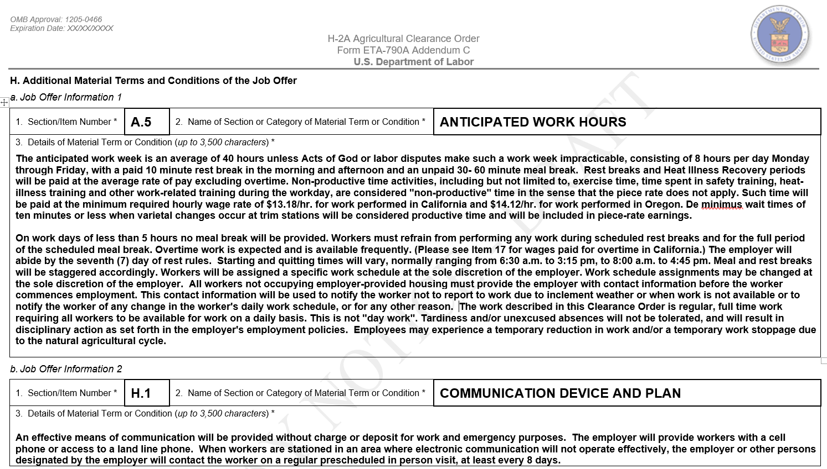
This approach will capture essential information in a standardized format that will facilitate a more consistent and effective review of the material terms and conditions of the job offer, not only for the SWA and OFLC, but also for workers recruited in connection with the job opportunity. Each entry on the Addendum C may include up to 3,500 characters, which is the equivalent of approximately 570 words and slightly more than one page of text, and the employer may complete as many additional “job offer” information sections on the Addendum C as are necessary to disclose fully all material terms and conditions of the job offer. Employers who retain material terms and conditions of their job offers in other free-form attachments can easily “cut-and-paste” text into this more standardized format, or use the Department’s electronic system to create, maintain, and reuse one or more entries on the Addendum C for subsequent application filings. The Department is exploring the possibility of including in its electronic filing system an option to use a digital service to translate the text of form entries into a language other than English, thereby reducing the burden for employers to create and maintain separate language translations of the form entries.
- Comments Related to H-2A Assurances, Obligations, and Requirements

One commenter commended the Department for the proposed Form ETA-790A, stating the proposed revision “is a vast improvement to the Form ETA-790” and expressed particular appreciation for the proposed sections that include conditions of employment and assurance for agricultural clearance orders.” Another commenter commended the Department for “offer[ing] the Forms 790 and 790A as ‘fillable’ PDF files” and eliminating “redundancy in the filings with the [SWAs] and OFLC,” which it stated is “one of employers’ top sources of frustration with the application filing process . . . particularly on non-compatible forms, requiring manual entry of the same information two or more times.”
One commenter stated that the “draft 790/790A . . . appears to require all employers using the Agricultural Recruitment System (ARS) to follow the requirements of the H-2A foreign labor program,” but non-H-2A employers do not need to follow these requirements. For example, the commenter noted that non-H-2A employers using the ARS are not required to complete Sections D and F of the Form ETA-790A, and recommended the Department clearly indicate that these sections apply only to H-2A employer. The commenter recommended the Department clarify in the instructions to the forms that there is a distinction between requirements for H-2A employers and the requirements for non-H-2A agricultural employers. In response to the commenter’s recommendation, the Department is proposing a minor modification to the General Instructions for the Form ETA-790, Item III.1, clarifying that employer seeking to employ only U.S. workers in agricultural employment should select the option entitled "790B (non-H-2A clearance order)" and proceed to complete that form, which is not for use in the H-2A program and is covered under ICR 1205-0134.
This commenter also expressed concern that the proposed Form ETA-790A includes H-2A requirements that belong on the Form ETA-9142A, and recommended the Department ensure the Form ETA-790A “follow[s] the requirements of § 653.501(c)(1)(iv),” as the INA requires. The Department appreciates the comment, but reminds the commenter that any job order submitted by an employer, which will be used in connection with a future Form ETA-9142A for H-2A workers, must meet the regulatory requirements for agricultural clearance orders in 20 CFR part 653, subpart F and the requirements set forth in 20 CFR 655.122.
Further, the commenter recommended the Department conduct “a review of statutory/regulatory data authorization for each data point during this process . . . to assure only required information is mandated on the Forms.” The commenter noted that “[t]o expand a statutory or regulatory requirement[] through an [ICR] is contrary to the express requirement of the PRA.” In response to this comment, the Department has conducted a thorough review of the language and determined that all language proposed in this ICR is consistent with applicable laws and regulations, and the Department is proposing to collect only the minimum information necessary for it to carry out its temporary labor certification role.
The combined worker advocacy organizations, along with one more commenter, opposed the Department’s proposed elimination of Fields 20 through 25 on the current Form ETA-790. Field 20 asks whether it is prevailing practice to use FLCs to recruit, supervise, transport, house and/or pay workers for these crop activities and if so, the FLC wage for each activity. The commenters believed that this question is “the most prominent notification to potential H-2A employers of their obligation to offer FLCs a competitive override [where] the use of FLCs is the prevailing practice.” The commenters expressed concern that removal of this question will hinder many farmworkers’ ability to “accept H-2A jobs [because] local farmworkers depend on [FLCs] to transport them to and from” work sites and will “make it difficult, if not impossible, for the [SWA] or the OFLC to determine what, if any, override is being offered by the potential H-2A employer.”
Fields 21 to 25 on the current Form ETA-790 collect information on the following: unemployment and workers’ compensation coverage; provision of tools, supplies, and equipment at no charge to workers; anticipated range of hours for different seasonal activities; whether collect calls are accepted; commission or benefits for sale arrangements made to workers; and whether there is any strike, work stoppage, slowdown, or interruption of operation at any worksites. The combined worker advocacy organizations noted the proposed declarations and assurance in the Forms ETA-9142A, Appendix A, and ETA-790A cover some, but not all of these issues. The commenters urged the Department to retain Fields 21 to 25 to ensure “that all of these specific questions and benefits will be uniformly addressed by employers for potential applicants.”
The Department appreciates the comments, but declines to make the requested modifications. The Department has the authority to determine the manner in which employers, who choose to use the H-2A program, assure compliance with all assurances, obligations, and conditions of employment applicable to hiring H-2A workers and/or U.S. workers for job opportunities under the Form ETA-790A. The Department proposes to retain the assurances, obligations, and conditions of employment applicable to all H-2A job opportunities (e.g., workers’ compensation coverage, employer provided tools and equipment, and no strike, lockout, or work stoppage) as standardized statements listed in Section I, which the employer must read and accept before signing the form. Section I summarizes the regulatory requirements to which the job order is subject in a manner that permits the employers to succinctly understand their obligations and responsibilities for deciding to participate in the H-2A program. Further, the Department recognizes that the Form ETA-790A communicates the terms and conditions of employment to workers who may be interested in the job opportunity. Rather than requiring employers to copy assurances into free-text fields or risk misstating a requirement, Section I presents these terms in uniform, understandable language that mirrors the regulation. The standardized statements in Section I also serve to protect workers employed under the Form ETA-790A from employers who are unaware of regulatory requirements or who seek to abuse the H-2A program. However, for variable terms and conditions of employment, which may or may not be applicable and require more detailed explanations based on the unique circumstances of the employer’s job opportunity (e.g., anticipated range of hours for different seasonal activities, whether collect calls are accepted, commission or benefits for sale arrangements made to workers), the Form ETA-790A contains both free-text fields and a new Addendum C through which this information may be disclosed.
The combined worker advocacy organizations also expressed concern about employers not paying workers on a regular pay schedule, which they suggest could be addressed by using the FLSA workweek requirement, noting that the “FLSA requires that a FLSA-covered employer designate a seven-day period as the workweek.” These commenters noted that the “H-2A regulations” require “the employer to keep records relating to its pay period and to furnish the worker with hours and earnings records showing beginning and ending dates of the pay period.” The commenters recommended the Department require employers to “furnish this information on the clearance order . . . .” The Department appreciates the comments and notes that the proposed Form ETA-790A already collects the frequency of pay as a term and condition of employment in Field A.9. However, the Department respectfully declines to adopt the FLSA workweek as a requirement, as to do so would require notice and comment rulemaking and is beyond the scope of this ICR. In addition, the assurances in Section I include Item 10, addressing hours and earnings statements, and Item 11, addressing rates of pay, that apprise applicants of the employer’s obligations in this area.
In addition, the combined worker advocacy organizations recommended the Department “somewhere briefly state” a worker’s right to the “three-quarters guarantee and the right of a worker who has completed the contract or been terminated without cause” to receive transportation and subsistence costs from the place of employment to the place from which the worker came to work. The commenters suggested the Department could include these statements “in Section A, Item 10, Section F, Item 2, and/or Section H Item 1.” The Department agrees with the commenters that these are important obligations to disclose in the ETA-790A and notes that they are already included as assurances in proposed Section I, Items 7.B and 8.
- Comment Related to Spanish Translation

One commenter recommended the Department create a Spanish language version of the Form ETA-790/790A, or include space in each of the forms to include a Spanish translation, because these forms “represent the H-2A contract that must be provided to H-2A and corresponding employees . . . .” The Department appreciates the recommendation and intends to make available a Spanish language version of the forms.

- Comments Related to Collecting Information on Joint Employers

One commenter asked how an employer may indicate it is filing with a joint employer, and to whom the employer should provide this information. The commenter stated that it is not clear whether it should disclose this information on the Form ETA-790 cover sheet or in the worksite information section of the Form ETA-790A. In response to the comment, the Form ETA-790A, Addendum B, collects information related to the name and address location where the employer submitting the application expects the workers requested to perform services. This information, coupled with the “joint-employer” entry on the Form ETA-9142A, Item A.1, marking it as a joint-employer application and submitting a signed Form ETA-9142A, Appendix A, from each employer provides sufficient information for the Department to identify and review applications from joint-employers.

The combined worker advocacy organizations recommended the Department change the Forms ETA-790 and ETA-790A so that they “expressly identify each joint employer as a joint employer.” The commenters expressed concern that without this change, workers that are transferred from one joint employer to another may not “understand[] the arrangement” and the commenters believe that the identification of “joint employers will give the workers knowledge they need to vindicate their rights under their contracts.” In addition, the commenters stated that identification of each joint employer will “highlight the responsibility of each employer as to the assurances provided and to make clear the work provided by each employer.” The Department appreciates the comment, but declines to make the requested modification. The proposed Forms ETA-790/790A and ETA-9142A appropriately collect information about the work that will be performed for disclosure to workers, including the agricultural businesses and locations where it will be performed. In addition, the forms require disclosure of the job as work for an individual employer or joint employers. The liability issues discussed are outside the scope of this ICR; however, each employer is required to read and agree to the assurances before the Department may issue a certification.

- Comments Related to SWA Use of the ETA-790/790A

A comment from a SWA requested clarification about the format of the employer’s signature on the Form ETA-790A. The commenter requested confirmation that the Department will continue to accept printed signatures on the Form, noting that its office prefers printed signatures. The Department appreciates the comment and notes that the ICR makes no change to signature requirements. An employer’s manual signature in Field I.5 is acceptable, as is an electronic or digital signature. See Form ETA-790A, General Instructions, Field I.5. The commenter also recommended the Department clarify the “style and format” of digital or electronic signatures. The Department declines to specify a particular style or format for acceptable digital or electronic signatures in the form instructions. To do so would unnecessarily limit employers’ ability to sign and the Department’s ability to accept new or different methods of signing digitally or electronically that satisfy security concerns and may also violate the APA unless the Department engaged in rulemaking.

The commenter also expressed concern about potential, visible differences between the proposed Form ETA-790/790A and version the SWA would use and print from its own electronic case management system. The commenter asked how closely the forms processed at the SWA would be required to match the style and formatting of this ICR. The Department understands the SWA’s concern and will be available to provide technical assistance to ensure all versions of the Form ETA-790/790A, whether developed by the Department or SWA, conform to the version approved by OMB through this ICR.

- The Department’s Proposed Form ETA-790

- Section I – Clearance Order Information

One commenter asserted the SWA contact information collection is expanded, unnecessary, and ripe for error. The commenter compared SWA completion of Fields 4 through 8 of the current Form ETA-790 to the SWA’s completion of Field 1 through 17 of the proposed Form ETA-790/790A, noting the higher number of fields and addition of an email address and job title. The commenter opined that the SWA’s email address is already known to OFLC and does not need to be collected. The commenter also urged the Department to refrain from issuing NODs to an employer based on incorrect/incomplete information input by the SWA. The Department appreciates the commenter’s concerns, but notes that the only new data collected is the job title (proposed Section I, Field 9), and the SWA contact’s email address (proposed Section I, Field 17), which is consistent with modernization of contact methods and information collection proposed throughout this ICR for the employer to communicate with both the SWA and OFLC. The Department notes that the current form collects a general SWA office phone number in Field 6, in addition to the SWA contact person’s direct phone number in Field 6.a, which the Department has eliminated in the proposed form. The commenter may not have performed a comparison of the individual collection items in Fields 4 through 8 of the current Form ETA-790 to the proposed fields under Section I of the Form ETA-790/790A. The proposed number of fields is greater, primarily, because the information is broken into smaller, more discrete data fields, as shown in the comparison table below, but imposes no undue burden on the SWA to complete.

Information Collection Item | Current Form  ETA-790 Fields | Proposed Form  ETA-790A Fields
SOC number and title | 4, 4a | 4, 5
Job order number | 5 | 1
SWA contact address | 6 | 10, 11, 12, 13, 14
SWA contact name, phone number/extension | 6a | 6, 7, 8, 15, 16
Job order start and end dates | 7, 8 | 2, 3

In addition, the data collected on the current Form ETA-790 is used not only by OFLC when processing an H-2A application, but also by other SWAs who receive a copy of the approved Form ETA-790/790A through the ARS and need to refer U.S. applicants back to the SWA that initially received and approved the job order. Finally, should the SWA-provided information in Section I require revision, OFLC would obtain the modified information directly from the SWA, not from the employer through a NOD.

- Section II – Employer Contact Information

One commenter recommended the Department add fields permitting an employer to include more than one contact person, in anticipation of scenarios including “the person listed as contact left employment” where inclusion of additional contact persons “would help to ensure availability and avoid disruption in business operations.” The Department appreciates the commenter’s concern, but declines to modify its proposed collection to add multiple contact names to the Form ETA-790/790A. The contact name for the employer listed on the Form ETA-790, Section II, should be the person most familiar with the content of this agricultural clearance order and able to communicate with the SWA, as appropriate. Further, should a change in the contact name become necessary after the Form ETA-790/790A is submitted to the SWA or the Form ETA-9142A is submitted to the Department, the employer or, if applicable, the employer's authorized attorney or agent may request such a modification. Such modifications do not affect the material terms and conditions of the job opportunity and are necessary for the Department and SWA to ensure effective contact with the employer during the recruitment period. Furthermore, permitting multiple contact names on the forms may lead to confusing and potentially duplicative communications among the employer, SWA, and the Department.

The same commenter also suggested the Department expand its collection to permit employers to disclose multiple contact phone numbers. The commenter recommended the Department provide fields to enter a second phone number (e.g., cell and office #). The Department appreciates the commenter’s suggestions, but declines to modify its proposed collection to add multiple phone numbers. The phone number disclosed on the Form ETA-790/790A should be the one commonly used by the employer to receive communications from the SWA about the job order or Department related to the processing of the H-2A application. Depending on the nature of its business operations, the employer may use this field to disclose a general office phone number or mobile cell phone number where it can be reached easily. Additional phone numbers for U.S. workers to apply for the employer’s job opportunity may be disclosed on the Form ETA-790A, Section G.

Three commenters recommended the Department add a field to the Form ETA-790 permitting an employer to include authorized agent contact information, where applicable. Two commenters recommended the Department add fields to indicate attorney or agent contact information (e.g., name, Federal Employer Identification Number [FEIN], telephone number, and email address). The Department appreciates the comment, but declines to modify the proposed Form ETA-790/790A to include the collection of information on an employer's agent or attorney. The Form ETA-790/790A is used to facilitate the recruitment of U.S. workers and for the SWA to circulate the employer’s job opportunity. Further, the Form ETA-790 is a coversheet to the Form ETA-790A, and it is important to keep the coversheet to only one page of essential information about the employer and job opportunity. Agents or attorneys submitting the Form ETA-790/790A to the SWA, on behalf of the employer, may elect to provide their own contact information at the time of submission using a coversheet or other separate documentation.

Four commenters recommended the Department change the Form ETA-790, Field II.14, “Business email address,” from a mandatory to a conditional collection because many employers do not have or use an email account. The Department appreciates the commenters’ concern that some small agricultural businesses may not possess an email address or have limited or no access to the internet, which would inhibit them from obtaining an email account and address. To address this concern, the Department’s proposed General Instructions to the Form ETA-790A state that “the email entered in this field must be the same as the one regularly used by the employer’s point of contact for its business operations and capable of sending and receiving electronic communications from the SWA with respect to the processing of this agricultural clearance order. If the employer’s point of contact does not possess a business email address, please enter ‘N/A’ in Field 14, Section II, Employer Contact Information, to signify that the collection item is ‘Not Applicable’ for employers who do not have a business email address.”

Another commenter requested clarification of how employers should provide “Doing Business As” (DBA) information - together with the legal name in Field 1 or separately in Field 2, so that the employer’s name appears correctly on certifications. The commenter described missing or duplicative appearances of “DBA” on certifications, depending on whether the preparer includes “DBA” in Field 2 or excludes it. The Department believes the field heading and related instructions are clear that the employer should enter the legal name in Field 1 and should enter the DBA, if any, in Field 2. However, the Department will add clarifying instructions to the General Instructions to the ETA-790/790A that will instruct employers not to include “DBA” in the entry to Field 1 or Field 2.

Finally, the combined worker advocacy organizations expressed concern that information collected in Section II, Fields 1 and 2 is insufficient to protect workers’ rights because “too many employers operate under dissolved, inactive, or defunct corporations, limited liability corporations, and limited liability partnerships . . . .” The commenters explained that these entities often “lack[] income and assets sufficient to pay wages owed to workers, back wages or civil monetary penalties assessed by the Department, or judgments obtained by the workers in civil litigation.” The commenters recommended the Department add checkboxes that correspond to Fields 1 and 2 that “require the employer to state the form of corporate business organization, if applicable” and “to declare that the business . . . is active and in good standing with the state.” The Department appreciates the commenters’ concern, but declines to make the suggested change because the corporate form is often apparent in the entity’s name and adding a checkbox to collect an employer’s attestation would not accomplish the goal of verifying an entity is in good standing.

- Section III – Type of Clearance Order

The Department received no comments about Section III of the proposed Form ETA-790.

- The Department’s Proposed Form ETA-790A

The proposed Form ETA-790A requires an employer to disclose all of the material terms and conditions of employment for the job opportunity, which must satisfy both the requirements for agricultural clearance orders in 20 CFR part 653, subpart F and the job order content requirements set forth in 20 CFR 655.122. Additionally, the Form ETA-790A will collect information related to the employer’s job opportunity, including the job title, number of workers needed, period of intended employment, and a description of the agricultural services or labor to be performed. It will require an employer to disclose the actual minimum qualifications or requirements of the job, including education, training, experience, and any other special requirements. Also, it will collect information about specific crops or agricultural activities, the places of intended employment (i.e., worksites), and the wage rate(s) that will be paid to workers in each crop or agricultural activity, as well as any other conditions or deductions from pay not required by law. Finally, it will collect information required to evaluate compliance with the INA, such as information on employer-provided housing. Employers will complete Form ETA-790A by reading and then attesting (i.e., signing and dating) to compliance with the required conditions of employment and assurances for H-2A agricultural clearance orders, as set forth under 20 CFR 653, subpart F, and 20 CFR 655, subpart B.
The Department uses this information to evaluate whether the employer has a bona fide need for temporary labor and whether the job opportunity can be classified as agricultural services or labor under the H-2A program. Further, this information will be used by the Department to determine whether the job qualifications or requirements are consistent with the normal and accepted qualifications required by U.S. employers who do not use the H-2A program, which is essential to ensuring no adverse effect on the wages of similarly employed U.S. workers in the area(s) of intended employment. See 20 CFR 655.122(b).
- Section A – Job Offer Information

- Job Title (Field A.1)

One commenter asserted that the job title information requested in Field A.1 is not required by 20 CFR 653.501, which requires only a description of the “nature of the work.” The commenter recommended the Department remove this field or engage in rulemaking to require an employer to provide the job title. The commenter also suggested that entry of a Standard Occupational Classification (SOC) code or Occupational Employment Statistics (OES) occupation should be sufficient to respond to Fields A.1, A.7a, and A.7b. The Department appreciates the commenter's concern, but declines to modify its proposed collection to eliminate the job title field on the Form ETA-790A. The Department has historically collected this information so that employers can specify the job title that most closely resembles the specific services or labor to be performed. The job title is used by the employer in its recruitment efforts and is more recognizable to potential U.S. applicants than a general occupational title developed by the O*NET/OES systems.

- Workers Needed (Field A.2)

The combined worker advocacy organizations expressed support for the Department’s proposed information collection in Field A.2. The commenters stated that information requests “for both the total number of workers needed and the total number of H-2A as opposed to just the total number of workers requested . . . gives a better understanding of whether the employer also employs domestic workers and how many, or whether the employer is largely dependent on H-2A workers.”

In contrast, three commenters expressed concern about the proposed information collection in Field A.2. One commenter stated that neither 20 CFR Part 653, nor Part 655, requires an employer to provide information on the “total number of workers needed.” This commenter recommended the Department reword the field to request “the number of workers the employer seeks to hire through the job order” so that the collected information is “limited to the number of workers sought through the ARS system.” A second commenter asked the Department to explain its “intent behind requesting ‘Total Workers Needed’” and a third commenter similarly recommended the Department clarify the “intent and meaning behind the phrase . . . .” The third commenter also expressed concern that the information may “be used against the employer in an enforcement action.” The commenter recommended the Department request an estimated or anticipated number of total workers needed because employers “often do not have accurate information about their labor needs months in advance when they complete this form.” Finally, the third commenter stated that it supports the proposed information collection if the Department intends to use the information to reduce partial certifications, characterizing partial certifications as a “penalty for hiring U.S. workers” because “partially-certified employers are left with little recourse if any hired U.S. workers fail to report to work.”

The Department appreciates the commenters’ concern and notes that the third commenter has correctly understood the Department’s purpose in collecting the total number of workers necessary to satisfy the employer’s seasonal or temporary need for labor to perform the job opportunity described on the Form ETA-790A. The Department notes that some employers already provide information (e.g., in the recruitment report) explaining the total labor need, the number of returning U.S. workers the employer anticipates hiring, and the remaining open positions that are the number of H-2A workers requested on their applications. However, many do not, or do not do so clearly, which creates delays in issuing the temporary labor certification decision. Collecting this single piece of information in the proposed Form ETA-790A, Item A.2, will facilitate a more efficient evaluation of an employer's recruitment report to determine whether there are insufficient U.S. workers to fill the employer's need such that it is appropriate to certify the application and, if so, the number of worker positions to certify (i.e., a full certification or a partial certification). See 20 CFR 655.156 and 655.165. Without this data point, OFLC must request additional information from employers after receiving the recruitment report—which delays the employer’s receipt of the certification—or issue a partial certification reducing the number of H-2A positions by the number of hired U.S. workers. Employers who fail to identify the hired workers as anticipatorily excluded from the number of H-2A workers sought must either proceed with a reduced workforce or appeal the partial certification. Like the certification delay necessary for OFLC to request for clarification before issuing a final determination, such appeals unnecessarily delay the employer's ability to reach full staffing. See 20 CFR 655.156 and 655.165. Enforcement concerns are outside the scope of this ICR; however, as the data point is standardizing the collection of information that employers already provide, whether in the recruitment report or after receiving a NOD or partial certification, it would not be expected to create new or different enforcement issues.

- Period of Intended Employment (Fields A.3 and A.4)

One commenter recommended the Department “allow/include” in Fields A.3 and A.4 “the allowance for abatement under 20 CFR 653.” The commenter notes that 20 CFR 655.122(o) “speaks only to ‘contract impossibility’” but “20 CFR 653 provides an exception from the period of employment” and “the exclusive manner in which the guarantee may be abated due to weather conditions or other acts of God beyond the employer’s control.” In response to the comments, the Department is proposing modifications to the Form ETA-790A and General Instructions permitting employers to use the new Addendum C to disclose fully additional details about the job offered. An employer may use Addendum C to address abatement of guaranteed work hours under 20 CFR 653.501(c)(1)(iv)(H), as appropriate.

- Hours of Work and Hourly Work Schedule (Fields A.5 and A.6)

Two commenters expressed concern that Fields A.5 and A.6 are insufficient to accommodate employers engaged in the herding and production of livestock. Both commenters noted that “[t]he work activities of a Range Livestock Herder generally require workers to be on call 24 hours per day, 7 days a week 20 CFR 655.200(b)(3).” The commenters recommended the Department provide a box that an employer could check to indicate it requires “a range worker who is on call 24 hours per day, 7 days a week or a box that [it] could fill in to indicate the work schedule.” The Department agrees with the commenters’ suggestion and it is proposing a new Field A.5 on the Form ETA-790A that will permit employers to identify whether the job opportunity requires workers to be on call 24 hours a day and 7 days a week. Employers selecting “Yes” in Field A.5 will not be required to disclose the anticipated days and hours of work as well as the hourly work schedule. In adding Field A.5, the Department has also renumbered all remaining collection fields in Section A of the Form ETA-790A.

Six commenters expressed concern that Fields A.5 and A.6 are too limited to collect all necessary information about work hours, which the commenters said can vary based on factors such as occupation, crop type, and different phases of an agricultural process. Four of these commenters suggested these fields include space for additional notes to explain, for example, flexible schedules, break periods, or additional hours are available on request. One commenter expressed concern that limiting Field A.5 “to a single number” of hours may “exclude employers from adding explanatory or clarifying language.” The commenter stated this is a concern because “there is no ‘normal’ or ‘average’ day of work,” as “[w]ork schedules are . . . dependent on natural growing cycles” as well as “sunrise/sunset times and weather patterns . . . .” The commenter recommended the Department change the field so that it permits entry of “flexible schedules” and additional notes on work hours, such as “worker may be requested to work additional hours,” and allow employers to “provide their best estimates” of schedules and hours, “explaining the minimum that could be guaranteed but that longer hours are optional.” Two additional commenters similarly noted variability in schedule due to weather or market conditions and recommended the Department provide additional space to “inform potential employees that the hourly work schedule may vary widely.” Another commenter also recommended the Department permit entry of the additional hours noted above, as well as space to disclose, for example, lunch breaks. One commenter noted that truck driver schedules may be flexible and may require occasional “long-haul delivery routes.” This commenter recommended the Department permit entry of additional information to explain flexibility in hours by “provid[ing] additional space to disclose additional shifts, or to allow[ing] for separate attachments . . . .”

Similarly, the combined worker advocacy organizations stated that work hours may vary based on the type of crop and the different phases of the agricultural process. The commenters noted, for example, that workers may work limited hours in the early phases of a production cycle for tobacco crops, but will work extended hours later in the process. These commenters expressed concern that employers fail to disclose “possible schedule variations” and that this “results in significant understating of . . . hours of expected work under the three quarters guarantee.” The commenters recommended the Department “state, either in [Fields A.5 or A.6], and in Addendum A . . . the anticipated days and hours of work and hourly work schedule for each crop, agricultural activity, or phase of crop production . . . .”

In response to the comments, the Department is proposing modifications to the Form ETA-790A and General Instructions to permit employers to use the new Addendum C to disclose the anticipated days and hours and hourly work schedule for each crop or agricultural activity, depending on the unique specifications of the employer’s job opportunity. The proposed Addendum C will capture essential information in a standardized format, in lieu of free-form attachments, to facilitate a more efficient review and clearer understanding of the material terms and conditions of the job offered, not only for the SWA and OFLC, but also for workers. The available space on the new Addendum C, described above, provides employers with more flexibility to specify essential job information, including variations in work schedules associated with the services or labor to be performed. In order to provide greater flexibility in the disclosure of different kinds of shift work for employers’ job opportunities, the Department has also proposed a modification to the collection of the hourly work schedule in Section A of the Form ETA-790A by permitting an employer to select AM or PM when entering the hourly start and end times of work.

One commenter recommended the Department limit Field A.5 to require only the “the anticipated number of days and hours per week,” rather than the proposed request for individual daily hours. The commenter stated that 20 CFR 655.122(i) “does not require individual daily hours” and instead requires that “the work hours must be offered during the work period specified in the work contract.” The commenter added that 20 CFR 653 requires only “the anticipated number of days and hours per week . . . .” This commenter recommended the Department eliminate Field A.6, stating that the regulations do not require this “data point” and that the answer to the question “may be misleading” because the work “starting time . . . may depend[] upon many factors, including day light, dew point, rain, heat or cold.” The Department appreciates the commenters’ concerns, but declines to make the requested modifications. The ARS regulation at 20 CFR 653.501(c)(1)(iv) requires that the job order state all the material terms and conditions of the employment, which include, but are not limited to, “anticipated period and hours of employment” and “anticipated number of days and hours per week for which work will be available. The information collected though Fields A.5 and A.6 enable the employer to satisfy the ARS regulatory requirement. Further, full disclosure of specific days/schedule anticipated for the work to be performed (e.g., Monday-Saturday, 7 AM to 3 PM vs. 6 days/week, 8 hours/day) is necessary to appropriately apprise U.S. workers of the job opportunity offered.

- Name of Crop/Ag. Activity and Description of Duties/Services (Fields A.7a and A.7b)

One commenter stated that neither statute nor regulations require employers to provide the information requested in Fields A.7a and A.7b regarding “the crop” and “the nature of the work” and the commenter recommended the Department eliminate these information collections until it has engaged in rulemaking to add provisions that require employers to provide this information. The Department respectfully disagrees with the commenter and it will retain these fields as proposed. As noted above, the ARS regulation cited, 20 CFR 653.501(1)(iv), requires that the job order state all of the material terms and conditions of employment. The information collected though “Description of the job duties or services to be performed” enables the employer to disclose “all material terms and conditions of the job,” which include, but are not limited to, “the crop” and “the nature of the work."

The same commenter asserted that Fields A.7a and A.7b request “information [that] is duplicative, as it is captured under the O*NET/OES description listed in Sec. A.1.” The commenter recommended the Department eliminate these questions and should instead require only “acknowledgment of the definition of ‘agricultural labor.’” The Department appreciates the commenter's concern, but declines to modify its proposed collection to eliminate these fields on the Form ETA-790A in which the employer will disclose the crop or agricultural activity and a description of the duties to be performed. The Department has historically collected this information so that employers can specify the nature of its particular need for services or labor to be performed. The particular services or labor an employer needs may not include all of the potential duties of a general occupational classification, which are broad and encompass many dozens of distinct job titles.

One commenter stated that Field A.7a is “vague and unclear” and that “the instructions merely repeat the information provided on the form.” The commenter recommended the Department “modify the instructions to provide additional guidance on what information it seeks to collect for this item, including potential examples to illustrate [the] desired level of specificity and the format” the Department expects. The Department appreciates the commenter’s concern and proposes to remove Field A.7a. In lieu of this field, the Department will permit the employer to identify the specific crops and agricultural activities when it describes the services or labor to be performed in renumbered Field 8a.

Several commenters expressed concern about the amount of space provided in this section of the form and in the corresponding section of Addendum A. These commenters expressed concern about the amount of space provided in Field A.7b, specifically. One of these commenters recommended the Department expand the size of the space provided in Field A.7b to allow an employer to describe the job duties fully and accurately. Another of the commenters stated that it is “critical” the Department permit additional attachments and noted the employer often includes a four-page attachment with its application. Finally, one commenter stated that it is unclear whether Fields A.7a and A.7b “pertain to multiple crop/agricultural activities or whether only a single crop/agricultural activity can be included in each of the three limited spaces available.” The commenter recommended the Department include in the instructions a statement that “multiple crop/agricultural activities may be included in each of the ‘job duty’ text spaces.” Alternatively, the commenter recommended the Department “pluralize the headings” of these fields so that they state “Name of Crop or Agricultural Activities” and include in the instructions a statement that employers may “submit multiple Forms ETA-790A Addendum A if additional space is needed.” A second commenter noted that the instructions to Field A.7b “[d]oes not specify how many forms of Addendum A the employer can use to disclose any additional job duties or other information required.”

In response to all of these comments, the Department is proposing modifications to the Form ETA-790A and General Instructions to clarify the collection of information related to the job duties the employer is requesting for temporary labor certification. The Department is also proposing modifications to the Addendum A to clarify the collection of information related to the specific crops and/or agricultural activities in the job opportunity. First, the Department is eliminating proposed Field A.7a, which collects the name of the crop and/or agricultural activity, and will permit employers to include this information with its description of the job duties to be performed in newly renumbered Field A.8a. This proposed modification will provide employers with greater flexibility to describe the unique specifications of their job opportunity in a free-form text field and identify work tasks that may be common across multiple crop varieties.

Second, in response to concerns related to insufficient space to disclose the job duties to be performed, the Department will clarify that employers will begin entering a description of the job duties in the space provided on the Form ETA-790A and use the Addendum C to complete the response to Field A.8a. For electronic filings, if the employer’s job description exceeds the box character limit in Field A.8a, the filing system will automatically provide the filer with the option of using the Addendum C for expanded space. For mailed or paper filings, if the employer’s job description exceeds the box provided, the filer will attach the Addendum C to complete the response to this item.

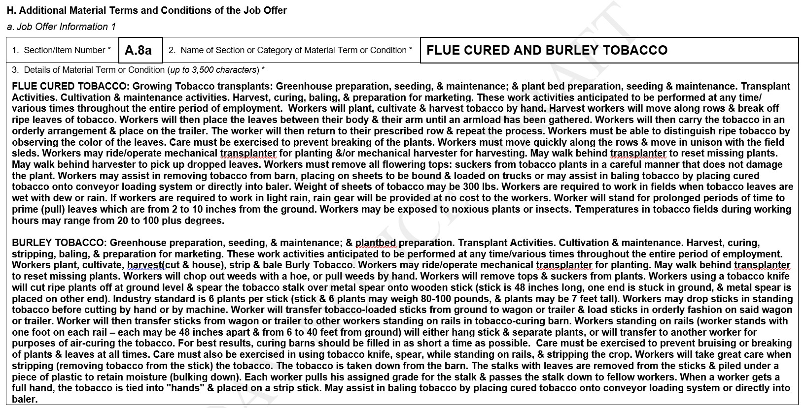
The Department provides below an illustration of how the Addendum C can be completed by employers to fully disclose the job duties to be performed for multiple crops and/or agricultural activities.
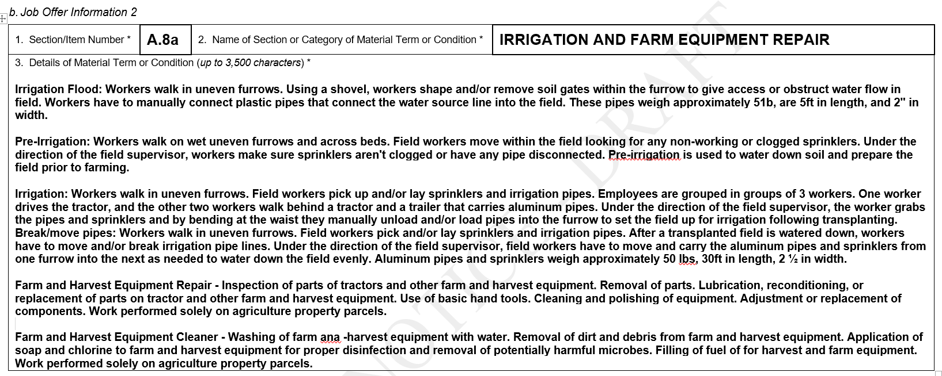
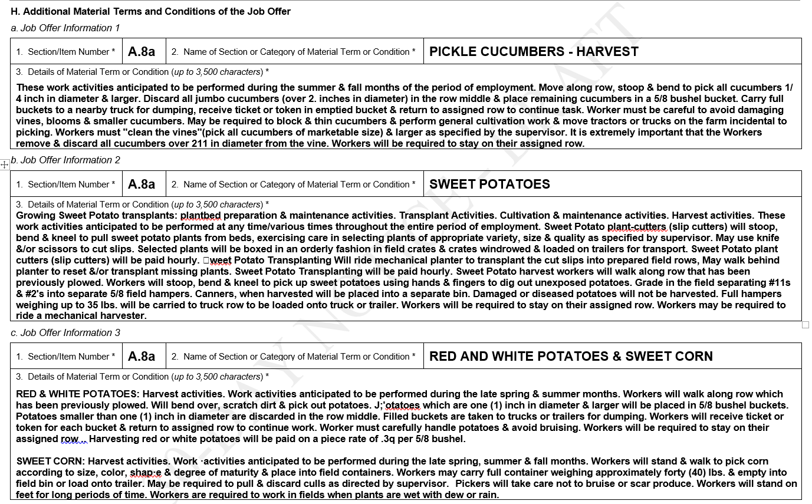

By incorporating the Addendum C into this ICR, the Department is proposing revisions to the Addendum A that will streamline and focus the collection of information on the payment of wages for specific crops and/or agricultural activities. Specifically, the Department proposes to reorganize the information collection in a worksheet style format with column headings to make it much easier for employers, particularly those with operations involving more complex work itineraries, to add crop varieties or agricultural activities on the Addendum A. Because many employers in the agricultural industry have large crews working on a wide array of diversified crops, the Department proposes to add a conditional new collection field called “Crop ID” to provide employers with the flexibility to organize their wage offer and pay information for multiple varieties of the same crops or commodities on the Addendum A. Furthermore, the Department has expanded the text field entitled “Piece Rate Units/Special Pay Information” to permit the entry of up to 500 characters for employers to provide detailed information about the wage offer related to a specific crop or agricultural activity. In the unlikely situation where the employer needs more space, the additional information about the wage offer can be disclosed on a subsequent row of the Addendum A using the same Crop ID.

The Department provides below an illustration of how employers can complete the Addendum A to disclose the wage information associate with different kinds of crops and/or agricultural activities under the job opportunity.
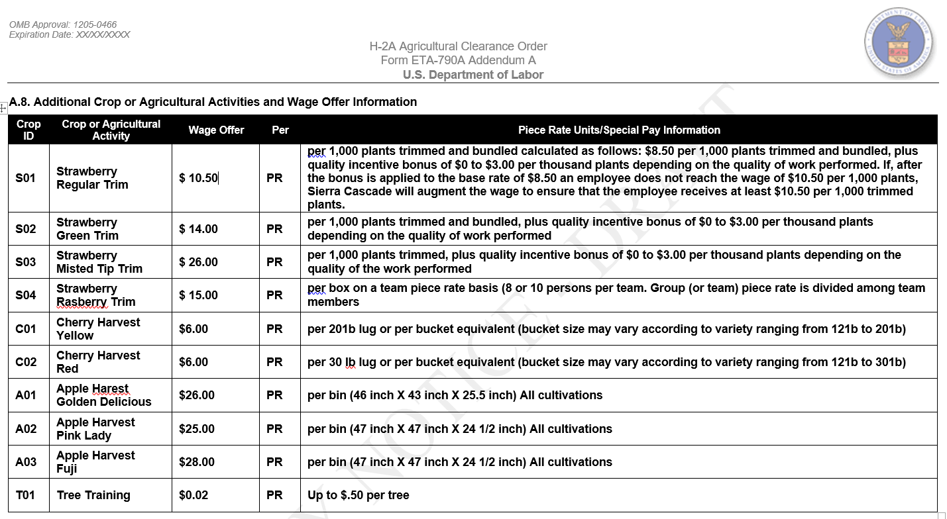

- Wage Offer(s) and Piece Rate(s) (Fields A.7c – A.7f)

Five commenters expressed concerns that Fields A.7c through A.7f are too limited to permit all employers to include all of the various potential types of wages. One commenter expressed concern that H-2ALCs “may not be able to list a complete wage offer in [A.7c] if they operate in multiple states.” This commenter also suggested the Form ETA-790A require either a wage entry in A.7c (hourly or monthly rate) or A.7e (piece rate), rather than requiring an entry in A.7c. Similarly, another commenter expressed concern that the “form does not include the ability to include a range of wage rates,” which the commenter noted may be “problematic for employers offering a range of compensation based on particular work activities” or “employers with worksites in multiple states . . . .” The commenter added that the form “does not provide a clear mechanism for disclosing overtime pay.” A third commenter expressed concern that Fields A.7c through A.7f, and the wage section of Addendum A do not provide sufficient space to account for the many “different piece rate[s] for each variety” of commodities that will be harvested. A fourth commenter expressed the same concern about Field A.7f. Both commenters recommended the Department permit separate attachments to include this information. A fifth commenter stated that Fields A.7c through A.7f “appear[] to limit the use of ‘base rates and bonuses.’” The commenter noted that “20 CFR 655.122(l) allows this pay structure provided the employer guarantees the” applicable wage rate and the commenter added that “bonuses . . . are expressly allowed under 20 CFR 653.501(c)(2)(i).” The commenter recommended the Department modify these fields to permit entry of the noted pay structures.

The Department appreciates the comments. With other changes the Department is proposing to Section A of the Form ETA-790A, Fields A.7c through A.7f will be renumbered as Fields A.8b through A.8e. As discussed in the previous section, the Department also proposes to reorganize the collection of information on the Addendum A into a worksheet style format with column headings to make it much easier for employers—particularly those with operations involving more complex work itineraries covering multiple states—to disclose wage offer and pay information for many crop varieties or agricultural activities. Where an employer has multiple applicable hourly rates (e.g., due to work in different states subject to different AEWRs), the employer may choose to disclose the distinct hourly rates by entering the crop and state on the Addendum A. For example, on Addendum A, the employer could enter the wage rate information for “Lettuce Harvesting – California” with the hourly AEWR covering work performed in California in one row, and then enter the wage rate information for “Lettuce Harvesting – Arizona” with the hourly AEWR covering work performed in Arizona.

Regarding the commenter’s suggestion to limit the wage offer entries to either an hourly rate or piece rate of pay, the Department declines to make the requested modification. These fields are designed to collect information about the basic wage offer for the job opportunity, including a disclosure of an hourly or monthly wage rate and conditional entries for a piece rate and the piece rate units or special pay information. Under the H-2A program, whenever an employer offers a piece rate, it must also disclose and guarantee an hourly wage. See 20 CFR 655.122(l)(2)(i). As a result, an hourly wage offer is always required. For employers that intend to offer a range of wage rates for each crop or agricultural activity, the Department will modify the General Instructions to clarify that Fields A.8b (“Wage Offer”) and A.8d (“Piece Rate Offer”) will collect the minimum wage offer, and to explain that disclosure of the upper range of any wage offers will be collected in the Piece Rate Units/Special Pay Information fields on the Form ETA-790A (Field A.8e) and Addendum A. In response to the comments regarding space limitations, the Department is proposing modifications to the Form ETA-790A and General Instructions that will permit employers to use the new Addendum C to disclose any other conditions about the wage offer, including overtime and bonus pay, based on the unique specifications of each job opportunity, as discussed above. The Department provides below an illustration of how employers can complete the Addendum C to disclose other conditions about the wage offer(s) associated with different kinds of crops and/or agricultural activities under the job opportunity.
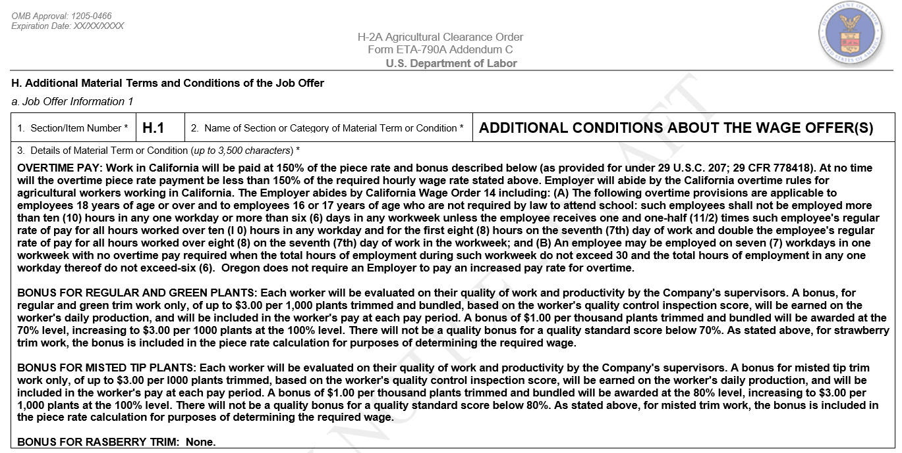

One commenter stated that it is unclear whether Addendum A may be used for all fields from A.7b through A.7f because the instructions to this section explicitly states Addendum A may be used for Field A.7b, but does not state this for Fields like A.7e. The commenter stated that if the Department intends to permit use of Addendum A to continue information requested in all of these fields, it should clarify that the disclaimer about use of Addendum A “modif[ies] the entirety of item 7, not just specific subparts.” If the Department did not so intend, the commenter recommended the Department “provide clarity as to how an employer should disclose multiple piece rates for different commodities or work activities.”

The Department appreciates the comments and agrees that using the term "wage offers" in Item A.8, matching the title of Item A.7.c, could be read to mean only additional hourly or monthly rates may be specified in Addendum A. The Department is proposing a minor modification to the Form ETA-790A and General Instructions to clarify that additional piece rates, not only additional hourly or monthly rates, may be specified on Addendum A. Additionally, the Department will propose revisions to the Form ETA-790A and General Instructions to clarify that Addendum A can be used to provide additional information from what is disclosed on renumbered Fields A.8b through A.8e or to disclose additional crops or agricultural activities and wage and/or piece rate offers.

Finally, one commenter recommended the Department include, in Field A.7d, “two boxes entitled ‘hour’ or ‘month’ for employers to provide a unit of pay in one or the other, as directed in the instructions for [the] ETA-790A.” The Department agrees with the commenter’s suggestion and it will propose modifications to this field reflecting the two available unit of pay options.

- Additional Conditions about Wage Offer(s) (Fields A.10)

Four commenters expressed concern about proposed Field A.10. Three of these commenters noted that the space provided is insufficient, given the Department’s refusal to accept uploaded information and the “amount of information employers are required to include.” One of those commenters noted that employers often include “include substantial and critical information in this section, including complex bonus and incentive systems, holiday pay, jury duty, and if a collective bargaining agreement (CBA) exists, required incentive pay items from a CBA.” Two of the commenters noted the lack of space to provide productivity standard information, while one of them noted the space is insufficient to include information about crop varieties and piece rates, “particularly for H-2ALC harvesting crews handling a variety of crops.” These commenters recommended the Department expand the space provided or permit employers to upload additional information. One commenter stated that “a more appropriate place” to collect information on “productivity standards is with the wage information section.” Another commenter recommended the Department clarify in the instructions to Field A.10 whether the field is intended to be a “‘spillover’ mechanism for the compensation methodology disclosed in Items 7c through 7f.” The commenter also stated that because Field A.10 only references “the piece units disclosed in Item 7F,” the Department should clarify in the instructions whether an employer can also include “additional wage information (e.g., overtime pay, multiple pay rates, etc.) beyond merely ‘productivity standards and bonus or work incentive payments,’ as the instructions direct.” Finally, the commenter noted that it is unclear whether the Department will accept attachments that include responses to Field A.10 because unlike Field A.7.b, Field A.10 does not include language stating the Department will not accept attachments. The commenter recommended the Department clarify in the instructions to Field A.10 whether it will accept attachments for that field.

In response to these comments, the Department is proposing modifications to the Form ETA-790A and General Instructions that permit employers to use the new Addendum C to disclose fully the additional conditions about wage offer(s), including production standards, based on the unique specifications of each job opportunity. As shown in the illustration above, the employer would enter the letter “H,” followed by a sequential number in Item 1, and then enter words such as “Additional Conditions About the Wage Offer(s)” in Item 2. The available space in proposed Item 3 of Addendum C provides the employer with up to 3,500 characters to further specify the wage details, such as entering “Holiday Pay – 1.5 times regular rate” or “Collective Bargaining Agreement provides bonus pay structure.” This collection item will provide employers with flexibility to include more complex wage offer information on a single entry. Although four sections of job offer information are provided on Addendum C, the employer may complete as many additional job offer information sections on Addendum C as are necessary to fully disclose all material terms and conditions of the job offer. To ensure all information related to the conditions of the wage offer(s) is collected in a single location, the Department will propose a corresponding modification to eliminate Field A.10 on the Form ETA-790A. In response to the commenter seeking clarification on what pay structures are permitted under the Department's regulations, this ICR does not make any changes to regulatory requirements governing the wage offer and pay guarantees to workers.

- Deductions from Pay (Field A.11)

One commenter expressed support for the Department’s proposal to include in Field A.11 a free-text field to collect information about deductions rather than the check boxes used in the current Form ETA-790. The commenter stated that the free-text field “affords employers the flexibility needed to address different tax and benefit deductions applicable to H-2A and corresponding domestic workers.”

In contrast, the combined worker advocacy organizations expressed concern that the proposed Form ETA-790A “no longer includes a specific breakdown of wage deductions,” which the commenters considered important because deductions from H-2A worker pay are exempt from Federal income tax withholding but deductions from U.S. worker pay are not. The commenters recommended the Department add check boxes for employers to use to distinguish the type of worker subject to the deduction. Another commenter also objected to the replacement of check boxes with a free-text field, stating that it burdens employers with the requirement to provide a written response to A.11, instead of checking a box. The commenter added that a written response may “make deductions less clear to prospective applicants” than a “simple visual reference” to a check box answer and applicants will “be forced to read a dense paragraph of disclosures.” The commenter recommended the Department retain the check box format and consider the addition of an “Other” free-text field, in which an employer may explain voluntary deductions and potential deviations from simple yes/no items (e.g., one location is in a state that collects income tax, while other locations are in states that do not collect income tax). The commenter also expressed concern that there is not enough space in the proposed free-text field to include all possible additional information and recommended the Department permit an employer to submit an attachment with additional information. Another commenter opposed the requirement to include a statement of all known deductions and the amounts in Field A.11, stating the question is redundant, the deductions “may not be determinable at the time of the application,” the deductions “vary between U.S. workers, non-resident [foreign workers, and H-2A visa workers,” and the identification of deductions “should be . . . the responsibility of the employee.”

The Department appreciates the commenters’ concerns, but declines to make the recommended modifications. This field collects information required under the H-2A regulations at 20 CFR 655.122(p)(requiring that “all deductions required by law” be made and “all deductions” not required by law be disclosed) and the Employment Services regulations at 20 CFR 653.501(c)(1)(iv)(F)(requiring disclosure of “any deductions” to be made). Legally required deductions vary by work location (e.g., different state laws) and worker status (e.g., H-2A vs domestic) and, for other deductions not required by law, the potential variety is unlimited. The Department agrees with some of the commenters and maintains that the method of disclosing deductions on the current Form ETA-790 using checkboxes is insufficient for employers and confusing to prospective H-2A and U.S. workers regarding which deductions actually apply to their pay. Employers with more complex work itineraries operating in multiple states, each of which have different income tax withholding laws, must make a single selection that is technically inaccurate. The vast majority of employers are not able to use the current checkbox method of collection to disclose all the deductions from pay. A free-text field is the most efficient and appropriate way to accommodate the information each employer may need to disclose. Therefore, the Department declines to modify the Form ETA-790A to reflect a checkbox method for employers to disclose deductions.

- Section B – Minimum Job Qualifications/Requirements

One commenter objected to the collection of “minimum job qualifications/requirements” in Section B. The commenter specifically objected to the information collected in Field B.1 (education requirements), stating “this information is not required and if added should include [the section symbol]” to mark it as conditional. In addition, this commenter stated that employers are not required to provide information about the months of required work experience and training, as requested by Fields B.2 and B.3. The commenter asserted these fields collect information that is “not required by 20 CFR 653” and while “20 CFR 655.122(b) may require” this information, it requires it “only for those areas that are not ‘bona fide’ and ‘consistent.’” The commenter objected to the requirement to provide affirmative responses in these fields, as well as the particular wording of the fields, which the commenter believes may create confusion by implying there should be requirements in each field. The commenter also objected to employers imposing requirements and qualifications that relate to performance of some, but not all, duties. The commenter expressed concern that workers will be asked to meet a particular experience requirement but will not actually perform any duties requiring that experience. The commenter also asserted that employers are not required to include basic job requirements (Field B.4) or additional information regarding the qualifications/requirements (Field B.6), “unless these [Fields] could be included under the ‘unlawful discriminatory specification’ or ‘prevailing work conditions’ clauses . . . .” Finally, the commenter asserted that the fields “require[] regurgitation of O*NET/OES listed activities/qualifications,” which the commenter considered to be the type of redundant information collection the PRA requires the Department to eliminate.

The Department appreciates the comments, but respectfully disagrees with the commenter’s assertions and declines to make the recommended changes to Section B. A job order that the employer will use for recruitment of U.S. workers in connection with an H-2A application must meet the regulatory requirements for entry in the ARS system and for the recruitment of workers. The employer’s actual minimum requirements and qualifications, as opposed to generic occupational norms or possibilities, is essential job information. For example, an employer’s duties may not involve all potential aspects of the occupation, negating the need for certain requirements or qualifications, or the employer may be willing to train workers, rather than require experience. In addition, full disclosure of the employer’s asserted minimum requirements and qualifications enables the SWA and OFLC to review the criteria the employer plans to use to screen U.S. applicants and prospective H-2A workers. In the event one or more requirements or qualifications do not comply with 20 CFR 655.122(b), the SWA and/or OFLC will notify the employer of the deficiency and ensure that only compliant requirements and qualifications are presented in recruitment of U.S. applicants and used to evaluate potential hires. Regarding use of minimum requirements and qualifications typical to an occupational classification, disclosure of the employer’s particular set of compliant minimum requirements and qualifications allows prospective applicants to decide whether to apply for the job and enables SWAs to refer qualified U.S. workers to the employer for hire. Any of the workers the employer hires to perform the job described on the job order and H-2A application must meet the requirements and possess the qualifications to perform any aspect of the job described.

The combined worker advocacy organizations expressed concern about the Department’s elimination of “questions regarding job experience, training, and working conditions found in question 16 on the current Form ETA-790,” which the commenters noted “are critically important to the recruitment of U.S. workers[,] as they set forth requirements for the job and . . . details about the working conditions.” The commenters stated that “failure to include these job requirements and conditions impedes DOL’s ability to properly certify the employer as able to hire U.S. workers . . . because U.S. workers might be available [if] given proper information.” Additionally, these commenters asserted that an H-2A job opportunity should not require a law degree or a doctorate and they recommended the Department remove these options from Field B.1.

The Department appreciates the comments. Regarding Field B.1, the Department disagrees with the commenters’ assertion and declines to modify this Field. Although job opportunities sought through the H-2A program typically do not generally require educational degrees (e.g., Master’s or higher), the INA does not prohibit consideration of such job opportunities for temporary labor certification. Regarding the collection of information on education, experience, and training requirements, the Department agrees that disclosure of these requirements is necessary and incredibly important. As noted above, the Department is proposing modifications to the Form ETA-790A and General Instructions that permits employers to use the new Addendum C to disclose fully the requirements and qualifications for the job opportunity in lieu of employer-created attachments. Specifically, the Department proposes to clarify that filers must begin entering job information in the space provided on the Form ETA-790A (e.g., Field B.6 –Additional Information Regarding Job Qualifications/Requirements) and use Addendum C, as necessary, to complete the response to a particular item. This approach will capture essential information in a standardized format to facilitate a more efficient review and understanding of the material terms and conditions of the job offered, not only for the SWA and OFLC, but also for workers. The available space on the new Addendum C provides the employer with flexibility to describe the education, experience, and training requirements that are essential to perform the work described in the job opportunity.

The combined worker advocacy organizations also expressed concern that Fields B.1, B.2, and B.3 “create[] a presumption that these jobs do require [education,] training[,] and work experience” because the Department is proposing to eliminate preliminary questions that ask whether the job requires any or all of the above. The commenters noted that employers may use experience, education, and training requirements to discourage U.S. workers from applying for the job opportunities. The commenters recommended the Department retain questions included in the current Form ETA-790 that ask whether the employer requires education, training, or experience, but also allow the employer to provide additional information about the requirements, if any. The Department understands the commenters’ concerns and will propose a minor modification to the General Instructions of the Form ETA-790A, Fields B.2 and B.3. Specifically, the Department will clarify that if an employer requires experience or training, the employer will quantify the amount required in these fields and/or use Field B.6 to provide additional information. The Department notes that the proposed instructions already address how to complete these items “if” the employer does not require any experience and/or training (i.e., enter “0” [zero]).

Several commenters expressed concern about the space available to provide information in response to fields in this proposed section. One commenter generally stated that Section B does not provide sufficient space to include “special requirements” and recommended the Department either provide an expanded space to note these requirements or permit employers to upload attachments that describe these requirements. Two commenters stated that Field B.2 is insufficient to describe the required experience, such as the “quantity of animals [the worker] has looked after.” One of these commenters recommended the Department expand the size of the space provided in Field B.2, “Work Experience,” so that an employer can “qualify the type of experience a worker must possess in order to perform the services or labor.”

The Department agrees with these comments and is proposing a minor modification to the General Instructions of the Form ETA-790A stating that employers needing to provide additional information on the qualifications or requirements for the job, such as those related to experience (Field B.2) and training (Field B.3), may use Field B.6 to fully disclose such job qualifications or requirements. The Department also is proposing modifications to the Form ETA-790A and General Instructions to permit employers to use the new Addendum C if additional space is needed to disclose more information about the unique specifications of each job opportunity. As illustrated in the example below, if additional space is required to fully disclose the qualification and requirement details on the Form ETA-790A, the employer would enter “B.6” in Item 1 and enter “Job Qualifications and Requirements” in Item 2.

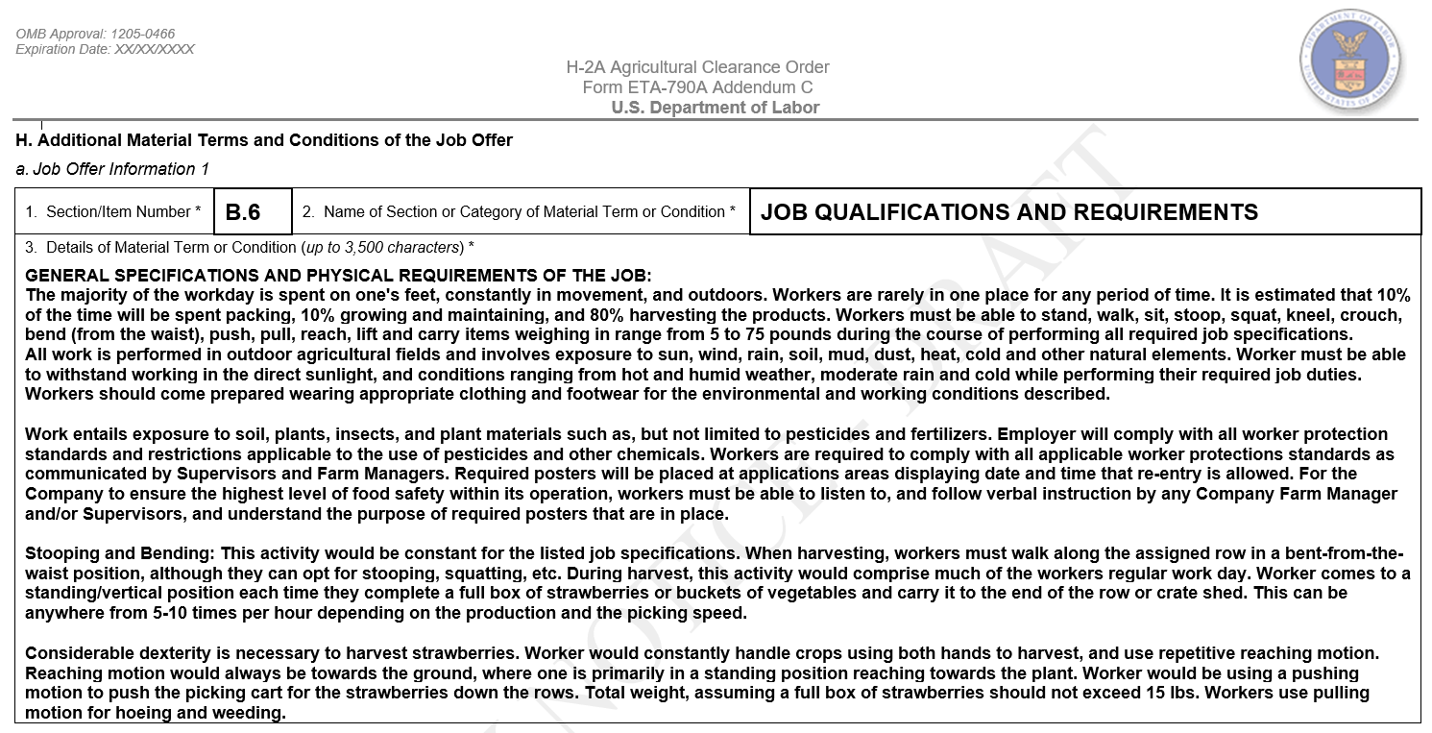

The available space in proposed Item 3 of Addendum C provides the employer with up to 3,500 characters to disclose the qualifications and requirements for the job opportunity. Although four sections of job offer information are provided on Addendum C, the employer may complete as many additional job offer information sections on Addendum C—including as many pages of Addendum C as are necessary—to fully disclose all qualifications and requirements of the job offer.

Two commenters expressed concern that Fields B.2 and B.3 only permit employers to express work experience and training in terms of the number of months required. The commenters noted that this may “make perfect sense . . . for work experience . . . but some employers’ training is measured in days or weeks.” One of the commenters recommended the Department modify Field B.3 so that it is not “restricted to only ‘months’,” while the other commenter recommended the Department provide “clarification (on the Form or in the instructions) as to how to communicate” requirements for training in “short time periods.” The Department agrees with the second commenter’s suggestion and is proposing a minor modification to the General Instructions stating that employers who need to express a training requirement of less than one month should enter "0" (i.e., zero) as the number of months required in B.3 and provide the specific number of days or weeks in Field B.6.

One commenter expressed concern that Fields B.2 and B.3 “request[] merely the numerical value for the” minimum training and experience required. The commenter stated that Field B.2 “does not provide a mechanism for specifying the nature of the training . . . (i.e., on-the-job training) or particularized training on a subset of duties . . . .” Similarly, the commenter stated that Field B.3 “does not provide a mechanism for specifying the nature of the experience required . . . .” The commenter noted that Field B.6 “appears to be a ‘spillover’ mechanism for this section, but this is unclear from the instructions provided . . . .” The commenter recommended the Department “provide an additional field allowing the employer to specify the type of training required” or, alternatively, suggested that “the instructions should expressly direct the employer to provide such additional information in [B.6].” The Department understands the commenter’s concern and, as previously discussed, will propose a minor modification to the General Instructions clarifying that an employer may use Field B.6 to disclose fully such job qualifications or requirements and/or the method of verification. If additional space is needed beyond what is provided in Field B.6, the employer will be able to use the new Addendum C to complete its response to any field in Section B of the Form ETA-790A.

One commenter asked the Department to clarify in the instructions what it means by “training” because the word can have a meaning that is synonymous with education or experience. The Department declines to define the term in the instructions to the form. The term "training" is not a defined term in the regulations and, therefore, carries a “common usage” meaning. To define the term beyond common usage would require public notice and comment rulemaking.

Another commenter asked the Department to clarify in the instructions what is meant by “driver requirements” and “certifications/license requirements” and explain how an employer should check the corresponding boxes if it requires a driver’s license and requires the worker to drive farm equipment. The commenter suggested the Department could clarify either by adding the word “‘license’ to the ‘driver requirements’ box, or amend[ing] the instructions to state that” driver’s license requirements should not be included in “the ‘certification/license requirements’ box.” In response, the Department notes that the proposed collection in Field B.4 is identical to what employers report in the current Form ETA-790. If the job opportunity requires a worker to hold a recognized certification or license (e.g., CDL license), the Department will clarify in the General Instructions that the employer should mark the “Certification/License Requirements” and specify the certification(s) and/or license(s) in Field B.6. However, if there are certain requirements that a worker needs to understand and/or possess in order to drive farm equipment, the employer should mark “Driver Requirements” and explain the requirements in Field B.6 or use the Addendum C. For example, an employer engaged in custom combining operations might use Field B.6 to describe the types of harvesting machines (e.g., self-propelled custom class) the worker will need to drive or service/repair or identify whether a clean driving record is required to drive grain and transporter trucks.

Finally, the combined worker advocacy organizations objected to the Department’s proposed combination of extensive sitting and extensive walking requirements into one check box and elimination of “OT/holiday is not mandatory” from this “Basic Job Requirements” checklist. The commenters noted that extensive walking and extensive standing requirements are very different from one another and expressed concern that potential applicants will not know whether the job opportunity requires extensive walking, extensive sitting, or both. The commenters recommended the Department create a distinct check box for each requirement. These commenters also recommended the Department add a field or check box that would indicate “OT/holiday is not mandatory,” which the commenters note "is included in [Field] 16.2 on the current Form ETA-790A.” The Department appreciates the comment and is proposing to modify the General Instructions to clarify that Field B.6 may be used to describe the work tasks and requirements selected more fully, for full disclosure and clarity. For example, a check in Field B.4.i indicates “extensive siting or walking” is required, which the employer can clarify through explanation in Field B.6. Because “OT/holiday not mandatory” is not a job requirement but a material term and condition of employment, related with work hours and work schedule, an employer can disclose this information using the new Addendum C, identified as an additional material term or condition of the job offer under Section H of the Form ETA-790A.

C. Section C – Place of Employment Information

One commenter objected to the level of geographic specificity that the Department requires an employer to provide in Section C. The commenter noted that 20 CFR 655.121(a) does not require “the specific [work] locations,” but instead “requires the ‘area of intended employment’” which “[§] 655.103 defines [as] the area ‘within normal commuting distance’ or within a ‘Metropolitan Statistical Area.’” The commenter stated that to the extent the information is not required by statute or regulation, the Department should eliminate the information collection or engage in rulemaking to add a requirement that employers provide the information.

The Department appreciates the comment and will propose modifications to Section C of the General Instructions that better reflect the relationship between the work locations collected and the area of intended employment. However, the Department respectfully disagrees with the commenter’s assertion that the Department’s regulations do not authorize the proposed information collections. The Department’s regulations define an area of intended employment as the geographic area within normal commuting distance of the place of the job opportunity (i.e., place of employment) for which the employer is seeking temporary labor certification. See 20 CFR 655.103(b). Prior to filing the Form ETA-9142A, the employer is required to submit the Form ETA-790/790A to the SWA serving the area of intended employment for review and conducting intrastate recruitment of U.S. workers. See 20 CFR 655.121. Collecting place of employment information on the Form ETA-790/790A is also essential to satisfy regulatory requirements related to the minimum terms and conditions of the job and processing agricultural clearance orders through the ARS. See 20 CFR 653.501.

Employers must then file the Form ETA-9142A along with a copy of the Form ETA-790/790A submitted to the SWA for the area of intended employment. See 20 CFR 655.130(a). The regulatory requirements establish the foundation for ensuring employers advertise their job opportunities to U.S. workers, and the advertisements must disclose the wage offer and the geographic area of intended employment with enough specificity to apprise applicants of any travel requirements and where applicants will likely have to reside to perform the services or labor. See 20 CFR 655.150 through 655.154. Thus, the Department collects this information under its regulatory authority for purposes of reviewing and verifying regulatory compliance with the requirements for application filing, conducting positive recruitment, and offering wages at least equal to the prevailing wage in the area of intended employment. Finally, the current OMB-approved collection of worksite information in the Form ETA-9142A, as well as the Department’s proposed Form ETA-790A, are consistent with the Department’s longstanding requirement that employers must disclose the geographic place(s) of employment with as much specificity as possible.

For these reasons, the proposed ETA-790A, Fields C.1 through C.6, require an affirmative response identifying the address/physical location, city, state, postal code, county, and any additional information for the place(s) of employment where work will be performed. The Department expects an employer to disclose, to the best of its knowledge at the time of filing the Forms ETA-790/790A, the places of employment and geographic area of intended employment with enough specificity to apprise applicants of any travel requirements and where applicants will likely have to reside to perform the services or labor. However, the Department understands that the level of geographic specificity the employer can provide for the place(s) of employment is highly dependent on the circumstances of the employer’s job opportunity. For example, one commenter expressed concern that employers engaged in the herding and production of livestock on the range will have difficulty completing Field C.1 because “[t]he range does not have an address and consists of multiple locations within a single county to multiple counties and sometimes states.” Another commenter noted that some employers with rural worksites will be unable to complete the mandatory Fields C.2, C.3, and C.4 because the places of employment in “extreme rural areas” may be “outside of incorporated cities” and “may not have a formal postal address that includes a city, state, and zip code.” The commenter recommended the Department make these fields conditional and permit “an employer [to] furnish merely the county and state of the worksite, along with [Global Positioning Satellite (GPS)] coordinates or more generalized geographic information . . . .”

The Department understands the commenters’ concerns, but declines to make these fields conditional, for the reasons stated above regarding the necessity of collecting worksite information. To address the commenters’ concerns, while retaining these fields as required, the Department will modify the proposed General Instructions to clarify that the employer must disclose, to the best of its knowledge at the time of filing the Forms ETA-790/790A, the place(s) of employment with enough specificity to apprise applicants of any travel requirements and where applicants will likely have to reside to perform the services or labor. For employers operating on work itineraries covering one or more areas of intended employment or those engaged in the herding or production of livestock on the range, the place of employment disclosed in Fields C.1 through C.6 may be the location where the work itinerary is expected to begin, a designated pick-up point where workers will meet, or the employer’s business or office location nearest where work will be performed in the area. For agricultural associations filing as a joint employer with its members, the place of employment disclosed in these fields may be the address of the agricultural association or the centralized location where workers will report for work assignments with members of the agricultural association. The employer may still use Field C.6 to provide more specific information about the fields where work will be performed in close proximity to the address location or more specific location information (e.g., GPS coordinates) and/or directions on how workers can reach the worksite, especially in very rural and isolated geographic areas. To disclose additional place(s) beyond the entry in Fields C.1 through C.6 (e.g., subsequent locations on an itinerary), the employer would use Addendum B.

D. Section D – Housing Information

The combined worker advocacy organizations expressed concern about the Department’s elimination of a question on the current Form ETA-790 that requests information “regarding directions to the [employer-provided] housing” and they noted that this information is important “because of the problems of employers submitting ‘phantom’ addresses [for] housing, such as in the middle of fields, and moving workers to unapproved, uninspected housing . . . .” The commenters recommended the Department add a field in Section D that would require an employer to “list the GPS coordinates of all housing units . . . and work sites . . . .” The commenters stated this information “will enable OFLC and the SWAs to engage in spot desk-checks of housing [and work sites] using online GPS mapping services such as Google Earth to ascertain when [the] information is incorrect.” In contrast, one commenter recommended collection of “just street addresses or latitude/longitude coordinates[,]” rather than requiring driving directions.

The Department understands the combined worker advocacy organizations’ concerns, but declines to mandate that all employers provide directions to the housing or GPS coordinates for all housing locations. The Department’s experience receiving and reviewing job orders demonstrates that the overwhelming majority of employers are able to disclose the exact address location(s) of the housing, which is more than sufficient to meet collection requirements and can be easily entered into free online geographic mapping applications by workers, OFLC, and SWA staff. Furthermore, Field D.10 of the proposed Form ETA-790A is a free-text field where the employer may disclose more specific directions on how workers can reach the housing location, especially in very rural and isolated geographic areas. The Department will make a minor modification to the General Instructions for Field D.10 to include the entry of GPS coordinates as another example for employers to use in completing the field.

The Department also believes the collection of directions to the housing or worksites, as opposed to collection of the address locations, would not address the commenters’ concerns about employers allegedly housing workers in locations other than the housing address disclosed on the Form ETA-790A. In the event SWA or outreach workers are unable to locate the housing using the address, an employer who delays or refuses to provide accurate directions to the housing, effectively delays the processing of its application by inhibiting a timely inspection of the housing it intends to provide to workers. In addition, the employer could risk discontinuation of recruitment services by the SWA under 20 CFR 658.501, which could result in sanctions (e.g., revocation or debarment) by the Department under the H-2A program.

Finally, one commenter noted “[r]ange rules allow for mobile housing [that] can be in multiple locations” and recommended the Department “add a checkbox” to Section D that permits an employer to indicate the mobile housing locations is the “same as worksite locations . . . .” The Department appreciates the commenter’s concern that the proposed Form ETA-790A, Section D, does not appear to accommodate the unique circumstances of employers providing agricultural labor or services on work itineraries where the use of mobile housing is permitted. To address this concern, the Department will propose a minor clarification to the General Instructions for Section D permitting employers in these unique circumstances to enter the nearest geographic location of the mobile housing unit where it resides at the time of filing the Form ETA-790A with the SWA. The disclosure of this information will assist the SWA in understanding how far it must travel in order to schedule and conduct an inspection of the employer’s mobile housing unit. The remaining collection items in Section D provide sufficient flexibility for these employers to identify the type of housing, total units and occupancy, and applicable housing standards, and to provide additional information regarding the mobile nature of these housing units. The Department provides below an illustration of how employers can complete Section C to disclose mobile housing provided to workers engaged in work itineraries covering multiple areas of intended employment.

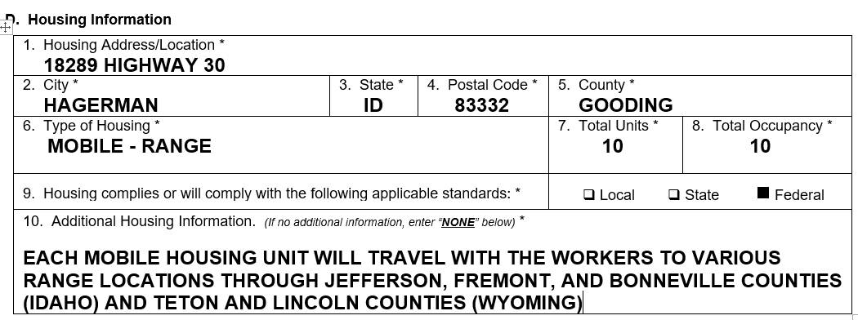

E. Section E – Provision of Meals

The combined worker advocacy organizations commended the Department for proposed Section E that collects information about the provision of meals for workers, “both at the place of employment and during inbound and outbound travel.” The commenters noted that this information “is key for H-2A workers and qualifying U.S. workers to understand their rights and obligations under the H-2A program including what their own financial responsibilities with respect to meals will be.”

One commenter expressed concern that “the level of specificity” required of responses to Field E.1 is unclear because the instructions for this field “direct the employer to describe ‘how’ the meals or kitchen facilities will be provided,” but “many employers enter into very informal arrangements with local restaurants . . . .” The commenter also noted that it is unclear whether the Department will accept attachments to provide additional information in response to this question because the Department did not explicitly state it would not accept attachments for this question, as it has with other proposed fields. The commenter recommended the Department “amend the instructions to explain precisely the level of detail it expects in this section” and state “explicit[ly] that it will accept a separate attachment . . . .”

In response to these comments, the Department notes that the Form ETA-790A, Field E.1, and General Instructions are nearly identical to what is collected on the current Form ETA-790 and instructions. As employers participating in the H-2A program are accustomed to providing this information already, the Department does not anticipate employers will have difficulty responding. However, the Department will propose a minor modification to the General Instructions by providing the following examples to help clarify the collection in Field E.1:

If the employer elects to provide kitchen and cooking facilities in lieu of providing meals, please describe the facilities and space for food preparation as well as the necessary equipment, appliances (including refrigeration), cooking accessories, and dishwashing facilities (e.g., sinks designed for this purpose) that are in working condition and will be used by workers to sufficiently prepare three meals a day. If the employer has an agreement with a third-party that will prepare the meals for the employer's workers identify the vendor and explain the employer's arrangement with the vendor with sufficient detail to apprise workers how, when, and where the workers will obtain the meals from the vendor that the employer will pay the vendor directly for the meals provided.

Important Note: Providing access to third-party vendors and requiring workers to purchase meals from the third-party vendor does not constitute compliance with the requirement to provide meals or facilities, even if the employer provides a meal stipend.

In response to the commenter’s concerns regarding apparent space limitations in Field E.1 and the request to permit free-form attachments, the Department declines to make the requested modifications. As previously discussed, the Department is proposing modifications to the Form ETA-790A and General Instructions to permit employers to use the new Addendum C to disclose fully the provision of meals to workers. If additional space is needed to complete the response to Field E.1, the employer would enter “E.1” in Item 1, “Provision of Meals” in Item 2, and then complete the description of providing meals to workers in Item 3 of Addendum C.

F. Section F – Transportation and Daily Subsistence

The combined worker advocacy organizations commended the Department for proposing a “set of questions” in Section F that “request[] specific information about the transportation and meals to be provided.” The commenters noted these questions are more specific than similar questions included on the current Form ETA-790 and the proposed questions “ensure employers are providing sufficient details regarding their specific” arrangements for transportation “for both transportation from the housing to the workplace and to and from the place from which the workers come to the place of employment.” The commenters recommended the Department clarify Field F.2 by adding the phrase “from the workers’ permanent place of residence,” which they believe will make it clearer “that the transportation reimbursements or payments normally are from the worker’s home town/permanent place of residence and not from the consular city . . . .” The Department appreciates the comments and will make a minor modification to the General Instructions clarifying that the inbound and outbound transportation is from and to "the place from which the worker has come to work for the employer," which mirrors the regulatory language at 20 CFR 655.122(h).

Two commenters recommended the Department provide additional guidance in the instructions for Fields F.1 and F.2, which one commenter believes are unclear or not helpful because they merely “restate the question[s].” The other commenter asserted that “historically it has been sufficient for the employer to attest that daily transportation will be provided” and stated that it is unclear what level of detail the Department expects in response to the proposed Field. This commenter recommended the Department clarify that employers must “provide daily transportation only to workers eligible for employer-provided housing,” not to “local workers who are [ineligible] for housing…” In addition, the commenter recommended the Department “eliminate the requirement that employers describe ‘how’ transportation is provided and instead prompt the employer to explain the daily transportation arrangements, if any . . . e.g., location of a centralized pick-up point, the fact that use of the transportation is voluntary . . . .”

The Department understands the commenters’ concerns and will propose minor modifications to the Form ETA-790A and General Instructions to help clarify the collection of information in Section F. For Field F.1, the Department will modify the language to read as follows: “Describe the terms and arrangements for daily transportation the employer will offer to workers.” The Department will also propose modifications to the General Instructions clarifying that the employer must, at a minimum, describe the arrangements for daily transportation between employer-provided housing and the places of employment at no cost to workers. Employers choosing to use centralized pick-up points in addition to employer-provided housing pick-up points should briefly describe the arrangements for transporting workers to and from the places of employment. The General Instructions will also clarify that the employer should disclose the mode(s) of transportation (e.g., vans or buses) that will be used each day, if known, as well as whether they will offer transportation at no cost to workers able to commute to work on a daily basis and/or those electing not to reside in employer-provided housing.

For Field F.2, the Department will modify the language to read as follows: “Describe the terms and arrangements for providing workers with transportation (a) to the place of employment (i.e., inbound) and (b) from the place of employment (i.e., outbound).” The Department will also propose modifications to the General Instructions clarifying that the employer must, at a minimum, state whether such transportation and daily subsistence will be provided by the employer or paid by the employer (e.g., advance payment or reimbursement) to the worker for reasonable costs incurred, and identify the modes of transportation, if known. For example, the employer may state that it will provide or pay for charter bus services or other modes of transportation to groups of H-2A or U.S. workers, or permit workers to select any means of transportation they choose and reimburse workers at no less than the most economical and reasonable common carrier transportation charges for the distances involved.

Finally, one commenter recommended the Department clarify whether it will permit employers to submit separate attachments containing additional information in response to Fields F.1 and F.2. As previously noted and in lieu of free-form attachments, the Department is proposing modifications to the Form ETA-790A and General Instructions to permit employers to use the new Addendum C to disclose fully the transportation services and daily subsistence that will be provided to workers.

G. Section G – Referral and Hiring Instructions

One commenter generally expressed concern that Section G will not be “large enough to accommodate the language required” in response to the fields in this section. The commenter recommended the Department make Section G expandable or permit employers to submit separate attachments in response to the Fields. Another commenter expressed concern that Field G.1, specifically, would not be large enough to “provide the necessary contact information for referrals . . . [i]n light of the ‘non-substantive’ changes to the 9142 announced [in] December [2018]” that require “the employer to list two . . . of the following . . . phone, email, and/or website.” The commenter recommended the Department clarify in the instructions that “those are the OFLC-approved means of referrals contacting the employer” or that the Department “is not mandating any particular means of communication and will not issue NODs if the 790A identifies a form of contact other than those three.” This commenter also noted that some employers may not use email for religious reasons and will not have an email address. The commenter recommends the Department change Field D.4 to permit an employer to “list an email or website for their filing agent . . . .” A third commenter recommended the Department clarify whether it will permit an employer to submit a separate attachment in response to Field G.1.

In response to the commenters’ concerns and recommendations, the Department proposes to expand the space in Field G.1 on the Form ETA-790A to permit the entry of approximately 5,000 characters, which is the equivalent of nearly two pages of single-spaced text. Additionally, the Department proposes a new Addendum C, which will allow employers to disclose, fully and completely, additional information concerning the material terms and conditions of the job offer. As previously noted and in lieu of free-form attachments, the Department is also proposing modifications to the Form ETA-790A and General Instructions to permit employers to use the new Addendum C to disclose fully how prospective applicants may be considered for employment under the job order.

The Department also understands the commenter’s concern that some agricultural businesses may not possess an email address or have limited or no access to the internet, which would inhibit them from obtaining an email account and/or possessing a website where prospective applicants can apply for the job opportunity. In December 2018, and as noted by the commenter, the Department received approval of non-substantive changes from OMB to modify Section H of the Form ETA-9142A to collect the following three fields: Telephone Number to Apply; Email Address to Apply; and Website Address (URL) to Apply. Through this ICR, the Department proposes to move the collection of this information from the Form ETA-9142A to Section G of the Form ETA-790A to reflect the following: Field G.2 – Telephone Number to Apply; Field G.3 – Email Address to Apply; and Field G.4 – Website Address (URL) to Apply. The Department also proposes modifications to the General Instructions incorporating the OMB-approved instructions for employers to complete these fields, which address the commenter’s concerns regarding the minimum information needed to identify the methods prospective applicants can apply for the job opportunity, and how employers who may not possess an email address or have limited or no access to the internet can comply with the reporting requirement.

H. Section H – Other Material Terms and Conditions of the Job Offer

Two commenters recommended the Department expand the space provided to respond in Field H.1 or permit employers to submit separate attachments containing additional information in response to the question. One of these commenters explained that “employers may have a significant volume of additional terms and conditions that apply to the job order, including numerous assurances, attestations, and information required” by law. Another commenter recommended the Department clarify the intent of Field H.1 and provide guidance on whether the employer should provide additional information about jobs involving herding and the production of livestock in this field or in another section of the form.

In response to the commenters’ concerns, the Department notes that Section H.1 of the proposed Form ETA-790A effectively serves the same purpose as current Field 28 of the Form ETA-790. This section is designed to provide the employer with the flexibility to disclose any other material terms, conditions, and benefits (monetary and non-monetary) that will be provided by the employer under this job opportunity, which have not already been disclosed in other sections of this form, or the employer requires additional space to complete a response to a previous item. To better accomplish this intent and to address the commenters’ concerns about the limited available space, the Department proposes to eliminate the limited text-field space contained in Section H and replace it with “Yes” or “No” checkboxes related to the new Addendum C. If more space is required to complete the Form ETA-790A, the employer will select “Yes” to Item H.1 and attach a one or more completed Addendum C pages to the form. Otherwise, the employer will select “No” to Item H.1. The proposed Addendum C will permit an employer to specify additional information on any collection item contained in the Form ETA-790A, where more space is required, or disclose other material terms or conditions of the job offer. If the employer needs to disclose a material term or condition of the job offer that is not covered by the Form ETA-790A using Addendum C, the employer may enter the letter “H,” followed by a sequential number, and then the name of the category for the material term or condition. For example, if material terms or conditions related to a communication device need to be disclosed for workers engaged in the herding or production of livestock on the range, the employer will enter “H.1” in Item 1 and “Communication Device and Plan” in Item 2. Item 3 of the proposed Addendum C provides the employer with additional space to specify the details of the identified material term or condition of the job offer.

Finally, the combined worker advocacy organizations noted that an “employer is forbidden from imposing job terms or conditions that are inconsistent with the H-2A statutes or regulations,” and the commenters recommended the Department add to the end of Field H.1 the statement “that are not inconsistent with H-2A program regulations” or similar language. The Department agrees and will propose a minor modification to the General Instructions specifying that the additional material terms and conditions of employment must comply with the requirements of the INA and the Department's regulations.

I. Section I – Conditions of Employment and Assurances for H-2A Agricultural Clearance Orders

The combined worker advocacy organizations commended the Department on proposed Section I because it “includes more specific and detailed conditions of employment and assurances . . . .” Specifically, the commenters appreciated that the Section includes: “[m]any of the employer’s obligations under the H-2A program with regard to the workers’ wages and working conditions;” requires an employer to “certify knowledge and compliance with the applicable laws and conditions of employment under penalty of perjury;” requires the employer to attest that it has read and understands the assurances and declarations in the Forms; and “provides workers an important detailed description of the terms and conditions of their employment— a document that they can turn to for enforcement if there are violations of those guarantees.”

In contrast, one commenter objected to this proposed Section “in its entirety” for several reasons. First, the commenter stated that the “attestations serve no purpose not already served by the regulations themselves.” Second, the commenter stated the Section unlawfully “attaches criminal penalties to civil administrative violations” because a false statement in the section would violate “several federal crimes [that] address providing materially false information to federal officers . . . .” Finally, the commenter expressed concern that the language contained in proposed Section I may conflict with state law, where the state “imposes a more stringent requirement than the federal regulations” and this may confuse applicants. The commenter urged the Department to “abandon” proposed Section I “and revert to the existing model of allowing employers to provide all the necessary assurances in their own modifiable terms.”

The Department respectfully disagrees with the commenter’s assertions and declines to make the requested modification to eliminate Section I or accept free-form attachments. The Department has the authority to determine the manner in which employers, who choose to use the H-2A program, assure compliance with all assurances, obligations, and conditions of employment applicable to hiring H-2A workers and/or U.S. workers for job opportunities under the Form ETA-790A. Section I summarizes the regulatory requirements to which the job order is subject in a manner that permits the employers to succinctly understand their obligations and responsibilities for deciding to participate in the H-2A program. The assurances, obligations, and conditions of employment statements contained in the Section I serve to protect workers employed under the Form ETA-790A from employers who are unaware of regulatory requirements or who seek to abuse the H-2A program. The Form ETA-790A is the form signed by employers at the time of filing the job order. The employer confirms in Section I that the statements on the forms are accurate and that it knows and accepts the obligations of the program. Thus, Section I is an essential component to the administration and enforcement of the H-2A program. Further, the Department notes that the attestations contained in Section I mirror the regulatory requirements and they do not create new obligations.

The combined worker advocacy organizations expressed concern that the language in assurance I.3 does not clearly reflect an employer’s “obligation to provide housing to all H-2A workers as required under the H-2A regulations.” The commenters recommended the Department modify the language to more clearly state that an employer must provide housing to all H-2A workers and that the phrase “who are not reasonably able to return to their residence within the same day” applies only to workers in corresponding employment. The Department agrees with the commenters and proposes a minor modification to the Form ETA-790A, Section I.3, that more clearly reflects the employer’s housing obligation under 20 CFR 655.122(d). Specifically, the Department will modify the assurance at Section I.3 to state the following: “Employer agrees to provide for or secure housing for H-2A workers and those workers in corresponding employment who are not reasonably able to return to their residence at the end of the work day.”

One commenter recommended the Department clarify, “in the assurances and/or instructions,” what the term “utilities” in Field I.3 means, as the commenter noted this term could include some or all of the following services: “[e]lectricity, gas . . . water . . . telephone service, cable or satellite television, and Internet access.” The Department appreciates the comment, but declines to make the requested modifications because examples of utilities already appear in the General Instructions for completing the Form ETA-790A, Section D – Housing Information, for Field D.a.10. To the extent the commenter is requesting an agency interpretation of the regulatory requirement to provide housing and housing-related incidentals free of charge beyond existing guidance, the Department maintains that such a request is beyond the scope of this ICR.

Two commenters noted that “many employers have found it more efficient for both the employer and the worker to establish a more central pick-up point.” One of these commenters recommended the Department amend Field I.7c to include the language “between housing provided or secured by the employer or designated pick-up point and the employer’s worksite(s).” The second commenter recommended the Department “add language to [I.7c] regarding the Portal-to-Portal Act” that clarifies the employer is not required to compensate workers for travel time between housing and the worksite. In response to the first commenter’s recommendation, the Department notes that the language in this assurance reflects the regulatory language at 20 CFR 655.122(h)(3), which requires an employer to provide daily transportation to the worksite from the employer-provided housing. While an employer may use additional pick-up points, doing so is not a regulatory requirement or an alternative to picking up workers from the employer-provided housing. In response to the second commenter’s recommendation, the Department declines to revise the ICR to include language from the Portal-to-Portal Act, as it requires an agency interpretation of that Act and is beyond the scope of this ICR.

One commenter recommended elimination of the required declaration that the employer has, “under penalty of perjury . . . read and reviewed the clearance order, including every page of this Form ETA-790A and all supporting addendums,” which the commenter asserted is not required by regulation or statute. The Department respectfully disagrees with the commenter that there is no legal basis for the employer to assure that it has read and reviewed this application, including every page of the Form ETA-9142A, Form ETA-790/790A, and supporting documentation, and that to the best of its knowledge the information contained therein is true and accurate. An employer may retain an agent or attorney to prepare the required forms and information for submission to the Department and communicate with the Department on its behalf. However, the Department reminds the commenter that regardless of whether the employer is represented by an attorney or agent, the employer is the actual filer and must sign the Forms ETA-790/790A and ETA-9142A. See 20 CFR 653.501(c) and 655.130(d). This proposed language is not only consistent with the Department’s regulatory requirements, but will strengthen program integrity by ensuring that employers that designate attorneys or agents to act on their behalf have full knowledge of the information and disclosures that are prepared on their behalf prior to the filing of the H-2A application forms and all other documentation to the Department. The Department also maintains this proposed revision will serve to protect the conditions of employment for workers and reduce the incentive for employers to claim lack of knowledge of program requirements during the course of an audit, enforcement, or investigative proceeding.

Three commenters expressed concerns about the language contained in Item I.8 regarding the three-fourths guarantee. One commenter recommended the Department eliminate language in Item I.8 addressing the three-fourths guarantee, asserting these “requirements are already clearly delineated in the H-2A regulations” and the language in Item I.8 “is potentially misleading or inaccurate.” Another commenter recommended the Department review and restate the sentence in Item I.8 to ensure that it directly match corresponding language at 20 CFR 655.122(i). The third commenter objected to the parenthetical reference to “voluntary work over 8 hours in a workday or on the worker’s Sabbath or Federal holidays,” noting that “[m]any employers’ daily guarantee may be 6 hours, 7 hours, or 10 hours.” The commenter recommended the Department not define a “specific number of hours . . . as it could be misconstrued as limiting the counting of hours over the stated guarantee to only those with a defined 8-hour work day.” This commenter further asserted that “some DOL enforcement personnel have maintained that this means employers cannot count the hours on any day that the full number of daily hours specified is not offered even if the total number of days has been worked.” The Department appreciates the commenters’ concerns, but respectfully disagrees that language in Item I.8 is misleading or inaccurate. The language contained in proposed assurance I.8 accurately reflects the regulatory language at 20 CFR 655.122(i). The second paragraph of I.8, specifically, contains the regulatory language of 20 CFR 655.122(i)(1)(iv) and (i)(3) and does not contain any additional language. The sentence including “voluntary work over 8 hours in a workday” matches the language at 20 CFR 655.122(i)(3). Although an eight-hour day may appear as an example in 20 CFR 655.122(i)(1)(iii), it is not presented as an example in 20 CFR 655.122(i)(3). To change the three-fourths guarantee assurance as the commenters suggest would require rulemaking and is beyond the scope of this ICR.

Finally, the combined worker advocacy organizations recommended that the Department include a requirement in Sections B and I that each employer must “assure and certify that any wages, piece rates, productivity standards, and other job requirements comply with applicable DOL guidance and standards.” The commenters express concern that “[t]oo many clearance orders include spurious job requirements the purpose of which is to deter U.S. workers and make it easy to terminate U.S. and H-2A workers for pretextual reasons.” The Department understands the commenters’ concern, but notes that the first assurance the commenters recommend appears in the proposed Form ETA-790A, Section I, Item 1, and the second assurance appears in the proposed Form ETA-9142A, Appendix A, Item B.1. The Department declines to place the burden, in fact or implied through an assurance, of conducting or finding alternative prevailing wage and qualifications surveys on employers without engaging in public notice and comment rulemaking.

J. General Instructions

One commenter recommended the Department clarify in the Form ETA-790A, General Instructions, that employers engaged in the herding or production of livestock on the range are not required to place a job order with the SWA between 60-75 days before the start date of work. The Department agrees with the commenter’s statement of procedures and notes the requested statement appears on page one of proposed General Instructions. The instructions state: “Except in emergency situations (20 CFR 655.134) or for job opportunities involving herding or production of livestock on the range (20 CFR 655.205), the employer must submit this job order no more than 75 calendar days and no fewer than 60 calendar days before the date of need.” This statement recognizes that, in accordance with 20 CFR 655.205, an employer submitting a job order for herding or production of livestock on the range is not required to comply with the job order filing timeframe requirement in 20 CFR 655.121(a). Thus, the Department does not believe a modification is required to address the commenter’s concern.

- The Department’s Proposed Changes to the Form ETA-790A, Addendum A

A. General Comments

One commenter objected to the proposed Addendum A “as a ‘spillover’ mechanism for the job description” because it runs counter to the Department’s efforts to streamline the form by “unnecessarily splitting the job duties and wage offers for specific crops and activities into disparate parts of the form.” The commenter added that this format may “confus[e] prospective job applicants[,] who may overlook critical details about the job.” The commenter urged the Department to eliminate Addendum A “and instead allow employers to submit a separate attachment . . . .” that includes all of this information in one place. A second commenter expressed concern that the Addendum A “does not seem to be formatted logically” and recommends the Department reorganize the fields.

The Department understands the first commenter’s concern, but respectfully disagrees that the separate collection of job duties and wage offers for specific crops and/or agricultural activities will confuse prospective applicants and hinder the Department’s efforts to streamline data collection. For many years, employers have disclosed a job description and schedule of the wage offers for a variety of crops and/or agricultural activities into disparate sections and fields on the current Form ETA-790. Further, each employer provides the Department and SWAs a wide variety of free-form attachments to supplement what it discloses on the current Form ETA-790, which are often confusing and resource-intensive to review for compliance with regulatory requirements. To address these issues and facilitate a more standardized format for collecting similar information from all employers, the Department is proposing modifications to the Addendum A that will streamline and focus the collection of information on the payment of wages for specific crops and/or agricultural activities. Specifically, the Department proposes to reorganize the information collection in a worksheet style format with column headings to make it much easier for employers, particularly those with operations involving more complex work itineraries, to add crop varieties or agricultural activities on the Addendum A. The proposed modifications will address the second commenter’s concern by eliminating the need to collect job duties on the Addendum A, and better organizing the collection of all wage offer information, by crops and/or agricultural activities, in a standardized and easy-to-read format for the Department, SWAs, and prospective applicants.

With the proposed modifications to the Addendum A, the Department also proposes to eliminate proposed Field A.7a on the Form ETA-790A, which collects the name of the crop and/or agricultural activity, and will permit employers to include this information with its description of the job duties to be performed in newly renumbered Field A.8a. This proposed modification will provide employers with greater flexibility to describe the unique specifications of their job opportunity in a free-form text field and identify work tasks that may be common across multiple crop varieties. Employers will begin entering a description of the job duties in the space provided on the Form ETA-790A and use the Addendum C to complete the response to Field A.8a. The Addendum C contains sufficient space and flexibility for employers to provide a comprehensive description of the job duties to be performed, by crop and/or agricultural activity, that can be located and reviewed by the Department, SWAs, and prospective applicants in a single location.

B. Section A.6 – Temporary Agricultural Services and Wage Offer Information

One commenter recommended the Department expand the size of the space provided to complete Field A.6a.2, “Description of the job duties or services to be performed.” As previously discussed and in response to the commenter’s suggestion, the Department proposes to eliminate the collection of job duties on the Addendum A. Employers will begin entering a description of the job duties in the space provided on the Form ETA-790A Field A.8a, and use the new Addendum C to complete a description of the job opportunity being requested for temporary labor certification.

One commenter recommended the Department include a free-form text field to include additional wage information, such as holiday and bonus pay, similar to the field provided in Field A.10 of the Form ETA-790A. Alternatively, the commenter recommended the Department permit employers to upload documents with additional information regarding wages. The Department appreciates the commenter’s suggestion and, as previously discussed, proposes to include a text field entitled “Piece Rate Units/Special Pay Information” permitting the entry of up to 500 characters of additional information about the wage offer related to a specific crop or agricultural activity. In situations where more space is needed to disclose terms and conditions related to holiday and bonus pay applicable to all workers, the employer may disclose this information using the new Addendum C.

C. General Instructions

One commenter recommended the Department specify in the instructions to Addendum A that an “employer may complete and attach as many Addendum A’s as necessary,” instead of stating the employer may “complete as many additional information sections as are necessary in order to disclose all the crop or agricultural activities workers will perform . . . .” The Department appreciates the commenter’s suggestion. In light of the proposed modifications to the Addendum A, the Department is clarifying the General Instructions to state that the Addendum A will collect up to 10 sections of wage offer information for each crop and/or agricultural activity. For electronic filings, if the employer needs to disclose more than 10 sections of wage offer information, the filing system will automatically provide the employer with the option of adding more rows to the Addendum A until the response is completed. For mailed or paper filings, the employer will make one or more copies of the Addendum A to complete and attach to the Form ETA-790A.

- The Department’s Proposed Changes to the Form ETA-790A, Addendum B

A. General Comments

One commenter asserted that “Addendum B engages in rulemaking” because it “mandates that employers complete an Addendum based on” the term “worksite,” and the commenter noted that the use of this term is “not supported in the regulations . . . .” The Department respectfully disagrees with the commenter’s assertions that the collection of worksite information is unnecessary, unsupported, and engages in rulemaking. As previously discussed, the Department’s ARS regulations and H-2A regulations require the employer to identify the place(s) of employment (worksites) as clearly as possible for various purposes (e.g., apprising U.S. workers of the geographic location of the job opportunity, any travel requirements, and whether the worker can live in his or her own residence while performing the job, and determining where U.S. worker recruitment must be conducted). See, e.g., 20 CFR 653.501(c)(1)(iv), 20 CFR 655.121(a), 20 CFR 655.122(d) and (h), and 20 CFR 655.152(b). As a condition of filing the Form ETA-790A, the employer is also assuring the Department that SWA outreach workers will have reasonable access to the workers during the conduct of outreach activities set forth at 20 CFR 653.107. See 20 CFR 653.501(c)(3)(vii). The employer’s disclosure of the place(s) of employment is essential for the SWA to know when and where the workers will be located to conduct field checks and related outreach activities. Finally, this information is essential to the Department’s ability to evaluate the availability of U.S. workers and ensure no adverse effect on the wages and working conditions of U.S. workers similarly employed, as required to certify an employer’s application. See 20 CFR 655.100.

B. Section C – Worksite Information

One commenter expressed concern that the proposed form “ignores the reality of agricultural work, in which work demands and locations may vary on a day-to-day basis” and in which employers “move workers freely between worksites . . . .” Another stated, “H-2ALC employers may not be able to state with precision when they will be able to begin and end harvesting operations at a particular location” or how many workers will be needed, and “[t]he only constant in crop maturity and weather is change.” Three commenters noted that many rural worksites do not have an address and one stated that it is “wholly unreasonable to require specific postal address information where none exists.” The Department appreciates the comments and agrees that it would be unreasonable to require the employer to include a postal address for a worksite that does not have one. The Department understands that the level of geographic specificity covering the place(s) of employment is highly dependent on the circumstances of the employer’s job opportunity.

Four commenters expressed concerns about the format of Addendum B, asserting it appears “burdensome” and “cumbersome” for providing worksite and/or housing information. One commenter asserted it is a redundant information collection and “serves no functional purpose.” Another commenter stated that “completing each item requested in Addendum B would add an additional 10-15 hours . . . in preparation time for most H-2A applications.” That commenter also expressed concern that the multiple Addendums these employers will need to complete might add “75 pages or more to the [employment] contract . . . assuming Addendum B would be part of the H-2A contract” provided to H-2A and corresponding U.S. workers.

One commenter generally stated that an employer will have difficulty completing some or all of the fields in Section C because the employer will not know this information for “every single one of [its] worksites.” Three commenters expressed similar concerns that it may be difficult for some employers to complete proposed Fields C.2, C.3, and C.4 because the employers may not know at the time of filing the specific dates workers will be assigned to a worksite or the specific number of workers that will be employed at the worksite. One of the commenters recommended the Department eliminate Fields C.3 and C.4 that request the “First Date” and “Last Date” of employment and instead instruct employers to include approximate dates of employment for each worksite in Field C.10, “Additional Worksite Information.” Similarly, another commenter recommended the Department permit an employer to “offer an estimate as to dates and numbers of workers as accurately as possible, but be able to change the specific information as circumstances dictate.” One commenter expressed a concern that Fields C.5 through C.8 “[w]ill be problematic for worksites that literally do not have an address.”

In response to all these comments, the Department proposes several modifications to the Addendum B providing employers, especially agricultural associations, H-2A Labor Contractors (H-2ALCs), and those with operations involving more complex work itineraries, with sufficient flexibility to disclose place of employment information they currently provide to the Department with a minimum amount of burden. First, the Department proposes to reorganize the information collection in a worksheet style format with column headings to make it much easier for employers to add worksite entries on the Addendum B. Second, the Department proposes to rename and only mandate the collection of the “Place of Employment” where work will be performed for all employers who need to complete an Addendum B. The Department will propose modifications to the General Instructions stating that employers must disclose, to the best of its knowledge at the time of filing the Form ETA-790A, geographic details related to the place of employment with enough specificity to apprise prospective applicants of any travel requirements and where they will likely have to reside to perform the services or labor. The General Instructions will identify a standard entry format that employers must use when completing this field (e.g., address/location, city, state, postal code, county), which the Department and SWA will review in accordance with regulatory requirements. Although addresses are required, if available, the revised General Instructions will state that if there is no address, the employer may enter “No Street Address Available” or “N/A”.

Third, the Department proposes to add a new Field C.3 called “Additional Information About the Place of Employment” that will provide employers with an open text field to inform the Department of any other details about the geographic area of intended employment based on the unique circumstances of their job opportunities. Employers in the logging industry, for example, perform work in predominantly nonmetropolitan areas and often involve large tracts of forests in counties that are identifiable only by forest grid identification numbers or even GPS coordinates. This new collection item will provide these employers with flexibility to describe the geographic area where work is expected to be performed. Similarly, H-2ALCs may be engaged in performing work in very rural areas where a street address location is too difficult to identify in Field C.2. These employers may use the new Field C.3 to provide more specific directions to the place of employment or enter GPS coordinates.

The remaining fields on the Addendum B will be conditional where the employer’s work itinerary necessitates disclosure of this information. For example, it is a longstanding requirement and common practice among employers engaged in animal shearing and custom combining operations to provide work itineraries for their crews that disclose the name of the agricultural business and the begin and end dates that work will be performed. In these situations, the employer would complete Fields C.1, C.4, and C.5 for each place of employment identified in Field C.2. To help employers understand these proposed modifications, the Department provides below several illustrations of how employers can complete the Addendum B.

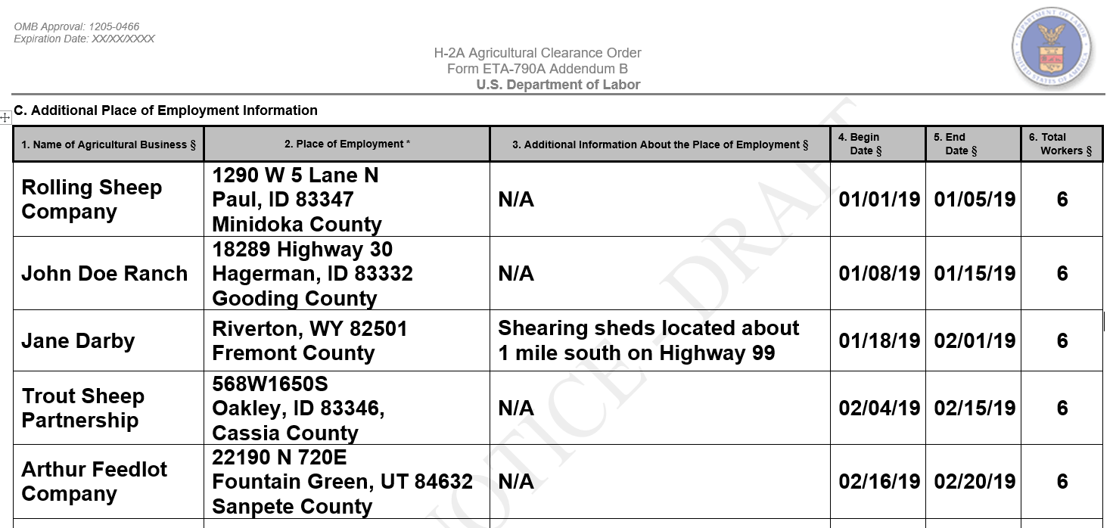
EXAMPLE 1: Employer Engaged in Itinerant Animal Shearing

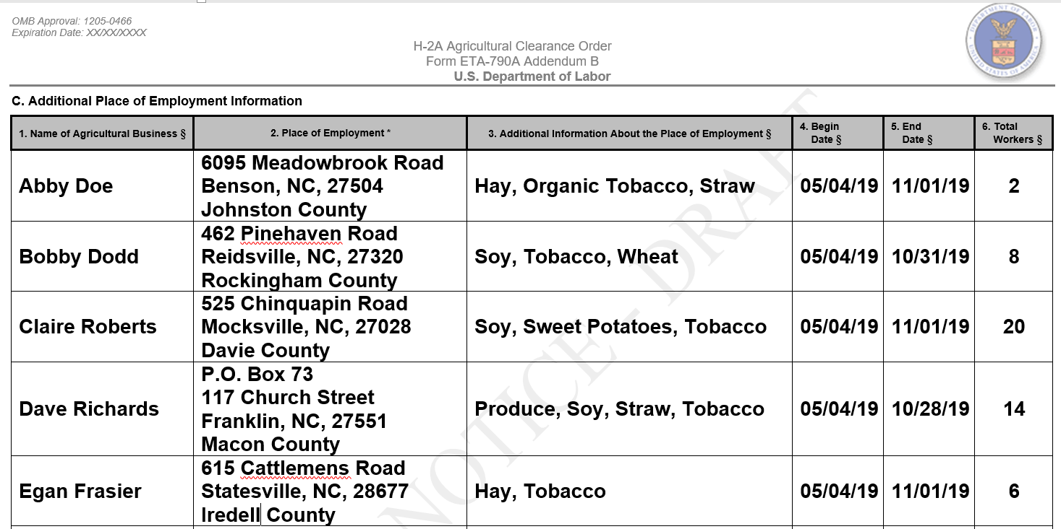
EXAMPLE 2: Agricultural Association Filing as Joint Employer

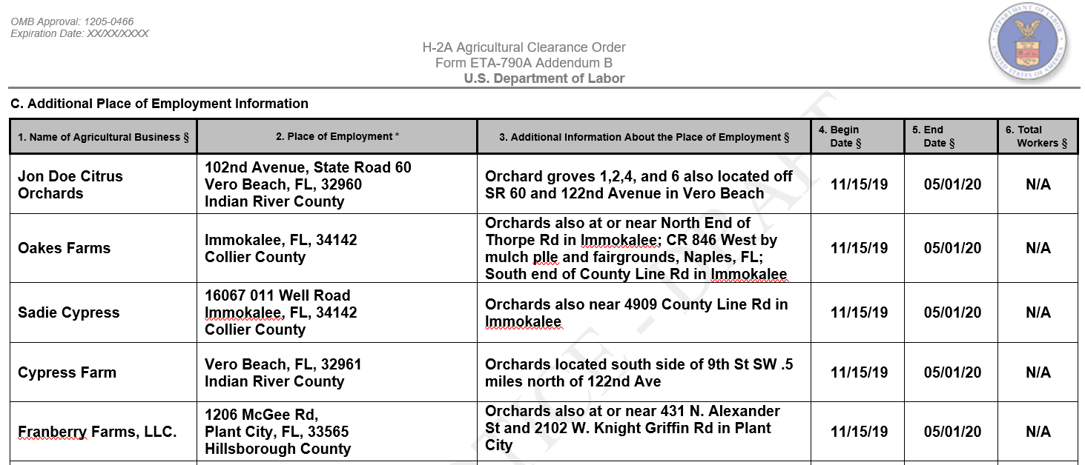
EXAMPLE 3: H-2A Labor Contractor

Finally, the Department notes that employers currently submit this information in a variety of paper-based formats attached to the Form ETA-790. The Department’s proposed Addendum B establishes a more effective and standardized format for collecting this existing information. The Department’s program experience demonstrates that the lists of places of employment submitted by employers are largely consistent and used across multiple years. Accordingly, once an employer initially completes the Addendum B, the burden of completing the Addendum B for use in subsequent applications will be significantly reduced.

In response to comments regarding the start and end date fields, Fields C.4 and C.5 of the Addendum B are conditional entries where the employer’s work itinerary necessitates disclosure of this information. These fields are intended primarily for H-2ALCs performing work under contract with each fixed-site grower listed and employers with workers performing work on an itinerary, where the work is performed at the locations listed according to an anticipated schedule.

Four commenters expressed concern that Addendum B does not include enough entries for employers with many worksites that currently submit an attachment that includes all worksites. One commenter asked the Department to clarify whether FLCs that employ workers at locations included in an itinerary will be required to complete multiple Addendums. Another commenter recommended the Department “lump worksites into purely county . . . .” Two commenters recommended the Department continue to allow employers to submit attachments identifying the worksites where work will be performed.” One of these two commenters also expressed a concern that Section C and the corresponding section of Addendum B only permit the inclusion of five places of employment, which is too limited, given some employers “may have as many as 300 worksites.” The commenter added that it would “require an enormous and untenable amount of time” for an employer “to copy potentially 75 additional pages of Addendum A and then fill out the requested information in each box” of Addendum B. The commenter recommended the Department make “clear that a separate attachment may be used in lieu of Addendum B.”

In response to these comments and as discussed above, the Department declines to permit employers to submit free-form attachments and will propose modifications to the Addendum B providing employers with sufficient flexibility to disclose all place of employment information they currently provide to the Department with a minimum amount of burden. The Department will also clarify the General Instructions to state that the Addendum B will collect up to 10 sections of information related to the places of employment. For electronic filings, if the employer needs to disclose more than 10 sections of information related to the places of employment, the filing system will automatically provide the employer with the option of adding more rows to Section C of the Addendum B until the response is completed. For mailed or paper filings, the employer will make one or more copies of Section C of the Addendum B to complete and attach to the Form ETA-790A.

One commenter expressed a concern that Section C “is not suited for the multiple county locations and multiple state locations of range herding livestock . . . .” The Department understands the commenter’s concerns and maintains the proposed Form ETA-790A and the Addendum B are sufficiently flexible to permit employers of range herding and production of livestock workers to identify their place(s) of employment with as much geographic specificity as possible. For example, if the workers will meet at ranch headquarters or a location near headquarters where the work itinerary will begin and then move with the herd through rangelands covering multiple areas of intended employment, the employer could complete the Form ETA-790A, as shown below, without the need to use the Addendum B:
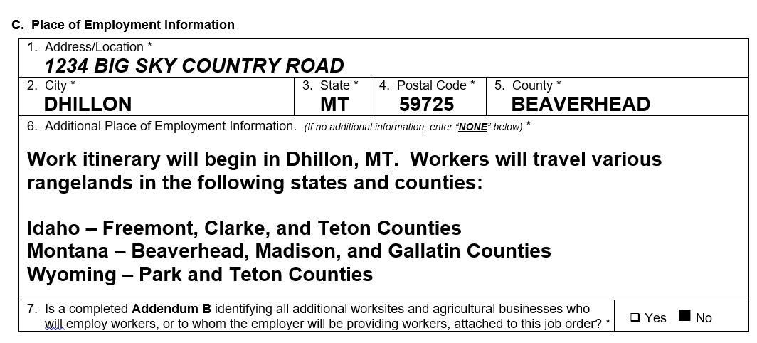

However, if these same workers will be performing work on the range for a majority of the period of employment and then will move with the herd to various fixed-site locations where addresses are known, the employer will enter the address where the work will begin on the Form ETA-790A, Section C, and then disclose the other fixed-site locations, along with any other information related to the itinerary, using Section C of the Addendum B.

One commenter also expressed a concern that Field C.10 “is quite small, which may not allow enough room to give directions to rural [places of employment]” or “other [necessary] information…” The Department appreciates the commenter’s concern and it will clarify in the General Instructions that new Field C.3 will permit an entry of up to 500 characters. The Department believes this is a sufficient amount of space for employers to use in describing the place of employment.

C. Section D – Housing Information

One commenter expressed concern that completing Addendum B “will be cumbersome and time consuming” for applicants with a large number of housing units and recommended the Department permit employer to submit separate attachments. The Department has addressed both aspects of this commenter’s concerns in detail above. First, the Department retains the prohibition on employers submitting free-form attachments, as it serves to collect all essential job-related information in a standardized format for circulation within the ARS. Second, the Department proposes modifications to the Addendum B, including reorganizing the information collection in a worksheet style format with column headings to make it much easier for employers to add housing entries on the Addendum B.

The combined worker advocacy organizations commended the Department for proposed Section D that requires an employer to “provide the location and descriptions for all other housing that will be provided to workers,” as the commenters noted that it is “critically important for DOL to ensure that adequate housing is available for all” workers. These commenters also commended the Department for proposing Fields D.7, D.8, and D.9, stating that they collect helpful information regarding “which housing standards are applicable and whether the housing complies with those standards, as well as the total units and occupants of the housing.” These commenters recommended the Department further strengthen Section D “by requiring that, for housing to which federal standards apply, the employer state whether the OSHA or the ETA standards apply.”

In contrast, two commenters expressed a concern that the intent and purpose of Field D.9 is unclear and a third commenter stated it collects information the employer should not be responsible for providing. The first commenter noted that a housing “inspection will meet multiple regulations” and asked whether an employer may select more than one of the housing standard options in D.9. The second commenter stated that D.9 is unnecessary because employer-provided housing “must comply with all three standards . . . .” This commenter also expressed concern that an employer or its agent may not know which standards apply at the time of filing because “[t]he state refuses to inspect [the housing] until the employer actually files the ETA-790.” The second commenter recommended the Department change D.9 to a “‘Yes’ or ‘No’ question as to whether the housing complies, or will comply, with all applicable housing standards . . . .” The third commenter stated that the housing authority conducting the inspection should provide this information and the commenter recommended the Department eliminate D.9.

The Department appreciates the question posed by the first commenter and will modify the General Instructions associated with the collection of applicable housing standards in Field D.9, Form ETA-790A, and Section D of the Addendum B to permit the selection of one or more of the applicable housing standards (local, State, Federal). In response to the second and third commenters, the Department notes that the employer is responsible for ensuring the housing it provides meets the applicable housing standards, which is generally known at the time of filing the Form ETA-790A with the SWA. If this is not known, employers typically gather information about which housing standards apply from State or local housing inspection authorities.

In response to the second commenter’s suggestion to modify this collection to only “Yes or No” values, the Department respectfully declines, as such a modification will provide little practical utility to the Department and the state or local authority that will conduct the inspection on the housing unit. In circumstances where rental or public accommodations are used, the regulations require the employer to document to the satisfaction of the CO that housing complies with applicable housing standards. If the employer’s housing is subject to SWA inspection, the SWA's inspection process will help to inform the employer as to the applicable standard and, therefore, appropriate selection, which the employer may ask to amend for accuracy after filing. An employer using public or rental accommodations that do not require an inspection from the SWA, must identify the applicable housing standards and confirm compliance to those standards, which may involve requesting information from the owner or operator of the rental or public accommodation. Regarding one commenter’s suggestion to add separate checkboxes covering different Federal standards (e.g., ETA or OSHA), the Department respectfully declines, as that determination is performed at the time the State or local housing authority arrives at the site to inspect the housing unit. Alternatively, if the specific Federal standards are known, the employer may use Field D.10, Form ETA-790A, or Field D.3 on the Addendum B to disclose this information.

One commenter noted that “[r]ange rules allow for mobile housing [that] can be in multiple locations” and recommended the Department “add a checkbox” to Section D that permits an employer to indicate the mobile housing information is the “same as worksite locations . . . .” A second commenter expressed a concern that it will be problematic or impossible for some employers to complete Fields D.1 through D.4 because their mobile housing units may not have an address. The Department appreciates the commenters’ concern that Section D does not appear to accommodate the unique circumstances of employers providing agricultural labor or services on work itineraries where the Department permits the use of mobile housing. In response to this concern, the Department will modify the General Instructions to clarify that employers in these unique circumstances may enter the geographic location of the mobile housing unit on Section D of the Form ETA-790A, where it resides at the time of filing the job order with the SWA. The employer will enter the address location using D.1 through D.5, and then use Field D.10 to specify that housing units will travel with the workers across various rangelands and identify the counties and state(s) in which the housing will be located during the period of employment. In doing so, employers in these unique circumstances will not need to complete Section D of the Addendum B. The disclosure of this information will assist the SWA in understanding how far it must travel in order to schedule and conduct an inspection of the employer’s mobile housing unit. The remaining collection items in Section D provide sufficient flexibility for these employers to identify the type of housing, total units and occupancy, applicable housing standards, and to provide additional information regarding the mobile nature of these housing units.

Finally, one commenter expressed a concern that Field D.10 does not provide sufficient space to provide all additional information about the employer’s housing. The Department appreciates the commenter’s concerns. The Department proposes to modify the General Instructions to clarify that the free-text fields on the Form ETA-790A, Section D, and the Addendum B will permit the entry of up to 500 characters of information related specifically to the housing unit(s). In situations where more space is needed to complete the response or where additional material terms and conditions related the use of employer-provided housing need to be disclosed, the employer may disclose this information using the new Addendum C.

D. General Instructions

One commenter asked the Department to clarify in the General Instructions “how many forms of Addendum B the employer can use to disclose any additional worksite information.” Another commenter noted that the General Instructions state an employer “must complete as many additional information sections as are necessary in order to disclose all the worksites . . . and housing that will be provided to the workers,” but recommended the Department remove the word “sections” to more clearly “specify whether the employer may complete and attach as many Addendum [B]’s as necessary.” In response to these commenters, the Department proposes to reorganize the information collection in a worksheet style format with column headings to make it much easier for employers to add housing entries on the Addendum B. The Department will also clarify the General Instructions to state that the Addendum B will collect up to 10 sections of information about employer-provided housing. For electronic filings, if the employer needs to disclose more than 10 sections of housing information, the filing system will automatically provide the employer with the option of adding more rows to Section D of the Addendum B until the response is completed. For mailed or paper filings, the employer will make one or more copies of Section D of the Addendum B to complete and attach to the Form ETA-790A.

- Comments Outside the Scope of the ICR Proposals

Two commenters submitted comments that raise issues or concerns outside the scope of this ICR in their entirety. In one of these comments, the commenter recommended the Department “streamlin[e] the recruitment process as this step in the certification is burdensome and expensive and almost never yields any results.” This comment raised concerns about the recruitment process contained in the 2010 H-2A Final Rule, not the collection of recruitment-related information, which is beyond the scope of this ICR. Another stated several complaints about WHD investigations, unreimbursed expenses when H-2A workers pursue a different job opportunity, corresponding worker/wage requirements, etc. The commenter also recommended changes to the program, such as payment of the minimum wage to H-2A workers. Like the recommendations regarding recruitment, the recommended changes do not relate to the collection of information under the 2010 H-2A Final Rule and these recommendations would require separate rulemaking.

Other commenters submitted comments containing some in-scope content, addressed above, along with out-of-scope concerns. One commenter included a recommendation that the Department create a system to permit employers to pay the certification fee electronically, while another recommended the Department “go one step further, and make these forms available to be completed online via the iCERT portal” in the same manner as the Form ETA-9142A. The recommendation to create an electronic payment system is beyond the scope of this ICR because the certification fee payment and collection process is unrelated to proposed changes to this ICR. Similarly, the recommendation that the Department add the ARS forms to the iCERT portal is outside the scope of this ICR, as to do so would require rulemaking. One commenter expressed concern that some SWAs “will not accept job orders reflecting an ‘anticipated’ work schedule in excess of 48 hours/week . . . .” The SWAs’ review of work schedules under current regulatory provisions is outside the scope of the Department’s ICR proposal. Finally, one commenter expressed concern about costs and burden associated with filings with other government agencies, which are burden concerns outside the scope of this ICR.

See 29 Fed. Reg. 6884 (Feb. 12, 2010) and 20 CFR 655, Subpart B.
See 8 CFR 214.2(h)(5)(ii), which establishes that the following determinations by the Department are final: “whether employment is as an agricultural worker, whether it is open to U.S. workers, if qualified U.S. workers are available, the adverse impact of employment of a qualified alien, and whether employment conditions, including housing, meet applicable requirements.”

