2020 National Teacher and Principal Survey (NTPS) Teacher and Principal Follow Up Survey
Cognitive Testing

Attachment 1: Communication Materials, Screener, and Consent Forms

OMB# 1850-0803 v. 278

National Center for Education Statistics (NCES)

October 2020

Contents
Recruitment advertisement text for teacher and principal interviews 3
Screeners 3
Principal Recruitment Screener 3
Teacher Recruitment Screener 6
National Teacher and Principal Survey (NTPS) Cognitive Interviews Frequently Asked Questions (FAQs) (Only to be e-mailed to participants who ask for more information) 8
Privacy Protection Email 9
Consent Email (after scheduling interview) 9
Reminder email (sent 1 business day before interview) 10
Skype For Business Attachment 11
Consent Forms 14
Principal Form 14
Teacher Form 16
Payment Procedure 18

Recruitment advertisement text for teacher and principal interviews
K-12 Teachers Needed for Testing a National Teacher Survey – Receive $40
The U.S. Census Bureau is looking for teachers of kindergarten through grade 12 to help test question wording on a national teacher survey. Public, charter, and private school teachers are all welcome! Interviews will be 90 minutes and will take place by computer and phone. Participants will receive $40. Please call [NAME] at xxx-xxx-xxxx or email [NAME] at xxxx@census.gov to learn more.

Principals Needed for Testing a National Principal Survey – Receive $75
The U.S. Census Bureau is looking for primary and secondary school principals to help test question wording on a national principal survey. Principals of public, charter, and private schools are all welcome! Interviews will be 90 minutes and will take place by computer and phone. Participants will receive $75. Please call [NAME] at xxx-xxx-xxxx or email [NAME] at xxxx@census.gov to learn more.

Screeners (by phone)

Principal Recruitment Screener
Hello. My name is [XXXXXX] and I work for the U.S. Census Bureau. [Thank you for responding to our advertisement / I am calling you back about the message you left regarding our advertisement]. We are working with the National Center for Education Statistics within the U.S. Department of Education, to test questions and text messages for the National Teacher and Principal Survey. We are interested in interviewing principals to learn how the survey questions can be improved. Would you be available for a 90 minute interview in [fill appropriate date/time for the round we are interviewing for]? If you choose to participate, you will be given $75.

Would you like to participate?
Yes - Great. I am going to ask you a few background questions to confirm your eligibility.
No – Okay, thank you for your time today.
[if they would like to participant but aren’t available now, ask if he / she is interested in participating at a future date].

- Are you a principal in a public school, a charter school, or a private school?
Public school
Charter school
Private school

- [If yes] Great what is your name?

- What is the best phone number to reach you at if you are selected for an interview?

- What state is your school in?

- What grades are taught in your school? Pre-K K 1 2 3 4 5 6 7 8 9 10 11 12

- How long have you worked, as a principal, at your current school?

- Do you have access to a phone that can receive text messages and would you be willing to do that as part of the study? [If yes] What is that phone number?

- Do you have access to a laptop or desktop computer?

- Do you have high speed internet access?

- Would you be willing to download a free software called Skype for Business to facilitate testing that you could remove immediately after the session?

11. Have you participated in a research study or focus group in the past 6 months? (RECRUIT NONE.)
- Yes (Continue)
- No (Continue)

- What is the email address we should use to contact you, should you qualify for a study? (write in)
_________________________________________________
If they have an e-mail then say: Whether or not you are selected I am going to email you some more information about how we protect the privacy of your data and your rights.
If they do not have an e-mail then read: Thanks for taking some time to answer my questions today. If you qualify, someone will be back in touch with you soon to schedule an interview.
The U.S. Census Bureau is required by law to protect your information. We are conducting this voluntary survey on behalf of the National Center for Education Statistics under the Education Sciences Reform Act of 2002 (ESRA 2002, 20 U.S.C., § 9543). All of the information you provide may be used only for statistical purposes and may not be disclosed, or used, in identifiable form for any other purpose except as required by law (20 U.S.C. §9573 and 6 U.S.C. §151).
Your privacy is also protected by the Privacy Act, Title 5 U.S. Code. Routine uses of these data are limited to those identified in the Privacy Act System of Record Notice titled, “SORN COMMERCE/Census-7, Demographic Survey Collection (non-Census Bureau Sampling Frame).”
If they are selected for interview this will be read to them:
The session will be conducted over the telephone using an application called [Skype]. You will use your computer at home and the researcher will be at their home and watch you complete the survey on your computer using [Skype]. A researcher will send you an email with a link to download the [Skype], a form explaining your rights as a participant, and a place for you to indicate the address you would like to receive the $75 at. Then they will set up a time to test the software with you before the session. Is this okay?
o Yes | → (CONTINUE – Great. In the next two days a researcher will email you a link to download Skype/TEAMS. Please check your email for this notification and further instruction.)
o No | → (thank you for your time, but at this time we are not conducting in person sessions. We will notify you if that changes. )

Teacher Recruitment Screener
Hello. My name is [XXXXXX] and I work for the U.S. Census Bureau. [Thank you for responding to our advertisement / I am calling you back about the message you left regarding our advertisement]. We are working with the National Center for Education Statistics within the U.S. Department of Education, to test questions for the National Teacher and Principal Survey. We are interested in interviewing teachers to learn how the survey questions can be improved. Would you be available for a 90 minute interview in [fill appropriate date/time for the round we are interviewing for]? If you choose to participate, you will be given $40.

Would you like to participate?
Yes - Great. I am going to ask you a few background questions to confirm your eligibility.
No – Okay, thank you for your time today.
[if they would like to participant but aren’t available now ask if he / she is interested in participating at a future date].

- Are you a teacher in a public school, a charter school, or a private school?
Public school
Charter school
Private school

- [If yes] Great what is your name?

- What is the best phone number to reach you at if you are selected for an interview?

- What state is your school in?

- What grades do you currently teach? Pre-K K 1 2 3 4 5 6 7 8 9 10 11 12

- What subject do you teach?

- How long have you been teaching at your current school?

- Do you have access to a phone that can receive text messages and would you be willing to do that as part of the study? [If yes] What is that phone number?

- Do you have access to a laptop or desktop computer?

- Do you have high speed internet access?

- Would you be willing to download a free software called Skype for Business to facilitate testing that you could remove immediately after the session?

- Have you participated in a research study or focus group in the past 6 months? (RECRUIT NONE.)
- Yes (Continue)
- No (Continue)

- What is the email address we should use to contact you, should you qualify for a study? (write in)
_________________________________________________
If they have an e-mail then say: Whether or not you are selected I am going to email you some more information about how we protect the privacy of your data and your rights. Thank you very much!

If they do not have an e-mail then read: Thanks for taking some time to answer my questions today. If you qualify, someone will be back in touch with you soon to schedule an interview.
The U.S. Census Bureau is required by law to protect your information. We are conducting this voluntary survey on behalf of the National Center for Education Statistics under the Education Sciences Reform Act of 2002 (ESRA 2002, 20 U.S.C., § 9543). All of the information you provide may be used only for statistical purposes and may not be disclosed, or used, in identifiable form for any other purpose except as required by law (20 U.S.C. §9573 and 6 U.S.C. §151).
Your privacy is also protected by the Privacy Act, Title 5 U.S. Code. Routine uses of these data are limited to those identified in the Privacy Act System of Record Notice titled, “SORN COMMERCE/Census-7, Demographic Survey Collection (non-Census Bureau Sampling Frame).”
If they are selected for interview this will be read to them:
The session will be conducted over the telephone using an application called [Skype]. You will use your computer at home and the researcher will be at the census and watch you complete the survey on your computer using [Skype]. A researcher will send you an email with a link to download the [Skype], a form explaining your rights as a participant, and a place for you to indicate the address you would like to receive the $40 at. Then they will set up a time to test the software with you before the session. Is this okay?
o Yes | → (CONTINUE – Great. In the next two days a researcher will email you a link to download Skype/TEAMS. Please check your email for this notification and further instruction.)
o No | → (thank you for your time, but at this time we are not conducting in person sessions. We will notify you if that changes. )

National Teacher and Principal Survey (NTPS) Cognitive Interviews Frequently Asked Questions (FAQs) (Only to be e-mailed to participants who ask for more information)

What is this study about?
For this particular study, we will ask you to answer a series of survey questions related to your background and experiences, and about your school. We will discuss how you arrived at your answers and how you interpreted the questions.
What will you do with the data?
The data will be used to improve the questionnaire. Direct quotes may be used in reports or in research presentations, but your name and your school’s name will never be used in any reports or presentations. Your participation and interest is very important to us.
What is the National Teacher and Principal Survey?
The National Teacher and Principal Survey (NTPS) is the nation’s primary source of information on what is happening in K-12 schools from both teacher and principal perspectives. It is fielded every two to three years by the National Center for Education Statistics (NCES). This survey used to be called the Schools and Staffing Survey (SASS).
Who is the National Center for Education Statistics?
The National Center for Education Statistics (NCES), http://nces.ed.gov/, is the primary federal statistical entity for collecting and analyzing data on topics related to education both in the United States and in comparison with other nations. NCES is part of the Institute of Education Sciences, within the U.S. Department of Education. The education statistics that NCES produces are used by Congress, federal and state agencies, educational organizations, researchers and policymakers, the general public, and others.
Do I have to participate?
Participation is voluntary. You may choose whether or not you want to be in this study. If you decide to be in the study, you may refuse to answer any question you do not want to answer or to stop participating at any time.
How much will I be paid?
Teachers will receive $40, principals providing feedback on the school questionnaire will receive $75 cash after completion of the interview.
How long will the study take?
The interview will take up to 90 minutes of your time.
Why should I participate?
We are testing new and modified questions and text messages that will be used in the next administration of the survey. Your input on how the new questions are working will help improve the study and the data we collect. By participating in this study you can help make sure that the NTPS collects the most complete and accurate data possible.

How is my privacy protected?
All of the information you provide may be used only for statistical purposes and may not be disclosed, or used, in identifiable form for any other purpose except as required by law (20 U.S.C. §9573 and 6 U.S.C. §151). Your name will not be attached to the answers you provide.
What information will be shared with the government/with NCES?
Your name will not be associated with any of the responses you give to the survey questions, and the Census Bureau will not provide the names of any participants to NCES. NCES will receive information about this study in a form that will not lead to the identification of any participants.

Privacy Protection Email
(All participants who call in for recruiting will be sent this email.)
Dear [participant name]:
Thanks for taking some time to answer my questions today. If you qualify, someone will be back in touch with you soon to schedule an interview.
The U.S. Census Bureau is required by law to protect your information. We are conducting this voluntary survey​ on behalf of the National Center for Education Statistics under the Education Sciences Reform Act of 2002 (ESRA 2002, 20 U.S.C., § 9543). All of the information you provide may be used only for statistical purposes and may not be disclosed, or used, in identifiable form for any other purpose except as required by law (20 U.S.C. §9573 and 6 U.S.C. §151).
Your privacy is also protected by the Privacy Act, Title 5 U.S. Code. Routine uses of these data are limited to those identified in the Privacy Act System of Record Notice titled, “SORN COMMERCE/Census-7, Demographic Survey Collection (non-Census Bureau Sampling Frame).”
We estimated that completing the screening questions will take 10 minutes on average. This information collection has been approved by the (OMB). You can validate that this survey is a legitimate federally-approved information collection using the Office of Management and Budget's approval number 1850-0803, which expires June 30, 2022. We are required to tell you this number to conduct this survey. Send comments regarding this estimate or any other aspect of this survey, including suggestions for reducing the time it takes to complete this survey to adrm.pra@census.gov.
Thank you for your time and your assistance,
[name]

Consent Email (after scheduling interview by phone)
Greetings [participant name],
We are looking forward to working with you on [Date, Time] for the upcoming education study. We will give you a call at [Participant phone number].
Below you will find a link to a webpage where you can give your signature to consent to participate in this research. We are also including instructions to download Skype For Business. Please sign the consent form and download the Skype software before the time of your interview.
[Consent form link]
[Per your request I have also included more information about the National Teacher and Principal Survey.]
[Skype for Business meeting link]
If you have any questions please contact me.
[email] or [phone number]
Thank you,
[name]
[Skype for business attachment]
[FAQ if requested]

NCES is authorized to conduct NTPS by the Education Sciences Reform Act of 2002 (ESRA 2002, 20 U.S.C. §9543). All of the information you provide may be used only for statistical purposes and may not be disclosed, or used, in identifiable form for any other purpose except as required by law (20 U.S.C. §9573 and 6 U.S.C. §151).
According to the Paperwork Reduction Act of 1995, no persons are required to respond to a collection of information unless it displays a valid OMB control number. The valid OMB control number for this voluntary information collection is 1850-0803 and the approval expires 06/30/2022. The time required to complete this information collection is estimated to average 75 minutes per response, including the time to review instructions and complete and review the information collection. If you have any comments concerning the accuracy of the time estimate, suggestions for improving this collection, or comments or concerns about the contents or the status of your individual submission of this questionnaire, please e-mail: julia.merlin@ed.gov, or write directly to: Julia Merlin, National Center for Education Statistics, Potomac Center Plaza, 550 12th Street, SW, Room 4014, Washington, DC 20202.

Reminder email (sent 1 business day before interview)
Greetings [participant name],
Thank you again for agreeing to participate in our education study on [Date, Time]. We are planning to call you at [phone number]. We hope you have had a chance to install the Skype for Business Software and sign the consent form. For your convenience we are attaching the consent form link and the software instructions again.
We are also including the invitation for the Skype meeting you will join in this email. Do not worry about joining the audio or video portion of meeting. We will use the phone number you gave us for audio.
We are planning to call you at [Participant phone number]. Please have your computer with the software installed turned on and a phone that can receive text messages available.
If anything has come up and you need to reschedule, or have us call a different phone number please contact me.
[email] or [phone number]
Thank you,
[name]
[Consent form link]
[Skype for Business meeting link]
[Skype for business attachment]

NCES is authorized to conduct NTPS by the Education Sciences Reform Act of 2002 (ESRA 2002, 20 U.S.C. §9543). All of the information you provide may be used only for statistical purposes and may not be disclosed, or used, in identifiable form for any other purpose except as required by law (20 U.S.C. §9573 and 6 U.S.C. §151).
According to the Paperwork Reduction Act of 1995, no persons are required to respond to a collection of information unless it displays a valid OMB control number. The valid OMB control number for this voluntary information collection is 1850-0803 and the approval expires 06/30/2022. The time required to complete this information collection is estimated to average 75 minutes per response, including the time to review instructions and complete and review the information collection. If you have any comments concerning the accuracy of the time estimate, suggestions for improving this collection, or comments or concerns about the contents or the status of your individual submission of this questionnaire, please e-mail: julia.merlin@ed.gov, or write directly to: Julia Merlin, National Center for Education Statistics, Potomac Center Plaza, 550 12th Street, SW, Room 4014, Washington, DC 20202..

Skype For Business Attachment
Skype for Business is the video conference platform that will be used to share your computer screen during part of your interview. Please note that Skype for Business differs from Skype. If you have Skype installed on your computer, you will still need to follow the below instructions for installing Skype for Business and joining a Skype for Business session.
Skype for Business provides the security needed to ensure your conversation with the interviewer remains private and confidential.

How to Join the Skype for Business session if Skype for Business is Installed
If you already have Skype for Business installed on your computer, simply open the meeting invitation and click the link to join the session. Note that you will need to join the session by clicking the “Join Skype Meeting” link. If you have trouble connecting via the link, the interviewer will help you. We will not be using the audio or video during the meeting so please don’t worry about having a microphone or camera.

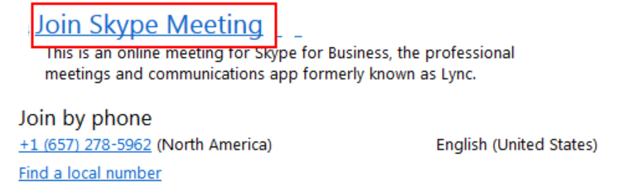

How to Join the Skype for Business session if Skype for Business is NOT Installed (Laptop/Desktop)
If you do not have Skype for Business installed on your computer, follow these steps:
1. Open the meeting invitation
2. Click the link to join the Skype for Business session
3. Sign in as a Guest: Enter a Guest name and click Join the meeting.
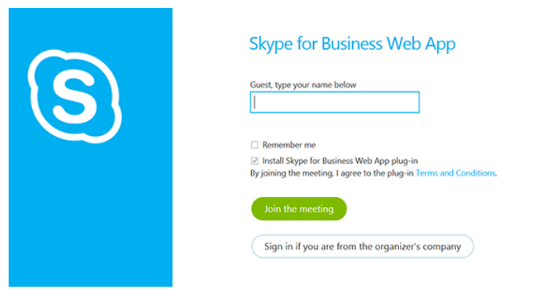
4. You will be prompted to download the Skype for Business Web App
5. Follow your browser’s instructions for downloading and installing the Skype for Business Web App plug-in.
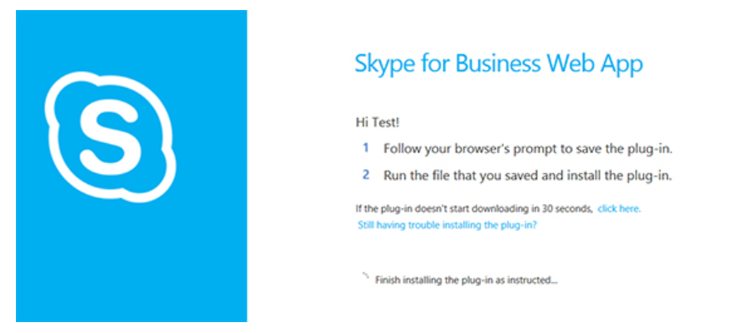

6. If you are unable to install using the Skype for Business Web App, download and install Skype for Business here.
a. Select your language.
b. Click the download button and save the lyncentry.msi program file to your hard disk.
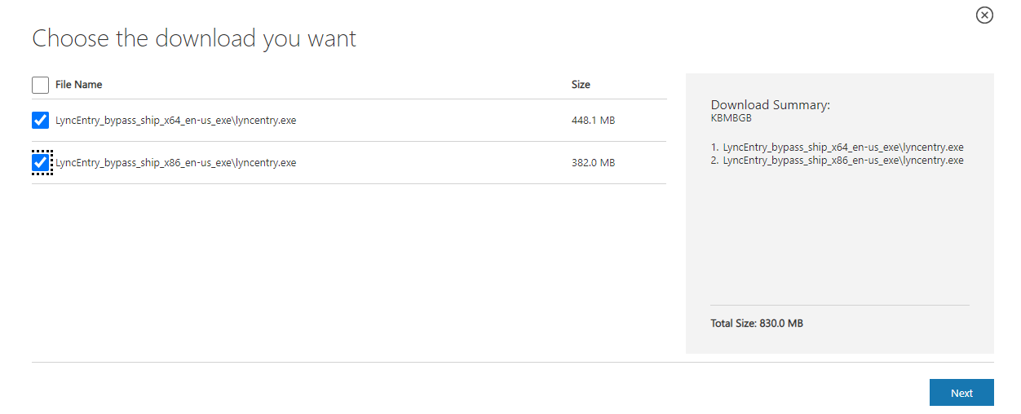
c. Find the lyncentry application in your Downloads folder.
d. Double-click the program file on your hard disk to begin installation.
e. When asked whether to allow the app to make changes to your device, click YES.
f. Follow the instructions on the screen to complete this installation.
7. Note: Once you join the Skype for Business meeting, you may be placed in a “waiting room” until the interviewer admits you to the meeting. This is to keep the meeting room secure and ensure only those who are invited to the meeting can join.

Consent Forms (Online form; participants will sign electronically prior to the interview, then additionally give verbal consent at the beginning of the interview)

Principal Form
National Teacher and Principal Survey Principal Follow Up Survey Consent Form to Participate in Research

Purpose. The National Teacher and Principal Survey (NTPS) Principal Follow Up Survey (PFS) is conducted by the National Center for Education Statistics (NCES), part of the U.S. Department of Education. The U.S. Census Bureau is under contract with NCES to develop messaging materials and the questionnaire. The purpose of this study is to evaluate the communications and procedures relating to the follow up questionnaire for the NTPS, in addition to the questionnaire itself.
Procedures. If you agree to participate, the U.S. Census Bureau will ask you to complete select questionnaire items from the NTPS PFS status survey, the NTPS Survey, and send several text messages to your phone. The U.S. Census Bureau will also ask you a series of debriefing questions that will help us revise the questionnaire. The interview should take about 90 minutes.

Confidentiality. Your participation is voluntary and all of the information you provide may be used only for statistical purposes and may not be disclosed, or used, in identifiable form for any other purpose except as required by law (20 U.S.C. §9573 and 6 U.S.C. §151). Your name will not be attached to the answers you provide.

Possible Risks and Discomforts. We do not anticipate any risks or discomforts for respondents. However, should you feel uncomfortable with any question asked you may skip the question or stop the interview at any time.

Voluntary Participation. Your participation is completely voluntary. Deciding to not participate will not be held against you. If you agree to participate, we will mail you $75 cash once the session is over.
With your permission, we would like to record this interview. The interview will be audio recorded and computer screen recorded for the survey portion to make sure we don’t miss anything that you say and to help us write a report summarizing the results of the interviews. Direct quotes may be used in reports or in research presentations, but your name will never be used in any reports or presentations. If you do not wish to be recorded you may still participate in the interview and will still receive $75 once the session is over.
I have read and understand the statements above. I consent to participate in this study.
Signature: _____________ Date:

The information that you provide in the spaces below will be used to release any incentive payments (cash or non-cash) to you. Census Bureau personnel will mail your incentive via USPS Priority Mail no later than five business days after completion of your interview. You will receive your incentive in about two weeks of completion of your interview, depending on mail service.

In the box below, please enter your name and the address where you want your incentive to be sent.

Finally please sign below and enter today's date.

Teacher Form
National Teacher and Principal Survey Teacher Follow Up Survey Consent Form to Participate in Research

Purpose. The National Teacher and Principal Survey (NTPS) Teacher Follow Up Survey (TFS) is conducted by the National Center for Education Statistics (NCES), part of the U.S. Department of Education. The U.S. Census Bureau is under contract with NCES to develop messaging materials and the questionnaire. The purpose of this study is to evaluate the communications and procedures relating to the follow up questionnaire for the NTPS, in addition to the questionnaire itself.

Procedures. If you agree to participate, the U.S. Census Bureau will ask you to complete select questionnaire items from the NTPS TFS survey, the NTPS Survey, and send several text messages to your phone. The U.S. Census Bureau will also ask you a series of debriefing questions that will help us revise the questionnaire. The interview should take about 90 minutes.

Confidentiality. Your participation is voluntary and all of the information you provide may be used only for statistical purposes and may not be disclosed, or used, in identifiable form for any other purpose except as required by law (20 U.S.C. §9573 and 6 U.S.C. §151). Your name will not be attached to the answers you provide.

Possible Risks and Discomforts. We do not anticipate any risks or discomforts for respondents. However, should you feel uncomfortable with any question asked you may skip the question or stop the interview at any time.
Voluntary Participation. Your participation is completely voluntary. Deciding to not participate will not be held against you. If you agree to participate, we will mail you $40 cash once the session is over.

With your permission, we would like to record this interview. The interview will be audio recorded and screen recorded to make sure we don’t miss anything that you say and to help us write a report summarizing the results of the interviews. Direct quotes may be used in reports or in research presentations, but your name will never be used in any reports or presentations. If you do not wish to be recorded you may still participate in the interview and will still receive $40 cash once the session is over.
I have read and understand the statements above. I consent to participate in this study.

Signature: _____________ Date:

The information that you provide in the spaces below will be used to release any incentive payments (cash or non-cash) to you. Census Bureau personnel will mail your incentive via USPS Priority Mail no later than five business days after completion of your interview. You will receive your incentive in about two weeks of completion of your interview, depending on mail service.

In the box below, please enter your name and the address where you want your incentive to be sent.

Finally please sign below and enter today's date.

Payment Procedure
We plan to pay in cash as follows:
At the end of the interview, the test administrator sends the money ($40/$75) using USPS Priority mail with tracking.

