National Center for Education Statistics

Attachment I: Communication Materials, Screener, and Consent Forms

2022 School Crime Supplement to
the National Crime Victimization Survey (SCS:22/ NCVS)
Cognitive Interviews

OMB# 1850-0803 v.282

November 2020

SCS:22/NCVS Cognitive Interview Recruitment Advertisements

Recruitment advertisement text for students.
Students Needed for Testing a National Survey
- The Census Bureau is looking for students ages 12-18 to help test question wording on a national survey about school-related topics. Interviews will be one hour and will take place by computer and phone. Students under age 18 must have a parent’s permission to participate. We will provide $25 to each student who participates in the study, plus $25 to the parent or guardian who assists their child with setting up the interview (federal employees are not eligible to receive the $25).
We need students ages 12-18 who meet any of the following criteria:
- Enrolled in a public or private middle or high school
- Attended school in person this school year
- Attended school virtually this school year
- Homeschooled in grades equivalent to 6-12 instead of attending a public or private school
- Had an experience in school they consider to be bullying this school year
To see if your child is eligible for the study, please complete a short questionnaire at
www.XXXXXXXX.com, or contact Kevin at (301) 763-4979 or csm.participate@census.gov for further information. Please mention the code SCHOOL when you call or email.

SCS:22/NCVS Cognitive Interview Recruitment Protocol and Eligibility Screener

RECRUITER-ADMINISTERED SCREENING QUESTIONNAIRE FOR SCHOOL CRIME SUPPLEMENT
[Note to interviewer: If a student under 18 calls to answer the screener questions for themselves, tell them that we have to briefly talk with their parents to get permission to screen them. If the parent is a monolingual Spanish speaker, let them know that we have staff who can call and ask for permission in Spanish.]
Introduction: Hello, I'm _____________________ from the Census Bureau.
IF OUTBOUND CALL: I’m calling about [an email you sent/a voicemail you left] about testing a survey for students ages 12-18. Any student who participates will receive $25 to thank them for their time. The parent or guardian who helps their child set up the 60-minute interview will also receive $25.
IF INBOUND CALL: Thanks for calling us about the test of a survey for students.
I just need to get a little bit of background information to find out if your child is eligible to participate.
1. What is your name? ___________________________________________
2. (ASK IF YOU DON’T HAVE THIS INFORMATION) What is your daytime phone number? (___)_____-________
3. How many children between the ages of 12 and 18 live in your household? _______
IF NO CHILDREN 12-18 I'm sorry. Right now we are only testing the survey with students ages 12-18. Thank you for your time.
IF MORE THAN ONE CHILD: Let’s start with the oldest child first.
 | Child 1 | Child 2 | Child 3 | Child 4
4. How old is that child? (Verify child is 12 -18)
5. What is that child’s name?
6. Is _____ male or female?
7. What grade is _____ in?
8. Is _____ of Hispanic, Latino, or Spanish origin?
9. Please choose one or more races that _____considers him/herself to be.
White
Black or African American
Asian
American Indian or Alaska Native
Native Hawaiian or other Pacific Islander
10. Does _____ speak English fluently?
11. What city and state does _____ live in?
12. Is _____ enrolled in a public school, a private school, or is [he/she] homeschooled?
13. Has ___ attended school in person this school year?
14. Has___ attended school virtually this school year?
15a. Has _____ ever had an experience they consider to be bullying by students from school?
15b. [IF YES TO 155a] When did the most recent bullying incident occur? Your best guess is fine.
16. Do you think ____ would be interested in participating in the study if they are selected?
IF MORE THAN ONE CHILD: Now let’s talk about the [second/third/fourth] oldest child.
17. Do you have access to a laptop or desktop computer that the child could use for the interview if they are selected?
18. Do you have high speed internet access?
19. If necessary, would you be able to download a free software called Skype for Business to facilitate testing that you could remove immediately after the session?
20. What is the email address we should use to contact you, should your child qualify for a study? (write in) ____________
21. In order to make sure that we recruit students from a variety of backgrounds, my last question is about your household’s annual income. Is your household's annual income....
a. above $25,000?
1 [ ] Yes 2 [ ] No - skip to conclusion
b. Is it above $50,000?
1 [ ] Yes 2 [ ] No - skip to conclusion
c. Is it above $100,000?
1 [ ] Yes 2 [ ] No
Conclusion:
IF THEY HAVE AN EMAIL ADDRESS:
Thanks for taking some time to answer my questions today. Whether or not you are selected I am going to email you some more information about how we protect the privacy of your data and your rights. [SKIP TO WRAP UP TEXT FOR ALL BELOW]
IF THEY DO NOT HAVE AN EMAIL ADDRESS:
Thanks for taking some time to answer my questions today. If you qualify, someone will be back in touch with you soon to schedule an interview.
The U.S. Census Bureau is required by law to protect your information. We are conducting this voluntary survey on behalf of the National Center for Education Statistics under the Education Sciences Reform Act of 2002 (ESRA 2002, 20 U.S.C., § 9543). All of the information you provide may be used only for statistical purposes and may not be disclosed, or used, in identifiable form for any other purpose except as required by law (20 U.S.C. §9573 and 6 U.S.C. §151).
Your privacy is also protected by the Privacy Act, Title 5 U.S. Code. Routine uses of these data are limited to those identified in the Privacy Act System of Record Notice titled, “SORN COMMERCE/CENSUS-3, Demographic Survey Collection (Census Bureau Sampling Frame).”
WRAP-UP TEXT FOR ALL:
Over the next few weeks, we will be selecting the students to test the survey. If your child is selected, we will be calling you to set up a time for the interview. Do you have any questions for me? IF NO QUESTIONS: Thank you for your time!
[END SCREENING PHONE CALL]
SELF ADMINISTERED SCREENING QUESTIONNAIRE FOR SCHOOL CRIME SUPPLEMENT
Available at www.XXXXXXXX.com
The U.S. Census Bureau is conducting research to improve questions in a national survey about school related topics. The purpose of this research is to get feedback on how easy or difficult the survey questions are to answer. Selected participants will be asked for their thoughts and opinions about some survey questions. If your child is eligible, we will invite them to a 60-minute interview which will be conducted via a secure video conferencing app. Your child will receive $25 for participating in the interview, and you will receive $25 for helping them schedule the interview and set up the video conferencing app.
To determine if they are eligible for the interview, we must ask you a few screening questions about their background and experiences at school. Your participation in the eligibility screening is completely voluntary. You may stop at any time or skip questions that you do not want to answer.
The U.S. Census Bureau is required by law to protect your information. We are conducting this voluntary survey​ on behalf of the National Center for Education Statistics under the Education Sciences Reform Act of 2002 (ESRA 2002, 20 U.S.C., § 9543). All of the information you provide may be used only for statistical purposes and may not be disclosed, or used, in identifiable form for any other purpose except as required by law (20 U.S.C. §9573 and 6 U.S.C. §151).
Your privacy is also protected by the Privacy Act, Title 5 U.S. Code. Routine uses of these data are limited to those identified in the Privacy Act System of Record Notice titled, “SORN COMMERCE/CENSUS-3, Demographic Survey Collection (Census Bureau Sampling Frame) (name change from COMMERCE/CENSUS-3, Special Censuses, Surveys, and Other Studies pending publication in the Federal Register).”
We estimated that completing the screening questions will take 10 minutes on average. This information collection has been approved by the Office of Management and Budget (OMB). You can validate that this survey is a legitimate federally-approved information collection using the Office of Management and Budget's approval number 1850-0803, which expires June 30, 2022. We are required to tell you this number to conduct this survey. Send comments regarding this estimate or any other aspect of this survey, including suggestions for reducing the time it takes to complete this survey to adrm.pra@census.gov.
If you have questions, please contact Jessica Holzberg, U.S. Census Bureau, Center for Behavioral Science Methods, 301-763-2298. If you would like to contact NCES directly, please contact Rachel Hansen at 202-245-7082.
If you are eligible for the study, we will call or email you to schedule a time for the interview.

1. What is your name? ___________________________________________
2. What is your daytime phone number? (___)_____-________
3. How many children between the ages of 12 and 18 live in your household? _______
IF NO CHILDREN 12-18, SKIP OUT OF QUESTIONNAIRE: Thank you for taking the time to answer our questions today. We will get back to you soon if you are eligible for an interview.
IF MORE THAN ONE CHILD: Please start with the oldest child first.
4. How old is that child? (Only allow responses between 12 -18): ____
5. What is that child’s name? ___________
6. Is _____ male or female? Male / Female
7. What grade is _____ in? 5th/6th/7th/8th/9th/10th/11th/12th/Other
Other Specify _______
8. Is _____ of Hispanic, Latino, or Spanish origin? Yes/No
9. Please choose one or more races that _____considers him/herself to be. Mark all that apply.
White
Black or African American
Asian
American Indian or Alaska Native
Native Hawaiian or other Pacific Islander
10. Does _____ speak English fluently? Yes / No
11. What city and state does _____ live in? __________
12. Is _____ enrolled in a public school, a private school, or is [he/she] homeschooled?
Public school / Private school/ Homeschooled
13. Has ___ attended school in person this school year? Yes / No
14. Has___ attended school virtually this school year? Yes / No
15a. Has _____ ever had an experience they consider to be bullying by students from school? Yes / No
15b. [IF YES TO 155a] When did the most recent bullying incident occur? Your best guess is fine. ___________
16. Do you think ____ would be interested in participating in the study if they are selected?
Yes / No
IF MORE THAN ONE CHILD: Please answer the questions about the [second/third/fourth] oldest child. [PAGE WILL REPEAT 4-16 FOR AS MANY CHILDREN AS WERE INDICATED IN Q3]
17. Do you have access to a laptop or desktop computer that the child could use for the interview if they are selected? Yes / No
18. Do you have high speed internet access? Yes / No
19. If necessary, would you be able to download a free software called Skype for Business to facilitate testing that you could remove immediately after the session? Yes / No
20. What is the email address we should use to contact you, should your child qualify for a study? _____________
21. In order to make sure that we recruit students from a variety of backgrounds, my last question is about your household’s annual income. Is your household's annual income....
a. above $25,000?
1 [ ] Yes 2 [ ] No - skip to conclusion
b. Is it above $50,000?
1 [ ] Yes 2 [ ] No - skip to conclusion
c. Is it above $100,000?
1 [ ] Yes 2 [ ] No

Thank you for taking the time to answer our questions today. We will get back to you soon if you are eligible for an interview.
[END OF SELF-ADMINISTERED SCREENER]
If they are selected for interview they will receive a follow-up phone call. This will be read to them when scheduling:
The session will be conducted using an application called Skype for Business. Your child will use your computer at home and the researcher will conduct the interview using the Skype for Business video conferencing software. A researcher will send you an email with a link to download Skype for Business, a form explaining your child’s rights as a participant, and a place for you to indicate the address you would like to receive the payment at. Then they will set up a time to test the software with you before the session if you would like. Is this okay?

SCHOOL CRIME SUPPLEMENT FREQUENTLY ASKED QUESTIONS (if requested)
What is this study about?
For this particular study, we will ask participants to answer a series of questions related to their experiences at school. We will discuss how they arrived at their answers and how they interpreted the questions.
What will you do with the data?
The data will be used to improve the questionnaire. Your child’s participation is voluntary and all of the information he/she provides may be used only for statistical purposes and may not be disclosed, or used, in identifiable form for any other purpose except as required by law (20 U.S.C. §9573 and 6 U.S.C. §151). Direct quotes may be used in reports or in research presentations, but their name will never be used in any reports or presentations. Your child’s participation and interest is very important to this study.
What is the School Crime Supplement?
The School Crime Supplement to the National Crime Victimization Survey (SCS/NCVS) collects information about school-related victimizations on a national level. This information will assist policymakers as well as academic researchers and practitioners at the federal, state, and local levels in making informed decisions concerning crime in schools.

Who is the National Center for Education Statistics?
The National Center for Education Statistics (NCES), http://nces.ed.gov/, is the primary federal statistical entity for collecting and analyzing data on topics related to education in the United States and as compared to other nations. NCES is part of the Institute of Education Sciences, within the U.S. Department of Education. The education statistics that NCES produces are used by Congress, federal and state agencies, educational organizations, researchers, the general public, and others.
Does my child have to participate?
Participation is voluntary. You may choose whether or not you want your child to be in this study. If you decide to allow him/her to participate in the study, your child may refuse to answer any question he/she does not want to answer or stop participating at any time.
Will my child receive anything for participation?
Each student participant will receive $25 after completing the interview. The parent or guardian who brings his/her participating student to and from the interview site will also receive $25.
How long will the study take?
The interview will take about one hour.
Why should my child participate?
We are testing new questions that will be added to the next administration of the survey. Your child’s input on how the new questions are working will help improve the study and the data we collect. By participating in this study, your child can help make sure that the SCS collects the most complete and accurate data possible.
How is my child’s privacy protected?
Your child’s participation is voluntary and all of the information he/she provides may be used only for statistical purposes and may not be disclosed, or used, in identifiable form for any other purpose except as required by law (20 U.S.C. §9573 and 6 U.S.C. §151). Your child’s name will not be attached to the answers they provide.
What information will be shared with NCES?
Your child’s name will not be associated with any of the responses they give to the survey questions, and the Census Bureau will not provide the names of any participants to NCES. NCES will receive information about this study in a form that will not lead to the identification of any participants.

Privacy Protection Email
(All participants who call in for recruiting will be sent this email.)
Dear [PARENT/GUARDIAN NAME]:
Thanks for taking some time to answer my questions today. If your child qualifies, someone will be back in touch with you soon to schedule an interview for your child.
The U.S. Census Bureau is required by law to protect your information. We are conducting this voluntary survey​ on behalf of the National Center for Education Statistics under the Education Sciences Reform Act of 2002 (ESRA 2002, 20 U.S.C., § 9543). All of the information you provide may be used only for statistical purposes and may not be disclosed, or used, in identifiable form for any other purpose except as required by law (20 U.S.C. §9573 and 6 U.S.C. §151).
Your privacy is also protected by the Privacy Act, Title 5 U.S. Code. Routine uses of these data are limited to those identified in the Privacy Act System of Record Notice titled, “SORN COMMERCE/CENSUS-3, Demographic Survey Collection (Census Bureau Sampling Frame) (name change from COMMERCE/CENSUS-3, Special Censuses, Surveys, and Other Studies pending publication in the Federal Register).”
We estimated that completing the screening questions will take 10 minutes on average. If students participate in the interview, that will take about an hour on average. This information collection has been approved by the (OMB). You can validate that this survey is a legitimate federally-approved information collection using the Office of Management and Budget's approval number 1850-0803, which expires June 30, 2022. We are required to tell you this number to conduct this survey. Send comments regarding this estimate or any other aspect of this survey, including suggestions for reducing the time it takes to complete this survey to adrm.pra@census.gov.
Thank you for your time and your assistance,
[NAME]

Consent Email (after scheduling interview)
Greetings [PARENT/GUARDIAN’S NAME],
We are looking forward to working with [CHILD’S NAME] on [DATE, TIME] for the upcoming school study. The day before the interview, we will send you a link for the Skype meeting you will join.
Below you will find a link to a webpage where you can give your signature to consent to participate in this research. We are also including instructions to download Skype for Business; please do so before our scheduled time. Please sign the consent form and download the software before the time of your interview.
[CONSENT FORM LINK]
[If parent/guardian wants more information add: Per your request I have also included more information about the School Crime Supplement to the National Crime Victimization Survey.]
[SKYPE FOR BUSINESS MEETING LINK]
If you have any questions or need assistance installing Skype for Business, please contact me.
[EMAIL] or [PHONE NUMBER]
Thank you,
[NAME]
[SKYPE FOR BUSINESS ATTACHMENT]
[FAQ IF REQUESTED]

Reminder email (sent one business day before interview)
Greetings [PARENT/GUARDIAN’S NAME],
Thank you again for agreeing to allow [CHILD’S NAME] to participate in our school study on [DATE, TIME]. We are planning to join the meeting using Skype for Business. We hope you have had a chance to install the Skype for Business Software and sign the consent form. For your convenience we are attaching the consent form link and the software instructions again. We are also including the link for the Skype meeting you will join in this email.
If anything has come up and you need to reschedule please contact me. If you have any trouble installing the software, please let me know. I would be happy to find a time to assist you before the interview.
[EMAIL] or [PHONE NUMBER]
Thank you,
[NAME]
[CONSENT FORM LINK]
[SKYPE FOR BUSINESS MEETING LINK]
[SKYPE FOR BUSINESS ATTACHMENT]

Skype for Business Attachment
Skype for Business is the video conference platform that will be used to during the interview. Please note that Skype for Business differs from Skype. If you have Skype installed on your computer, you will still need to follow the below instructions for installing Skype for Business and joining a Skype for Business session.
Skype for Business provides the security needed to ensure your conversation with the interviewer remains private and confidential.

How to Join the Skype for Business session if Skype for Business is installed
If you already have Skype for Business installed on your computer, simply open the email and click the link to join the session. See link in red box in image below. If you have trouble connecting via the link, the interviewer will help you.

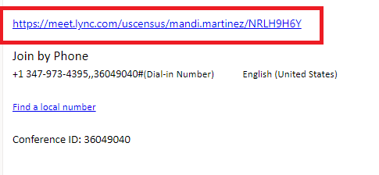

How to Join the Skype for Business session if Skype for Business is NOT Installed (Laptop/Desktop)
If you do not have Skype for Business installed on your computer, follow these steps:
1. Open the email
2. Click the link to join the Skype for Business session
3. Sign in as a Guest: Enter a Guest name and click Join the meeting.
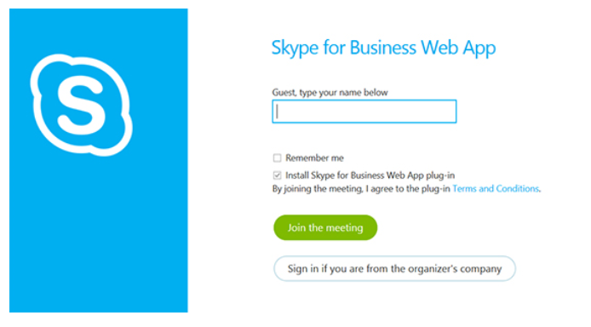
4. You will be prompted to download the Skype for Business Web App
5. Follow your browser’s instructions for downloading and installing the Skype for Business Web App plug-in.
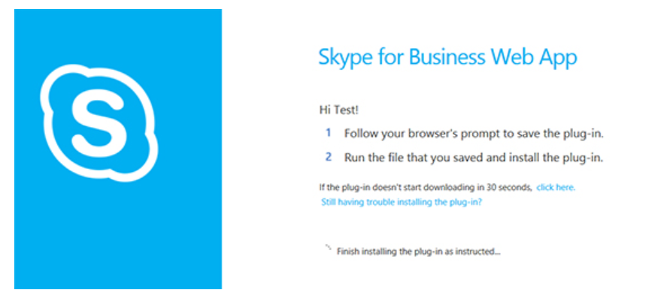

6. If you are unable to install using the Skype for Business Web App, download and install Skype for Business here.
a. Select your language
b. Click the download button and save the lyncentry.msi program file to your hard disk.
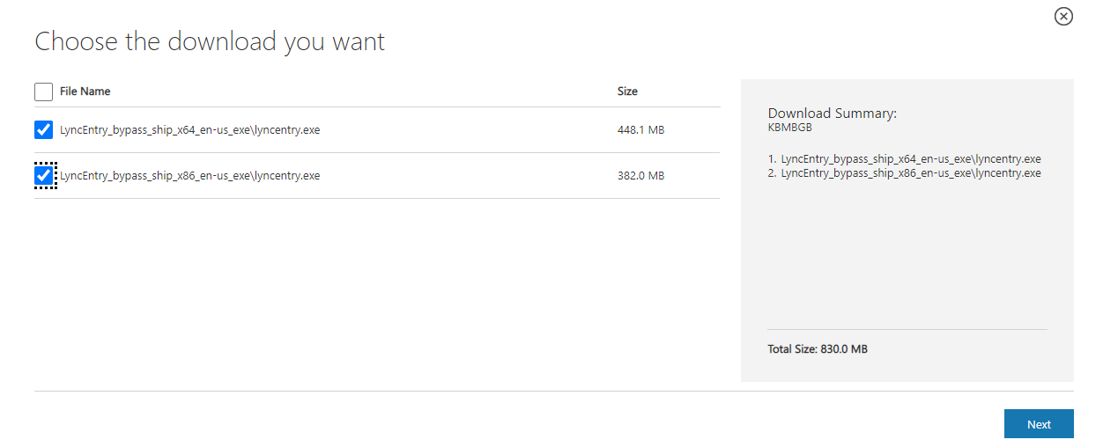
c. Find the lyncentry application in your Downloads folder.
d. Double-click the program file on your hard disk to begin installation.
e. When asked whether to allow the app to make changes to your device, click YES.
f. Follow the instructions on the screen to complete this installation.
7. Note: Once you join the Skype for Business meeting, you may be placed in a “waiting room” until the interviewer admits you to the meeting. This is to keep the meeting room secure and ensure only those who are invited to the meeting can join.

Consent Forms

School Crime Supplement to the National Crime Victimization Survey
Student Consent to Participate in Research
[for students 18-years-old]

Purpose. The School Crime Supplement to the National Crime Victimization Survey (SCS/NCVS) is conducted by the National Center for Education Statistics (NCES) of the U.S. Department of Education. NCES is authorized to conduct this study by the Education Sciences Reform Act of 2002 (ESRA 2002, U.S.C. 20 §9543). The U.S. Census Bureau is under contract with NCES to develop the questionnaires. The purpose of this study is to evaluate the SCS/NCVS questionnaire items.

Procedures. If you agree to participate, the U.S. Census Bureau will ask you to complete select questionnaire items from the SCS/NCVS. The U.S. Census Bureau also will ask a series of debriefing questions that will help us revise the current questionnaire. The interview should take about 60 minutes.

Confidentiality. Your participation is voluntary and all of the information you provide may be used only for statistical purposes and may not be disclosed, or used, in identifiable form for any other purpose except as required by law (20 U.S.C. §9573 and 6 U.S.C. §151). Your name will not be attached to the answers you provide.

Possible Risks and Discomforts. We do not anticipate any risks or discomforts for respondents. However, should you feel uncomfortable with any question asked you may skip the question or stop the interview at any time.

Voluntary Participation. Your participation is completely voluntary. A decision to not participate will not be held against you. If you agree to participate, you will receive $25 as a thank you for your time and input in the study.

Further Questions.
If you have questions, please contact Jessica Holzberg, U.S. Census Bureau, Center for Behavioral Science Methods, 301-763-2298. If you would like to contact NCES directly, please contact Rachel Hansen at 202-245-7082.

With your permission, we would like to record this interview. The interview will be audio recorded for the survey portion to make sure we don’t miss anything that you say and to help us write a report summarizing the results of the interviews. Direct quotes may be used in reports or in research presentations, but your name will never be used in any reports or presentations. If you do not wish to be recorded you may still participate in the interview and will still receive $25 once the session is over.

I have read and understand the statements above. I consent to participate in this study.

___________________________________ ___________________________
Participant's signature Date
___________________________________
Participant's printed name
________________________________
Researcher's signature
OMB Control Number: 1850-0803. Approval expires 06/30/2022.
School Crime Supplement to the National Crime Victimization Survey Parental Consent to Participate in Research [for students younger than 18-years-old]
Purpose. The School Crime Supplement to the National Crime Victimization Survey (SCS/NCVS) is conducted by the National Center for Education Statistics (NCES) of the U.S. Department of Education. NCES is authorized to conduct this study by the Education Sciences Reform Act of 2002 (ESRA 2002, U.S.C. 20 §9543). The U.S. Census Bureau is under contract with NCES to develop the questionnaires. The purpose of this study is to evaluate the SCS/NCVS questionnaire items.

Procedures. If you agree to allow your child to participate, the U.S. Census Bureau will ask your child to complete select questionnaire items from the SCS/NCVS. The U.S. Census Bureau also will ask a series of debriefing questions that will help us revise the current questionnaire. The interview should take about 60 minutes.

Confidentiality. Your child’s participation is voluntary and all of the information he/she provides may be used only for statistical purposes and may not be disclosed, or used, in identifiable form for any other purpose except as required by law (20 U.S.C. §9573 and 6 U.S.C. §151). Your child’s name will not be attached to the answers they provide.

Possible Risks and Discomforts. We do not anticipate any risks or discomforts for respondents. However, should your child feel uncomfortable with any question asked, your child may skip the question or stop the interview at any time.

Voluntary Participation. Your child’s participation is completely voluntary. A decision to not participate will not be held against your child. If you agree to allow your child to participate, your child will receive $25 as a thank you for their time and input in the study.

Further Questions.
If you have questions, please contact Jessica Holzberg, U.S. Census Bureau, Center for Behavioral Science Methods, 301-763-2298. If you would like to contact NCES directly, please contact Rachel Hansen at 202-245-7082.

With your permission, we would like to record this interview. The interview will be audio recorded for the survey portion to make sure we don’t miss anything that you say and to help us write a report summarizing the results of the interviews. Direct quotes may be used in reports or in research presentations, but your name will never be used in any reports or presentations. If you do not wish to allow your child to be recorded, your child may still participate in the interview and will still receive $25 for their participation.

By signing below, you agree that your child, _______________________________, may participate in this study.
Your signature below will indicate that your questions have been answered satisfactorily, and that you have read and understood the information provided above.

___________________________________ ___________________________
Parent’s signature Date
___________________________________
Parent’s printed name
________________________________
Researcher's signature
OMB Control Number: 1850-0803. Approval expires 06/30/2022.

