National Center for Education Statistics

*Attachment 1 – Recruitment, Consent Forms, and Receipt Acknowledgment Materials*

*2020-2021 National Teacher and Principal Survey (NTPS)*

*Screener and Respondent Portal Usability Testing*

OMB# 1850-0803 v.251

June 2019

**2020-21 NTPS Portal Usability Testing**

**Attachment 1**

**Recruitment, Consent Forms, and Receipt Acknowledgment Materials**

Table of Contents

Email text for personal and professional contacts 2

Shorter recruitment advertisement text for Craigslist 3

Census Bureau broadcast message: Participants Needed for a Research Study 3

Recruiting Flyer 4

Informed Consent 5

Incentive Receipt Acknowledgement Form 6

Mailing Materials to be used during Interviews 7

# Email text for personal and professional contacts

Dear [contact]:

The U.S. Census Bureau is assisting with a study conducted by the National Center for Education Statistics (NCES) of the U.S. Department of Education. In an effort to improve a web survey, we are specifically looking for school administrators or administrative support staff for elementary, middle, or high schools to participate in a one-time, voluntary web survey and provide feedback after completing it.

If you are eligible and participate in the study, you will **receive $75** as a thank you for your participation.

**What will I be doing in a usability study?**

You will be asked to complete two web surveys and do several short tasks using the web. You will also be asked questions about your experience with and perceptions of the web surveys.

**What types of information will I be asked to provide?**

As part of this study, you will be asked to verify or provide school contact information and basic information for each teacher at your school, including teacher names, email addresses, and subject matter(s) taught. Please be assured that both the National Center for Education Statistics (NCES) of the U.S. Department of Education and the U.S. Census Bureau follow strict procedures to protect the confidentiality of study participants. All of the information you provide may be used only for statistical purposes and may not be disclosed, or used, in identifiable form for any other purpose except as required by law (20 U.S.C. §9573 and 6 U.S.C. §151).

**How long is a session?**

The session will last approximately 90 minutes.

**When and where?**

The study will be held [DAYS, DATES]. Ideally, the session will take place at your school so you can access the necessary information.

**Interested in participating?**

Please reply to this email with your contact information or call me at [ADD PHONE]. I’ll ask you some questions to help us determine if you are eligible for the study.

If someone you know is interested in participating, please contact [contact info].

Thank you for your time and help with this important study.

Sincerely,

[Recruitment Contact Info]

# Short recruitment advertisement text for Craigslist

K-12 School Staff Needed for Testing a National School Survey- **Receive $75**  
  
The U.S. Census Bureau is looking for Administrative staff in K-12 schools to participate in an interview about their school. Specifically, we are seeking staff who can best provide information about the teachers at their school, including each teacher's name, email address, and subjects taught. Staff from public, charter, or private schools are welcome to participate. Administrative staff who participate in the in-person interview will complete a portion of the National Teacher and Principal Survey for the National Center for Education Statistics (NCES).  
  
Interviews are around 90 minutes and will take place in August 2019. We would like the interview to take place at the school. Participants will **receive $75**.  
  
Please email your contact information to [csm.participate@census.gov](mailto:csm.participate@census.gov) or call Kevin at (301) 763-4979 and mention **SCHOOL** to learn more.

# Census Bureau broadcast message: Participants Needed for a Study

***From the Desk of Paul Beatty, Chief, Center for Behavioral Science Methods...***

The U.S. Census Bureau is looking for Administrative staff in K-12 schools to participate in an interview about their school. Specifically, we are seeking staff who can best provide information about the teachers at their school, including each teacher's name, email address, and subjects taught. Staff from public, charter, or private schools are welcome to participate. Administrative staff who participate in the in-person interview will complete a portion of the National Teacher and Principal Survey for the National Center for Education Statistics (NCES).

Interviews are around 90 minutes and will take place in August 2019. We would like the interview to take place at the school. Participants will receive $75.

If you know anyone who meets these criteria, please let them know about this research opportunity. Please have them email their contact information to csm.participate@census.gov or call Kevin at (301) 763-4979 and mention SCHOOL to learn more.

# Recruiting Flyer

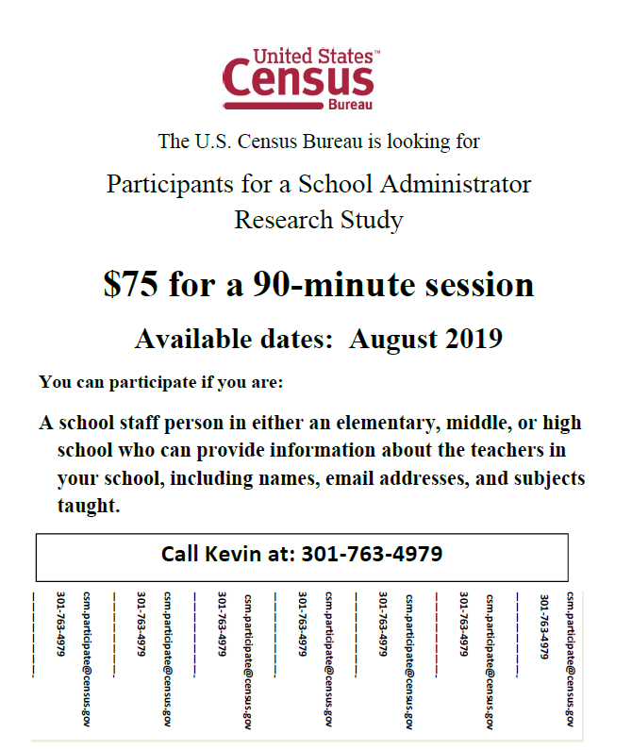

**You can participate if you are:**

**A school staff person in either an elementary, middle, or high school who can provide information about the teachers in your school, including names, email addresses, subjects taught and full or part-time status.**

**Call Kevin at: 301-763-4979**

**Kevin.J.Younes@census.gov**

**301-763-4979**

**————————-**

**Kevin.J.Younes@census.gov**

**301-763-4979**

**————————-**

**Kevin.J.Younes@census.gov**

**301-763-4979**

**————————-**

**Kevin.J.Younes@census.gov**

**301-763-4979**

**————————-**

**Kevin.J.Younes@census.gov**

**301-763-4979**

**————————-**

**Kevin.J.Younes@census.gov**

**301-763-4979**

**————————-**

**Kevin.J.Younes@census.gov**

**301-763-4979**

**­­————————-**

**Kevin.J. Younes@census.gov**

**301-763-4979**

**————————-**

**Kevin.J. Younes@census.gov**

**301-763-4979**

# Informed Consent

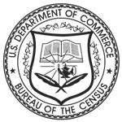

**Consent Form**

**For Individual Participants**

**Usability Testing of the 2020-2021 NTPS Screener and Portal**

Each year the Census Bureau conducts many different usability evaluations. For example, the Census Bureau routinely tests the wording, layout, and behavior of products, such as websites and online surveys and questionnaires in order to obtain the best information possible.

You have volunteered to take part in a study to improve the usability of the 2020-21 National Teacher and Principal Survey (NTPS) Screener and Portal. The Census Bureau is administering the NTPS Portal usability testing on behalf of the National Center of Education Statistics (NCES). NCES is authorized to conduct this study by the Education Sciences Reform Act of 2002 (ESRA 2002, 20 U.S.C. §9543).

In order to have a complete record of your comments, your usability session will be audio- and video-recorded. Only your device will be video-recorded. We plan to use the recordings to improve the design of the product. Only staff directly involved in the research project will have access to the recordings. Your participation is voluntary and all of the information you provide may be used only for statistical purposes and may not be disclosed, or used, in identifiable form for any other purpose except as required by law (20 U.S.C. §9573 and 6 U.S.C. §151). The OMB control number for this study is 1850-0803.

**I have volunteered to participate in this usability study, and I give permission for my recordings to be used for the purposes stated above.**

Participant’s Name: ______________________________________

Participant's Signature: ____________________________________ Date: ­­­­­__________

Researcher’s Name: _____________________________________

Researcher's Signature: ___________________________________ Date: __________

# Incentive Receipt Acknowledgement Form

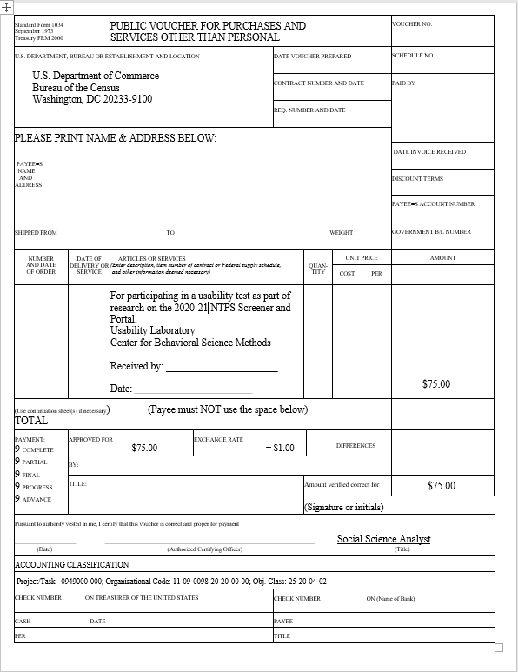

# Mailing Materials to be used during Interviews

Please see Attachment 3 for more detailed information about the use of these materials

Figure 1: Letter for screener portion of usability test (this is a new letter – 9L2)

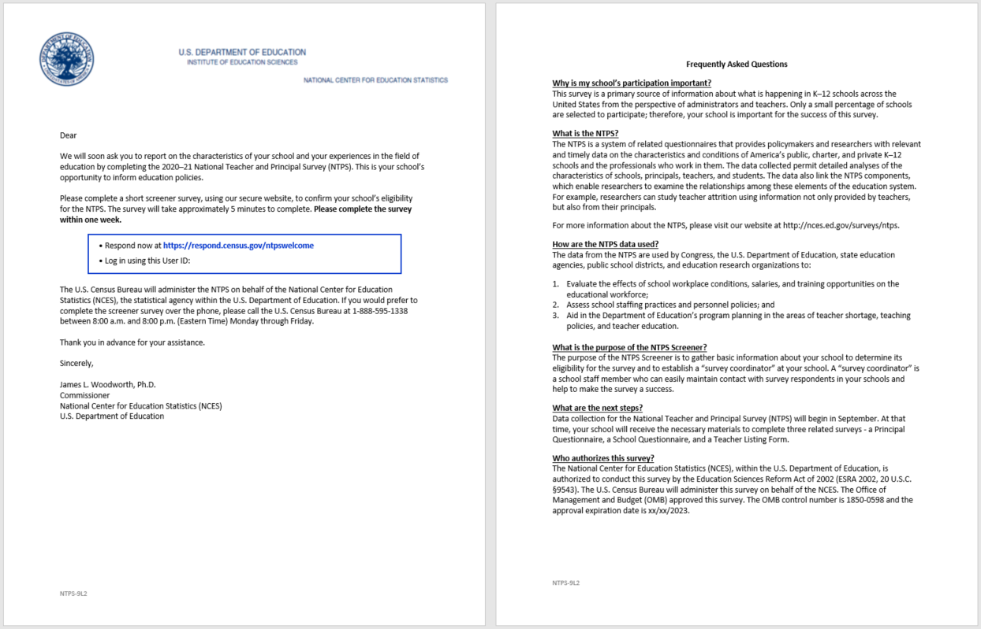

Figure 2: Coordinator letter in mail package for the TLF portion of the interview (this is a new letter – 11L2C)

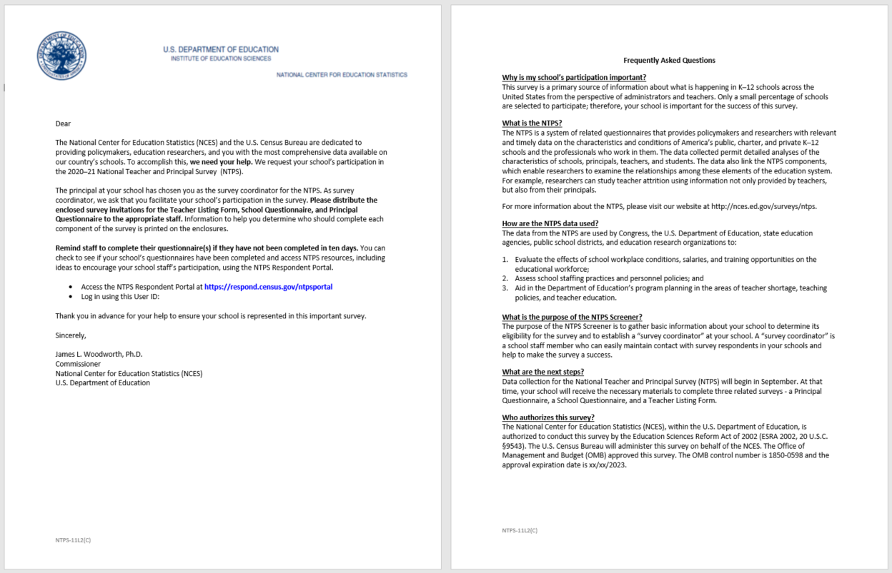

Figure 3: Letter for teacher listing portion of usability test for pre-populated TLFs 11L(TLF)1

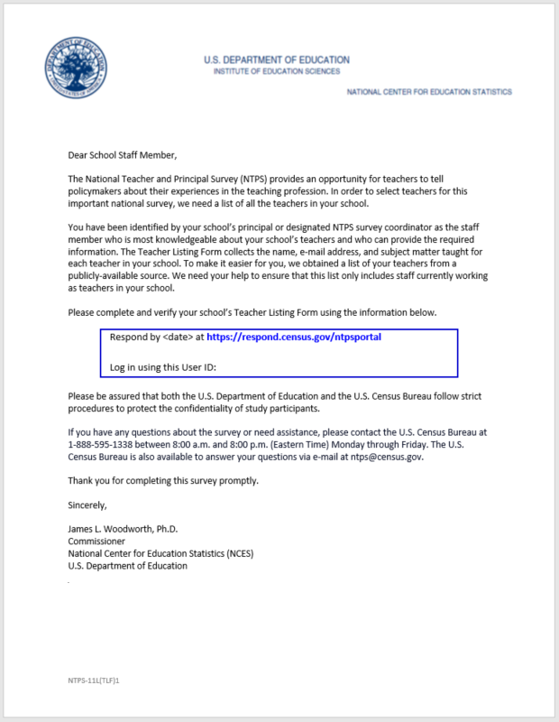

Figure 4: Letter for teacher listing portion of usability test when no pre-populated data is in the TLFs 11L(TLF)2

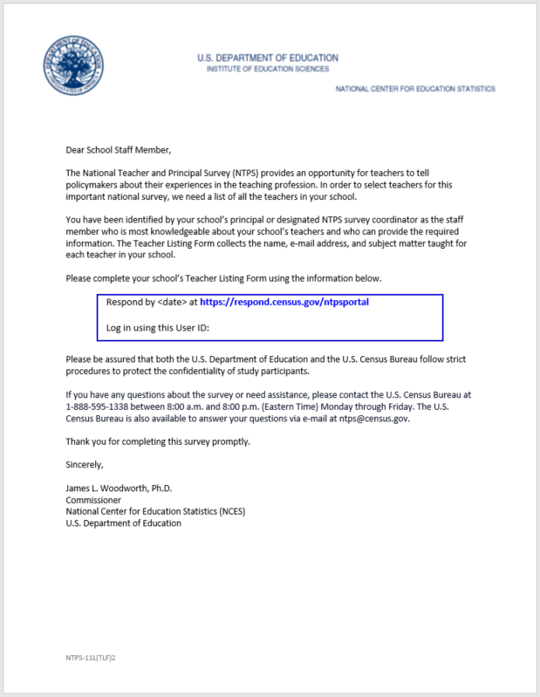

Figure 5: NTPS-11L(PQ) This letter is in the mail package. Participants do not need to complete this survey. Participants will tell us what they would do with this letter.

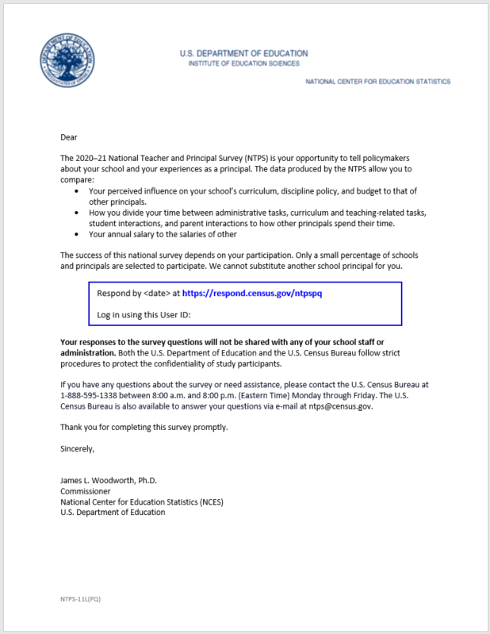

Figure 6: NTPS-11L(SQ) This letter is in the mail package. Participants do not need to complete this survey. Participants will tell us what they would do with this letter.

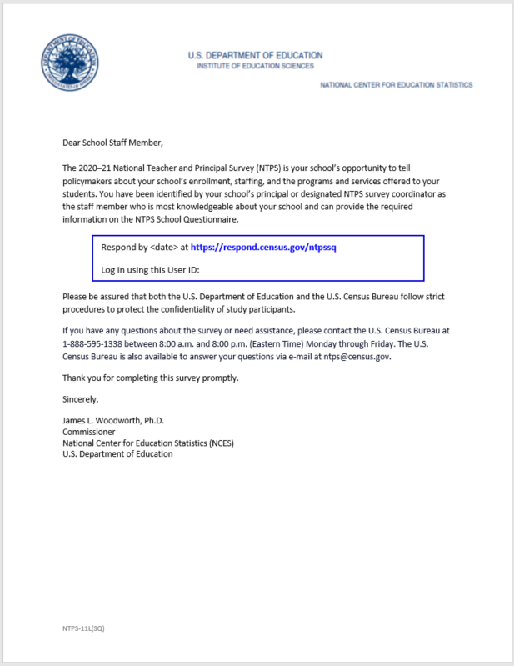

Figure 7: Debriefing: Review this original letter for the screener (9L1)

