National Center for Education Statistics

*Attachment 4 -Screener and Portal Instrument Screen Shots from the Specification*

*2020-2021 National Teacher and Principal Survey (NTPS)*

*Screener and Respondent Portal Usability Testing*

OMB# 1850-0803 v.251

June 2019

**2020-21 NTPS Screener and Portal Usability Testing**

**Attachment 4**

**Screener Screen Shots for Usability Testing –**

(example screens from specification)

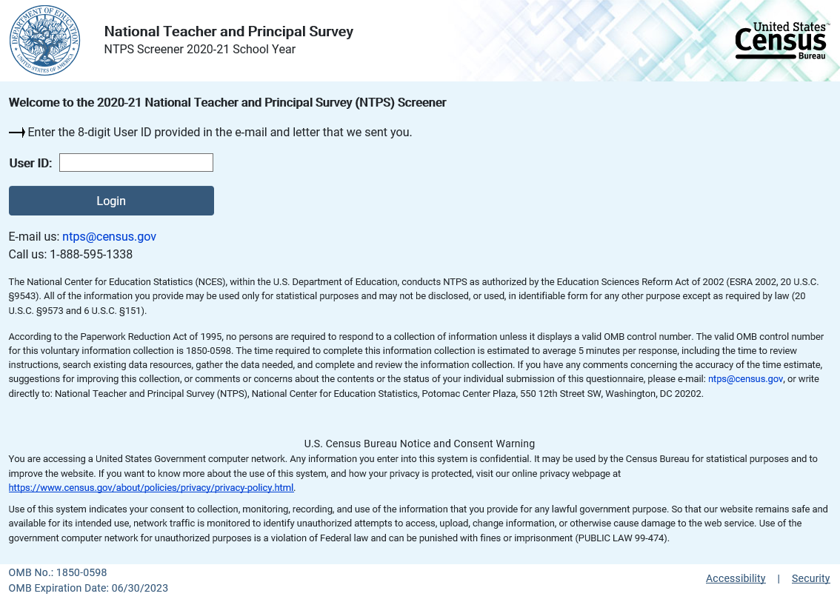

Recovery

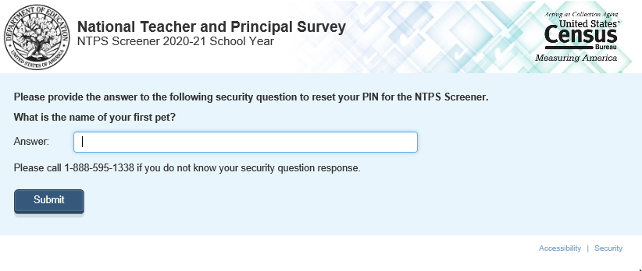

Recovery (with new PIN)

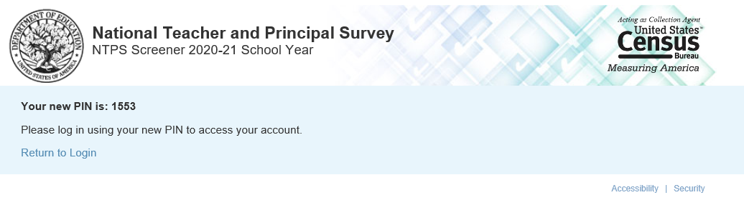

Assign_pin

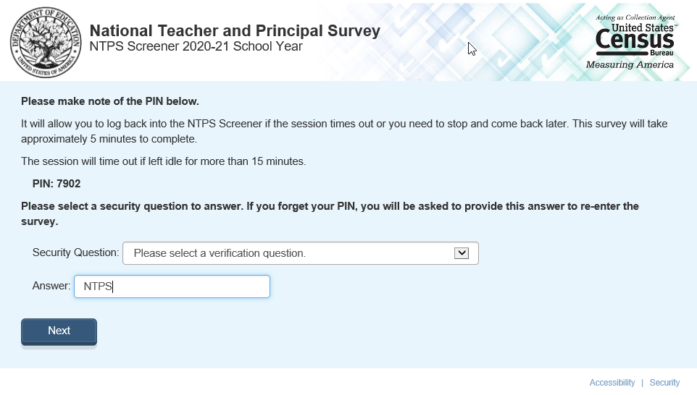

Assign_pin (after timing out on this page)

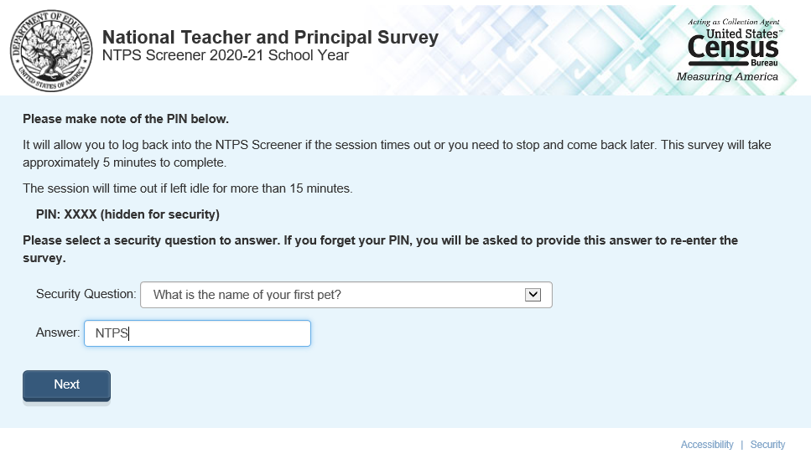

S_address

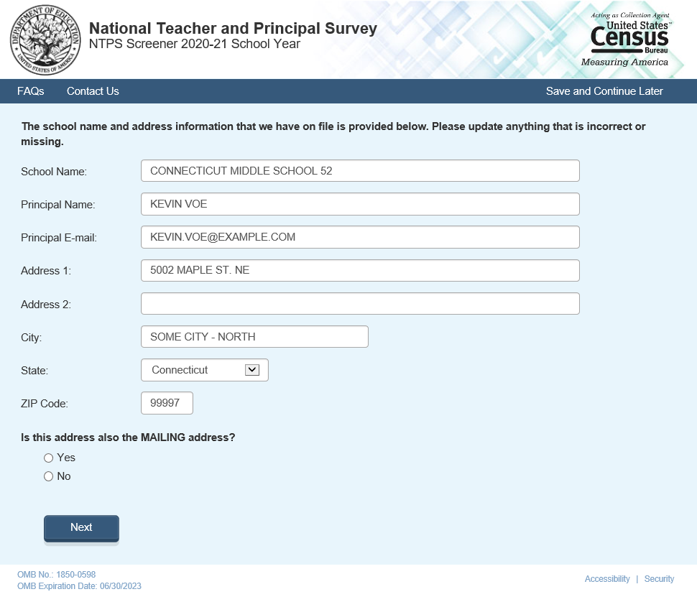

S_address (if sep_campus_flag = 1)

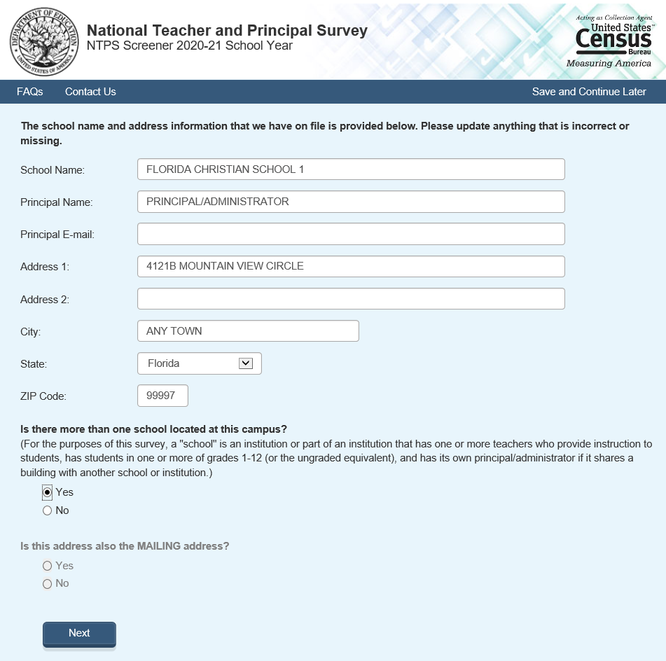

S_sepschinfo

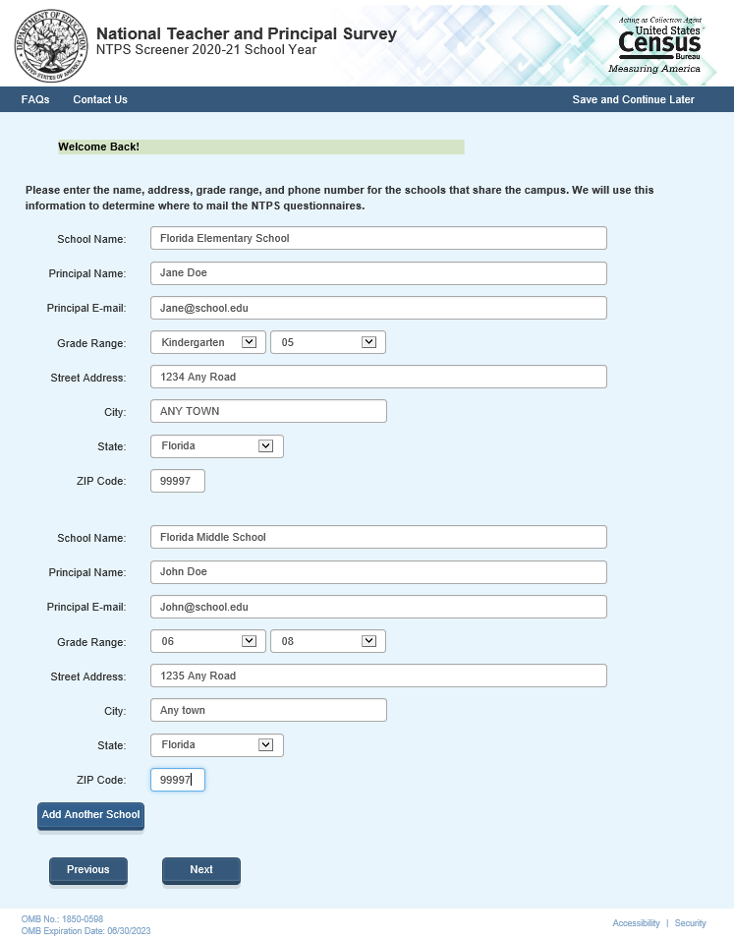

Septhankyou

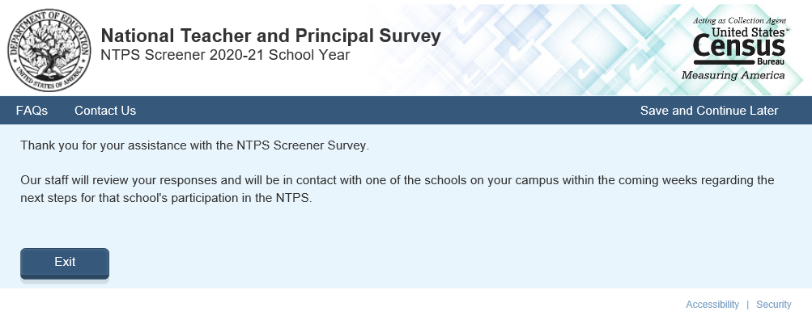

S_mailing

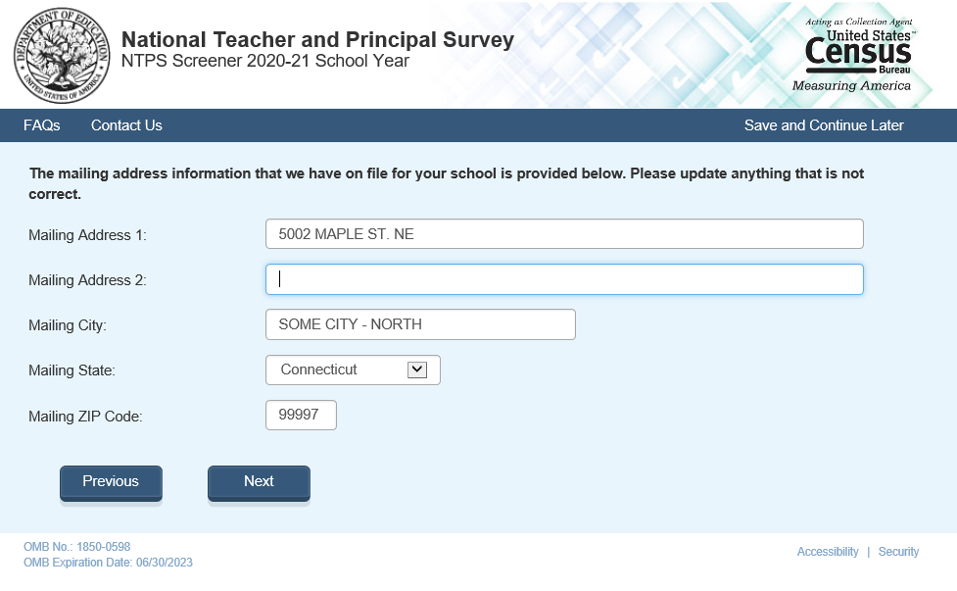

S_typeyn

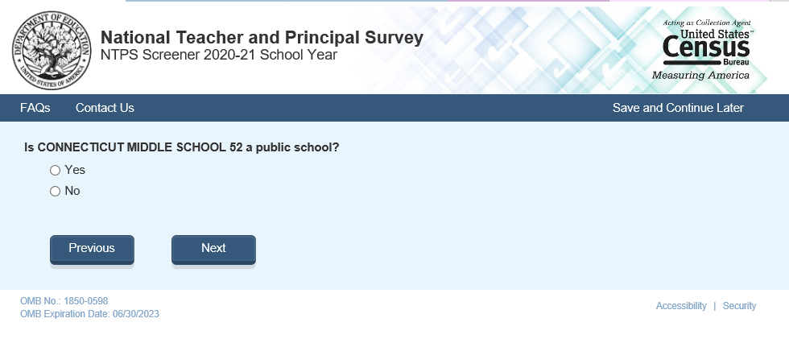

S_type

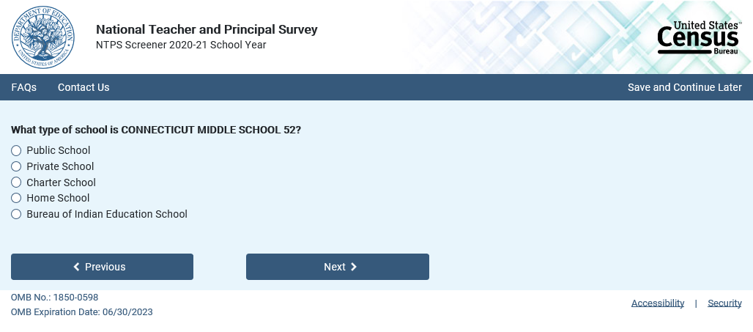

S_charter

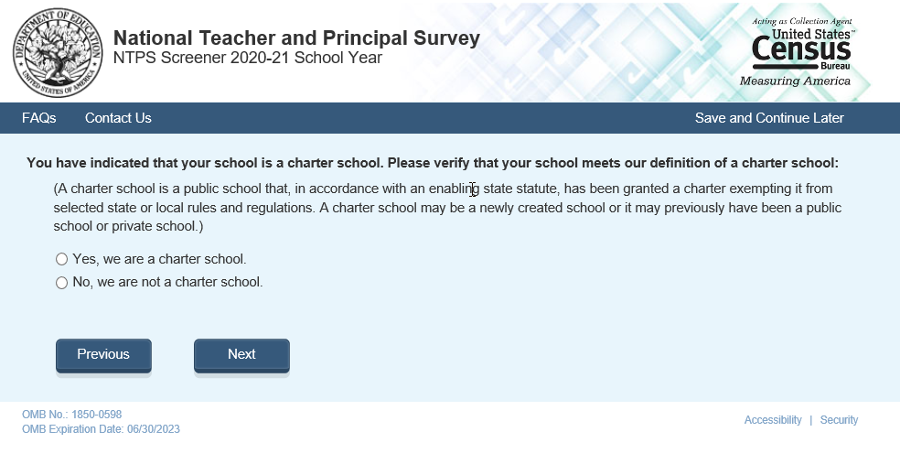

S_grades (without answer)

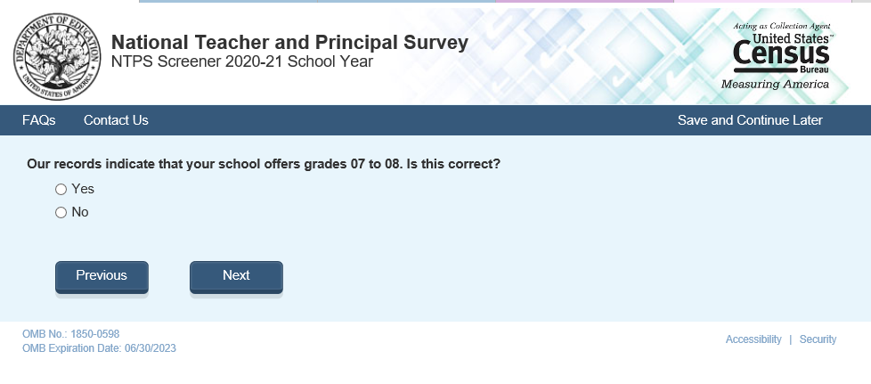

S_grades (with a “no” answer)

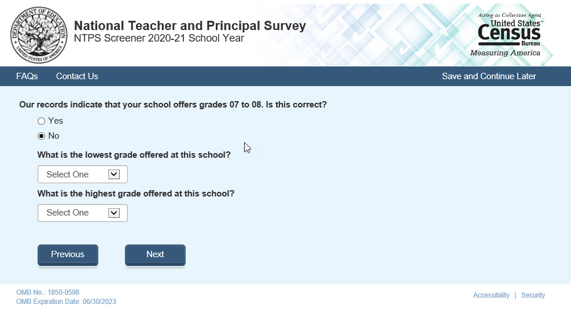

S_ungraded

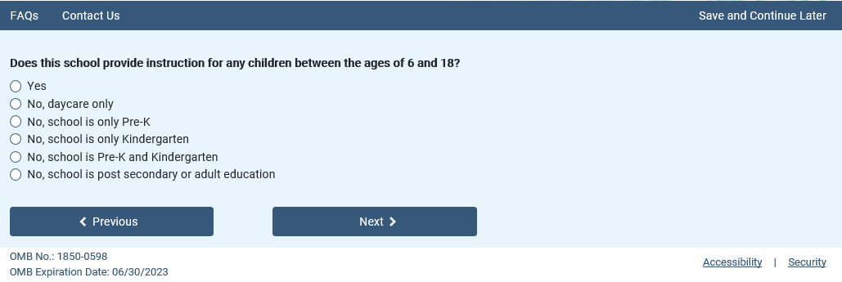

S_contact

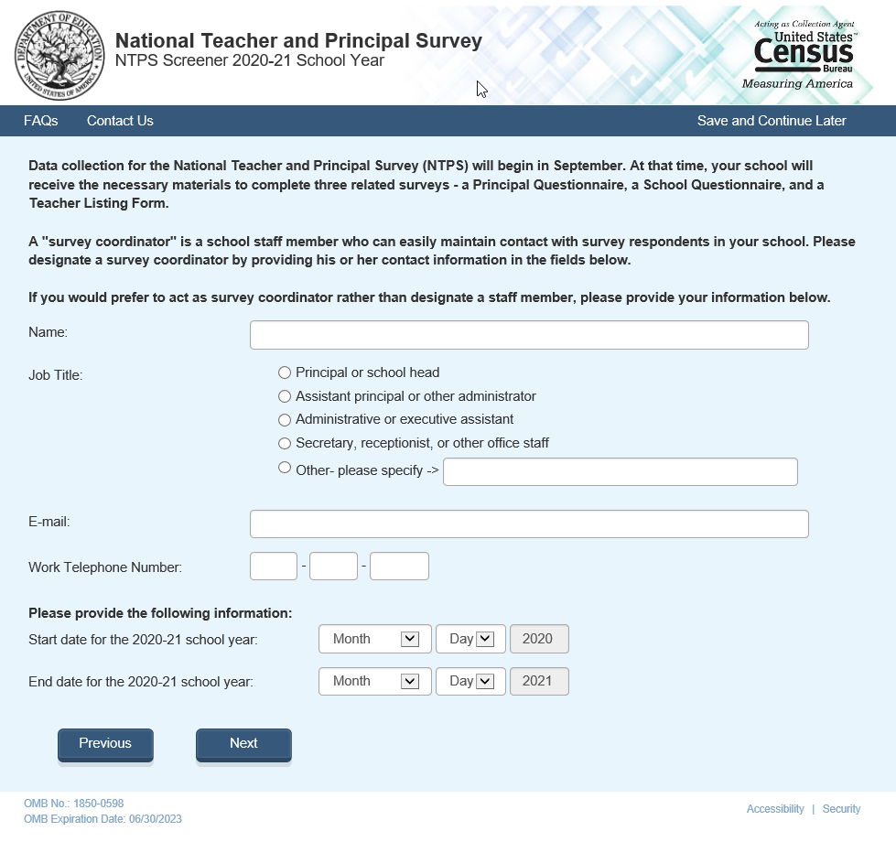

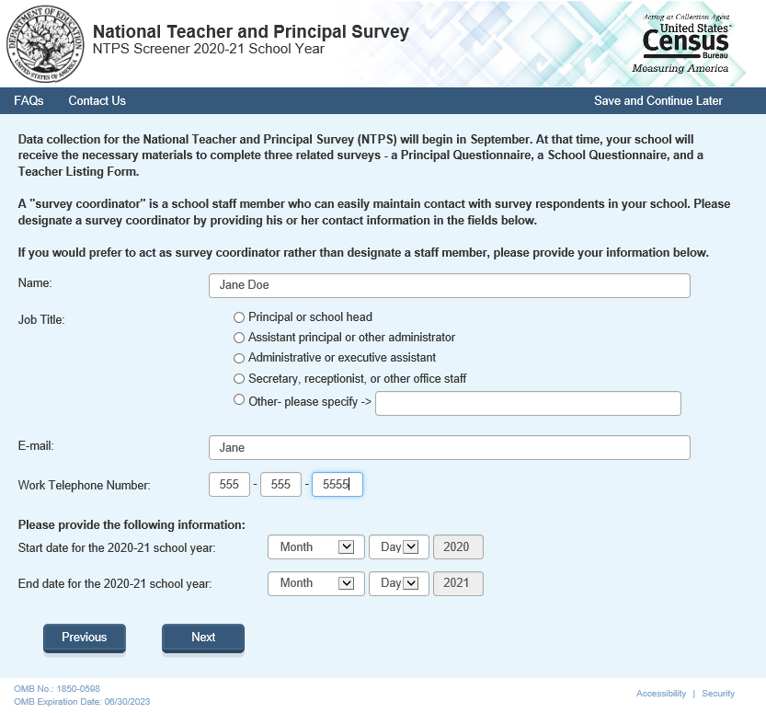

Error message

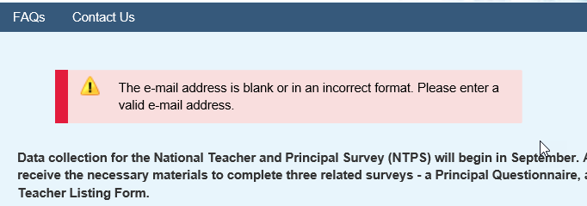

S_end

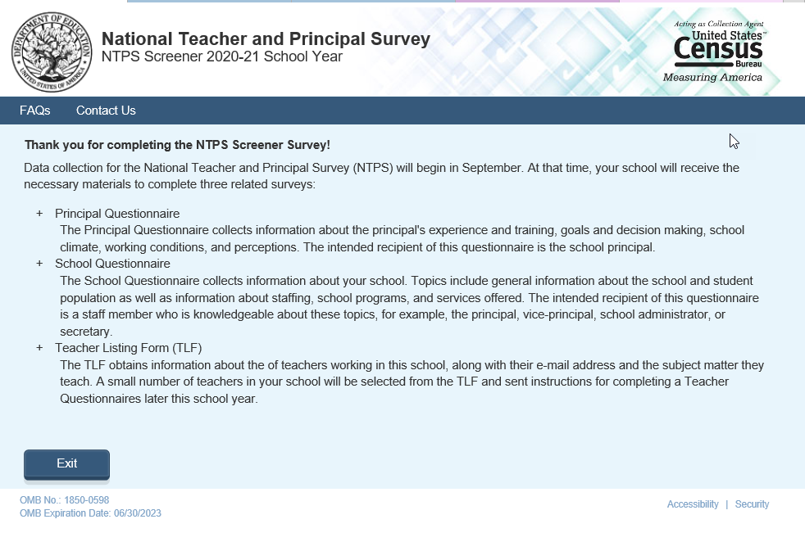

Contactus

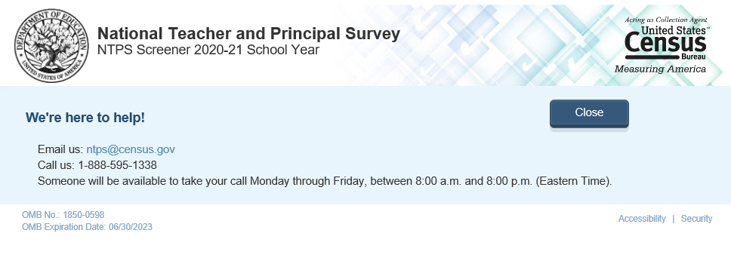

FAQs (1)

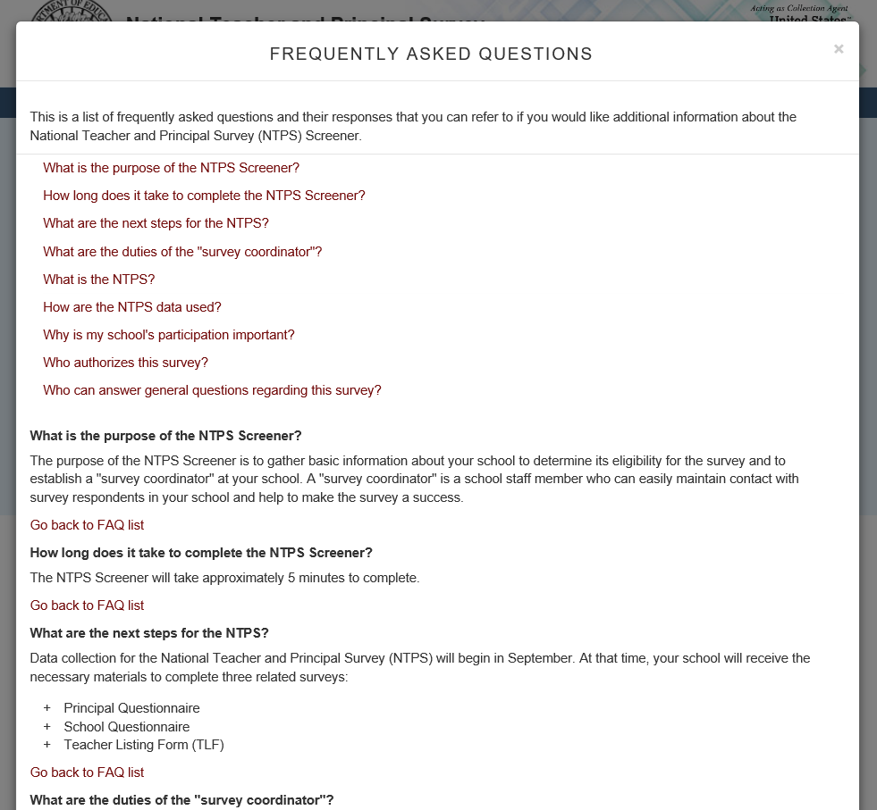

FAQs (2)

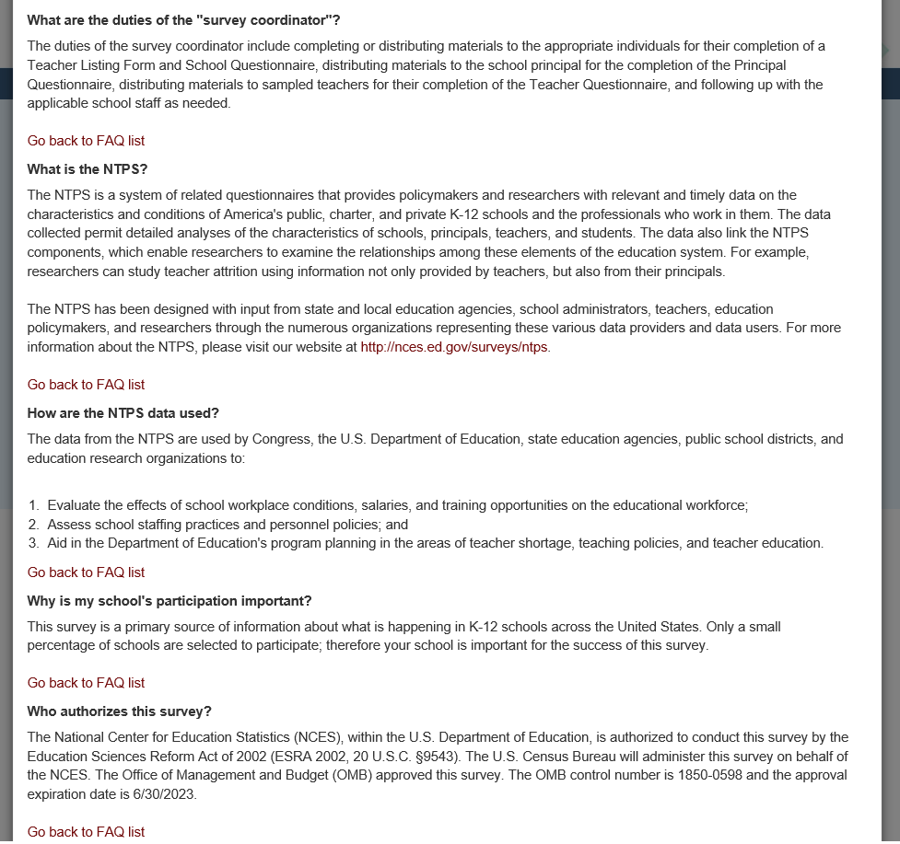

FAQs (3)

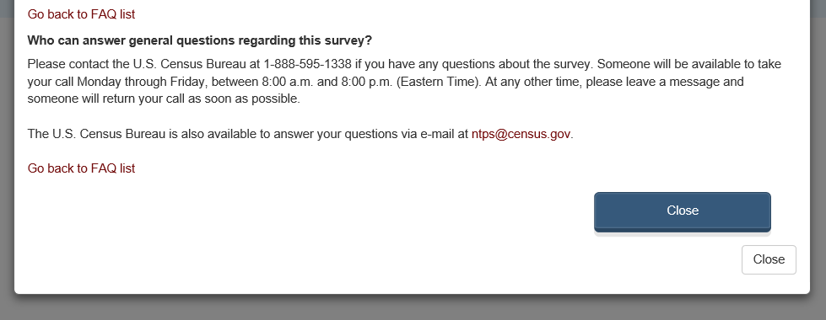

**Portal Screen Shots for Usability Testing**

(example screens from specification)

Item: Log In (login)

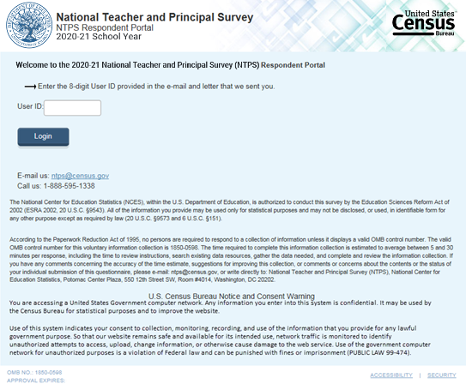

Item: PIN Page (pin)

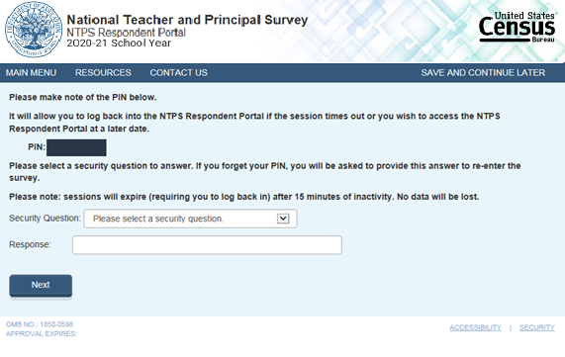

Item: NTPS Administrator Screen (main_menu_search)

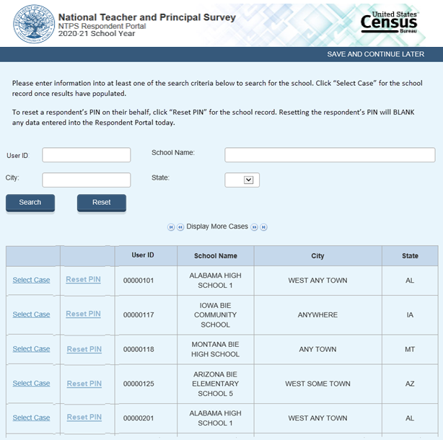

Item: NTPS Portal Main Menu (main_menu)

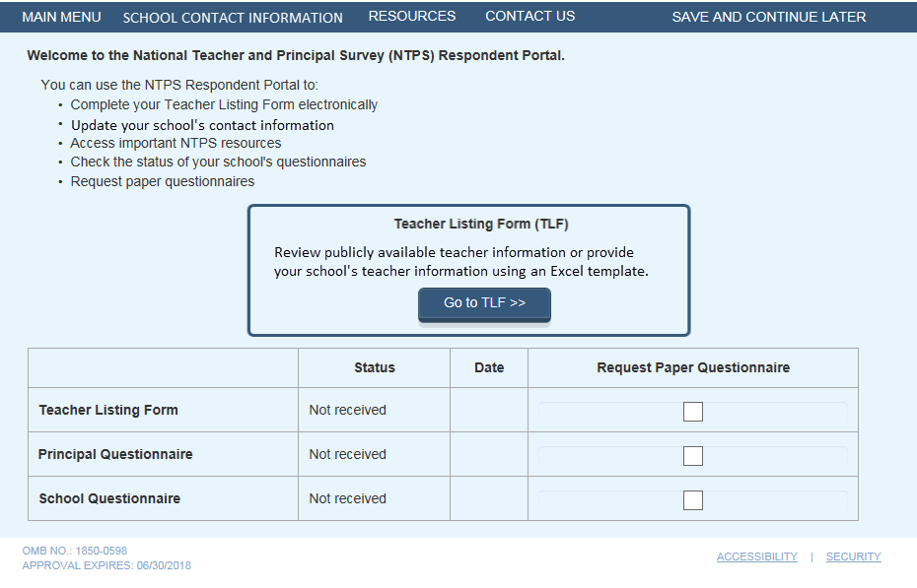

TLF compare

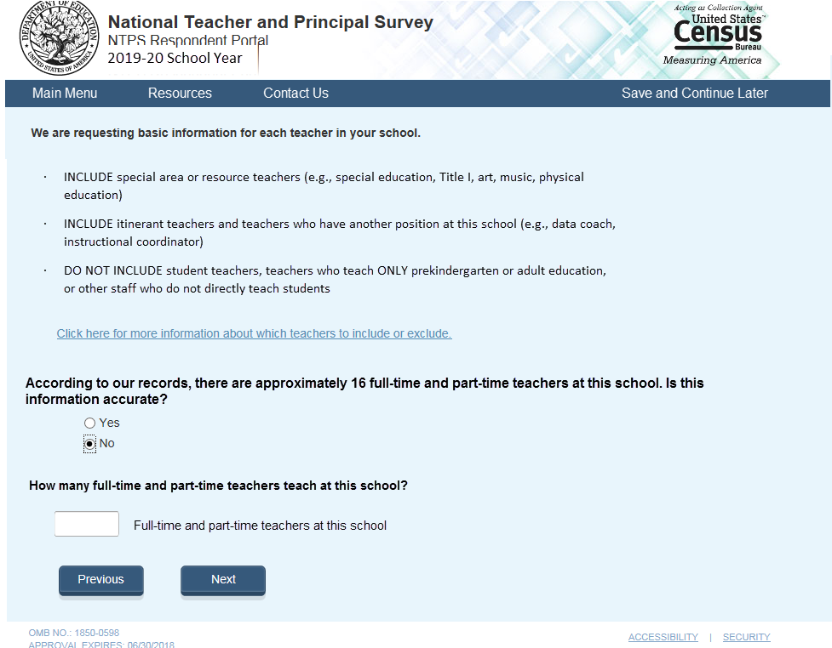

TLF start

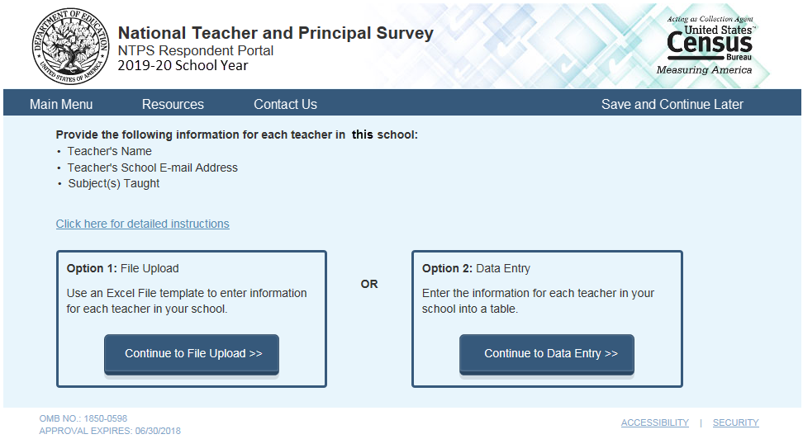

TLF upload

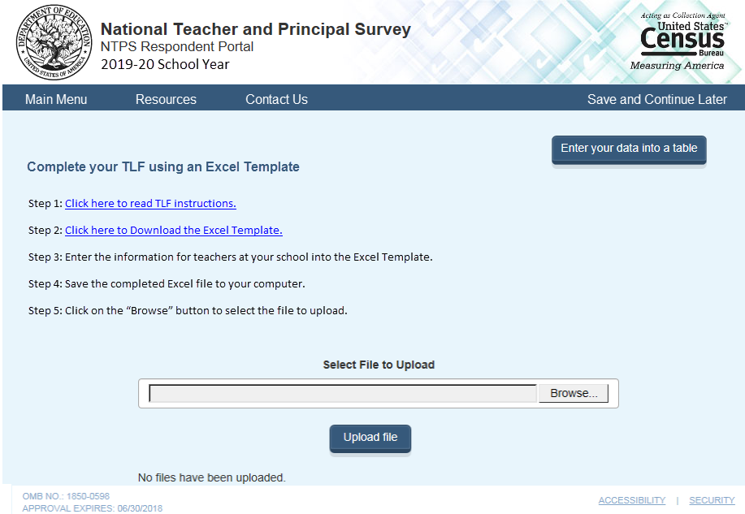

After a file has been uploaded, if parsing is unsuccessful:

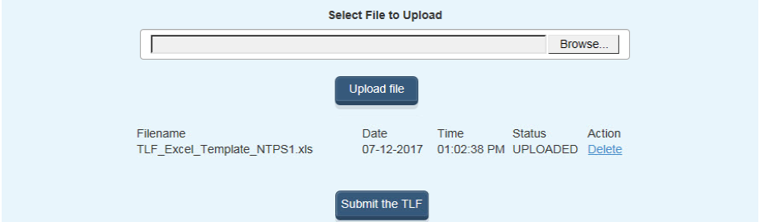

After a file has been uploaded, if parsing is successful:

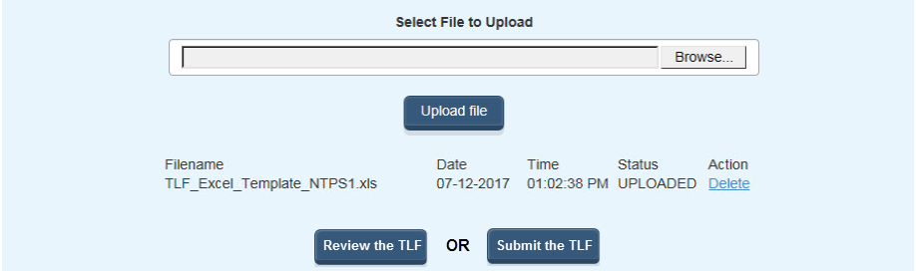

Pre-populated TLF Verification Intro (verification_intro)

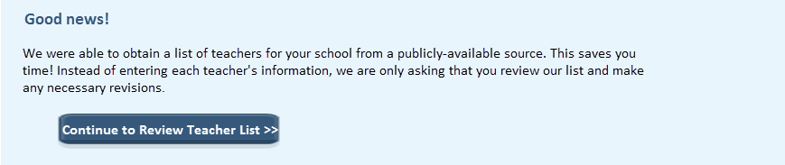

Input/Review Teacher Listing Form (summary)

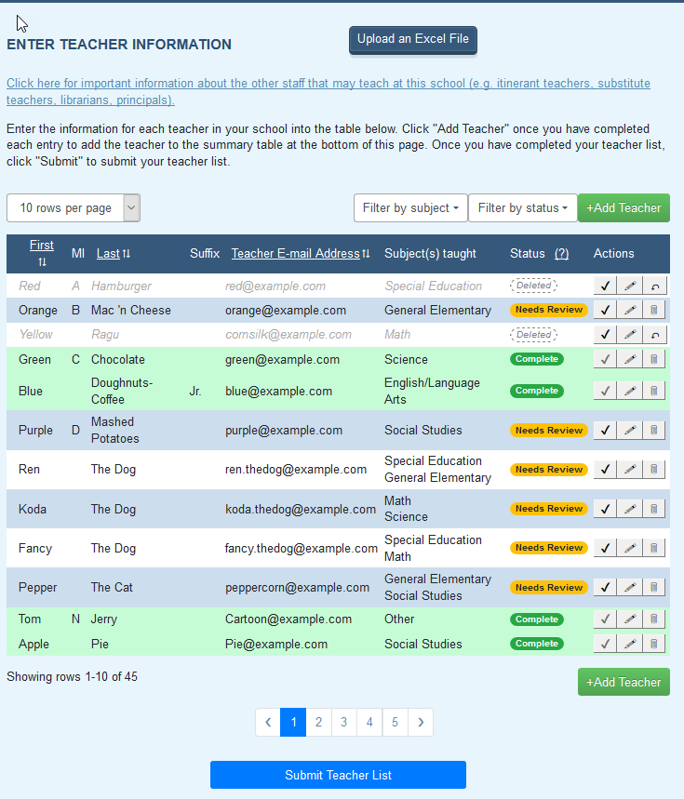

Modal: TLF General Information (instructions)

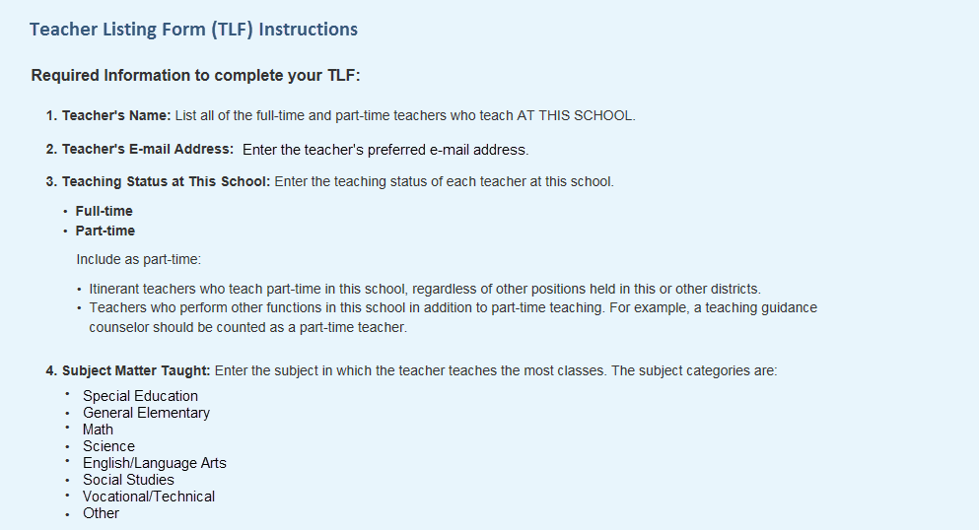

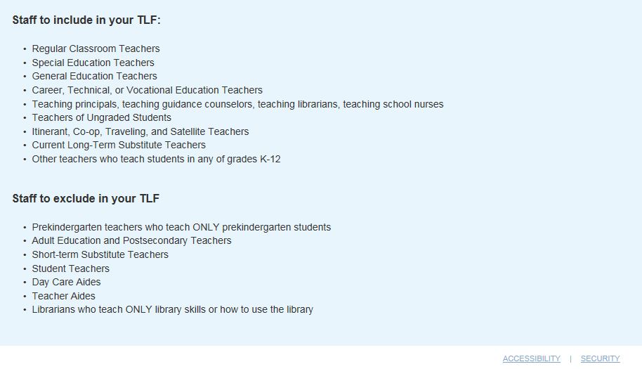

TLF Contact Page (followup)

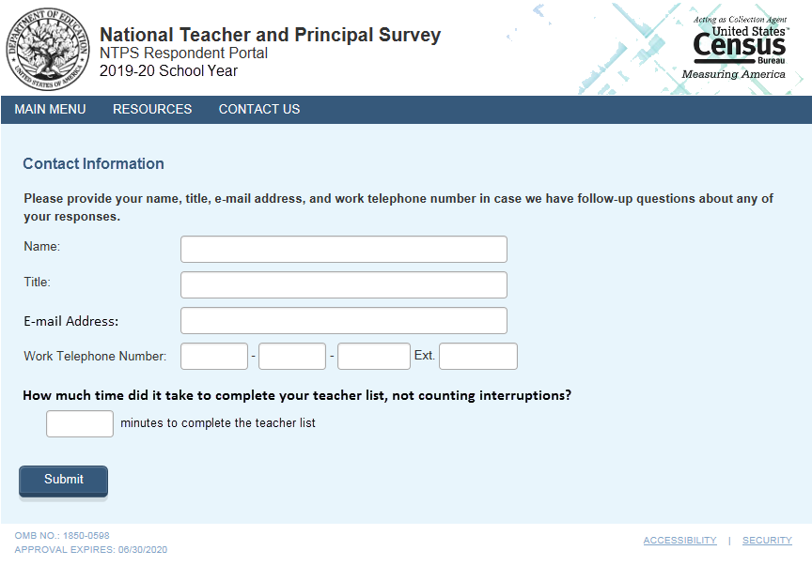

Thank you (thank_you)

