 | U.S. DEPARTMENT OF ENERGY  Energy Information Administration  Office of Oil, Gas and Coal Supply Statistics  Washington, DC 20585 | OMB Number: 1905-0057  Expiration Date: 05/31/2022  Product No.: 2019.1  Burden: 45 hours

ANNUAL REPORT OF DOMESTIC OIL AND GAS RESERVES
FORM EIA-23L
County Level Survey Instructions

SURVEY YEAR 2019

Table of Contents

Page
General Instructions 2
A. Purpose 2
B. Who Must Submit Form EIA-23L 2
C. What Must Be Submitted 2
D. When and Where to Submit 2
E. Record Keeping Requirements 2
F. Sanctions 2
G. Disclosure of Information 2
H. Reporting Standards 3
1. Proved Reserves 3
2. Survey Year Production 3
3. Total Operated Basis 3
4. States and Geographic Subdivisions 4
5. Field Codes No Longer Used 4
6. Reporting Units 4
7. Prior Year's Filings 4
a. Properties Were Purchased or Acquired 4
b. Properties Were Sold or Transferred 4
c. Gas Type Reclassified 4
d. First Time Reporting Reserves 5
8. Schedule Preparation Standards 5
9. Reserves Information Gathering System (RIGS) Software 5
10. EIA Secure File Transfer Information……………………….. 5
Specific Instructions 6
I. Cover Page - Operator Identification 6
J. Schedule A - Operated Proved Reserves, Production, and
Related Data by County 6
K. Schedule B - Footnotes 8
L. Definitions 8
M. Field Naming and Coding Conventions 11
N. Location Codes 12
1. Geographic Codes 12
2. County Codes 12
3. State and Geographic Subdivision Codes 13
Maps of Selected State Subdivisions 14

For Information, Assistance, or Additional Forms

Contact the EIA-23L Coordinator 800-879-1470

8:00 a.m. – 4:30 p. m. Central Time

GENERAL INSTRUCTIONS

A. PURPOSE
The Energy Information Administration (EIA) of the Department of Energy (DOE) seeks to gather and summarize credible and timely data regarding proved reserves and production of crude oil, natural gas, lease condensate, and other related matters with Form EIA-23L. The Government will use the resulting information to develop national and regional estimates of proved reserves of domestic crude oil, natural gas, and natural gas liquids and to facilitate national energy policy decisions.
B. WHO MUST SUBMIT FORM EIA-23L
It is not feasible to perform a complete census of all domestic oil and gas well operators (see Section L Definitions, page 8) every year. Instead, the U.S. Energy Information Administration selects a sample of operators from each producing area of the United States; (e.g., state, state subdivision, state waters, and Federal Offshore waters) for a survey year (Survey Year sample).

Each operator selected as part of the Survey Year sample must file Form EIA-23L regardless of their total survey year production levels.

Selection to the Survey Year sample is determined by the total or gross (8/8ths) annual operated production rate within the producing area. Production refers to the total survey year production from all domestic oil and/or gas wells you operated on December 31, of the survey year, including wells abandoned during the survey year.

Each operating affiliate of a parent company must file its own Form EIA-23L. The parent company must file only if it is an operator itself.

Note that as defined, day-to-day physical operation of a well or wells does not alone qualify a person as the operator. Physical operation may occasionally be divorced from operatorship, such as in the instance of manipulation of swing wells by a gas pipeline company representative or the manipulation and maintenance of wells located on an offshore platform by the platform manager. While the operator's own personnel usually perform such duties, the key factor is that the operator is the person who makes management decisions regarding the well(s) in question on behalf of the owner(s).

If you are not certain whether you are the operator, contact the EIA-23L Coordinator 800-879-1470 for assistance in making this determination. If you are not the operator of oil and/or gas wells on December 31, 2019 (perhaps a former operator or solely a working or royalty interest owner), you should complete and sign the Cover Page and return it to EIA along with a letter stating when operations ceased and what became of the wells you previously operated.
C. WHAT MUST BE SUBMITTED
Production data and estimates of proved reserves of crude oil, natural gas, and lease condensate are required of each
operator selected.

Operators must file:
- Cover Page
- Schedule A - Operated proved reserves, production, and related data by county
- Schedule B - Footnotes
D. WHEN AND WHERE TO SUBMIT
The completed 2019 survey forms must be submitted on or before April 14, 2020. Filing electronically, using Secure File Transfer or Fax, is encouraged.

Secure File Transfer: See page 5 for information

Fax completed forms to: 202 586-1076

Mail completed paper forms to:
Oil and Gas Surveys
U. S. Department of Energy, EIA
Ben Franklin Station
PO Box 279
Washington DC 20044-0279

When entering responses on hard copies, type or print in black ink using all capital letters. EIA-23L forms and instructions are available on the EIA website.
E. RECORD KEEPING REQUIREMENTS
All records necessary to reconstruct the data on this form must be retained and available for a period of three (3) years from the filing due date.

EIA may perform quality assurance on the data, assessing the accuracy of the resulting information. Two principal quality assurance activities are: 1) government personnel will make or supervise independent reserve estimates on a selected basis or, 2) a sample of operators will be visited to review the data submitted.
F. SANCTIONS
The timely submission of Form EIA-23L by those required to report is mandatory under Section 657 of Public Law 95-91 (42 USC 7267). Failure to respond may result in a civil penalty of $10,366 a day for each violation. The government may bring a civil action to prohibit reporting violations that may result in a temporary restraining order or a preliminary or permanent injunction without bond. In such civil action, the court may also issue mandatory injunctions commanding any person to comply with these reporting requirements.
G. DISCLOSURE OF INFORMATION
The annual production of crude oil, lease condensate, and natural gas reported on Form EIA-23L are considered public information. These data elements may be released in company-identifiable form and will not be protected from disclosure in identifiable form when releasing statistical aggregate information. All other information, including reserves, reported on Form EIA-23L will be protected and not disclosed to the public to the extent that it satisfies the criteria for exemption under the Freedom of Information Act (FOIA), 5 U.S.C. §552, the DOE regulations, 10 C.F.R. §1004.11, implementing the FOIA, and the Trade Secrets Act, 18 U.S.C. §1905.

The Federal Energy Administration Act requires the EIA to provide company-specific data to other Federal agencies when requested for official use. The information reported on this form may also be made available, upon request, to another component of the Department of Energy (DOE); to any Committee of Congress, the Government Accountability Office, or other Federal agencies authorized by law to receive such information. A court of competent jurisdiction may obtain this information in response to an order. The information may be used for any nonstatistical purposes such as administrative, regulatory, law enforcement, or adjudicatory purposes.

Disclosure limitation procedures are applied to the protected statistical data published from EIA-23L survey information to ensure that the risk of disclosure of identifiable information is very small.

Confidential information collected on Form EIA-23L will be provided to United States Department of Interior offices (the Bureau of Ocean Energy Management and the United States Geological Survey) for statistical purposes only, in conducting their resource estimation activities.

H. REPORTING STANDARDS
- Proved Reserves
EIA recognizes that the judgment of geologists and petroleum engineers is required in the reserve estimation process, and that as a result, proved reserves are estimates rather than precise quantitative measurements.

Proved reserves of oil and gas as of December 31, 2019 are the estimated quantities of oil and/or gas, which geological and engineering data demonstrate with reasonable certainty to be recoverable in future years from known reservoirs under existing economic and operating conditions. (See Proved Reserves, Crude Oil; Proved Reserves, Natural Gas; and Proved Reserves, Lease Condensate, Section L Definitions, page 8.)

- Survey Year Production
Production data are required from all operators. If the actual production data are not available at the time Form EIA-23L is prepared, estimate production. Note that amended schedules are not required to correct preliminary production data. Production data reported in the prior year survey may have been subsequently revised or corrected, thereby altering the end of the prior year reserves. Any change in the end of the prior year reserves due to this factor should be accounted for as part of the Revision Increases or Revision Decreases reported in the current survey.

If any properties were acquired during the survey year, production data from the acquired properties should be reported from the date of purchase. If any properties were sold during the survey year, production data should be reported until the date of sale.
- Total Operated Basis
All data on Schedule A (reserves and related data by county) are to be reported on an 8/8ths or Total Operated Basis. When reporting on this basis, production and reserves data for any properties on which operations were acquired during the survey year should be reported from the date of transfer or purchase. If any properties were sold or transferred to a new operator during the survey year, report production until the date of sale or transfer, and enter the proved reserves sold or transferred as Sales (Schedule A, Rows 12-15, Column D).

EXAMPLES:

Of the total 8/8ths interest, respondent's share is 50 percent and the associated royalty share is 6.25 percent. Respondent operates property. Respondent reports 100 percent of proved reserves and production.

Of the total 8/8ths interest, respondent's share is zero but it operates the property (i.e., a contract operator). Respondent reports 100 percent of proved reserves and production.

- States and Geographic Subdivisions
The state or geographic subdivision in which to report proved reserves and production data is determined by the location of the wells producing the oil and/or gas. If a field overlaps two or more states, subdivisions, or counties, the proved reserves data must be subdivided into the appropriate geographic components. Refer to the Section: Maps of Selected Sate Subdivisions for the subdivision boundaries in the States of Alaska, California, Louisiana, New Mexico, and Texas.

Offshore proved reserves data are required separately for the state and federal domains. If an offshore field lies on or between disputed boundaries, include all data in the state offshore area.

- Field Codes No Longer Used
EIA no longer requires field codes, as proved reserves estimates should be reported by State, State subdivision, and county. For recordkeeping purposes, field or play names can be optionally included when operators subdivide reserves within a county with differing Type Codes.

- Reporting Units
Volumes must be reported in whole numbers and not contain decimals. All volumes are to be reported in the appropriate reporting units as shown below:

a. Crude Oil: All crude oil volumes are to be reported in thousands of barrels (MBbls) (42 U.S. gallons per barrel at atmospheric pressure corrected to 60° Fahrenheit) and excluding basic sediment and water.

b. Natural Gas: All natural gas volumes are to be reported in millions of cubic feet (MMCF) at 14.73 psia and 60° Fahrenheit, wet after lease separation.

It is recognized that the operator in many instances has no knowledge of the ultimate reduction of the gas stream produced from his properties, which may result from further downstream processing. The operator is requested to report volumes of natural gas, which remain after processing through lease and field separation facilities. Lease use and flared and vented gas are also considered production and should be included in the volumes reported.

The EIA obtains data from gas processing plants separately. Gas volumes reported on Form EIA-23L should not be corrected for liquids removed by these plants. If you do not know if a field facility through which your gas is processed is currently reporting data to the EIA or not, contact the EIA-23L Coordinator at 800-879-1470 to obtain information on those plants which report.

Operators must segregate natural gas data into associated-dissolved and nonassociated gas entries (see natural gas, associated-dissolved and natural gas, nonassociated, Section L Definitions, page 8.). For a given reservoir, the gas type should represent the state classification as of December 31, of the survey year. This gas type may differ from the classification reflected in the prior year's Form EIA-23L filing.

An unusual situation may occur when, for pressure maintenance, a field is injected with natural gas produced from another field. The resultant increase in proved gas reserves is considered a Revision Increase for those volumes that are reasonably expected to be recovered at some future date. A Schedule B footnote must indicate the total injected volume and the expected future recoveries.

c. Lease Condensate: All lease condensate volumes are to be reported in thousands of barrels (MBbls) (42 U.S. gallons per barrel, at atmospheric pressure corrected to 60° Fahrenheit).

d. Rounding: Round liquid volumes 500 barrels and above up to ‘1’ MBbls, and less than 500 barrels down to ‘0’ MBbls. Round gas volumes 500 MCF and above up to ‘1’ MMCF, and less than 500 MCF down to ‘0’ MMCF.

e. Negative and Positive Volumes: All data are to be entered as whole number integers without plus (+) or minus (-) symbols. By definition, Revision Decreases, Sales, and Production all constitute reserve decreases and are entered without the minus symbol.

- Prior Year's Filing
Entries for Total Proved Reserves December 31, 2018, Schedule A, Column (A) in this year's Form EIA-23L filing should not differ from those quantities reported as end-of-year reserves in the prior year's filing.

a. Properties Were Purchased or Acquired
If operations were transferred from another company to the respondent during the survey year, then these reserves should be shown in Acquisitions, Schedule A, Column (E). Reserves and production for the acquired properties should be reported from the date of purchase. Additionally, a Schedule B footnote must be provided indicating the name of the previous operator and the month in which operations were acquired.

b. Properties Were Sold or Transferred
If operations were transferred to another company during the survey year, then these reserves should be shown in Sales, Schedule A, Column (D). Reserves and production for these properties should be reported until the date of sale. Additionally, a Schedule B footnote must be provided indicating the name of the new operator and the month in which operations were transferred. In the event the respondent no longer operates any properties in a given county, then the Total Proved Reserves December 31, 2019, Schedule A, Column (H) would be zero.

c. Gas Type Reclassified
In the case where the type of gas was improperly reported or reclassified from associated-dissolved (AD) to non-associated (NA), or vice-versa, report the Total Proved Reserves, December 31, 2018, Schedule A, Column (A) from prior year’s Schedule A for the previous classification.
Eliminate the reserves of that classification by Revision Decreases, Schedule A, Column (C) and create the reserves of the new classification by equal Revision Increases, Schedule A, Column (B). Enter zero for Total Proved Reserves, December 31, 2018, Schedule A, Column (A) for the new classification. Note the reclassification of natural gas on Schedule B.
d. First Time Reporting Reserves
If a respondent reports reserves estimates in the current survey but not in the prior year's survey because such estimates were not available in the company records at that time, add Survey Year Production, Schedule A, Column (I), and Total Proved Reserves December 31, 2019, Schedule A, Column (H). Enter the sum in Total Proved Reserves December 31, 2018, Schedule A, Column (A).

- Schedule Preparation Standards
Prior to submission, completed forms must be assembled and paginated consecutively within each schedule in the following order:

- Cover Page

- Schedule A: Sort alphabetically by state, then by subdivision within that state, then by county, and then by type code. The last Schedule A page is to contain the Company Totals for all reported counties.

- Schedule B: In the same sequence as Schedule A.

- Reserves Information Gathering System (RIGS) Software
Form EIA-23L Reserves Information Gathering System (RIGS) Software provides respondents with an efficient and effective means for filing Form EIA-23L using a personal computer.

To download and use the RIGS software:
- Click to open the EIA-23L Reserves Information Gathering System webpage or type this URL in your browser:
https://www.eia.gov/survey/form/eia_23l/rigs.php
- Follow the steps to download the file containing the application
For complete instructions for running the RIGS applications, see the RIGS User’s Guide.
- EIA Secure File Transfer (SFT) Information
EIA is ensuring the security of your transactions by using the latest Internet security technology. The technology being used to protect your data is encryption which is the scrambling of data into a code that is unreadable to anyone who does not have the key that deciphers it. The secure hypertext transfer protocol (HTTPS) is a communications protocol designed to transfer this encrypted information between computers over the World Wide Web. All information is protected by 128-bit encryption to maintain the privacy and confidentiality of your data. The only thing you need to take advantage of strong encryption technology is a secure browser, one that supports 128-bit encryption.

To use the EIA HTTPS secure file transfer system:

- Click to open the SFT webpage
or type in this URL in your browser:
https://signon.eia.doe.gov/upload/noticeoog.jsp
The EIA SFT Notice to Users page appears.

- Read and then click the Accept button.
The Secure File Transfer System page appears.
At the bottom of this page, in blue text, click on Instructions for Secure File Transfer.

If you have any trouble transferring your files, please call the EIA User Services Center 202-586-8959 or email them at User-Services-Center@eia.gov.

SPECIFIC INSTRUCTIONS

I. COVER PAGE - Operator Identification

Part I. Identification

EIA Operator ID Code: If this item is missing, contact the EIA-23L coordinator.

Operator Name, Address, City, State, Zip Code. Enter the legal name and address of the operator. If a foreign address, enter city, local equivalent of State name (e.g., province), and country.

Item 1: Contact Information. Name, telephone number, fax number, and email address of the person most knowledgeable about the reported data. This person should be familiar with the data provided, and will be the person to whom inquiries will be directed, if necessary.

Item 2: Was your company an oil and gas field operator? Check the appropriate box and follow the instructions for completing the rest of the form.

Item 3: Company Status, Name, and/or Address Change or Correction. If there was a change to the company name or address, or if the company was sold, merged with another company, or the company went out of business, check the appropriate box and complete Item 4.

Item 4: Note Change Company Name, Address, and/or Contact Information. If any box in Item 3 was checked, enter the new or correct company name, address, or contact person here.

Part II. Approval

Items 5 thru 8: Approval - Enter the name and title of the individual designated by the respondent company to review and approve the accuracy of this submission and the date of the signing. This report should be reviewed and approved by a responsible officer or the office responsible for regulatory filings. If filed electronically, there is no requirement to submit a signed cover page.
J. SCHEDULE A - Operated Proved Reserves,
Production, and Related Data by County
All proved reserves, production, and reserve changes data on Schedule A are to be reported on a Total Operated Basis for each county in which the respondent operated oil and/or gas wells on December 31, of the survey year, including abandonments during the survey year. (See Total Operated Basis, Section H, Item 3.)

SECTION 1.0: Operator Detailed Data Report
Report the information in this section on each Schedule A submitted.

Item 1.1: EIA Operator ID Code – This is the same as the Cover Page EIA Operator ID Code.

Item 1.2: Operator Name - This is the same operator name on the Cover Page. Enter the first 35 characters of the operator name. If the name exceeds 35 characters, do not abbreviate, but simply truncate the extra characters from the right.

Item 1.3: Original - Enter an ‘X' in the box if this is the first submission of this schedule for the survey year. Otherwise leave blank.

Item 1.4: Amended - Enter an ‘X' if this schedule amends a previously submitted schedule. Otherwise, leave blank.

Item 1.5: Page – Enter the current page number in this schedule series.

SECTION 2.0: County Data (Operated Basis)

Production data and/or estimates of proved reserves of crude oil, natural gas, and lease condensate are required of each operator selected. Production refers to the total survey year production from all domestic oil and/or gas wells you operated on December 31 of that survey year, including wells abandoned or sold during the survey year.

Production data and proved reserve estimates are required by county from all operators filing Form EIA-23L that were selected as part of the Survey Year sample.

If it would make your forms preparation easier, a new state or state subdivision may be started in the first county data block of a new Schedule A page. In all other cases, utilize all three-county data blocks on each Schedule A. When completing more than one page of Schedule A, do not renumber items 2.1 through 2.3 on successive pages. However, be certain to enter the correct, consecutive page numbers on each page in item 1.5.

Subitem 1: State Code - Enter the two-character alphabetic abbreviation of the State that data reported for this county pertains. For offshore fields, use the abbreviation of the adjacent state. (See Geographic Codes, page 13.)

Subitem 2: Subdivision Code - Enter the two-digit code of the appropriate geographic subdivision to which data reported for this county pertain. Leave blank if not applicable. (See Geographic Codes, page 13.)

Subitem 3: County Code - Enter the three-digit numeric code for the county or parish in which operated wells are located.

Subitem 4: County Name - Enter the name of the county or parish in which operated wells are located.

Subitem 5: Type Code - Enter the alpha code to classify the reservoir from which the reported production and proved reserves come. These alpha codes are C for conventional reservoirs, SH for shale reservoirs, and LP for other low permeability reservoirs. Low permeability reservoirs are tight sandstone, mudstone, or carbonate reservoirs with permeability values of 0.1 millidarcy or less. If you are uncertain of the reservoir type, enter UN for unknown.
Coalbed Reservoir Type Code eliminated in 2018
Natural gas produced from coalbed reservoirs, also called coalbed methane, used to have its own type code, CB, but as of December 31, 2017 coalbed methane proved reserves have shrunk to represent only 2.6% of total U.S. natural gas proved reserves and EIA will not include coalbed methane proved reserves as a separate category of natural gas proved reserves in its annual report. Coalbed reservoirs should be labeled as conventional, type code C.
Shale Reservoir Type Code use limited to 300 counties in 12 major U.S. shale plays
In order to improve accuracy of its reporting of proved reserves and production from shale reservoirs, EIA has identified counties in the United States that current geologic data suggests contain shale reservoirs. These counties are listed in the new Appendix C. of the County Code Master List, Counties in Major U.S. Shale Plays. This appendix contains a list of 300 identified counties in the United States that may contain proved reserves in twelve major U.S. shale plays: Bakken, Barnett, Eagle Ford, Fayetteville, Haynesville, Marcellus, New Albany, Niobrara, Three Forks, Utica, Woodford, and Wolfcamp. Outside of these identified counties, proved reserves and production should be reported by an operator as Conventional or Low Permeability until EIA verifies the existence of a new major U.S. Shale Play and adds new counties to Appendix C.
Subitem 6: Field, Play, or Prospect Name (optional) – To assist in subdividing reported production and proved reserves within a county that have different Type Codes, a field, play, or prospect name (for offshore areas) can be entered in this optional subitem.

Subitem 7: Proved Nonproducing Reserves. - Enter the estimated volumes of proved reserves in the county which were in nonproducing status at the end of the survey year. This includes proved developed nonproducing and proved undeveloped reserves. (See Nonproducing Reserves Section L Definitions, page 8.)

Subitem 8: Footnote - For Schedule B, Footnotes, enter an ‘X’. Leave blank if there is no footnote information.

Subitem 9: # of Producing Wells - For the county, enter the number of operated wells that were producing crude oil, natural gas, and/or lease condensate on December 31 of the survey year. If proved reserves and production are subdivided within a county (e.g. by Type Code), this well count data should be subdivided as well.

Subitem 10: # of wells added in 2019 – For the county, enter the number of wells completed or purchased during the survey year.

Subitem 11: # of wells sold in 2019 – For the county, enter the number of wells sold to another operator or abandoned during the survey year.

Type of Hydrocarbons:

Subitem 12: Crude Oil (MBbls)

Subitem 13: Associated-Dissolved Gas (MMCF)

Subitem 14:Non-associated Gas (MMCF)

Subitem 15: Lease Condensate (MBbls)

Column (A): Total Proved Reserves, December 31, 2018 Enter the volumes of total proved reserves as of December 31, 2018. (See Proved Reserves of Crude Oil; Proved Reserves of Lease Condensate; and Proved Reserves of Natural Gas, Wet after Lease Separation; Section L Definitions, page 8.)

Column (B): Revision Increases - Enter the total of upward revisions made in the county during the survey year. Explain any revision increase in excess of 2,500 MBbls of liquid or 15,000 MMCF of gas in a Schedule B footnote and check Subitem 8. To the extent that reserves are revised upward due to implementation of secondary or tertiary recovery techniques, such revisions should be indicated by volume and by recovery method in a Schedule B footnote. Also, indicate in a Schedule B footnote the volume of any upward revisions due to the transfer of unproved reserves to proved status. (See Revisions, Section L Definitions, page 8.)

Column (C): Revision Decreases - Enter the total of downward revisions made in the county during the survey year. Do not enter a minus sign as entries in this column are assumed to be negative. Explain any revision decrease in excess of 2,500 MBbls of liquid or 15,000 MMCF of gas in a footnote on Schedule B and check Subitem 8. (See Revisions, Section L Definitions, page 8.)

Column (D): Sales - If operations were transferred to another company during the survey year, then these reserves should be reported as Sales. Enter the reserves for these properties until the date of sale. Additionally, a Schedule B footnote must be provided indicating the name of the new operator and the month in which operations were transferred. In the event the respondent no longer operates any properties in this county, then Total Proved Reserves December 31, 2019 Schedule A, Column (H) will be zero. (See Sales, Section L Definitions, page 8.) Sales is not the same as Survey Year Production (see Column G below).

Column (E) Acquisitions - If operations were transferred from another company to the respondent during the survey year, then these reserves should be reported as Acquisitions. Enter the reserves for the acquired properties from the date of purchase or transfer. Additionally, a Schedule B footnote must be provided indicating the name of the previous operator and the month in which operations were acquired. (See Acquisitions, Section L Definitions, page 8.)

Column (F) Extensions and Discoveries – If proved reserves were added to a county during the survey year because of successful exploratory drilling, then these reserves should be reported as Extensions and Discoveries. Extensions are reserves additions that result from expanding the proved acreage of previously discovered reserves through additional drilling. Discoveries are the sum of new field discoveries, and new reservoir discoveries found in a county (or county-equivalent area) during a survey year. (See Extensions and Discoveries, Section L Definitions, page 9.)

Column (G) Survey Year Production - Enter the volumes produced from wells in the county during the survey year. If wells were sold or transferred during the Survey Year, report the production up until the date of sale or transfer. Similarly, report the production from acquired wells between the date of acquisition and December 31, 2019. (See Production, Crude Oil; Production, Lease Condensate; and Production, Natural Gas, Wet After Lease Separation, Section l Definitions)
Column (H) Total Proved Reserves, December 31, 2019
Enter the volumes of total proved reserves as of December 31, 2019. This item should be the algebraic sum of Columns (a) + (b) + (e) + (f), less Columns (c), (d), and (g). This value includes producing and non-producing reserves and therefore should always be equal to or greater than the values shown in Subitem 7.

Company Totals
Company totals for each of the volumetric data elements reported are required. Enter these company totals in the next available County Data (Operated Basis) block. Enter ‘ZZ’ in State Code and Company Totals in Subitem 6 to identify these data as company totals.
K. SCHEDULE B - Footnotes
Submit footnotes in clarification of reported data items. This includes revisions, sales, or acquisitions of properties during the survey year. Additionally, you may footnote any other reported item if this will enhance its clarity.

Item 1.1 EIA Operator ID Code - This is the same as the Cover Page EIA Operator ID Code.

Item 1.2 Operator Name - This is the same operator name on the Cover Page. Enter the first 35 characters of the operator name. If the name exceeds 35 characters, do not abbreviate, but simply truncate the extra characters from the right.

Item 1.3 Original - Enter an ‘X' in the box if this is the first submission of this schedule for the survey year. Otherwise leave blank.

Item 1.4 Amended - Enter an ‘X' if this schedule amends a previously submitted schedule. Otherwise, leave blank.

Item 1.5 Page - Enter the current page number in this schedule series.

Footnote Data: Use all lines on each Schedule B page before using additional pages. Columns (a) thru (e) must be filled in only for the first line of each footnote.

Column (A) State Code - Enter the state abbreviation from Schedule A referenced by this footnote.

Column (B) Subdivision Code - Enter the Subdivision Code from Schedule A referenced by this footnote.

Column (C) County Code - Enter the county code from Schedule A referenced by this footnote.

Column (D) Type Code - Enter the type code from Schedule A referenced by this footnote.

Column (E) Hydrocarbon Type - Enter the number for the type of hydrocarbon shown in Schedule A referenced by this footnote. For example, use 12 for crude oil, 13 for associated dissolved gas, 14 for non-associated gas, and 15 for lease condensate. Use 7 for footnote references to proved non-producing reserves regardless of the type of hydrocarbon.

Column (F) Column - Enter the alphabetic column designation (A through H) from Schedule A referenced by the footnote.

Column (G) Footnotes - Enter the text of the footnote, using as many lines as necessary.
L. DEFINITIONS
These definitions have been formulated with reference to the particular purposes of Form EIA-23L. They are not necessarily synonymous with the same or similar terms used in DOE regulations, and are not to be construed as definitions applicable for any purposes other than the collection and reporting of data on Form EIA-23L.

Acquisitions: The volumes of proved reserves of crude oil, natural gas, and/or lease condensate associated with properties that were purchased and/or transferred from another company to the respondent’s operatorship during the survey year.

Affiliated (Associated) Company: An entity that is directly or indirectly owned, operated, or controlled by another entity. (See Person and Control)

Control: The term control (including the terms controlling, controlled by, and under common control with) means the possession, direct or indirect, of the power to direct or cause the direction of the management and policies of a person, whether through the ownership of voting shares, by contract or otherwise. (See Person)
County: The largest administrative division of most states in the United States. A County-equivalent term in the state of Louisiana is Parish, or borough in the state of Alaska.

Crude Oil (excluding Lease Condensate): A mixture of hydrocarbons that exists primarily in the liquid phase in natural underground reservoirs and remains liquid at atmospheric pressure after passing through surface separating facilities. Such hydrocarbons as lease condensate and natural gasoline recovered as liquids from natural gas wells in lease or field separation facilities and later mixed into the crude stream are excluded. Depending upon the characteristics of the crude stream, it may also include:
- small amounts of hydrocarbons that exist in gaseous phase in natural underground reservoirs but are liquid at atmospheric pressure after being recovered from oil well (casinghead) gas in lease separators and are subsequently commingled with the crude stream without being separately measured
- small amounts of non-hydrocarbons produced with the oil, such as sulfur and various metals.
When a state regulatory agency specifies a definition of crude oil which differs from that above, the state definition is to be followed and its use footnoted on Schedule B.
Extensions and Discoveries: Additions to a county's proved reserves that result from (1) extension of the proved acreage of previously discovered (old) reserves through additional drilling in periods subsequent to discovery and (2) discovery of new fields with proved reserves or of new reservoirs of proved reserves in old fields.

Field: An area consisting of a single reservoir or multiple reservoirs all grouped on, or related to, the same individual geological structural feature and/or stratigraphic condition. There may be two or more reservoirs in a field that are separated vertically by intervening impervious strata or laterally by local geologic barriers or by both.

Field Area: A geographic area encompassing two or more pools that have a common gathering and metering system, the reserves of which are reported as a single unit. This concept applies primarily to the Appalachian region. (See Pool)

Field Separation Facility: Surface equipment designed to separate some combination of oil, water, and gas produced from one or more leases, and managed by the operator of one or more of these leases. (See Lease Condensate)

Lease Condensate: A mixture consisting primarily of pentanes and heavier hydrocarbons which is recovered as a liquid from natural gas in lease or field separation facilities. This excludes natural gas plant liquids, such as butane, propane, and ethane which are recovered at downstream natural gas processing plants or facilities. The output of natural gas processing plants is reported on Form EIA-64A, Annual Report of the Origin of Natural Gas Liquids Production and Form EIA-816, Monthly Natural Gas Liquids Report.

Lease Separator: A facility installed at the surface for the purpose of separating gases from:
- produced crude oil and water at the temperature and pressure conditions of the separator, and/or
- that portion of the produced natural gas stream, which liquefies at the temperature and pressure conditions of the separator
- or water from either oil or gas or both.

Natural Gas: A gaseous mixture of hydrocarbon compounds, the primary one being methane. The parameters for measurement are cubic feet at 60 degrees Fahrenheit and 14.73 pounds per square inch absolute (psia). The Energy Information Administration measures wet natural gas and its sources of production, associated/dissolved natural gas and non-associated natural gas, and dry natural gas, which are produced from wet natural gas. This EIA survey does not include landfill gas (biomass gas), synthetic natural gas, coke oven gas, or manufactured gas.

Wet natural gas: A mixture of hydrocarbon compounds and small quantities of various non-hydrocarbons existing in the gaseous phase or in solution with crude oil in porous rock formations at reservoir conditions. The principal hydrocarbons normally contained in the mixture are methane, ethane, propane, butane, and pentane. Typical non-hydrocarbon gases that may be present in reservoir natural gas are water vapor, carbon dioxide, hydrogen sulfide, nitrogen, and trace amounts of helium. Under reservoir conditions, natural gas and its associated liquefiable portions occur either in a single gaseous phase in the reservoir or in solution with crude oil and are not distinguishable at the time as separate substances. Note: The Securities and Exchange Commission and The Financial Accounting Standards Board refer to this product as natural gas.

Associated-dissolved natural gas: Natural gas that occurs in crude oil reservoirs either as free gas (associated) or as gas in solution with crude oil (dissolved gas).

Non-associated natural gas: Natural gas that is not in contact with significant quantities of crude oil in the reservoir.

Dry natural gas: Natural gas that remains after:
- the liquefiable hydrocarbon portion has been removed from the gas stream (i.e., gas after lease, field and/or plant separation); and
- any volumes of non-hydrocarbon gases have been removed where they occur in sufficient quantity to reduce the gas quality below minimum pipeline specifications (rendering it unmarketable).

Natural Gas Processing Plant: Facilities designed to recover natural gas liquids from a stream of natural gas that may or may not have passed through lease separators and/or field separation facilities. These facilities also control the quality of the natural gas stream to be marketed, e.g. removal of nonhydrocarbon gases. Cycling plants are classified as natural gas processing plants.

New Field: A field discovered during the survey year.

New Field Discoveries: The volumes of proved reserves of crude oil, natural gas, and/or lease condensate discovered in new fields during the survey year.

Nonproducing Reserves: Quantities of proved liquid or gaseous hydrocarbon reserves that have been identified, but which did not produce during the last survey year regardless of the availability and/or operation of production, gathering or transportation facilities. This includes both proved undeveloped and proved developed nonproducing reserves.

Old Reservoir: A reservoir discovered prior to the survey year.

Operator: The person responsible for the management and day-to-day operation of one or more crude oil and/or natural gas wells as of December 31, 2019. The operator is generally a working interest owner or a company under contract to the working interest owner(s). Wells included are those, which have proved reserves of crude oil, natural gas, and/or lease condensate in the reservoirs associated with them, whether or not they are producing. Wells abandoned during 2019 are also to be considered operated as of December 31, 2019. (See Person, Proved Reserves of Crude Oil, Proved Reserves of Natural Gas, Proved Reserves of Lease Condensate, Survey Year, and Reservoir)

Ownership: (See Working Interest Ownership Basis)

Parent Company: A firm that directly or indirectly controls another entity. (See Affiliated {Associated} Company and Control)

Pool: In general, a reservoir. In certain situations a pool may consist of more than one reservoir. (See Field Area)

Production, Crude Oil: The volume of crude oil that was extracted from oil reservoirs during the survey year. These volumes are determined through measurement of the volumes delivered from lease storage tanks or at the point of custody transfer, with adjustment for:
- net differences between opening and closing lease inventories
- basic sediment and water
- Crude oil used on the lease is considered production.

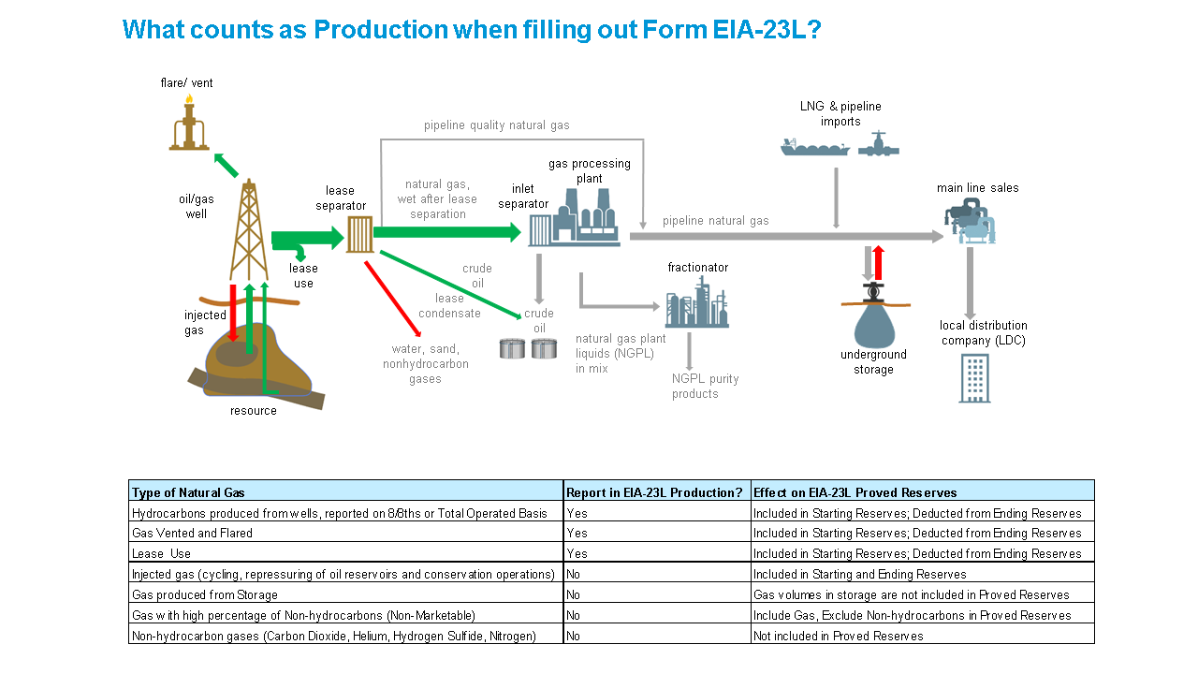
Production, Lease Condensate: The volume of lease condensate produced during the survey year. Lease condensate volumes include only those volumes recovered from lease or field separation facilities. (See Lease Condensate)

Production, Natural Gas: The volume of natural gas withdrawn from reservoirs during the survey year less:
- the volume returned to such reservoirs in cycling, repressuring of oil reservoirs and conservation operations
- the shrinkage resulting from the removal of lease condensate
- non-hydrocarbon gases where they occur in sufficient quantity to render the gas unmarketable.
Lease use and flared and vented gas are considered production and should be included in the volumes reported. Volumes of gas withdrawn from gas storage reservoirs and native gas, which has been transferred to the storage category, are not considered production.

Prospect: An area of exploration or development in which hydrocarbons have been predicted to exist in economic quantity. A prospect is commonly an anomaly, such as a geologic structure or a seismic amplitude anomaly, which is recommended by exploration personnel for drilling a well. A single drilling location may also be called a prospect but the term is more properly used in the context of exploration.
Proved Reserves, Crude Oil: Proved reserves of crude oil as of December 31 of the survey year are the estimated volumes of all liquids defined as crude oil, which geological and engineering data demonstrate with reasonable certainty to be recoverable in future years from known reservoirs under existing economic and operating conditions.
Reservoirs are considered proved if economic producibility is supported by actual production or conclusive formation test (drill stem or wire line), or if economic producibility is supported by core analyses and/or electric or other log interpretations. The area of an oil reservoir considered proved includes:
- that portion delineated by drilling and defined by gas-oil and/or oil-water contacts, if any
- the immediately adjoining portions not yet drilled, but which can be reasonably judged as economically productive on the basis of available geological and engineering data.
In the absence of information on fluid contacts, the lowest known structural occurrence of hydrocarbons is considered to be the lower proved limit of the reservoir.

Volumes of crude oil placed in underground storage are not considered proved reserves.

Reserves of crude oil which can be produced economically through application of improved recovery techniques (such as fluid injection) are included in the proved classification when successful testing by a pilot project, or the operation of an installed program in the reservoir, provides support for the engineering analysis on which the project or program was based.

Estimates of proved crude oil reserves do not include the following:
- oil that may become available from known reservoirs in the future
- natural gas liquids (including lease condensate)
- oil, the recovery of which is subject to reasonable doubt because of uncertainty as to geology, reservoir characteristics, or economic factors
- oil that may occur in undrilled prospects
- oil that may be recovered from oil shales, coal, Gilsonite and other such sources.
It is not necessary that production, gathering or transportation facilities are installed or operative for a reservoir to be considered proved.

Proved Reserves, Lease Condensate: Proved reserves of lease condensate as of December 31 of the survey year are the estimated volumes expected to be recovered in future years in conjunction with the production of proved reserves of natural gas based on the recovery efficiency of lease and/or field separation facilities currently installed. (See Lease Condensate and Proved Reserves of Natural Gas)

Proved Reserves, Natural Gas: Proved reserves of natural gas as of December 31 of the survey year are the estimated volumes which analysis of geologic and engineering data demonstrates with reasonable certainty to be recoverable in future years from known reservoirs under existing economic and operating conditions. Reservoirs are considered proved if economic producibility is supported by actual production or conclusive formation test (drill stem or wire line), or if economic producibility is supported by core analyses and/or electric or other log interpretations.

The area of a gas reservoir considered proved includes:
- that portion delineated by drilling and defined by gas-oil and/or gas-water contacts, if any
- the immediately adjoining portions not yet drilled, but which can be reasonably judged as economically productive on the basis of available geological and engineering data.
In the absence of information on fluid contacts, the lowest known structural occurrence of hydrocarbons is considered to be the lower proved limit of the reservoir.
Volumes of natural gas placed in underground storage are not considered proved reserves.

For natural gas reserves, wet after lease separation, an appropriate reduction in the reservoir gas volume must be made to cover the removal of the liquefiable portions of the gas in lease and/or field separation facilities and the exclusion of nonhydrocarbon gases where they occur in sufficient quantity to render the gas unmarketable.

It is not necessary that production, gathering or transportation facilities are installed or operative for a reservoir to be considered proved. It is to be assumed that compression will be initiated if and when economically justified.

Reserves: (See Proved Reserves)

Reservoir: A porous and permeable underground formation containing an individual and separate natural accumulation of producible hydrocarbons (oil and/or gas) which is confined by impermeable rock or water barriers and is characterized by a single natural pressure system.

Revisions: Changes to prior year-end proved reserves estimates, either positive or negative, resulting from new information other than an increase in proved acreage (extension). Revisions include increases of proved reserves associated with the installation of improved recovery techniques or equipment. They also include correction of prior survey year arithmetical or clerical errors or corrections to prior year-end production volumes to the extent that these alter previous reserves estimates.

Sales: The volumes of proved reserves of crude oil, natural gas, and/or lease condensate associated with properties that were sold and/or transferred during the survey year from the respondent’s operatorship to that of another company.

Subdivision: A prescribed portion of a given state or other geographical region defined in this publication for statistical reporting purposes.

Subsidiary Company: A company which is controlled through the ownership of voting stock or a corporate joint venture in which a corporation is owned by a small group of businesses as a separate and specific business or project for the mutual benefit of the members of the group. (See Control)

Survey Year: The year to which data reported on this form pertains.

Total Operated Basis: The total reserves or production associated with the wells operated by an individual operator. This is also commonly known as the gross operated or 8/8ths basis.

Working Interest: Rights that permits the owner(s) to explore, develop, and operate a property. The working interest owner(s) bear(s) the costs of exploration, development, and operation of the property. In return for these investments, the owner(s) is (are) entitled to a share of the mineral production from the property or to a share of the proceeds from the property.

Working Interest Ownership: Working interest ownership is the respondent's working interest in a given property used to proportion the operating expenses. (See Working Interest).

M. FIELD NAMING CONVENTIONS
Form EIA-23L collects data on a county-level basis, but operators completing the form have the option to subdivide their estimates within a county by field, play, or prospect name. The information below regarding field naming conventions is included for operators choosing this option.

1. Field Naming Conventions

Field naming conventions are used to provide a standard nomenclature for each geologic field that is recognizable to both the personnel working with Form EIA-23L and the computer system and fits into 26 characters. In most instances, field names should reflect the conventions imposed by state oil and gas regulatory agencies. Field names that have come into general acceptance in an area may be used, unless they have been specifically altered or replaced by the appropriate naming authority. Also, field names used strictly by one company must give precedence to the state recognized name.

Exceptions occur for names of fields located in Texas and New Mexico, states in which the regulatory agencies consider geologic reservoirs to be fields. For example, in Texas, Parker (Pennsylvanian) and Parker (Wolfcamp) are considered separate fields by the state. In actuality, Parker is the name of the geologic field and Pennsylvanian and Wolfcamp are reservoir names of the geologic reservoirs in the field (by Texas Railroad Commission convention, the geologic reservoir name appears in parentheses after the geologic field name). For the purpose of reporting names on Schedule A of form EIA-23L, only the geologic field name should be used. In the example above, PARKER would be entered as the field name, Subitem 6, in the field data block of Schedule A. Some specific conventions include the following:

- Offshore field names usually (but not always) consist of a basic offshore area name and block number specified by the Bureau of Ocean Energy Management. Example: East Cameron South addition Block 265. If offshore area names must be abbreviated to fit within 26 characters allowed, the following standard abbreviations should be used:

Name Code Name Code

NORTH N NORTH ADDITION NA
SOUTH S SOUTH ADDITION SA
EAST E EAST ADDITION EA
WEST W WEST ADDITION WA
BLOCK BLK SOUTH EXTENSION SX
ISLAND IS EAST EXTENSION EX

For example, High Island East Addition South Extension Block A-375 would be HIGH IS EA SX BLK A-375.

Such abbreviations should not be applied to names of onshore fields (except for non-cardinal compass points such as NW for northwest or SE for southeast). If an onshore field name is too long to fit in the allotted space, truncate it on the right and provide the full name on Schedule B.

- Compass point words used in field names are to be placed at the end of the field name (i.e. Three Mile Creek North). Exceptions are made for geographic places, such as East Texas field of East Texas or East Branch, a field named for East Branch, Pennsylvania.

- Special attention should be given to reporting field names in Michigan. Most fields have the section, township, and range after the field name. For example: Kalkaska 12-27N-7W. Operators should report field name as indicated.

- If a field that has been reported in the previous survey year is changed or aliased to another field according to the field code publication, report the data under the new field name. For example, Mud Spring is an alias of Four Mile Creek. All data that was previously reported under Mud Spring should now be reported under and combined with any previous Four Mile Creek data.

- Lease names are not acceptable in lieu of geologic field names. To determine the field name for a particular lease, contact the EIA-23L Field Coordinator 1-800-879-1470, the state geologic survey, or conservation commission. If a field name cannot be determined, report the field name as unknown with associated field code 999002.

N. LOCATION CODES

1. State and Geographic Codes

State and geographic codes are to be entered on Schedule A for all counties reported by respondents and Schedule B if there is a footnote. See table and maps below.

2. County Codes

County codes are to be entered for all fields reported by respondents. The County Code Master List (CCML) provides the EIA standard county name spellings and codes for use in the Form EIA-23L, Annual Report of Domestic Oil and Natural Gas Reserves. EIA County Code Master List

State and Federal Subdivision Codes

Alabama Onshore AL
Alabama – State Offshore1 AL99
Alaska – North Onshore AKN
Alaska – North State Offshore1 AK88
Alaska - South Onshore AKS
Alaska - South State Offshore1 AK99
Alabama - Onshore AL
Alabama - State Offshore1 AL99
Arkansas AR
Arizona AZ
California – Los Angeles Basin Onshore CA1
California – Coastal Region Onshore CA2
California – San Joaquin Basin Onshore CA3
California – State Offshore1 CA99
Colorado CO
Connecticut CT
District of Columbia DC
Delaware DE
Federal Offshore – Atlantic (Lower 48 East Coast) FAEC
Federal Offshore – Alaska Arctic
(North of Bering Strait, Chuckchi and Beaufort Seas) AKAA
Federal Offshore – Alaska Pacific
(South of Bering Strait, Bering Seas and Pacific) AKPA
Federal Offshore - Gulf of Mexico
Eastern Planning Area FGEP
Federal Offshore - Gulf of Mexico
Central Planning Area FGCP
Federal Offshore - Gulf of Mexico
Western Planning Area FGWP
Federal Offshore - Pacific (Lower 48 West Coast) FPWC
Florida - Onshore FL
Florida - State Offshore1 FL99
Georgia GA
Hawaii HI
Iowa IA
Idaho ID
Illinois IL
Indiana IN
Kansas KS
Kentucky KY
Louisiana – North (Monroe & Shreveport Districts) LAN
Louisiana – South (Lafayette District) LAS
Louisiana – State Offshore LA99
Massachusetts MA
Maryland MD
Maine ME
Michigan MI
Minnesota MN
Missouri MO
Mississippi - Onshore MS
Mississippi - State Offshore1 MS99
Montana MT
North Carolina NC
North Dakota ND
Nebraska NE
New Hampshire NH
New Jersey NJ
New Mexico - East NME
New Mexico - West NMW
Nevada NV
New York NY
Ohio OH
Oklahoma OK
Oregon OR
Pennsylvania PA
Rhode Island RI
South Carolina SC
South Dakota SD
Tennessee TN
Texas - Railroad Commission District 1 TX1
Texas - Railroad Commission District 2
Onshore TX2
Texas - Railroad Commission District 3
Onshore TX3
Texas - Railroad Commission District 4
Onshore TX4
Texas - Railroad Commission District 5 TX5
Texas - Railroad Commission District 6 TX6
Texas - Railroad Commission District 7B TX7B
Texas - Railroad Commission District 7C TX7C
Texas - Railroad Commission District 8 TX8
Texas - Railroad Commission District 8A TX8A
Texas - Railroad Commission District 9 TX9
Texas - Railroad Commission District 10 TX10
Texas - State Offshore1 TX99
Utah UT
Virginia VA
Vermont VT
Washington WA
Wisconsin WI
West Virginia WV
Wyoming WY

Company Totals ZZ

1If you are not certain whether an offshore field lies in the Federal or the state domain, assume that it lies in the state domain and indicate this in a footnote in Schedule B.

MAPS OF SELECTED STATE SUBDIVISIONS

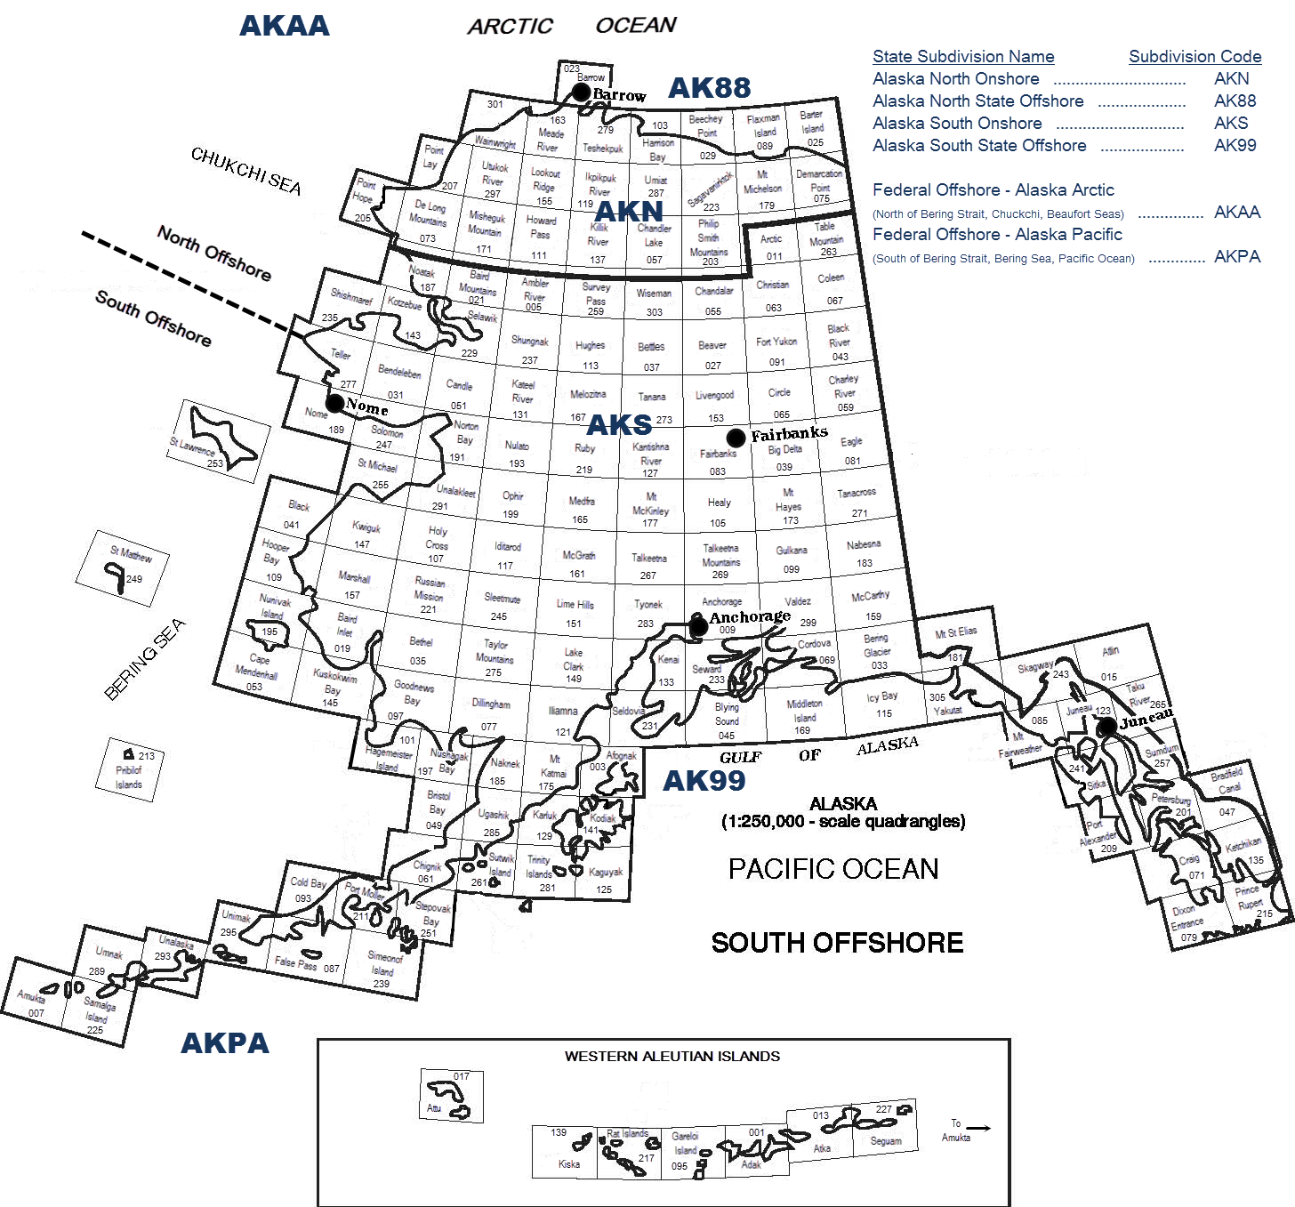

Alaska Subdivisions and U.S. Geological Survey Quadrangles

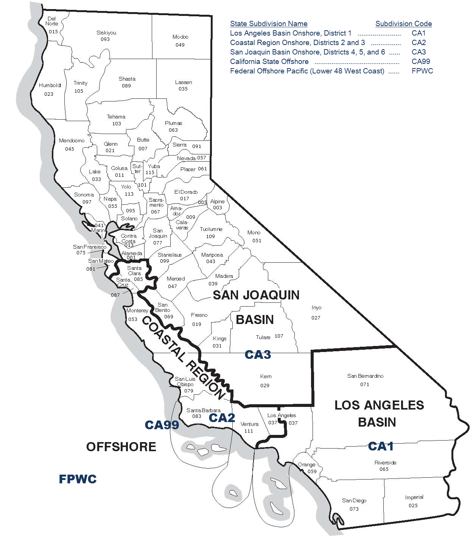
Source: Energy Information Administration, Office of Oil, Gas, and Coal Supply Statistics.

Subdivisions of California
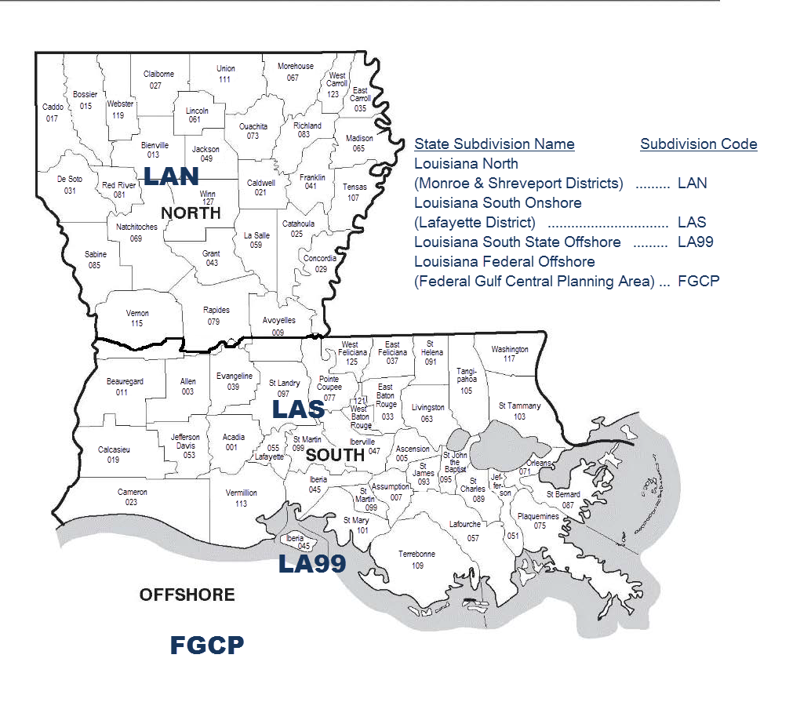

Source: Energy Information Administration, Office of Oil, Gas, and Coal Supply Statistics
Subdivisions of Louisiana
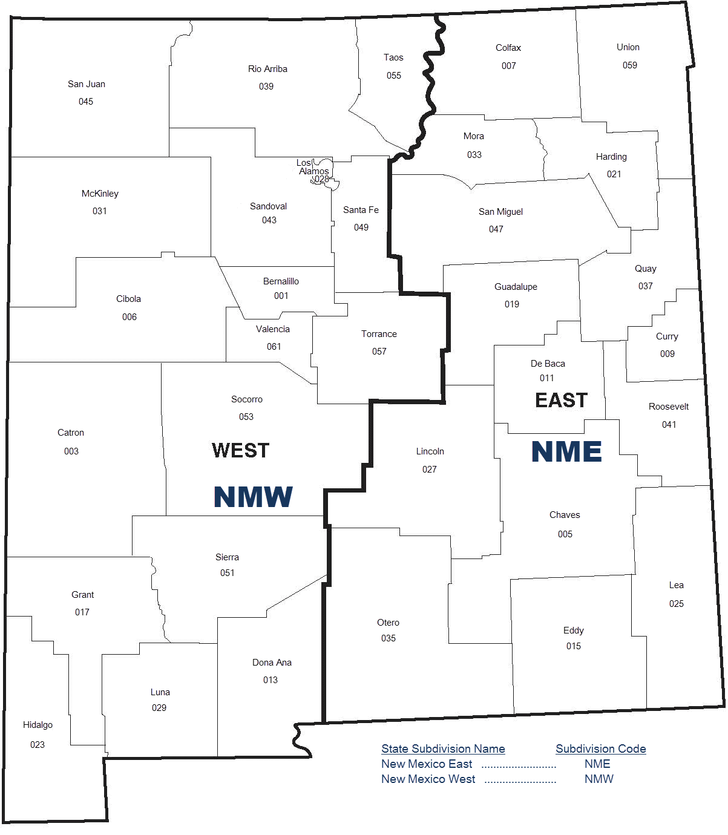

Source: Energy Information Administration, Office of Oil, Gas, and Coal Supply Statistics

Subdivisions of New Mexico

Subdivisions of Texas

Western Planning Area, Gulf of Mexico Outer Continental Shelf Region

Source: U.S. Department of the Interior
Central Planning Area, Gulf of Mexico Outer Continental Shelf Region

Source: U.S. Department of the Interior

Eastern Planning Area, Gulf of Mexico Outer Continental Shelf Region

Source: U.S. Department of the Interior.

Energy Information Administration

Secure File Transfer System
Welcome to EIA’s Secure File Transfer System. Following are the instructions for sending your Excel and .Dat files to EIA by HTTPS.

- Open your browser and type in the URL:

https://signon.eia.doe.gov/upload/noticeoog.jsp

The Secure File Transfer Notice to Users page will come up.

- If you wish to continue, press the Accept button with your mouse. The Secure File Transfer page will come up.

- You may navigate through the boxes on the page either with the tab key or with your mouse.

- Type your name, company name, phone number and email address into the boxes provided. Note that the email address is required so that we can send you a confirmation of the receipt of your data.

- In the yellow box, select the Browse button after File 1.

- A dialog box will come up which will allow you to find the file on your hard drive or other mapped drives. Select the file with a double mouse click (or single mouse click on the file and mouse click on the Open button). The name will appear in the white box on the Secure File Transfer page. (Note that you can type in the full path of the file if you wish, but there is a greater chance of making a mistake.)

- If you have other files that you want to transfer, repeat steps 6 and 7 up to four more times.

- If you want to start over with the file selection, select the Reset button.

- If you are ready to submit your files, select the Submit button. Please be patient; it may take a minute or two to upload your files. Do not close your browser during the upload. Wait to see the confirmation page.

- A confirmation page will be displayed that will tell you the names of the files you have transferred, the confirmation number for each file, and the date and time of the transfer.

- If you have more files to transfer, select the Back to Secure Upload button to return to the Secure File Transfer page. Your contact information will remain, but the file section will be empty.

- Repeat steps 6-10.

- When you are finished, close your browser by clicking on the X in the upper right corner.

- If you have any trouble transferring your files, please call the EIA-23L Coordinator at 800-879-1470.

About Transferring Files Securely with HTTPS:

EIA is ensuring the security of your transactions by using the latest Internet security technology. The technology being used to protect your data is encryption which is the scrambling of data into a code that is unreadable to anyone who does not have the key that deciphers it. The secure hypertext transfer protocol (HTTPS) is a communications protocol designed to transfer this encrypted information between computers over the World Wide Web. All information is protected by 128-bit encryption to maintain the privacy and confidentiality of your data. The only thing you need to take advantage of strong encryption technology is a secure browser, one that supports 128-bit encryption.

A conventional reservoir is a porous sedimentary rock formation (e.g., sandstone, limestone, or dolomite) with enough naturally occurring permeability to permit oil or natural gas to readily flow to a wellbore.

