Stateside Add Process:
1) Address Status
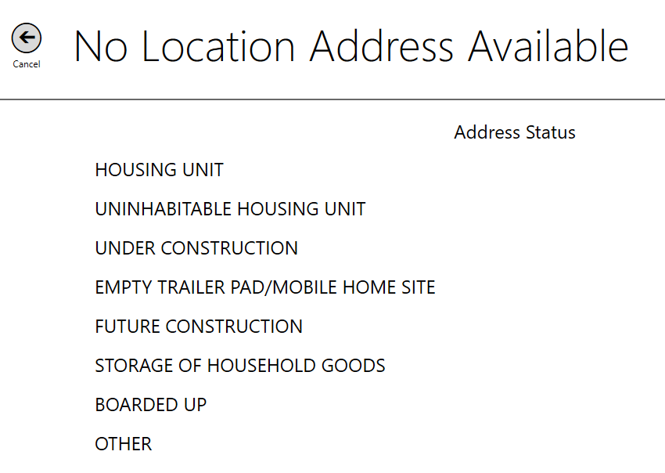
2) Structure Type:
3) Location Address:
Location Address Help Screen:
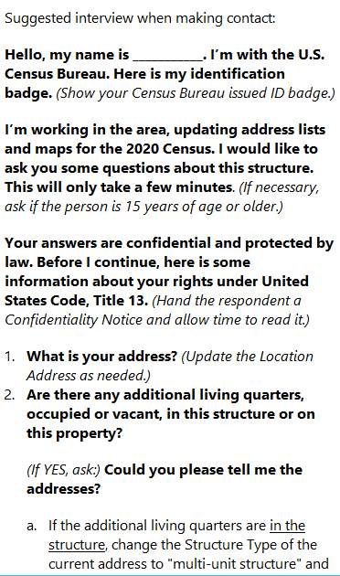
Address Canvassing OMB Approval Numbers Example from Help Screen:
4) Contact made?
5) Mailing Address:
Mailing Address Help Screen:
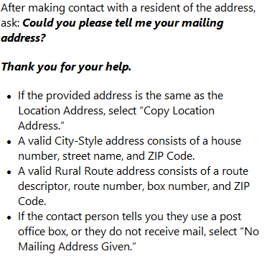
6) Mapspot:
7) Structure type-multiunit structure
Location Address Help Screen for Multiunit Structure:
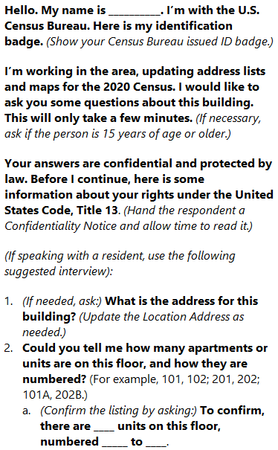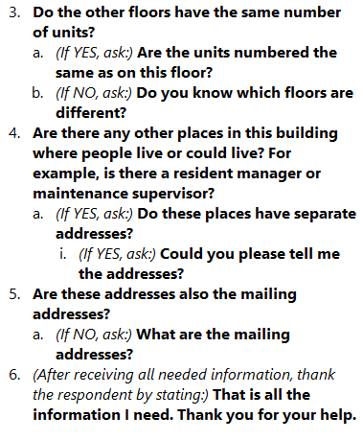

8) Does another address need to be added to this structure?
9) Structure Type: Trailer/Mobile Home
10) Structure Type: Boat, Tent, etc

11) Coverage Question:
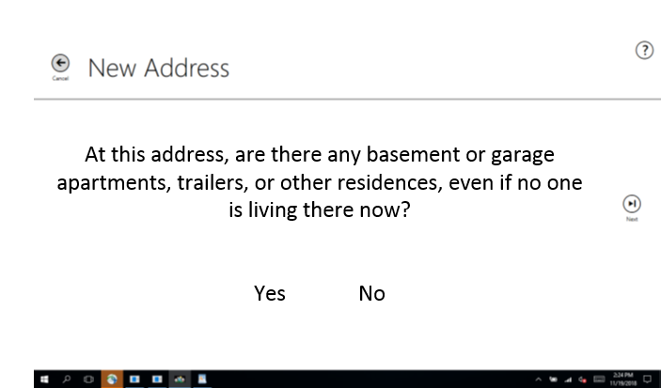

12) Location/Physical Description
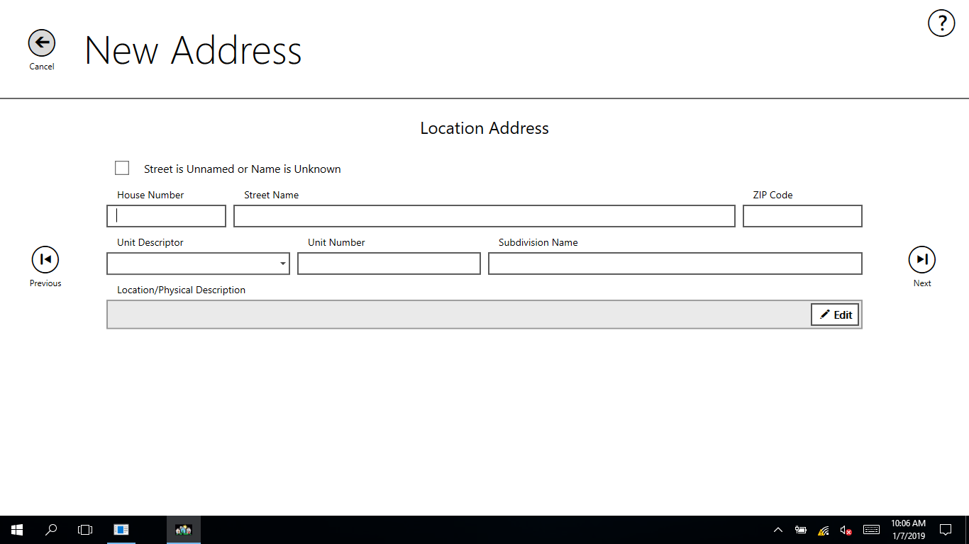

Puerto Rico Add Process:
- Address Status (language will be translated for PR at a later time):
- Structure Type:
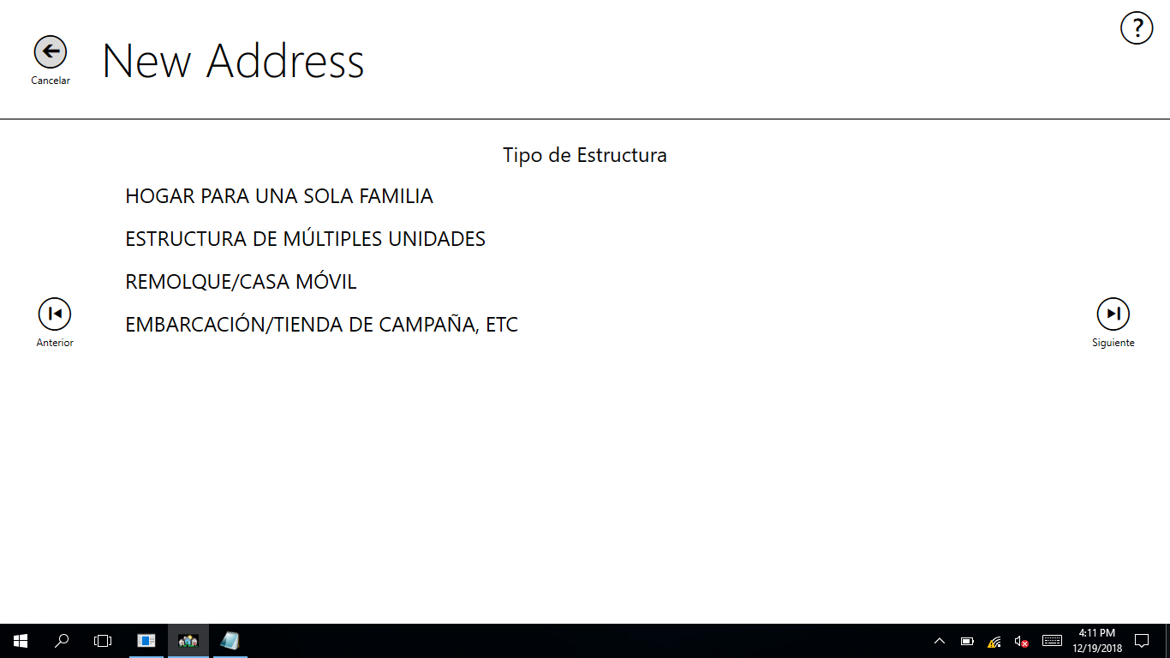
- Location Address (single family home, trailer/mobile home, boat/tent/etc)- General:
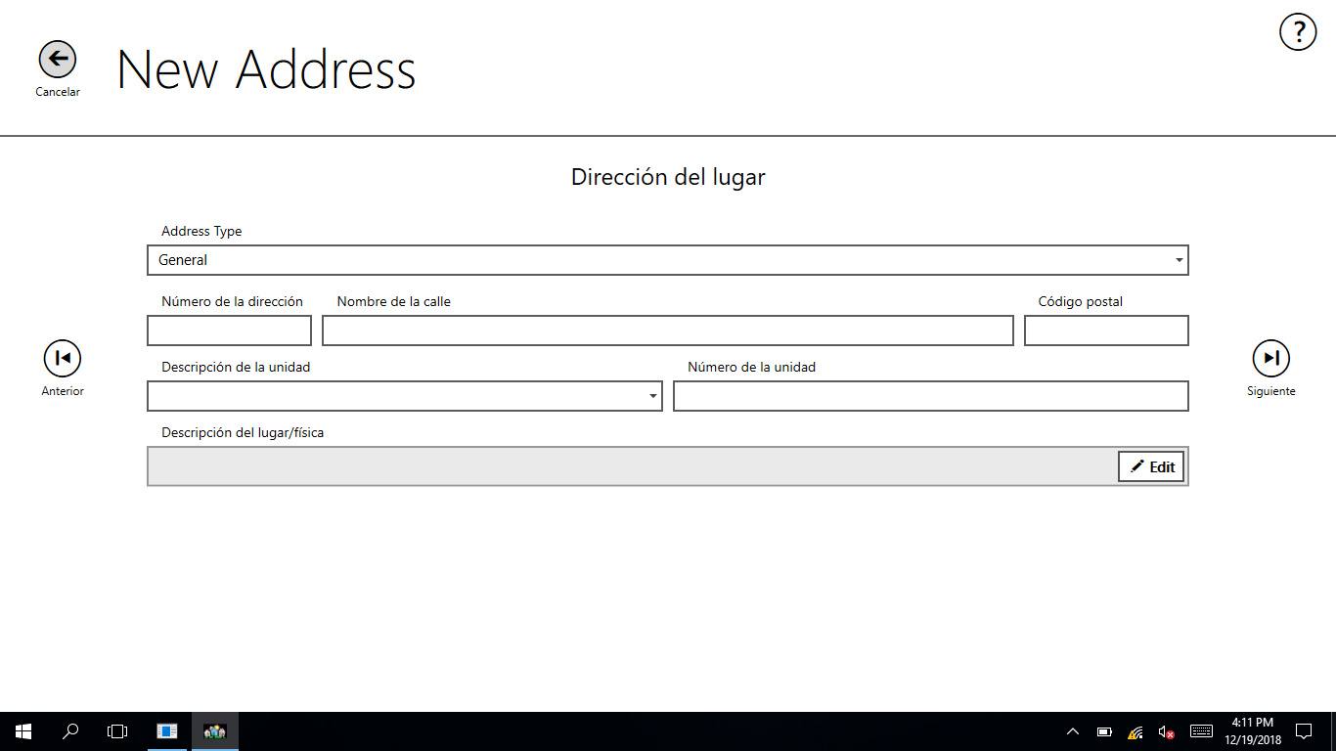
3) Location Address (single family home, trailer/mobile home, boat/tent/etc)- Nombre de Area:
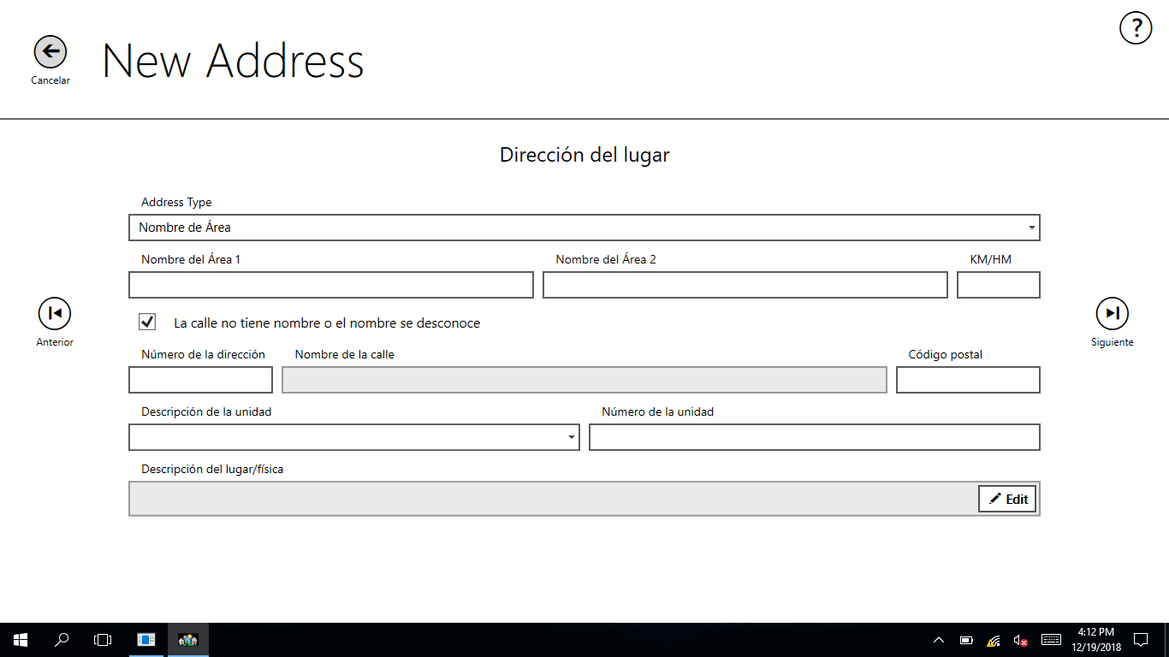

3) Location Address (single family home, trailer/mobile home, boat/tent/etc)-Urbanizacion:
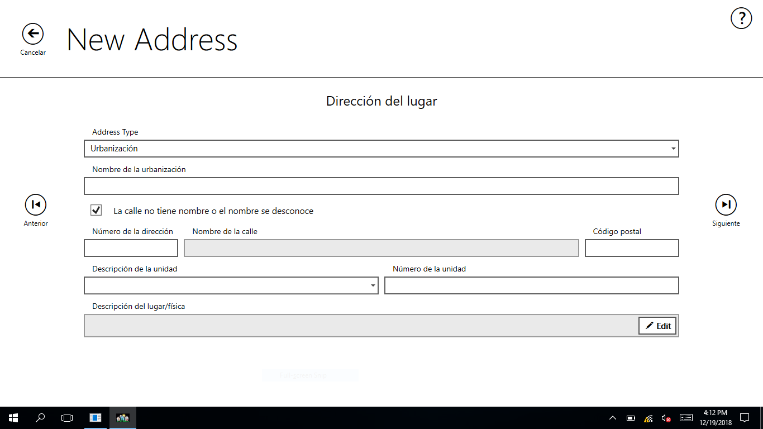
4) Contact made?
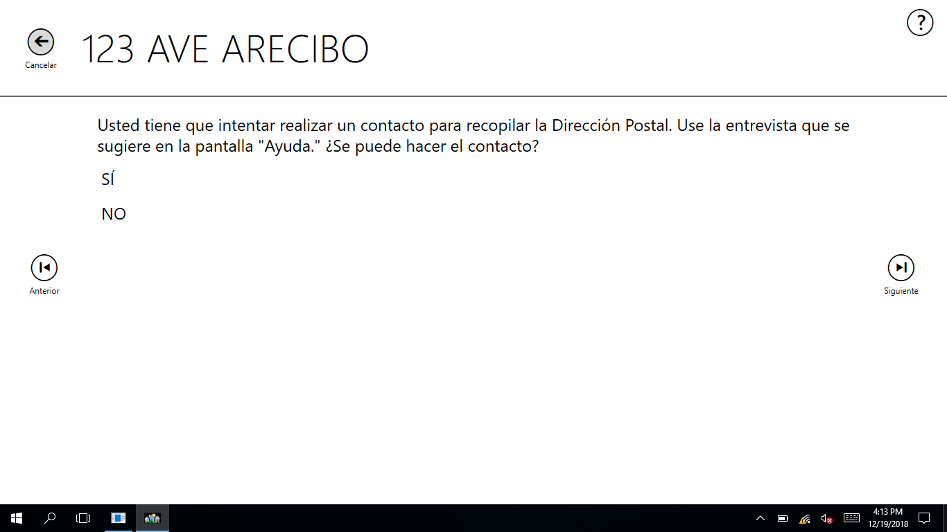

5) Mailing Address (single family home, trailer/mobile home, boat/tent/etc)- General:
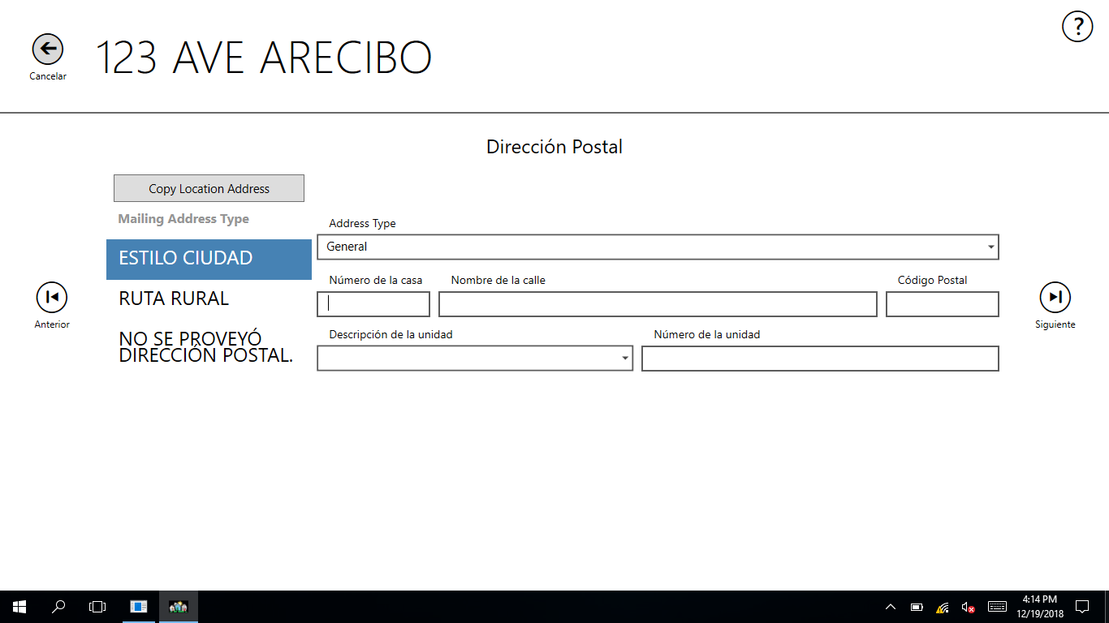
5) Mailing Address (single family home, trailer/mobile home, boat/tent/etc) - Urbanizacion:
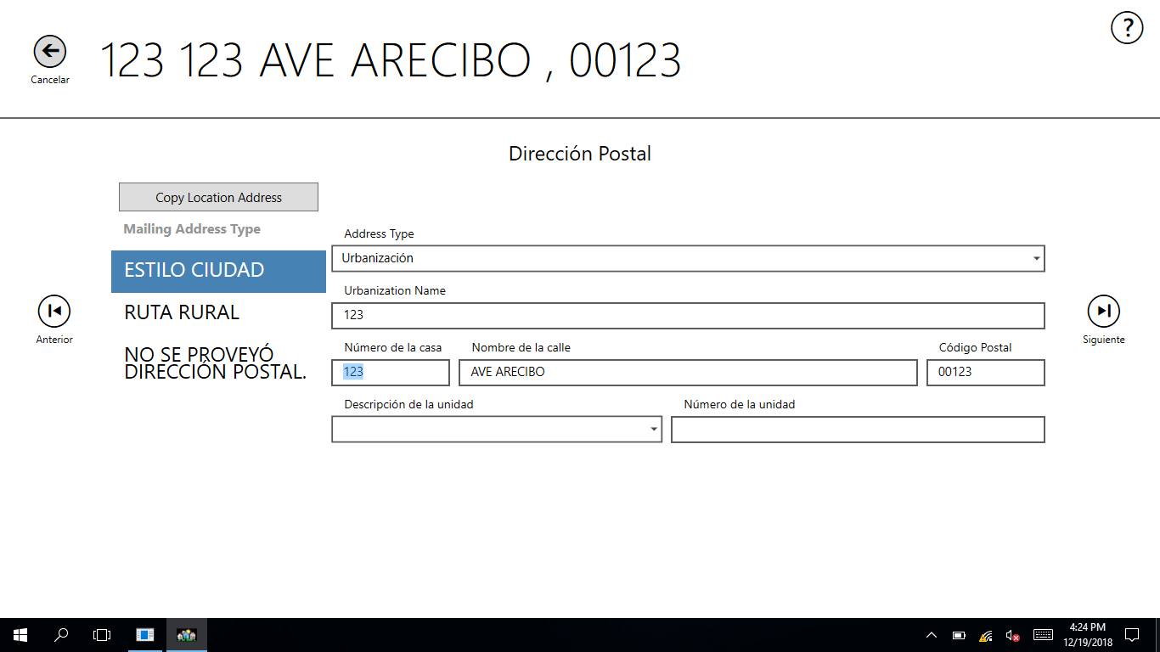

5) Mailing Address (single family home, trailer/mobile home, boat/tent/etc) – Nombre de Area:
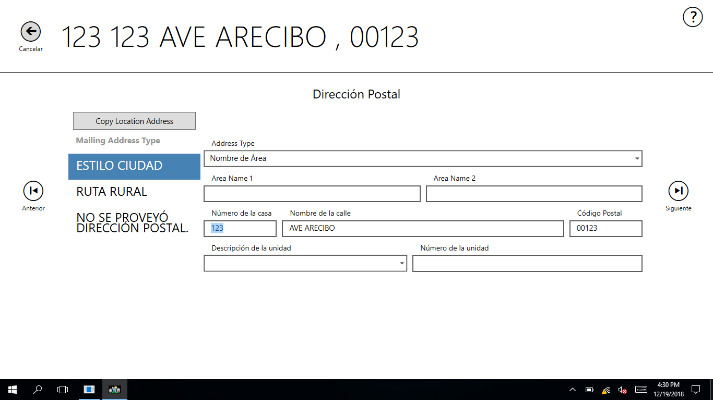

3) Location Address (Multiunit) – Urbanizacion:
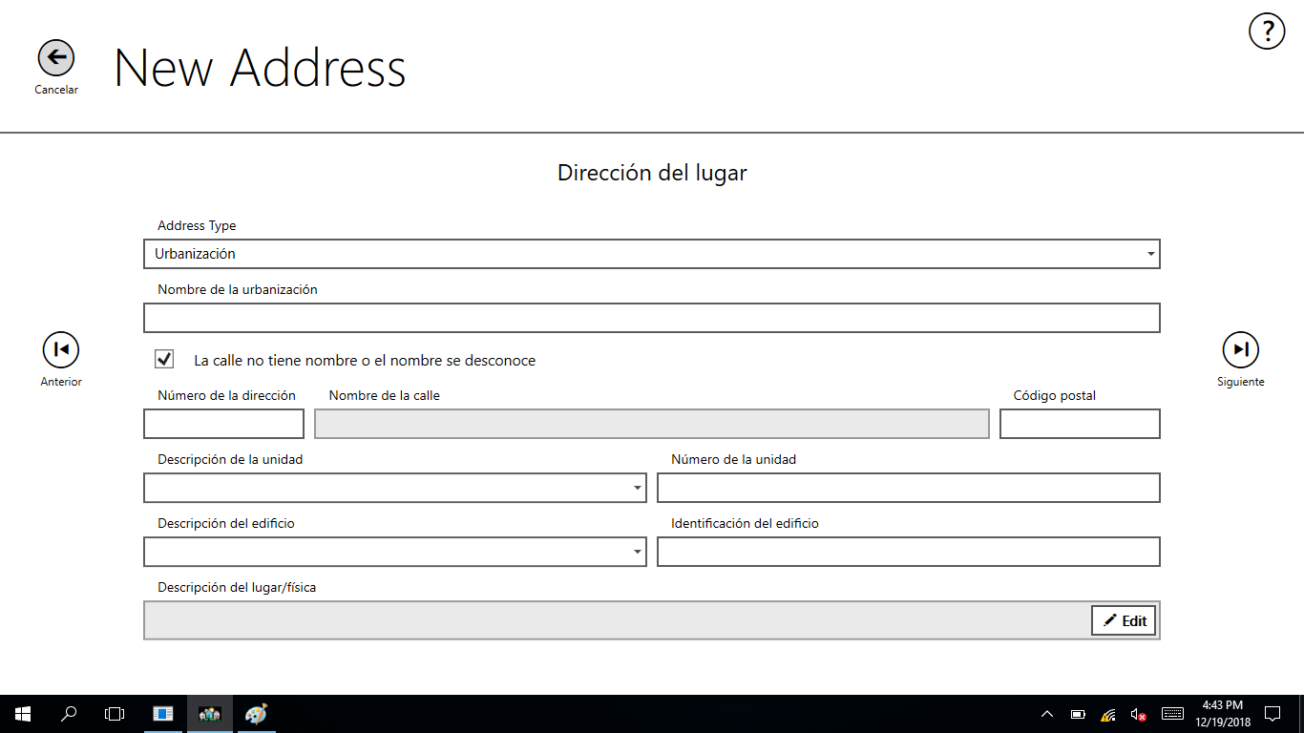
3) Location Address (Multiunit) – General
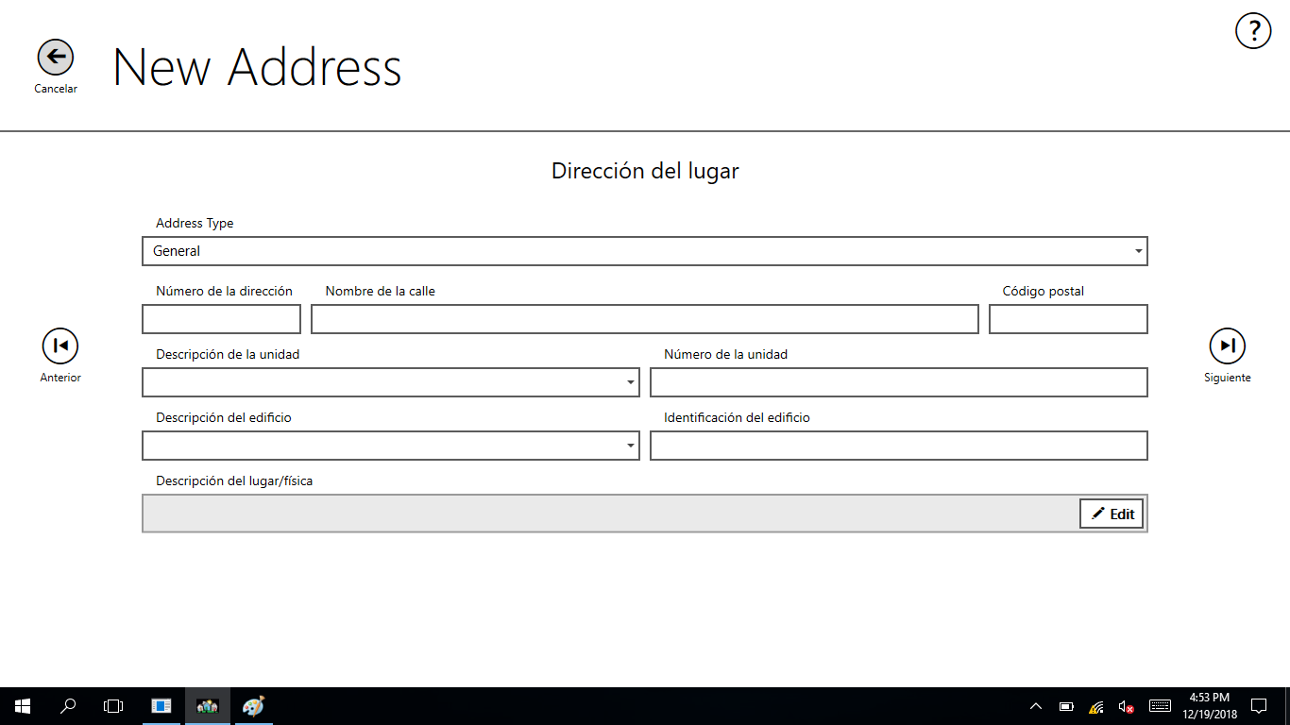

3) Location Address (Multiunit) – Condominio o Residencial
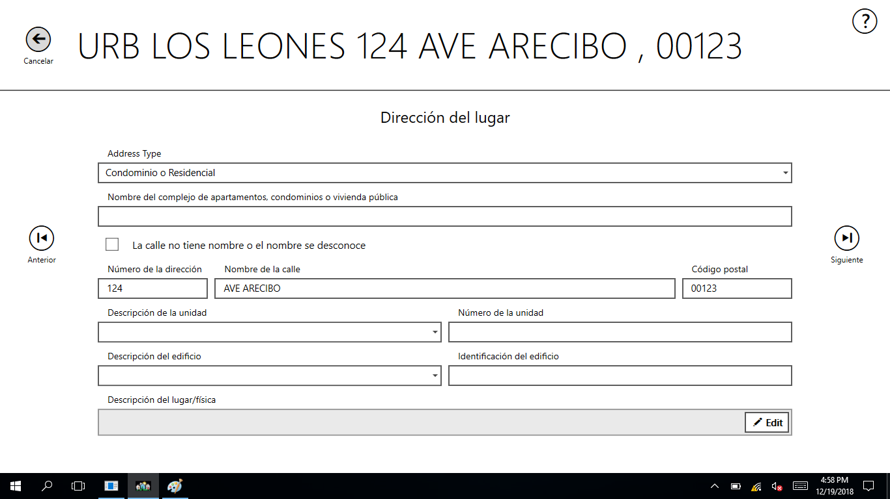
3) Location Address (Multiunit) – Nombre de Area
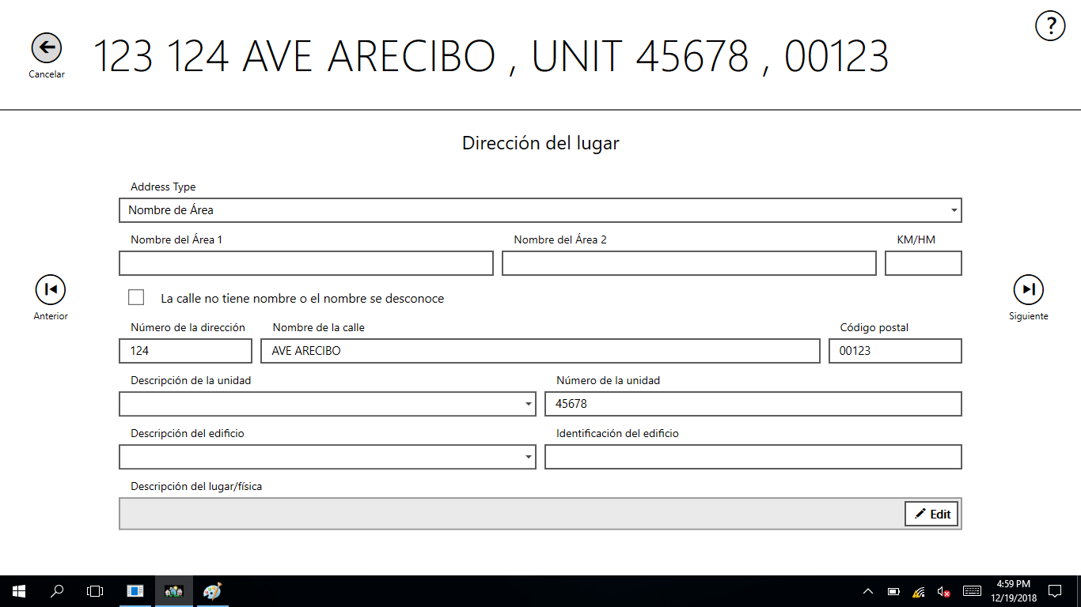

5) Mailing Address (Multiunit) – Urbanizacion
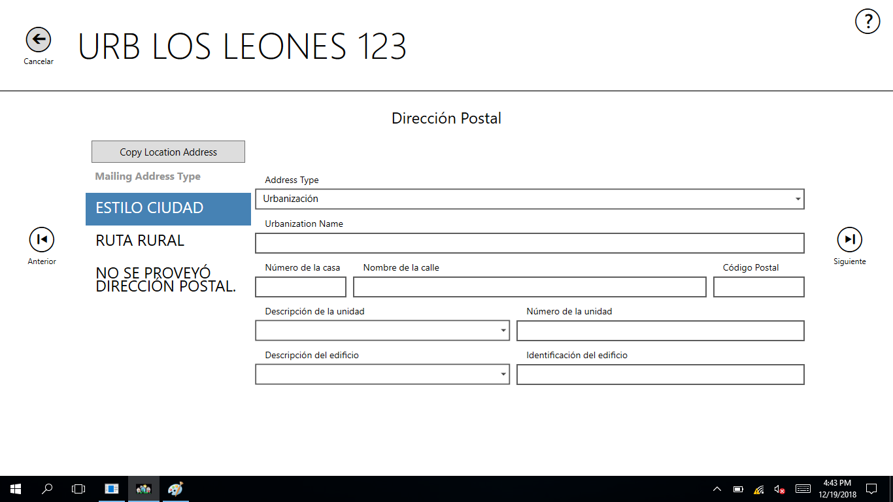
5) Mailing Address (Multiunit) – Condominio o Residencial
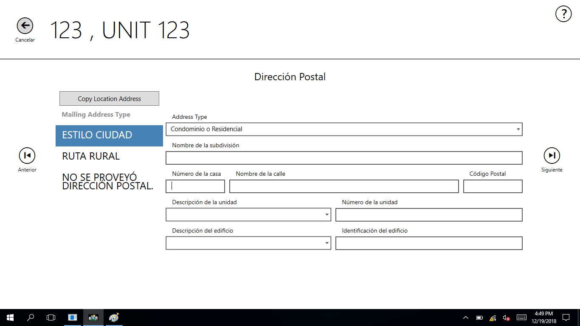

5) Mailing Address (Multiunit) – Nombre de Area
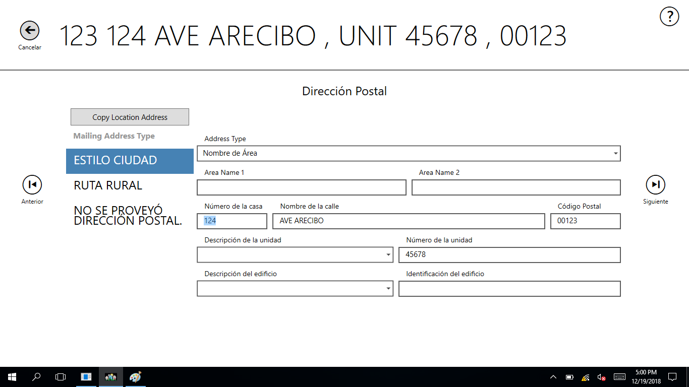
5) Mailing Address (Multiunit) – General
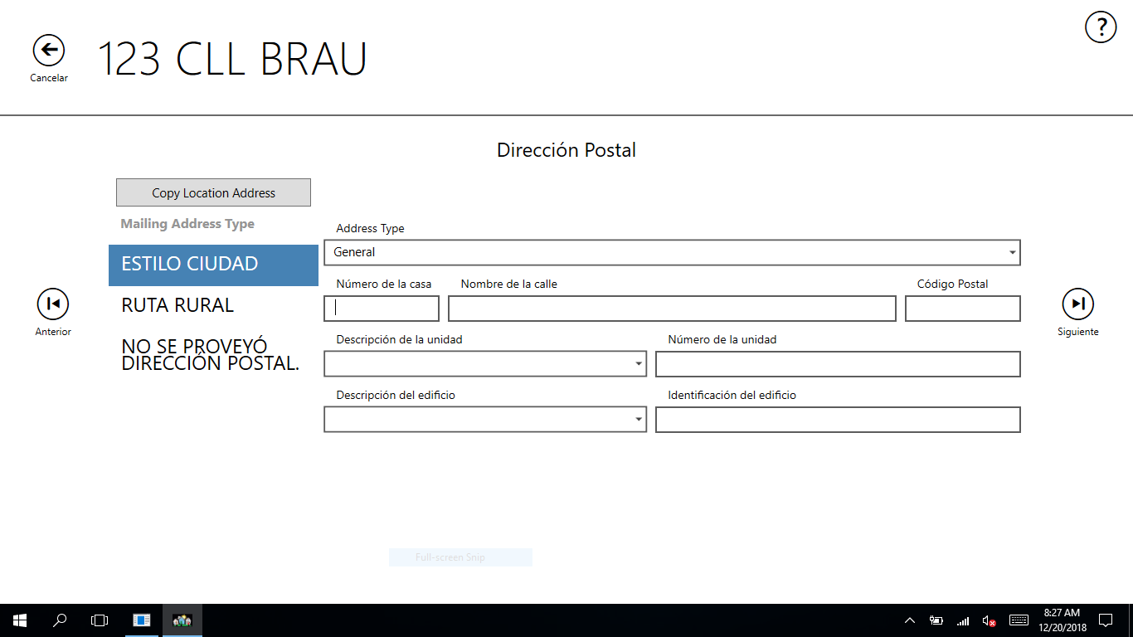
8) Does another address need to be added to this structure (multiunit)?
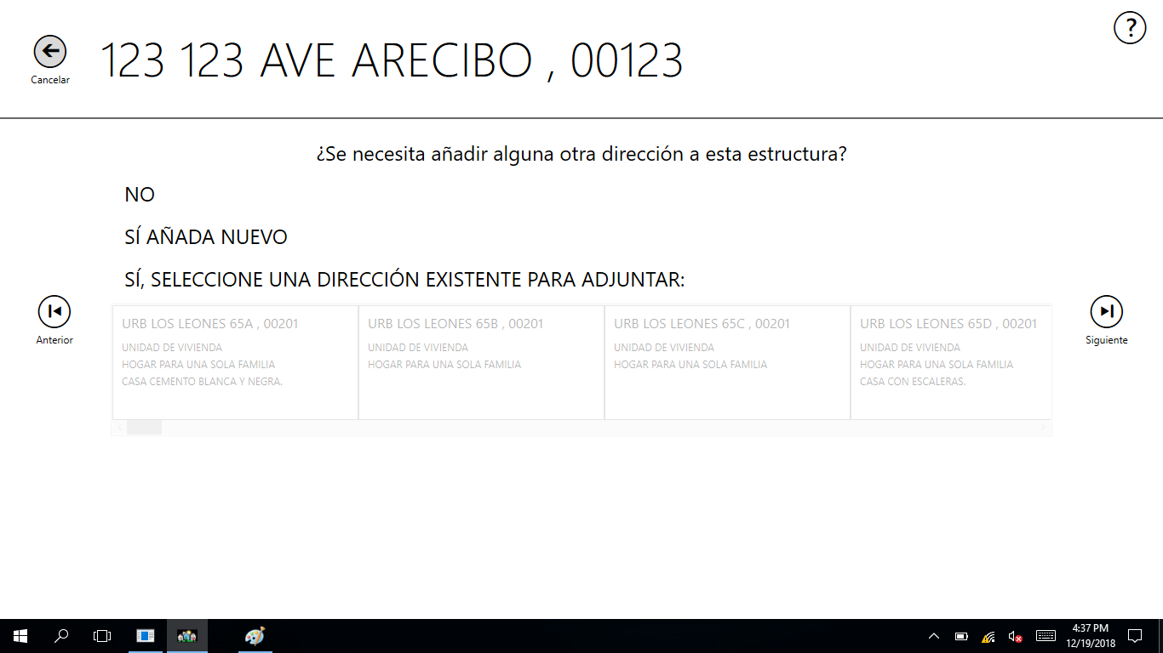

11) Coverage Question (language will be translated for PR at a later time):

12) Location/Physical Description
