Annual Wholesale Trade Survey (0607-0195)
Non-substantive Change Request

This non-substantive change submission covers the proposal to add 'Ceased Operation' option to existing Organizational Change question on all five of our forms (SA-42, SA-42A, SA-42A-MSBO, SA-42-agbr and SA-42A-agbr) and adding the existing purchases question to the agent and broker forms (SA-42-agbr and SA-42A-agbr) for Survey Year 2019.
CEASED OPERATION:
We are proposing the addition of 'Ceased Operation' as an option for selection to the existing Organizational Change question. The current question options do not capture closures/deaths that occurred during or prior to the survey year. Therefore, companies in this situation are required to complete the entire survey - even though they may not have any responses for the current survey year.
Exiting question:
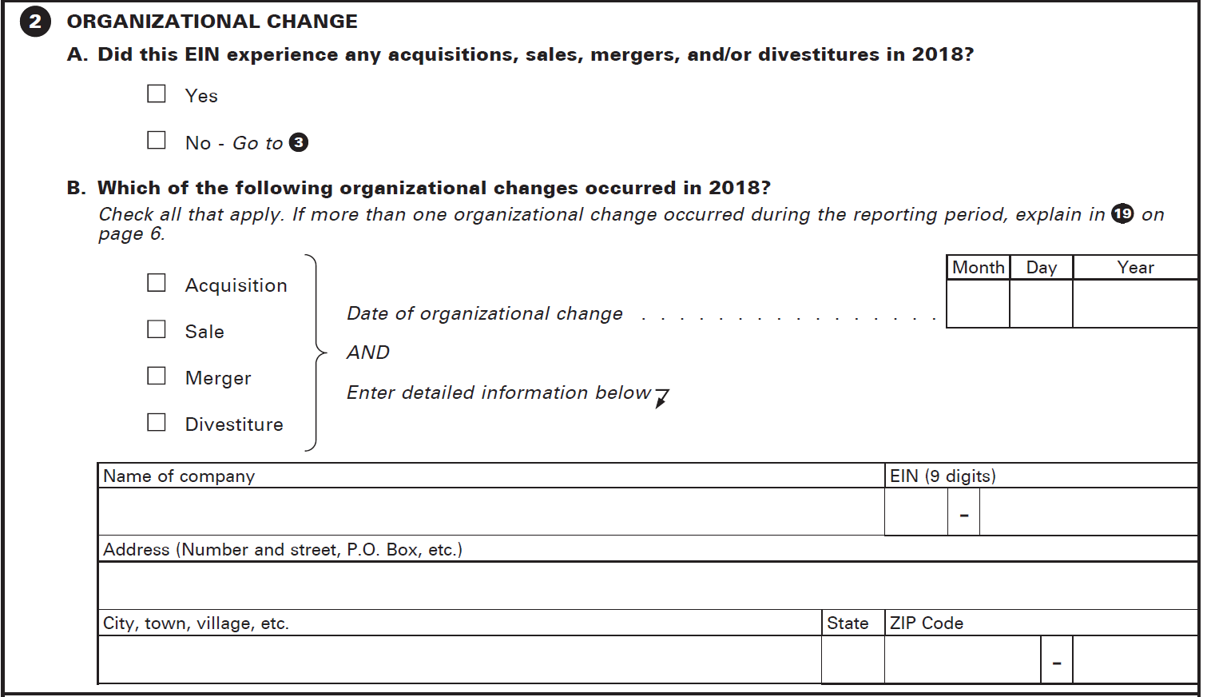
Proposed question (detailed company information lines will remain):
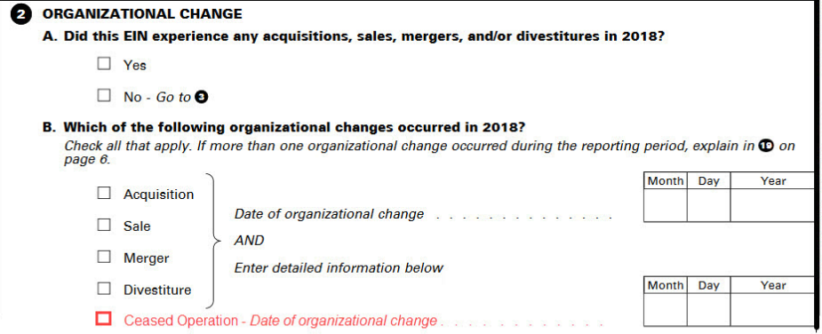
This change would affect all 5 of the existing forms and would reduce unnecessary respondent burden for companies that ceased operation prior to the survey year. Within the current instrument, companies that have 'Ceased Operation' (closure/death) during or prior to the survey year have to continue throughout the entire survey. Within the proposed instrument, companies that report out of business due to 'Ceased Operation' (closure/death) and the change date is prior to the survey year would be skipped to the end of the survey. Companies that report out of business due to 'Ceased Operation' (closure/death) and the change date was during the survey year would continue to flow through the remainder of the survey in order to capture their part-year data.
PURCHASES:
We are proposing the addition of the existing purchases of products question to be added to our agent and broker forms (SA-42-agbr and SA-42A-agbr). This question is currently on our distributor forms (SA-42 and SA-42A) and asks for information regarding purchases of products for resale. The question (as it is stated on distributor forms) is below:
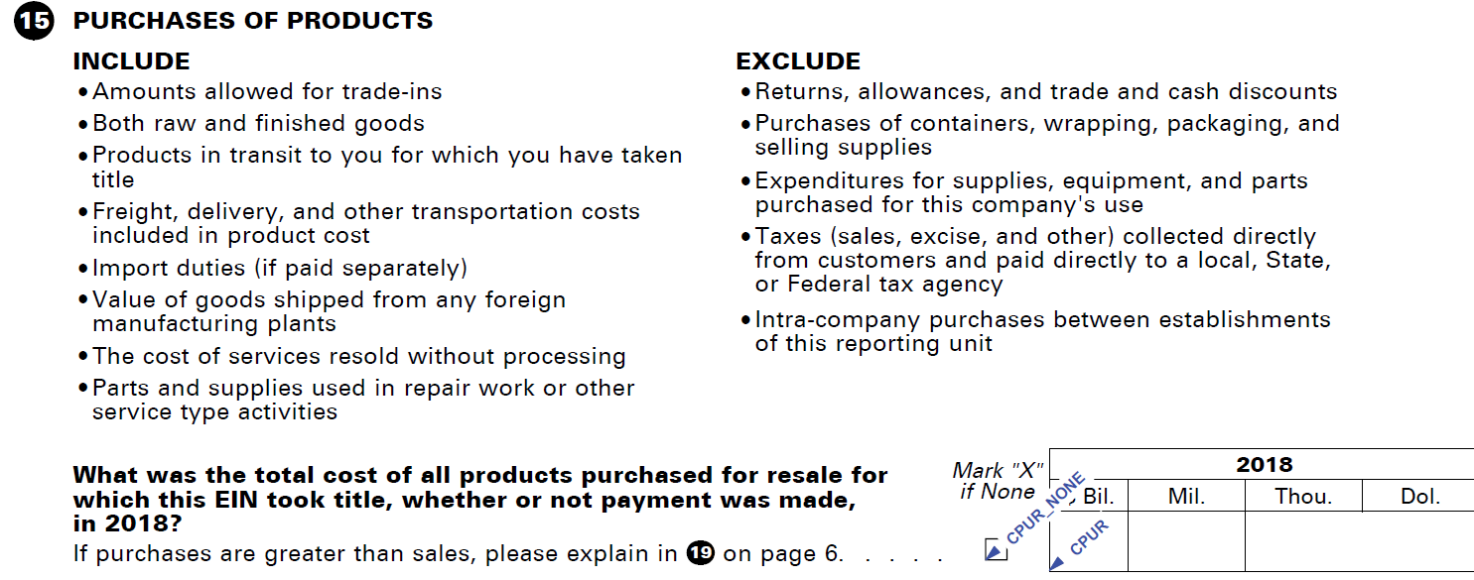
Adding this question to the agent and broker forms would be primarily used for data analysis purposes. At this time, we do not plan to publish this data. However, if the data quality eventually meets Bureau standards for dissemination, we would like to publish this in the future. Agents mainly make commissions on the sale of others’ goods but they also can make purchases on their own account and sell those goods. We currently ask agents and brokers (agbrs) to provide commissions (the amount they made as a commission from the sales made on the account of others) and the amount of sales they made on their own account (of products they purchased and took title to). These items are often misreported and require a call to the company and /or analyst editing. The addition of the purchases question will assist analysts in making a decision on whether or not the purchases on own account seems reasonable without having to further burden the company with a follow-up to verify data reported.
Having this information also will assist in classification. Agents and brokers would be wholesale distributors if their revenue from their own sales outweigh their revenue from commissions.

BURDEN:
The current burden of this collection is 11,085 hours. This burden is based on collecting the Business Expense and tax questions during survey year 2017 (collected in 2018) which are included only once every 5 years. Our OMB clearance request submitted October 24, 2017 documented this burden and also our intention to reduce this burden to 4,597 hours for survey year 2018. The changes documented above will have the net effect of reducing this burden to 4,586 hours.
The burden reduction for ceased operation is based solely on available counts of cases that we know could have utilized the ceased operation option to skip the form questions. Only 57% of the total mailed cases had payroll data and were able to be considered in the burden reduction calculation. We believe there are more cases that we are currently unable to identify, that could benefit from this additional option to further reduce the overall burden. Alphas data is hard to estimate, since most payroll data is available by establishment or EIN and therefor mainly on Single-Unit cases.
Based on our experience with fielding the purchases question already existing on the distributor forms, we do expect respondents to readily have the information, resulting in little additional burden. For the 2018 Annual Wholesale Trade Survey the agent and broker forms each require about 24 minutes to complete. The additional burden to report this question is estimated at 3 minutes on average. Therefore, the addition of this question may increase the burden hours for agbr forms to 27 minutes or 0.45/hr. See the table below for budget impacts.
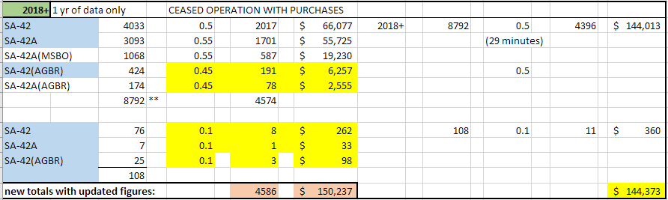
Total burden impact of both proposed changes would be:

