Attachment P1: Youth Cognitive Interview Guide
Understanding Use of Electronic Vapor Devices (EVDS) among Youth
December 1, 2017
This guide will be used by the cognitive interviewer. Participants will receive a questionnaire that does not include any probes (shown in textboxes) or skip pattern instructions.

Welcome and thank you for participating in today’s interview. This interview is being sponsored by the Centers for Disease Control and Prevention (also known as the CDC). We are interested in hearing your opinions about electronic vaping devices. These are battery powered devices that generate a vapor which users inhale.

[NYTS 2017]
- What do you call these devices shown below?

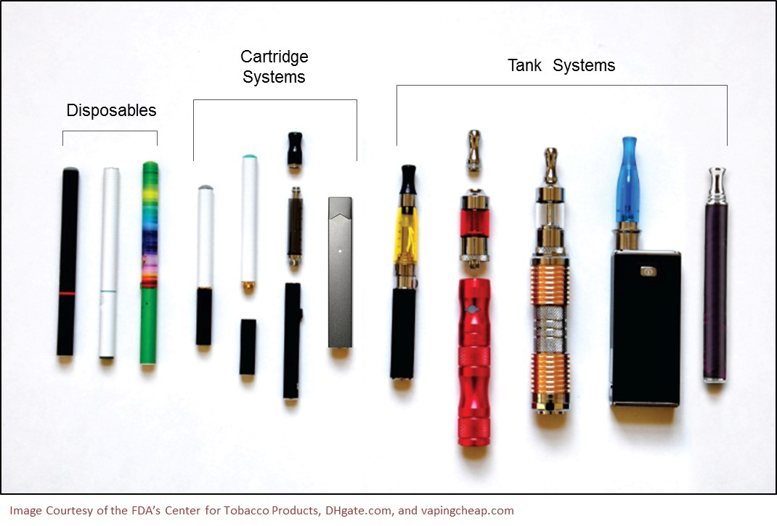

- What have you heard other people call them?
- In your opinion, is there one name or term that you think describes all of these things? (Or, are these different types of products?)
- Have you heard the term electronic vaping devices before? What about the word e-cigarettes? Vaping?
- There are many different terms and names people use to describe these products. You may also know them as electronic cigarettes, e-cigarettes, e-cigs, vape-pens, hookah-pens, e-hookahs, e-cigars, e-pipes, personal vaporizers, or mods. Some brand examples include NJOY, Blu, Vuse, MarkTen, Logic, Vapin Plus, eGo, Halo, and Juul. Which ones in this list seem familiar? Which product names have you not heard before? Have you heard of mods?
- What term is best for our questionnaire if we want everyone or almost everyone to understand it?
- Which sounds more familiar to you: electronic vaping devices or electronic vaping products?
- If part of a survey question said that “Electronic vaping devices are battery powered devices that usually contain a nicotine-based liquid that is vaporized and inhaled.”
  - Does this sentence make sense to you? What are you picturing when you read this?
  - What does “vaporized” mean to you?
What does “nicotine-based liquid” mean to you? Could you guess what this term means?

[1]

Have you ever been curious about using an electronic vaping device?

- Definitely yes
- Probably yes
- Probably not
- Definitely not

[NYTS 2017, Q27]
- How did you choose your answer? [NOTE: DO NOT ASK THIS FIRST PROBE IF PARTICIPANT EXPLAINS THEIR RESPONSE.]
- What does it mean to be “curious” about using an e-cigarette?
- Is there another word besides ‘curious’ that teens use to describe their interest in electronic vapor devices

[2]

Have you ever used an electronic vaping device, even once or twice?

- Yes
- No

[NYTS 2017, Q28]
- [IF YES] What kind of device did you use?
- What does it mean to “use” an electronic vaping device? What does “use” mean here?
- Would you give a different answer if this question asked about using an e-cigarette? Or do you think those questions are asking the same thing?
- Do you think there is a difference between e-cigarettes and electronic vaping devices or do you think of them as being the same type of thing?

ASK IF 2 = YES.

[3]

How old were you when you first tried using an electronic vaping device, even once or twice?

- I have never used e-cigarettes
- 8 years old or younger
- 9 years old
- 10 years old
- 11 years old
- 12 years old
- 13 years old
- 14 years old
- 15 years old
- 16 years old
- 17 years old
- 18 years old
- 19 years old or older

[NYTS 2017, Q29]
[NOTE TO INTERVIEWER: LOWER PRIORITY ITEM. DO NOT SPEND A LOT OF TIME ON THIS QUESTION.]
- Did you guess or were you certain about your response?
- What does it mean to “try an e-cigarette once”? What does it mean to “try an e-cigarette twice”?

ASK IF 2 = YES.

[4]

In total, on how many days have you used electronic vaping devices in your entire life?

- 0 days
- 1 day
- 2 to 10 days
- 11 to 20 days
- 21 to 50 days
- 51 to 100 days
- Over 100 days

[NYTS 2017, Q30]
- How did you figure out your answer?
- Did you guess or did you know the exact answer?
- What does it mean to use an electronic vaping device on “one day”?
- [IF PARTICIPANT SELECTS C-G] You selected X. Were you counting actual different days you used e-cigarettes, or were you merely counting the different times you used the device? Did you use different devices on different days, or did you use the same device?
- What if this question said, “On how many days have you vaped?” Would that question make sense to you? Do the terms “used” and “vaped” mean the same thing?

ASK IF 2 = YES.

[5]

During the past 30 days, on how many days did you use electronic vaping devices?

- 0 days
- 1 or 2 days
- 3 to 5 days
- 6 to 9 days
- 10 to 19 days
- 20 to 29 days
- All 30 days

[NYTS 2017, Q31]
- Did you guess or did you know the exact range of days?
- Did you notice that this question asked about the past 30 days? What does 30 days mean to you?
- [NOTE: DO NOT ASK THIS PROBE IF ALREADY ASKED ABOVE.] [IF PARTICIPANT SELECTS B-G] You selected X. Did you use different devices on different days, or did you use the same device?

[6]

During the past 30 days, where did you get or buy the electronic vaping devices that you have used? (Select one or more)

- I have never tried an e-cigarette in the past 30 days
- A gas station or convenience store
- A grocery store
- A drugstore
- A mall or shopping center kiosk/stand
- On the Internet
- A vape shop or other store that only sells e-cigarettes
- Some other place not listed here
- From a family member
- From a friend
- From some other person that is not a family member or a friend

[NYTS 2017, Q32]
[NOTE TO INTERVIEWER: IF PARTICIPANT DOES NOT USE EVPs, ASK THEM ABOUT THIS QUESTION IN GENERAL.]
- What is the difference between “getting” and “buying” electronic vaping devices?
- Which products did you buy? Which ones did get?
- Have you bought e-cigarettes from anywhere else (other than what is listed here)?
- Have you gotten e-cigarettes from anyone else (other than what is listed here)?
- In your opinion, are vape shops and smoke shops similar or different? Why? [IF SIMILAR] Do you think we should combine vape shop and smoke shop here?
- Were you thinking about the past 30 days when you answered this question or were you thinking about in general?

[7]

Do the electronic vaping devices you usually use contain nicotine?

- Yes
- No
- Don’t know

[ADAPTED FROM PATH ADULT SURVEY]
[NOTE TO INTERVIEWER: IF PARTICIPANT DOES NOT USE EVPs, ASK THEM ABOUT THIS QUESTION IN GENERAL.]
- What if this question asked about the past 30 days – would your response change? What if it asked about the past year?
- Do you know what nicotine is? How would you describe it?
- Do you know if your electronic vaping device contains nicotine? If so, how much nicotine?
- [IF PARTICIPANT DOESN’T USE EVPs] Do you know if other people your age use electronic vaping devices that contain nicotine?
- Let’s look at a slightly different question on the next page…

[8]

What strength electronic vaping device do you use most often?

    - No nicotine
    - Light (10 milligrams of nicotine or less)
    - Medium (11-17 milligrams of nicotine)
    - Strong (18-23 milligrams of nicotine)
    - Extra strong (24 milligrams of nicotine or more)
    - I don’t know

[ADAPTED FROM CALIFORNIA STUDENT TOBACCO SURVEY, 2017-2018]
            - Does this question make sense to you?
              - Do you think people will understand it when they read it?
              - Do you think they will understand the response options?
- Which question would it be easier for you to understand, this one, or the one on the previous page?
- How do you know if an electronic vaping device contains nicotine?

ASK IF 2 = YES.

[9]

During the past 30 days, what brand of electronic vaping device did you usually use? (Select 1)

- JUUL
- Vuse
- MarkTen
- blu
- A mod not listed here
- Another brand not listed here
- Not sure

[NOTE: IF PARTICIPANT DOES NOT USE EVPs, ASK THEM ABOUT THIS QUESTION IN GENERAL.]
      - Tell me how you chose your answer. [NOTE: DO NOT ASK IF PARTICIPANT EXPAINS THEIR ANSWER.]
      - Did you notice this question asked about the brand that you “usually” use? Was it hard to pick your ‘usual’ brand. What if we allowed you to pick more than one?
      - Have you heard of the word JUUL before? Have you ever heard of Juul? What have you heard about it? Do you know anyone who uses it?
      - In your own words, what is a mod?
      - What other brands should we include in this list because they’re used a lot?

[10]

What are the reasons you have used electronic vaping devices? (Select one or more)

- Friend or family member used them
- Friends or classmates pressured me into it
- To do tricks
- These devices are cool
- To help me quit other tobacco, such as cigarettes
- They cost less than other tobacco products, such as cigarettes
- They are easier to get than other tobacco products, such as cigarettes
- They are less harmful than other tobacco products, such as cigarettes
- They are available in flavors, such as mint, candy, fruit, or chocolate
- They can be used at times or in places where smoking cigarettes isn’t allowed
- I used these devices for some other reason
- I have never tried an electronic vaping device

[ADAPTED FROM NYTS 2017, Q33 AND PATH SURVEY]
[NOTE TO INTERVIEWER: IF PARTICIPANT DOES NOT USE EVPs, ASK THEM ABOUT THIS QUESTION IN GENERAL.]
- How did you choose your answer(s)? Were you thinking of reasons that made you use e-cigarettes the first time, or were you thinking of reasons why you currently use them?
- Are any of these choices confusing to you?
- Are there any other reasons that we didn’t list here? Do you know of other reasons people in your grade use e-cigarettes?

[11]

Have you ever used an e-cigarette or electronic vaping device to use marijuana?

    - Yes
    - No

[ALTERNATIVE WORDING FOR NYTS 2017, Q34]
- How did you choose your answer? [DON’T ASK THIS PROBE IF PARTICIPANT EXPLAINS THEIR RESPONSE.]
- Is it clear that we’re asking if you have used marijuana by vaporizing it in an electronic vaping device? [IF NO] How were you thinking of using it? (smoke, eat, drink, dab)
- [IF NO] Have you heard of people using electronic vaping devices to use marijuana? [IF YES] How do they describe it or explain it?

[12]

In the last 30 days, how many days did you use an e-cigarette or electronic vaping device to use marijuana?

    - 1 or 2 days
    - 3 to 5 days
    - 6 to 9 days
    - 10 to 19 days
    - 20 to 29 days
    - All 30 days

[13]

Do you think that you will try an electronic vaping device soon?

- Definitely yes
- Probably yes
- Probably not
- Definitely not

[NYTS 2017, Q35]
- How did you choose your answer?
- What does this question mean by “soon”? What were you thinking of when this question asked about soon?
- What does “try” an electronic vaping device mean?
  - Would you use words like “trying a device”?
  - Would different wording be clearer? Like “use an e-cigarette”?
- What if we asked about “trying vaping” instead? Would that mean the same thing or would that be different?

[14]

Do you think you will use an electronic vaping device in the next year?

- Definitely yes
- Probably yes
- Probably not
- Definitely not

[NYTS 2017, Q36]
            - How did you choose your answer?
            - What is the difference between “soon” and “in the next year”?
            - How would you explain the difference between definitely and probably?
            - Should there be an extra choice between definitely and probably?

[15]

If one of your best friends were to offer you an electronic vaping device, would you use it?

- Definitely yes
- Probably yes
- Probably not
- Definitely not

[NYTS 2017, Q37]
- Why did you choose your answer?
- What does it mean to “offer someone an electronic vaping device”?

[16]

“Dripping” is a method of heating electronic vaping device liquid by dripping drops directly onto a heating element and then immediately inhaling. Have you ever used the dripping method to add e-liquid to your electronic vaping device?

  - Yes
  - No
  - Don’t know / Not sure

[STYLES 2017, DRIP 1]
- [IF NO] Have you ever heard of dripping? [IF YES] Where? How did you hear about it?
- [ONLY IF PARTICIPANT HAS HEARD OF DRIPPING] Do people usually call it dripping, or do they call it something else?
- When it says heating element, what is it referring to? What is a coil?
- Have you ever heard of e-liquid or “juice”?
- Do people use a different word for e-liquid? [NO] What about juice, e-juice, or syrup?

[17]

“Heat-not-burn” tobacco products heat tobacco sticks or capsules to produce an aerosol or “vapor.” They are different from electronic vaping devices such as e-cigarettes, which heat a liquid to produce an aerosol or “vapor.” Some brands of “heat-not-burn” tobacco products include iQOS, glo, Ploom TECH, and Revo. Before today, have you heard of “heat-not-burn” tobacco products?

  - Yes
  - No
  - Don’t know / Not sure

[STYLES 2017, 17. New]
- [IF NO OPTION SELECTED] Can you take a guess about what heat-not-burn tobacco products are?
- What do you think of this description?
  - Is it easy to follow?
  - What is especially helpful?
  - What is confusing?
- Can you describe what an aerosol is? What is it?
- What is the difference between aerosol and vapor?
- Have you ever heard of people say that the vape cloud is an aerosol? Do they call it a vapor? Anything else?
- Have you heard of tobacco sticks or capsules? What are they?

[18]

Thinking about all types of electronic vaping devices, have you used the disposable kind or rechargeable/refillable/tank kind?

    - I have never tried an electronic vaping device
    - Only the disposable kind
    - Only the rechargeable/refillable/tank kind
    - Both the disposable kind and rechargeable/refillable/tank kind

[NYTS 2016, Q34]
[NOTE TO INTERVIEWER: LOWER PRIORITY ITEM. OMIT AS NEEDED BASED ON AVAILABLE TIME.]
- Which types of electronic vaping devices were you thinking of when you answered this question?
- Did the first response option confuse you at all? Should we put it at the bottom?
- What is the disposable kind? What are you picturing?
- Does “rechargeable/refillable/tank kind” make sense to you?

[CLOSING]

I would like to thank you for coming here today and participating in this interview. CDC would like to thank you for sharing your opinions as they will be very useful in helping them to understand people’s reactions and thoughts about the survey questions we have talked about. CDC would like to remind you that there is no safe tobacco product, including the products we have talked about today. There are some fliers on the table that have more information. Please take one.

