Request for Approval under the “Generic Clearance for the Collection of Routine Customer Feedback” (OMB Control Number: 0938-1185)
TITLE OF INFORMATION COLLECTION:

End Stage Renal Disease Quality Reporting System (EQRS) Customer Satisfaction and Task Prioritization Survey for Release 1 of the EQRS redesign project.

PURPOSE:

The Centers for Medicare & Medicaid Services (CMS) Center for Clinical Standards and Quality (CCSQ) engaged the End Stage Renal Disease Quality Reporting System (EQRS) Business Requirements and Application Developer Organization (BRADO) contract to integrate CROWNWeb, QIP, and REMIS into a single, new system to be known as EQRS. The results of this consolidation effort will be referred to throughout this document as EQRS.

CROWNWeb

The Consolidated Renal Operations in a Web-enabled Network (CROWNWeb) is an Internet, roles-based application that allows dialysis facilities to electronically transmit patient, clinical and facility data. CROWNWeb enables the sharing of data among CMS, ESRD facilities, ESRD Network Organizations, and the public via the Dialysis Facility Compare/Reporting websites.

ESRD QIP

The End-Stage Renal Disease Quality Incentive Program (ESRD QIP) uses clinical/reporting measures, performance standards, and scoring methodologies to rate providers of ESRD dialysis services. Dialysis Facilities that do not meet or exceed these QIP performance standards will be subject to a payment reduction of up to two percent.

REMIS

The Renal Management Information System (REMIS) primary function is to calculate ESRD coverage periods for patients receiving dialysis treatments. REMIS receives claims data, entitlement data from SSA, transplant data, and patient data from CROWNWeb to make such determinations. The results of ESRD patient coverage period calculations are sent on a daily basis by REMIS to the CMS Enrollment Database (EDB) where actual Medicare Entitlement for ESRD coverage is determined. REMIS also sends monthly patient death notifications to SSA to flag ESRD entitlement that should be discontinued.

New EQRS System

The EQRS project team is currently conducting analysis and gathering data from existing CROWNWeb, QIP, and REMIS users in order to create a user-centered, responsive application for the future EQRS application. Using feedback from users, the new EQRS system will be more efficient, with users able to complete their tasks more quickly and with greater overall ease of use.

This fast track request to conduct a Customer Satisfaction and Task Prioritization survey is a part of EQRS analysis, while also supporting the CCSQ Customer Satisfaction feedback initiative to measure the improved user experience of EQRS.

The data collected in the survey will be used to guide the EQRS project team in decision-making around future structure, user flows, navigation, and layout, and will establish a customer satisfaction baseline for EQRS. The survey features 18 questions using one of three formats – multiple choice, Likert rating, and open-ended. It is anticipated that the survey will take participants approximately 15 minutes to complete.

Benefits of the Customer Satisfaction and Task Prioritization survey include:

- Benchmarking task efficiency and customer satisfaction with the as-is state of navigation and usability in the legacy systems.
- Establishing task prioritization, within the user interface (UI), of commonly accessed sections and features of the legacy systems.
- Measuring task efficiency and satisfaction of end users for proposed solutions and comparing them against benchmarks.

The information collected through the customer satisfaction survey is both qualitative and quantitative in nature and will be identify key themes for designing the dashboard of EQRS. The data collection will not include statistical analysis as the number of survey recipients will be unknown. The EQRS project team would like to cap the number of survey respondents at 200.

DESCRIPTION OF RESPONDENTS:

Target respondents are the primary audience of CROWNWeb (which has a large overlap with QIP users). This audience is made up of users of CROWNWeb within ESRD facilities. The survey will be distributed to participants via email from the training organization contracted to the ESRD program.

TYPE OF COLLECTION: (Check one)

[ ] Customer Comment Card/Complaint Form [X] Customer Satisfaction Survey
[ ] Usability Testing (e.g., Website or Software [ ] Small Discussion Group
[ ] Focus Group [ ] Other: ______________________

CERTIFICATION:

I certify the following to be true:
- The collection is voluntary.
- The collection is low-burden for respondents and low-cost for the Federal Government.
- The collection is non-controversial and does not raise issues of concern to other federal agencies.
- The results are not intended to be disseminated to the public.
- Information gathered will not be used for the purpose of substantially informing influential policy decisions.
- The collection is targeted to the solicitation of opinions from respondents who have experience with the program or may have experience with the program in the future.

Name:
Victoria Schlining
EQRS Senior IT Program Manager & Chief Data Officer
CMS/CCSQ/ISG/DPES EQRS Team Lead
Centers for Medicare & Medicaid Services (CMS)
Center for Clinical Standards and Quality (CCSQ)
Division of ESRD and PQRS Systems
Office: 410-786-6878
Email: victoria.schlining@cms.hhs.gov
7500 Security Blvd
Baltimore, MD 21244-1850

To assist review, please provide answers to the following question:

Personally Identifiable Information:
- Is personally identifiable information (PII) collected? [ ] Yes [X] No
- If Yes, will any information that is collected be included in records that are subject to the Privacy Act of 1974? [ ] Yes [ ] No
- If Yes, has an up-to-date System of Records Notice (SORN) been published? [ ] Yes [ ] No

Gifts or Payments:
Is an incentive (e.g., money or reimbursement of expenses, token of appreciation) provided to participants? [ ] Yes [X] No

BURDEN HOURS

Category of Respondent | No. of Respondents | Participation Time | Burden
Private Sector | Capped at 200 | 15 minutes | 50 hours
Totals | Capped at 200 | 15 minutes | 50 hours

FEDERAL COST: The estimated annual cost to the Federal government is none. Current EQRS Release 1.0 has allocated the survey cost.

If you are conducting a focus group, survey, or plan to employ statistical methods, please provide answers to the following questions:

The selection of your targeted respondents
- Do you have a customer list or something similar that defines the universe of potential respondents and do you have a sampling plan for selecting from this universe? [X] Yes [ ] No

If the answer is yes, please provide a description of both below (or attach the sampling plan)? If the answer is no, please provide a description of how you plan to identify your potential group of respondents and how you will select them?

The EQRS Customer Satisfaction and Task Prioritization survey will be distributed via email to existing subscribers training contractor email distribution lists. Subscribers who volunteer to take the survey will be selected via random number generator.

A cap will be placed at 200 for the number of survey responses captures to limit the number of burden hours needed for the survey. All survey responses will be anonymous, and no PII will be captured.

Administration of the Instrument
- How will you collect the information? (Check all that apply)
[ ] Web-based or other forms of Social Media
[ ] Telephone
[ ] In-person
[ ] Mail
[X] Other, Explain: Email and Web-based
- Will interviewers or facilitators be used? [ ] Yes [X] No

Please make sure that all instruments, instructions, and scripts are submitted with the request.

Instructions for completing Request for Approval under the “Generic Clearance for the Collection of Routine Customer Feedback”

TITLE OF INFORMATION COLLECTION: Provide the name of the collection that is the subject of the request. (e.g. Comment card for soliciting feedback on xxxx)

PURPOSE: Provide a brief description of the purpose of this collection and how it will be used. If this is part of a larger study or effort, please include this in your explanation.

DESCRIPTION OF RESPONDENTS: Provide a brief description of the targeted group or groups for this collection of information. These groups must have experience with the program.

TYPE OF COLLECTION: Check one box. If you are requesting approval of other instruments under the generic, you must complete a form for each instrument.

CERTIFICATION: Please read the certification carefully. If you incorrectly certify, the collection will be returned as improperly submitted or it will be disapproved.

Personally Identifiable Information: Provide answers to the questions. Note: Agencies should only collect PII to the extent necessary, and they should only retain PII for the period of time that is necessary to achieve a specific objective.

Gifts or Payments: If you answer yes to the question, please describe the incentive and provide a justification for the amount.

BURDEN HOURS:
Category of Respondents: Identify who you expect the respondents to be in terms of the following categories: (1) Individuals or Households;(2) Private Sector; (3) State, local, or tribal governments; or (4) Federal Government. Only one type of respondent can be selected per row.
No. of Respondents: Provide an estimate of the Number of respondents.
Participation Time: Provide an estimate of the amount of time required for a respondent to participate (e.g. fill out a survey or participate in a focus group)
Burden: Provide the Annual burden hours: Multiply the Number of responses and the participation time and divide by 60.

FEDERAL COST: Provide an estimate of the annual cost to the Federal government.

If you are conducting a focus group, survey, or plan to employ statistical methods, please provide answers to the following questions:

The selection of your targeted respondents. Please provide a description of how you plan to identify your potential group of respondents and how you will select them. If the answer is yes, to the first question, you may provide the sampling plan in an attachment.

Administration of the Instrument: Identify how the information will be collected. More than one box may be checked. Indicate whether there will be interviewers (e.g. for surveys) or facilitators (e.g., for focus groups) used.

Submit all instruments, instructions, and scripts are submitted with the request.

Screenshots for user survey:

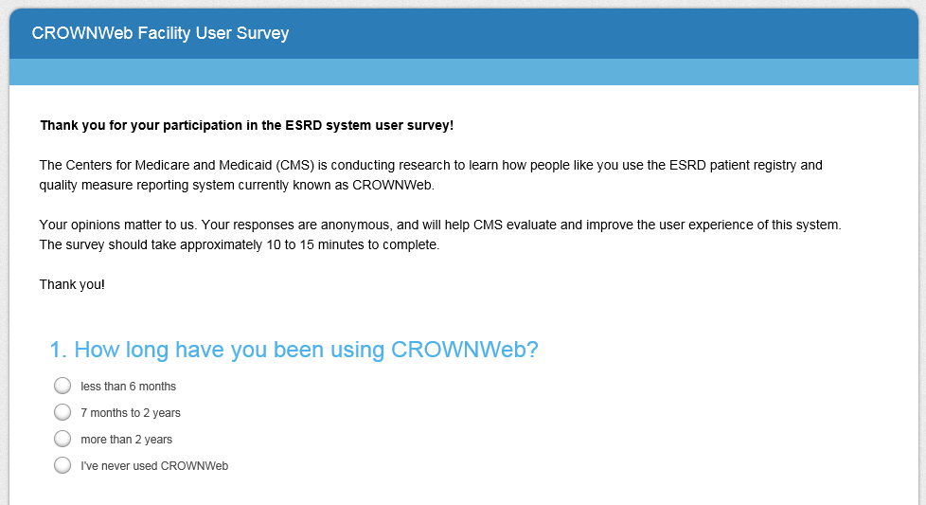
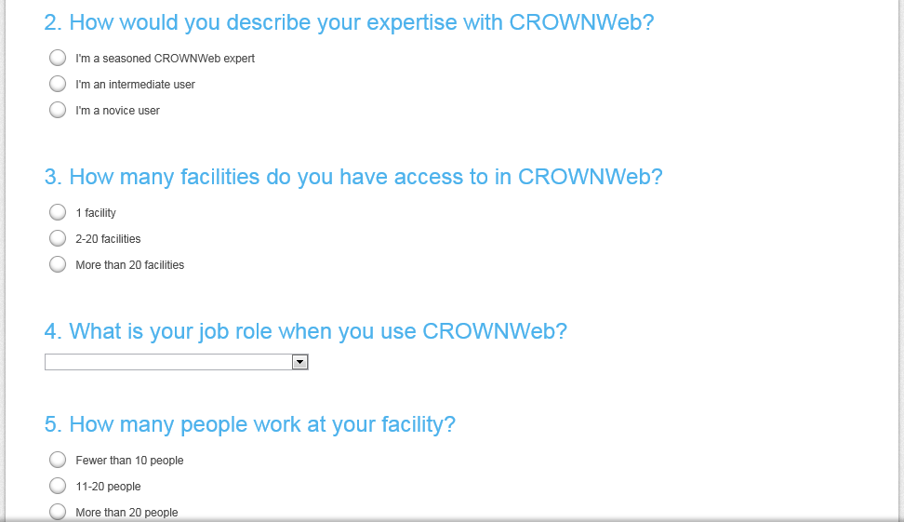
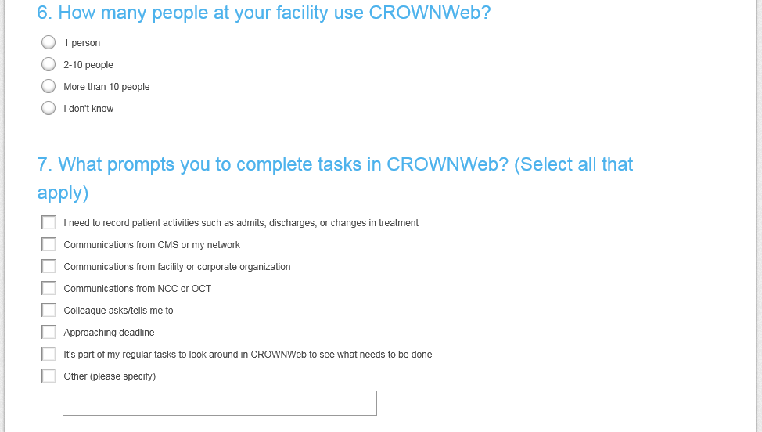
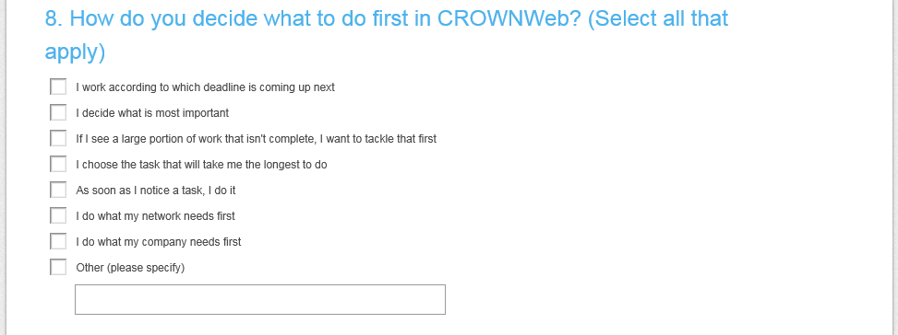
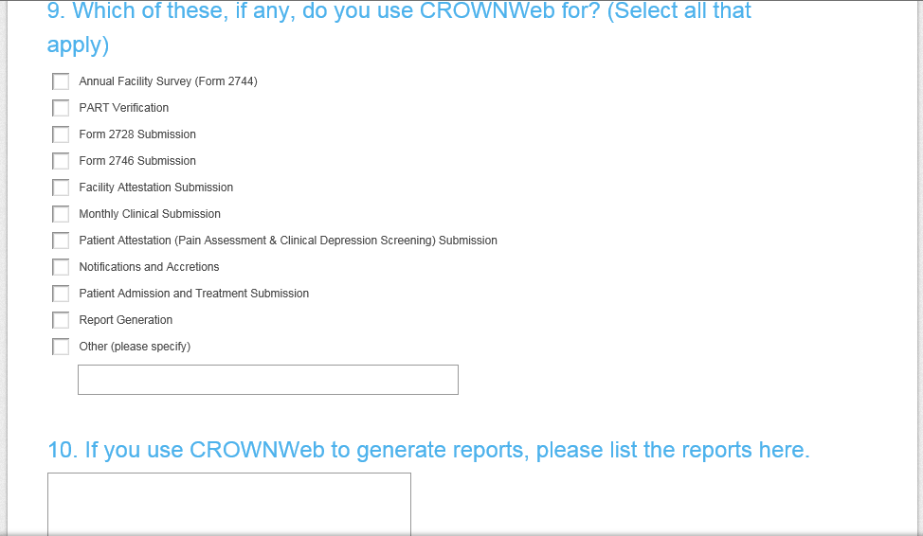
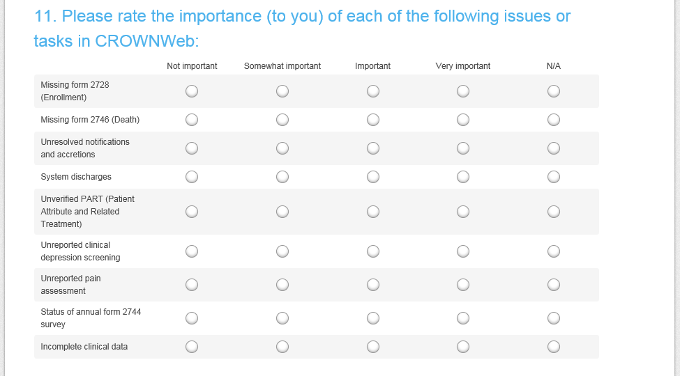
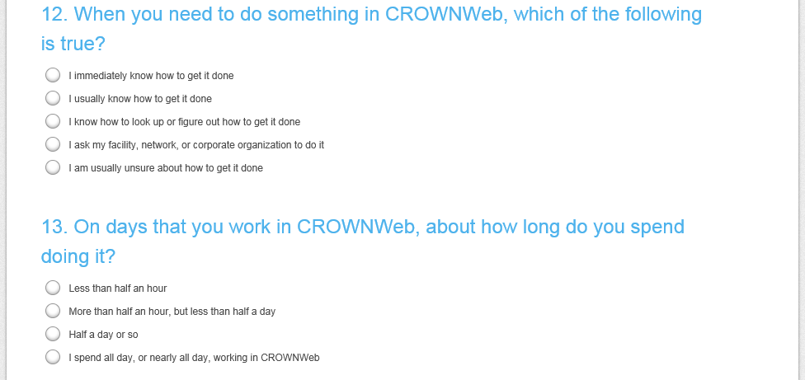
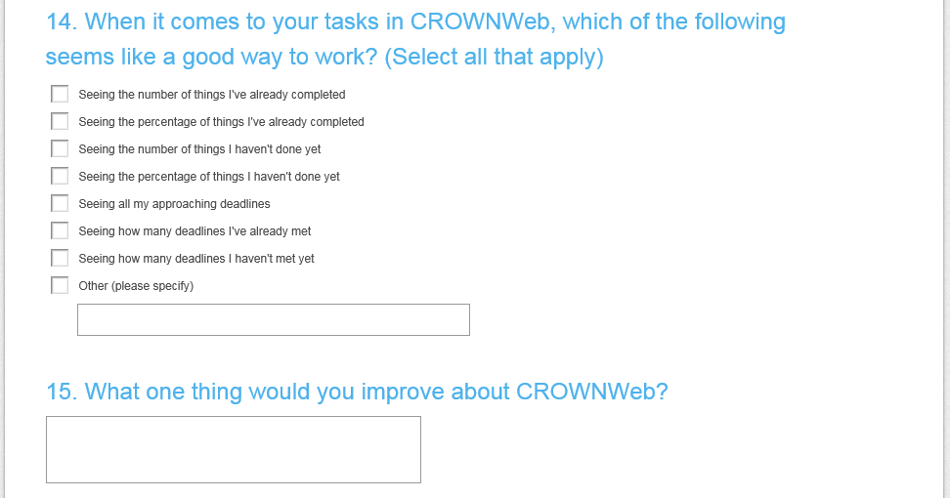
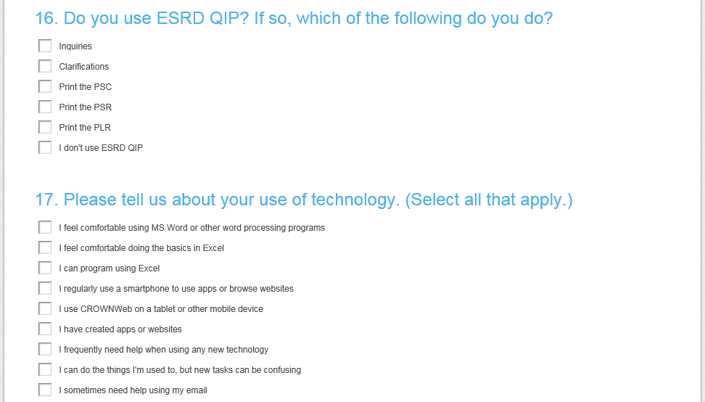
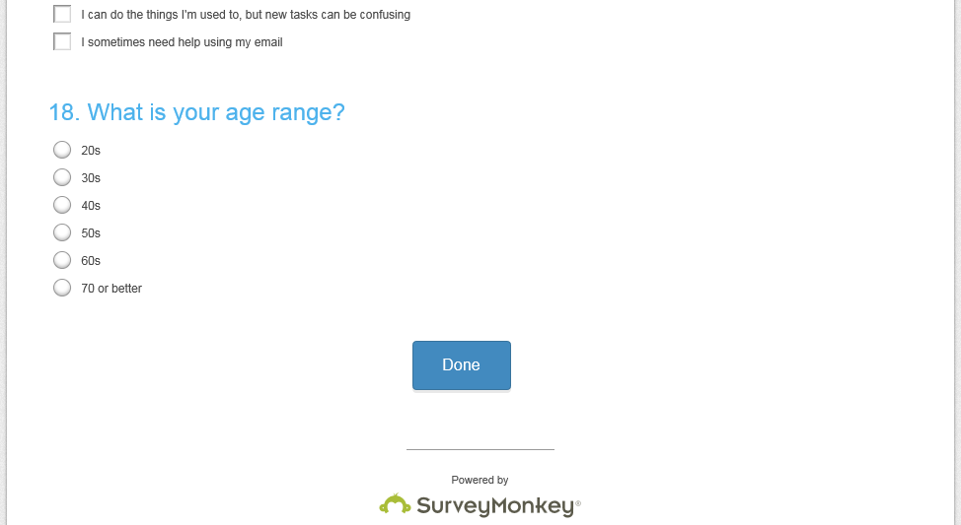

Email text used to recruit user participants for the survey:

Under contract to the Centers for Medicare & Medicaid Services (CMS), the End Stage Renal Disease Quality Reporting System (EQRS) Business Requirements and Application Development Organization (BRADO) contractor is assessing the current state CROWNWeb, QIP, and REMIS for future consolidation into one new product called EQRS.
We are asking for your participation in a survey that will help with evaluation and redesign efforts for EQRS.
Please only complete the survey once. Your survey responses are anonymous, and the survey will take approximately 15 minutes to complete.
Please Note: The survey would be best completed by a person who currently uses CROWNWeb, QIP, or REMIS.
The Office of Management and Budget (OMB) has approved 200 participants for the survey under the Paperwork Reduction Act (PRA), and the survey will close once the maximum number of responses have been collected.
The OMB Control Number is 0938-1185 and the expiration date is XX-XX-XXXX.

Thank you!

