USGS AshFall Reporting Database
OMB Control Number 1028-0106

Kristi L Wallace, U.S. Geological Survey/Alaska Volcano Observatory, Anchorage, AK/USA/email: kwallace@usgs.gov, phone: 907-786-7109

SCREEN SHOTS AND FORMS THE PUBLIC WILL SEE:
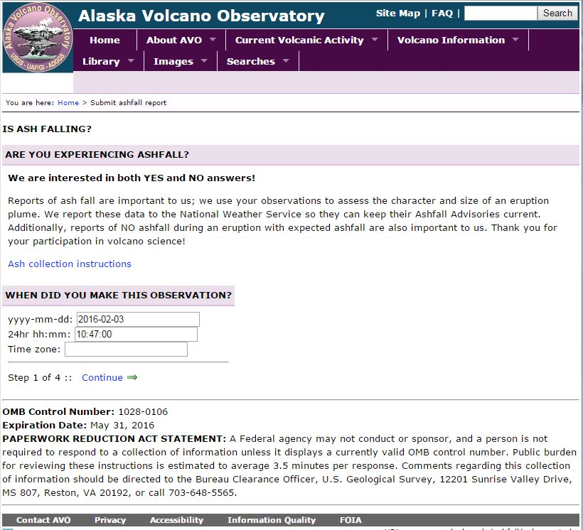
1st form public will see
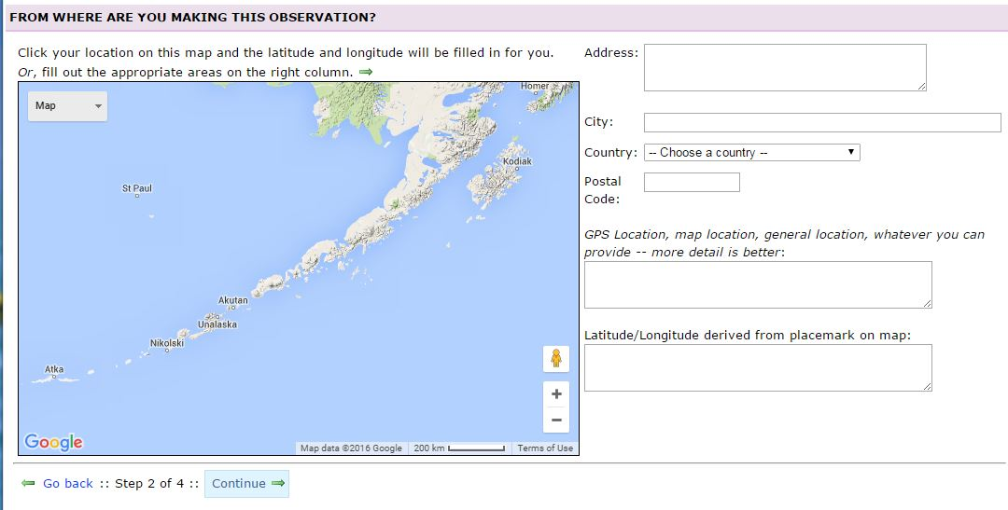
2nd form public will see

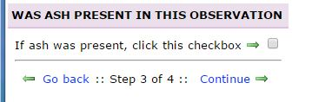

3rd form public will see and if they do not see ash they will press continue and go to slide 7 or contact information
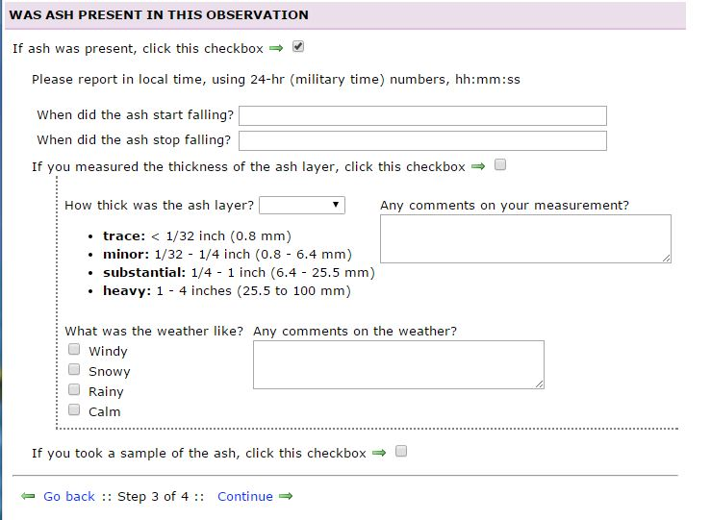
4th form public will see if they are reporting on “yes” ash
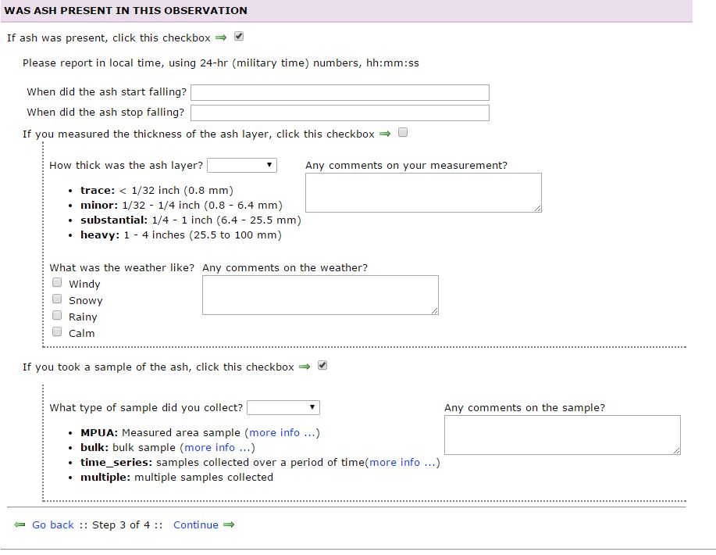
5th form public will see if they are reporting on “yes” ash and they have collected a sample

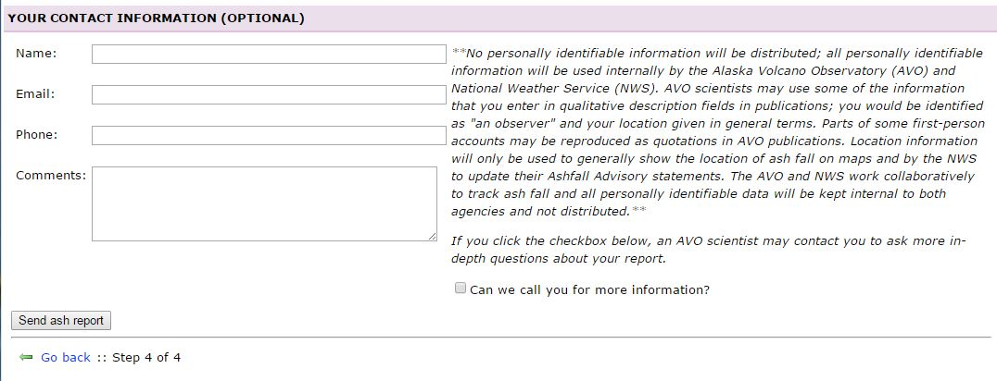
6th and final form public will see – this is so we can follow up with observations and collections to verify facts.

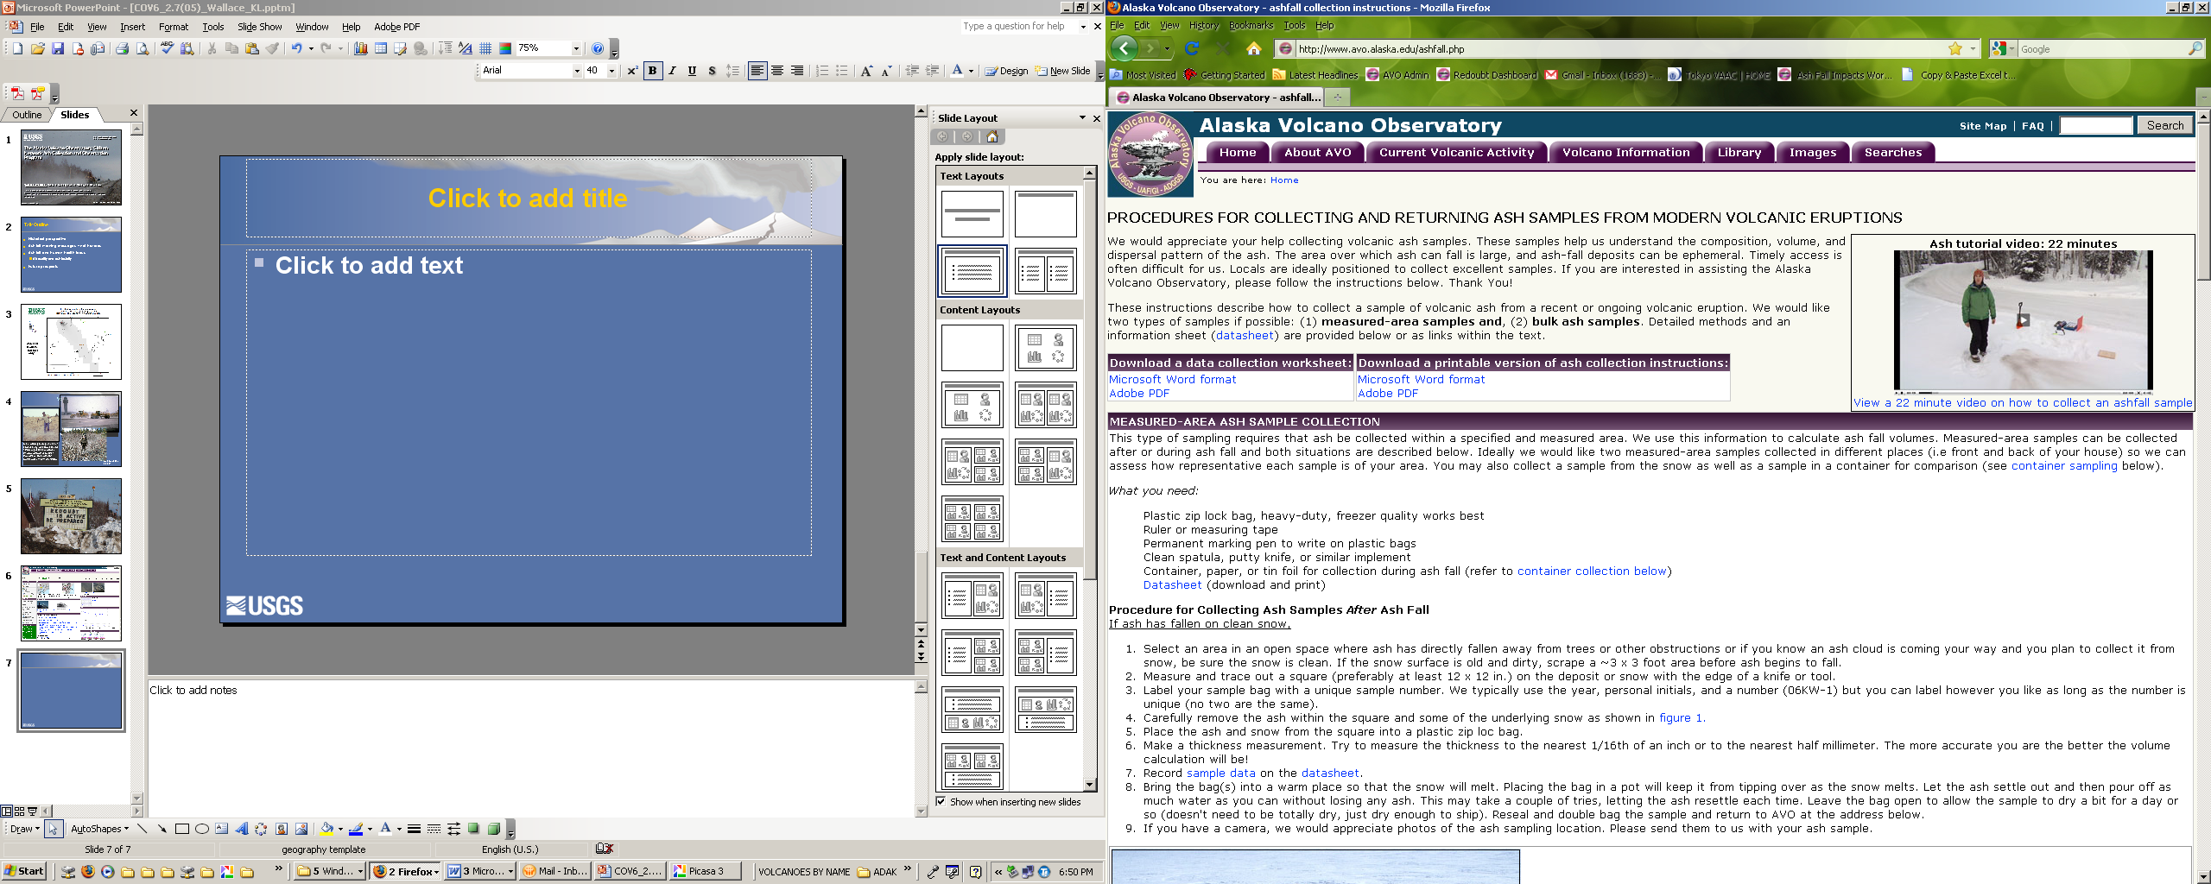

Webpage with instructions on making collections, the public can click on this from the AshFall Report Database to see what we are asking for in specific. Instructions for ashfall collection and datasheet included as a separate document.

