FORMULAS ONLINE REFERENCE GUIDE

(Posted to the TTB Website at <http://www.ttb.gov/foia/fonl.html>

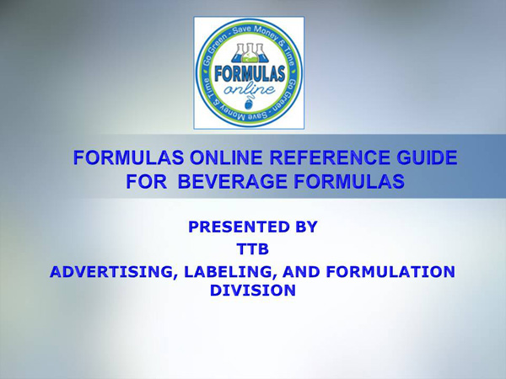

[**WELCOME!**](javascript:showSlide(1))[**ALFD FORMULATION TEAM**](javascript:showSlide(2))[**What is Formulas Online?**](javascript:showSlide(3))[**TOPICS**](javascript:showSlide(4))

[**First Steps: TTBONline.gov Portal**](javascript:showSlide(5))[**Registration**](javascript:showSlide(12))[**Basics of Formula Submission**](javascript:showSlide(31))[**Common Errors**](javascript:showSlide(60))[**Formulas Online: System Features**](javascript:showSlide(69))[**Q&A\***](javascript:showSlide(64))[**Questions?**](javascript:showSlide(75))

NOTE: Only the first slide is shown in this document. Go to the TTB Website at <http://www.ttb.gov/foia/fonl.html> to see the entire FONL Reference Guide.