HIDDEN TEXT TO CONTROL APPENDIX PAGE NUMBER – DO NOT DELETE
2019–20 NATIONAL POSTSECONDARY STUDENT AID STUDY (NPSAS:20)
Institution Contacting and List Collection

Appendix D
Institution Contacting Materials

OMB # 1850-0666 v.23
Submitted by
National Center for Education Statistics
U.S. Department of Education

April 2019
revised June 2019

This appendix includes the contacting materials, instructions, and website text that will be used for recruiting institutions to participate in the 2019–20 National Postsecondary Student Aid Study (NPSAS:20) enrollment list collection. The materials below are based primarily on those developed and approved for the 2017–18 National Postsecondary Student Aid Study, Administrative Collection (NPSAS:18-AC) [OMB #1850-0666 v.20-21]. A second package requesting clearance for the student interview and student records portions of NPSAS:20 will be submitted in summer 2019.
The NPSAS:20 contact materials are divided by mailing, such that all materials for one mailing packet are included together. Mailings to institutions may include pens, notepads, or other small courtesy items bearing a logo related to the study and/or the National Center for Education Statistics (NCES), which will serve as reminders to institution staff as well as tokens of appreciation for their efforts. These items may also be distributed at conferences attended by potential NPSAS participants.
Each mailing in this appendix is separated by a heading, and each section includes a description of the mailing and the materials that are included. These descriptions are located in the gray box, directly below the section heading. An institution contacting flowchart is provided in section B.3 of the Supporting Statement Part B of this submission.
The instructions and website text included in this appendix are based on those submitted for NPSAS:18-AC and assume that each institution will create their own student enrollment list files using the instructions and file specifications included in this appendix. NCES is currently exploring options to provide institutions with templates, programs for statistical software, or additional tools that will reduce the burden associated with gathering and formatting the data for the student enrollment list. If one of these approaches proves feasible, the materials below will be updated to give institutions the option of creating their own enrollment list file using the specifications or downloading the template or program provided to them on NCES’ Postsecondary Data Portal (PDP) website.
For the sake of space, text stating OMB authorization and the control number has not been included in each letter and e-mail. However, all letters will include the following text:

NCES is authorized to conduct the 2019–20 National Postsecondary Student Aid Study (NPSAS:20) by the Education Sciences Reform Act of 2002 (ESRA 2002, 20 U.S.C. §9543) and the Higher Education Opportunity Act of 2008 (HEOA 2008, 20 U.S.C. §1015). The data are being collected for NCES by RTI International, a U.S.-based nonprofit research organization. All of the information you provide may be used only for statistical purposes and may not be disclosed, or used, in identifiable form for any other purpose except as required by law (20 U.S.C. §9573 and 6 U.S.C. §151).
According to the Paperwork Reduction Act of 1995, no persons are required to respond to a collection of information unless it displays a valid OMB control number. The valid OMB control number for this voluntary information collection is 1850-0666. The time required to complete this information collection is estimated to average approximately 35 hours per response, including the time to review instructions, search existing data sources, gather the data needed, and complete and review the information collection. If you have any comments concerning the accuracy of the time estimate, suggestions for improving this information collection, or any comments or concerns regarding the status of your individual submission of these data, please write directly to: Postsecondary Data Portal studies, National Center for Education Statistics, PCP, 550 12th St., SW, 4th floor, Washington, DC 20202.

All e-mails will include:

OMB Control Number: 1850-0666
Learn more about our confidentiality procedures at: surveys.nces.ed.gov/xxxx.

Contents
Contents D-3
Chief Administrator Mailing D-5
Chief Administrator Letter and E-mail – Past Participant D-6
Chief Administrator Letter and E-mail – New Institution – Campus Coordinator Recommendation D-8
Chief Administrator Letter and E-mail – New Institution – No Campus Coordinator D-10
Study Brochure D-11
Chief Administrator Reminder E-mail D-14
Campus Coordinator Welcome Mailing D-15
Registration Letter and E-mail – Institutions in Both the Fall and Spring Collections D-16
Registration Letter and E-mail – Spring Collection Only – Campus Coordinator Named from Other Source D-17
Quick Guide to NPSAS:20 D-18
Registration Instructions D-21
Registration Reminder Letter and E-mail D-24
Registration Thank You E-mail D-25
Coordinator List Request Mailing D-26
List Request Letter and E-mail D-27
Student Enrollment List Preparation Instructions D-28
List Request Reminder Letter and E-mail D-36
List Thank You E-mail D-37
PDP User Approval E-mail for Campus Coordinator D-38
Data You Can Use Mailer and E-mail D-39
“Please Represent Your State” Mailer and E-mail D-40
BPS Base Year Mailer and E-mail D-41
Registration/List Collection Is Ending Mailer and Email D-42
Final Weeks of List Collection E-mail – From Project Director D-43
Final Weeks of List Collection E-mail – From NCES D-44
Reduced Data Elements List Collection E-mail – From Project Director D-45
Postsecondary Data Portal Login Instructions D-46
Nonrespondent Follow-Up Materials D-48
Letter to Nonrespondent Institutions D-49
Text of Flyer for Nonrespondents – Public Institutions D-50
Text of Flyer for Nonrespondents – For-Profit Institutions D-54
Request to State Organizations to Encourage Institution Participation D-55
NPSAS Study Timeline Graphic D-56
Spanish Mailing Materials D-57
Chief Administrator Letter and E-mail – Past Participant D-58
Chief Administrator Letter and E-mail – New Institution – Campus Coordinator Recommendation D-60
Chief Administrator Letter and E-mail – New Institution – No Campus Coordinator D-62
Study Brochure D-64
Registration Letter and E-mail – Institutions in Both the Fall and Spring Collections D-68
Registration Letter and E-mail – Spring Collection Only – Campus Coordinator Named from Other Source D-70
Quick Guide to NPSAS:20 D-72
List Request Letter and E-mail D-75
Timeline Graphics D-76
PDP Website Content – Pre-Login (Not Study Specific) D-77
About the PDP D-78
FAQs (prior to log-in) D-78
Contact Us D-80
Confidentiality D-80
PDP Website Content – After Login D-82
Welcome Page D-82
Task Menu D-82
Designate A Coordinator Page D-83
Registration Page D-83
Enrollment List Page D-90
Archive Notes or Other Documentation Page D-91
FAQs (after log-in) D-91
Contact Materials Page D-95
Resources Page D-95
Resource Materials D-97
Confidentiality and Data Security Fact Sheet D-97
FERPA Fact Sheet D-99
Disclosure Notice D-107
Scripts and Storyboards for Instructional Videos D-108

Chief Administrator Mailing
This mailing (letter and corresponding e-mail) is sent to each institution’s chief administrator at the start of data collection. The mailing includes a letter requesting the institution’s participation in NPSAS:20 and a NPSAS:20 brochure. There will be four versions of the letters/emails to be sent to:
- institutions that participated in NPSAS:18-AC, NPSAS:16, and/or the BPS or the HSLS student records (SR) collections (BPS:12 SR and HSLS:09 F2 SR respectively) and from which we are requesting both a fall (calibration) and a spring enrollment list
- institutions that participated in NPSAS:18-AC, NPSAS:16, BPS:12 SR, and/or HSLS:09 F2 SR and from which we are requesting only a spring enrollment list
- institutions that were not sampled for or did not participate in NPSAS:18-AC, NPSAS:16, BPS:12 SR, or HSLS:09 F2 SR and for which we identified a potential coordinator through the Higher Education Directory
- institutions that were not sampled for or did not participate in NPSAS:18-AC, NPSAS:16, BPS:12 SR, or HSLS:09 F2 SR and for which we cannot identify a potential campus coordinator
The materials for this mailing are included below.

Chief Administrator Letter and E-mail – Past Participant
(Date)
(Salutation) (FirstName) (LastName)
(Title)
(Institution)
(Address)
(City), (State) (Zip)
Dear (Salutation) (LastName):
The U.S. Department of Education’s National Center for Education Statistics (NCES) is beginning its next cycle of the National Postsecondary Student Aid Study (NPSAS). NPSAS is endorsed by [fill name of organization most closely tied to institution]. I am pleased to inform you that [Institution] has been selected to participate in this new cycle, NPSAS:20, focusing on students enrolled during the 2019-20 academic year. We have provided a general timeline of study activities for you below.
[Timeline graphic – see page D-56]
The last time [Institution] participated in NPSAS, [fill last PC we had] served as your Campus Coordinator. Soon, we will contact [him/her/him or her] with guidance on how to proceed with this new data collection. If you wish to name a new Coordinator, you may do so through the NCES Postsecondary Data Portal (PDP). We provide credentials allowing you to access the PDP at the bottom of this letter.
Highlights of NPSAS:20
- NPSAS:20 results will be produced at national and, for undergraduates, at state levels, too.
- Assuming enough institutions participate, at the end of NPSAS:20 we will provide you with a 2019-20 data feedback report comparing financial aid estimates at the national, sector, and, for undergraduates, state levels.
- [If fall: Some institutions, including yours, are being asked to provide separate Fall and Spring enrollment lists to allow their students to be interviewed earlier in the data collection period, ensuring that we have enough time to collect the information needed for this cycle of NPSAS.]
- NPSAS:20 includes a longitudinal study component, the Beginning Postsecondary Students Longitudinal Study (BPS), which will report on the persistence, attainment, and employment of postsecondary students through their first 5 years of enrollment.
- The NPSAS:20 data collection website includes recent enhancements designed to make it easier for the Coordinator to complete study tasks.
Because we know your staff time is limited, we have been working very hard to simplify the reporting requirements and minimize the time and effort needed to participate in NPSAS:20.
Want to learn more?
To learn more about NPSAS overall, I invite you to visit the NCES study website (https://nces.ed.gov/surveys/npsas/). To learn more about how NPSAS data are used, visit the NPSAS research website at https://nces.ed.gov/surveys/npsas/POLICY AND RESEARCH PAGE.
We look forward to working with you over the next year. If you have questions about your participation in NPSAS:20, please contact RTI’s data collection manager, [fill name for this institution], at XXXXXX (e-mail). I can be reached at XXXX (e-mail).
Sincerely yours,
(NCES staff name)
(NCES staff title)
National Center for Education Statistics (NCES)
Institute of Education Sciences
U.S. Department of Education
Enclosures
Please note: If you wish to update your Campus Coordinator, log in to the Postsecondary Data Portal using the following information:
surveys.nces.ed.gov/xxxx
Your user ID: (UserID)

Chief Administrator Letter and E-mail – New Institution – Campus Coordinator Recommendation
(Date)
(Salutation) (FirstName) (LastName)
(Title)
(Institution)
(Address)
(City), (State) (Zip)
Dear (Salutation) (LastName):
The U.S. Department of Education’s National Center for Education Statistics (NCES) is beginning its next cycle of the National Postsecondary Student Aid Study (NPSAS), a congressionally mandated study of how students and their families pay for college. I am pleased to inform you that [Institution] has been selected to participate in NPSAS:20, which will focus on students enrolled during the 2019-20 academic year. NPSAS is endorsed by [fill name of organization most closely tied to institution]. Assuming enough institutions participate, at the end of NPSAS:20 we will provide you with a 2019-20 data feedback report comparing financial aid estimates at the sector and national levels and, for undergraduates, at the state level as well.
What’s required of you and your staff?
Participation in NPSAS:20 occurs in steps, laid out for you below. We plan to invite [fill name] to serve as Campus Coordinator for [Institution]. If you wish to name a different Coordinator, we provide instructions on how to log in to the Postsecondary Data Portal (PDP), the data collection system for NPSAS:20, at the bottom of this letter. Soon, we will contact [fill name] with guidance on how to register your institution in the PDP and provide a 2019-20 enrollment list to our contractor, RTI International (RTI), the research organization carrying out the NPSAS:20 data collection on behalf of NCES. RTI will select a sample of students from your list and, later, collect data on sampled students’ enrollment, budget, and financial aid for 2019-20. Because we know your staff time is limited, we have been working very hard to simplify the reporting requirements and minimize the time and effort needed to participate in NPSAS:20.
[Timeline graphic – see page D-56]
Want to learn more?
To learn more about NPSAS overall, I invite you to visit the NCES study website (https://nces.ed.gov/surveys/npsas/). To learn more about how NPSAS data are used, visit the NPSAS research website at https://nces.ed.gov/surveys/npsas/POLICY AND RESEARCH PAGE.
We look forward to working with you over the next year. If you have questions about your participation in NPSAS:20, please contact RTI’s data collection manager, [fill name for this institution], at XXXXXX (e-mail). I can be reached at XXXX (e-mail).
Sincerely yours,
(NCES staff name)
(NCES staff title)
National Center for Education Statistics (NCES)
Institute of Education Sciences
U.S. Department of Education
Enclosures

To name an alternative Campus Coordinator for [Institution], please visit the NPSAS:20 Postsecondary Data Portal (PDP):
surveys.nces.ed.gov/xxxx
Your user ID: (UserID)

Chief Administrator Letter and E-mail – New Institution – No Campus Coordinator
(Date)
(Salutation) (FirstName) (LastName)
(Title)
(Institution)
(Address)
(City), (State) (Zip)
Dear (Salutation) (LastName):
The U.S. Department of Education’s National Center for Education Statistics (NCES) is beginning its next cycle of the National Postsecondary Student Aid Study (NPSAS), a congressionally mandated study of how students and their families pay for college. I am pleased to inform you that [Institution] has been selected to participate in NPSAS:20, which will focus on students enrolled during the 2019-20 academic year. NPSAS is endorsed by [fill name of organization most closely tied to institution]. Assuming enough institutions participate, at the end of NPSAS:20 we will provide you with a 2019-20 data feedback report comparing financial aid estimates at the sector and national levels and, for undergraduates, at the state level as well.
What’s required of you and your staff?
Participation in NPSAS:20 occurs in steps, laid out for you below. All you have to do is name a Campus Coordinator, who will be asked to register your institution in the Postsecondary Data Portal (PDP), the data collection system for NPSAS:20, and provide a 2019-20 enrollment list to our contractor, RTI International (RTI), the research organization carrying out the NPSAS:20 data collection on behalf of NCES. RTI will select a sample of students from your list and, later, collect data on sampled students’ enrollment, budget, and financial aid for 2019-20. Because we know your staff time is limited, we have been working very hard to simplify the reporting requirements and minimize the time and effort needed to participate in NPSAS:20.
[Timeline graphic – see page D-56]
To name [Institution]’s Campus Coordinator, please visit the PDP:
surveys.nces.ed.gov/xxxx
Your user ID: (UserID)
Want to learn more?
To learn more about NPSAS overall, I invite you to visit the NCES study website (https://nces.ed.gov/surveys/npsas/). To learn more about how NPSAS data are used, visit the NPSAS research website at https://nces.ed.gov/surveys/npsas/POLICY AND RESEARCH PAGE.
We look forward to working with you over the next year. If you have questions about your participation in NPSAS:20, please contact RTI’s data collection manager, [fill name for this institution], at XXXXXX (e-mail). I can be reached at XXXX (e-mail).
Sincerely yours,
(NCES staff name)
(NCES staff title)
National Center for Education Statistics (NCES)
Institute of Education Sciences
U.S. Department of Education
Enclosures

Study Brochure
2019–20 National Postsecondary Student Aid Study (NPSAS:20)
What Is NPSAS?
The National Postsecondary Student Aid Study (NPSAS) is a nationally representative study focused primarily on how students and their families pay for postsecondary education. Student interview data are combined with institution and administrative record data to form a comprehensive research dataset with information on student enrollment, financial aid, and employment. NPSAS data are used by federal and state government, postsecondary institutions, associations advocating for higher education, researchers, employers, and other private agencies. It is the primary source of information used to analyze the effectiveness of student financial aid and to inform public policy on programs such as Pell grants and Direct/Stafford loans.
In addition to national-level estimates, the 2019-20 academic year NPSAS data collection (NPSAS:20) will provide state-representative financial aid estimates for undergraduates, which will allow for evaluation of the different types of financial aid available at the state level. With these data, state decision makers can compare themselves to other states, as well as to the nation as a whole.
How Are the Data Used?
After each NPSAS is completed, NCES releases key statistics on financial aid then makes the data available to researchers who conduct their own analyses. NPSAS data are an important resource for informing decisions related to student financial aid programs and effecting change to the benefit of students and their families. Analysis of NPSAS data from prior years has led to reinstatement of year-round Pell grants and the “prior-prior year” change to the FAFSA, which enables students to better research their aid options and file for aid earlier. “Prior-prior year” means that students are able to use tax information from two years ago to file their FAFSA.
In addition to these more prominent examples, NPSAS data are regularly cited in association and other national reports, scholarly journals, newspaper articles, and other publications, on a variety of topics, including student demographics, financial aid and debt accumulation, and work while enrolled in postsecondary education.
Why Should My Institution Participate?
NPSAS is intended to be representative of students attending all types of postsecondary institutions. Your participation ensures that institutions and students like yours are accurately represented in the sample. Each institution is unique and cannot be “replaced” in NPSAS.
With your participation, and if enough institutions participate, you will receive a data feedback report comparing financial aid estimates at the sector and national levels and, for undergraduates, at the state level.
It is also important to note that NPSAS:20 will serve as the base-year study for the next Beginning Postsecondary Students Longitudinal Study (BPS:20), which tracks first-time students’ paths through postsecondary education over the course of six academic years. BPS permits examination of factors affecting student persistence in and completion of postsecondary education programs, their transitions to employment, and changes over time in their goals, marital status, income, and debt. Using BPS data to gain insight into these longer-term outcomes would not be possible without NPSAS.
Can I Access NPSAS National Data for My Own Use?
Absolutely! NCES’s DataLab (https://nces.ed.gov/datalab) provides a suite of powerful and intuitive online data tools for creating tables and conducting analyses using NPSAS and other NCES datasets. Many different reports and publications are also available for download from the main NCES website.
Institutions can use NPSAS data to expand their benchmarking work and provide a useful complement to their Integrated Postsecondary Education Data System (IPEDS) data.
About NCES
NCES is authorized by federal law to collect, collate, analyze, and report complete statistics on the condition of education in the United States and other nations. Through the Higher Education Opportunity Act of 2008 (20 U.S.C. §1015), Congress requires that NCES collect information from postsecondary institutions about how students and their families finance education beyond high school. NPSAS has collected information from postsecondary students and institutions since 1987.
Confidentiality of Data
NCES is required to follow strict procedures to protect personal information in the collection, reporting, and publication of data. All of the information provided by individuals or institutions may be used only for statistical purposes and may not be disclosed, or used, in identifiable form for any other purpose except as required by law (20 U.S.C. §9573 and 6 U.S.C. §151).
The Family Educational Rights and Privacy Act of 1974 (FERPA, 34 CFR §§ 99.31(a)(3) and 99.35) permits institutions to disclose personally identifiable information from students’ education records, without consent, to authorized representatives of the Secretary of Education in connection with an evaluation of federally supported education programs. RTI International, as the contractor for NCES, has been given the authority to collect information from institution records on behalf of NCES.
Protection of Electronic Files
All electronic files from institution records will be protected. Computer accounts used to access data will be password protected with multilevel access controls to ensure that only authorized individuals are allowed access to confidential data. For the web-based data collection, proven methods of protection for online sessions and data security over the Internet will be used. Secure Sockets Layer (SSL) protocol will be used to encrypt the data. All the data entry modules on the website will be password protected, which will require the user to log in to the site before accessing confidential data.
Preparation of Data for Public Release
It will not be possible to identify specific individuals in any data released to the public (e.g., statistical tables and data files).

For assistance, please contact the Help Desk (9 AM to 9 PM ET):
or visit the website: https://XXXXX
Postsecondary Data Portal Help Desk
1-XXX-XXX-XXXX
XXX@rti.org
If you have questions or concerns about NPSAS:20, contact:
RTI International

Jennifer Wine, Ph.D.
Director, NPSAS:20
XXX@rti.org

1-XXX-XXX-XXX

National Center for Education Statistics (NCES)

Tracy Hunt-White, Ph.D.
NCES Project Officer, NPSAS:20
XXX@ed.gov
(XXX) XXX-XXXX
Conducted by

<NCES logo>

U.S. Department of Education
National Center for Education Statistics (NCES), Washington, DC
https://nces.ed.gov

OMB Control Number: 1850-0666. Learn more about our confidentiality procedures at: https://surveys.nces.ed.gov/XXX.

Chief Administrator Reminder E-mail
We recently contacted you, asking that you name a Campus Coordinator to facilitate [fill institution]’s participation in the 2019-20 National Postsecondary Student Aid Study (NPSAS:20).
By participating, NPSAS:20 will provide you with estimates allowing you to compare your state with others and with the nation as a whole on key measures such as:
- Average financial need and percentage of students with financial need
- Average merit and need-based state grants and percentage of students with grants
- Cumulative loan debt
- Percentage of students with Pell grants
- Cumulative undergraduate borrowing by loan type
No other national study of financial aid does that! Your institution’s participation is important to ensuring we can provide state-level results for undergraduates.
It’s easy to kick off your participation. Just name your Campus Coordinator by visiting the NPSAS:20 Postsecondary Data Portal (PDP):
surveys.nces.ed.gov/xxxx
Your user ID: (UserID)
NPSAS is endorsed by [fill name of organization most closely tied to institution]. If you have questions about your participation, please contact RTI’s data collection manager, [fill name for this institution], at XXXXXX (e-mail). I can be reached at XXXX (e-mail).

(NCES staff name)
(NCES staff title)
National Center for Education Statistics (NCES)
Institute of Education Sciences
U.S. Department of Education

Campus Coordinator Welcome Mailing

This mailing is sent to each institution’s NPSAS:20 coordinator. It includes a letter/e-mail welcoming the coordinator to NPSAS20, a NPSAS:20 brochure, and a guide for getting started. There will be five versions of the letter/e-mail:
- institutions that participated in NPSAS:18-AC, NPSAS:16, BPS:12 SR, and/or HSLS:09 F2 SR and from which we are requesting both a fall (calibration) and a spring enrollment list
- institutions that participated in NPSAS:18-AC, NPSAS:16, BPS:12 SR, and/or HSLS:09 F2 SR and from which we are requesting only a spring enrollment list
- institutions that were not sampled for or did not participate in NPSAS:18-AC, NPSAS:16, BPS:12 SR, or HSLS:09 F2 SR and for which we identified a potential coordinator through the Higher Education Directory
- institutions that were not sampled for or did not participate in NPSAS:18-AC, NPSAS:16, BPS:12 SR, or HSLS:09 F2 SR and for which the Chief Administrator named a coordinator
- institutions that were not sampled for or did not participate in NPSAS:18-AC, NPSAS:16, BPS:12 SR, or HSLS:09 F2 SR and for which the IPEDS Keyholder recommended a coordinator
The same brochure included in the chief administrator mailing is included. The guide for getting started is included below.

Registration Letter and E-mail – Institutions in Both the Fall and Spring Collections
[Date]
[Salutation] [FirstName] [LastName]
[Title]
[Institution]
[Address]
[City], [State] [Zip]
Dear [Salutation] [LastName]:
The U.S. Department of Education’s National Center for Education Statistics (NCES) is beginning its next cycle of the National Postsecondary Student Aid Study (NPSAS), a congressionally mandated study of how students and their families pay for college. [Institution] has been selected to participate in NPSAS:20, which will focus on students enrolled during the 2019-20 academic year.
You are receiving this[letter/e-mail] because you were selected to be the NPSAS Campus Coordinator by the chief administrative officer of your institution the last time [Institution] was sampled for NPSAS in [LastSampledYear].
[If fall: For NPSAS:20, [Institution] has been selected among a small group of institutions to provide two Student Enrollment List files following the timeline below. The new Fall Enrollment List plays a key part in ensuring that we use the soundest methodology for the student interview component of the study. The Spring Enrollment List will include the same data elements as the fall list, so any queries you create in the fall can be reused in the spring with very few edits.] As a coordinator for NPSAS:20, you will be asked to complete the following tasks between now and November 2020:
[Timeline graphic – see page D-56]
As the study progresses, we will provide you with detailed instructions for completing each portion of the study. At this time, we ask that you log in to the NCES Postsecondary Data Portal (PDP) and complete the Registration Page using the information provided in the box below. Enclosed is a guide to help you. During Registration, you will be asked to name colleagues at your institution who may be involved in providing data for NPSAS:20. Users you name will gain access to the PDP and receive information on the study. For this reason, please be sure that the users you identify are allowed to see personal information about students.
surveys.nces.ed.gov/xxxx
Your user ID: (UserID)
Because we know your staff time is limited, we have been working very hard to simplify the reporting requirements and minimize the time and effort needed to participate in NPSAS:20. A representative of RTI International, our contractor for NPSAS:20, will reach out soon to answer any questions you may have.
For more information on NPSAS, please visit the NCES study website (https://nces.ed.gov/surveys/npsas/).
We look forward to working with you over the next year. If you have questions about your participation in NPSAS:20, please contact RTI’s data collection manager, [DCMforSchool], at [DCMe-mail]. I can be reached at [NCESe-mail].
Sincerely,
NCES staff name
NCES staff title
National Center for Education Statistics (NCES)
Institute of Education Sciences
U.S. Department of Education
Enclosures

Registration Letter and E-mail – Spring Collection Only – Campus Coordinator Named from Other Source
[Date]
[Salutation] [FirstName] [LastName]
[Title]
[Institution]
[Address]
[City], [State] [Zip]
Dear [Salutation] [LastName]:
The U.S. Department of Education’s National Center for Education Statistics (NCES) is beginning its next cycle of the National Postsecondary Student Aid Study (NPSAS:20), a congressionally mandated study of how students and their families pay for college. [Institution] has been selected to participate in NPSAS:20, which will focus on students enrolled during the 2019-20 academic year.
You are receiving this [letter/e-mail] because [If Higher Ed Directory: , as [fill position] for your institution, you are well placed to provide NPSAS:20 data on behalf of [Institution]. The chief administrative officer of your institution has been notified.]/[If named by Chief Administrator or IPEDS Keyholder: your institution’s [chief administrative officer named you to be the/IPEDS keyholder provided your name as a potential] NPSAS Campus Coordinator. As a coordinator for NPSAS:20, you will be asked to complete the following tasks between now and November 2020:
[Timeline graphic – see page D-56]
As the study progresses, we will provide you with detailed instructions for completing each portion of the study. At this time, we ask that you log in to the Postsecondary Data Portal (PDP) and complete the Registration Page using the information provided in the box below. Enclosed is a guide to help you. During Registration, you will be asked to name colleagues at your institution who may be involved in providing data for NPSAS:20. Users you name will gain access to the PDP and receive information on the study. For this reason, please be sure that the users you identify are allowed to see personal information about students.
surveys.nces.ed.gov/xxxx
Your user ID: (UserID)
Because we know your staff time is limited, we have been working very hard to simplify the reporting requirements and minimize the time and effort needed to participate in NPSAS:20. A representative of RTI International, our contractor for NPSAS:20, will reach out soon to answer any questions you may have.
For more information on NPSAS, please visit the NCES study website (https://nces.ed.gov/surveys/npsas/).
We look forward to working with you over the next year. If you have questions about your participation in NPSAS:20, please contact RTI’s data collection manager, [DCMforSchool], at [DCMe-mail]. I can be reached at [NCESe-mail].
Sincerely,
NCES staff name
NCES staff title
National Center for Education Statistics (NCES)
Institute of Education Sciences
U.S. Department of Education

Enclosures

Quick Guide to NPSAS:20
The Postsecondary Data Portal (PDP) is the data collection website for all institution-based postsecondary sample surveys conducted by the National Center for Education Statistics (NCES). You can access the PDP at surveys.nces.ed.gov/xxxx. The PDP provides information on the studies that have collected or are currently collecting data from colleges, universities, and vocational and trade schools throughout the United States. You can also find links to the studies’ pages at NCES and to DataLab, which provides a suite of powerful and intuitive online data tools for creating tables and conducting analyses using NPSAS and other NCES datasets.
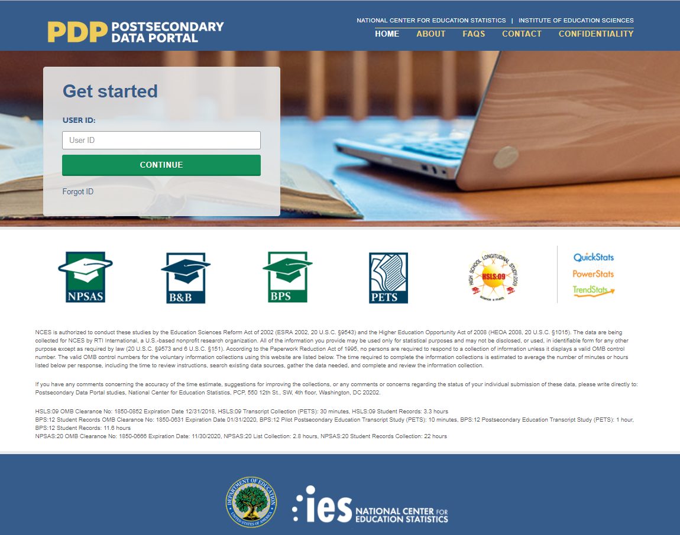
This image is provided as an example. The PDP website is still being developed and the final image may include aesthetic changes that do not impact the content of the page.
The PDP includes resources to help you complete NPSAS:20. On the FAQs page, you can learn about NCES and how your institution was chosen to participate. The Contact page lists the names, telephone numbers, and e-mail addresses for staff involved with the collections at NCES and at RTI International, the nonprofit organization collecting the data on behalf of NCES. Efforts to protect study data are detailed on the Confidentiality page.
Log in to the PDP using the user ID listed on your welcome letter. You will be e-mailed a security code that will allow you to complete the log in process. Once logged in, you may download your welcome packet, view instructional videos, and add additional users from your institution.
The PDP Task Menu will show you the steps you need to complete as a participating institution.

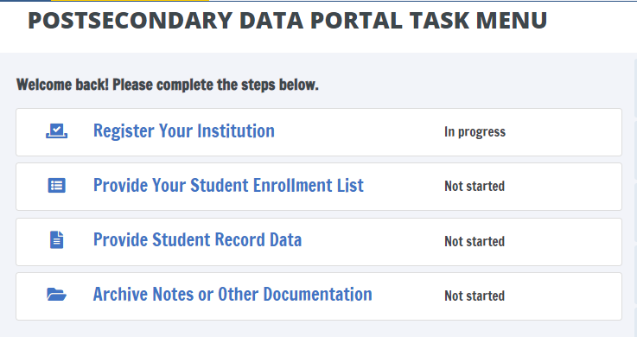
This image is provided as an example. The PDP website is still being developed and the final image may include aesthetic changes that do not impact the content of the page.

The NPSAS:20 Help Desk is available, 9 AM to 9 PM ET, to answer your questions about NPSAS:20, troubleshoot technical issues, and discuss any obstacles to participation. Contact us at.
[number]
xxxx@rti.org
As a NPSAS:20 participating institution, you will be asked to complete the following steps over the 2019-20 academic year:
[Timeline graphic - see page D-56]
1. Register Your Institution by designating staff who will provide your institution’s data, specifying your institution’s term structure, and answering some brief background questions about your institution.
Registration also sets the due date for the next step in the NPSAS:20 data collection. Due dates will vary based on the term structure you specify.
[graphic]

2. Submit Your 2019-20 Student Enrollment List, which will be used to select your institution’s student sample. When it is time to prepare your list, RTI will send you detailed instructions about which students should be included on your enrollment list.
[graphic]
3. Provide Student Record Data for the students at your institution sampled for NPSAS:20. Student records data include demographic, enrollment, budget, and financial aid information. You will receive your list of sampled students approximately 4 to 6 weeks after you submit your student enrollment list.
There are three modes for submitting student records data:
- Web mode - recommended for samples of up to 20 students;
- Excel mode - recommended for samples of 20 to 100 students; and
- CSV mode - recommended for samples greater than 100.
[Other options for delivery of student record data – such as SAS or STATA files – can be arranged by contacting the Help Desk.]
[graphic]

Registration Instructions
Registering your institution through the Postsecondary Data Portal (PDP) is an important first step in the NPSAS:20 data collection. As you register, you will be able to confirm your contact information, specify your institution’s term structure, provide needed information about your institution, and establish a due date for the next step in data collection, providing a student enrollment list. This guide will help you make sure you have all the information you need to be successful.
To get started, log on to the Postsecondary Data Portal (PDP) at surveys.nces.ed.gov/XXX and select “Register Your Institution” from the Task Menu. There you will find a brief video tutorial about registering your institution to help you get started.
1) Designate PDP Users
To begin, you will be asked to confirm your contact information and provide information for any additional staff who will assist you with providing your institution’s NPSAS:20 data on the PDP. You may choose to designate staff from multiple departments at your institution in order to provide the general demographic, enrollment, budget, and financial aid data needed. Each person you designate will receive credentials for logging into the Postsecondary Data Portal website. For this reason, please be sure that the users you identify are allowed to see personal information about students.
2) Provide Your Term Structure
Next, you will need to specify your institution’s term structure for the 2019-20 academic year, that is from July 1, 2019 to June 30, 2020. Later, when you provide your institution’s student records data, you will report each sampled student’s enrollment status (e.g., full-time, half-time), and financial aid received, for the entire 2019-20 academic year by term. For that reason, setting up the correct term structure is the most important step in the registration process.
If your institution has distinct terms with explicit start and end dates, you should report this information by term.
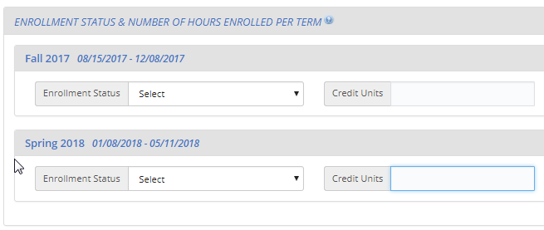
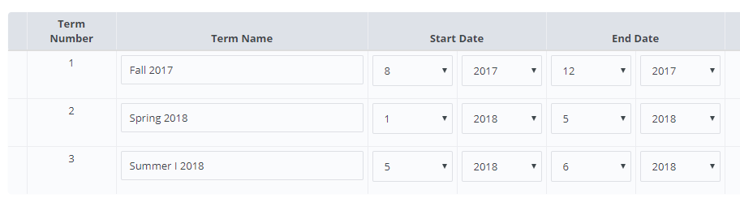
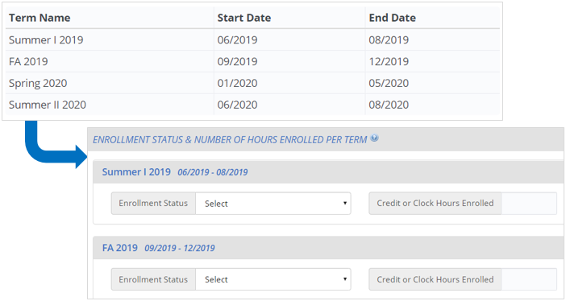
This image is provided as an example. The PDP website is still being developed and the final image may include aesthetic changes that do not impact the contact of the page.
If your institution enrolls students continuously throughout the year, or if you have more than 12 terms per year, you should report your student data by month.
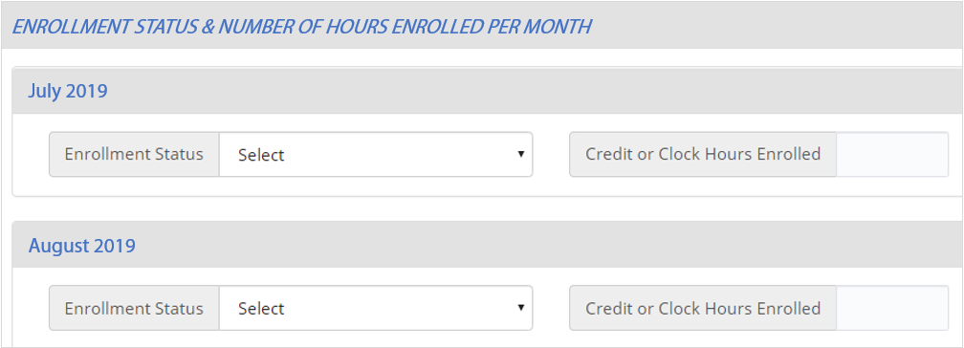
This image is provided as an example. The PDP website is still being developed and the final image may include aesthetic changes that do not impact the contact of the page.

Whenever possible, we will preload information about your institution’s term structure, and you will be asked to confirm or update the preloaded information.
Which Terms Should I Report?
You should enter the starting and ending month and year for all terms/enrollment periods at your institution for the 2019-20 academic year. Terms may start prior to July 1, 2019 or end after June 30, 2020, but some portion of the term must occur between July 1 and June 30.
Be sure to include:
- Summer sessions (instructions provided below).
- Short sessions longer than two weeks in duration (e.g., Maymester, January term).
- Terms for special types of students (e.g. medical students).
Unique Situations in Terms:
Summer sessions: Summer sessions should be included if any portion of the term falls in the period of July 1, 2019 through June 30, 2020. If your institution’s summer terms cross the June 30/July 1 cutoff (sometimes called “crossover terms”), enter summer terms for both the 2019 and 2020 summer sessions.
Terms starting and ending in the same month, but on different days: If your institution has terms that share the same start and end month, but start and end on different days in the month, you can save time by only entering that term once (as month/year).
For example, the following sessions may be reported as a single term because they share the same start and end month:

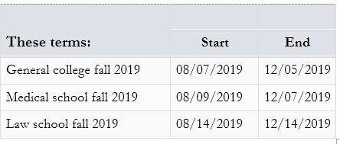
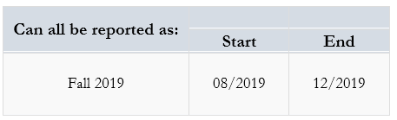

Terms starting and ending in different months: If your institution has terms that start or end in different months, please enter the terms separately.
Term: | Start | End
General college spring 2019 | 01/2020 | 05/2020
Medical school spring 2019 | 01/2020 | 04/2020
Law school spring 2019 | 02/2020 | 05/2020

3) Provide Background Information
Finally, you will be asked some brief questions about your institution, such as the type(s) of Student Information System(s) (SIS) you use and how you define standard academic credits.

What Happens After Registration?
After you register, staff from RTI International, the data collection contractor, will contact you to confirm your due date for your enrollment list and provide detailed instructions for preparing the enrollment list file.
The enrollment list file will include the following information:
General and Demographic Information | Enrollment Information
Student name | Degree program
Student ID number | Class level
Social Security Number | Major
Date of Birth | High school completion date
Sex | Dual enrollment in high school
Ethnicity | Date first enrolled in your institution
Race | First-time beginning student indicator
Veteran/active duty military status
Local address
Permanent address
E-mail address
Phone number

Once received, project staff will review your list to make sure it has all the necessary components. They may contact you if there are any questions about your list.

What Happens After You Submit Your Enrollment List?
After your enrollment list is accepted, your institution’s student sample will be selected. Project staff will contact you again, about 4 to 6 weeks after you submit your list, with instructions for providing student records data for the sampled students.

The NPSAS:20 Help Desk
The Help Desk is available, 9 AM to 9 PM ET, to answer your questions about NPSAS:20, troubleshoot technical issues, and discuss any obstacles to participation. Contact us at [number] or xxxx@rti.org.

Registration Reminder Letter and E-mail
[Date]
[Salutation] [FirstName] [LastName]
[Title]
[Institution]
[Address]
[City], [State] [Zip]
Dear [Salutation] [LastName]:
I am writing to remind you that [Institution] has been sampled for the 2019-20 National Postsecondary Student Aid Study (NPSAS:20), and that you have been identified as your institution’s Campus Coordinator.
Key facts about NPSAS:20:
- It is the definitive dataset informing federal postsecondary financial aid policy and practice.
- It will provide national and, for undergraduates, state-level data across different institution types.
- It forms the sample for the Beginning Postsecondary Students Longitudinal Study (BPS), which will report on persistence, attainment, and employment among first-time postsecondary students.
Your participation is very important! Without it, students at [Institution] will not be represented in the NPSAS data.
Please log in to the Postsecondary Data Portal (PDP) and register your institution in our study data collection system at the website below.
PDP Website: surveys.nces.ed.gov/xxxx
Your User ID: [UserID]
If you have any further questions about the study, please contact us at Xxxx@rti.org, or [HelpDeskNumber].
Sincerely,
[DCMName]
Data Collection Manager, NPSAS:20

Registration Thank You E-mail
Subject: NPSAS:20 Registration Completed
Dear [Salutation] [LastName]:
Thank you for completing the NPSAS:20 registration for [Institution]! This e-mail serves as a record that you have completed this task.
The next step in the study is submission of your [Summer/Fall 2019/2019-20 Enrollment List]. [When this phase of the study begins in January 2020/Shortly], you will receive a request with instructions for completing this step.
We very much appreciate your participation in this important study!
[Name]
Institution Relations Specialist
NPSAS:20
DID YOU KNOW? About 39 percent of undergraduates received student loans from any source in 2015-16.
Source: U.S. Department of Education, National Center for Education Statistics (NCES), 2015-16 National Postsecondary Student Aid Study (NPSAS:16).

Coordinator List Request Mailing
This mailing is sent to each institution’s coordinator after the Registration Page has been completed. It includes a letter that confirms the institution’s due date for providing its student enrollment list and instructions for preparing the list. The letter and the instructions for this mailing is included below. There will be three versions:
- requesting a fall enrollment list from the calibration group
- requesting a spring enrollment list from the calibration group
- requesting a spring enrollment list (non-calibration)

List Request Letter and E-mail
[Date]
[Salutation] [FirstName] [LastName]
[Title]
[Institution]
[Address]
[City], [State] [Zip]
Dear [Salutation] [LastName]:
Thank you very much for registering for the 2019-20 National Postsecondary Student Aid Study (NPSAS:20). We are pleased that [Institution] will participate in this important study, conducted by the U.S. Department of Education’s National Center for Education Statistics (NCES) and administered by RTI International.
Below is a summary of where you are in the study. The next step is providing your [Fall Student Enrollment List/Student Enrollment List/full-year Student Enrollment List].
[Timeline graphic – see page D-56]
Your [Fall] Student Enrollment List due date is: [DueDate]. Please contact us at [PortalHelpe-mail] or [PortalHelpNumber] if you would like to discuss this date.
Enclosed are instructions for providing the Fall Student Enrollment List, which should include all eligible students enrolled in your institution between July 1, 2019 and [date]. [If Fall: As we mentioned in our first contact, this fall list will help to ensure we are using the soundest methodology for the student interview component of the study. In early 2020, we will request the same data elements for students enrolled between July 1, 2019 and April 30, 2020.] [The full-year list/This list] will be used to create a sample of students for the Student Records portion of the study.
NEW FOR NPSAS:20 – Please include students who were concurrently enrolled in high school and your institution on your enrollment list. More details are in the instructions guide.
Postsecondary Data Portal Website: surveys.nces.ed.gov/xxxx
Your User ID: [UserID]
For more info on how NPSAS data are used, please visit [ResearchSiteURL].
Thank you for your efforts in support of NPSAS:20. If you have questions about your participation in NPSAS:20, please contact RTI’s data collection manager, [DCMforSchool], at [DCMe-mail]. I can be reached at [NCESe-mail].
Sincerely,
Jennifer Wine, Ph.D. NCES staff name
Director, NPSAS:20 NCES staff title
RTI International National Center for Education Statistics (NCES)
U.S. Department of Education
Enclosures

Student Enrollment List Preparation Instructions
Different versions of the student enrollment list preparation instructions will be sent to institutions depending on whether they were selected to provide a fall enrollment list. There will be three versions of the instructions:
- Summer/fall enrollment list collection
- Spring enrollment list for institutions selected for fall collection
- Full-year enrollment list for institutions NOT selected for fall collection.
Preparing Your [Summer/Fall 2019; Spring] Student Enrollment List for NPSAS:20
These instructions will guide you through preparing the list of students enrolled at your institution between July 1, 2019 and [date]. [If summer/fall instructions: In early 2020, you will be asked to provide an updated list of students enrolled between July 1, 2019 and [date].]
[If Spring instructions only:
You have already provided a list of students enrolled at your institution between July 1, 2019 and [date]. Now, please provide an updated list of all students enrolled between July 1, 2019 and [date].
When providing the updated list, you may choose whichever option is most convenient for your institution:
- Option A: provide all students enrolled between July 1, 2019 and [date], regardless of whether they were already included on your fall enrollment list. Our staff will compare the two lists and deduplicate the students for you.
- Option B: include only those students who were newly enrolled between October 31, 2019 and [date] (e.g., exclude students you already provided on your fall enrollment list).]

Step 1: Determine Which Students to Include
Your institution’s enrollment list should include students from all campuses, colleges, and schools, including graduate schools, reported to IPEDS under your institution’s IPEDS UNITID.
Provide a list of all eligible students enrolled at any time between July 1, 2019, and [date].
Some students may not be eligible for NPSAS; please carefully review the eligibility criteria below.
Eligible for NPSAS:20
Eligible students are those who, at any time between July 1, 2019 and [date], were enrolled in a term or course of instruction at your institution that is one of the following:
- an academic program; OR
- a course for credit that could be applied toward fulfilling the requirements for an academic degree;
- an occupational or vocational program that requires at least 3 months or 300 clock hours of instruction to receive a degree, certificate, or other formal award;
- noncredit remedial coursework within a Title IV eligible program (up to 30 semester or trimester hours, 45 quarter hours, or 900 clock hours).
NOT Eligible for NPSAS:20
Students are ineligible for NPSAS:20 if they meet any of the following conditions. Exclude these students from your student enrollment list.
Refunded tuition. Exclude students who dropped out of your institution early enough to receive a full refund of their tuition.
Paid tuition solely to another institution. Exclude students who attend this institution under joint arrangements with another institution and pay tuition solely to the other institution.
Enrolled solely in a remedial program. Students who are enrolled solely in a remedial program are not eligible.
For additional help determining which students should be included on your enrollment list, see the Frequently Asked Questions section on page 3 of this document.
Step 2: Prepare the Student Enrollment List
Prepare your list, preferably as an Excel (.xlx or xlsx) or comma-separated values (.csv) file, using the Student Enrollment List File Layout Specifications included on page 5 of this document.
The specifications provide a list of the data elements that we are requesting and the valid values for each element. If any of the requested elements do not apply to your institution, you may leave the field blank.
If you use codes other than the valid values listed in the file layout specifications, please provide us with a detailed description of the codes.
Step 3: Check for Errors
Please take a moment and review your enrollment list file for errors. Examples of common errors found on student enrollment lists include:
1. Data elements not associated with the correct student because rows shifted during sorting or copying and pasting.
2. Critical data elements not provided for all students.
3. Eligible students omitted from the list because they attend campus/school other than the main campus (e.g., law school, medical school).
Step 4: Submit Your Student Enrollment List
Gather the information below and have it on hand when you submit your student enrollment list on the PDP.
1. Date the list was prepared: Please record the date your student list was prepared, even if it is not the same as the date you submit the list.
2. Contact information: Please provide the name, department, e-mail address, and phone number for all individuals responsible for preparing your list in case we have questions about the list.
3. Comments: Provide any details that will clarify the layout of the enrollment list you are submitting, as well as any information necessary to correctly interpret the data provided. Define any special codes or abbreviations (e.g., major codes, class levels).
4. Exclusion counts: Provide counts of the students that were excluded from your Student Enrollment List for the following reasons:
- student did not meet the NPSAS eligibility requirements listed in Step 1
- student requested that their information not be provided to external parties
- student was excluded for any other reason.
To ensure data quality, the number of students submitted on your list will be compared to enrollment counts reported to IPEDS. Providing us with information about the number of excluded students will help to explain discrepancies and will expedite the processing of your list.
5. An estimate of how long it took your institution to prepare the student enrollment list.
When you are ready, log in to the Postsecondary Data Portal website at surveys.nces.ed.gov/xxxx.
From the Task Menu, select Provide Your Student Enrollment List and follow the on-screen instructions. You will be asked to provide your list and the information list above.
Uploading is the most secure and most efficient method for submitting your list. If you are unable to upload your list, please contact the Help Desk to make other arrangements.
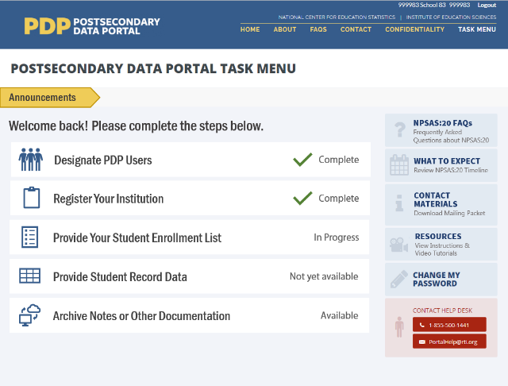
Frequently Asked Questions
Should I include non-degree seeking students?
Yes. Non-degree seeking students should be included if they are enrolled in a course for credit that could be applied toward fulfilling the requirements for an academic degree.
Should I include students taking remedial courses?
It depends. Students who are taking noncredit remedial coursework within a Title IV eligible program are eligible and should be included. Students who are enrolled solely in a remedial program are not eligible and should not be included.
Should I include students at branch or extension campuses on the list?
Yes, if the branch or extension campus reports to IPEDS through the same IPEDS UNITID as the institution that was selected for NPSAS:20. If the branch or extension campus reports to IPEDS through a different IPEDS UNITID, do not include the students from the branch or extension campus on the student list.
Our law/dental/medical/veterinary school has its own registrar’s office. Should I include students from those schools on the list of enrolled students?
Yes, if the other registrar's office reports to IPEDS through the same IPEDS UNITID as the institution that was selected for NPSAS:20. If the other registrar's office reports to IPEDS using a separate IPEDS UNITID, then students registered by that office should not be included.
I understand that NPSAS is a financial aid study. Should I include students who did not apply for or did not receive financial aid?
Yes. NPSAS includes aided as well as non-aided students.
I understand that students on the list need to have been enrolled between July 1, 2019 and [date]. Does it matter if the student also had enrollment outside of that period?
No. A student is eligible as long as he or she was enrolled at any time between July 1, 2019 and [date] and meets the other eligibility criteria, regardless of whether he or she also had enrollment outside of that timeframe.
Should I include...nonmatriculated students?
...non-degree seeking students? | Yes, include these students on the list if they otherwise satisfy the student eligibility requirements on page 1.
...part-time students?
...postbaccalaureate students?
...students taking correspondence courses?
...distance education students?
...foreign exchange students?
...continuing education students?
...extension division students?
Note that students may be eligible for NPSAS:20 even if they are not in a formal degree program. For example, someone who is taking a credit-bearing computer programming course to enhance his or her job skills would be considered eligible and should be included on the enrollment list.
Should I include students who enrolled but later withdrew without completing any courses?
Include all eligible students who enrolled and paid their tuition and fees UNLESS they withdrew early enough to receive a full refund of their tuition and fees.
Should I include students taking courses on this campus when this is not the students' home institution?
No, do not include students on your enrollment list who pay their tuition solely to another institution. We consider students to be enrolled at the institution to which they pay their tuition.
Should I include graduate students on the list if they were enrolled in a graduate program but were only auditing courses (e.g., because they did not need any more credits for graduation)?
Yes. Students enrolled in academic programs are eligible for this study, even if they are no longer enrolled in courses for credit.
Should I include international students on the student enrollment list?
Yes. International students should be included on the student enrollment list if they meet the other eligibility criteria. Note that study abroad students who are paying tuition to another institution are not eligible.
My institution uses different student degree program classifications than you request. How should I provide degree program?
If possible, please categorize your students within the student degree program categories that we request. However, if this is not possible, please classify the students as indicated in your institution's records and provide us with the definitions of these classifications. You can upload these classifications with your list, or e-mail them to [E-MAIL ADDRESS].
What should I do if I cannot provide students’ first names, middle initials, last names, and name suffixes as four separate fields?
When uploading your file on the website, let us know how your file is constructed by providing comments in the text box located on the upload page or in an e-mail to [E-MAIL ADDRESS].
What if my institution does not have student ID numbers separate from SSNs?
If your institution does not have separate student ID numbers, you can either leave the student ID field blank or use SSN in the student ID field and the SSN field.

NPSAS:20 Student Enrollment List File Layout Specifications
Field # | Student data element | Valid Values | Notes | Critical Data Element | Max field length
 | IPEDS UNITID |  |  | X | 6
 | Student ID |  |  | X | 25
 | First name |  |  | X | 100
 | Middle initial |  |  |  | 50
 | Last name |  |  | X | 100
 | Name suffix (e.g., Jr., Sr., III, etc.) |  |  |  | 50
 | Social Security Number (SSN) |  | We will use SSNs to match students to the U.S. Department of Education's Central Processing System (CPS) database, which contains information from the Free Application for Federal Student Aid (FAFSA), the National Student Loan Data System (NSLDS), and other databases prior to selecting the student sample. Matching to these databases prior to sampling will help us to select a representative sample of students. | X | 9
 | Date of birth month (MM) | 01-12 |  | X | 2
 | Date of birth day (DD) | 01-31 |  | X | 2
 | Date of birth year (YYYY) | 1940-2008 |  | X | 4
 | Sex | 0 = Male  1 = Female  2 = Other  -1 = Unknown |  |  | 2
 | Veteran or Active Duty Military status | 0 = No  1 = Yes, veteran  2 = Yes, active duty military  -1 = Unknown | Please indicate whether the sample member is a veteran of the U.S. Armed Forces or is serving on active duty (not whether the sample member is receiving veteran's benefits). |  | 2
 | Student was solely a dual enrollment high school student or completing high school requirements? | 1 = Yes, student was enrolled in high school between July 1, 2019 and [date], 2020  0 = No, student was not enrolled in high school between July 1, 2019 and [date], 2020  -1 = Unknown | The purpose of this item is to identify students who are not eligible for NPSAS:20 because they were dually enrolled in high school or completing high school requirements for their entire period of enrollment at your institution in the July 1, 2019 to [date] timeframe.  Answer YES if the student was dually enrolled in high school or completing high school requirements for all enrollment at your institution within the July 1, 2019 to [date] timeframe.  Answer NO if the student was dually enrolled but completed high school and continued to be enrolled at your institution in a postsecondary course of study at any time between July 1, 2019 and [date]. | X | 2
 | High school completion date month (MM) |  |  |  | 2
 | High school completion date day (DD) |  |  |  | 2
 | High school completion date year (YYYY) |  |  |  | 4
 | Ethnicity | 0 = Not Hispanic or Latino  1 = Hispanic or Latino  -1 = Unknown | If the student declined to provide his or her ethnicity or race, indicate “Unknown.”  Note that these ethnicity and race categories differ from those reported to IPEDS but are consistent with IPEDS requirements for the collection of ethnicity and race.  For more information about IPEDS requirements for the collection and reporting of ethnicity and race, visit https://surveys.nces.ed.gov/ipeds/visfaq_re.aspx#1. |  | 2
 | Race: White | 1 = Yes  0 = No  -1 = Unknown | If the student declined to provide his or her ethnicity or race, indicate “Unknown.”  Note that these ethnicity and race categories differ from those reported to IPEDS but are consistent with IPEDS requirements for the collection of ethnicity and race.  For more information about IPEDS requirements for the collection and reporting of ethnicity and race, visit https://surveys.nces.ed.gov/ipeds/visfaq_re.aspx#1. |  | 2
 | Race: Black or African American | 1 = Yes  0 = No  -1 = Unknown |  |  | 2
 | Race: Asian | 1 = Yes  0 = No  -1 = Unknown |  |  | 2
 | Race: American Indian or Alaska Native | 1 = Yes  0 = No  -1 = Unknown |  |  | 2
 | Race: Native Hawaiian or Pacific Islander | 1 = Yes  0 = No  -1 = Unknown |  |  | 2
 | Permanent address 1 |  |  |  | 100
 | Permanent address 2 |  |  |  | 100
 | Permanent city |  |  |  | 100
 | Permanent state |  |  |  | 2
 | Permanent country (if not U.S.) |  |  |  | 50
 | Permanent ZIP code |  |  |  | 25
 | Local/most recent address 1 |  |  |  | 100
 | Local/most recent address 2 |  |  |  | 100
 | Local/most recent city |  |  |  | 100
 | Local/most recent state |  |  |  | 2
 | Local/most recent ZIP code |  |  |  | 9
 | Phone number 1 |  | Enter a valid 10-digit phone number with no spaces, parentheses, or dashes.
 | Phone number 1 type | 1=Home  2=Mobile  3=Other
 | Phone number 2 |  | Enter a valid 10-digit phone number with no spaces, parentheses, or dashes.
 | Phone number 2 type | 1=Home  2=Mobile  3=Other
 | Campus e-mail |  |  |  | 100
 | Permanent e-mail |  |  |  | 100
 | Date first enrolled at this institution (month) | 1 - 12 |  |  | 2
 | Date first enrolled at this institution (day) | 1 - 31 |  |  | 2
 | Date first enrolled at this institution (year) | 1940 - 2020 |  |  | 4
 | First-time Beginning Student? | 0 = No  1 = Yes | A student is considered a first-time beginner (FTB) for NPSAS:20 if he or she is an undergraduate student who enrolled in college for the first time at this institution between July 1, 2019 and June 30, 2020.  Students are NOT FTBs if they were enrolled in a postsecondary class for credit at this or any other postsecondary institution prior to July 1, 2019, unless the credit was advanced placement (AP) credit, international baccalaureate (IB) credit, or any other postsecondary credit or formal award earned while the student was still completing high school.  Please note that this is not the same as the first-time full-time designation reported to IPEDS. | X | 1
 | Degree Program | 1 = Enrolled in undergraduate courses, not in a degree program  2 = Undergraduate certificate or diploma (occupational or technical program)  3 = Associate's degree  4 = Bachelor's degree  5 = Enrolled in graduate courses, not in a degree program  6 = Post-baccalaureate certificate program  7 = Dual bachelor's/master's degree  8 = Master's degree program  9 = Post-master's certificate  10 = Doctoral degree - research/scholarship  11 = Doctoral degree - professional practice  12 = Doctoral degree – other  -1 = Unknown | In what degree program is this student enrolled? If the student is no longer enrolled, report the degree program for his or her last term enrolled.  If the student was enrolled in more than one program, enter the highest degree program. If the student was enrolled in a dual degree program in which both degrees are the same level (such as a dual MD/PhD or dual MA/MBA), respond based on the student’s primary degree program. | X | 2
 | Class level | 1 = 1st Year/Freshman  2 = Sophomore  3 = Junior  4 = Senior  5 = 5th Year or higher undergraduate  6 = Undergraduate (unclassified)  7 = Student with bachelor's or advanced degree taking undergraduate courses  8 = 1st year graduate  9 = Beyond 1st year graduate  10 = Graduate (unclassified)  -1=Unknown | Enter the student's class level. If the student is no longer enrolled, provide the student’s class level during his or her last term enrolled.  If class level was used to determine financial aid eligibility, report that class level for this item. Otherwise, report the class level as defined by your institution.  Institutions typically define class level based on the number of earned credits.  An example of a commonly used classification:  • 0-29 earned credit hours for first-year/freshman  • 30-59 earned credit hours for sophomore  • 60-89 earned credit hours for junior  • 90+ earned credit hours for senior. |  | 2
 | Student’s first major |  | If your institution’s majors include codes or abbreviations, please include an explanation with your enrollment list. | X | 30
 | Classification of Instructional Programs (CIP) code for student’s first major | Format = NNNNNN (no decimal) | The Classification of Instructional Programs (CIP) provides a taxonomic scheme that supports the accurate tracking and reporting of fields of study and program completions. For more information about the Classification of Instructional Programs, see https://nces.ed.gov/ipeds/cipcode/. | X | 6
 | Student’s second major |  | If your institution’s majors include codes or abbreviations, please include an explanation with your enrollment list. |  | 30
 | Classification of Instructional Programs (CIP) code for student’s second major | Format = NNNNNN |  |  | 6

List Request Reminder Letter and E-mail
[Date]
[Salutation] [FirstName] [LastName]
[Title]
[Institution]
[Address]
[City], [State] [Zip]
Dear [Salutation] [LastName]:
I am writing to remind you of the [upcoming/recently passed] due date for your Student Enrollment List. This portion of the 2019-20 National Postsecondary Student Aid Study (NPSAS:20) will allow us to draw a sample of students enrolled at [Institution] for inclusion in the Student Records and Student Interview portions of the study.
Your current due date is [DueDate].
Please log into the Postsecondary Data Portal (PDP) and submit your Student Enrollment List.
PDP Website: surveys.nces.ed.gov/xxxx
Your User ID: [UserID]
If you need to set a new due date, or you have any further questions about the study, please contact us at Xxxx@rti.org, or [HelpDeskNumber].
Sincerely,
[DCMName]
Data Collection Manager, NPSAS:20

List Thank You E-mail
Subject: NPSAS:20 Enrollment List Submitted
Dear [Salutation] [LastName]:
Thank you for submitting the [fill text: Fall/Spring Student Enrollment List for [Institution]]! This e-mail serves as a record that you have completed this task. We may contact you shortly if there are any questions about your file.
The next step in the study is submission of your full-year 2019-20 Enrollment List. In early 2020, you will receive a request with instructions for completing this step.
We very much appreciate your participation in this important study!
[Name]
Institution Relations Specialist
NPSAS:20
[IF FALL: DID YOU KNOW? In 2015-16, about 72 percent of undergraduate students received some form of financial aid, which includes grants, loans, and work-study.]
[IF SPRING: DID YOU KNOW? Among undergraduate students, the average amount of aid received from any sources was $12,300 in 2015-16.]
Source: U.S. Department of Education, National Center for Education Statistics (NCES), 2015-16 National Postsecondary Student Aid Study (NPSAS:16).

PDP User Approval E-mail for Campus Coordinator
Subject: Please approve new NPSAS:20 website user
Dear [Salutation] [LastName]:
I am writing to request your approval of [first name] [lastname] having access to the 2019-20 National Postsecondary Student Aid Study (NPSAS:20) Postsecondary Data Portal website. As the Campus Coordinator, your approval is needed before we create an account and user ID for additional institution staff who will be providing data for NPSAS:20. The request for this person’s access comes from [current PDP user (name)/NPSAS:20 Help Desk staff]. Please simply reply to this e-mail saying that you approve. We will create a user ID for the individual and send it and the website address directly to the new user.
If you prefer, you can log in to the Postsecondary Data Portal (PDP) and approve the new user yourself. After logging in, click Manage PDP Users, find the person’s name, and then click on the I Approve Access button.
If you have any questions about the study, please contact us at Xxxx@rti.org, or [HelpDeskNumber].
Sincerely,
[DCMName]
Data Collection Manager, NPSAS:20

PDP Website: surveys.nces.ed.gov/xxxx
Your User ID: [UserID]

Data You Can Use Mailer and E-mail
NPSAS Gives You Data You Can Use…
…but we need your participation.
Did you know that you will be able to get data for [State] from the current National Postsecondary Student Aid Study (NPSAS)?
NPSAS will send you state-level financial aid estimates for undergraduates and other data you can share with your critical target audiences, like your institution’s leadership and your state’s legislators.
Key Data from NPSAS:
- Average financial need and percentage of students with need
- Average merit and need-based state grants and percentage of students with grants
- Cumulative undergraduate borrowing amounts by loan type
Please log in to our study website and register for NPSAS:20/provide an enrollment list on behalf of [Institution] as soon as you can. Your participation now will ensure that NPSAS provides the best quality data to the postsecondary community.
PDP Website: surveys.nces.ed.gov/xxxx
Your User ID: [UserID]
[IF MAILER: NPSAS Help Desk: [HelpDeskNumber] | xxxx@rti.org]
[IF E-MAIL: If you have any further questions about the study, please contact us at XXXX@RTI.ORG, or [HelpDeskNumber].
Sincerely,
[DCMName]
Data Collection Manager, NPSAS:20]

“Please Represent Your State” Mailer and E-mail
NPSAS is designed to represent <State>…
…but we need your participation.
Did you know that you will be able to get state-level data for [State] for undergraduates from the current National Postsecondary Student Aid Study (NPSAS)?
Traditionally, NPSAS data have provided a national picture of how students and their families pay for college. NPSAS:20 is designed to also provide state-level information for undergraduates. Want to know how state aid granted in [State] compares to that of [NeighborState]? Or how total tuition charged in [Sector] schools in [State] compares to the national average? NPSAS cannot provide data for those comparisons without your participation.
Please log in to our study website and register for NPSAS:20/provide an enrollment list on behalf of [Institution] as soon as you can. Your participation now will ensure that NPSAS provides the best quality data to the postsecondary community.
PDP Website: surveys.nces.ed.gov/xxxx
Your User ID: [UserID]
[IF MAILER: NPSAS Help Desk: [HelpDeskNumber] | xxxx@rti.org]
[IF E-MAIL:
If you have any further questions about the study, please contact us at xxxx@rti.org, or [HelpDeskNumber].
Sincerely,
[DCMName]
Data Collection Manager, NPSAS:20]

BPS Base Year Mailer and E-mail
NPSAS studies provide insight into student experience…
…but we need your participation.
Did you know that the sample for the upcoming Beginning Postsecondary Students Longitudinal Study (BPS) will be drawn from the National Postsecondary Student Aid Study (NPSAS)?
BPS surveys first-time, beginning students three times over six years. Information collected from BPS participants will be compiled with transcript information and other administrative data to provide a comprehensive picture of student demographics, experiences, persistence, transfer, and degree
attainment for the BPS population. The student enrollment list you provide for NPSAS:20 allows eligible first time students from [Institution] to be sampled for BPS.
Please log in to our study website and register for NPSAS:20/provide an enrollment list on behalf of [Institution] as soon as you can. Your participation now will ensure that NPSAS provides the best quality data to the postsecondary community.
PDP Website: surveys.nces.ed.gov/xxxx
Your User ID: [UserID]
[IF MAILER: NPSAS Help Desk: [HelpDeskNumber] | xxxx@rti.org]

[IF E-MAIL:
If you have any further questions about the study, please contact us at xxxx@rti.org, or [HelpDeskNumber].
Sincerely,
[DCMName]
Data Collection Manager, NPSAS:20]

Registration/List Collection Is Ending Mailer and Email
NPSAS Registration/List Collection is coming to an end…
…and we need your participation.
We are moving into the next phase of NPSAS:20. So that [Institution] can move to the next phase as well, please log in to the Postsecondary Data Portal (PDP) and complete the NPSAS:20 registration/submit your student enrollment list at your earliest convenience.
Participating in NPSAS means having your institution’s students represented in a national study on postsecondary student aid. Taking part, along with other institutions in [State], allows the National Center for Education Statistics (NCES) to provide state-representative data for undergraduates, which will be used to gain a better understanding of the financial aid landscape in [State]. The entire NPSAS team values your contribution; our study could not exist without it.
Please log in to the Postsecondary Data Portal (PDP) and [register your institution for NPSAS:20/submit a student enrollment list] at your earliest convenience.
PDP Website: surveys.nces.ed.gov/xxxx
Your User ID: [UserID]
If you need to set a new due date, or you have any further questions about the study, please contact us at xxxx@rti.org, or [HelpDeskNumber].
Sincerely,
[DCMName]
Data Collection Manager, NPSAS:20

Final Weeks of List Collection E-mail – From Project Director
Dear [Salutation] [LastName]:
Did you know that you will be able to get data for your state and region from the current National Postsecondary Student Aid Study (NPSAS:20)? NPSAS:20 will send you state-level financial aid estimates for undergraduates and other data you can share with your critical target audiences, like your institution’s leadership and your state’s legislators. Also with NPSAS:20 data, you will be able to compare your state with others and with national estimates on key measures like:
- Average financial need and percentage of students with need
- Average merit and need-based state grants and percentage of students with grants
- Cumulative loan debt
- Percentage of students with Pell grants
- Cumulative undergraduate borrowing by loan type
As you probably have heard already, we are in the final weeks of this NPSAS:20 collection. If you want to be able to receive these important data for (state), we need your help. Please upload the 2019-20 enrollment list for (Inst Name) to the NPSAS data portal (https://surveys.nces.ed.gov/xxxx). Your User ID is printed below – just follow the instructions and prompts to log in.
Please call [PhoneNumber] or send an e-mail to [e-mailAddr] if you have questions or need assistance with the process.
Study website: https://surveys.nces.ed.gov/xxxx
User ID: (UserID)
Thank you for your support of NPSAS. Your participation now will ensure that NPSAS provides the best quality data to the postsecondary community.
Sincerely,
Jennifer Wine, Ph.D.
Director, NPSAS:20

Final Weeks of List Collection E-mail – From NCES

Dear [Salutation] [LastName]:

I am e-mailing to encourage your institution’s participation in the 2019–20 National Postsecondary Student Aid Study (NPSAS:20). The last day to provide a student enrollment list and be included in the study is [EndDate]. NPSAS:20 is conducted by the National Center for Education Statistics (NCES) under a congressional mandate to gather information from postsecondary institutions on how students and their families finance college. Your participation is important to making this study a success.
NPSAS data play a key role in evaluating the effectiveness of federal financial aid programs in meeting the needs of students. NPSAS data are cited in journal and newspaper articles, foundation policy briefs, and a wide array of other publications and reports, and are focused on a variety of topics, including financial aid use and debt accumulation, education outcomes, and the changing demographics of today’s students. We want to make sure these data accurately represent, and are available to, institutions like yours. If enough institutions participate, including [fill institution], we will provide you with a data feedback report comparing financial aid estimates at the sector and national levels and, for undergraduates, at the state level.
We try to accommodate institutions’ individual needs whenever possible, and we do have some flexibility in certain aspects of the study. To discuss this, or if you have any questions about your participation in NPSAS:20, please contact the NPSAS Project Director, Dr. Jennifer Wine, at [PhoneNumber] or via e-mail at [e-mailAddr]. If you have any comments or general feedback that you would like to provide to NCES about this data collection, please contact me at [PhoneNumber] (e-mail address: [e-mailAddr]).
Please let us know how we can assist you. Thank you again for your cooperation and interest.
Sincerely,
Please log on and provide data at:
https://surveys.nces.ed.gov/xxxx
Your user name: «UserID»
If you do not recall your password, click Forgot Password.

NCES staff person
NCES staff title
National Center for Education Statistics (NCES)
Institute of Education Sciences
U.S. Department of Education

.

Reduced Data Elements List Collection E-mail – From Project Director

Dear [Salutation] [LastName]:

We are in the final weeks of the 2019-20 National Postsecondary Student Aid Study (NPSAS:20) and we need your help. We need a student enrollment list from your institution, <fill institution>, to make NPSAS:20 and its resulting data as beneficial as possible to the students, institutions, and organizations within the U.S. higher education community, as well as researchers, policymakers, and legislators at both the national and state levels. If you have already provided your list by the time this e-mail reaches you, please disregard this e-mail and thank you so much.

Each variable we request on the enrollment list is important to the study, but given that data collection ends at the end of the month and your institution’s participation is so important we are now requesting that your student enrollment list contain only the following variables:
- First name
- Last name
- Social Security Number (or institution student ID if you are unable to provide SSN)
- Student Level (undergraduate student = 1; graduate student = 2)

To submit your enrollment list, please visit https://surveys.nces.ed.gov/xxxx, log in with the user ID below, and follow the prompts and instructions. After we receive your enrollment list, we will sample students from it and then request student records from your institution for only those students. Please call [PhoneNumber] or send an e-mail to [e-mailAddr] if you have questions or need assistance with the process.

Study website: https://surveys.nces.ed.gov/xxxx
User ID: [UserID]

Thank you for your support of the National Postsecondary Student Aid Study. Your efforts are greatly appreciated.

Sincerely,

Jennifer Wine, Ph.D.
Director, NPSAS:20

Postsecondary Data Portal Login Instructions
These instructions will be sent to institutions that have difficulty with the login process on an as-needed basis.
In order to safeguard all data transmitted between your institution and NCES, we use a secure HTML website with two-factor authentication. This site is called the Postsecondary Data Portal (PDP) and can be accessed at surveys.nces.ed.gov/xxxx. Below are instructions on how to access the Portal and what to do if you are unable to gain access.
1) Go to the PDP website and enter your User ID.
You can find your User ID in the letter or E-mail we sent to you. If you cannot find that letter or e-mail, please contact our HelpDesk at xxx-xxx-xxxx and we will send your User ID to the e-mail address associated with the account. Once you have entered your User ID, click “Continue”.
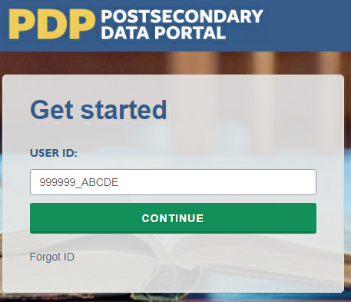
2) Create a Password (First Time Users)
The first time you access the PDP, you will need to create a password. You will also be prompted to create a new password every 60 days. Should you forget your password, you will be able to set a new password using the “Forgot Password” link. Below are the specifications for creating a password that the system will accept.
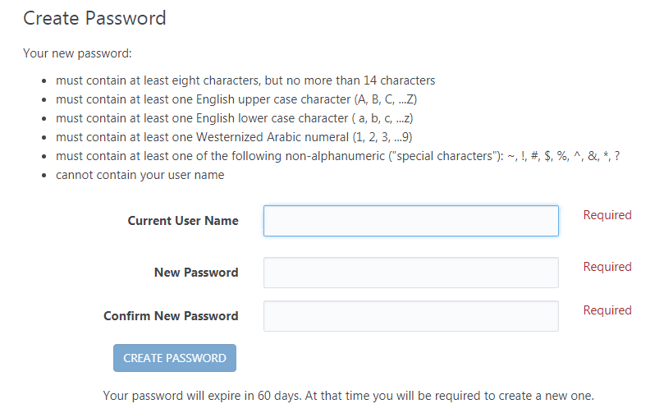
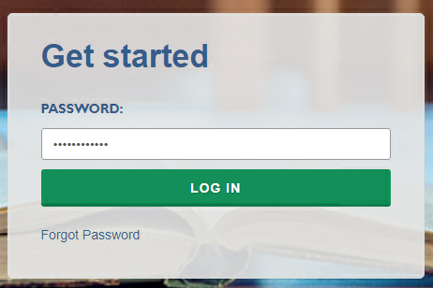
3) Complete Two-Factor Authentication
After you create your password the first time, it will be valid for 60 days. The next step is to enter your password when prompted, and click “Log In”.
Entering the correct password will prompt the system to send a code via e-mail to the e-mail address associated with your User ID. It will come from the address no-reply@ed.gov. This e-mail can take up to 10 minutes to arrive in your inbox, depending on your institution’s e-mail system. If you do not see it in your main inbox, please check any alternative inboxes you may have (“Other” inbox in Outlook, “Promotions” inbox in Gmail, etc.), as well as your Spam folder. If you still do not see the e-mail, please contact our Help Desk at xxx-xxx-xxxx or [helpdesk e-mail].
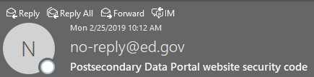
Thank you for beginning the log-in process at the NCES Postsecondary Data Portal (PDP) Website. Please enter the 6-digit security code shown below on the website to finish logging in. The code expires in 30 minutes.
123456
Enter the code provided in the e-mail when prompted, and you will be logged into the PDP.
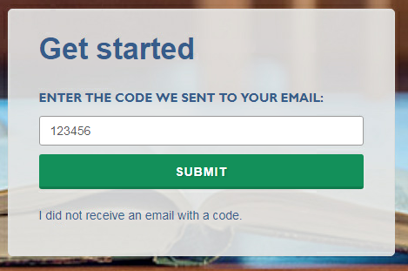

Nonrespondent Follow-Up Materials
Nonrespondents will be sent letters and informational flyers with information specific to institution type as needed during data collection. Letters and flyer content are included below. This section also includes a letter to state organizations requesting that they encourage specific non respondent institutions to participate.

Letter to Nonrespondent Institutions
[Date]
«cname»
«title»
«instname»
«Addr1» «Addr2»
«City», «st» «zip»
Dear «salutation» «lname»:
You are receiving this letter because we want to encourage your institution’s participation in the 2019–20 National Postsecondary Student Aid Study (NPSAS:20). NPSAS:20 is conducted by the U.S. Department of Education’s National Center for Education Statistics (NCES) under a congressional mandate to gather information from postsecondary institutions on how students and their families finance college. Your participation is important to making this study a success.
NPSAS data play a key role in evaluating the effectiveness of federal financial aid programs in meeting the needs of today’s postsecondary students, and are helpful to the postsecondary institutions and researchers concerned with these students. NPSAS data appear in a wide array of reports, journal and newspaper articles, and foundation policy briefs which focus on a variety of topics, including financial aid use, debt accumulation, and education outcomes. Just as important, we want to make sure these data are available to you and institutions like yours. If enough institutions, including yours, participate, we will provide you with a data feedback report comparing financial aid estimates at the sector and national levels and, for undergraduates, at the state level as well – but unfortunately, the data feedback reports can be prepared for participating institutions only.
There are a variety of tools available for people who want to access NPSAS data through NCES’s DataLab site (https://nces.ed.gov/datalab). PowerStats and QuickStats, for example, provide users with an interface for creating tables and conducting analyses with the prior NPSAS datasets. The College and Career Tables Library offers access to thousands of tables produced for NCES publications.
If you have any questions about accessing prior NPSAS data or your participation in NPSAS:20, please contact the NPSAS Project Director, Dr. Jennifer Wine, at [XXX] or via e-mail at [E-MAIL ADDRESS]. If you have any comments or general feedback that you would like to provide to NCES about this data collection, please contact Tracy Hunt-White, Ph.D., Project Officer, NPSAS:20, at XXX (e-mail address: xxxx@ed.gov).
Thank you again for your cooperation and interest. Let us know how we can assist you.
Sincerely,
Please log on and provide data at:
surveys.nces.ed.gov/xxxx
Your user ID: «UserID»
If you do not recall your password, click Forgot Password.
(NCES staff name)
(NCES staff title)
National Center for Education Statistics (NCES)
Institute of Education Sciences
U.S. Department of Education
Enclosure

Text of Flyer for Nonrespondents – Public Institutions
(Page 1)
2019–20 National Postsecondary Student Aid Study (NPSAS:20)
According to NPSAS:16 data, about 72 percent of all undergraduates received some form of financial aid in 2015–16: some 55 percent received federal aid, 22 percent received state aid, and 25 percent received aid funded by the postsecondary institution they attended.
NPSAS is a nationally representative study of how students and their families pay for postsecondary education. It has been conducted since 1987 by the U.S. Department of Education’s National Center for Education Statistics (NCES) and is congressionally mandated through the Higher Education Opportunity Act of 2008 (20 U.S.C. §1015). NPSAS is used by policymakers and researchers to better understand the financial needs of postsecondary students in the United States.
The National Center for Education Statistics (NCES) designed NPSAS:20 to provide representative samples for each of the U.S. states, making it different from most previous NPSAS studies. This design will allow researchers and other data users to generate state-representative financial aid estimates for undergraduates and compare financial aid types at the state level.
Family Educational Rights and Privacy Act of 1974
The data request for NPSAS fully conforms to the requirements of the Family Educational Rights and Privacy Act of 1974 (FERPA) (20 U.S.C. 1232g; 34 CFR Part 99). FERPA, under provision of 34 CFR §§ 99.31(a)(3) and 99.35, permits institutions to disclose without consent individual student education records to NCES, as an authorized representative of the Secretary of Education, in connection with an evaluation of federally supported education programs. RTI International, as the contractor for NCES, has been given the authority to collect information from institution records on behalf of NCES. Student data are subject to strict protections that are adhered to by NCES and its contractor organizations. All of the provided student information may be used only for statistical purposes and may not be disclosed, or used, in identifiable form for any other purpose except as required by law (20 U.S.C. §9573 and 6 U.S.C. §151).
Why Should Public Institutions Participate?
We need your participation in NPSAS:20 to ensure that we have data on students’ financial aid needs and how well they are being met, especially in terms of federal student aid. NPSAS:16 data show the following:
- Fifty-five percent of all undergraduates received federal student aid.
- Thirty-nine percent of all undergraduates received federal Pell Grants and 36 percent took out federal Direct Loans.
- Undergraduates who received federal Pell Grants received an average amount of $3,700.
- Undergraduate borrowers took out an average of $6,600 in federal Direct Loans overall, $3,700 in Direct Subsidized Loans, and $4,000 in Direct Unsubsidized Loans.
Participants Receive a Data Feedback Report
After the data are collected and if enough institutions, including yours, have participated, we will provide a data feedback report comparing financial aid estimates at the sector and national levels and, for undergraduates, at the state level.
.

(Page 2)
Page 2 of the flyer will look like the image below, but the information on the left side of the page will contain these updated data:

- NPSAS: Three-fifths of undergraduates received grant aid in 2015-16, and 39% borrowed money to pay college expenses.

[data from the below First Look table will be used to create a chart]

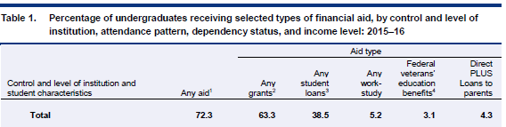

Source: U.S. Department of Education, National Center for Education Statistics (NCES), 2015-16 National Postsecondary Student Aid Study (NPSAS:16).

- BPS: Among 2011–12 first-time beginning postsecondary students who first enrolled in a public 2-year institution, 8 percent had completed a certificate, 18 percent had completed an associate’s degree, and 13 percent had completed a bachelor’s degree by 2017. Among their peers who first enrolled in a 4-year institution, 59 percent had completed a bachelor’s degree, 6 percent had completed an associate’s degree, and 2 percent had completed a certificate at any institution by 2017.

[data from the below First Look tables will be used to create a chart]

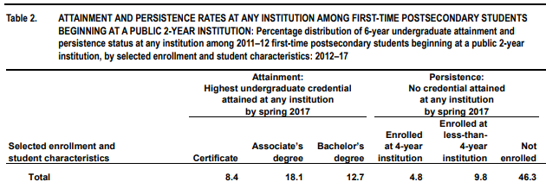
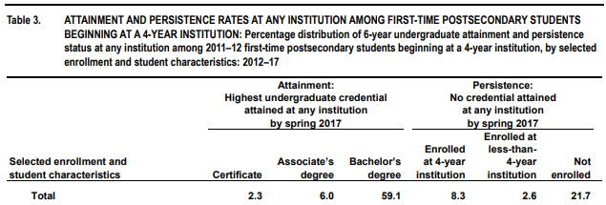

Source: U.S. Department of Education, National Center for Education Statistics (NCES), 2012/17 Beginning Postsecondary Students Longitudinal Study (BPS:12/17).

- B&B: Four years after completing their degree requirements, 16% of 2007-08 bachelor’s degree recipients were enrolled in additional education, 65% were employed full-time in one job, 14% were employed part time or in multiple jobs, 9% were unemployed, and 12% were out of the labor force.

[data from the below Web Tables will be used to create a chart]

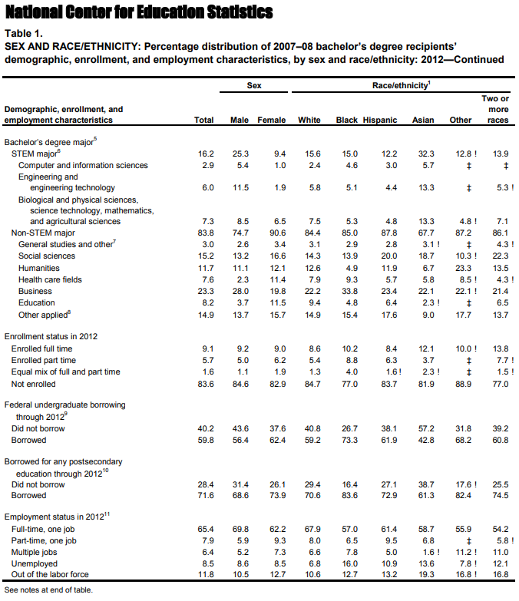
Source: U.S. Department of Education, National Center for Education Statistics (NCES), 2008/12 Baccalaureate and Beyond Longitudinal Study (B&B:08/12).

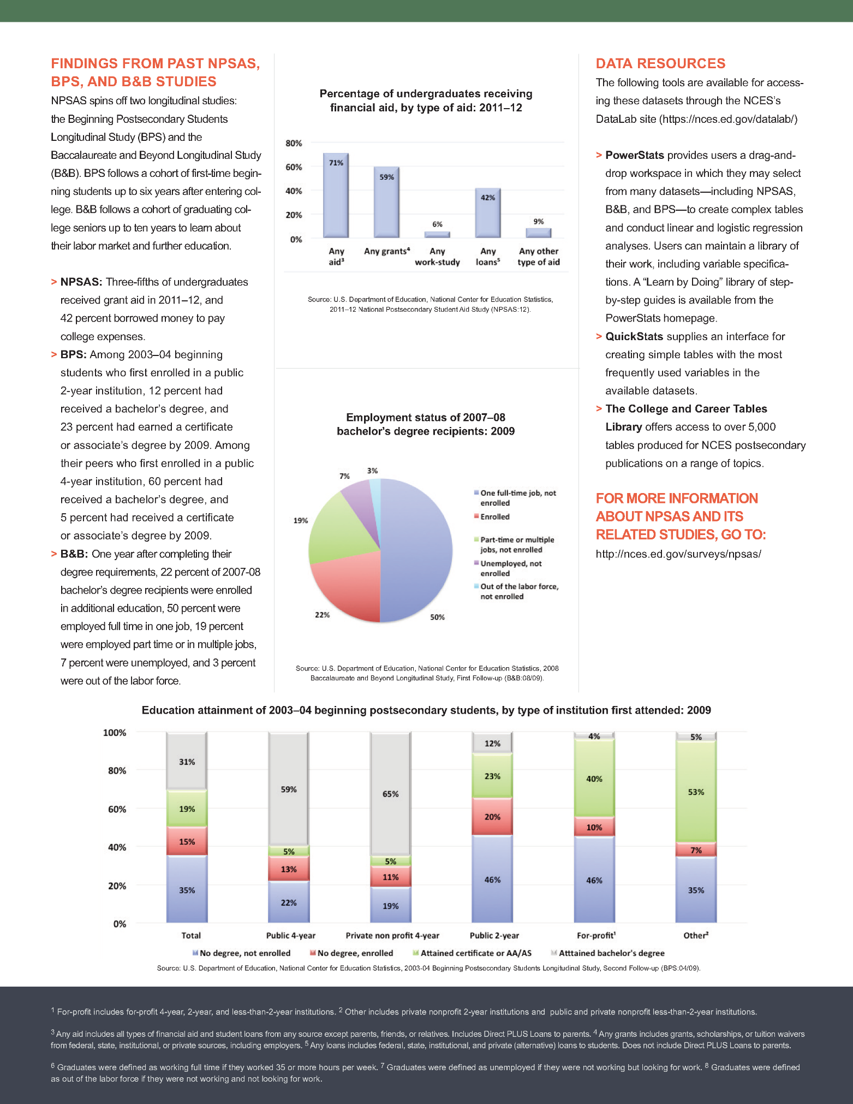

Text of Flyer for Nonrespondents – For-Profit Institutions
(Page 1)
2019–20 National Postsecondary Student Aid Study (NPSAS:20)
According to NPSAS:16 data, sixty-nine percent of undergraduates at proprietary institutions in 2015-16 were first-generation postsecondary students (that is, a student for whom neither parent earned a bachelor’s degree or higher), compared with 44 percent of students at private nonprofit institutions and 57 percent of students at public institutions.
NPSAS is a nationally representative study of how students and their families pay for postsecondary education. It has been conducted since 1987 by the U.S. Department of Education’s National Center for Education Statistics (NCES) and is congressionally mandated through the Higher Education Opportunity Act of 2008 (20 U.S.C. §1015). NPSAS is used by policymakers and researchers to better understand the financial needs of postsecondary students in the United States.
NCES designed NPSAS:20 to provide representative samples for each of the U.S. states, making it different from most previous NPSAS studies. This design will allow researchers and other data users to generate state-representative financial aid estimates for undergraduates and compare financial aid types at the state level.
Family Educational Rights and Privacy Act of 1974
The data request for NPSAS fully conforms to the requirements of the Family Educational Rights and Privacy Act of 1974 (FERPA) (20 U.S.C. 1232g; 34 CFR Part 99). FERPA, under provision of 34 CFR §§ 99.31(a)(3) and 99.35, permits institutions to disclose without consent individual student education records to NCES, as an authorized representative of the Secretary of Education, in connection with an evaluation of federally supported education programs. RTI International, as the contractor for NCES, has been given the authority to collect information from institution records on behalf of NCES. Student data are subject to strict protections that are adhered to by NCES and its contractor organizations. All of the provided student information may be used only for statistical purposes and may not be disclosed, or used, in identifiable form for any other purpose except as required by law (20 U.S.C. §9573 and 6 U.S.C. §151).
Why Should Proprietary Institutions Participate?
Proprietary institutions serve a diverse and disadvantaged student population. NPSAS:16 data show the following:
- The median age of students at proprietary institutions is 27 years old, whereas the median age of students at public institutions is 22 years and 21 years at private nonprofit institutions.
- The median income of parents of dependent students at proprietary institutions is $31,000. At public institutions, the median parental income of dependent students is $60,000 and $86,000 for parents of dependent students at private nonprofit institutions.
- Twenty-seven percent of undergraduates at proprietary institutions are Black and 25 percent are Hispanic. At public institutions, 14 percent of undergraduates are Black and 25 percent are Hispanic. At private nonprofit institutions, the rates are 14 percent Black and 21 percent Hispanic.
We need your participation in NPSAS:20 to ensure that we have data on your students’ financial aid needs and how well they are being met, especially in terms of federal student aid.
Participants Receive a Data Feedback Report
After the data are collected and if enough institutions, including yours, have participated, we will provide a data feedback report comparing financial aid estimates at the sector and national levels and, for undergraduates, at the state level.

(Page 2 is the same as public institution flyer.)

Request to State Organizations to Encourage Institution Participation
(Date)

(Salutation) (FirstName) (LastName)
(Title)
(Organization)
(Address)
(City), (State) (Zip)
Dear (Salutation) (LastName):
The National Center for Education Statistics (NCES) within the U.S. Department of Education is pleased to announce that the 2019-20 National Postsecondary Student Aid Study (NPSAS:20) is currently in progress in institutions across all 50 States, Puerto Rico, and the District of Columbia. NPSAS:20 is designed to provide national-level estimates on student financial aid, and now will be able to provide state-level estimates for undergraduates as well. State policymakers will have access to information on how state financial aid interacts with federal aid programs, be able to disaggregate types of state financial aid by student characteristics, and be able to benchmark measures such as merit- and need-based aid recipients against other similar states. In order for NPSAS:20 to be a success, we need your help!
As you know, for NPSAS:20 to produce these valuable state-level financial aid data for undergraduates in [fill State]/the [fill sector] in [fill state], your student sample must be representative. However, the current participation rate for your institutions [is / may] not [be] sufficient to yield a representative sample for [fill state/the [fill sector] in [fill state]. For that reason, I am writing to ask that you reach out to encourage institution participation. [For State Coordinating bodies or entities for which it is permissible to disclose the sampled institutions and contacts: Please e-mail [E-MAIL ADDRESS] if you would like information on which institutions have not yet responded.]
If you have any questions about the study, please contact Jennifer Wine, Ph.D., Director, NPSAS:20, at XXXX or via e-mail at [E-MAIL ADDRESS]. If you have any comments or general feedback that you would like to provide to NCES about this data collection, please contact Tracy Hunt-White, Ph.D., Project Officer, NPSAS:20, at XXXX (e-mail address: xxxx@ed.gov).Thank you in advance for encouraging participation in this important study.
Sincerely,
(electronic signature)
NCES staffperson name
NCES staffperson title
National Center for Education Statistics (NCES)
Institute of Education Sciences
U.S. Department of Education
Enclosures

[the words “your State” will be replaced with “Puerto Rico” or “the District of Columbia” as appropriate]

NPSAS Study Timeline Graphic

The timeline graphics below will be used throughout the contact materials, PDP website text, instructions, and materials included in this appendix. “[Timeline graphic]” is used throughout the materials to indicate where the images will be inserted.
The graphic will be updated throughout collection based on (1) the intended audience for the materials (Chief Administrator or Campus Coordinator), (2) the institutions’ current step in the NPSAS:20 data collection process, and (3) whether the institution is selected for the fall 2019 enrollment list collection.
The three examples below illustrate how the timelines will appear and how they will be updated throughout NPSAS:20 data collection.

Example A: Initial timeline send to Campus Coordinators, for institutions participating in the fall 2019 enrollment list collection.
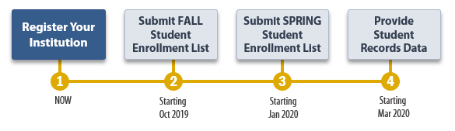
Example B: Initial timeline send to Campus Coordinators, for institutions selected for the spring 2020 enrollment list collection only (not the fall 2019 list collection).
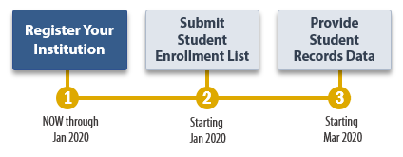
Example C: Timeline sent to Campus Coordinators with the enrollment list request materials, after the initial steps have been completed.
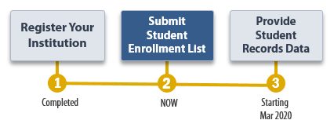

Spanish Mailing Materials
Each of the letters included earlier in this appendix as well as the study brochure, the Quick Guide to NPSAS:20, and the timeline graphics have been translated into Spanish for institutions in Puerto Rico. The Spanish materials are included below.

Chief Administrator Letter and E-mail – Past Participant
(Date)
(Salutation) (FirstName) (LastName)
(Title)
(Institution)
(Address)
(City), (State) (Zip)
Estimado(a) (Salutation) (LastName):
El Centro Nacional de Estadísticas de la Educación (NCES por sus siglas en inglés) del Departamento de Educación de los Estados Unidos está comenzando el próximo ciclo del Estudio Nacional de Ayuda Financiera a Estudiantes de Postsecundaria (NPSAS por sus siglas en inglés). NPSAS cuenta con el apoyo de [fill name of organization most closely tied to institution.] Me complace informarle que [Institution] ha sido seleccionada para participar en este nuevo ciclo, NPSAS:20, el cual se enfocará en los estudiantes matriculados durante el año académico 2019-20. A continuación presentamos un calendario general de las actividades del estudio.
[Timeline graphic – see page D-76]
La última vez que [Institution] participó en NPSAS, [fill last PC we had] se desempeñó como Coordinador(a) de Campus. A la brevedad nos pondremos en contacto con [él/ella/él o ella] para darle instrucciones sobre cómo proceder para esta nueva recolección de datos. Si usted prefiere nombrar a otra persona como Coordinador(a), puede hacerlo a través del Portal de Datos de Postsecundaria de NCES (PDP). Al pie de esta carta encontrará las credenciales que le permitirán ingresar al PDP.
Aspectos destacados de NPSAS:20
- Los resultados de NPSAS:20 se prepararán a nivel nacional; para los estudiantes subgraduados también a nivel estatal o territorial.
- Si suficientes instituciones participan, al final de NPSAS:20 le proporcionaremos a usted un reporte de resultados de los datos 2019-20 en el cual habrá comparaciones entre los estimados de ayuda financiera a nivel nacional, por sector, y --para estudiantes subgraduados-- a nivel estatal o territorial.
- [If fall: A algunas instituciones, incluyendo la suya, se les está pidiendo que presenten una lista de estudiantes matriculados para el otoño y otra para la primavera, para permitir que sus estudiantes sean entrevistados más al principio del periodo de recolección de datos, lo cual asegurará que tengamos suficiente tiempo para recolectar la información necesaria para este ciclo de NPSAS.]
- NPSAS:20 incluye un componente que es un estudio longitudinal, el Estudio Longitudinal de Estudiantes que Comienzan Programas Postsecundarios (BPS, por sus siglas en inglés), el cual reportará sobre la persistencia, los logros y el empleo de los estudiantes postsecundarios a lo largo de sus primeros 5 años de matriculación.
- El sitio para recolección de datos de NPSAS:20 incluye mejoras recientes diseñadas para hacer más fácil (al Coordinador/a la Coordinadora) completar las actividades del estudio.
Somos conscientes de que el tiempo de su personal es limitado; por eso hemos estado esforzándonos por simplificar los requisitos de provisión de datos y minimizar el tiempo y el esfuerzo necesarios para participar en NPSAS:20.

¿Desea más información?
Para más información sobre NPSAS en general, le invito a visitar la página web de NCES sobre el estudio (https://nces.ed.gov/surveys/npsas/). Para saber más sobre cómo se utilizan los datos de NPSAS, visite la página de investigación de NPSAS en https://nces.ed.gov/surveys/npsas/POLICY AND RESEARCH PAGE.
Esperamos trabajar con usted en el curso del próximo año. Si tiene alguna pregunta sobre su participación en NPSAS:20, por favor póngase en contacto con [fill gender appropriate depending on who is named: el administrador/la administradora] de recolección de datos de RTI, [fill name for this institution], escribiéndole a XXXXXX (e-mail). Puede comunicarse conmigo a mi dirección: XXXX (e-mail).
Le saluda atentamente,
(NCES staff name)
(NCES staff title)
Centro Nacional de Estadísticas de la Educación (NCES)
Instituto de Ciencias de la Educación
Departamento de Educación de los Estados Unidos
Anexos
Nota: Si desea designar un nuevo Coordinador(a) de Campus, entre al Portal de Datos de Postsecundaria usando la siguiente información:
surveys.nces.ed.gov/xxxx
Su ID de usuario (User ID): (UserID)

Chief Administrator Letter and E-mail – New Institution – Campus Coordinator Recommendation
(Date)
(Salutation) (FirstName) (LastName)
(Title)
(Institution)
(Address)
(City), (State) (Zip)
Estimado(a) (Salutation) (LastName):
El Centro Nacional de Estadísticas de la Educación (NCES por sus siglas en inglés) del Departamento de Educación de los Estados Unidos está comenzando el próximo ciclo del Estudio Nacional de Ayuda Financiera a Estudiantes de Postsecundaria (NPSAS por sus siglas en inglés). Se trata de un estudio que se hace bajo un mandato del Congreso para entender cómo los estudiantes y sus familias pagan por sus estudios universitarios. Me complace informarle que [Institution] ha sido seleccionada para participar en NPSAS:20, el cual se enfocará en los estudiantes matriculados durante el año académico 2019-20. NPSAS cuenta con el apoyo de [fill name of organization most closely tied to institution.]. Si suficientes instituciones participan, al final de NPSAS:20 le proporcionaremos a usted un reporte de resultados de los datos 2019-20 en el cual habrá comparaciones entre los estimados de ayuda financiera del sector y los niveles nacionales. Para estudiantes subgraduados, también se incluirán estimados a nivel estatal o territorial.

¿Qué se requiere de usted y de su personal?
La participación en NPSAS:20 se hace por pasos, los cuales están explicados más abajo. Planeamos invitar [fill name] para que sea [el Coordinador/la Coordinadora] del Campus para [Institution]. Si usted prefiere nombrar a otra persona como Coordinador(a), le daremos instrucciones al pie de esta carta sobre cómo ingresar al Portal de Datos de Post-Secundaria (PDP), el sistema para recolectar datos para NPSAS:20. A la brevedad nos pondremos en contacto con [fill name] para darle instrucciones sobre cómo registrar su institución en el PDP y proporcionar una lista de estudiantes matriculados de 2019-20 a nuestro contratista, RTI International, la organización de estudios de investigación que lleva a cabo la recolección de datos de NPSAS:20 en nombre de NCES. RTI seleccionará una muestra de estudiantes de la lista que ustedes proporcionen y, más adelante, recolectará datos sobre la matriculación, el presupuesto y la ayuda financiera para 2019-20 de los estudiantes que estén en la muestra. Somos conscientes de que el tiempo de su personal es limitado; por eso hemos estado esforzándonos por simplificar los requisitos de provisión de datos y minimizar el tiempo y el esfuerzo necesarios para participar en NPSAS:20.
[Timeline graphic – see page D-76]
¿Desea más información?
Para más información sobre NPSAS en general, le invito a visitar la página web de NCES sobre el estudio(https://nces.ed.gov/surveys/npsas/). Para saber más sobre cómo se utilizan los datos de NPSAS, visite la página de investigación de NPSAS en https://nces.ed.gov/surveys/npsas/POLICY AND RESEARCH PAGE.
Esperamos trabajar con usted en el curso del próximo año. Si tiene alguna pregunta sobre su participación en NPSAS:20, por favor póngase en contacto con [fill gender appropriate depending on who is named: el administrador/la administradora] de recolección de datos de RTI, [fill name for this institution], escribiéndole a XXXXXX (e-mail). Puede comunicarse conmigo a mi dirección: XXXX (e-mail).
Le saluda atentamente,
(NCES staff name)
(NCES staff title)
Centro Nacional de Estadísticas de la Educación (NCES)
Instituto de Ciencias de la Educación
Departamento de Educación de los Estados Unidos
Anexos

Para designar un nuevo Coordinador(a) de Campus para [Institution], por favor visite el Portal de Datos de Postsecundaria (PDP):
surveys.nces.ed.gov/xxxx
Su ID de usuario (User ID): (UserID)

Chief Administrator Letter and E-mail – New Institution – No Campus Coordinator
(Date)
(Salutation) (FirstName) (LastName)
(Title)
(Institution)
(Address)
(City), (State) (Zip)
Estimado(a) (Salutation) (LastName):
El Centro Nacional de Estadísticas de la Educación (NCES por sus siglas en inglés) del Departamento de Educación de los Estados Unidos está comenzando el próximo ciclo del Estudio Nacional de Ayuda Financiera a Estudiantes de Postsecundaria (NPSAS por sus siglas en inglés). Se trata de un estudio que se hace bajo un mandato del Congreso para entender cómo los estudiantes y sus familias pagan por sus estudios universitarios. Me complace informarle que [Institution] ha sido seleccionada para participar en NPSAS:20, el cual se enfocará en los estudiantes matriculados durante el año académico 2019-20. NPSAS cuenta con el apoyo de [fill name of organization most closely tied to institution.]. Si suficientes instituciones participan, al final de NPSAS:20 le proporcionaremos a usted un reporte de resultados de los datos 2019-20 en el cual habrá comparaciones entre los estimados de ayuda financiera del sector y los niveles nacionales. Para estudiantes subgraduados, también se incluirán estimados a nivel estatal o territorial.

¿Qué se requiere de usted y de su personal?
La participación en NPSAS:20 se hace por pasos, los cuales están explicados más abajo. Lo único que necesitamos de usted es que designe un Coordinador(a) de Campus, a quien le pediremos que registre su institución en el Portal de Datos de Postsecundaria (PDP), el sistema de recolección de datos para NPSAS:20 y le proporcione una lista de estudiantes matriculados de 2019-20 a nuestro contratista, RTI International, la organización de estudios de investigación que lleva a cabo la recolección de datos de NPSAS:20 en nombre de NCES. RTI seleccionará una muestra de estudiantes de la lista que ustedes proporcionen y, más adelante, recolectará datos sobre la matriculación, el presupuesto y la ayuda financiera para 2019-20 de los estudiantes que estén en la muestra. Somos conscientes de que el tiempo de su personal es limitado; por eso hemos estado esforzándonos por simplificar los requisitos de provisión de datos y minimizar el tiempo y el esfuerzo necesarios para participar en NPSAS:20.

[Timeline graphic – see page D-76]
Para designar un Coordinador(a) de Campus para [Institution], por favor ingrese al PDP:
surveys.nces.ed.gov/xxxx
Su ID de usuario (User ID): (UserID)
¿Desea más información?
Para más información sobre NPSAS en general, le invito a visitar la página web de NCES sobre el estudio (https://nces.ed.gov/surveys/npsas/). Para saber más sobre cómo se utilizan los datos de NPSAS, visite la página de investigación de NPSAS en https://nces.ed.gov/surveys/npsas/POLICY AND RESEARCH PAGE.
Esperamos trabajar con usted en el curso del próximo año. Si tiene alguna pregunta sobre su participación en NPSAS:20, por favor póngase en contacto con [fill gender appropriate depending on who is named: el administrador/la administradora] de recolección de datos de RTI, [fill name for this institution], escribiéndole a XXXXXX (e-mail). Puede comunicarse conmigo a mi dirección: XXXX (e-mail).
Le saluda atentamente,
(NCES staff name)
(NCES staff title)
Centro Nacional de Estadísticas de la Educación (NCES)
Instituto de Ciencias de la Educación
Departamento de Educación de los Estados Unidos
Anexos

Study Brochure
Estudio Nacional de Ayuda Financiera a Estudiantes de Postsecundaria (NPSAS:20)
¿Qué es NPSAS?
El Estudio Nacional de Ayuda Financiera a Estudiantes de Postsecundaria (NPSAS, por sus siglas en inglés) es un estudio representativo a nivel nacional que se enfoca principalmente en cómo los estudiantes y sus familias pagan por los estudios postsecundarios. Los datos de las entrevistas a los estudiantes se combinan con los datos de los récords institucionales y administrativos para formar un conjunto de datos exhaustivo para investigación con información sobre matriculación, ayuda financiera y empleo de los estudiantes. Los datos de NPSAS son usados por el gobierno federal y los gobiernos estatales, las instituciones postsecundarias, las asociaciones que promueven la educación superior, los investigadores, empleadores y otras agencias privadas. Es la fuente más importante de información que se usa para analizar la efectividad de la ayuda financiera para estudiantes, y para informar a programas de políticas públicas tales como las becas Pell y los préstamos Directos/Stafford.
Además de estimados a nivel nacional, la recolección de datos de NPSAS del año académico 2019-20 (NPSAS:20) proporcionará estimados de ayuda financiera para estudiantes subgraduados representativos a nivel estatal o territorial, lo cual permitirá evaluar los distintos tipos de ayuda financiera disponibles a nivel estatal o territorial. Con estos datos, los encargados de las decisiones estatales o territoriales podrán compararse con otros estados, así como también con la nación en su conjunto.
¿Cómo se usan los datos?
Después de completar cada estudio NPSAS, NCES publica estadísticas claves sobre ayuda financiera y luego pone los datos a disposición de investigadores que hacen sus propios análisis. Los datos de NPSAS son un recurso importante para informar las decisiones relacionadas con los programas de ayuda financiera para estudiantes y hacer cambios que benefician a los estudiantes y a sus familias. El análisis de los datos de NPSAS de años previos ha llevado al restablecimiento de las becas Pell a lo largo del año y el cambio a FAFSA de “prior-prior year”, todo lo cual permite a los estudiantes investigar mejor sus opciones de ayuda financiera y presentar la solicitud más temprano. “Prior-prior year” significa que los estudiantes pueden usar la información de impuestos de dos años atrás para completar su solicitud FAFSA.
Además de estos ejemplos muy visibles, los datos de NPSAS son citados regularmente en reportes de asociaciones y otras organizaciones nacionales, en revistas académicas, en artículos de periódicos y en otras publicaciones sobre temas variados, incluyendo datos demográficos de los estudiantes, ayuda financiera y acumulación de deuda, así como también sobre trabajo de los estudiantes mientras están matriculados en educación postsecundaria.
¿Por qué debería participar mi institución?
El estudio NPSAS está diseñado para ser representativo de los estudiantes que asisten a instituciones postsecundarias de todo tipo. Su participación asegura que instituciones y estudiantes como los de ustedes estén representados adecuadamente en la muestra. Cada institución es única y no puede ser “remplazada” en NPSAS.
Con su participación, y si suficientes instituciones participan, usted recibirá un reporte de resultados de los datos en el cual habrá comparaciones entre los estimados de ayuda financiera por sector y a nivel nacional, y—para estudiantes subgraduados—a nivel estatal o territorial.
También es importante destacar que NPSAS:20 servirá como el estudio del año base del próximo Estudio Longitudinal de Estudiantes que Comienzan Programas Postsecundarios (BPS:20), el cual sigue a estudiantes nuevos en su camino a través de los estudios postsecundarios durante el curso de seis años académicos. BPS permite examinar factores que afectan cómo los estudiantes persisten en programas de estudios postsecundarios y los completan, cómo hacen la transición a empleos, y los cambio a lo largo del tiempo en sus metas, su estado civil, sus ingresos y deudas. Sin NPSAS, no sería posible usar datos de BPS para entender mejor estos resultados a más largo plazo.

¿Puedo tener acceso a los datos nacionales de NPSAS para mi propio uso?
¡Sin duda! El DataLab de NCES (https://nces.ed.gov/datalab) proporciona un paquete de poderosas e intuitivas herramientas en línea para crear tabulaciones de datos y llevar a cabo análisis usando conjuntos de datos de NPSAS y otros datos de NCES. También hay disponibles numerosos y variados reportes y publicaciones que pueden descargarse del sitio principal de NCES.
Las instituciones pueden usar datos de NPSAS para extender su trabajo de establecer parámetros (benchmarking) y proporcionar un complemento útil a sus datos del Sistema Integrado de Educación Postsecundaria (IPEDS).
Acerca de NCES
NCES está autorizado por ley federal para recolectar, combinar, analizar y reportar estadísticas completas sobre la situación de la educación en los Estados Unidos y otros países. A través de la Ley de Oportunidades para la Educación Superior de 2008 (20 U.S.C. §1015), el Congreso requiere que NCES obtenga información de instituciones postsecundarias acerca de cómo los estudiantes y sus familias financian los estudios luego de la escuela superior. NPSAS viene obteniendo información de estudiantes e instituciones postsecundarias desde 1987.
Confidencialidad de los datos
NCES tiene que seguir estrictos procedimientos para proteger la información personal al recolectar, reportar y publicar los datos. Toda la información proporcionada por individuos o instituciones puede usarse solamente para propósitos estadísticos y no puede divulgarse ni usarse de manera que permita identificar a los participantes para ningún propósito a menos que lo exija alguna ley (20 U.S.C. §9573 and 6 U.S.C. §151).
La Ley de Derechos Educativos y Privacidad Familiar de 1974 (FERPA, por sus siglas en inglés, 34 CFR §§ 99.31(a)(3) y 99.35) permite a las instituciones revelar información de los archivos educativos de los estudiantes que permita identificarlos, sin el consentimiento de ellos, a representantes debidamente autorizados del Secretario de Educación en conexión con una evaluación de programas educativos que reciben fondos federales. RTI International es el contratista de NCES al cual se ha otorgado la autoridad para recolectar información de récords institucionales a nombre de NCES.
Protección de archivos electrónicos
Se protegerá a todos los archivos electrónicos de récords de instituciones. Las cuentas de computadora que se usen para tener acceso a los datos estarán protegidas con una contraseña con controles de acceso multinivel para asegurar que solo a los individuos autorizados se les permite el acceso a datos confidenciales. Para la recolección de datos en Internet, se usarán métodos comprobados para la protección de sesiones en línea y seguridad de datos en Internet. Para encriptar los datos se usará el protocolo Secure Sockets Layer (SSL). Todos los módulos para ingreso de datos en el sitio de internet estarán protegidos con una contraseña, la cual requerirá que el usuario ingrese al sitio antes de poder tener acceso a datos confidenciales.
Preparación de los datos para divulgación pública
No será posible identificar a individuos específicos en ningún dato divulgado al público (por ejemplo, tabulaciones estadísticas y archivos de datos).

Si necesita asistencia, por favor contacte a la Línea de Ayuda (de 9am a 9pm, hora del Este):
o visite el sitio: https://XXXXX
Línea de ayuda del Portal de Datos de Postsecundaria
1-XXX-XXX-XXXX
XXX@rti.org
Si tiene alguna pregunta o inquietud acerca de NPSAS:20, pude contactar a:
RTI International

Jennifer Wine, Ph.D.
Directora, NPSAS:20
XXX@rti.org

1-XXX-XXX-XXX

Centro Nacional de Estadísticas de la Educación (NCES)

Tracy Hunt-White, Ph.D.
Oficial del Proyecto en NCES, NPSAS:20
XXX@ed.gov
(XXX) XXX-XXXX
Llevado a cabo por

<NCES logo>

Departamento de Educación de los Estados Unidos
Centro Nacional de Estadísticas de la Educación (NCES), Washington, DC
https://nces.ed.gov

Número de control de OMB: 1850-0666. Para más información sobre nuestros procedimientos de confidencialidad at: https://surveys.nces.ed.gov/XXX.

Registration Letter and E-mail – Institutions in Both the Fall and Spring Collections
[Date]
[Salutation] [FirstName] [LastName]
[Title]
[Institution]
[Address]
[City], [State] [Zip]
Estimado(a) [Salutation] [LastName]:

El Centro Nacional de Estadísticas de la Educación (NCES, por sus siglas en inglés) del Departamento de Educación de los Estados Unidos está comenzando el próximo ciclo del Estudio Nacional de Ayuda Financiera a Estudiantes de Postsecundaria (NPSAS, por sus siglas en inglés). Se trata de un estudio que se hace bajo un mandato del Congreso para entender cómo los estudiantes y sus familias pagan por sus estudios universitarios. [Institution] ha sido seleccionada para participar en NPSAS:20, el cual se enfocará en los estudiantes matriculados durante el año académico 2019-20.

NPSAS cuenta con el apoyo de [fill name of organization most closely tied to institution.] Me complace informarle que [Institution] ha sido seleccionada para participar en este nuevo ciclo, NPSAS:20, el cual se enfocará en los estudiantes matriculados durante el año académico 2019-20. A continuación presentamos un calendario general de las actividades del estudio.
Le estamos enviando [esta carta/este correo electrónico] porque el más alto funcionario administrativo de su institución le designó a usted como Coordinador(a) de Campus para NPSAS la última vez que [Institution] fue parte de la muestra de NPSAS en [LastSampledYear].
[If fall: Para NPSAS:20, [Institution] es parte de un pequeño grupo de instituciones que han sido seleccionadas para presentar dos Listas de Estudiantes Matriculados de acuerdo con el calendario que aparece a continuación. La nueva Lista de Estudiantes Matriculados de Otoño juega un papel fundamental para asegurar que podamos utilizar la metodología más robusta para el componente del estudio en que se entrevista a los estudiantes. La Lista de Estudiantes Matriculados de Primavera incluirá los mismos datos que la lista del otoño; por lo tanto, cualquier búsqueda que usted programe en el otoño en su sistema podrá reusarse en la primavera con muy pocos cambios.] Como coordinador(a) de NPSAS:20 le pediremos que complete las siguientes actividades entre ahora y noviembre de 2020:

[Timeline graphic – see page D-76]
A medida que el estudio avance, le daremos instrucciones detalladas para completar cada porción del estudio. Ahora le estamos pidiendo que ingrese al Portal de Datos de Postsecundaria (PDP) de NCES usando la información que le damos en el recuadro que aparece más abajo y que complete la Página de Registración. Adjunto encontrará una guía de ayuda. Durante la registración le preguntaremos los nombres de colegas en su institución que tal vez deban participar en la provisión de datos para NPSAS:20. Los usuarios que usted nombre tendrán acceso al PDP y recibirán información sobre el estudio. Por este motivo, por favor asegúrese que los usuarios que usted identifique están autorizados a ver información personal sobre los estudiantes.
surveys.nces.ed.gov/xxxx
Su ID de usuario: (UserID)
Somos conscientes de que el tiempo de su personal es limitado; por eso hemos estado esforzándonos por simplificar los requisitos de provisión de datos y minimizar el tiempo y el esfuerzo necesarios para participar en NPSAS:20. Un representante de RTI International, nuestro contratista para NPSAS:20, se pondrá en contacto con usted a la brevedad para contestar cualquier pregunta que tenga.

Para más información sobre NPSAS, por favor visite la página web de NCES sobre el estudio (https://nces.ed.gov/surveys/npsas/).
Esperamos trabajar con usted en el curso del próximo año. Si tiene alguna pregunta sobre su participación en NPSAS:20, por favor póngase en contacto con [fill gender appropriate depending on who is named: el administrador/la administradora] de recolección de datos de RTI, [DCMforSchool], escribiéndole a [DCMe-mail]. Puede comunicarse conmigo a mi dirección: [NCESe-mail].
Le saluda atentamente,
NCES staff name
NCES staff title
Centro Nacional de Estadísticas de la Educación (NCES)
Instituto de Ciencias de la Educación
Departamento de Educación de los Estados Unidos
Anexos

Registration Letter and E-mail – Spring Collection Only – Campus Coordinator Named from Other Source
[Date]
[Salutation] [FirstName] [LastName]
[Title]
[Institution]
[Address]
[City], [State] [Zip]
Estimado(a) [Salutation] [LastName]:
El Centro Nacional de Estadísticas de la Educación (NCES, por sus siglas en inglés) del Departamento de Educación de los Estados Unidos está comenzando el próximo ciclo del Estudio Nacional de Ayuda Financiera a Estudiantes de Postsecundaria (NPSAS, por sus siglas en inglés). Se trata de un estudio que se hace bajo un mandato del Congreso para entender cómo los estudiantes y sus familias pagan por sus estudios universitarios. [Institution] ha sido seleccionada para participar en NPSAS:20, el cual se enfocará en los estudiantes matriculados durante el año académico 2019-20.

Le estamos enviando [esta carta/este correo electrónico] porque [If Higher Ed Directory: , como [fill position] de su institución, usted parece ser la persona indicada para proporcionar datos a NPSAS:20 en nombre de [Institution]. El más alto funcionario administrativo de su institución ha sido notificado.]/ [If named by Chief Administrator or IPEDS Keyholder: el [más alto funcionario administrativo/el responsable de acceso a IPEDS] de su institución nos dio su nombre como posible Coordinador(a) de Campus para NPSAS. Como coordinador(a) para NPSAS:20, le pediremos que complete las siguientes actividades entre ahora y noviembre de 2020]:
[Timeline graphic – see page D-76]
A medida que el estudio avance, le daremos instrucciones detalladas para completar cada porción del estudio. Ahora le estamos pidiendo que ingrese al Portal de Datos de Postsecundaria (PDP) de NCES usando la información que le damos en el recuadro que aparece más abajo y que complete la Página de Registración. Adjunto encontrará una guía de ayuda. Durante la registración le preguntaremos los nombres de colegas en su institución que tal vez deban participar en la provisión de datos para NPSAS:20. Los usuarios que usted nombre tendrán acceso al PDP y recibirán información sobre el estudio. Por este motivo, por favor asegúrese que los usuarios que usted identifique están autorizados a ver información personal sobre los estudiantes.

surveys.nces.ed.gov/xxxx
Su ID de usuario: (UserID)
Somos conscientes de que el tiempo de su personal es limitado; por eso hemos estado esforzándonos por simplificar los requisitos de provisión de datos y minimizar el tiempo y el esfuerzo necesarios para participar en NPSAS:20. Un representante de RTI International, nuestro contratista para NPSAS:20, se pondrá en contacto con usted a la brevedad para contestar cualquier pregunta que tenga.
Para más información sobre NPSAS, por favor visite la página web de NCES sobre el estudio (https://nces.ed.gov/surveys/npsas/).
Esperamos trabajar con usted en el curso del próximo año. Si tiene alguna pregunta sobre su participación en NPSAS:20, por favor póngase en contacto con [fill gender appropriate depending on who is named: el administrador/la administradora] de recolección de datos de RTI, [DCMforSchool], escribiéndole a [DCMe-mail]. Puede comunicarse conmigo a mi dirección: [NCESe-mail].
Le saluda atentamente,
NCES staff name
NCES staff title
Centro Nacional de Estadísticas de la Educación (NCES)
Instituto de Ciencias de la Educación
Departamento de Educación de los Estados Unidos
Anexos

Quick Guide to NPSAS:20
Guía rápida para NPSAS:20
El Portal de Datos de Postsecundaria (PDP) es el sitio en internet para la recolección de datos para todas las encuestas postsecundarias por muestreo basadas en instituciones que realiza el Centro Nacional de Estadísticas de la Educación (NCES). Usted puede ingresar al PDP en surveys.nces.ed.gov/xxxx. El PDP brinda información sobre los estudios en los cuales hemos recolectado datos (o estamos haciéndolo actualmente) de colegios, universidades y escuelas vocacionales y de oficios por todo los Estados Unidos. También puede encontrar enlaces a las páginas de cada estudio en NCES y para el DataLab, donde se proporciona un paquete de poderosas e intuitivas herramientas en línea para crear tabulaciones de datos y llevar a cabo análisis usando conjuntos de datos de NPSAS y otros datos de NCES.
This image is provided as an example. The PDP website is still being developed and the final image may include aesthetic changes that do not impact the content of the page.
El PDP incluye recursos para ayudarle a completar NPSAS:20. En la página de Preguntas Frecuentes (FAQs) usted podrá informarse sobre NCES y sobre cómo su institución salió seleccionada para participar. La página de Contactos (Contact) tiene una lista con los nombres, números de teléfono y direcciones de correo electrónico del personal que trabaja en la recolección de datos en NCES y en RTI International, la organización sin fines de lucro que está recolectando los datos en nombre de NCES. Las medidas tomadas para proteger los datos del estudio se detallan en la página de Confidencialidad (Confidentiality).
Ingrese al PDP con el ID de usuario (user ID) que aparece en su carta de bienvenida. Le enviaremos por correo electrónico un Código de seguridad que le permitirá completar el proceso de ingreso. Una vez ingresado al portal, podrá descargar su paquete de bienvenida, mirar videos instructivos y agregar usuarios adicionales de su institución.
El Menú de Tareas del PDP le mostrará los pasos que necesita completar como institución participante.
This image is provided as an example. The PDP website is still being developed and the final image may include aesthetic changes that do not impact the content of the page.
La Línea de Ayuda de NPSAS:20 está disponible de 9 AM a 9 PM hora del Este, para contestar sus preguntas sobre NPSAS:20, identificar y resolver problemas técnicos, y hablar sobre cualquier obstáculo para su participación. Puede contactarnos en:
[number]
xxxx@rti.org
Como institución participante en NPSAS:20, se les pedirá que completen los siguientes pasos durante el año académico 2019-20:
[Timeline graphic - see page D-76]
1. Registrar su institución designando al personal que proporcionará los datos de su institución, especificando la estructura de periodos académicos de su institución y contestando algunas breves preguntas sobre las características de su institución.
La registración también permite fijar la fecha límite para el paso siguiente en la recolección de datos de NPSAS:20. Las fechas límites dependerán de la estructura de períodos académicos que usted especifique.
[graphic]

2. Entregue su Lista de Estudiantes Matriculados de 2019-20, la cual se usará para seleccionar la muestra de estudiantes de su institución. Cuando llegue el momento de preparar su lista, RTI le enviará instrucciones detalladas sobre cuáles estudiantes deberá incluir en su lista de estudiantes matriculados.
[graphic]
3. Proporcione los Datos de los Récords de los Estudiantes para los estudiantes de su institución seleccionados en la muestra para NPSAS:20. Los datos de los récords de los estudiantes incluyen información demográfica, de matriculación, de presupuesto y de asistencia financiera. Usted recibirá su lista de estudiantes seleccionados en la muestra aproximadamente de 4 a 6 semanas después que usted envíe su lista de estudiantes matriculados.
Hay tres modos para enviar los datos de los récords de los estudiantes:
- Modo Web – se recomienda para muestras de hasta 20 estudiantes;
- Modo Excel – se recomienda para muestras de entre 20 y 100 estudiantes; y
- Modo CSV – se recomienda para muestras de más de 100 estudiantes.
[Otras opciones para entregar los datos de los récords de los estudiantes – como archivos de SAS o STATA – se pueden permitir si contacta a la Línea de Ayuda.]
[graphic]

List Request Letter and E-mail
[Date]
[Salutation] [FirstName] [LastName]
[Title]
[Institution]
[Address]
[City], [State] [Zip]
Estimado(a) [Salutation] [LastName]:
Muchas gracias por registrarse para el Estudio Nacional de Ayuda Financiera a Estudiantes de Postsecundaria de 2019-20 (NPSAS:20). Nos complace que [Institution] va a participar en este estudio importante que lleva a cabo el Centro Nacional de Estadísticas de la Educación (NCES, por sus siglas en inglés) del Departamento de Educación de los Estados Unidos. El estudio es administrado por RTI International.
A continuación, hay un resumen de su progreso en el estudio. El próximo paso es entregar su [Lista de Estudiantes Matriculados de Otoño/Lista de Estudiantes Matriculados/Lista de Estudiantes Matriculados para todo el año].
[Timeline graphic – see page D-76]
Su Lista de Estudiantes Matriculados [de Otoño] tiene como fecha límite de entrega: [DueDate]. Por favor póngase en contacto con nosotros en [PortalHelpe-mail] o llamando a [PortalHelpNumber] si quiere hablar sobre esta fecha.
Adjunto encontrará instrucciones para proporcionar la Lista de Estudiantes Matriculados de Otoño, la cual debe incluir a todos los estudiantes elegibles, matriculados en su institución entre el 1º de julio de 2019 y [date]. [If Fall: Como mencionamos en nuestro primer contacto, esta lista de otoño nos ayudará a asegurar que estamos utilizando la metodología más robusta para el componente del estudio en que se entrevista a los estudiantes. A principios de 2020, le pediremos los mismos datos para los estudiantes matriculados entre el 1º de julio de 2019 y el 30 de abril de 2020.] [La lista de todo el año/ Esta lista] se usará para crear una muestra de estudiantes para la porción del estudio sobre los Récords Estudiantiles.
NUEVO EN NPSAS:20 – Por favor incluya en su lista de estudiantes matriculados a los estudiantes que estaban matriculados al mismo tiempo en la escuela secundaria y en su institución. Hay más detalles sobre esto en la guía de instrucciones.
surveys.nces.ed.gov/xxxx
Su ID de usuario: [UserID]
Para más información sobre cómo se usan los datos de NPSAS, por favor visite [ResearchSiteURL].
Muchas gracias por sus actividades para apoyar a NPSAS:20. Si tiene preguntas sobre su participación en NPSAS:20, por favor póngase en contacto con [fill gender appropriate depending on who is named: el administrador/la administradora] de recolección de datos de RTI, [DCMforSchool], escribiéndole a [DCMe-mail]. Puede comunicarse conmigo a mi dirección: [NCESe-mail].

Le saluda atentamente,
Jennifer Wine, Ph.D. NCES staff name
Directora, NPSAS:20 NCES staff title
RTI International Centro Nacional de Estadísticas de la Educación (NCES)
Departamento de Educación de los Estados Unidos
Anexos

Timeline Graphics
Registre su institución | Entregue la lista de estudiantes matriculados en OTOÑO | Entregue la lista de matriculados en PRIMAVERA | Proporcione los datos de los récords estudiantiles
1 | 2 | 3 | 4
AHORA | Comenzando en octubre de 2019 | Comenzando en enero de 2020 | Comenzando en marzo de 2020

Registre su institución | Entregue la lista de estudiantes matriculados | Proporcione los datos de los récords estudiantiles
1 | 2 | 3
AHORA y hasta enero de 2020 | Comenzando en enero de 2020 | Comenzando en marzo de 2020

PDP Website Content – Pre-Login (Not Study Specific)

The Postsecondary Data Portal (PDP) is the web-based data collection system for all NCES sample studies that collect data from postsecondary institutions. The sections of the website that are accessible prior to login include generic information about NCES postsecondary studies and the PDP itself, including answers to frequently asked questions. The content of these pages is included below. Study-specific information that is available after login is included in the next section.
Home page
The PDP website hosts data collection for multiple studies, and therefore some information may be added or removed as studies that use the PDP begin and end. This content includes the list of studies, their OMB numbers, and time estimates; links to the NCES websites for each study; and the list of contact persons.
Before a study is added, revisions and additions to the portal’s content will be submitted to OMB for review as part of the study’s clearance request; the website will be changed after the request is approved.
Page Header
About the PDP
PDP FAQs
Contact Us
Confidentiality
Login Area
Get Started
USERID __________
Forgot ID? Click Send User ID below to have your user ID sent to the e-mail address that you enter. Otherwise, click Cancel.
E-mail Address: __________________________________
Studies That Use the PDP
[NPSAS logo] National Postsecondary Student Aid Study – Learn more <link to NCES website for NPSAS>
[B&B logo] Baccalaureate & Beyond Longitudinal Study – Learn more <link to NCES website for B&B>
[BPS logo] Beginning Postsecondary Students Longitudinal Study – Learn more <link to NCES website for BPS>
[HSLS:09 logo] High School Longitudinal Study of 2009 – Learn more <link to NCES website for HSLS:09>
[QuickStats/PowerStats/TrendStats logos] DataLab – Learn more <link to https://nces.ed.gov/datalab/>

PRA Statement
NCES is authorized to conduct these studies by the Education Sciences Reform Act of 2002 (ESRA 2002, 20 U.S.C. §9543) and the Higher Education Opportunity Act of 2008 (HEOA 2008, 20 U.S.C. §1015). The data are being collected for NCES by RTI International, a U.S.-based nonprofit research organization. All of the information you provide may be used only for statistical purposes and may not be disclosed, or used, in identifiable form for any other purpose except as required by law (20 U.S.C. §9573 and 6 U.S.C. §151).
According to the Paperwork Reduction Act of 1995, no persons are required to respond to a collection of information unless it displays a valid OMB control number. The valid OMB control numbers for the voluntary information collections using this website are listed below. The time required to complete the information collections is estimated to average the number of minutes or hours listed below per response, including the time to review instructions, search existing data sources, gather the data needed, and complete and review the information collection.
If you have any comments concerning the accuracy of the time estimate, suggestions for improving the collections, or any comments or concerns regarding the status of your individual submission of these data, please write directly to: Postsecondary Data Portal studies, National Center for Education Statistics, PCP, 550 12th St., SW, 4th floor, Washington, DC 20202.
NPSAS:20 OMB Clearance No: xxxx-xxxx Expiration Date: xx/xx/xxxx
NPSAS:20 List Collection: 5 hours, NPSAS:20 Student Records Collection: 30 hours
Footer
[ED logo]
[IES logo]
<Link to https://nces.ed.gov/>

About the PDP
About this website
The Postsecondary Data Portal (PDP) is the data collection website for all NCES institution-based postsecondary sample surveys. The PDP reduces the time it takes to respond to NCES data requests and makes the data submission process as simple and straightforward as possible.
Benefits of the PDP include the following:
- Centralization. It is a central hub for uploading postsecondary institution data for all NCES sample studies.
- Continuity. Future data requests will remain as static as possible, and reports or programs you create to provide the data can be updated minimally to complete future requests.
- Security. Data are secured through password-protected access and Secure Sockets Layer (SSL) encryption.
- Tools at Your Fingertips. You can access DataLab, our powerful, easy-to-use suite of online data analysis tools that includes more than 30 federal education datasets.
Any data released to the public will be in aggregate form (e.g., statistical tables, graphs). Review the FAQs or log in to learn more about confidentiality and data security on the PDP. Background information on each study can be accessed from the Home page.
The Education Sciences Reform Act of 2002 (ESRA 2002, 20 U.S.C. §9543) and the Higher Education Opportunity Act of 2008 (HEOA 2008, 20 U.S.C. §1015) authorize NCES to collect and disseminate information about education in the United States. NCES is the primary federal statistical entity for collecting and analyzing data related to education in the U.S. and other nations. NCES is located within the Institute of Education Sciences of the U.S. Department of Education. NCES fulfills a Congressional mandate to collect, collate, analyze, and report complete statistics on the condition of American education; conduct and publish reports; and review and report on education activities internationally.
NCES has contracted with RTI International to administer the studies included on this website. RTI is an independent, nonprofit contract research organization located in Research Triangle Park, NC, that was established by a joint action of three major universities in North Carolina: University of North Carolina at Chapel Hill, North Carolina State University, and Duke University. RTI began operations in 1958 and has provided contract support to NCES on postsecondary research dating back to 1971.
Annually, NCES also conducts a system of interrelated surveys entitled the Integrated Postsecondary Education Data System (IPEDS) through a different website. IPEDS gathers information from every college, university, and technical and vocational institution that participates in the federal student financial aid programs. IPEDS data are made available to students and parents through the College Navigator college search website and to researchers and others through the IPEDS Data Center.

FAQs (prior to log-in)
These FAQs are available from the PDP home page before the user logs in.
Who is collecting these data?
The National Center for Education Statistics (NCES), part of the U.S. Department of Education's Institute of Education Sciences, conducts the studies listed on the Home page of this website. NCES, the primary federal statistical entity for collecting and analyzing data related to education in the U.S. and other nations, contracts with RTI International to collect data for these studies. RTI International is an independent, nonprofit research organization based in the Research Triangle of North Carolina.
By what authority does NCES collect this information?
NCES is authorized by Congress to conduct these studies in the Education Sciences Reform Act of 2002 (ESRA 2002, 20 U.S.C. §9543) and the Higher Education Opportunity Act of 2008 (HEOA 2008, 20 U.S.C. §1015). Each study has been approved by the U.S. Office of Management and Budget (OMB).
How was my institution selected?
For the National Postsecondary Student Aid Study (NPSAS), institutions are sampled from all Title IV institutions included in the Integrated Postsecondary Education Data System (IPEDS), a repository of data on all Title IV institutions.
Why is participation important?
The National Postsecondary Student Aid Study (NPSAS) is the primary source of data used by federal government agencies and higher education associations to analyze the effectiveness of current federal student financial aid programs. NPSAS provides comprehensive data on postsecondary students’ enrollment status, education goals, employment, and demographic characteristics. Many agencies and organizations, including the U.S. Department of Education, the Congressional Budget Office (CBO), the Government Accountability Office (GAO), the Office of Management and Budget (OMB), the American Council on Education (ACE), the National Association of Independent Colleges and Universities (NAICU), and the National Association of Student Financial Aid Administrators (NASFAA) use NPSAS data to prepare reports that influence the direction of federal student aid policies.
NPSAS also serves as the base year study for two longitudinal postsecondary studies, the Beginning Postsecondary Students Longitudinal Study (BPS) and the Baccalaureate and Beyond Longitudinal Study (B&B). These studies follow students over time and capture both education and employment outcomes for postsecondary students across the nation. The combination of data collected by these studies allows for analyses of the important links between the cost of postsecondary education, financial aid burden, academic performance, and employment and financial outcomes over time.
The data collected through the studies are used by researchers, policymakers, and administrators to analyze and nationally benchmark information about current postsecondary students; to analyze national trends over time; and to inform decisions about postsecondary education at the institutional, state, and national levels.
Participation of each sampled institution is critical to the success of the study. Full participation assures that the data used accurately represent students attending all different types of postsecondary institutions in the United States.
Do we need to have the student's permission before providing this information?
No. Student or parental consent is not required for release of student record information for the purposes of these studies. The data request for NPSAS fully conforms to the requirements of the Family Educational Rights and Privacy Act of 1974 (FERPA). FERPA, under provision of 34 CFR §§ 99.31(a)(3) and 99.35, permits institutions to disclose without consent individual student education records to NCES, as an authorized representative of the Secretary of Education, in connection with an evaluation of federally supported education programs. Student data are subject to strict protections that are adhered to by NCES and its contractor organizations. You can review this regulation on the U.S. Department of Education's website at https://www2.ed.gov/policy/gen/reg/ferpa.
FERPA regulations also stipulate that all disclosures be reported in the student record, with an indication of who received the information and their legitimate interests in the information. For schools without electronic student record systems, a Disclosure Notice can be printed from the Resources page of this website. These notices fulfill the requirements of 34 CFR 99.32(a) pursuant to the Family Educational Rights and Privacy Act (20 U.S.C. §1232g). Electronic student record systems will require the insertion of a similar statement. The Resources page also includes a FERPA Fact Sheet, which includes more information about how NPSAS conforms to FERPA requirements.
Are the collected data kept secure and confidential?
Both NCES and RTI International follow strict procedures to protect study participants’ information. For more information on confidentiality and data security see surveys.nces.ed.gov/xxxx/Home/Confidentiality.
What assistance is available from RTI staff?
The Help Desk at RTI International is available to answer your questions about the studies and navigating this website. Please call 1-XXX-XXX-XXXX or e-mail [E-MAIL ADDRESS] with your questions or concerns. Help Desk staff are available from 9 AM to 9 PM Eastern time, Monday - Friday.

Contact Us
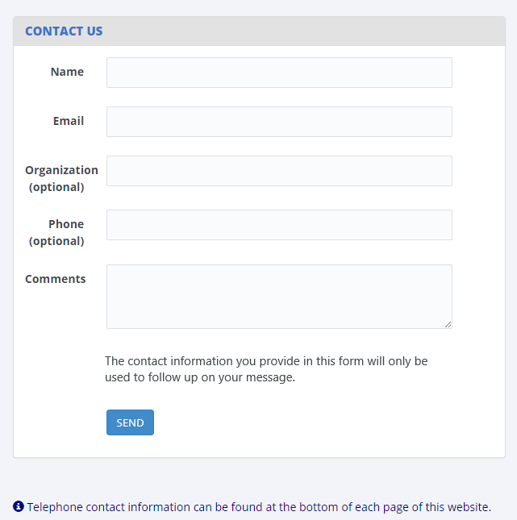

Confidentiality
Confidentiality and Data Security
All of the information provided as part of NCES sample studies may be used only for statistical purposes and may not be disclosed, or used, in identifiable form for any other purpose except as required by law (20 U.S.C. §9573 and 6 U.S.C. §151). Any student data released to the general public (for example, in statistical tables) are formatted so that it is not possible to identify specific individuals.
Specific measures have been taken to protect data submitted through this website:
- Data are collected over a secure server and connection, protected by Secure Sockets Layer technology (SSL; 128-bit encryption). A unique study identification variable (not the Social Security number or institution student ID) are created and maintained for each sampled student to protect against inadvertent disclosure of confidential data.
- All electronic data are secured in protected data files, and personally identifiable information (PII) is stored in files separate from the descriptive information. The data are stored securely on an Enhanced Security Network, which is certified and accredited as a NIST moderate security level network. NCES and RTI employ strict procedures for the transfer of PII; maintenance, storage, and use of direct identifiers; replacement of direct identifiers with internal codes; security of master survey files; and reporting of data security breaches in accord with the U.S. Department of Education Incident Handling Procedures. For more information on NIST security level, please see FIPS Publication 199 at https://nvlpubs.nist.gov/nistpubs/FIPS/NIST.FIPS.199.pdf.
- All NCES staff and contractors are subject to severe fines and possible imprisonment for disclosing individual responses.
- All RTI project staff members have signed Confidentiality Agreements and Affidavits of Nondisclosure and are prohibited by law from using the obtained information for any purposes other than this research study.
- Data security procedures are reviewed and approved by NCES data security staff.
Confidentiality and data security protection procedures have been put in place for the studies accessible through this website to ensure that the contractor and its subcontractors comply with all privacy requirements, including:
1. The statement of work of each contract;
2. Family Educational Rights and Privacy Act (FERPA) of 1974 (20 U.S.C. §1232(g));
3. Privacy Act of 1974 (5 U.S.C. §552a);
4. Privacy Act Regulations (34 CFR Part 5b);
5. Computer Security Act of 1987;
6. U.S.A. Patriot Act of 2001 (P.L. 107-56);
7. Education Sciences Reform Act of 2002 (ESRA 2002, 20 U.S.C. §9573);
8. Cybersecurity Enhancement Act of 2015 (6 U.S.C. §151);
9. Foundations of Evidence-Based Policymaking Act of 2018, Title III, Part B, Confidential Information Protection;
10. The U.S. Department of Education General Handbook for Information Technology Security General Support Systems and Major Applications Inventory Procedures (March 2005);
11. The U.S. Department of Education Incident Handling Procedures (February 2009);
12. The U.S. Department of Education, ACS Directive OM: 5-101, Contractor Employee Personnel Security Screenings;
13. NCES Statistical Standards; and
14. All new legislation that impacts the data collected through the contract for this study.
The data collection contractor complies with the U.S. Department of Education’s IT security policy requirements as set forth in the Handbook for Information Assurance Security Policy and related procedures and guidance, as well as IT security requirements in the Federal Information Security Management Act (FISMA), Federal Information Processing Standards (FIPS) publications, Office of Management and Budget (OMB) Circulars, and the National Institute of Standards and Technology (NIST) standards and guidance. All data products and publications will also adhere to the NCES Statistical Standards, as described at the website: https://nces.ed.gov/statprog/2012 /.

PDP Website Content – After Login
This section includes content of the Postsecondary Data Portal (PDP) that is available to users after logging in to the website. The post-login webpages are customized based on the study or studies for which the institution has been sampled. The Task Menu, Designate a Coordinator, and Designate PDP Users pages are used for all studies that collect data through the PDP. The remaining pages in this section are specific to the NPSAS:20 enrollment list collection. The content of these pages, included below, was based primarily on the materials developed and approved for NPSAS:18-AC (OMB #1850-0666).

Welcome Page
Welcome to NPSAS:20!
Announcements
This section will be used to post announcements on the PDP during data collection, if needed. Content of these announcements may include upcoming website maintenance or updates about technical problems with the PDP (such as bug fixes).
What to Expect During NPSAS:20
[NPSAS:20 Overview Video]
NPSAS:20 Timeline
[Graphic depicting steps in NPSAS:20 data collection]
As an institution participating in NPSAS:20, you will be expected to complete the following steps during the 2019-20 academic year:
1. Register Your Institution – starting October 2019
Designate staff who will provide your institution’s data, specify your institution’s term structure, and answer some brief background questions about your institution.
2. Provide Your Student Enrollment List – starting [date]
Submit a list of all students enrolled at your institution between July 1, 2019 and [date]. The due date for providing your list will vary based on your institution’s term structure.
3. Provide Student Records Data – starting March 2020
Submit additional information for the students at your institution who are sampled for NPSAS:20. The student records data includes demographic, enrollment, budget, and financial aid information. You will receive your list of sampled students approximately 4 to 6 weeks after you submit your student enrollment list.
You can view this page any time by clicking “What to Expect” in the Help Menu at right.

Task Menu
The Task Menu displays a checklist of items that the institution completes to provide data. The specific items that appear on the Task Menu are customized for each study. The Task Menu below shows an example for an institution that has been selected for NPSAS:20 only. There are currently no planned data collections that will overlap with NPSAS:20.
Welcome back! Please complete the steps below.
- Designate a Coordinator
- Register Your Institution
- Provide Your Student Enrollment List
- Provide Student Record Data (The content of the student records pages will be submitted as part of the student data collection package in July 2019.)
- Archive Notes or Other Documentation

Designate A Coordinator Page
This page will only appear on the Task Menu for institutions without a prior coordinator from NPSAS:18-AC, BPS:12 SR, or HSLS:09 F2 SR.
Please provide the name and contact information for the person who will serve as your institution’s Campus Coordinator for NPSAS:20. We will follow up with the Coordinator to provide instructions and upcoming deadlines.
Please note that we need a 'FedEx-friendly' address - no PO Box addresses, please!
Campus Coordinator
Salutation
Name
Title
Department |  | Select the option that most closely matches the Campus Coordinator’s department at your institution.
Address
Telephone
E-mail
Alternate e-mail

Registration Page
On this page, institutions will be asked to confirm their term structure or provide terms for the 2019-20 NPSAS year. Institutions will receive a subset of these of items depending on whether (1) their term structure was preloaded into the PDP, (2) whether they are a continuous enrollment institution, and (3) whether the institution is set up as a reporter institution (i.e., the institution will provide data via a central contact person for several campuses/schools in the NPSAS study).
DESIGNATE (All institutions)
Please confirm your contact information and provide information for any additional staff who will assist you with providing your institution’s data for NPSAS:20. Over the course of NPSAS:20, you will be asked to provide the following:
- Information about your institution’s term structure.
- A list of all students enrolled at your institution between July 1, 2019 and [date].
- Student records data, which includes demographic, enrollment, budget, and financial aid, for a subset of your students.
Each person you designate will receive credentials for logging into the Postsecondary Data Portal website. Please be sure that the users you identify are allowed to see personal information about students. You may need to designate staff from multiple departments at your institution.
Campus Coordinator (User 1)
Salutation | [Coordinator salutation]
Name | [Coordinator name]
Title | [Coordinator title]
Department | [Coordinator department] | Select the option that most closely matches this user’s department at your institution.
Address | [Coordinator address]
Telephone | [Coordinator telephone]
E-mail | [Coordinator e-mail]
Alternate e-mail
Campus Coordinator? | Yes/No
Should be copied on e-mails about NPSAS:20? | Yes/No
[ADD USER]
User 2
Salutation
Name
Title
Department |  | Select the option that most closely matches this user’s department at your institution.
Address
Telephone
E-mail
Alternate e-mail
Campus Coordinator? | Yes/No
Should be copied on e-mails about NPSAS:20? | Yes/No
You can add users any time by selecting “Manage PDP Users” from the right-hand menu.
[ADD USER] [DELETE USER] [APPROVE USER]

REGINST (All institutions)
As a reminder, participating in NPSAS:20 involves a few steps.
[Timeline graphic – see page D-56]
You have already designated your PDP users. Next, you will register your institution to participate in NPSAS:20. This step will involve answering some brief questions about your institution and providing information about your institution’s term structure.
Before you begin, watch this brief video that walks you through the registration process.
[Registration page video]
INSTNAME (All institutions)
Our records indicate that the name of your institution is <name>.
Is that correct?
1 = Yes
0 = No
If no, please enter the correct name of your institution: _______________
TERMINST (All institutions)
When you provide student records data, you will be asked to report each sampled student’s enrollment status (such as full-time or half-time) for the period of July 1, 2019 to June 30, 2020. You will also be asked about students’ tuition, budget, and financial aid during this period. To collect this information, we need to know about your institution’s term structure.
If your institution has distinct terms with explicit start and end dates, you should report students’ enrollment information by term.
If your institution enrolls students continuously throughout the year, or if you have more than 12 terms per year, you should report students’ enrollment information by month.
REPORTTERM (For Reporter institutions only)
Click here to review the list of institutions selected for NPSAS:20.
Do all these institutions have the same term structure? For example,
Do all these institutions enroll continuously throughout the year?
Do all of these institutions have explicit terms with the same start and end dates?
1 = All institutions are on the same schedule
2 = Some institutions have different schedules
REPORTDIFF (For Reporter institutions only)
Thank you. We will contact you to discuss the best way to report enrollment status for your sampled students.
CONTCONF (For institutions that are preloaded as continuous enrollment institutions)
As a reminder, when you provide student records data, to report each sampled student’s enrollment status (such as full-time or half-time) between July 1, 2019 and June 30, 2020. To collect this information, we need to learn about your institution’s term structure.
Our records indicate that your institution offers continuous enrollment for your students, rather than terms with explicit start and end dates. Is this correct?
1 = Yes
0 = No
TERMCONF (For institutions with terms preloaded)
Our records indicate that your institution has the following terms for the July 1, 2019 to June 30, 2020 academic year.
As a reminder, when you provide student records data, you will be asked to indicate students’ enrollment status for each of these terms. You will also be asked about students’ tuition, budget, and financial aid for this period.
[Term name] | [start date] | [end date] | [academic year]
[Term name] | [start date] | [end date] | [academic year]
[Term name] | [start date] | [end date] | [academic year]
[Term name] | [start date] | [end date] | [academic year]
[Term name] | [start date] | [end date] | [academic year]
[Term name] | [start date] | [end date] | [academic year]
Are these terms correct? To review the instructions about which terms should be included, click here.
1= Yes, these terms are correct
2 = No, I need to revise these terms
3 = No, my institution has continuous enrollment
BENRTYPE (For institutions with no term information preloaded)
As a reminder, when you provide student records data, you will be asked to report each sampled student’s enrollment status (such as full-time or half-time) for the period of July 1, 2019 to June 30, 2020. You will also be asked about students’ tuition, budget, and financial aid during this period.
Please indicate whether you will report students’ enrollment status by term or by month. If you are not sure which to choose, contact our Help Desk at [number].
Report by term. Provide term names and dates for each term in the July 1, 2019 to June 30, 2020 timeframe. For details about which terms should be included, review Step 4 below.
Report by month. Report enrollment status for each calendar month within the academic year. Recommended for institutions that enroll continuously throughout the academic year, or for institutions with more than 12 terms in the academic year.
1 = Report Enrollment Status by Term
2 = Report Enrollment Status by Month
PROVTERM (For institutions with no term information preloaded)
Enter the name, start date, end date, and academic year of each of the terms/enrollment periods occurring at <institution name> in the July 1, 2019 to June 30, 2020 timeframe. For each term, indicate the academic year as defined by your institution’s academic calendar. Terms may start prior to July 1, 2019 or end after June 30, 2020, but some portion of the term must occur between July 1 and June 30.
Please include:
- Summer sessions.
- Short sessions longer than two weeks in duration (e.g., Maymester, January term).
- Terms for special types of students (e.g. medical students).
How to report summer sessions: Summer sessions should be included if any portion of the term falls in the period of July 1, 2019 through June 30, 2020. For institutions with summer terms that cross the June 30/July 1 cutoff (sometimes called “crossover terms”), two years of summer sessions will fall in the July 1, 2019 to June 30, 2020 timeframe. If this is the case, please report both years of summer sessions and indicate the academic year for each term as defined by your institution’s academic calendar.
How to report overlapping terms: If your institution has more than one term that starts and ends in the same month, you only need to report the term one time. For example, if the general college and medical school both have fall semesters that start in August and end in December, you need only provide one fall semester, even if they don’t start on the same days of the month. If the terms start or end in different months, please provide the terms separately. For additional help, click here.
[Term name] | [start date] | [end date] | [academic year] | Remove
[Term name] | [start date] | [end date] | [academic year] | Remove
[Term name] | [start date] | [end date] | [academic year] | Remove
[Term name] | [start date] | [end date] | [academic year] | Remove
[Term name] | [start date] | [end date] | [academic year] | Remove
[Term name] | [start date] | [end date] | [academic year] | Remove
If multiple terms share the same start and end month, you can save time by only entering that term once.
The following sessions may be reported as a single term because they start and end in the same month:
Term Name | Start Date | End Date
General college fall 2019 | 08/07/2019 | 12/05/2019
Medical school fall 2019 | 08/09/2019 | 12/07/2019
Law school fall 2019 | 08/14/2019 | 12/14/2019
The following sessions should be reported as separate terms because they start and end in different months:
Term Name | Start Date | End Date
General college spring 2019 | 01/22/2020 | 05/05/2020
Medical school spring 2019 | 01/09/2020 | 04/28/2020
Law school spring 2019 | 02/04/2020 | 05/14/2020
REVTERM (For institutions with term information preloaded)
Please revise your institution’s terms/enrollment periods occurring at <institution name> in the July 1, 2019 to June 30, 2020 timeframe. For each term, indicate the academic year as defined by your institution’s academic calendar. Terms may start prior to July 1, 2019 or end after June 30, 2020, but some portion of the term must occur between July 1 and June 30.
Please include:
- Summer sessions.
- Short sessions longer than two weeks in duration.
- Terms for special types of students (e.g. medical students).
How to report summer sessions: Summer sessions should be included if any portion of the term falls in the period of July 1, 2019 through June 30, 2020. For institutions with summer terms that cross the June 30/July 1 cutoff (sometimes called “crossover terms”), two years of summer sessions will fall in the July 1, 2019 to June 30, 2020 timeframe. If this is the case, please report both years of summer sessions and indicate the academic year for each term as defined by your institution’s academic calendar.
How to report overlapping terms: If your institution has more than one term that starts and ends in the same month, you only need to report the term one time. For example, if the general college and medical school both have fall semesters that start in August and end in December, you need only provide one fall semester, even if they don’t start on the same days of the month. If the terms start or end in different months, please provide the terms separately. For additional help, click here.
[Term name] | [start date] | [end date] | [academic year] | Remove
[Term name] | [start date] | [end date] | [academic year] | Remove
[Term name] | [start date] | [end date] | [academic year] | Remove
[Term name] | [start date] | [end date] | [academic year] | Remove
[Term name] | [start date] | [end date] | [academic year] | Remove
[Term name] | [start date] | [end date] | [academic year] | Remove
If multiple terms share the same start and end month, you can save time by only entering that term once.
The following sessions may be reported as a single term because they start and end in the same month:
Term Name | Start Date | End Date
General college fall 2019 | 08/07/2019 | 12/05/2019
Medical school fall 2019 | 08/09/2019 | 12/07/2019
Law school fall 2019 | 08/14/2019 | 12/14/2019
The following sessions should be reported as separate terms because they start and end in different months:
Term Name | Start Date | End Date
General college spring 2019 | 01/22/2020 | 05/05/2020
Medical school spring 2019 | 01/09/2020 | 04/28/2020
Law school spring 2019 | 02/04/2020 | 05/14/2020
LISTDATE (For institutions in spring enrollment list collection only)
In the next stage of the study, you will be asked to provide a list of all students enrolled at your institution between July 1, 2019 and [date]. We need to establish the date you will be able to provide this list.
Please plan to provide the list when you will be able to report the final list of students who were enrolled between July 1, 2019 and [date]. Please remember to take your institution’s add/drop period into account.
Click here to view the list of data elements that will be requested on your student enrollment list.
Based on your institution’s term structure, your suggested due date is [date]. Can you provide the enrollment list by this date?
1 = Yes, we will provide the list by [date].
0 = No, please contact me to discuss a due date.
LISTDATE (For institutions in fall and spring enrollment list collections)
In the next stage of the study, you will be asked to provide two lists of students enrolled at your institution. We need to establish the date you will be able to provide these lists. Click here to view the list of data elements that will be requested on your student enrollment list.
The first list will include all students enrolled between July 1, 2019 and October 31, 2019. Please plan to provide this list when you will be able to report the final list of students who were enrolled between July 1, 2019 and October 31, 2019.
The second list will include all students enrolled between July 1, 2019 and [date]. Please plan to provide this list when you will be able to report the final list of students who were enrolled between July 1, 2019 and [date].
Please remember to take your institution’s add/drop periods into account.
Based on your institution’s term structure, the suggested due date for your first list (students enrolled from July 1, 2019 through October 31, 2019) is [date]. Can you provide the first enrollment list by this date?
1 = Yes, we will provide the first list by [date].
0 = No, please contact me to discuss a due date.
The suggested due date for your second list (students enrolled from July 1, 2019 through [date] is [date]. Can you provide the first enrollment list by this date?
1 = Yes, we will provide the second list by [date].
0 = No, please contact me to discuss a due date.
Please provide following data elements on your student enrollment list. We will send you detailed instructions for creating the student enrollment list in advance of your due date.
General and Demographic Information | Enrollment Information
Student name | Degree program
Student ID number | Class level
Social Security Number | Major
Date of Birth | High school completion date
Sex | Dual enrollment in high school
Ethnicity | Date first enrolled in your institution
Race | First-time beginning student indicator
Veteran/active duty military status
Local address
Permanent address
E-mail address
Phone number
STANCRED (All institutions)
How many units of credit does your institution typically award upon satisfactory completion of a standard academic course (e.g., English 101)?
1 = 1 unit
2 = 3 units
3 = Other Amount (specify)
4 = Differs by program, class level, or for some other reason
5 = Institution is clock hour only
SIS (All institutions)
What student records software system does your institution currently use (e.g., Banner, Peoplesoft)?
1 = Ellucian Banner
2 = Ellucian Colleague
3 = Ellucian PowerCampus
4 = Jenzabar CX
5 = Jenzabar EX
6 = Oracle PeopleSoft
7 = Other (specify):
OBSTACLE (All institutions)
Please indicate any major obstacles that may impact your institution’s participation in NPSAS:20.
1 = Software transition
2 = Accreditation
3 = Merging with another institution
4 = Closing/teaching out
5 = Other (specify):
Comments:
ENDORSE (All institutions)
We would like to include your name and title in the contact materials we send to students sampled from your institution. This information will help students understand the importance of NPSAS and the role that institution support plays in the success of the study.
If you agree, we will include the following sentence in some of our student letters and emails. Click here to see examples of these materials.
“In recent months, we have worked closely with [contact name], [contact title] at your institution to facilitate [institution name]’s participation in this important research.”
May we mention your name and title in the contact materials we send to students sampled from your institution?
1 = Yes
0 = No
[IF YES:] Thank you. Your name and title will appear in the letter as follows. Please make any necessary corrections, then click Next to continue with registration.
First Name | [Contact first name]
Last Name | [contact last name]
Title | [contact title]
Department Name | [contact title]
REGEND (All institutions)
Thank you! Your institution is now registered for NPSAS:20. We will contact you soon to confirm your due date and provide additional information about preparing your student enrollment list.
In the meantime, you can view the list of data elements that will be requested on your student enrollment list.

Enrollment List Page
Provide Your Student Enrollment List
Follow the steps below to submit your student enrollment list.
1. Check your list for errors
Please take the time to review your list for errors, including the following common errors:
- Data associated with the wrong student (i.e., rows shifted during sorting or copying and pasting).
- Critical data elements are missing.
- List omits students from campuses/schools (e.g., law school, medical school) reported under your IPEDS UNITID.
2. Provide information about your list
Date your list of students was prepared:
Staff who prepared the list:
[PDP User 1]
[PDP User 2]
[PDP User 3]
Other:
Name_____________
Department_____________
E-mail Address_______________
Telephone number_________________
In the space below, provide any information that will help us review your enrollment list, including details about the file layout, special codes or abbreviations, or any other information necessary to correctly interpret the data you provided.
Comments: __________________________________________
3. Report excluded student counts
In each of the categories shown below, approximately how many students have been excluded from your institution's enrollment list?
Exclusion reason | Count of students
Did not meet the NPSAS eligibility requirements
Student requested that their information not be provided to external parties
Excluded for any other reason
Total
4. Upload Student Enrollment List
Press the Upload File button to locate your enrollment list file.
*(Files must be of type: .txt, .csv, .xls, .xlsx, .doc or .zip. Please zip your file if it is larger than 3MB.)
[Upload File]
How long did it take your institution to prepare the student enrollment list? ____ hours
[Submit]
Thank you, your institution’s enrollment list has been submitted. We will review your list and contact you if we have any questions.
We will contact you again when your student sample is ready and it is time to provide student records data, approximately 4–6 weeks from now. Click here to view the list of student records data elements that will be requested. You can view this list any time on the Resources page of the PDP. You only need to provide these data elements for the subset of students who are sampled for NPSAS:20, so please do not prepare your data submission until you have received the sampled student list.

Archive Notes or Other Documentation Page
If you have notes, programs, or other documentation about how you prepared the data request that you would like to store for future reference, you can upload them to this page. This step is optional.
In the future, if your institution is selected for another NPSAS study, this documentation will be available for your institution to download from the PDP.
These files will be stored using the same safeguards as the student-level data collected through this website. More information about data security on the PDP may be found on the Confidentiality page.

FAQs (after log-in)
This section contains answers to frequently asked questions (FAQs) about the National Postsecondary Student Aid Study (NPSAS) and other studies that collect data using the PDP website.
Click Expand All to view all FAQs on one page. You can also download a copy of these FAQs s a PDF document.
General FAQs about NCES sample studies
Who is collecting these data?
The National Center for Education Statistics (NCES), part of the U.S. Department of Education's Institute of Education Sciences, conducts the studies listed on the Home page of this website. NCES, the primary federal statistical entity for collecting and analyzing data related to education in the U.S. and other nations, contracts with RTI International to collect data for these studies. RTI International is an independent, nonprofit research organization based in the Research Triangle of North Carolina.
By what authority does NCES collect this information?
NCES is authorized by Congress to conduct these studies in the Education Sciences Reform Act of 2002 (ESRA 2002, 20 U.S.C. §9543) and the Higher Education Opportunity Act of 2008 (HEOA 2008, 20 U.S.C. §1015). Each study has been approved by the U.S. Office of Management and Budget (OMB).
Why is participation important?
The National Postsecondary Student Aid Study (NPSAS) is the primary source of data used by federal government agencies and higher education associations to analyze the effectiveness of current federal student financial aid programs. NPSAS provides comprehensive data on postsecondary students’ enrollment status, education goals, employment, and demographic characteristics. Many agencies and organizations, including the U.S. Department of Education, the Congressional Budget Office (CBO), the Government Accountability Office (GAO), the Office of Management and Budget (OMB), the American Council on Education (ACE), the National Association of Independent Colleges and Universities (NAICU), and the National Association of Student Financial Aid Administrators (NASFAA) use NPSAS data to prepare reports that influence the direction of federal student aid policies.
NPSAS also serves as the base year study for two longitudinal postsecondary studies, the Beginning Postsecondary Students Longitudinal Study (BPS) and the Baccalaureate and Beyond Longitudinal Study (B&B). These studies follow students over time and capture both education and employment outcomes for postsecondary students across the nation. The combination of data collected by these studies allows for analyses of the important links between the cost of postsecondary education, financial aid burden, academic performance, and employment and financial outcomes over time.
The data collected through the studies are used by researchers, policymakers, and administrators to analyze and nationally benchmark information about current postsecondary students; to analyze national trends over time; and to inform decisions about postsecondary education at the institutional, state, and national levels.
Participation of each sampled institution is critical to the success of the study. Full participation assures that the data used accurately represent students attending all different types of postsecondary institutions in the United States.
Do we need to have the student's permission before providing this information?
No. Student or parental consent is not required for release of student record information for the purposes of these studies. The data request for NPSAS fully conforms to the requirements of the Family Educational Rights and Privacy Act of 1974 (FERPA). FERPA, under provision of 34 CFR §§ 99.31(a)(3) and 99.35, permits institutions to disclose without consent individual student education records to NCES, as an authorized representative of the Secretary of Education, in connection with an evaluation of federally supported education programs. Student data are subject to strict protections that are adhered to by NCES and its contractor organizations. You can review this regulation on the U.S. Department of Education's website at https://www2.ed.gov/policy/gen/reg/ferpa.
FERPA regulations also stipulate that all disclosures be reported in the student record, with an indication of who received the information and their legitimate interests in the information. For schools without electronic student record systems, a Disclosure Notice can be printed from the Resources page of this website. These notices fulfill the requirements of 34 CFR 99.32(a) pursuant to the Family Educational Rights and Privacy Act (20 U.S.C. §1232g). Electronic student record systems will require the insertion of a similar statement. The Resources page also includes a FERPA Fact Sheet, which includes more information about how NPSAS conforms to FERPA requirements.
Are the collected data kept secure and confidential?
Both NCES and RTI International follow strict procedures to protect study participants’ information. For more information on confidentiality and data security see surveys.nces.ed.gov/xxxx/Home/Confidentiality.
What assistance is available from RTI staff?
The Help Desk at RTI International is available to answer your questions about the studies and navigating this website. Please call 1-XXX-XXX-XXXX or e-mail [E-MAIL ADDRESS] with your questions or concerns. Help Desk staff are available from 9 AM to 9 PM Eastern time, Monday - Friday.
NPSAS FAQs
Background and Purpose of NPSAS
What is this study all about?
NPSAS, which is designed to capture information on how students pay for education beyond high school, is the primary source of data used by federal government agencies and higher education associations to analyze the effectiveness of current federal student financial aid programs. NPSAS collects information on students' demographics, enrollment, education and living expenses, employment, and the type of financial assistance, if any, received by students (e.g., grants, scholarships, loans, awards, stipends). NPSAS includes students from all types of postsecondary institutions—private-for-profit, public and private nonprofit, 2- and 4-year colleges and universities, and less-than-2-year institutions in the 50 states, the District of Columbia, and Puerto Rico.
Why are institutions contacted before NPSAS data are needed?
Providing institutions with the basic information needed before the earliest student enrollment lists are collected provides additional time for institutions to develop an action plan to address each of the data collection steps.
How was my institution selected?
Your institution was sampled from all institutions included in the Integrated Postsecondary Education Data System (IPEDS), a repository of data on all Title IV institutions. To be eligible for inclusion in the institution sample, an institution must have met the following conditions: (1) offered an education program designed for persons who have completed secondary education; (2) offered an academic, occupational, or vocational program of study lasting at least 3 months or 300 clock hours; (3) offered access to the general public, except for U.S. service academies; and (4) been located in the 50 states, the District of Columbia, or Puerto Rico.
What is the purpose of NPSAS:20?
The National Postsecondary Student Aid Study (NPSAS) is the primary source of data used by federal government agencies and higher education associations to analyze the effectiveness of current federal student financial aid programs. NPSAS provides comprehensive data on the enrollment status, education goals, employment, and demographic characteristics of postsecondary students. Many agencies and organizations, including the U.S. Department of Education, the Congressional Budget Office (CBO), the Government Accountability Office (GAO), the Office of Management and Budget (OMB), the American Council on Education (ACE), the National Association of Independent Colleges and Universities (NAICU), and the National Association of Student Financial Aid Administrators (NASFAA) use NPSAS data to prepare reports that influence the direction of federal student aid policies.
What is the role of the Campus Coordinator?
The Campus Coordinator's role is to serve as a liaison between your institution and the NCES data collection contractor, RTI International. The Coordinator will be responsible for providing data for NPSAS and may also collaborate with staff in other units within the institution to obtain the requested information.
What are the steps involved with data collection?
NPSAS data collection comprises the following steps:
1) If necessary, the institution’s chief administrator names a Campus Coordinator.
2) The Campus Coordinator registers the institution for NPSAS:20, including designating other users at the institution who will help provide data.
3) The Coordinator provides the student enrollment list.
4) RTI International draws a sample of students from the student enrollment list.
5) The Coordinator provides student records data for the sampled students.
How much time will NPSAS take to complete?
The estimated average time for each institution to complete all the tasks for this study is 35 hours. This estimate includes the average time to register the institution (10 minutes), prepare the student enrollment list (5 hours), and provide the student record data (30 hours). If you have any comments concerning the accuracy of this time estimate, suggestions for improving the data collections, or any comments or concerns regarding the status of your individual submission of these data, please write to: Postsecondary Data Portal studies, National Center for Education Statistics, PCP, 550 12th St., SW, 4th floor, Washington, DC 20202
Creating the Student Enrollment List
How will the sample at my institution be selected?
The enrollment list that you provide to the NCES data collection contractor, RTI International, will be used to select a random sample of students at all academic levels, including undergraduate, master's, and doctoral students.
How long will it take to create the student enrollment list?
The estimated average time needed to create the list of enrolled students is 5 hours. This estimate includes time for reviewing list preparation instructions and preparing the student enrollment list.
What do I need to do first?
The PDP Task Menu will walk you through the steps you need to complete. If your institution doesn’t yet have a Campus Coordinator, the first step will be for your Chief Administrator to fill out the Designate a Coordinator page.
Once the Campus Coordinator is named, he or she should complete the Designate PDP Users page, which is used to confirm contact information for the Campus Coordinator and provide information for any additional staff who will assist with providing your institution’s data for NPSAS:20.
Second, the Coordinator should complete the Register Your Institution page. This page collects background information about your institution, information about the term/enrollment periods at your institution for the 2019-20 academic year, and sets a due date for your student enrollment list.
After registering, we will contact the Coordinator to confirm your due date for the student enrollment list and provide detailed instructions preparing the list.
Why do you need students' contact information?
The contact information will be used to contact sampled students and invite them to participate in the student survey portion of the study. Note that all information provided by individuals or institutions for NPSAS:20 may be used only for statistical purposes and may not be disclosed, or used, in identifiable form for any other purpose except as required by law (20 U.S.C. §9573 and 6 U.S.C. §151).
If you have questions or concerns, please contact the Help Desk at 1-XXX-XXX-XXXXor send an e-mail to [E-MAIL ADDRESS]. We will supply additional information about the study and the laws protecting the confidentiality of the data collected.
When do you need the list of enrolled students?
Enrollment lists will be collected beginning in [date]. The specific due date for your institution is based on your term structure and is determined after the “Register Your Institution Page” is completed.
Please contact RTI at 1-XXX-XXX-XXXXor via e-mail at [E-MAIL ADDRESS] if you have any questions or concerns about submitting your student enrollment list.
Why do I need to provide Social Security numbers (SSNs) in addition to student ID numbers?
We use SSN as an identifier to match data for students included in NPSAS with data from other sources that have information pertinent to NPSAS. Examples of other sources include the U.S. Department of Education's Central Processing System (CPS) database, which contains information from the Free Application for Federal Student Aid (FAFSA), and the National Student Loan Data System (NSLDS). Matching to these databases prior to sampling will help us to select a representative sample of students.
The release of this information to NCES without explicit consent is permissible under the Family Educational Rights and Privacy Act of 1974 (FERPA). FERPA, under provision of 34 CFR §§ 99.31(a)(3) and 99.35, permits institutions to disclose without consent personally identifiable information from student education records to NCES, as an authorized representative of the Secretary of Education, in connection with an evaluation of federally supported education programs. RTI International, as the contractor for NCES, has been given the authority to collect information from institution records on behalf of NCES. A definition of personally identifiable information can be found in 34 CFR 99.3. Personal identifiers, such as Social Security numbers and student numbers, are included in the definition. You can review this legislation on the U.S. Department of Education’s website at https://www2.ed.gov/policy/gen/reg/ferpa.
Both NCES and RTI follow strict procedures to protect the privacy and confidentiality of study participants. Information about data security may be found on the Confidentiality page on the PDP. For more information on confidentiality and data security see surveys.nces.ed.gov/xxxx/Home/Confidentiality.
What will happen to the student enrollment list file after you select the sample?
The student enrollment list data will be stored securely on an Enhanced Security Network, which is certified and accredited as a NIST moderate security level network. The U. S. Department of Education has strict requirements to protect personally identifiable information (PII), and both NCES and RTI International employ strict procedures for protecting the confidentiality of PII and other sensitive information in all phases of the project. These procedures include guidelines for the transfer of PII; maintenance, storage, and use of direct identifiers; replacement of direct identifiers with internal codes; security of master survey files; and reporting of data security breaches in accordance with the U.S. Department of Education Incident Handling Procedures. For more information on NIST security level, please see FIPS Publication 199 at https://nvlpubs.nist.gov/nistpubs/FIPS/NIST.FIPS.199.pdf. For more information on confidentiality and data security see surveys.nces.ed.gov/xxxx/Home/Confidentiality.

Contact Materials Page
Download an electronic copy of the hardcopy packets that were mailed to your institution.
Welcome Packet to Chief Administrator
Welcome Letter
NPSAS:20 Brochure
Welcome Packet to Campus Coordinator
Registration Letter
NPSAS:20 Brochure
Quick Guide to NPSAS:20
Registration Instructions
Student Enrollment List Request Packet
Enrollment List Request Letter
Student Enrollment List Instructions
Student Records Request Packet (These materials will be included in the student clearance package in July 2019)
Student Records Request Letter
Student Records Handbook

Resources Page
General NPSAS:20 Resources
NPSAS:20 Brochure
NPSAS:20 Endorsements (Included in appendix B)
Confidentiality and Data Security Fact Sheet
FERPA Fact Sheet
Disclosure Notice
NPSAS:20 Overview [VIDEO]
Registering Your Institution [VIDEO]
NPSAS:20 Frequently Asked Questions
Quick Guide to NPSAS:20
Registration Instructions
Student Enrollment List Resources
Student Enrollment List Instructions
Student Enrollment List Overview [VIDEO]
Student Records Resources (These materials will be included in the student clearance package in summer 2019)
Student Records Handbook
Student Records: Selecting a Mode [VIDEO]
Student Records: Web Mode [VIDEO]
Student Records: Excel Mode [VIDEO]
Student Records: CSV Mode [VIDEO]
To download an electronic copy of the hardcopy packets that were mailed to your institution, click here.
To review the Frequently Asked Questions, click here.

Resource Materials
This section includes content that appears in the “Resources” section of the Postsecondary Data Portal (PDP).

Confidentiality and Data Security Fact Sheet
THE 2019-20 NATIONAL POSTSECONDARY STUDENT AID STUDY
Confidentiality and Data Security Fact Sheet
Your institution has been selected to participate in the 2019-20 National Postsecondary Student Aid Study (NPSAS:20). NPSAS is designed to provide information on how students and their families meet the cost of education beyond high school. Lists of students provided by institutions will be used to select a sample of students who will be asked to complete a questionnaire online.
Data Collected for NPSAS
The information collected about students includes demographic information used for sampling (such as degree program); contact information; and personal identifiers (such as Social Security numbers and student IDs), which are used to deduplicate lists of students across institutions and to match students against federal financial aid records. The security of this information is, of course, of paramount importance to the U.S. Department of Education’s National Center for Education Statistics (NCES) and its contractors, as well as to participating institutions and respondents. It is important for each institution sampled to be fully aware of the federal laws that both authorize the release of student information and protect the confidentiality of record data and survey responses.
NPSAS is Authorized by Congress
The Education Sciences Reform Act of 2002 (ESRA 2002, 20 U.S.C. §9543) and the Higher Education Opportunity Act of 2008 (HEOA 2008, 20 U.S.C. §1015) authorize NCES to collect, acquire, compile, and disseminate full and complete statistics on the condition and progress of education, including postsecondary education. The provisions of ESRA can be found at the following website: https://www.ed.gov/policy/rschstat/leg/edpicks.jhtml?src=ln.
Federal Law Protects the Confidentiality of Data Collected for NPSAS
Both NCES and its contractor for NPSAS:20, RTI International, follow strict procedures to protect the privacy and confidentiality of study participants. All RTI project staff members have signed confidentiality agreements and affidavits of nondisclosure. Any data released to the public are in aggregate form (e.g., statistical tables, graphs) so that individual students cannot be identified. All of the information provided by individuals and institutions may be used only for statistical purposes and may not be disclosed, or used, in identifiable form for any other purpose except as required by law (20 U.S.C. §9573 and 6 U.S.C. §151). For more information on confidentiality and data security see surveys.nces.ed.gov/xxxx/Home/Confidentiality.
Federal Law Authorizes Release of Personally Identifiable Information to NCES and Its Agents
NPSAS:20 requests students’ directory and personally identifiable information from institutions. The Education Sciences Reform Act of 2002 (ESRA 2002, 20 U.S.C. §9543) and the Higher Education Opportunity Act of 2008 (HEOA 2008, 20 U.S.C. §1015) authorize NCES and its current contractors (RTI International for NPSAS:20) to gather this information.
The data request for NPSAS fully conforms to the requirements of the Family Educational Rights and Privacy Act of 1974 (FERPA) [20 U.S.C. 1232g; 34 CFR Part 99]. FERPA is designed to protect the privacy rights of students and their families by providing consistent standards for the release of personally identifiable student and family information. NCES and its data collection agent for NPSAS:20, RTI International, are explicitly authorized under an exception to FERPA’s general consent rule (in which the right to consent is held by the student, regardless of age) to obtain student-level data from institutions. This exception provides for the collection of data on any eligible student, without prior consent, if the disclosure is to authorized representatives of the Secretary of Education [34 CFR §§ 99.31(a)(3) and 99.35]. You can review this regulation on the U.S. Department of Education's website at https://www2.ed.gov/policy/gen/reg/ferpa. For questions regarding the applicability of FERPA to this study, school officials may contact the Family Policy Compliance Office (FPCO) at this e-mail address: +@ed.gov.
Data Collected are Stored Securely
Both NCES and RTI International follow strict procedures to protect study participants’ information. These procedures include obtaining signed confidentiality agreements from all personnel who will have access to individual identifiers, personnel training regarding the meaning of confidentiality, and controlled access to computer files.
All electronic data from institution records and students are carefully protected. Computer accounts used to access electronic data are password protected. Only project staff members with clearance from the study database manager are able to log on to these accounts. Personally identifying variables (e.g., name, address, and phone numbers) are kept separate from data variables such as educational experience or financial aid.
A unique study identification number (not the Social Security number or student ID) are created and maintained for each sampled student to protect against inadvertent disclosure of confidential data. Any data released to the general public (for example, statistical tables) are tailored so that it is not possible to identify specific individuals or institutions.
These confidentiality and data security protection procedures have been put in place to ensure that RTI International and its subcontractors comply with all privacy requirements, including:
1. The statement of work of each contract;
2. Family Educational Rights and Privacy Act (FERPA) of 1974 (20 U.S.C. §1232(g));
3. Privacy Act of 1974 (5 U.S.C. §552a);
4. Privacy Act Regulations (34 CFR Part 5b);
5. Computer Security Act of 1987;
6. U.S.A. Patriot Act of 2001 (P.L. 107-56);
7. Education Sciences Reform Act of 2002 (ESRA 2002, 20 U.S.C. §9573);
8. Cybersecurity Enhancement Act of 2015 (6 U.S.C. §151);
9. Foundations of Evidence-Based Policymaking Act of 2018, Title III, Part B, Confidential Information Protection;
10. The U.S. Department of Education General Handbook for Information Technology Security General Support Systems and Major Applications Inventory Procedures (March 2005);
11. The U.S. Department of Education Incident Handling Procedures (February 2009);
12. The U.S. Department of Education, ACS Directive OM: 5-101, Contractor Employee Personnel Security Screenings;
13. NCES Statistical Standards; and
14. All new legislation that impacts the data collected through the contract for this study.
The data collection contractor, RTI International, complies with the U.S. Department of Education’s IT security policy requirements as set forth in the Handbook for Information Assurance Security Policy and related procedures and guidance, as well as IT security requirements in the Federal Information Security Management Act (FISMA), Federal Information Processing Standards (FIPS) publications, Office of Management and Budget (OMB) Circulars, and the National Institute of Standards and Technology (NIST) standards and guidance. All data products and publications will also adhere to the NCES Statistical Standards, as described at the website: https://nces.ed.gov/statprog/2012/.

FERPA Fact Sheet
FERPA Fact Sheet
The release of the information requested for NPSAS:20 without explicit consent is permissible under the Federal Educational Rights Privacy Act (FERPA). For the purposes of this collection of data, FERPA permits educational institutions to disclose personally identifiable information from students’ education records, without consent, to authorized representatives of the Secretary of Education in connection with an evaluation of Federally supported education programs (34 CFR §§ 99.31(a)(3) and 99.35). As a contractor for NCES, RTI is an authorized representative of the Secretary.
FERPA requires educational institutions to maintain a record of the disclosure of student information to NCES (see 34 CFR 99.32). The record of disclosure must include: 1) the parties who have requested or received personally identifiable information records (NCES/RTI) and 2) the legitimate interests the parties had in obtaining the information (the 2019-20 National Postsecondary Student Aid Study). For institutions without electronic student record systems, a Disclosure Notice may be printed from the Resources page on the PDP.
See the highlighted sections below for excerpts of FERPA that pertain to this exemption and the requirement to maintain a record of the disclosure.
Family Educational Rights and Privacy Act, 34 CFR PART 99
Subpart A—GENERAL
§99.1 To which educational agencies or institutions do these regulations apply?
§99.2 What is the purpose of these regulations?
§99.3 What definitions apply to these regulations?
§99.4 What are the rights of parents?
§99.5 What are the rights of students?
§99.7 What must an educational agency or institution include in its annual notification?
§99.8 What provisions apply to records of a law enforcement unit?
Subpart B—WHAT ARE THE RIGHTS OF INSPECTION AND REVIEW OF EDUCATION RECORDS?
§99.10 What rights exist for a parent or eligible student to inspect and review education records?
§99.11 May an educational agency or institution charge a fee for copies of education records?
§99.12 What limitations exist on the right to inspect and review records?
Subpart C—WHAT ARE THE PROCEDURES FOR AMENDING EDUCATION RECORDS?
§99.20 How can a parent or eligible student request amendment of the student's education records?
§99.21 Under what conditions does a parent or eligible student have the right to a hearing?
§99.22 What minimum requirements exist for the conduct of a hearing?
Subpart D—MAY AN EDUCATIONAL AGENCY OR INSTITUTION DISCLOSE PERSONALLY IDENTIFIABLE INFORMATION FROM EDUCATION RECORDS?
§99.30 Under what conditions is prior consent required to disclose information?
§99.31 Under what conditions is prior consent not required to disclose information?
§99.32 What recordkeeping requirements exist concerning requests and disclosures?
§99.33 What limitations apply to the redisclosure of information?
§99.34 What conditions apply to disclosure of information to other educational agencies or institutions?
§99.35 What conditions apply to disclosure of information for Federal or State program purposes?
§99.36 What conditions apply to disclosure of information in health and safety emergencies?
§99.37 What conditions apply to disclosing directory information?
§99.38 What conditions apply to disclosure of information as permitted by State statute adopted after November 19, 1974, concerning the juvenile justice system?
§99.39 What definitions apply to the nonconsensual disclosure of records by postsecondary educational institutions in connection with disciplinary proceedings concerning crimes of violence or non-forcible sex offenses?
Subpart E—WHAT ARE THE ENFORCEMENT PROCEDURES?
§99.60 What functions has the Secretary delegated to the Office and to the Office of Administrative Law Judges?
§99.61 What responsibility does an educational agency or institution, a recipient of Department funds, or a third party outside of an educational agency or institution have concerning conflict with State or local laws?
§99.62 What information must an educational agency or institution or other recipient of Department funds submit to the Office?
§99.63 Where are complaints filed?
§99.64 What is the investigation procedure?
§99.65 What is the content of the notice of investigation issued by the Office?
§99.66 What are the responsibilities of the Office in the enforcement process?
§99.67 How does the Secretary enforce decisions?
Subpart A—GENERAL
§99.1 To which educational agencies or institutions do these regulations apply?
(a) Except as otherwise noted in §99.10, this part applies to an educational agency or institution to which funds have been made available under any program administered by the Secretary, if—
(1) The educational institution provides educational services or instruction, or both, to students; or
(2) The educational agency is authorized to direct and control public elementary or secondary, or postsecondary educational institutions.
(b) This part does not apply to an educational agency or institution solely because students attending that agency or institution receive non-monetary benefits under a program referenced in paragraph (a) of this section, if no funds under that program are made available to the agency or institution.
(c) The Secretary considers funds to be made available to an educational agency or institution of funds under one or more of the programs referenced in paragraph (a) of this section—
(1) Are provided to the agency or institution by grant, cooperative agreement, contract, subgrant, or subcontract; or
(2) Are provided to students attending the agency or institution and the funds may be paid to the agency or institution by those students for educational purposes, such as under the Pell Grant Program and the Guaranteed Student Loan Program (titles IV-A-1 and IV-B, respectively, of the Higher Education Act of 1965, as amended).
(d) If an educational agency or institution receives funds under one or more of the programs covered by this section, the regulations in this part apply to the recipient as a whole, including each of its components (such as a department within a university).
(Authority: 20 U.S.C. 1232g)
Subpart D—MAY AN EDUCATIONAL AGENCY OR INSTITUTION DISCLOSE PERSONALLY IDENTIFIABLE INFORMATION FROM EDUCATION RECORDS?
§99.30 Under what conditions is prior consent required to disclose information?
(a) The parent or eligible student shall provide a signed and dated written consent before an educational agency or institution discloses personally identifiable information from the student's education records, except as provided in §99.31.
(b) The written consent must:
(1) Specify the records that may be disclosed;
(2) State the purpose of the disclosure; and
(3) Identify the party or class of parties to whom the disclosure may be made.
(c) When a disclosure is made under paragraph (a) of this section:
(1) If a parent or eligible student so requests, the educational agency or institution shall provide him or her with a copy of the records disclosed; and
(2) If the parent of a student who is not an eligible student so requests, the agency or institution shall provide the student with a copy of the records disclosed.
(d) “Signed and dated written consent” under this part may include a record and signature in electronic form that—
(1) Identifies and authenticates a particular person as the source of the electronic consent; and
(2) Indicates such person's approval of the information contained in the electronic consent.
(Authority: 20 U.S.C. 1232g (b)(1) and (b)(2)(A))
§99.31 Under what conditions is prior consent not required to disclose information?
(a) An educational agency or institution may disclose personally identifiable information from an education record of a student without the consent required by §99.30 if the disclosure meets one or more of the following conditions:
(1)(i)(A) The disclosure is to other school officials, including teachers, within the agency or institution whom the agency or institution has determined to have legitimate educational interests.
(B) A contractor, consultant, volunteer, or other party to whom an agency or institution has outsourced institutional services or functions may be considered a school official under this paragraph provided that the outside party—
(1) Performs an institutional service or function for which the agency or institution would otherwise use employees;
(2) Is under the direct control of the agency or institution with respect to the use and maintenance of education records; and
(3) Is subject to the requirements of §99.33(a) governing the use and redisclosure of personally identifiable information from education records.
(ii) An educational agency or institution must use reasonable methods to ensure that school officials obtain access to only those education records in which they have legitimate educational interests. An educational agency or institution that does not use physical or technological access controls must ensure that its administrative policy for controlling access to education records is effective and that it remains in compliance with the legitimate educational interest requirement in paragraph (a)(1)(i)(A) of this section.
(2) The disclosure is, subject to the requirements of §99.34, to officials of another school, school system, or institution of postsecondary education where the student seeks or intends to enroll, or where the student is already enrolled so long as the disclosure is for purposes related to the student's enrollment or transfer.
NOTE: Section 4155(b) of the No Child Left Behind Act of 2001, 20 U.S.C. 7165(b), requires each State to assure the Secretary of Education that it has a procedure in place to facilitate the transfer of disciplinary records with respect to a suspension or expulsion of a student by a local educational agency to any private or public elementary or secondary school in which the student is subsequently enrolled or seeks, intends, or is instructed to enroll.
(3) The disclosure is, subject to the requirements of §99.35, to authorized representatives of—
(i) The Comptroller General of the United States;
(ii) The Attorney General of the United States;
(iii) The Secretary; or
(iv) State and local educational authorities.
(4)(i) The disclosure is in connection with financial aid for which the student has applied or which the student has received, if the information is necessary for such purposes as to:
(A) Determine eligibility for the aid;
(B) Determine the amount of the aid;
(C) Determine the conditions for the aid; or
(D) Enforce the terms and conditions of the aid.
(ii) As used in paragraph (a)(4)(i) of this section, financial aid means a payment of funds provided to an individual (or a payment in kind of tangible or intangible property to the individual) that is conditioned on the individual's attendance at an educational agency or institution.
(5)(i) The disclosure is to State and local officials or authorities to whom this information is specifically—
(A) Allowed to be reported or disclosed pursuant to State statute adopted before November 19, 1974, if the allowed reporting or disclosure concerns the juvenile justice system and the system's ability to effectively serve the student whose records are released; or
(B) Allowed to be reported or disclosed pursuant to State statute adopted after November 19, 1974, subject to the requirements of §99.38.
(ii) Paragraph (a)(5)(i) of this section does not prevent a State from further limiting the number or type of State or local officials to whom disclosures may be made under that paragraph.
(6)(i) The disclosure is to organizations conducting studies for, or on behalf of, educational agencies or institutions to:
(A) Develop, validate, or administer predictive tests;
(B) Administer student aid programs; or
(C) Improve instruction.
(ii) Nothing in the Act or this part prevents a State or local educational authority or agency headed by an official listed in paragraph (a)(3) of this section from entering into agreements with organizations conducting studies under paragraph (a)(6)(i) of this section and redisclosing personally identifiable information from education records on behalf of educational agencies and institutions that disclosed the information to the State or local educational authority or agency headed by an official listed in paragraph (a)(3) of this section in accordance with the requirements of §99.33(b).
(iii) An educational agency or institution may disclose personally identifiable information under paragraph (a)(6)(i) of this section, and a State or local educational authority or agency headed by an official listed in paragraph (a)(3) of this section may redisclose personally identifiable information under paragraph (a)(6)(i) and (a)(6)(ii) of this section, only if—
(A) The study is conducted in a manner that does not permit personal identification of parents and students by individuals other than representatives of the organization that have legitimate interests in the information;
(B) The information is destroyed when no longer needed for the purposes for which the study was conducted; and
(C) The educational agency or institution or the State or local educational authority or agency headed by an official listed in paragraph (a)(3) of this section enters into a written agreement with the organization that—
(1) Specifies the purpose, scope, and duration of the study or studies and the information to be disclosed;
(2) Requires the organization to use personally identifiable information from education records only to meet the purpose or purposes of the study as stated in the written agreement;
(3) Requires the organization to conduct the study in a manner that does not permit personal identification of parents and students, as defined in this part, by anyone other than representatives of the organization with legitimate interests; and
(4) Requires the organization to destroy all personally identifiable information when the information is no longer needed for the purposes for which the study was conducted and specifies the time period in which the information must be destroyed.
(iv) An educational agency or institution or State or local educational authority or Federal agency headed by an official listed in paragraph (a)(3) of this section is not required to initiate a study or agree with or endorse the conclusions or results of the study.
(v) For the purposes of paragraph (a)(6) of this section, the term organization includes, but is not limited to, Federal, State, and local agencies, and independent organizations.
(7) The disclosure is to accrediting organizations to carry out their accrediting functions.
(8) The disclosure is to parents, as defined in §99.3, of a dependent student, as defined in section 152 of the Internal Revenue Code of 1986.
(9)(i) The disclosure is to comply with a judicial order or lawfully issued subpoena.
(ii) The educational agency or institution may disclose information under paragraph (a)(9)(i) of this section only if the agency or institution makes a reasonable effort to notify the parent or eligible student of the order or subpoena in advance of compliance, so that the parent or eligible student may seek protective action, unless the disclosure is in compliance with—
(A) A Federal grand jury subpoena and the court has ordered that the existence or the contents of the subpoena or the information furnished in response to the subpoena not be disclosed;
(B) Any other subpoena issued for a law enforcement purpose and the court or other issuing agency has ordered that the existence or the contents of the subpoena or the information furnished in response to the subpoena not be disclosed; or
(C) An ex parte court order obtained by the United States Attorney General (or designee not lower than an Assistant Attorney General) concerning investigations or prosecutions of an offense listed in 18 U.S.C. 2332b(g)(5)(B) or an act of domestic or international terrorism as defined in 18 U.S.C. 2331.
(iii)(A) If an educational agency or institution initiates legal action against a parent or student, the educational agency or institution may disclose to the court, without a court order or subpoena, the education records of the student that are relevant for the educational agency or institution to proceed with the legal action as plaintiff.
(B) If a parent or eligible student initiates legal action against an educational agency or institution, the educational agency or institution may disclose to the court, without a court order or subpoena, the student's education records that are relevant for the educational agency or institution to defend itself.
(10) The disclosure is in connection with a health or safety emergency, under the conditions described in §99.36.
(11) The disclosure is information the educational agency or institution has designated as “directory information”, under the conditions described in §99.37.
(12) The disclosure is to the parent of a student who is not an eligible student or to the student.
(13) The disclosure, subject to the requirements in §99.39, is to a victim of an alleged perpetrator of a crime of violence or a non-forcible sex offense. The disclosure may only include the final results of the disciplinary proceeding conducted by the institution of postsecondary education with respect to that alleged crime or offense. The institution may disclose the final results of the disciplinary proceeding, regardless of whether the institution concluded a violation was committed.
(14)(i) The disclosure, subject to the requirements in §99.39, is in connection with a disciplinary proceeding at an institution of postsecondary education. The institution must not disclose the final results of the disciplinary proceeding unless it determines that—
(A) The student is an alleged perpetrator of a crime of violence or non-forcible sex offense; and
(B) With respect to the allegation made against him or her, the student has committed a violation of the institution's rules or policies.
(ii) The institution may not disclose the name of any other student, including a victim or witness, without the prior written consent of the other student.
(iii) This section applies only to disciplinary proceedings in which the final results were reached on or after October 7, 1998.
(15)(i) The disclosure is to a parent of a student at an institution of postsecondary education regarding the student's violation of any Federal, State, or local law, or of any rule or policy of the institution, governing the use or possession of alcohol or a controlled substance if—
(A) The institution determines that the student has committed a disciplinary violation with respect to that use or possession; and
(B) The student is under the age of 21 at the time of the disclosure to the parent.
(ii) Paragraph (a)(15) of this section does not supersede any provision of State law that prohibits an institution of postsecondary education from disclosing information.
(16) The disclosure concerns sex offenders and other individuals required to register under section 170101 of the Violent Crime Control and Law Enforcement Act of 1994, 42 U.S.C. 14071, and the information was provided to the educational agency or institution under 42 U.S.C. 14071 and applicable Federal guidelines.
(b)(1) De-identified records and information. An educational agency or institution, or a party that has received education records or information from education records under this part, may release the records or information without the consent required by §99.30 after the removal of all personally identifiable information provided that the educational agency or institution or other party has made a reasonable determination that a student's identity is not personally identifiable, whether through single or multiple releases, and taking into account other reasonably available information.
(2) An educational agency or institution, or a party that has received education records or information from education records under this part, may release de-identified student level data from education records for the purpose of education research by attaching a code to each record that may allow the recipient to match information received from the same source, provided that—
(i) An educational agency or institution or other party that releases de-identified data under paragraph (b)(2) of this section does not disclose any information about how it generates and assigns a record code, or that would allow a recipient to identify a student based on a record code;
(ii) The record code is used for no purpose other than identifying a de-identified record for purposes of education research and cannot be used to ascertain personally identifiable information about a student; and
(iii) The record code is not based on a student's social security number or other personal information.
(c) An educational agency or institution must use reasonable methods to identify and authenticate the identity of parents, students, school officials, and any other parties to whom the agency or institution discloses personally identifiable information from education records.
(d) Paragraphs (a) and (b) of this section do not require an educational agency or institution or any other party to disclose education records or information from education records to any party except for parties under paragraph (a)(12) of this section.
(Authority: 20 U.S.C. 1232g(a)(5)(A), (b), (h), (i), and (j)).
§99.32 What recordkeeping requirements exist concerning requests and disclosures?
(a)(1) An educational agency or institution must maintain a record of each request for access to and each disclosure of personally identifiable information from the education records of each student, as well as the names of State and local educational authorities and Federal officials and agencies listed in §99.31(a)(3) that may make further disclosures of personally identifiable information from the student's education records without consent under §99.33(b).
(2) The agency or institution shall maintain the record with the education records of the student as long as the records are maintained.
(3) For each request or disclosure the record must include:
(i) The parties who have requested or received personally identifiable information from the education records; and
(ii) The legitimate interests the parties had in requesting or obtaining the information.
(4) An educational agency or institution must obtain a copy of the record of further disclosures maintained under paragraph (b)(2) of this section and make it available in response to a parent's or eligible student's request to review the record required under paragraph (a)(1) of this section.
(5) An educational agency or institution must record the following information when it discloses personally identifiable information from education records under the health or safety emergency exception in §99.31(a)(10) and §99.36:
(i) The articulable and significant threat to the health or safety of a student or other individuals that formed the basis for the disclosure; and
(ii) The parties to whom the agency or institution disclosed the information.
(b)(1) Except as provided in paragraph (b)(2) of this section, if an educational agency or institution discloses personally identifiable information from education records with the understanding authorized under §99.33(b), the record of the disclosure required under this section must include:
(i) The names of the additional parties to which the receiving party may disclose the information on behalf of the educational agency or institution; and
(ii) The legitimate interests under §99.31 which each of the additional parties has in requesting or obtaining the information.
(2)(i) A State or local educational authority or Federal official or agency listed in §99.31(a)(3) that makes further disclosures of information from education records under §99.33(b) must record the names of the additional parties to which it discloses information on behalf of an educational agency or institution and their legitimate interests in the information under §99.31 if the information was received from:
(A) An educational agency or institution that has not recorded the further disclosures under paragraph (b)(1) of this section; or
(B) Another State or local educational authority or Federal official or agency listed in §99.31(a)(3).
(ii) A State or local educational authority or Federal official or agency that records further disclosures of information under paragraph (b)(2)(i) of this section may maintain the record by the student's class, school, district, or other appropriate grouping rather than by the name of the student.
(iii) Upon request of an educational agency or institution, a State or local educational authority or Federal official or agency listed in §99.31(a)(3) that maintains a record of further disclosures under paragraph (b)(2)(i) of this section must provide a copy of the record of further disclosures to the educational agency or institution within a reasonable period of time not to exceed 30 days.
(c) The following parties may inspect the record relating to each student:
(1) The parent or eligible student.
(2) The school official or his or her assistants who are responsible for the custody of the records.
(3) Those parties authorized in §99.31(a) (1) and (3) for the purposes of auditing the recordkeeping procedures of the educational agency or institution.
(d) Paragraph (a) of this section does not apply if the request was from, or the disclosure was to:
(1) The parent or eligible student;
(2) A school official under §99.31(a)(1);
(3) A party with written consent from the parent or eligible student;
(4) A party seeking directory information; or
(5) A party seeking or receiving records in accordance with §99.31(a)(9)(ii)(A) through (C).
(Authority: 20 U.S.C. 1232g(b)(1) and (b)(4)(A))
§99.35 What conditions apply to disclosure of information for Federal or State program purposes?
(a)(1) Authorized representatives of the officials or agencies headed by officials listed in §99.31(a)(3) may have access to education records in connection with an audit or evaluation of
Federal or State supported education programs, or for the enforcement of or compliance with Federal legal requirements that relate to those programs.
(2) The State or local educational authority or agency headed by an official listed in §99.31(a)(3) is responsible for using reasonable methods to ensure to the greatest extent practicable that any entity or individual designated as its authorized representative—
(i) Uses personally identifiable information only to carry out an audit or evaluation of Federal- or State-supported education programs, or for the enforcement of or compliance with Federal legal requirements related to these programs;
(ii) Protects the personally identifiable information from further disclosures or other uses, except as authorized in paragraph (b)(1) of this section; and
(iii) Destroys the personally identifiable information in accordance with the requirements of paragraphs (b) and (c) of this section.
(3) The State or local educational authority or agency headed by an official listed in §99.31(a)(3) must use a written agreement to designate any authorized representative, other than an employee. The written agreement must—
(i) Designate the individual or entity as an authorized representative;
(ii) Specify—
(A) The personally identifiable information from education records to be disclosed;
(B) That the purpose for which the personally identifiable information from education records is disclosed to the authorized representative is to carry out an audit or evaluation of Federal- or State-supported education programs, or to enforce or to comply with Federal legal requirements that relate to those programs; and
(C) A description of the activity with sufficient specificity to make clear that the work falls within the exception of §99.31(a)(3), including a description of how the personally identifiable information from education records will be used;
(iii) Require the authorized representative to destroy personally identifiable information from education records when the information is no longer needed for the purpose specified;
(iv) Specify the time period in which the information must be destroyed; and
(v) Establish policies and procedures, consistent with the Act and other Federal and State confidentiality and privacy provisions, to protect personally identifiable information from education records from further disclosure (except back to the disclosing entity) and unauthorized use, including limiting use of personally identifiable information from education records to only authorized representatives with legitimate interests in the audit or evaluation of a Federal- or State-supported education program or for compliance or enforcement of Federal legal requirements related to these programs.
(b) Information that is collected under paragraph (a) of this section must—
(1) Be protected in a manner that does not permit personal identification of individuals by anyone other than the State or local educational authority or agency headed by an official listed in §99.31(a)(3) and their authorized representatives, except that the State or local educational authority or agency headed by an official listed in §99.31(a)(3) may make further disclosures of personally identifiable information from education records on behalf of the educational agency or institution in accordance with the requirements of §99.33(b); and
(2) Be destroyed when no longer needed for the purposes listed in paragraph (a) of this section.
(c) Paragraph (b) of this section does not apply if:
(1) The parent or eligible student has given written consent for the disclosure under §99.30; or
(2) The collection of personally identifiable information is specifically authorized by Federal law.
(Authority: 20 U.S.C. 1232g(b)(1)(C), (b)(3), and (b)(5))

Disclosure Notice
Information from student records for this individual has been provided to RTI International, a data collection agent for the 2019-20 National Postsecondary Student Aid Study (NPSAS:20), conducted by the National Center for Education Statistics (NCES) within the U.S. Department of Education. This disclosure statement fulfills the requirement of 34 CFR 99.32(a) pursuant to the Family Educational Rights and Privacy Act of 1974 (20 U.S.C. 1232g).
Strict protection of all information obtained for NPSAS:20 is assured by current federal laws and regulations. All of the information provided may be used only for statistical purposes and may not be disclosed, or used, in identifiable form for any other purpose except as required by law (20 U.S.C. §9573 and 6 U.S.C. §151).
March 2019
NPSAS:20 OMB # 1850-0666; Expiration Date: (insert date)

Scripts and Storyboards for Instructional Videos
Brief instructional videos will be embedded throughout the PDP and will walk users through participating in NPSAS:20 and providing data. Scripts and storyboards for the first three videos are provided below. The images in these storyboards are provided as examples of the content that will appear in the videos. The PDP website is still being developed; the final videos may include aesthetic changes that do not impact the content of the pages.
Scripts and storyboards for four student records videos will be included in the student records OMB package, to be submitted in summer 2019.

NPSAS:20 Overview Video
Script for Audio | Visual | Scene Description
Your participation in the National Postsecondary Student Aid Study, or NPSAS, is important. NPSAS is the primary data source used to understand the effectiveness of federal student financial aid programs and to make decisions that affect students, their families, and the institutions they attend.  As an institution participating in NPSAS:20, you will be expected to complete several steps over the 2019-20 academic year. You will complete these steps through the Postsecondary Data Portal, or PDP, website. The PDP website is the data collection website for all NCES institution-based postsecondary sample surveys. | 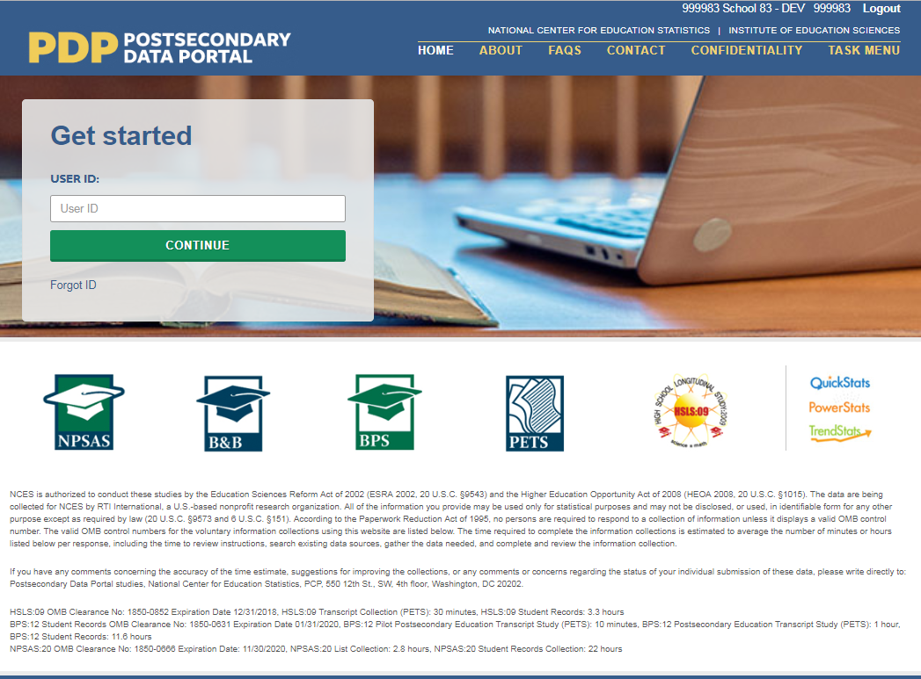 | Shot of PDP home page.  Cursor clicks in Get Started box, logs in to the PDP.
First, you will register your institution for NPSAS:20. When you register, you will designate staff who will submit data for NPSAS:20. You may need to designate staff from multiple departments at your institution to provide general demographic, enrollment, budget, and financial aid data. Each person you designate will receive their own credentials for logging into the PDP website.  You will also provide important background information about your institution, including your term structure, and set the due date for providing your student enrollment list. The due date for providing your list will vary based on your institution’s term structure. |  | Shot of NPSAS timeline graphic. Mouse over and highlight “Register Your Institution.”
Next, you will submit a list of all students enrolled at your institution between July 1, 2019 and [date]. After you submit your enrollment list, we will review the list and sample the students for NPSAS:20. During this time, we may contact you with questions about the list. |  | Shot of NPSAS timeline graphic. Mouse over and highlight “Submit Student Enrollment List.”
Finally, you will submit student records data for the students at your institution who are sampled for NPSAS:20. The student records data includes demographic, enrollment, budget, and financial aid information. You will receive your list of sampled students approximately 4 to 6 weeks after you submit your student enrollment list. |  | Shot of NPSAS timeline graphic. Mouse over and highlight “Provide Student Records Data.”
The PDP has resources to help you complete NPSAS:20:  - The Task Menu will show you the steps you need to complete next. | 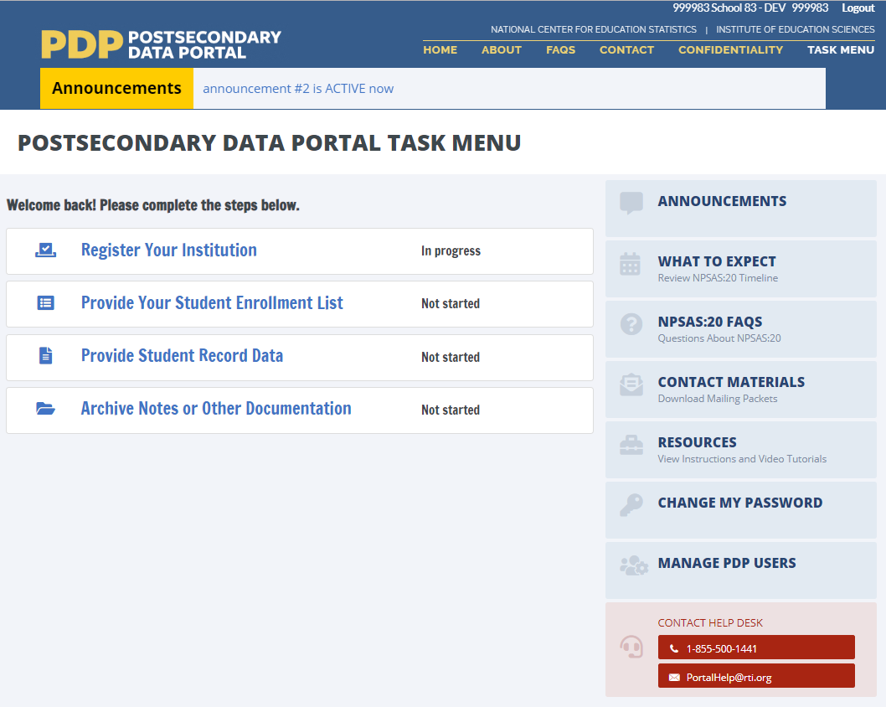 | Shot of PDP Task Menu. Mouse over to highlight steps in the Task Menu.
- View the FAQs page to answer your questions about NPSAS:20. | 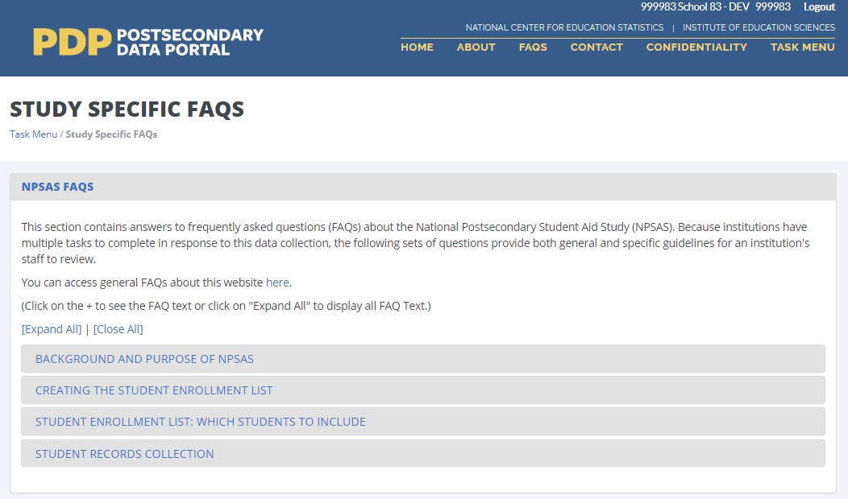 | Click FAQs link, open FAQ page.
- The Resources page has instructions, videos, and other reference materials. | 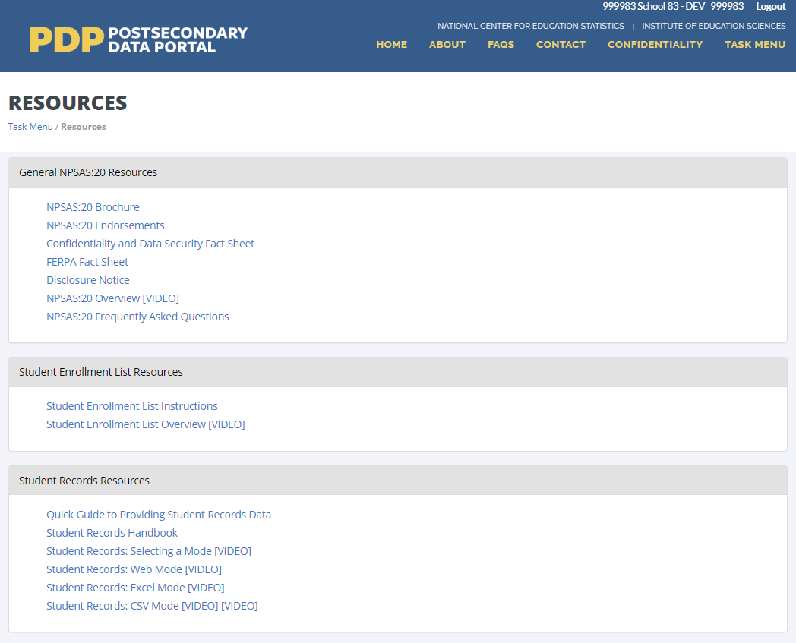 | Click Resources link, open Resources page.
- On the Contact Materials page, you can download a copy of the mailing materials that were sent to your institution. | 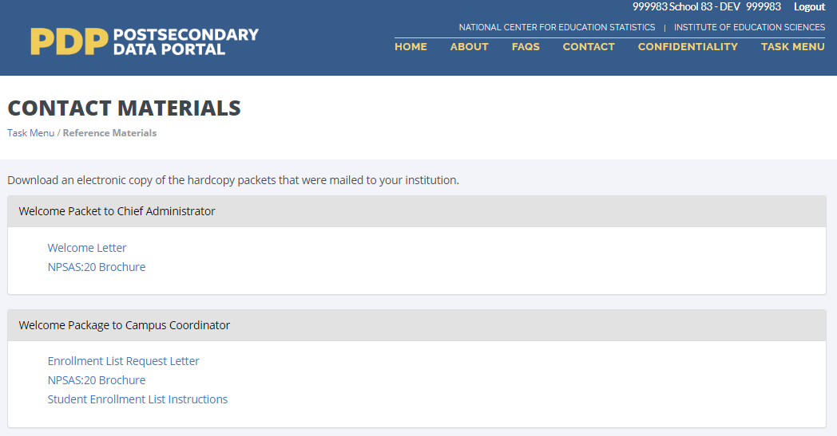 | Click Contact Materials link, open Contact Materials page.
On the Manage PDP Users page, you can manage the staff at your institution who have access to the PDP. | 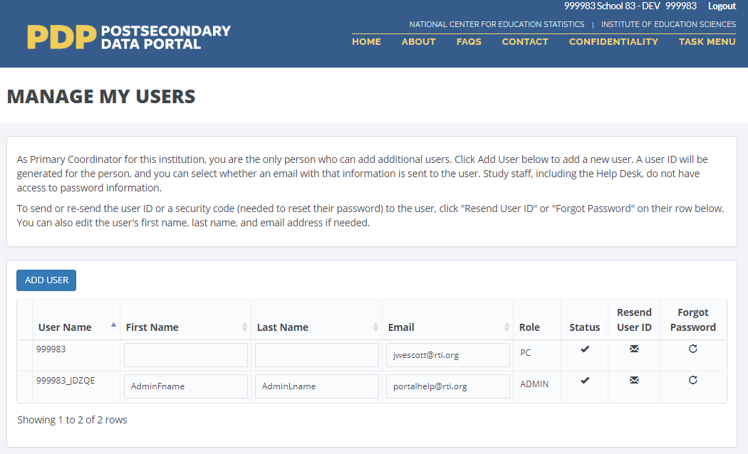 | Click Manage PDP Users link, open Manage PDP Users page.
Finally, if you need assistance, you can contact the Help Desk. |  | Shot of Task Menu. Mouse over to highlight Help Desk contact information.

Registration Page Video
Script for audio | Visual | Scene Description
When you register your institution for NPSAS:20, you will first designate staff at your institution who will provide data. | 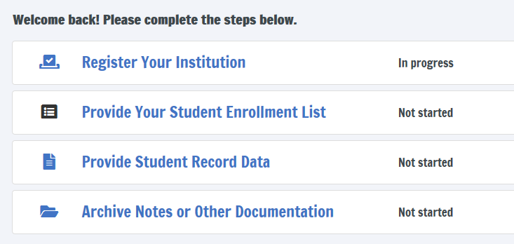 | Open on shot of PDP Task Menu.  Mouse over “Register” link, click to open registration page.
You may need to designate staff from multiple departments at your institution to provide general demographic, enrollment, budget, and financial aid data. | 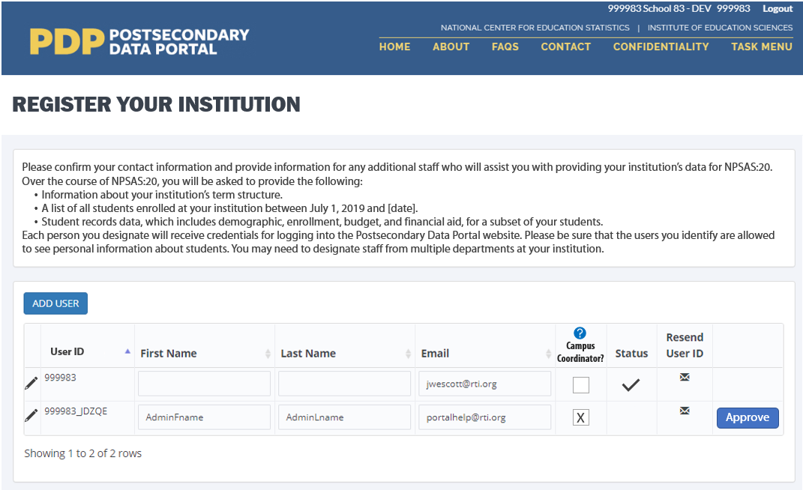 | Shot of DESIGNATE form on the registration page. Mouse over form, click Add User button to add a new user.
Each person you designate will receive their own credentials for logging in to the PDP website. | 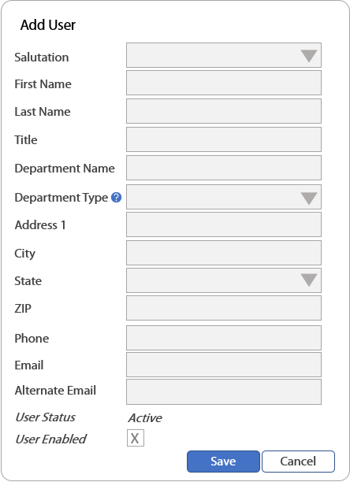 | Shot of Add User form.  Enter contact information for the new user into the form.
Next, we will collect information about your institution’s term structure. This information will be used for two purposes:  - Setting your due date for providing the student enrollment list.  - Determining how you will report student-level enrollment and financial aid data. | 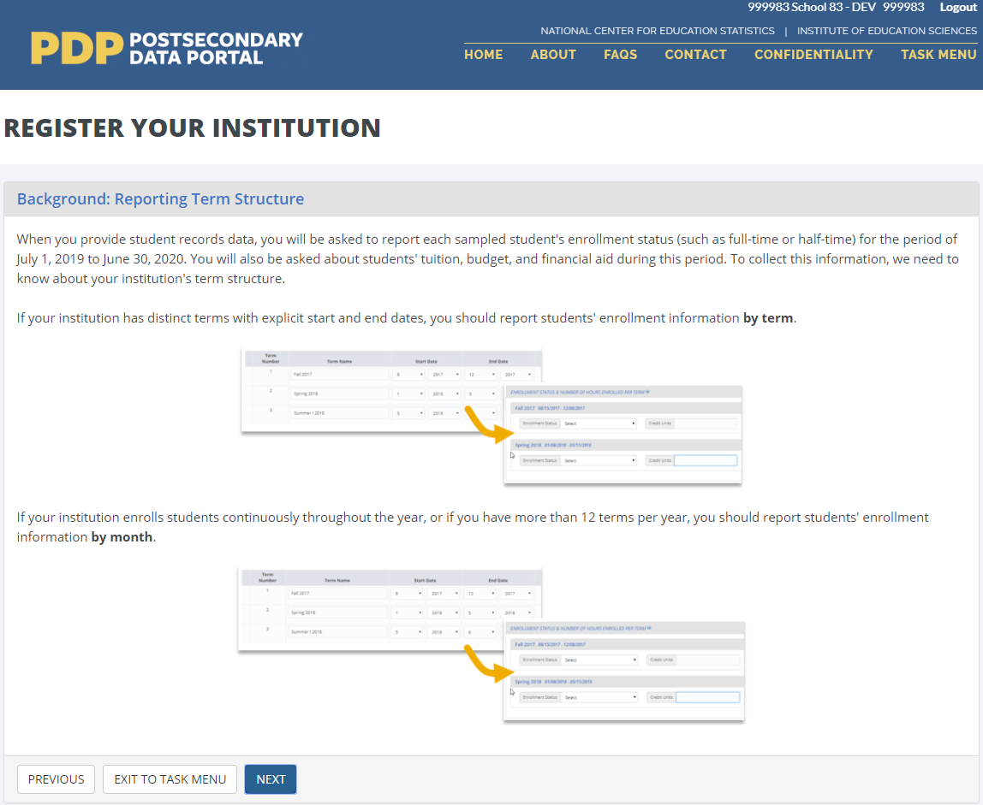 | Shot of TERMINST form.
When you provide student records data, you will be asked to report each sampled student’s enrollment status (such as full-time or half-time) and financial aid received for the period of July 1, 2019 to June 30, 2020.  If your institution has distinct terms with explicit start and end dates, you should report this information by term. |  | Close shot of Enrollment Status section from Student Records instrument.  Mouse over drop-down box, click to expand the box, select “full-time” response option.
During registration, you will be asked to confirm or provide the term name, start date, and end date for every term in the July 1, 2019 to June 30, 2020 time period. | 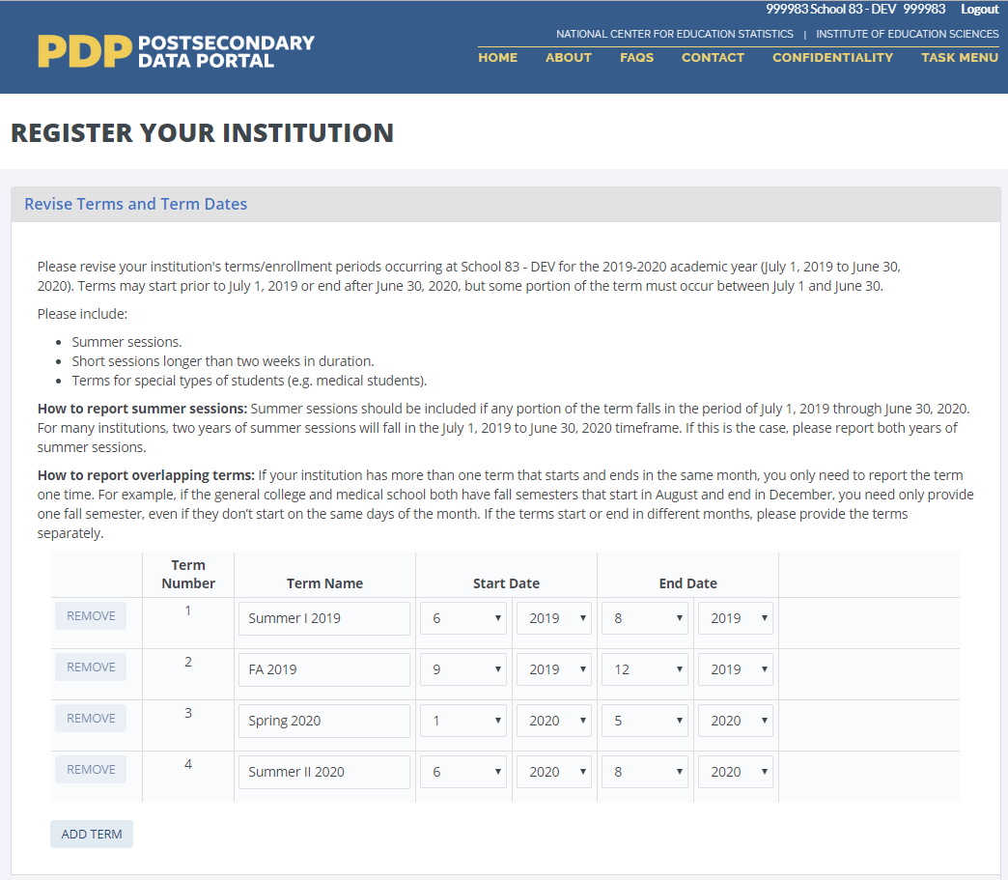 | Shot of REVTERM form. Mouse over drop-down boxes and revise start and end dates for one term.  Click Next.
If your institution enrolls students continuously throughout the year, or if you have more than 12 terms per year, you should choose to report enrolment information by month. | 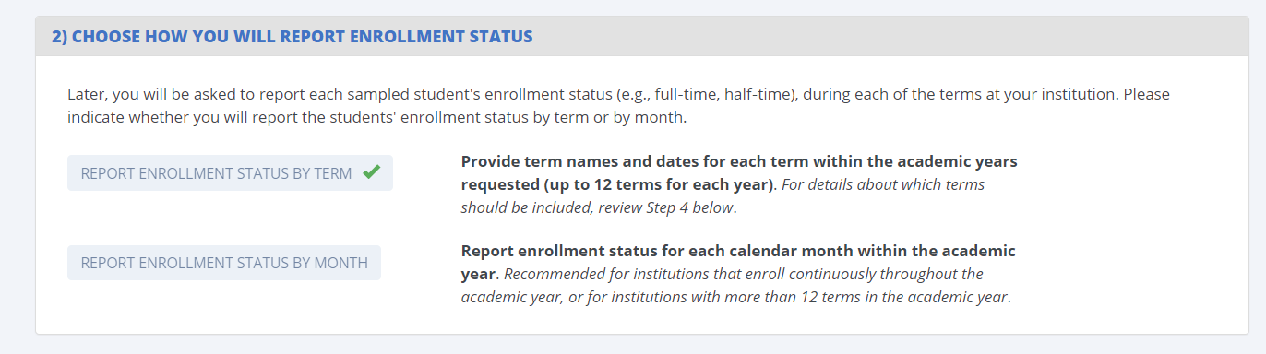 | Shot of BENRTYPE form. Mouse over form, select “Report Enrollment Status by Month” option.
Whenever possible, we will preload information about your institution’s term structure. You can either confirm the preloaded information or choose to provide new term information. | 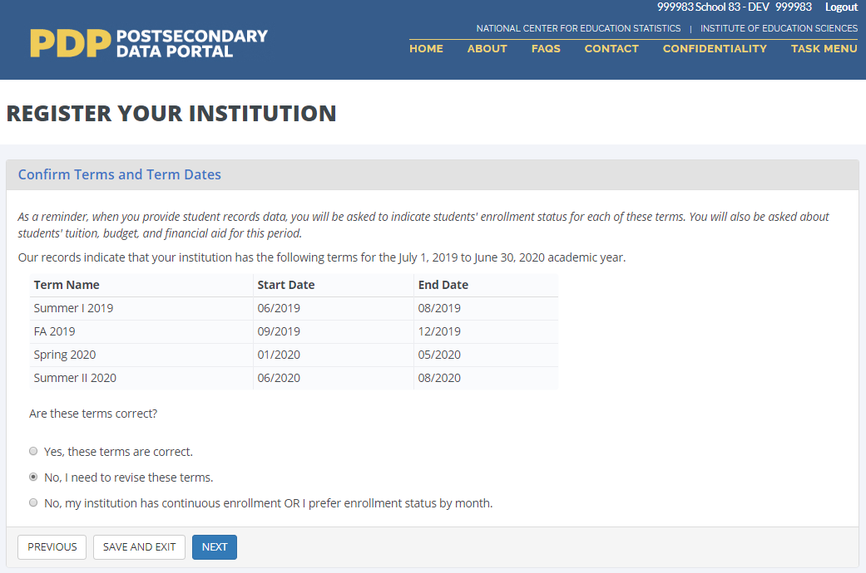 | Shot of TERMCONF form.
Finally, you will be asked some brief background questions about your institution. | 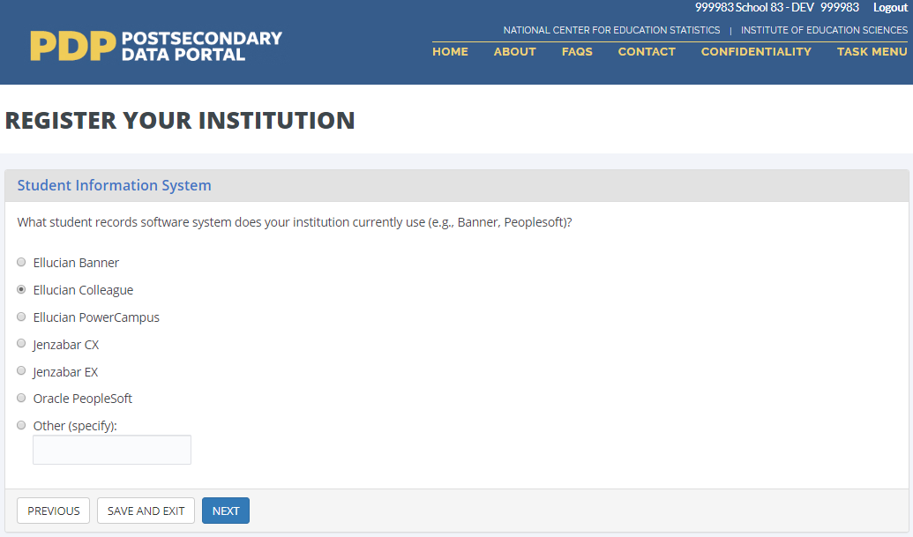 | Shot of SIS form. Click one of the radio button options, click Next.
Once you submit information through the Registration page, you will no longer be able to make changes. Please contact us if you need to revise your registration information. | 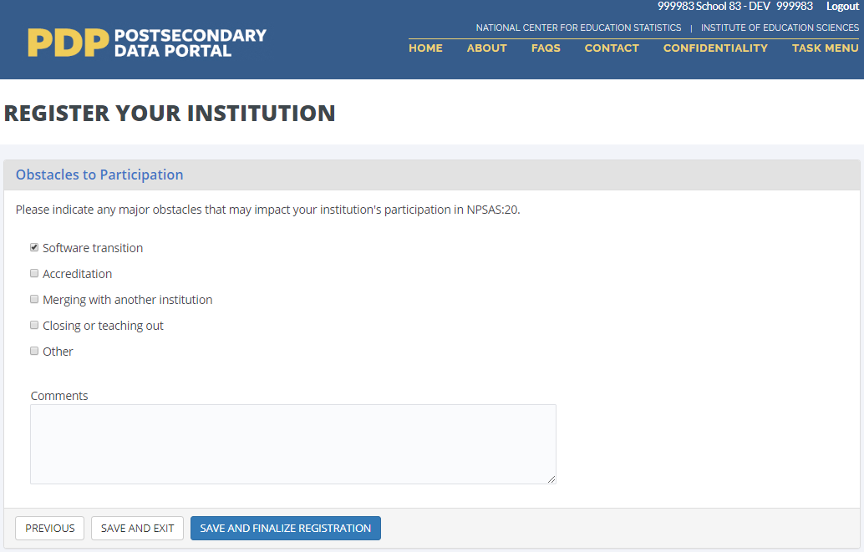 | Shot of OBSTACLE form. Click one of the checkboxes, then click Save and Finalize Registration.

Enrollment List Page Video
Script for Audio | Visual | Scene Description
The next step for NPSAS:20 is to submit a list of all students enrolled at your institution between July 1, 2019 and [date] who are eligible for NPSAS:20. |  | Open on shot of PDP Task Menu.  Mouse over “Provide your student enrollment list” link, click to open page.
The enrollment list instructions include information about which students are eligible and should be included on your enrollment list. | 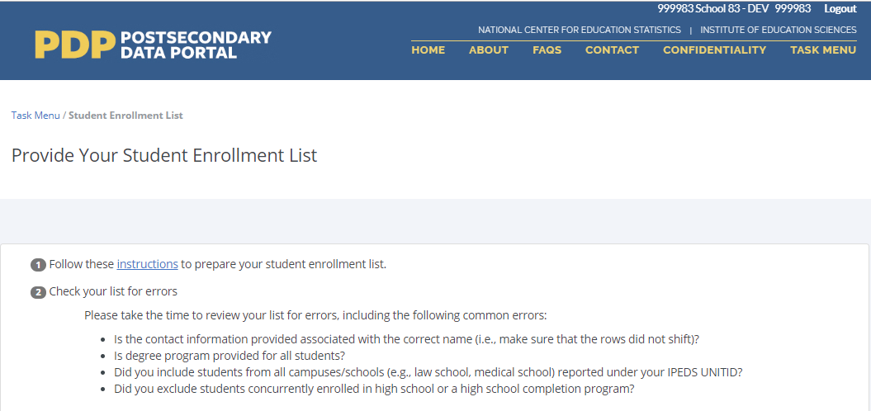 | Shot of Provide Your Student Enrollment List page.  Cursor over instructions hyperlink and click link.
The list instructions also include file layout specifications. These specifications include the list of data elements you should include on your list and which data elements are most critical. | 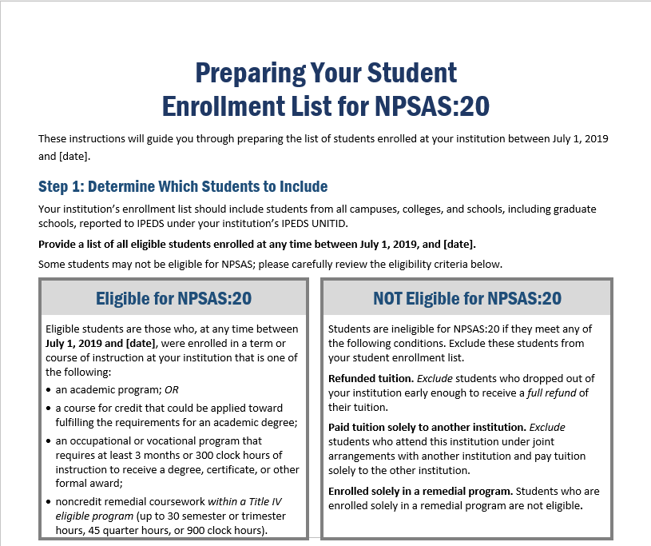 | Shot of enrollment list instructions document. Scroll down to the file layout specifications table.
Once you’ve prepared and reviewed your list, upload your list file on the PDP. | 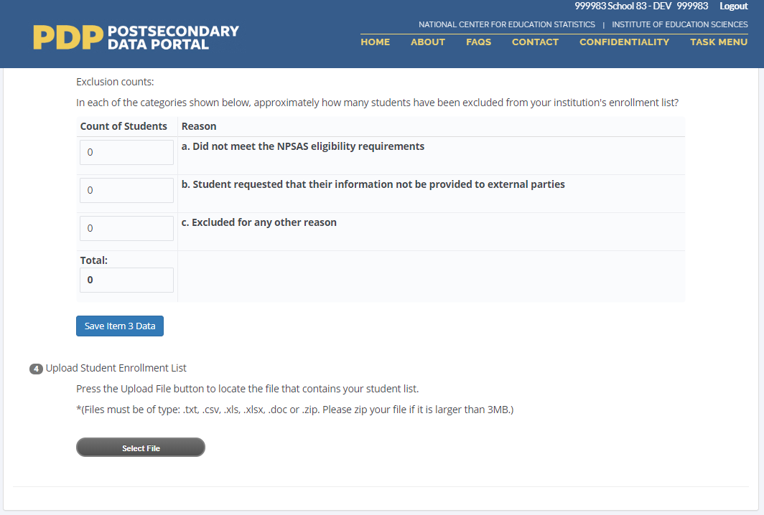 | Shot of Provide Your Student Enrollment List page. Cursor clicks on Select File button, selects a file to upload, and uploads file.
Please also provide counts of ineligible students that you excluded from your list. This information will help us review the list and compare it against enrollment counts reported to IPEDS.  After you submit your enrollment list, we will review the list and sample the students for NPSAS:20. During this time, we may contact you with questions about the list. | 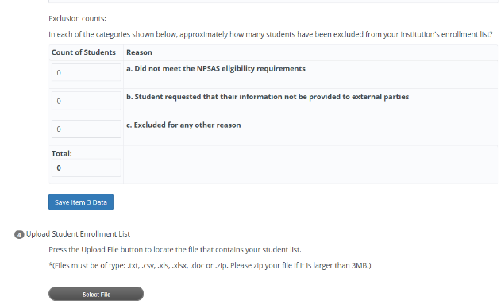 | Shot of Provide Your Student Enrollment List page. Cursor clicks on each field and enters a value.  Cursor scrolls to the end of the page and clicks the Submit button.
Once your students have been sampled, we will contact you again with instructions for providing student records data for the sampled students. We will contact you with these instructions about 4 to 6 weeks after you submit your list. |  | Shot of NPSAS:20 timeline.

Institutions that refuse to provide the full list of data elements will be offered a reduced list of data elements. Those institutions will receive a set of revised instructions that contain the items marked “X” in this column.

